Extended Data
Extended Data Table 1 | Temporal comparison of crisis patterns: aggregate vs matched-location analysis.
Panel A: All locations
Metric | Early (2011–2017) | Late (2018–2023)
Locations monitored | 492 | 739
Phase 4+ rate | 1.7% | 4.6%
Panel B: Matched locations (observed in both periods)
Metric | Early (2011–2017) | Late (2018–2023)
Locations | 486 | 486
Observations | 32438 | 32554
Phase 4+ rate | 1.7% | 4.8%
Panel C: Location cohort characteristics
Cohort | n locations | Phase 4+ rate | Definition
Dropped | 6 | 0.0% | Observed in 2011-2017 only
New | 253 | 3.6% | Observed in 2018-2023 only
Consistent | 359 | 1.4% → 3.9% | Observed in >=12 of 14 years
Matched-location analysis shows Phase 4+ rates increasing from 1.7% to 4.8%. Monitoring expanded from 492 to 739 locations; 253 new locations with 3.6% Phase 4+ rate entered in the late period, partially diluting the aggregate trend. Chi-square tests for proportions; Welch's t-test for duration. All p-values are Bonferroni-corrected.

Extended Data Table 2 | Sensitivity analysis: data source prioritization.
Comparison of FEWS NET vs IPC priority configurations using MAX aggregation and 12-month interpolation. Minimal differences between data source prioritization approaches.
Metric | FEWS NET priority | IPC priority
P(4→3) | 13.66% | 10.33%
P(3→4) | 1.95% | 1.57%
Recovery ratio (4→3)/(3→4) | 7.0:1 | 6.58:1
P(3→2) | 6.77% | 5.74%
P(2→3) | 5.74% | 4.97%
Phase 3→2 ratio | 1.18:1 | 1.16:1
Episodes | 1,658 | 1,453
Countries | 49 | 49
Seasonal crisis % | 72.6% | 68.1%
Phase 3 crossover (months) | 28.5 | 37.8

Extended Data Table 3 | Interpolation threshold sensitivity.
Results across three interpolation gap thresholds using FEWS NET priority and MAX aggregation. The 12-month threshold (*) is used in the main analysis. Results robust across all thresholds.
Metric | 6-month gap | 12-month gap* | 18-month gap
P(4→3) | 13.81% | 13.66% | 13.51%
P(3→4) | 1.99% | 1.95% | 1.93%
Recovery ratio | 6.93:1 | 7.0:1 | 7.0:1
P(3→2) | 6.9% | 6.77% | 6.77%
P(2→3) | 5.72% | 5.74% | 5.72%
Phase 3→2 ratio | 1.21:1 | 1.18:1 | 1.18:1
Episodes | 1,658 | 1,658 | 1,658
Seasonal crisis % | 73.9% | 72.6% | 72.6%
Protracted % | 5.7% | 5.9% | 5.9%
Phase 3 crossover | 28.5 mo | 28.9 mo | 29.6 mo

Extended Data Table 4 | Data source consistency analysis.
Agreement between FEWS NET and Cadre Harmonisé/IPC classifications where both exist for the same area-month (Panel A), and consistency of IPC area classifications with food security input indicators benchmarked to IPC phase thresholds (Panel B). Data source coverage by period (Panel C). Analysis based on HFID v1.1.1 (311,838 records across 80 countries).

Panel A: FEWS NET vs CH/IPC Classification Agreement
Metric | Value
Overlapping records (both sources) | 12,617
Exact phase match | 49.0%
Agreement within ±1 phase | 95.2%
Disagreement ≥2 phases | 4.8%
Critical disagreement (Phase ≤2 vs ≥4) | 0.7%
Mean difference (FEWS − CH) | -0.42 ± 0.69
Direction: CH classifies higher | 44.3%
Direction: FEWS classifies higher | 6.7%

Panel B: IPC Phase vs Food Security Input Indicators
IPC Phase | FCS mean (n = 4,162) | FCS benchmark | rCSI mean (n = 3,683) | rCSI benchmark
Phase 1 | 0.216 | <0.05 | 0.315 | <0.05
Phase 2 | 0.368 | 0.05–0.20 | 0.451 | 0.05–0.20
Phase 3 | 0.511 | 0.20–0.40 | 0.530 | 0.20–0.40
Phase 4 | 0.500 | 0.40–0.60 | 0.505 | 0.40–0.60
Values represent proportion of population with insufficient food consumption (FCS) or crisis-level coping (rCSI). Benchmark ranges from IPC Technical Manual v3.1. Both indicators suggest IPC area classifications are systematically more conservative than input data alone would imply (observed means exceed benchmark upper bounds at all phases).

Panel C: Data Source Coverage Over Time
Period | FEWS NET records | CH/IPC records
2011–2016 | 68,436 | 0
2017–2018 | 17,993 | 14,293
2019–2020 | 18,110 | 26,141
2021–2023 | 30,495 | 53,070
2024 (partial) | 3,300 | 3,974
CH/IPC coverage expanded from zero (pre-2017) to dominant source by 2020. The matched-location analysis in Extended Data Table 1 controls for this transition by comparing identical locations across periods. Where both sources provided classifications for the same area-month (n = 12,617 records, Phases 1–4), agreement statistics are reported in Panel A.

Extended Data Table 5 | Left-censoring sensitivity analysis.
Comparison of episode-level statistics with and without left-censored episodes. Transition matrices are computed from the full interpolated time series and are not affected by left-censoring.
Metric | All episodes  (primary) | Excluding  left-censored | Left-censored  only
Episodes | 1658 | 1517 | 141
Countries | 49 | 41 | 27
Locations | 490 | 396 | 141
Mean duration (months) | 11.6 | 10.3 | 25.8
Median duration (months) | 4.0 | 4.0 | 18.0
Phase 4+ episodes | 11.6% | 9.6% | 33.3%
Ongoing at end | 17.6% | 14.5% | 51.1%
Seasonal crisis | 72.6% | 75.9% | 36.9%
Prolonged moderate | 13.5% | 12.7% | 31.2%
Protracted emergency | 5.9% | 4.2% | 17.0%
Rapid onset | 3.2% | 2.9% | 6.4%
Entrenched moderate | 2.3% | 2.2% | 2.8%
Oscillating | 1.0% | 0.9% | 2.1%
Severe shock | 1.0% | 0.8% | 2.8%
Escalating | 0.4% | 0.4% | 0.7%

Extended Data Table 6 | Full pipeline sensitivity analysis (9 variants).
Complete sensitivity analysis across all pipeline configuration variants. Recovery asymmetry (ratio > 1) is robust across all 9 variants. Primary analysis uses variant 2 (FEWS + MAX + 12mo, ratio = 7.0:1).
# | Priority | Agg. | Gap | Admin | P(4→3)  % | P(3→4)  % | Ratio  4→3 | P(3→2)  % | Ratio  3→2 | Episodes | Countries | P3 cross-  over (mo)
1 | FEWS | max | 6mo | admin1 | 13.81 | 1.99 | 6.93 | 6.9 | 1.21 | 1,658 | 49 | 28.5
2 | FEWS | max | 12mo | admin1 | 13.66 | 1.95 | 7.0 | 6.77 | 1.18 | 1,658 | 49 | 28.9
3 | FEWS | max | 18mo | admin1 | 13.51 | 1.93 | 7.0 | 6.77 | 1.18 | 1,658 | 49 | 29.6
4 | IPC | max | 6mo | admin1 | 10.39 | 1.6 | 6.51 | 5.84 | 1.19 | 1,453 | 49 | 39.8
5 | IPC | max | 12mo | admin1 | 10.33 | 1.57 | 6.58 | 5.74 | 1.16 | 1,453 | 49 | 40.3
6 | IPC | max | 18mo | admin1 | 10.23 | 1.55 | 6.58 | 5.75 | 1.16 | 1,453 | 49 | 41.3
7 | FEWS | admin2 | 12mo | admin2 | 13.8 | 1.2 | 11.5 | 7.13 | 1.4 | 10,976 | 49 | 31.0
8 | FEWS | dictzip | 12mo | admin1 | 13.28 | 1.44 | 9.23 | 7.68 | 1.57 | 1,461 | 49 | 29.0
9 | FEWS | median | 12mo | admin1 | 13.44 | 1.36 | 9.89 | 8.13 | 1.8 | 1,375 | 46 | 30.3

Extended Data Table 7 | Regional recovery asymmetry.
Recovery ratios by region with bootstrap 95% confidence intervals. Regions sorted by ratio (lowest to highest). "Other" region (105 locations) excluded due to zero Phase 4 transitions.
Region | n locs | P(4→3) | P(3→4) | Ratio | 95% CI | Countries
Horn of Africa | 168 | 11.34% | 3.14% | 3.61:1 | 2.7–5.2 | DJI, ETH, KEN, SDN, SOM, SSD, UGA
Central Africa | 53 | 13.86% | 2.75% | 5.04:1 | 3.2–8.8 | CAF, CMR, COD
West Africa | 109 | 8.13% | 1.43% | 5.67:1 | 2.3–32.2 | BEN, CIV, GHA, GIN, LBR, NGA, SLE, TGO
Asia | 91 | 14.8% | 2.09% | 7.07:1 | 5.3–10.1 | AFG, BGD, LBN, MMR, PAK, PSE, YEM
Sahel | 86 | 12.5% | 0.55% | 22.82:1 | 9.1–289.0 | BFA, GMB, MLI, MRT, NER, SEN, TCD
Central America | 64 | 46.84% | 1.61% | 29.1:1 | 17.5–67.3 | GTM, HND, HTI, SLV
Southern Africa | 69 | 18.97% | 0.5% | 37.83:1 | 20.6–130.9 | MDG, MOZ, MWI, SWZ, ZMB, ZWE

Extended Data Table 8 | Quarterly aggregation analysis.
Transition probabilities computed from quarterly-aggregated data (maximum IPC phase within each calendar quarter). Quarterly aggregation reduces the recovery ratio from 7.0:1 to 6.0:1, consistent with coarser temporal resolution smoothing short-duration recoveries.
Metric | Monthly analysis | Quarterly analysis
P(4→3) | 13.66% | 24.8%
P(3→4) | 1.95% | 4.16%
Recovery ratio | 7.0:1 (CI: 5.8–8.7) | 5.96:1 (CI: 4.9–7.3)
P(3→2) | 6.77% | 13.24%
P(2→3) | 5.74% | 13.15%
Phase 3→2 ratio | 1.18:1 | 1.01:1
Records | 73,396 transitions | 25,160 quarterly records
Locations | 745 | 745

Extended Data Figures
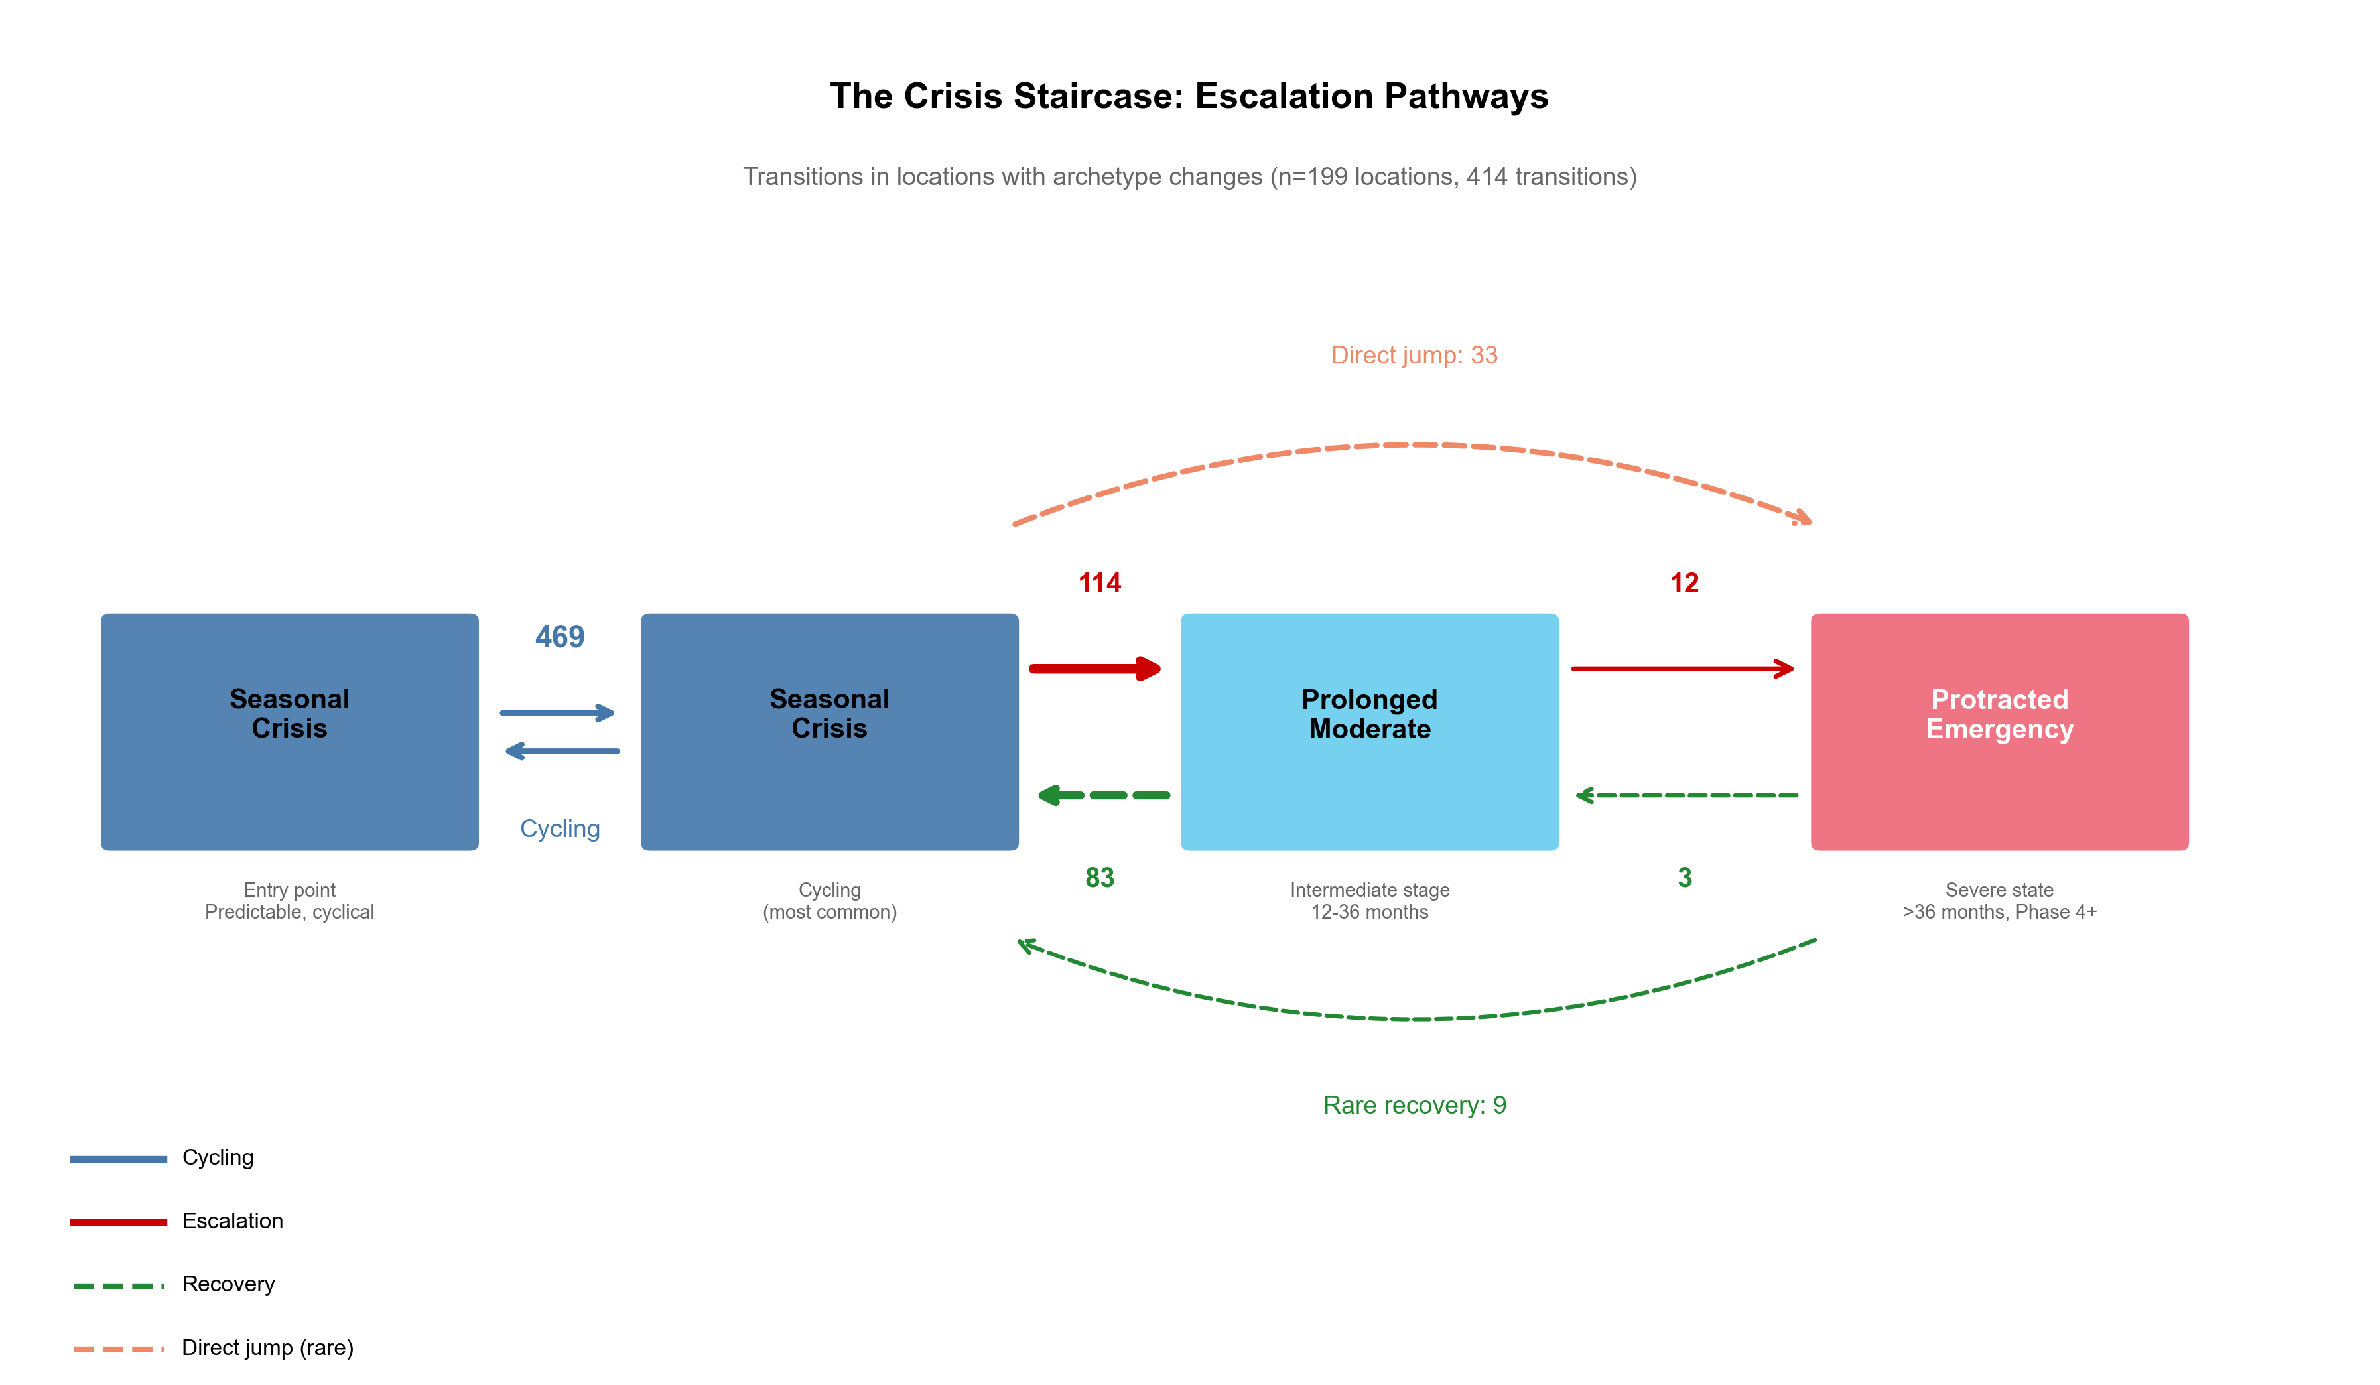
Extended Data Fig. 1 | Crisis staircase escalation pathways. The “crisis staircase” showing how food crises progressively worsen through repeated transitions. Boxes represent crisis archetypes ordered by severity. The circular arrow (n=469) shows locations cycling between seasonal crisis episodes without escalation. Red arrows show the dominant escalation pathway: seasonal crisis to prolonged moderate (n=114) to protracted emergency (n=12). Dashed arrows indicate direct jumps (n=30) and rare recovery transitions. Data source: HFID v1.1.1, 2011–2024, 200 locations with archetype changes, 415 transitions.

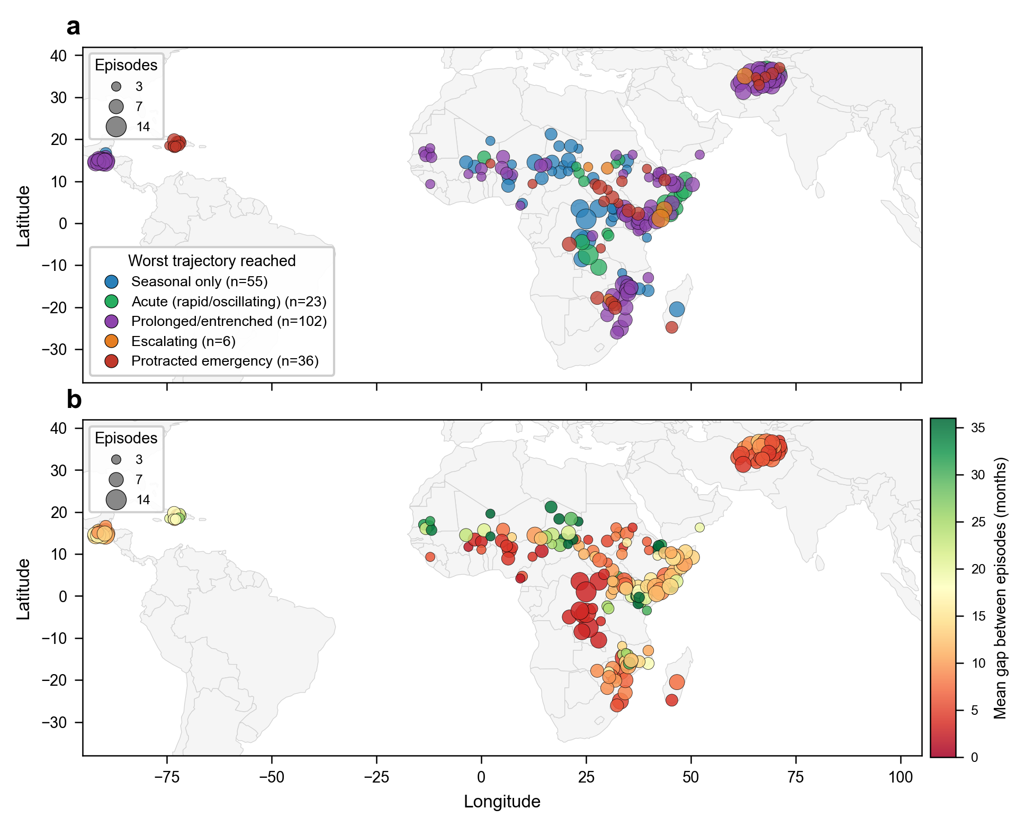
Extended Data Fig. 2 | Geographic distribution of recurring food crises and recovery gap compression. (a) Locations with three or more crisis episodes (n = 222 admin1 regions across 26 countries), colored by worst trajectory archetype reached. Point size is proportional to the total number of episodes at each location. Protracted emergencies (red, n = 36) and escalating crises (orange, n = 6) are concentrated in the Horn of Africa, the Sahel, and the Great Lakes region. (b) Mean recovery gap duration between consecutive episodes at the same location. Shorter gaps (red) indicate compressed recovery windows where populations have insufficient time to rebuild livelihoods before the next crisis. 59 locations (27%) have a mean gap of ≤6 months, and the median gap across all locations is 11.3 months. Coordinates represent admin1 region centroids; country boundaries from Natural Earth.

