Supporting Information

Cation effects on the electro-oxidation of alcohols are not mediated solely by their interactions with adsorbed OH
Alan J. Gibson¹, Tadeu Luiz Gomes Cabral², Victor Y. Yukuhiro^{2,3}, Claudio F. Tormena², Pablo S. Fernández^{2,3} and Angel Cuesta^{1,4}

¹Advanced Centre for Energy and Sustainability (ACES), School of Natural and Computing Sciences, University of Aberdeen, Aberdeen, AB24 3UE, Scotland, UK
²Chemistry Institute, Universidade Estadual de Campinas (UNICAMP), 13083-970 Campinas, São Paulo, Brazil
³Center for Innovation on New Energies (CINE), Universidade Estadual de Campinas, 13083-841, São Paulo, Brazil
⁴Instituto de Química Física Blas Cabrera, CSIC, C. Serrano, 119, E-28006 Madrid, Spain

Section S1: UV-Vis Reflectance Experiments
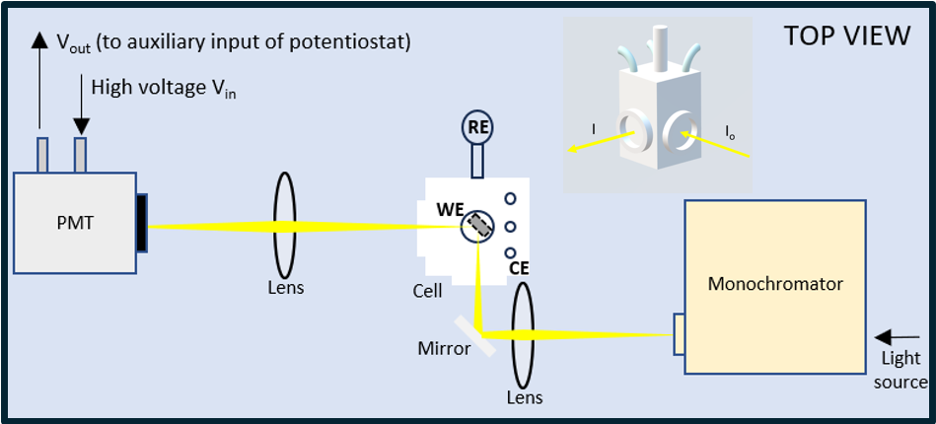
Figure S1. Diagram depicting our home-made UV-Vis reflectance spectrometer, showing the components along the optical path and the spectroelectrochemical cell.
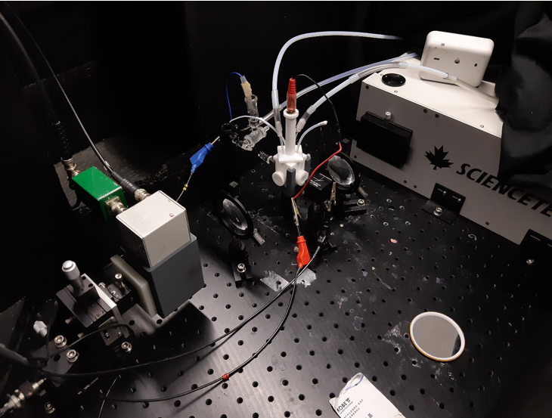
Figure S2. Image of our home-made UV-Vis reflectance spectrometer.

Section S2: ATR-SEIRAS Experiments

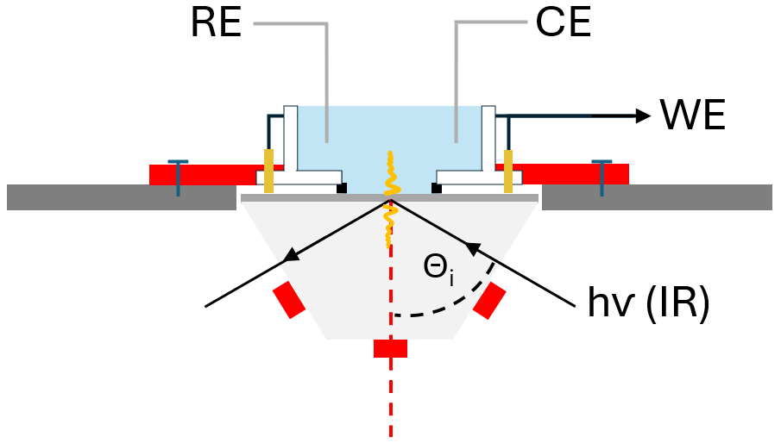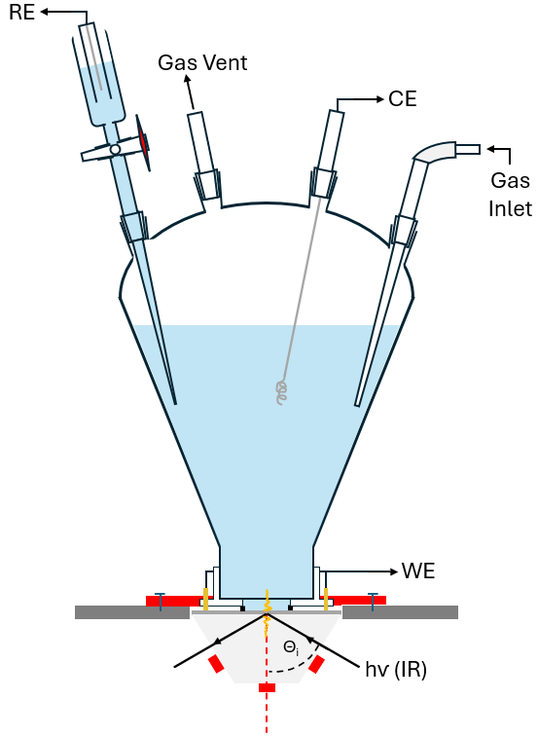

Figure S3. Diagram of our custom-made ATR-SEIRAS spectroelectrochemical cell and ATR element, arranged in the Kretschmann configuration.

Section S3: Pt film preparation procedure
The WE for ATR-SEIRAS experiments is a nano-structured polycrystalline Pt_{poly} film, deposited on a Si ATR prism. The deposition process involved polishing one face of the triangular Si prism, bevelled at 60º, with 1 µm alumina slurry on a microfibre pad. The prism is then sonicated twice each successively in fresh acetone and ultra-pure water (Elga Veolia, 18.2 MΩ cm). The prism is then etched and coated with a very thin Pd film, the Pd particles within which will act as nucleation centres for deposition of the Pt film, using a plating solution of 5 mM PdCl₂ + 2 % HF at room temperature. After rinsing in ultra-pure water and drying in a clean Ar stream, the prism is held at 65 ºC in a water bath and coated with Pt using a commercial Pt plating solution (1 mL Lectroless Pt100 (Electroplating Engineering of Japan), 100 µL 25 % m/v ammonia, 20 µL Lectroless Pt100 reducer (Electroplating Engineering of Japan), 880 µL ultra-pure water). The prism is then rinsed and dried again, as described above. The continuity of the film is tested by measuring the resistance between opposing corners of the covered prism face. Typical resistance values are 15-20 Ω.

Section S4: Blank Reflectograms of Pt at λ = 250 and 500 nm Overlayed
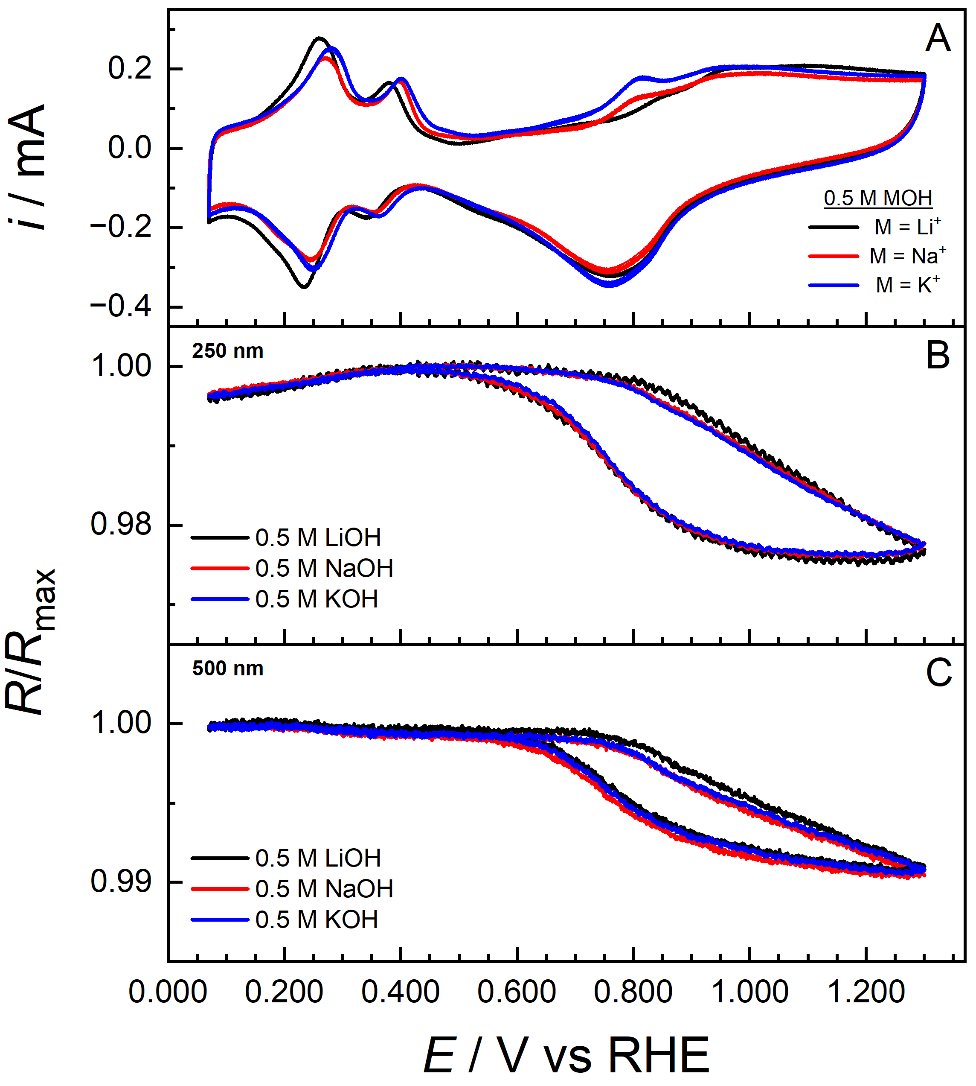
Figure S4. CVs of a Pt_{poly} disc electrode in contact with 0.5 M MOH (M = Li⁺ (black), Na⁺ (red) and K⁺ (blue)) (A), scan rate = 50 mV/s, along with reflectograms recorded synchronously with these CVs at λ = 250 nm (B) and 500 nm (C). Signal averaged reflectograms, obtained by co-adding 8-10 individual experiments, are presented.
Reflectograms recorded at 250 nm (Fig. S4B) remain sensitive, although more so, to surface oxidation and reduction, and in addition are sensitive to H_{UPD}. The H_{UPD} region coincides with a decrease in reflectance of 0.5%. The positive- and negative-going scans of the reflectogram overlap in this region, reflecting the reversible nature of the H_{UPD} process. The reflectance remains essentially independent of potential between 0.35 V and 0.75 V in the positive-going scan, again due to the very low electroreflectance of Pt, followed by a decrease of 2.5% between ca. 0.75 V-0.80 V and 1.3 V coinciding with the oxidation of the Pt surface. In the negative-going scan, the reflectance returns to that in the positive-going scan at 0.45 V, when surface oxide reduction is complete. When present, the reflectance at this wavelength is also sensitive to adsorbed carbon monoxide.
Section S5: NMR Spectroscopy data
Further details and the complete ¹H-DOSY datasets for glycerol are provided below. The corresponding raw free induction decay (FID) files are freely available in the online repository at https://doi.org/10.25824/redu/FDYCRH.
- Self-Diffusion Coefficients
Table S1: Diffusion coefficient (D) of glycerol (GLY), its associated error, and difference in diffusion coefficient (ΔD = D^{KOH} − D^{LiOH}) for samples containing varying concentrations of KOH or LiOH. Base concentrations are given in mM, diffusion coefficients and their corresponding errors are reported in units of 10⁻¹⁰ m² s⁻¹, and the differences in diffusion coefficients are expressed as percentages (%) relative to the diffusion coefficients measured in the presence of KOH. The diffusion coefficient of GLY was obtained as the average of nine resolved glycerol peaks, and the associated uncertainties are the propagated errors.
Base Concentration | GLY + KOH |  | GLY + LiOH |  | ΔD
Base Concentration | D | error | D | error | ΔD
0 | 7.47 | 0.08 | 7.47 | 0.08 | 0.0
50 | 7.40 | 0.09 | 7.37 | 0.1 | 0.4
100 | 7.36 | 0.07 | 7.24 | 0.05 | 1.6
250 | 7.23 | 0.11 | 7.05 | 0.09 | 2.5
500 | 6.95 | 0.09 | 6.66 | 0.05 | 4.2
750 | 6.66 | 0.09 | 6.34 | 0.08 | 4.8
1000 | 6.45 | 0.16 | 6.02 | 0.08 | 6.7

- ¹H-DOSY Data for Glycerol Samples
  - Pure Glycerol
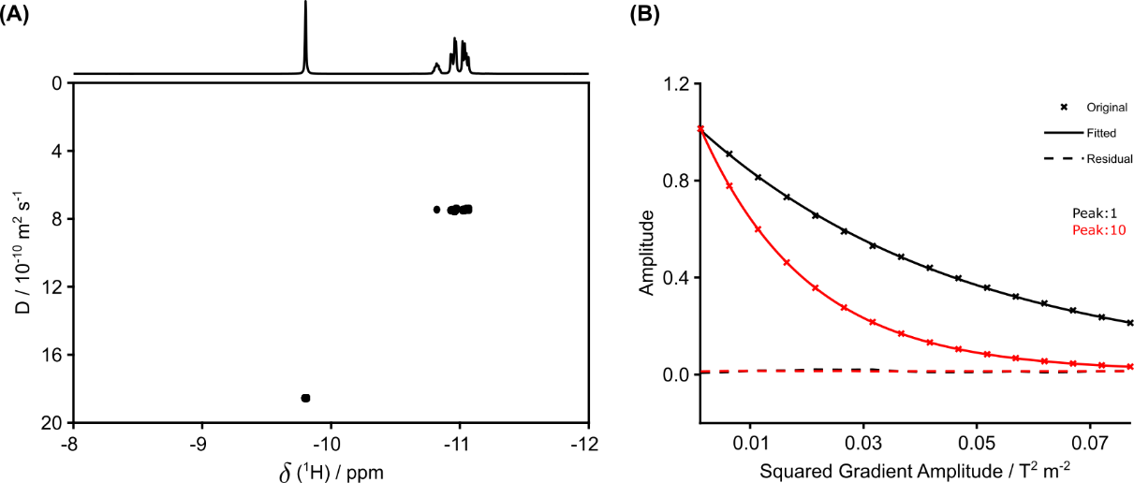
Figure S5: (A) 400 MHz ¹H-DOSY plot highlighting the −12 to −8 ppm region for glycerol (GLY, −11.1 to −10.8 ppm) and water (H₂O, −9.8 ppm) acquired in D₂O. (B) Associated signal-fitting for both components (peak 1 corresponds to GLY, peak 10 to H₂O).

Table S2: ¹H-DOSY (400 MHz) measurements of glycerol (GLY) and water (H₂O) acquired in D₂O. Frequencies correspond to chemical shifts and are reported in ppm, while diffusion coefficients and their errors are expressed in units of 10⁻¹⁰ m² s⁻¹.
Compound | Frequency | Exp. Ampl. | Fit. Ampl. | Error | Diff. coef. | Error
GLY | -11.06655 | 0.23571 | 0.24023 | 0.0007 | 7.43466 | 0.03817
GLY | -11.05005 | 0.28989 | 0.29548 | 0.00073 | 7.43256 | 0.03244
GLY | -11.03722 | 0.42522 | 0.43454 | 0.00091 | 7.47203 | 0.02774
GLY | -11.02102 | 0.44869 | 0.45983 | 0.00078 | 7.48646 | 0.0223
GLY | -10.96908 | 0.44896 | 0.45773 | 0.00105 | 7.43065 | 0.03024
GLY | -10.95839 | 0.49199 | 0.50325 | 0.00127 | 7.51189 | 0.0334
GLY | -10.93975 | 0.26624 | 0.27226 | 0.00048 | 7.48786 | 0.02307
GLY | -10.92936 | 0.27459 | 0.28215 | 0.00043 | 7.49571 | 0.02005
GLY | -10.81876 | 0.14759 | 0.15115 | 0.00016 | 7.46387 | 0.01377
H₂O | -9.80226 | 1 | 1.06434 | 0.00063 | 18.54796 | 0.01658

  - Glycerol + 50 mM KOH
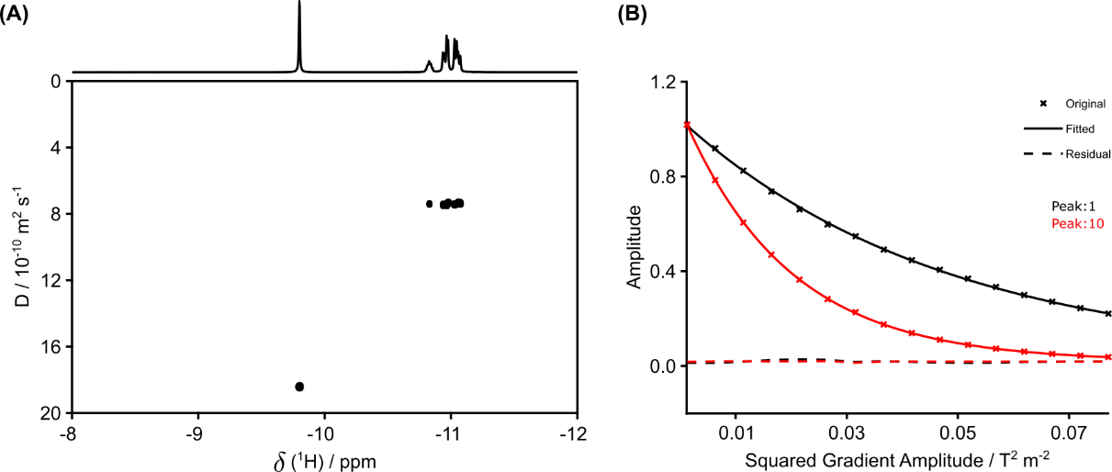
Figure S6: (A) 400 MHz ¹H-DOSY plot highlighting the −12 to −8 ppm region for glycerol (GLY, −11.1 to −10.8 ppm) and water (H₂O, −9.8 ppm) acquired in D₂O containing 50 mM KOH. (B) Associated signal-fitting for both components (peak 1 corresponds to GLY, peak 10 to H₂O).

Table S3: ¹H-DOSY (400 MHz) measurements of glycerol (GLY) and water (H₂O) acquired in D₂O containing 50 mM KOH. Frequencies correspond to chemical shifts and are reported in ppm, while diffusion coefficients and their errors are expressed in units of 10⁻¹⁰ m² s⁻¹.
Compound | Frequency | Exp. Ampl. | Fit. Ampl. | Error | Diff. coef. | Error
GLY | -11.07296 | 0.23223 | 0.23704 | 0.00074 | 7.36882 | 0.04078
GLY | -11.05677 | 0.28581 | 0.29279 | 0.00061 | 7.3274 | 0.02718
GLY | -11.04394 | 0.42754 | 0.43691 | 0.00081 | 7.39069 | 0.02432
GLY | -11.02774 | 0.4568 | 0.46654 | 0.00095 | 7.42734 | 0.02685
GLY | -10.97611 | 0.43999 | 0.45048 | 0.0008 | 7.338 | 0.02319
GLY | -10.96542 | 0.49802 | 0.50781 | 0.00123 | 7.44811 | 0.03186
GLY | -10.94678 | 0.26796 | 0.2732 | 0.00066 | 7.44054 | 0.03156
GLY | -10.93639 | 0.28135 | 0.2871 | 0.00063 | 7.45652 | 0.02901
GLY | -10.82671 | 0.15284 | 0.15611 | 0.00034 | 7.40794 | 0.02832
H₂O | -9.80074 | 1 | 1.06355 | 0.00139 | 18.41442 | 0.03659

  - Glycerol + 100 mM KOH
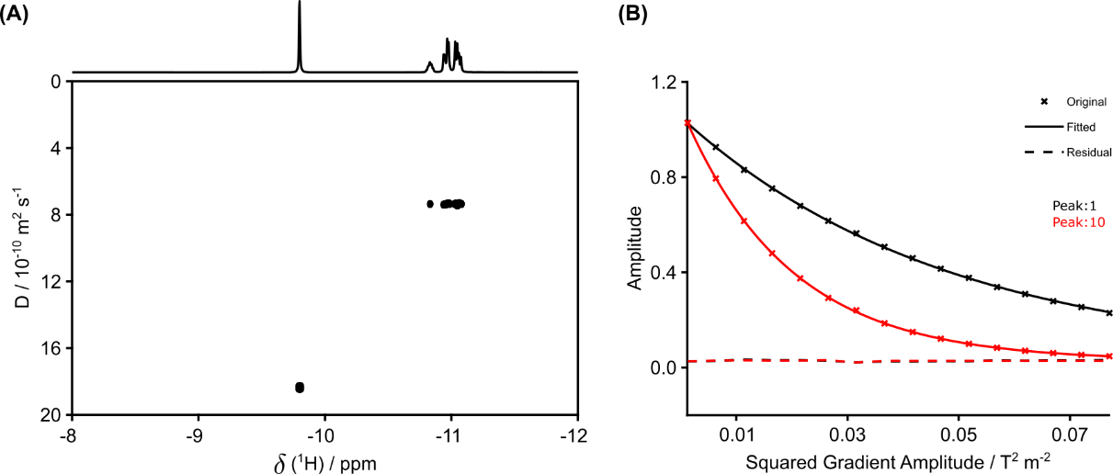
Figure S7: (A) 400 MHz ¹H-DOSY plot highlighting the −12 to −8 ppm region for glycerol (GLY, −11.1 to −10.8 ppm) and water (H₂O, −9.8 ppm) acquired in D₂O containing 100 mM KOH. (B) Associated signal-fitting for both components (peak 1 corresponds to GLY, peak 10 to H₂O).

Table S4: ¹H-DOSY (400 MHz) measurements of glycerol (GLY) and water (H₂O) acquired in D₂O containing 100 mM KOH. Frequencies correspond to chemical shifts and are reported in ppm, while diffusion coefficients and their errors are expressed in units of 10⁻¹⁰ m² s⁻¹.
Compound | Frequency | Exp. Ampl. | Fit. Ampl. | Error | Diff. coef. | Error
GLY | -11.0751 | 0.22198 | 0.22705 | 0.00048 | 7.35433 | 0.02736
GLY | -11.0586 | 0.27118 | 0.278 | 0.00056 | 7.32733 | 0.02613
GLY | -11.04608 | 0.40135 | 0.4105 | 0.00093 | 7.40663 | 0.0298
GLY | -11.02958 | 0.42335 | 0.43629 | 0.00081 | 7.35099 | 0.02428
GLY | -10.97825 | 0.41722 | 0.42746 | 0.00074 | 7.34306 | 0.02255
GLY | -10.96756 | 0.4629 | 0.47658 | 0.00074 | 7.34181 | 0.02016
GLY | -10.94922 | 0.24927 | 0.25566 | 0.00054 | 7.38201 | 0.02748
GLY | -10.93853 | 0.25806 | 0.26512 | 0.00049 | 7.40311 | 0.02428
GLY | -10.82946 | 0.14534 | 0.14897 | 0.00022 | 7.35976 | 0.01968
H₂O | -9.79921 | 1 | 1.06307 | 0.00205 | 18.36364 | 0.05354

  - Glycerol + 250 mM KOH
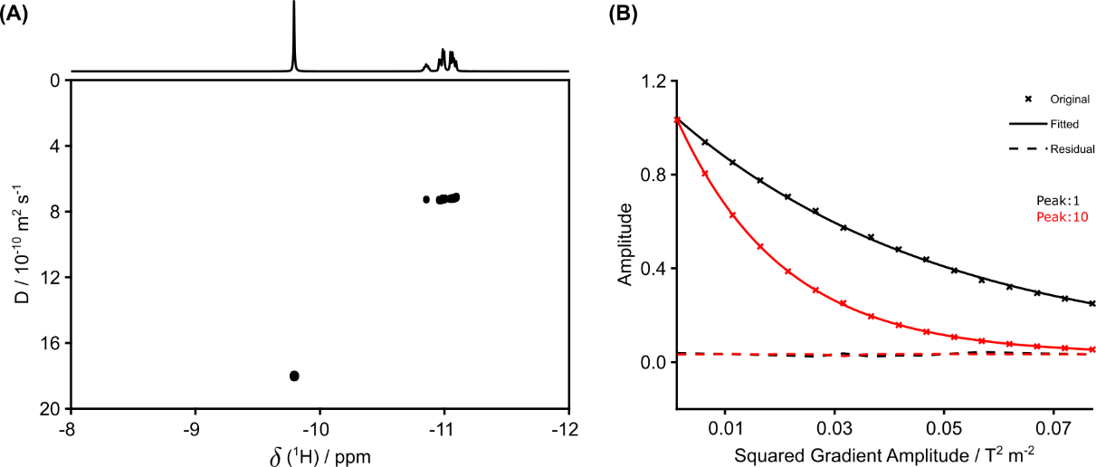
Figure S8: (A) 400 MHz ¹H-DOSY plot highlighting the −12 to −8 ppm region for glycerol (GLY, −11.1 to −10.8 ppm) and water (H₂O, −9.8 ppm) acquired in D₂O containing 250 mM KOH. (B) Associated signal-fitting for both components (peak 1 corresponds to GLY, peak 10 to H₂O).

Table S5: ¹H-DOSY (400 MHz) measurements of glycerol (GLY) and water (H₂O) acquired in D₂O containing 250 mM KOH. Frequencies correspond to chemical shifts and are reported in ppm, while diffusion coefficients and their errors are expressed in units of 10⁻¹⁰ m² s⁻¹.
Compound | Frequency | Exp. Ampl. | Fit. Ampl. | Error | Diff. coef. | Error
GLY | -11.09252 | 0.14823 | 0.15275 | 0.00058 | 7.12434 | 0.04849
GLY | -11.07632 | 0.18261 | 0.18827 | 0.00062 | 7.18741 | 0.04256
GLY | -11.06349 | 0.2692 | 0.27781 | 0.00081 | 7.20456 | 0.03748
GLY | -11.0473 | 0.28578 | 0.2945 | 0.00079 | 7.21979 | 0.03469
GLY | -10.99719 | 0.28011 | 0.28842 | 0.00087 | 7.23102 | 0.03898
GLY | -10.98619 | 0.31111 | 0.31993 | 0.00058 | 7.21337 | 0.02346
GLY | -10.96817 | 0.16571 | 0.17068 | 0.0004 | 7.3037 | 0.03057
GLY | -10.95717 | 0.17292 | 0.17825 | 0.00048 | 7.29534 | 0.03482
GLY | -10.85176 | 0.1001 | 0.10285 | 0.00022 | 7.2632 | 0.02834
H₂O | -9.79188 | 1 | 1.06308 | 0.00191 | 18.00962 | 0.04904

  - Glycerol + 500 mM KOH
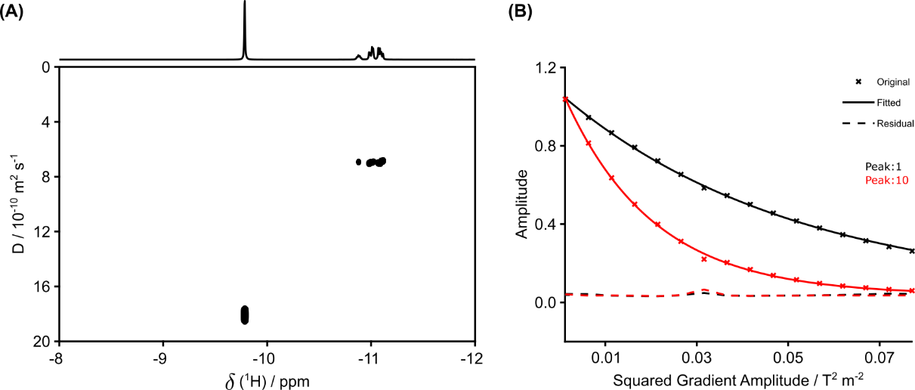
Figure S9: (A) 400 MHz ¹H-DOSY plot highlighting the −12 to −8 ppm region for glycerol (GLY, −11.1 to −10.9 ppm) and water (H₂O, −9.8 ppm) acquired in D₂O containing 500 mM KOH. (B) Associated signal-fitting for both components (peak 1 corresponds to GLY, peak 10 to H₂O).

Table S6: ¹H-DOSY (400 MHz) measurements of glycerol (GLY) and water (H₂O) acquired in D₂O containing 500 mM KOH. Frequencies correspond to chemical shifts and are reported in ppm, while diffusion coefficients and their errors are expressed in units of 10⁻¹⁰ m² s⁻¹.
Compound | Frequency | Exp. Ampl. | Fit. Ampl. | Error | Diff. coef. | Error
GLY | -11.1139 | 0.10132 | 0.10425 | 0.00036 | 6.8469 | 0.04282
GLY | -11.09771 | 0.126 | 0.12947 | 0.00034 | 6.86488 | 0.03334
GLY | -11.08518 | 0.18616 | 0.19121 | 0.00042 | 7.01467 | 0.02828
GLY | -11.06899 | 0.19903 | 0.20433 | 0.00057 | 6.99361 | 0.03546
GLY | -11.0198 | 0.19038 | 0.19511 | 0.00026 | 6.91168 | 0.01654
GLY | -11.0088 | 0.21554 | 0.22099 | 0.00022 | 6.96828 | 0.01241
GLY | -10.99078 | 0.11328 | 0.11605 | 0.00037 | 6.97983 | 0.04021
GLY | -10.97978 | 0.12059 | 0.12363 | 0.00036 | 7.02846 | 0.03665
GLY | -10.87803 | 0.07371 | 0.07539 | 0.00014 | 6.93034 | 0.02375
H₂O | -9.78393 | 0.99529 | 1.0621 | 0.00741 | 18.08272 | 0.19109

  - Glycerol + 750 mM KOH
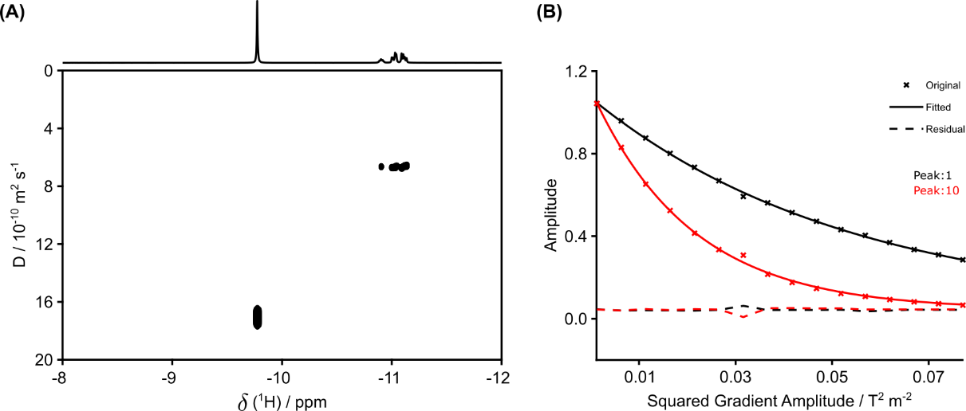
Figure S10: (A) 400 MHz ¹H-DOSY plot highlighting the −12 to −8 ppm region for glycerol (GLY, −11.1 to −10.9 ppm) and water (H₂O, −9.8 ppm) acquired in D₂O containing 750 mM KOH. (B) Associated signal-fitting for both components (peak 1 corresponds to GLY, peak 10 to H₂O).

Table S7: ¹H-DOSY (400 MHz) measurements of glycerol (GLY) and water (H₂O) acquired in D₂O containing 750 mM KOH. Frequencies correspond to chemical shifts and are reported in ppm, while diffusion coefficients and their errors are expressed in units of 10⁻¹⁰ m² s⁻¹.
Compound | Frequency | Exp. Ampl. | Fit. Ampl. | Error | Diff. coef. | Error
GLY | -11.13376 | 0.07824 | 0.0803 | 0.0003 | 6.58279 | 0.04646
GLY | -11.11757 | 0.09737 | 0.09988 | 0.00031 | 6.59787 | 0.03799
GLY | -11.10474 | 0.14183 | 0.14509 | 0.00025 | 6.6602 | 0.02117
GLY | -11.08885 | 0.15209 | 0.15511 | 0.00044 | 6.71966 | 0.03497
GLY | -11.04058 | 0.14557 | 0.14925 | 0.00027 | 6.61099 | 0.02221
GLY | -11.02927 | 0.16406 | 0.16743 | 0.00042 | 6.69123 | 0.03112
GLY | -11.01155 | 0.08547 | 0.08707 | 0.0002 | 6.71448 | 0.02865
GLY | -11.00055 | 0.09212 | 0.09386 | 0.00022 | 6.70984 | 0.02929
GLY | -10.90187 | 0.05976 | 0.06114 | 0.00011 | 6.64519 | 0.02252
H₂O | -9.77385 | 0.99916 | 1.06141 | 0.0093 | 17.06693 | 0.22641

  - Glycerol + 1000 mM KOH
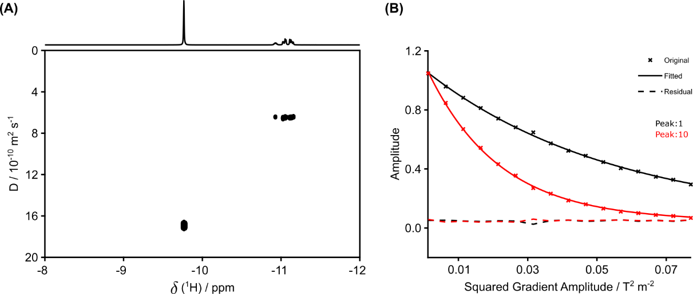
Figure S11: (A) 400 MHz ¹H-DOSY plot highlighting the −12 to −8 ppm region for glycerol (GLY, −11.1 to −10.9 ppm) and water (H₂O, −9.8 ppm) acquired in D₂O containing 1000 mM KOH. (B) Associated signal-fitting for both components (peak 1 corresponds to GLY, peak 10 to H₂O).

Table S8: ¹H-DOSY (400 MHz) measurements of glycerol (GLY) and water (H₂O) acquired in D₂O containing 1000 mM KOH. Frequencies correspond to chemical shifts and are reported in ppm, while diffusion coefficients and their errors are expressed in units of 10⁻¹⁰ m² s⁻¹.
Compound | Frequency | Exp. Ampl. | Fit. Ampl. | Error | Diff. coef. | Error
GLY | -11.15484 | 0.06517 | 0.06682 | 0.0003 | 6.39479 | 0.05391
GLY | -11.13865 | 0.08117 | 0.08297 | 0.00025 | 6.45464 | 0.03626
GLY | -11.12612 | 0.11861 | 0.12184 | 0.00054 | 6.44469 | 0.05379
GLY | -11.11024 | 0.12736 | 0.13042 | 0.00056 | 6.46306 | 0.05198
GLY | -11.06227 | 0.12093 | 0.12366 | 0.00028 | 6.43564 | 0.02771
GLY | -11.05096 | 0.1373 | 0.14035 | 0.00074 | 6.44729 | 0.06409
GLY | -11.03355 | 0.07093 | 0.07249 | 0.00025 | 6.45674 | 0.0421
GLY | -11.02194 | 0.0769 | 0.07829 | 0.00052 | 6.51597 | 0.08135
GLY | -10.926 | 0.04926 | 0.05057 | 0.00016 | 6.40327 | 0.03835
H₂O | -9.7656 | 0.99663 | 1.06654 | 0.00576 | 16.92187 | 0.13845

  - Glycerol + 50 mM LiOH
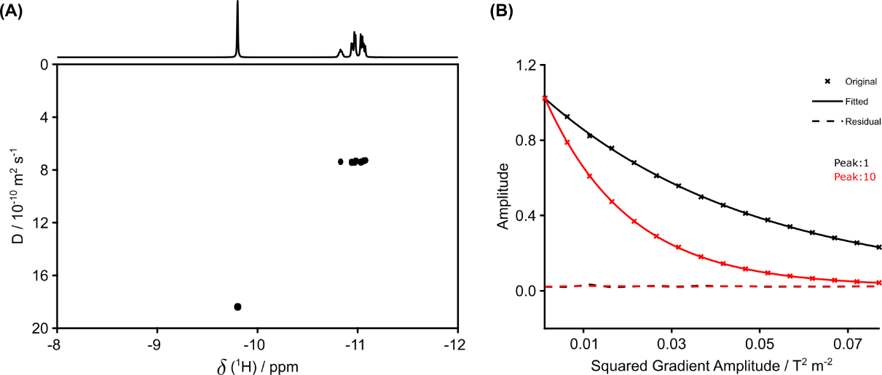
Figure S12: (A) 400 MHz ¹H-DOSY plot highlighting the −12 to −8 ppm region for glycerol (GLY, −11.1 to −10.8 ppm) and water (H₂O, −9.8 ppm) acquired in D₂O containing 50 mM LiOH. (B) Associated signal-fitting for both components (peak 1 corresponds to GLY, peak 10 to H₂O).

Table S9: ¹H-DOSY (400 MHz) measurements of glycerol (GLY) and water (H₂O) acquired in D₂O containing 50 mM LiOH. Frequencies correspond to chemical shifts and are reported in ppm, while diffusion coefficients and their errors are expressed in units of 10⁻¹⁰ m² s⁻¹.
Compound | Frequency | Exp. Ampl. | Fit. Ampl. | Error | Diff. coef. | Error
GLY | -11.0748 | 0.20422 | 0.20885 | 0.00051 | 7.27832 | 0.03168
GLY | -11.0583 | 0.25042 | 0.25612 | 0.00053 | 7.30324 | 0.02682
GLY | -11.04547 | 0.37171 | 0.38038 | 0.00073 | 7.36758 | 0.02499
GLY | -11.02927 | 0.39513 | 0.40523 | 0.00103 | 7.4023 | 0.03338
GLY | -10.97764 | 0.38677 | 0.39504 | 0.00064 | 7.31997 | 0.02116
GLY | -10.96694 | 0.43371 | 0.44394 | 0.00118 | 7.40419 | 0.03485
GLY | -10.94831 | 0.23234 | 0.23776 | 0.00064 | 7.41356 | 0.03512
GLY | -10.93792 | 0.24346 | 0.2495 | 0.00083 | 7.41883 | 0.0436
GLY | -10.82793 | 0.13489 | 0.13795 | 0.00033 | 7.38032 | 0.03161
H₂O | -9.80135 | 1 | 1.06251 | 0.0014 | 18.38433 | 0.03682

  - Glycerol + 100 mM LiOH
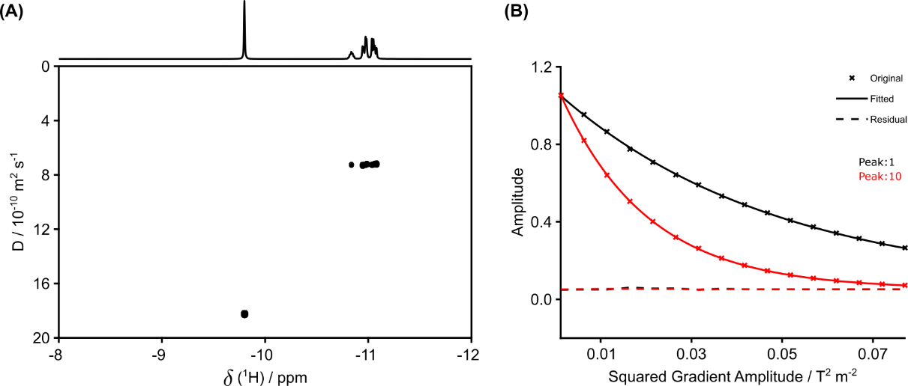
Figure S13: (A) 400 MHz ¹H-DOSY plot highlighting the −12 to −8 ppm region for glycerol (GLY, −11.1 to −10.8 ppm) and water (H₂O, −9.8 ppm) acquired in D₂O containing 100 mM LiOH. (B) Associated signal-fitting for both components (peak 1 corresponds to GLY, peak 10 to H₂O).

Table S10: ¹H-DOSY (400 MHz) measurements of glycerol (GLY) and water (H₂O) acquired in D₂O containing 100 mM LiOH. Frequencies correspond to chemical shifts and are reported in ppm, while diffusion coefficients and their errors are expressed in units of 10⁻¹⁰ m² s⁻¹.
Compound | Frequency | Exp. Ampl. | Fit. Ampl. | Error | Diff. coef. | Error
GLY | -11.0803 | 0.18832 | 0.19233 | 0.00042 | 7.20128 | 0.02819
GLY | -11.0638 | 0.22948 | 0.23459 | 0.00039 | 7.2099 | 0.02133
GLY | -11.05096 | 0.33865 | 0.34711 | 0.0002 | 7.23165 | 0.00759
GLY | -11.03477 | 0.35885 | 0.36868 | 0.0004 | 7.25449 | 0.01389
GLY | -10.98344 | 0.35434 | 0.36258 | 0.00039 | 7.21096 | 0.0138
GLY | -10.97305 | 0.39319 | 0.40342 | 0.00022 | 7.27218 | 0.00695
GLY | -10.95442 | 0.20996 | 0.2156 | 0.00021 | 7.26997 | 0.01285
GLY | -10.94372 | 0.21786 | 0.22393 | 0.00041 | 7.29236 | 0.02398
GLY | -10.83465 | 0.12338 | 0.12655 | 0.00011 | 7.25011 | 0.01083
H₂O | -9.79951 | 1 | 1.06249 | 0.00135 | 18.25126 | 0.03507

  - Glycerol + 250 mM LiOH
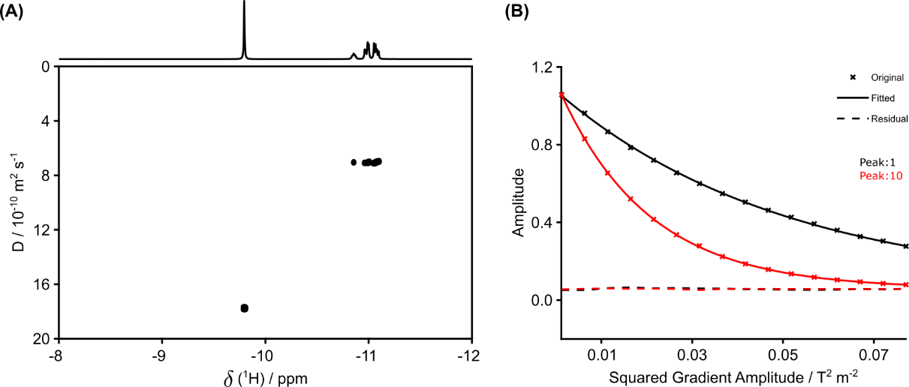
Figure S14: (A) 400 MHz ¹H-DOSY plot highlighting the −12 to −8 ppm region for glycerol (GLY, −11.1 to −10.8 ppm) and water (H₂O, −9.8 ppm) acquired in D₂O containing 250 mM LiOH. (B) Associated signal-fitting for both components (peak 1 corresponds to GLY, peak 10 to H₂O).

Table S11: ¹H-DOSY (400 MHz) measurements of glycerol (GLY) and water (H₂O) acquired in D₂O containing 250 mM LiOH. Frequencies correspond to chemical shifts and are reported in ppm, while diffusion coefficients and their errors are expressed in units of 10⁻¹⁰ m² s⁻¹.
Compound | Frequency | Exp. Ampl. | Fit. Ampl. | Error | Diff. coef. | Error
GLY | -11.09649 | 0.14253 | 0.14506 | 0.00042 | 6.9737 | 0.03657
GLY | -11.07999 | 0.17506 | 0.1781 | 0.00053 | 6.9988 | 0.03765
GLY | -11.06716 | 0.25957 | 0.26499 | 0.00059 | 7.05689 | 0.0282
GLY | -11.05096 | 0.27607 | 0.28234 | 0.00064 | 7.1054 | 0.02897
GLY | -11.00055 | 0.26802 | 0.27246 | 0.00074 | 7.02258 | 0.03435
GLY | -10.98986 | 0.30148 | 0.30812 | 0.00065 | 7.08022 | 0.02678
GLY | -10.97153 | 0.16111 | 0.16484 | 0.00026 | 7.07734 | 0.02005
GLY | -10.96083 | 0.1685 | 0.17303 | 0.00032 | 7.0869 | 0.02371
GLY | -10.85359 | 0.09766 | 0.09983 | 0.00017 | 7.04705 | 0.02118
H₂O | -9.79524 | 0.99663 | 1.05711 | 0.00168 | 17.7613 | 0.04268

  - Glycerol + 500 mM LiOH
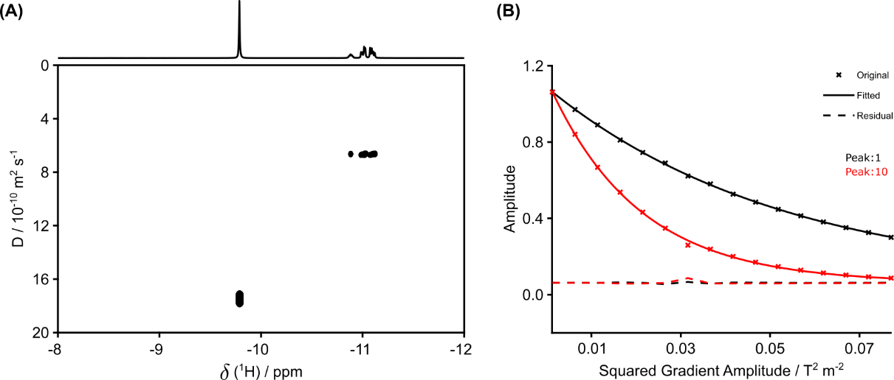
Figure S15: (A) 400 MHz ¹H-DOSY plot highlighting the −12 to −8 ppm region for glycerol (GLY, −11.1 to −10.9 ppm) and water (H₂O, −9.8 ppm) acquired in D₂O containing 500 mM LiOH. (B) Associated signal-fitting for both components (peak 1 corresponds to GLY, peak 10 to H₂O).

Table S12: ¹H-DOSY (400 MHz) measurements of glycerol (GLY) and water (H₂O) acquired in D₂O containing 500 mM LiOH. Frequencies correspond to chemical shifts and are reported in ppm, while diffusion coefficients and their errors are expressed in units of 10⁻¹⁰ m² s⁻¹.
Compound | Frequency | Exp. Ampl. | Fit. Ampl. | Error | Diff. coef. | Error
GLY | -11.12001 | 0.09556 | 0.09777 | 0.00018 | 6.6338 | 0.02246
GLY | -11.10352 | 0.11753 | 0.12047 | 0.00018 | 6.64262 | 0.01818
GLY | -11.09099 | 0.17338 | 0.17743 | 0.00009 | 6.65697 | 0.00655
GLY | -11.0748 | 0.18416 | 0.18863 | 0.00013 | 6.70136 | 0.00844
GLY | -11.02561 | 0.17888 | 0.18272 | 0.00023 | 6.62257 | 0.01578
GLY | -11.01461 | 0.20005 | 0.20456 | 0.00029 | 6.70226 | 0.01742
GLY | -10.99658 | 0.10545 | 0.1077 | 0.00009 | 6.67836 | 0.01056
GLY | -10.98558 | 0.11066 | 0.1132 | 0.00013 | 6.70165 | 0.01435
GLY | -10.88109 | 0.06725 | 0.06865 | 0.00012 | 6.6411 | 0.02178
H₂O | -9.78729 | 0.99732 | 1.05929 | 0.0064 | 17.47314 | 0.15978

  - Glycerol + 750 mM LiOH
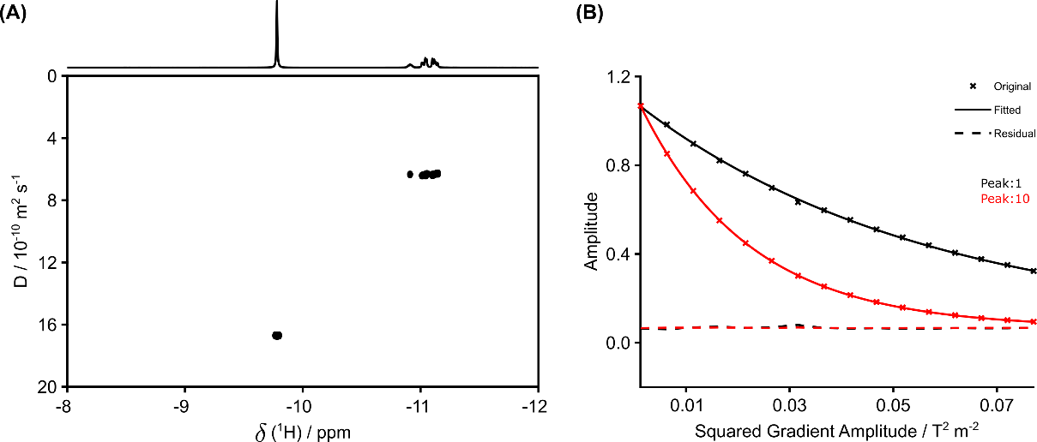
Figure S16: (A) 400 MHz ¹H-DOSY plot highlighting the −12 to −8 ppm region for glycerol (GLY, −11.1 to −10.9 ppm) and water (H₂O, −9.8 ppm) acquired in D₂O containing 750 mM LiOH. (B) Associated signal-fitting for both components (peak 1 corresponds to GLY, peak 10 to H₂O).

Table S13: ¹H-DOSY (400 MHz) measurements of glycerol (GLY) and water (H₂O) acquired in D₂O containing 750 mM LiOH. Frequencies correspond to chemical shifts and are reported in ppm, while diffusion coefficients and their errors are expressed in units of 10⁻¹⁰ m² s⁻¹.
Compound | Frequency | Exp. Ampl. | Fit. Ampl. | Error | Diff. coef. | Error
GLY | -11.14446 | 0.06894 | 0.07019 | 0.00021 | 6.28638 | 0.03632
GLY | -11.12826 | 0.08562 | 0.08723 | 0.00019 | 6.29737 | 0.02662
GLY | -11.11543 | 0.12546 | 0.12816 | 0.00022 | 6.32231 | 0.02079
GLY | -11.09954 | 0.13407 | 0.13671 | 0.00031 | 6.36896 | 0.02755
GLY | -11.05127 | 0.12929 | 0.13154 | 0.00026 | 6.31458 | 0.0237
GLY | -11.04027 | 0.14503 | 0.14778 | 0.0004 | 6.37664 | 0.03312
GLY | -11.02224 | 0.0758 | 0.07725 | 0.00015 | 6.37792 | 0.02375
GLY | -11.01125 | 0.0803 | 0.08196 | 0.00016 | 6.40759 | 0.02359
GLY | -10.90889 | 0.05096 | 0.05203 | 0.00012 | 6.33865 | 0.02751
H₂O | -9.78057 | 0.99573 | 1.05268 | 0.00103 | 16.70403 | 0.02477

  - Glycerol + 1000 mM LiOH
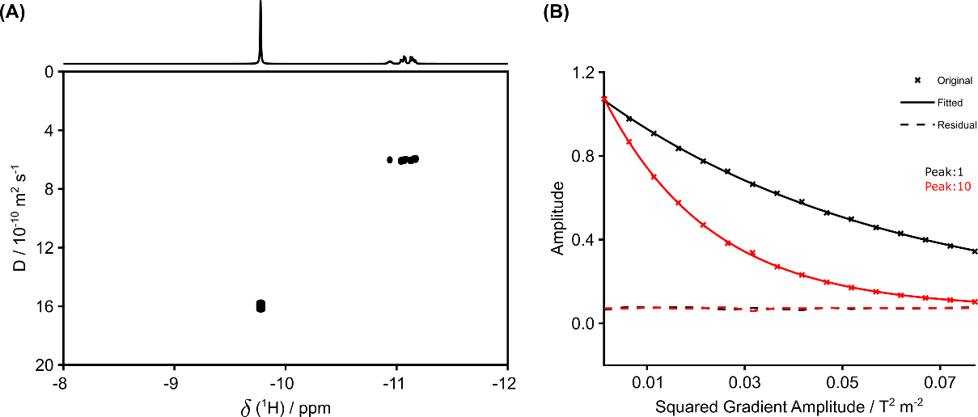
Figure S17: (A) 400 MHz ¹H-DOSY plot highlighting the −12 to −8 ppm region for glycerol (GLY, −11.2 to −10.8 ppm) and water (H₂O, −9.8 ppm) acquired in D₂O containing 1000 mM LiOH. (B) Associated signal-fitting for both components (peak 1 corresponds to GLY, peak 10 to H₂O).

Table S14: ¹H-DOSY (400 MHz) measurements of glycerol (GLY) and water (H₂O) acquired in D₂O containing 1000 mM LiOH. Frequencies correspond to chemical shifts and are reported in ppm, while diffusion coefficients and their errors are expressed in units of 10⁻¹⁰ m² s⁻¹.
Compound | Frequency | Exp. Ampl. | Fit. Ampl. | Error | Diff. coef. | Error
GLY | -11.16982 | 0.05508 | 0.05582 | 0.00017 | 5.9484 | 0.03478
GLY | -11.15362 | 0.06839 | 0.06955 | 0.00013 | 5.9602 | 0.02117
GLY | -11.14079 | 0.10103 | 0.10308 | 0.00012 | 6.01627 | 0.0142
GLY | -11.1249 | 0.10854 | 0.11064 | 0.00022 | 6.05053 | 0.02386
GLY | -11.07724 | 0.10274 | 0.10494 | 0.00013 | 5.97445 | 0.01462
GLY | -11.06624 | 0.11647 | 0.11868 | 0.00023 | 6.04633 | 0.02319
GLY | -11.04852 | 0.06046 | 0.06167 | 0.00015 | 6.05353 | 0.02862
GLY | -11.03722 | 0.06456 | 0.06613 | 0.00018 | 6.08114 | 0.03271
GLY | -10.9367 | 0.04032 | 0.04127 | 0.0001 | 6.01982 | 0.02733
H₂O | -9.77538 | 0.9952 | 1.05085 | 0.00373 | 15.98553 | 0.08594

Section S6: Computational data

Table S15: Gibbs free energies (G, in Hartree) computed for each glycerol complex (G_{complex}), along with the individual contributions from the glycerol (G_{GLY}) and each cation (G_{cation}). The corresponding binding Gibbs free energies (∆G_{bind =} G_{complex} − G_{GLY} − G_{cation} , in kJ mol⁻¹) are also reported. All energies were computed at the ωB97X-D4/def2-TZVPD/SMD(water) level of theory.
Complex | G_{complex} / Ha | G_{GLY} / Ha | G_{cation} / Ha | ΔG_{bind} / kJ mol⁻¹
GLY—K⁺ | −944.84285768 | −344.96797474 | −599.85666424 | −47.7
GLY—Li⁺ | −352.44697856 | −344.96841660 | −7.444147360 | −90.4

Additional details, including all initial and fully optimized structures and the complete output files from the computational calculations, are freely available in the online repository at https://doi.org/10.25824/redu/FDYCRH.

Section S7: ATR-SEIRAS data
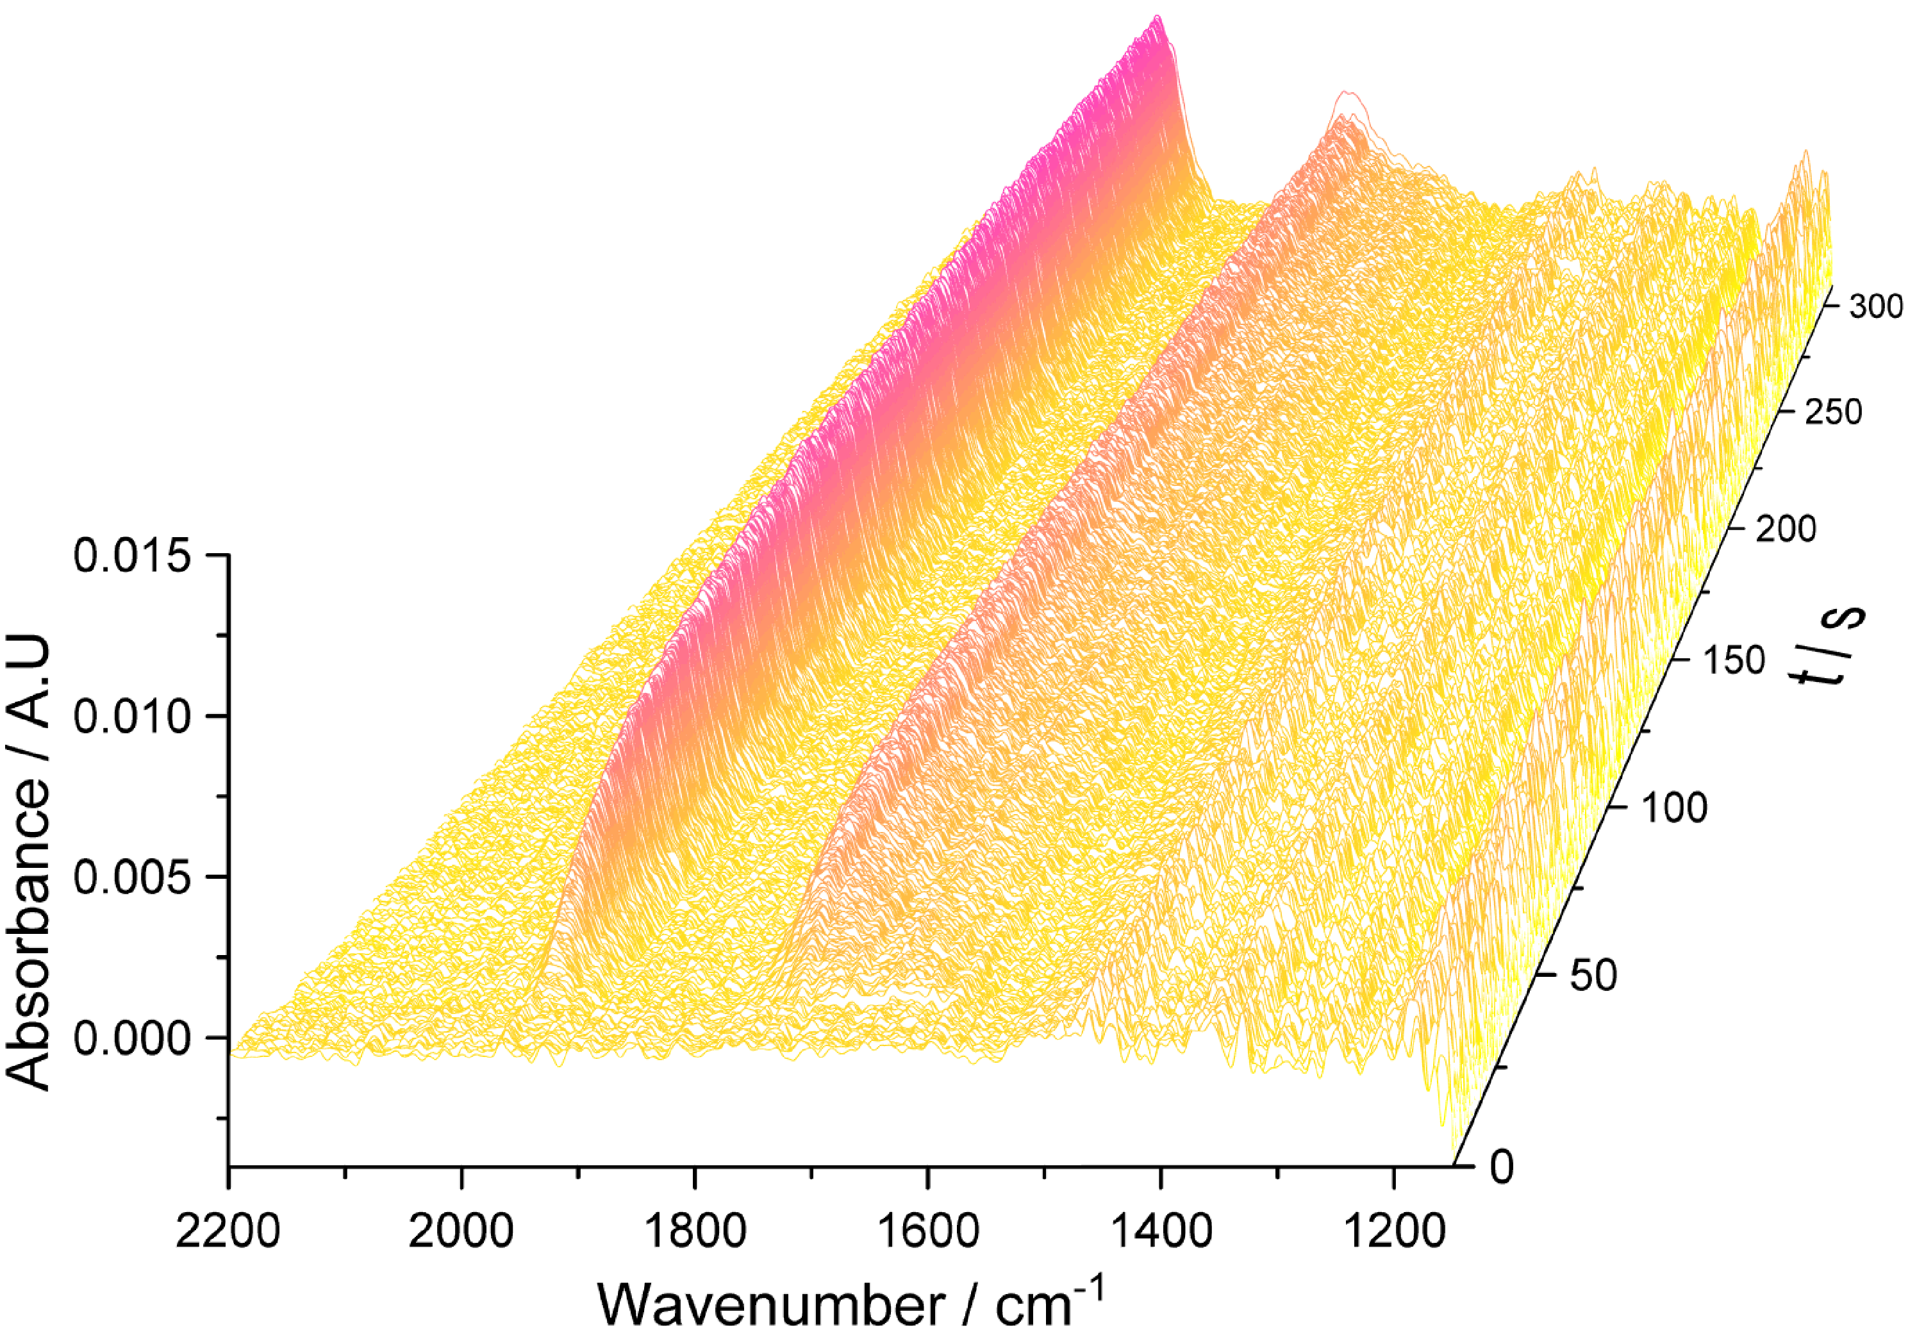
Figure S18. Time-resolved ATR-SEIRA spectral series of a Pt_{poly} film in contact with 0.5 M LiOH + 0.1 mM glycerol, recording during a potential step from 0.6 V-0.25 V. Spectral window = 1150-2200 cm⁻¹. Background spectrum collected at 0.6 V.

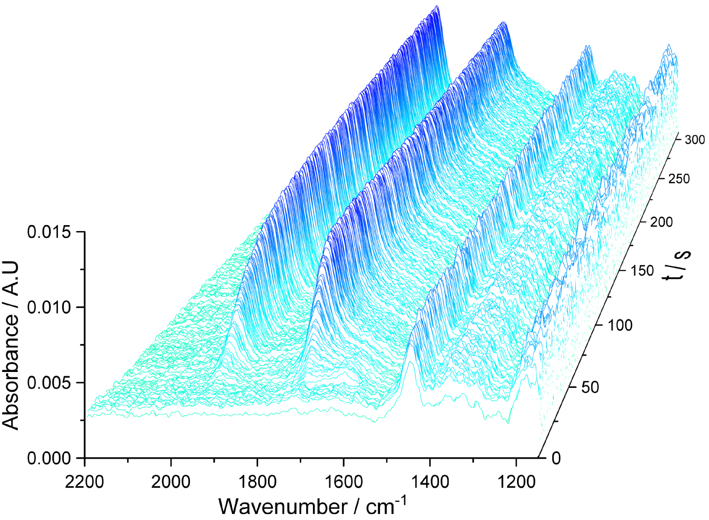
Figure S19. Time-resolved ATR-SEIRA spectral series of a Pt_{poly} film in contact with 0.5 M KOH + 0.1 mM glycerol, recording during a potential step from 0.6 V-0.25 V. Spectral window = 1150-2200 cm⁻¹. Background spectrum collected at 0.6 V.
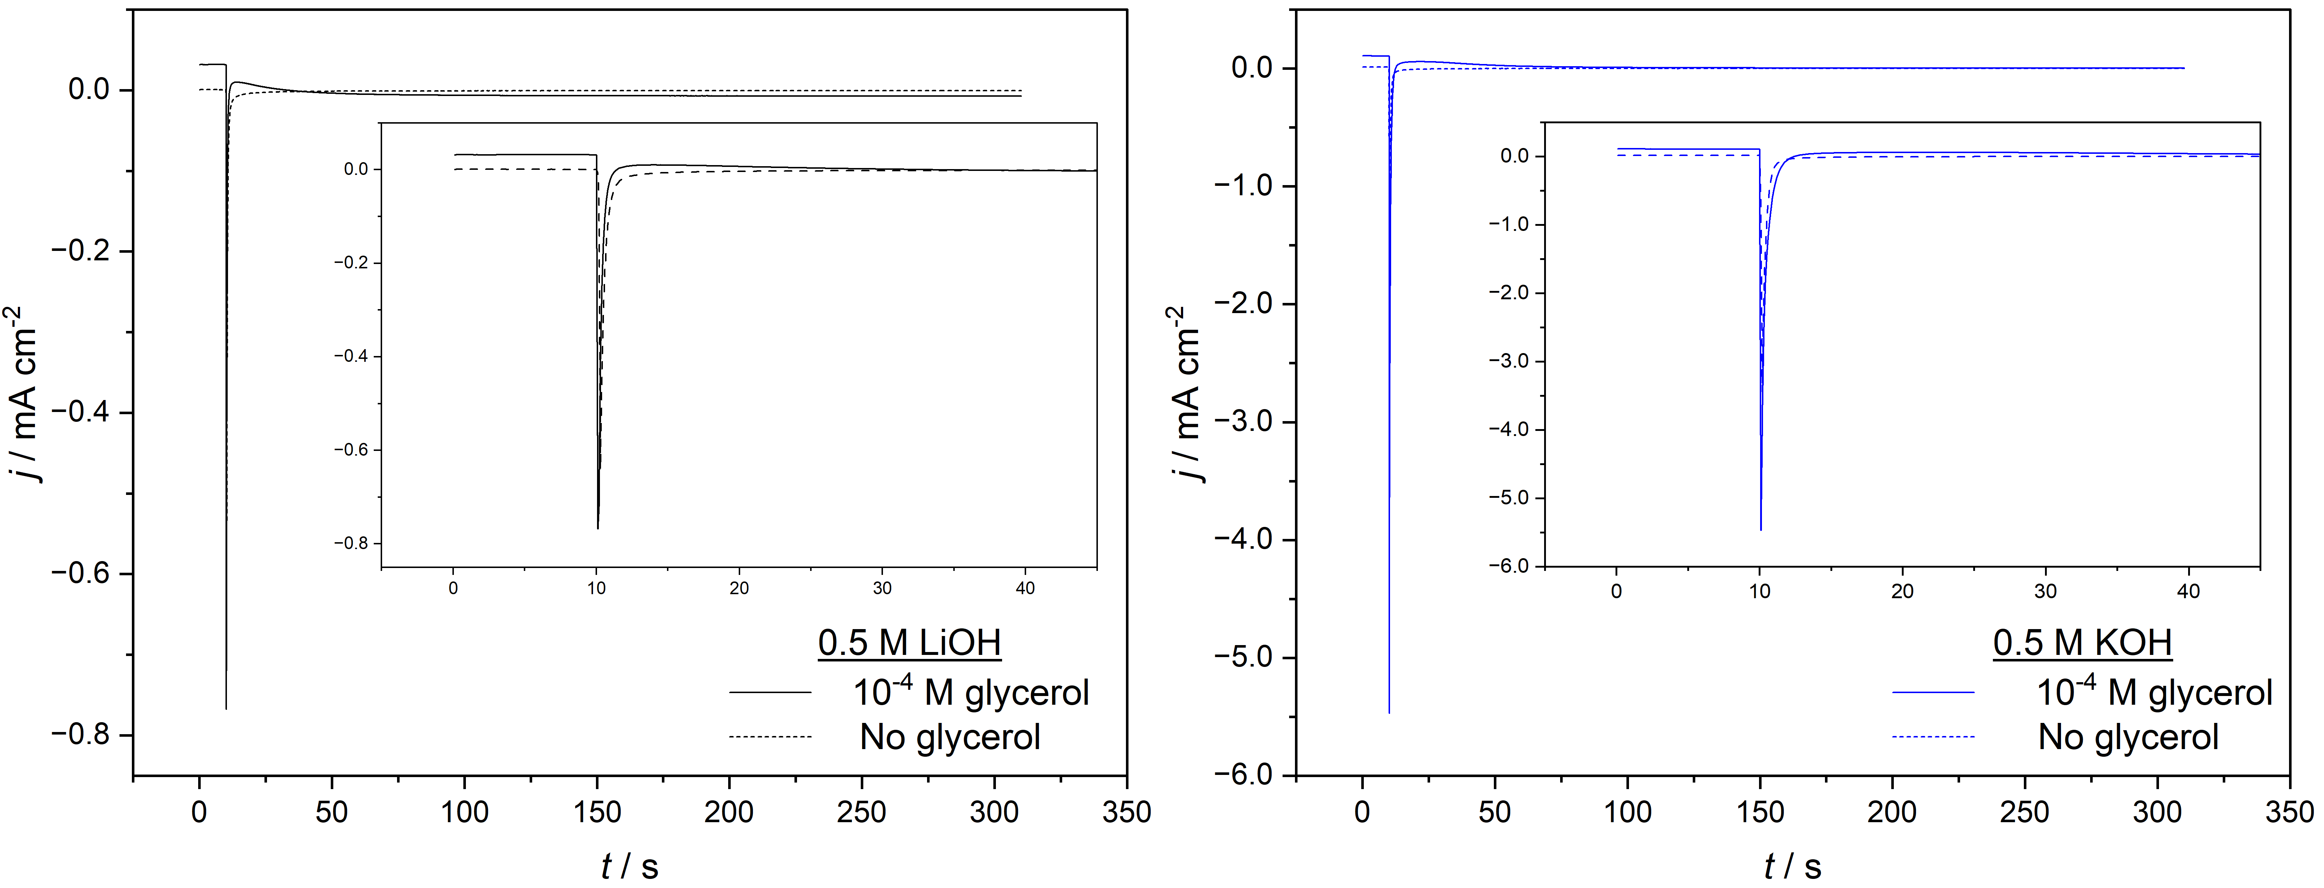
Figure S20. Current transients of a Pt_{poly} film in contact with 0.5 M MOH (M = Li⁺ (black) and K⁺ (blue)), during a potential step from 0.6 V-0.25 V in the presence (solid line) and absence (dashed line) of + 0.1 mM glycerol. The potential step was applied at time 10 s. Inset regions show a magnification of the first 40 s of each transient.

Figure S21. A1 and A2: CVs of a Pt_{poly} film in contact with 0.5 M MOH (M = Li⁺ (black) and K⁺ (blue), both with (bold line) and without (thin line) 0.1 mM glycerol in solution, scan rate = 50 mV/s. B1 and B2: CVs of a Pt_{poly} film in contact with 0.5 M MOH + 0.1 mM glycerol (M = Li⁺ (black) and K⁺ (blue)), scan rate = 5 mV/s, across which the ATR-SEIRA spectral series in Fig. S6 were recorded. Red dotted lines indicate the potential window over which the time-resolved ATR-SEIRA data presented in Figs. S9 and S10 were recorded.

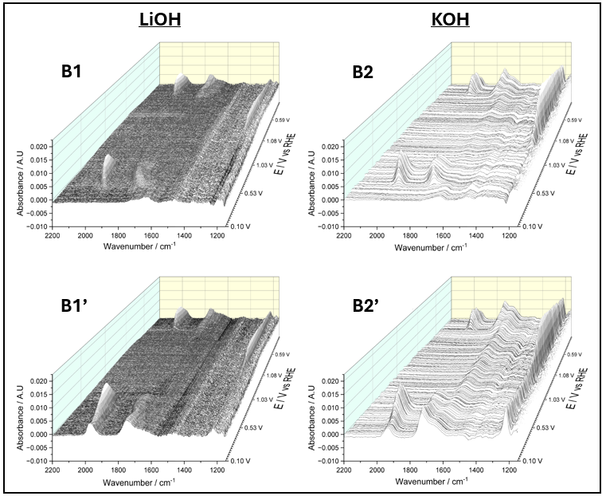
Figure S22. ATR-SEIRA spectral series of a Pt_{poly} film in contact with 0.5 M MOH (M = Li⁺ (B1 and B1’) and K⁺ (B2 and B2’) + 0.1 mM glycerol, recording during the CVs presented in Figs. S5B1 and S5B2. Unprimed and primed labels correspond to the first and second voltametric cycles respectively, recorded following a potential step from 0.6 V to 0.1 V. Spectral window = 1150-2200 cm⁻¹. Background spectrum collected at 0.6 V.
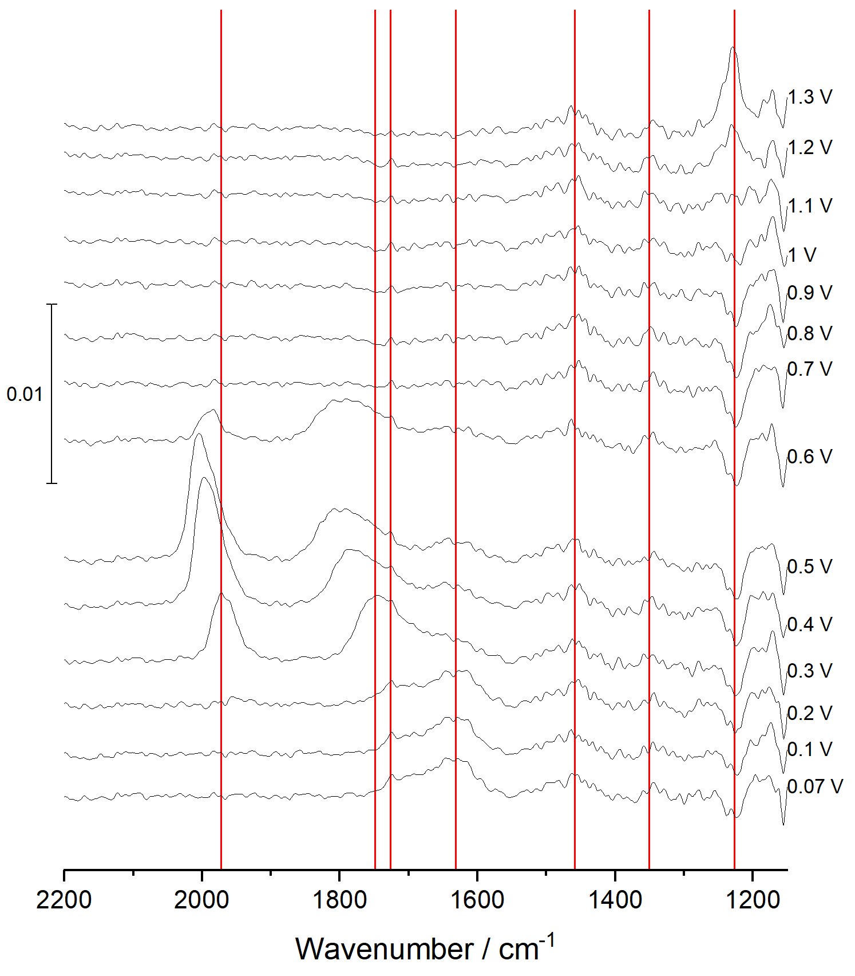
Figure S23. ATR-SEIRA spectra of a Pt_{poly} film in contact with 0.5 M LiOH + 0.1 mM glycerol at 0.1 V intervals, recording during the forward scan of the first cycle of the CV presented in Fig. S5B1. The corresponding spectral series can be found in Fig. S6B1. Spectral window = 1150-2200 cm⁻¹. Background spectrum collected at 0.6 V. Red vertical lines indicate the approximate positions of bands that could be distinguished from the non-resonant background.
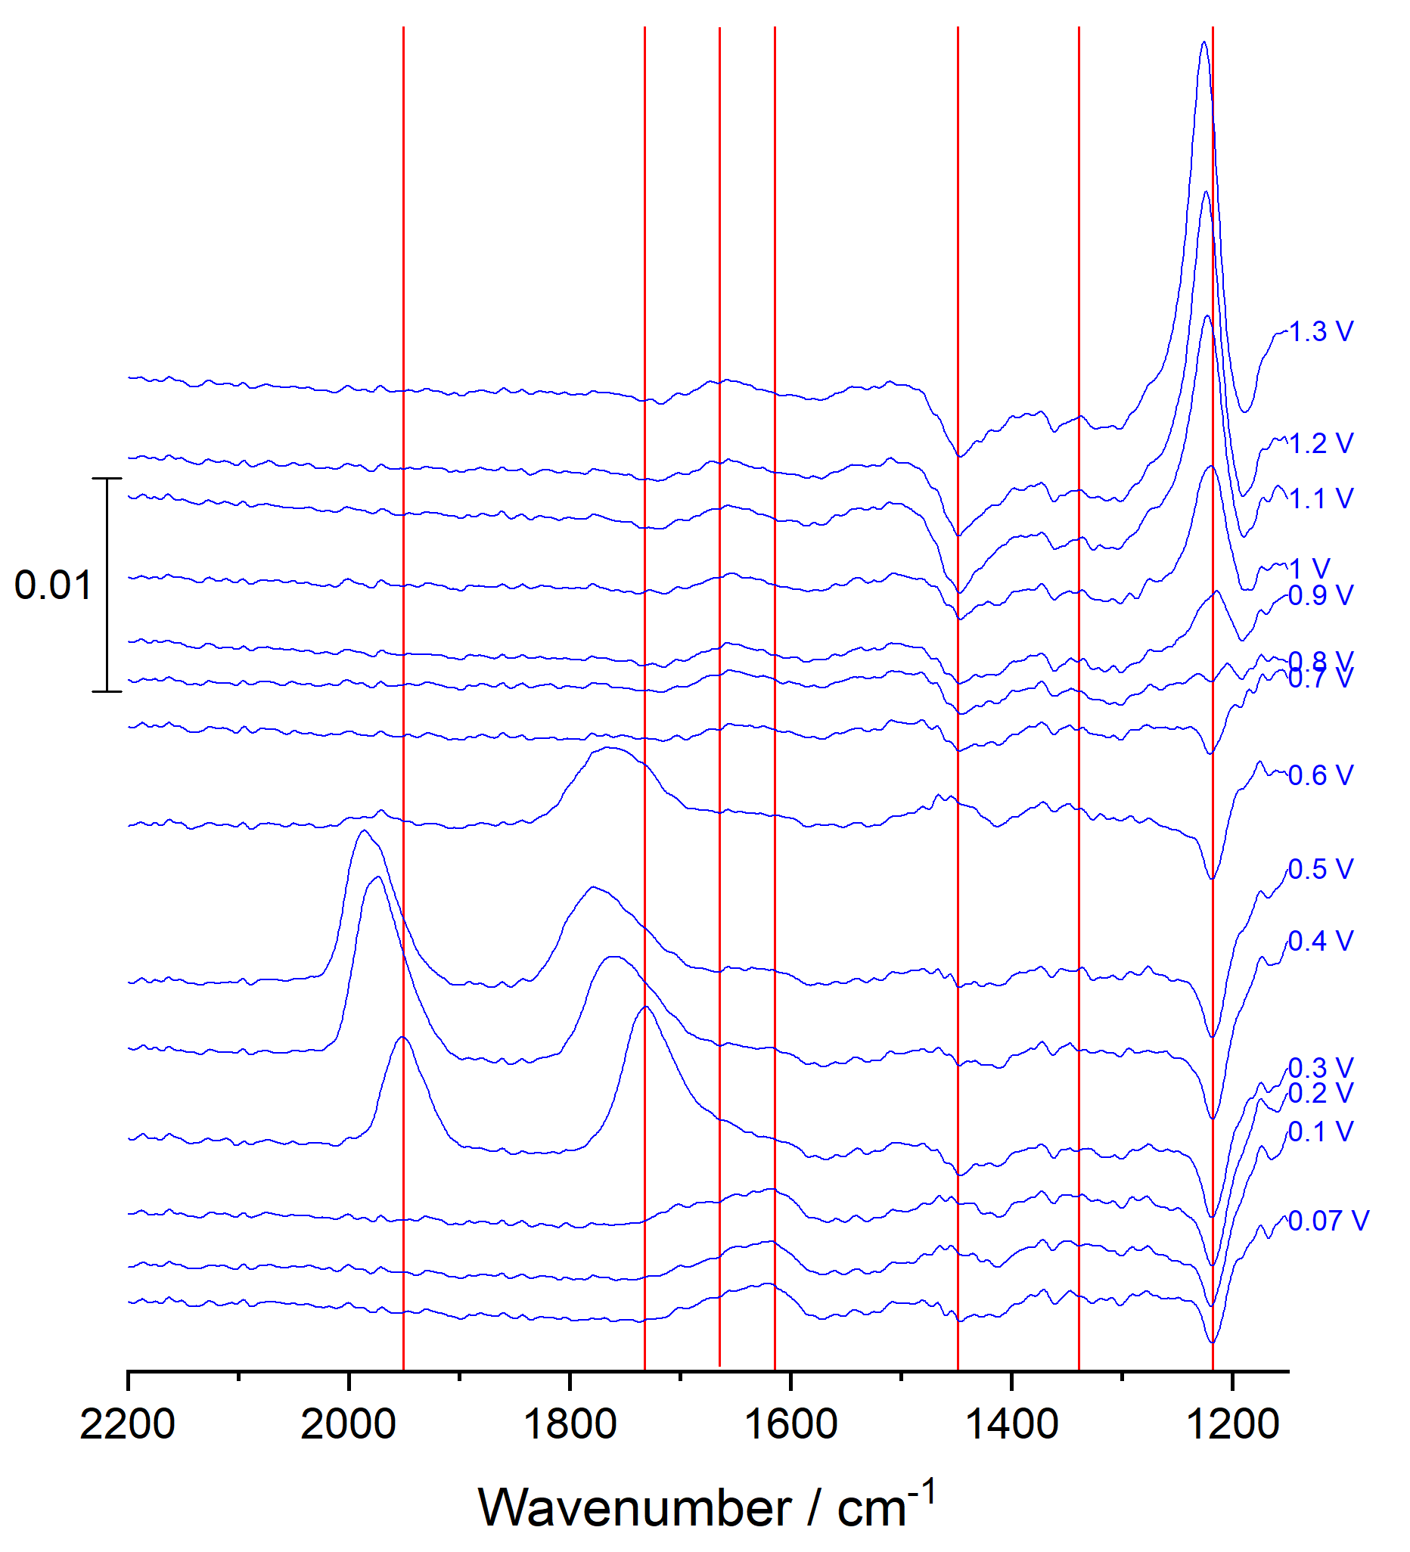
Figure S24. ATR-SEIRA spectra of a Pt_{poly} film in contact with 0.5 M KOH + 0.1 mM glycerol at 0.1 V intervals, recording during the forward scan of the first cycle of the CV presented in Fig. S5B2. The corresponding spectral series can be found in Fig. S6B2. Spectral window = 1150-2200 cm⁻¹. Background spectrum collected at 0.6 V. Red vertical lines indicate the approximate positions of bands that could be distinguished from the non-resonant background.
Description of the bands observed in Figs. S9-S11. The band around 1980 cm⁻¹ corresponds to the C-O stretching mode of linearly-bonded CO_{ad} (CO_{L}). A broader band is also found around 1740 cm⁻¹, comprising the same stretching mode of bridge- and multiply-bonded CO_{ad} (CO_{B} + CO_{M}). As CO_{ad} bands are redshifted in alkaline media as compared to acidic media, this overlaps with the H-O-H bending mode of water, which is centred around 1650 cm⁻¹, and with a band around 1620 cm⁻¹. The latter and a band at 1450 cm⁻¹ are attributed to the antisymmetric and symmetric O-C-O stretching vibrations of a carboxylate group at the solution-facing end of an adsorbed species. A small band is also resolved around 1340 cm⁻¹, which we tentatively attribute to the symmetric O-C-O stretching mode of a bridge-bonded adsorbed carboxylate. These bands would result from products of the reaction generated during collection of the background spectrum at 0.6 V. Finally, a sharp, intense band is found at 1230 cm⁻¹, which we are wary of assigning because the Si-O stretching frequently interferes with signals in this region.

