Supplemental Information for:

Behind the Skeleton: Unraveling the Genetic Basis of Skeletal Variation in the Coral Platygyra daedalea

Shoug Alguthmi, Craig T. Michell, Sebastian Schmidt-Roach, Marcelle Muniz-Barreto, Viswasanthi Chandra, Ronell Sicat, Thomas Theussl, Manuel Aranda

Figure S1. Scanning preparation of skeletons. A. Coral skeletons fixed in packing foam cut to fit inside a plastic cylinder for micro-computed tomography scanning. B. Avizo 3D window displaying a 3D coral with a zoom-in of the color map settings. The values included were from the end of larger clusters (lower values) on the left to the center of the smallest cluster (larger values) on the right. Excluding the large cluster was to remove the plastic cylinder; if moved further, it would remove skeletal structures. While the smaller cluster maintains optimal light levels for visualization.
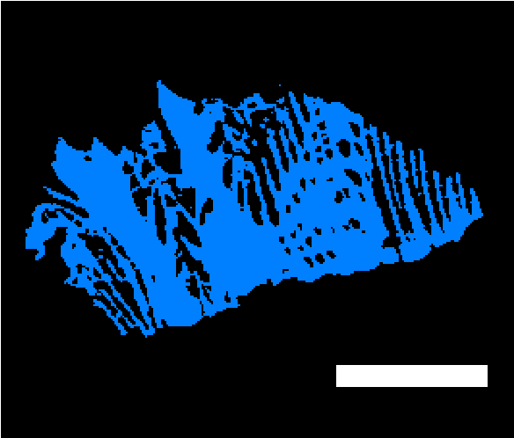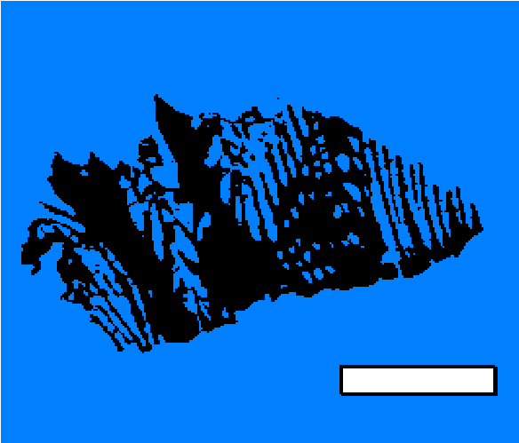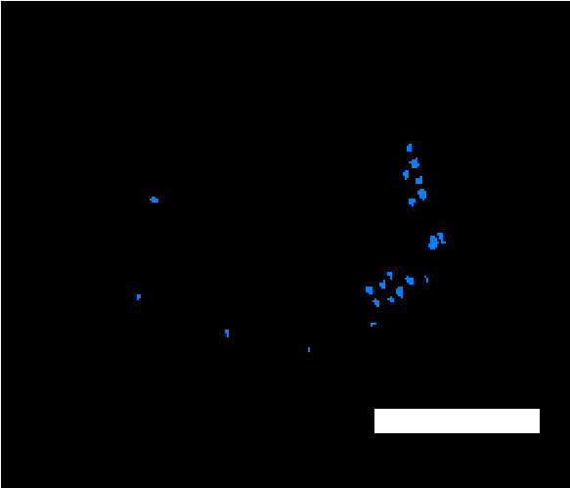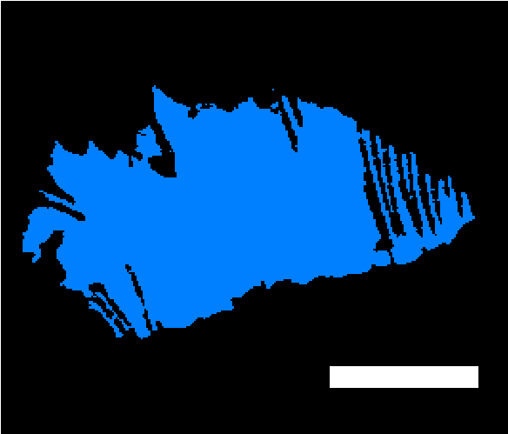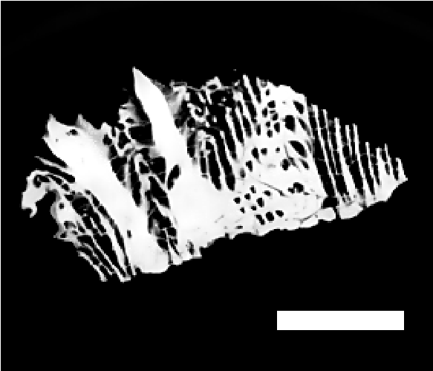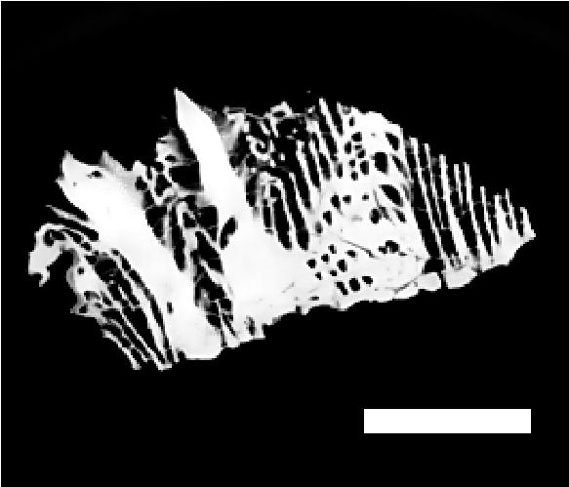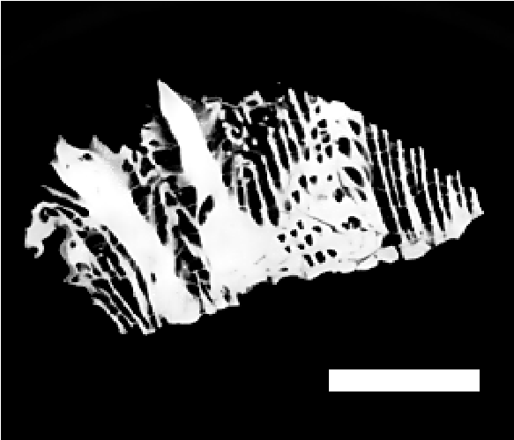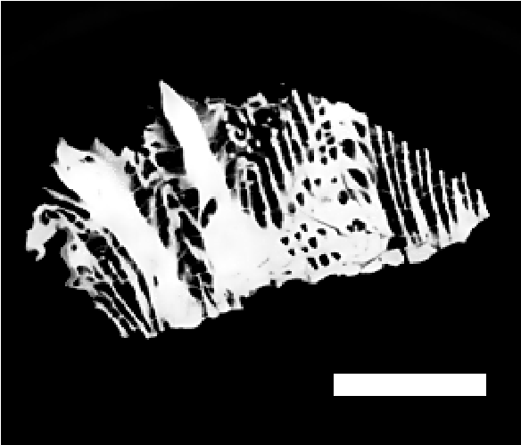
Skeleton
Low
High
Non-Skeletal
Voids
Filled Skeleton
Image

Segmentation
(Auto-threshold)
Input Images

Figure S2. Workflow for porosity ratio analysis in Avizo 3D. Coral skeletons were segmented into skeleton and void volumes using auto-threshold. Border artifacts and background noise were removed. Final porosity was calculated as the volume fraction of voids relative to the skeleton. A detailed description of each step is provided in the Methods section. Blue represents the portion of the image segmented. Scale bar = 10 mm.
Figure S3: Exclusion of voids induced by boring organisms during image processing for porosity. A. Horizontal cross-section selected from the middle of the coral skeleton with a focus on a barnacle structure with its borings. B. Segmentation with the auto-threshold tool with low settings. C. Image processing with the Border kill tool removed background and open voids, including those introduced by boring organisms. Scale bar = 10 mm.
Figure S4: Population structure of the reduced genetic data set, with a maximum likelihood nuclear tree on the left and the admixture proportions in bar charts for each individual on the right. Population 1 in green, population 2 in pink, and population 3 in yellow.

Figure S5: Platygyra daedalea transversal sections showing porosity patterns.
A. Longitudinal sections of each DS1_9, the most porous skeleton in the study, and YAN1_6, the least porous skeleton, based on our porosity ratio results. B. Horizontal sections of each DS1_9 and YAN1_6. Scale bar = 10 mm.

