Supplementary information

Optical Semantic Holographic Communication
- Parameters of the semantic encoding network

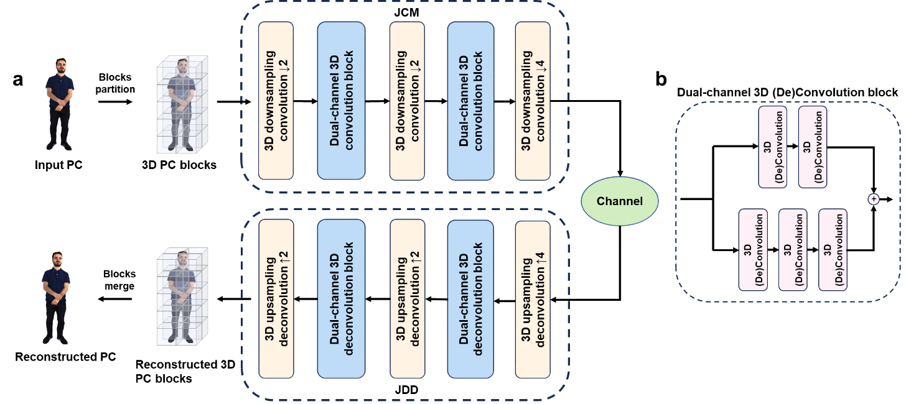

Fig. S1. (a) Detailed structure of our 3D convolution-based joint coding and modulation (JCM) network for PC transmission. (b) Structure of the dual-channel 3D (de)convolution block.
Fig. S1 illustrates the structure of our semantic coding networking. Table S1 presents the parameters of our novel semantic encoding network architecture, where a relatively symmetric structure is used for both the encoder and the decoder. The convolution layers within the dual-channel 3D convolution and dual-channel 3D deconvolution blocks share identical parameters across all layers within each block. These blocks use smaller convolution kernel sizes to extract fine-grained local features from PCs. As they have a stride of 1, the blocks do not alter the dimensions of the input data. The 3D downsampling convolution and 3D upsampling deconvolution layers, which employ larger kernel sizes, capture high-level semantic information and enable upsampling and downsampling operations. In the 3D downsampling deconvolution layers, the stride parameter defines the downsampling rate, reducing the spatial dimensions of the output data through convolution operations. In contrast, in the 3D upsampling deconvolution layers, the stride represents the upsampling rate, increasing the spatial dimensions of the output data through deconvolution operations. The “Out channel number” parameter indicates the number of spatial channels output in each layer, and we set this number to 48. As the final layer of the decoder reconstructs the latent features into their original format, its output dimension is set to 1 (representing the geometric occupancy channel). The final layer of the decoder employs a sigmoid activation function to compute the geometric occupancy probability for each point, facilitating subsequent cross-entropy loss calculations.
 | Layername | Convolution kernel size | Stride | Out channel number | Activation function
JCM | 3D downsampling  convolution 1 | 9 | 2 | 48 | ReLu
JCM | Convolution layers in dual-channel 3D Convolution block 1 | 3 | 1 | 48 | ReLu
JCM | 3D downsampling  convolution 2 | 5 | 2 | 48 | ReLu
JCM | Convolution layers in dual-channel 3D Convolution block 2 | 3 | 1 | 48 | ReLu
JCM | 3D downsampling  convolution 3 | 5 | 4 | 48 | None
Channel
JDD | 3D upsampling  deconvolution 1 | 5 | 4 | 48 | ReLu
JDD | Convolution layers in dual-channel 3D deconvolution block 1 | 3 | 1 | 48 | ReLu
JDD | 3D upsampling  deconvolution 2 | 5 | 2 | 48 | ReLu
JDD | Convolution layers in dual-channel 3D deconvolution block 2 | 3 | 1 | 48 | ReLu
JDD | 3D upsampling  deconvolution 3 | 9 | 2 | 1 | Sigmoid

Table S1. Detailed parameters of the semantic encoder network.
To enhance the noise robustness of the model, the JCM and joint demodulation and decoding (JDD) were trained end-to-end under an additive white Gaussian noise channel with a signal-to-noise ratio (SNR) of 10 dB. The training dataset is derived from the High-Resolution Geometry and Color (HighResGC) dataset, which includes 3D PC models taken from a variety of domains, such as cultural heritage and human bodies. Specifically, 50 models were selected from the MPEG, JPEG Pleno, PointXR, VSENSE, and M-PCCD datasets, which collectively constitute the HighResGC dataset¹⁻³. Each PC model was subsequently partitioned into non-overlapping sequential blocks, with each block corresponding to a resolution of 32, thereby generating the PC block data used for the neural network training. For the training process, we employed a batch size of 64 and a learning rate of 0.0001.
- Detailed experimental setup
The experimental setup is shown in Fig. S2. Here, C19 serves as the pilot channel while C34 functions as the pump channel. The signal channels are distributed from C26–C33 and C35–C41. The center wavelengths of each channel are listed in Table. S2. At the transmitter side, 15 comb lines (C26–C33 and C35–C41) are filtered by a waveshaper and used to carry data. IQ modulators are used to modulate single-polarization data onto the data carriers, where the modulation signals are driven by an arbitrary waveform generator (AWG). After modulation, the 15 data channels are combined with the pilot (C19) comb. The coupled optical signals are then amplified to 20 dBm. Subsequently, the amplified signals are combined with the pump (C34). The spectra of the transmitted optical comb signals at the transmitter and receiver were recorded with an optical spectrum analyzer, as presented in Fig. S3. After 100 km of HCF transmission, each data channel is selected by the waveshaper and fed into an integrated coherent receiver (ICR). The local oscillator (LO) for the ICR is selected using a dense wavelength division multiplexer. The electrical signal detected in the ICR is recorded by a real-time digital phosphor oscilloscope and processed offline.

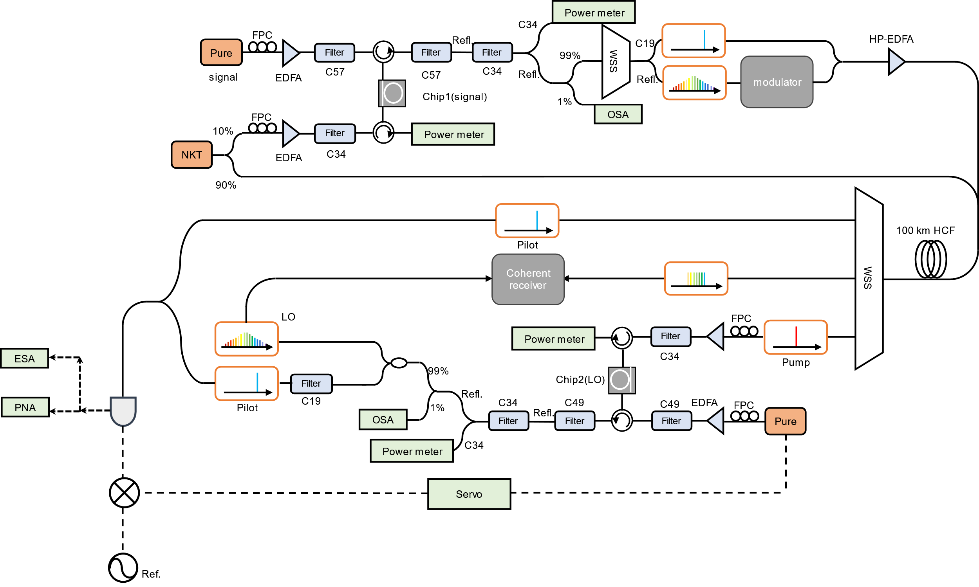

Fig. S2. The detailed experimental setup. OSA, optical spectrum analyzer. ESA, electrical spectrum analyzer. PNA, phase noise analyzer. PD, photodetector. EDFA, erbium doped fiber amplifier. SSMF, standard single mode fiber. LO, local oscillator. RF, radio frequency. WSS, waveshaper. HP-EDFA, high-power erbium doped fiber amplifier.
Channel number | Center wavelength (nm) | Channel number | Center wavelength (nm)
C17 | 1563.86 | C40 | 1545.32
C18 | 1563.05 | C41 | 1544.53
C19 | 1562.23 | C42 | 1543.73
C20 | 1561.42 | C43 | 1542.94
C21 | 1560.61 | C44 | 1542.14
C22 | 1559.79 | C45 | 1541.35
C23 | 1558.98 | C46 | 1540.56
C24 | 1558.17 | C47 | 1539.77
C25 | 1557.36 | C48 | 1538.98
C26 | 1556.55 | C49 | 1538.19
C27 | 1555.75 | C50 | 1537.40
C28 | 1554.94 | C51 | 1536.61
C29 | 1554.13 | C52 | 1535.82
C30 | 1553.33 | C53 | 1535.04
C31 | 1552.52 | C54 | 1534.25
C32 | 1551.72 | C55 | 1533.47
C33 | 1550.92 | C56 | 1532.68
C34 | 1550.12 | C57 | 1531.90
C35 | 1549.32 | C58 | 1531.12
C36 | 1548.51 | C59 | 1530.33
C37 | 1547.72 | C60 | 1529.55
C38 | 1546.92 | C61 | 1528.77
C39 | 1546.12 | C62 | 1527.99

Table S2. Center wavelength of each channel in the C band. Each channel has a frequency interval of 100 GHz.
- Digital signal processing procedure
Fig. S3 provides a diagram illustrating the digital signal processing streams. The detailed description is presented in Method.
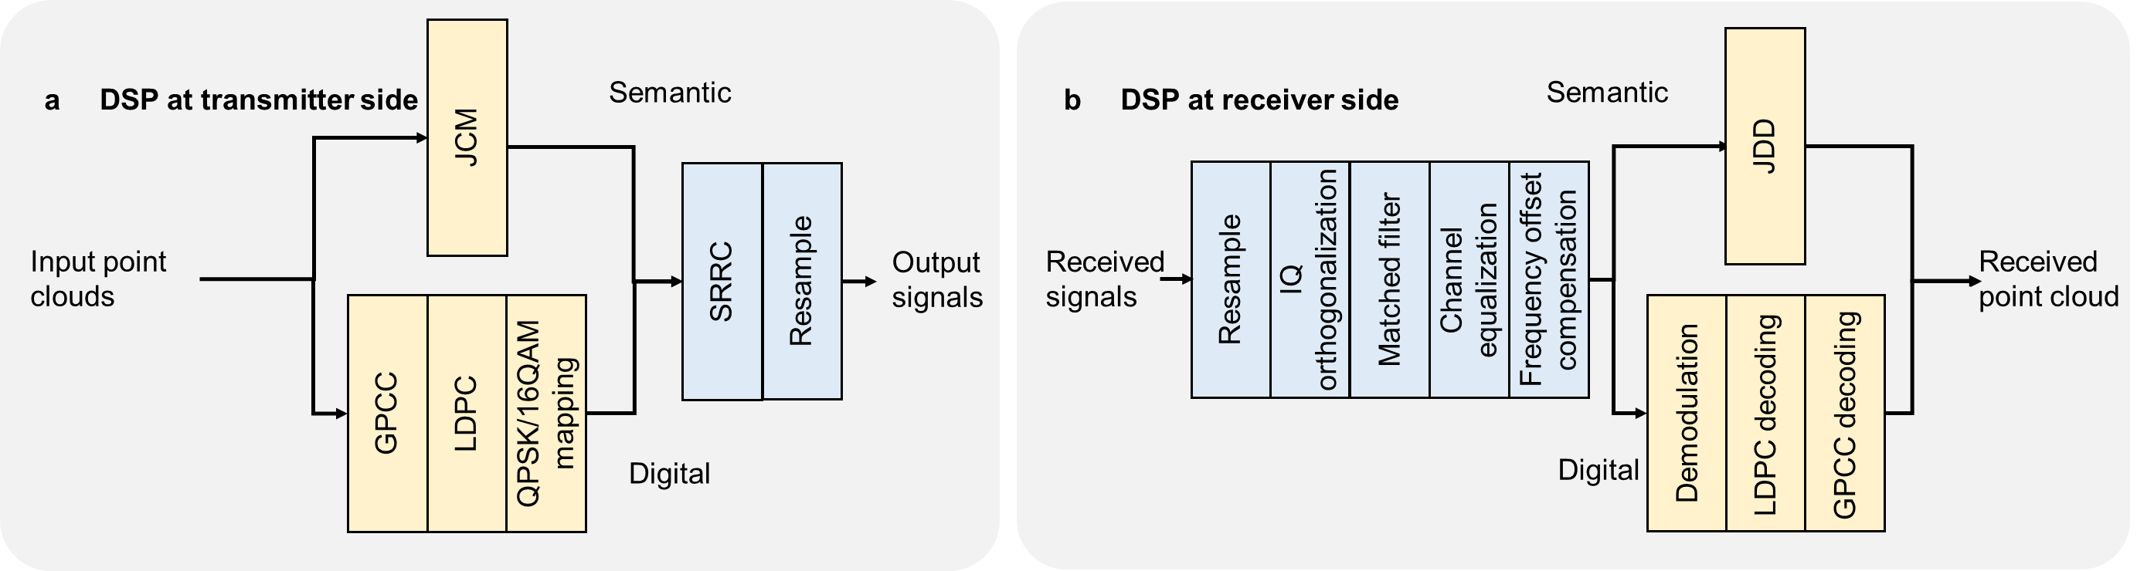

Fig. S3. Detailed digital signal processing procedure on the transmitter side and the receiver side.
- Generation of the dual coherence-cloned microcomb
In the experiment, two silicon nitride on-chip micro-ring cavities with a free spectral range of 100 GHz each were used to generate mutually coherent dual microcombs. The cross sections of both microcavities are 1650$×$800 nm2. The microcavity chips were both packaged with ultraviolet-glued input/output lenses and polarization-maintaining fibers, as depicted in Fig. S4(A). The auxiliary laser heating (ALH) method was used to generate dissipative Kerr soliton (DKS) microcombs in two silicon nitride microcavities. An extra auxiliary laser was adopted to maintain the frequency of the resonance, resulting from the photothermal effect when the pump laser acquiring the red-detuning region of the microcavity⁴. Unlike other schemes, such as fast scanning⁵, power kicking⁶, pulse driven⁷ and self-injection locking⁸, ALH method can access the soliton state with higher certainty, repeatability and simplicity. Besides, the microcomb generated by the ALH method can maintain stability over a long period of operation⁹. Thus, the robust microcomb can be employed as the laser source in the long-distance communication scenarios¹⁰. And in the transmitter, a DKS microcomb $C_{Tx}\left(m\right)$was generated, from which 15 comb lines $C_{Tx}\left(m\right)=±1,±2,…,±7,8$ were selected as the data carriers and modulated using a IQ modulator. As shown in Fig. S4(B), the 15-channel signals and pump laser were transmitted 100 km to the receiver through a 10-segment HCF. In the receiver, the transmitted pump laser $C_{Tx}\left(m\right)=0$ was used to regenerate another DKS microcomb, which acted as the receiver local oscillator microcomb $C_{Rx}\left(m\right)$ (see Fig. 3(b) in the main text).

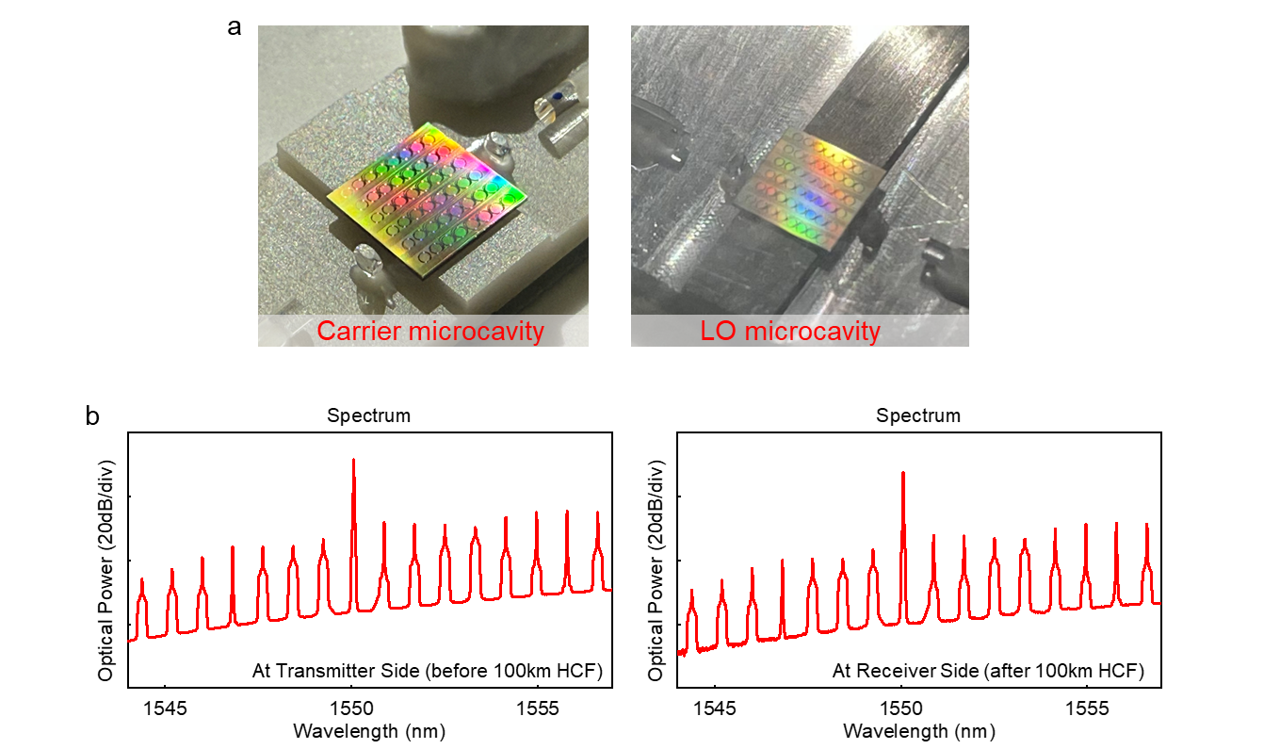

Fig. S4. Generation of the dual coherence-cloned microcomb. (a) The silicon nitride microcavity chips for carrier and LO microcomb. (b) The optical spectra of the transmitted 15 carrier comb lines before and after 100km HCF.
- Two-point locking of the dual microcomb
After transmitting the pump laser of the carrier microcomb and using it to generate the local oscillator microcomb, the dual microcomb undergo the same fluctuations resulting from the same pump laser. Thus, it can be considered as “one-point locked” dual microcomb. Since the optical frequency of the $μ$-th microcomb line $f_{μ}$ is determined by two degrees of freedom, i.e., the frequency of the pump laser and the repetition rate of the soliton microcomb:
$f_{μ}=f_{p}+μ×f_{rep}$ (1)
with the comb line number $μ$ counted from the pump. Therefore, the distinct repetition rates and the uncorrelated jitter caused by the fluctuations of the two independent microcavities lead to weak coherence between the laser carrier microcomb and the local oscillator microcomb. To achieve coherence-cloned regeneration of the DKS microcomb, we extracted the 14th comb line $C_{Tx}\left(14\right)$ of the laser carrier microcomb as a pilot signal. This pilot signal${ C}_{Tx}\left(14\right)$, along with the 15 data channels, was amplified up to about 30 dBm before being coupled with the pump laser and transmitted to the receiver. In the receiver, the 14th comb line of the local oscillator microcomb ${ C}_{Rx}\left(14\right)$ was phase locked to the pilot signal $C_{Tx}\left(14\right)$ using an optical phase-locked loop technology. With this tool, the feedback signal is fed to the auxiliary laser frequency to adjust the repetition rate of $C_{Rx}$ by configuring the pump-cavity frequency detuning[7]. With this approach, $C_{Tx}$and $C_{Rx}$ share not only the same pump laser but also the 14th comb line. Consequently, the electrical spectrum of the beat note signal between signal microcomb and the regenerated microcomb before and after locking are shown in Fig. 3(c) of the main text. In this figure, the pump laser and pilot comb line of the signal optical comb are transmitted over 100 km to generate a local oscillator optical comb and achieve remote dual microcomb locking. It can be clearly observed that before locking, the beat note signal between the pilot comb line and its corresponding comb line, sharing the same mode number, on the local oscillator optical comb are relatively broad, indicating a large width of the beat note signal. However, after locking, the linewidth of the beat note signal is significantly suppressed, with the electrical spectrum becoming much narrower and sharper.
- Generalization capability analysis for semantic encoding networks
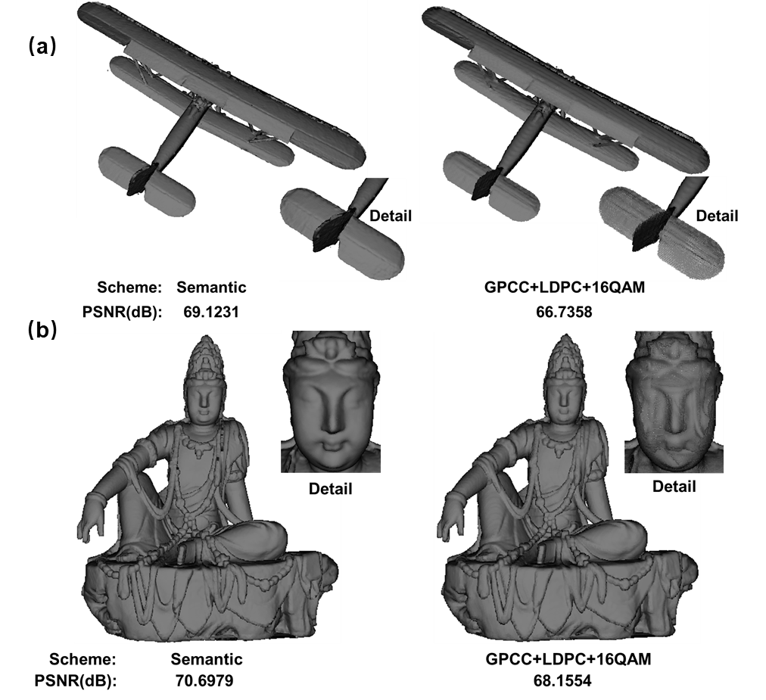

Fig. S6. The transmission results of (a) plane and (b) sculpture.
The method we proposed is generalizable. To address this, we have supplemented the evaluation with additional results using two representative point cloud categories with distinct geometric characteristics, as shown in Fig. S6. Plane, characterized by smooth contours and symmetric structures. Sculpture, with large planar surfaces and sharp edges. For each category, we compared the PSNR performance of our semantic transmission scheme against the traditional digital approach (GPCC+LDPC+16QAM) under identical transmission conditions. The results show that our JCM network consistently outperforms the baseline across all samples: For plane, the PSNR improvement is 2.4 dB; For sculpture, the improvement is 2.6 dB. Notably, the semantic scheme maintains stable performance even for point clouds with highly irregular geometries and sparse point distributions, confirming its generalization capability. We believe the results strengthen the validity of our approach and better demonstrate its practical relevance for real-world holographic communication scenarios.
References
- Alexiou E, Tung K, Ebrahimi T. Towards neural network approaches for point cloud compression. Applications of digital image processing XLIII. SPIE, 2020, 11510: 18-37.
- Alexiou E, Yang N, Ebrahimi T. PointXR: A toolbox for visualization and subjective evaluation of point clouds in virtual reality. 2020 Twelfth International Conference on Quality of Multimedia Experience (QoMEX). IEEE, 2020: 1-6.
- Zerman E, Gao P, Ozcinar C, et al. Subjective and objective quality assessment for volumetric video compression. Electronic Imaging, 2019, 31: 1-7.
- Zhou, H. et al. Soliton bursts and deterministic dissipative Kerr soliton generation in auxiliary-assisted microcavities. Light Sci Appl 8, 50 (2019).
- Stone, J.R. et al. Thermal and nonlinear dissipative-soliton dynamics in Kerr-microresonator frequency combs. Phy. Rev. Lett. 121, 063902 (2018).
- Brasch, V. et al. Photonic chip–based optical frequency comb using soliton Cherenkov radiation. Science. 351,357-360 (2016).
- Obrzud, E. et al. Temporal solitons in microresonators driven by optical pulses. Nat. Photonics. 11, 600-607 (2017).
- Shen, B. et al. Integrated turnkey soliton microcombs. Nature 582, 365–369 (2020).
- Geng,Y. et al., Enhancing the long-term stability of dissipative Kerr soliton microcomb. Opt. Lett. 45, 5073-5076 (2020)
- Geng, Y. et al. Coherent optical communications using coherence-cloned Kerr soliton microcombs. Nat Commun 13, 1070 (2022).

