Supplementary information

An AI-discovered all-in-one ink yields cost-effective perovskite solar modules exceeding 22% efficiency

Can Deng^{1,15}, Liu Tang^{1,15}, Wei Wu^{1,15}, Cong Chen^{3,15}, Xiangyu Sun^{1,15}, Zhi Li², Pingping Luo¹, Ziyi Liu¹, Dongni Li¹, Li Tang¹, Huanyi Zhou², Kaiwen Dong², Jiang He², Hong Lu⁴, Heng Li^{1,5}, Liyi Yang^{1,5}, Baohua Zhong¹, Yushan Song⁵, Chunyang Yin⁸, Sai Bai⁸, Xu Xiao⁹, Shunchang Liu⁹, Hongbin Xiao¹*, Larry Lüer^{10,11}, Jiyun Zhang^{10,11}, Christoph Brabec^{10,11}, Hairen Tan⁷, Huanping Zhou⁶, Chongwen Li²*, Yicheng Zhao¹*

Corresponding authors: Hongbin Xiao, xiaohongbin@uestc.edu.cn; Chongwen Li, chongwen.li@seu.edu.cn; Yicheng Zhao, zhaoyicheng@uestc.edu.cn

Supplementary Note 1: Detailed optimization workflow of PerovSeek
To efficiently navigate the vast formulation space (1.4 × 10¹²), the optimization campaign was structured into four distinct phases. The specific execution details for each phase are summarized below:
Phase I: Orthogonal Design Initialization. An orthogonal experimental design was initially employed to broadly survey the landscape, generating a baseline dataset of 100 formulation-spectra-performance triplets. We utilized the baseline dataset to train the Gaussian Process Regression (GPR) model on formulation-performance data, while concurrently fine-tuning the pre-trained model on spectra-performance data; the latter achieved a prediction accuracy of 80% (Supplementary Fig. 13). The best device in this phase yielded a PCE of 12.38%, with an open-circuit voltage (V_{OC}) of 1.082 V, a fill factor (FF) of 52.81%, a short-circuit current density (J_{SC}) of 21.67 mA cm⁻².
Phase II: Coarse Bayesian Optimization. Utilizing a batch-noisy-expected-improvement acquisition function, we sampled 62 formulations per round from the GPR model, which are then fabricated into films using our high-throughput experimental platform. The corresponding spectra are rapidly obtained, and the corresponding PCEs of virtual devices are predicted by the pre-trained model for selecting the top-16 candidates for full-device fabrication. The resulting data are then fed back to update both the GPR model and the pre-trained model for the next iteration. After four closed-loop iterations, the solvent ratio converged to DMF: NFM: EA = 81:17:2 (Fig. 2b). This phase significantly improved the PCE to 21.15% (V_{OC} = 1.096 V, FF = 81.25%, J_{SC} = 23.75 mA cm⁻²).
Phase III: Dimension Reduction. With the solvent system fixed, the search space was reduced by two orders of magnitude. However, two subsequent optimization rounds yielded marginal gains and a narrowed PCE distribution (Fig. 2c), with diminishing expected improvement values (Supplementary Fig. S14). This signalled a physical bottleneck (insufficient optical absorption) rather than a compositional one.
Phase IV: Fine Bayesian Optimization. To address the identified bottleneck, the precursor concentration was first increased from 1.42 M to 1.67 M. Following this adjustment, three rounds of optimization were performed to adapt the system to the higher concentration, resulting in a J_{SC} increase to 24.28 mA cm⁻². Subsequently, we adjusted the FA/Cs ratio to optimize the optical bandgap (Supplementary Fig. S15). With the composition fixed, five final rounds of Bayesian optimization were executed to fine-tune the concentrations of hole-transport molecules and additives, allowing the algorithm to ultimately reach the global optimum. The final ink formulation comprises 1.67 M FA_{0.91}Cs_{0.09}PbI₃ in DMF: NFM: EA (81:17:2), with 0.04 mol% Me-4PACz, 0.02 mol% Py3, 0.01 mol% 4PADCB, 0.1 mol% 4F-BASZ, 0.5 mol% F3EABr, and 0.3 mol% SPFBS.
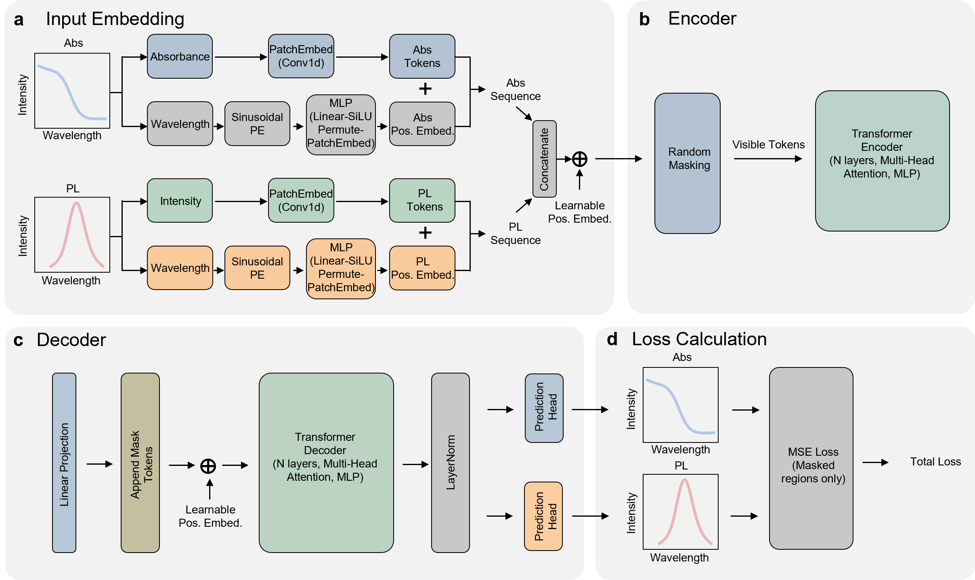
Supplementary Fig. 1. Architecture of the masked spectral pre-training model. a, Abs and PL spectra are tokenized via 1D convolutional patch embedding and combined with sinusoidal positional embeddings (PE) to form a unified sequence of tokens. b, A subset of the tokens is randomly masked, and only the visible tokens are fed into the Transformer Encoder to extract latent features. c, Learnable mask tokens are appended to the encoded latent representation, which is then processed by the Transformer Decoder to reconstruct the original spectral features. d, The model is trained to minimize the Mean Squared Error (MSE) loss between the reconstructed and original spectra, calculated exclusively on the masked regions to enforce self-supervised learning.

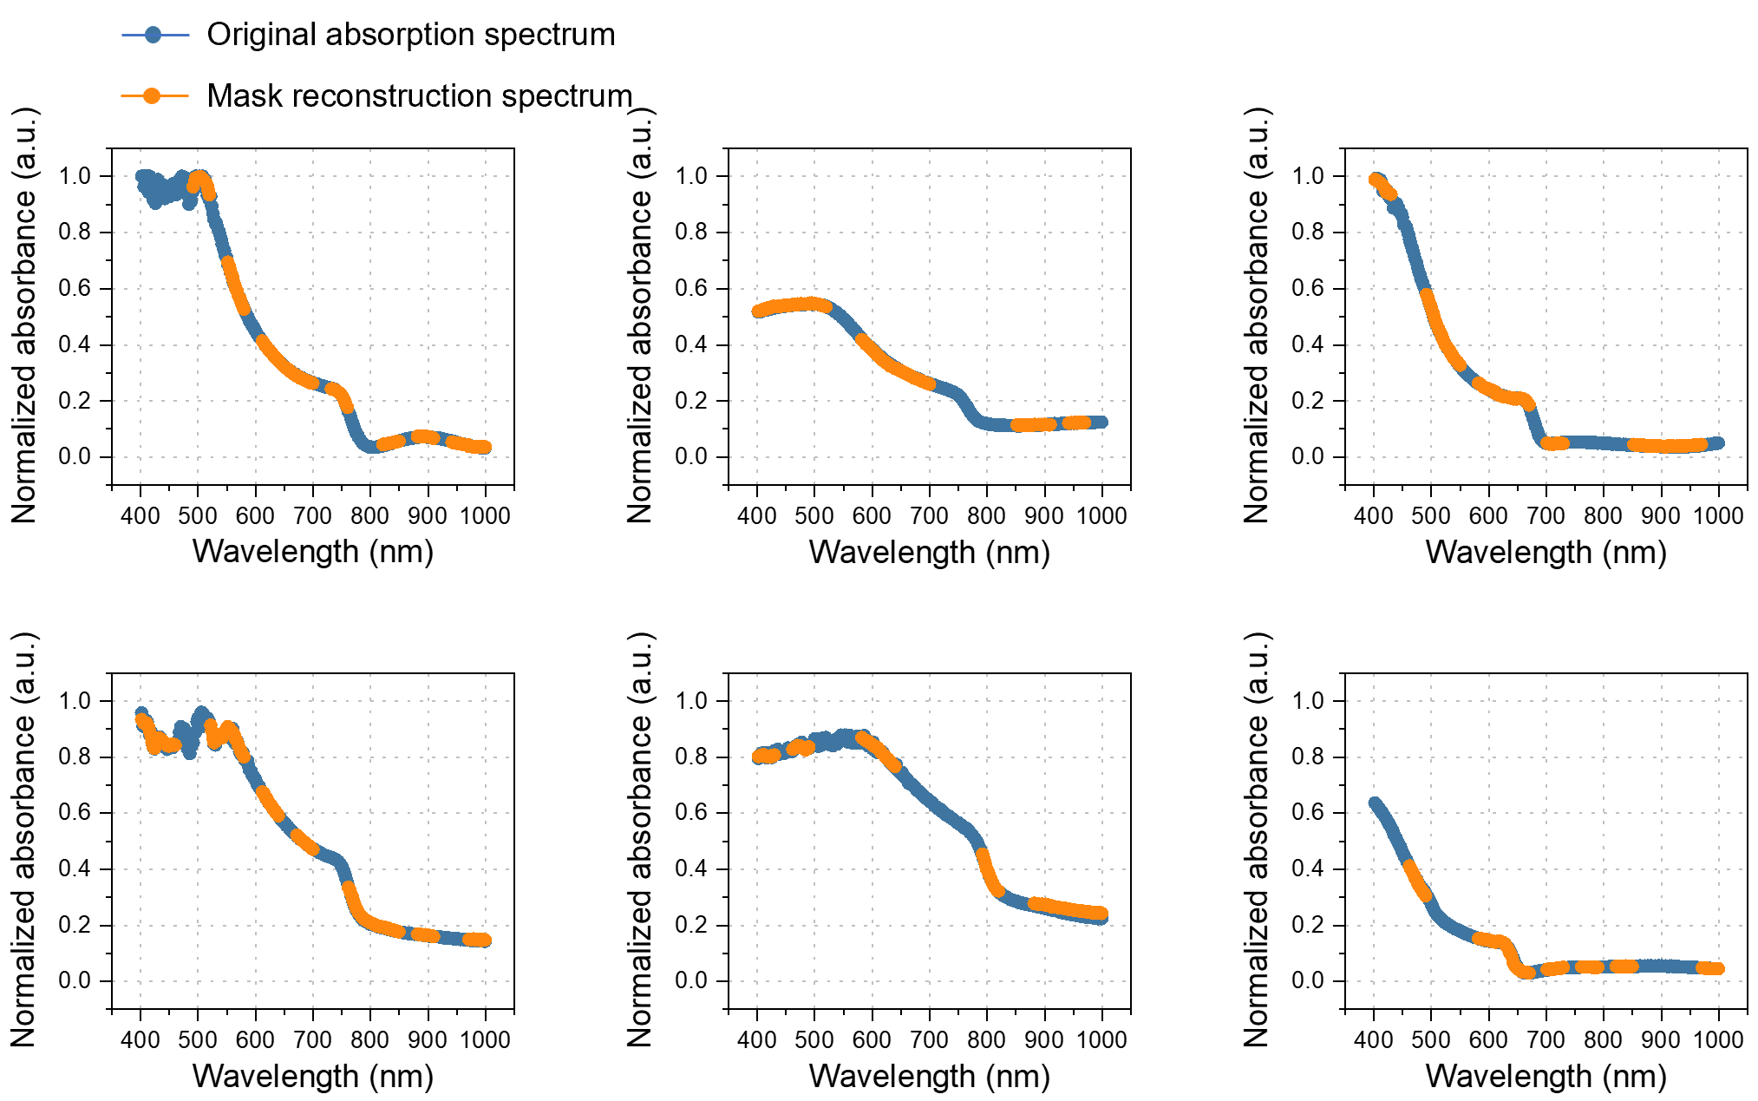
Supplementary Fig. 2. Reconstruction quality of UV-vis absorption spectra in the pre-trained model under six different spectral masking strategies during pre-training. Throughout the training process, 50% of spectral patches are randomly masked, requiring the model to reconstruct the missing portions based on the unmasked patches.
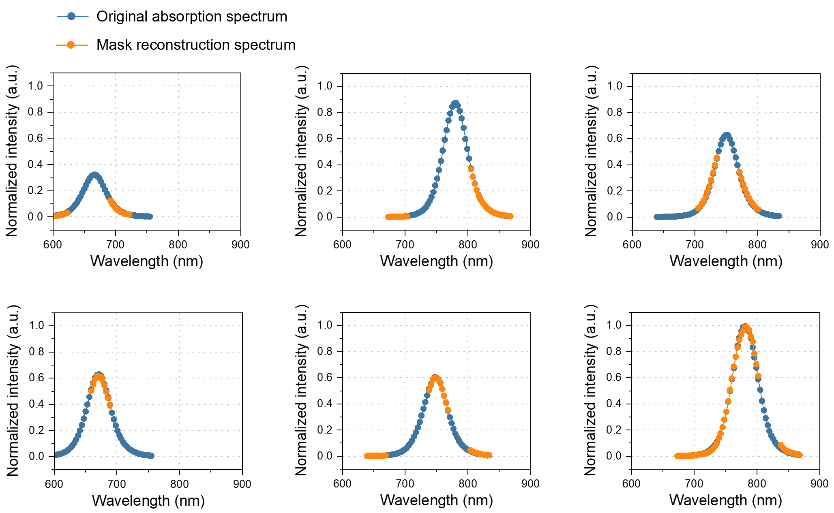
Supplementary Fig. 3. Reconstruction quality of photoluminescence spectra in the pre-trained model under six different spectral masking strategies during pre-training. Throughout the training process, 50% of spectral patches are randomly masked, requiring the model to reconstruct the missing portions based on the unmasked patches.
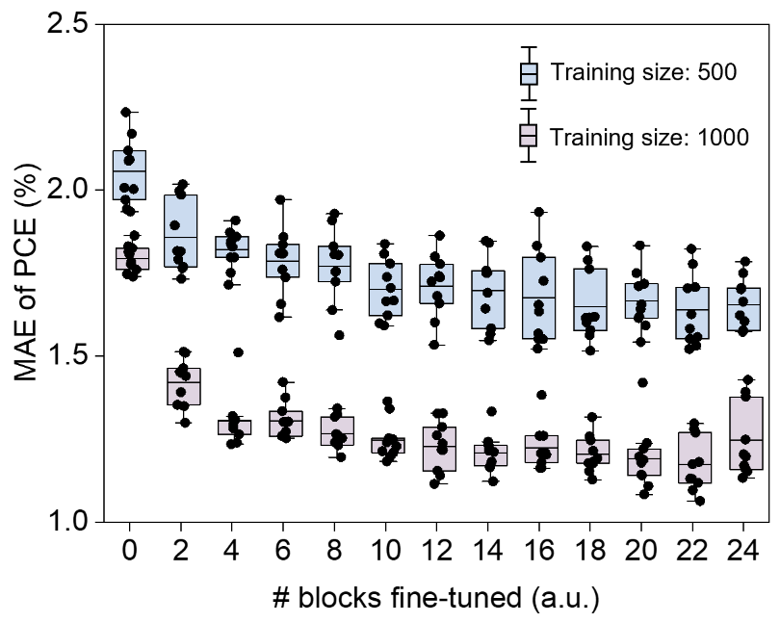
Supplementary Fig. 4. Partial fine-tuning results of the pre-trained model under two different training size. The model is fine-tuned on the last K transformer blocks and the weighted prediction head. Here, fine-tuning “0 blocks” corresponds to updating only the prediction head, while fine-tuning “24 blocks” represents updating all the entire model. (Test set: n=1000)
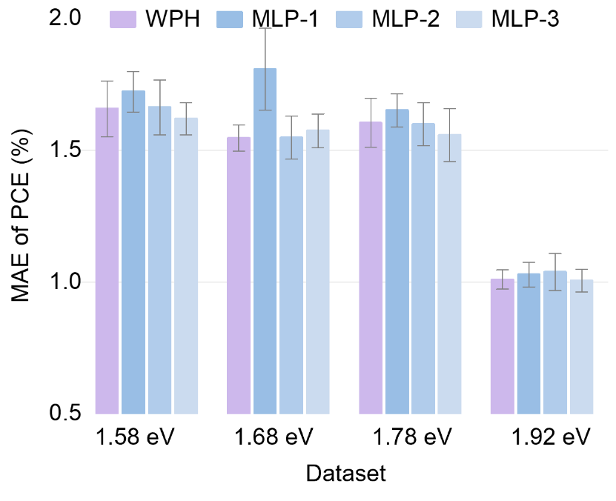
Supplementary Fig. 5. Prediction performance comparison among four different prediction heads. The input encoded data has a shape of batch3236. WPH: weighted prediction head. MLP-1: The data is flattened to a shape of batch × 1152 and then processed by an MLP with layer sizes [1152, 1024, 256, 64]. MLP-2: The data is averaged over the second dimension to a shape of batch × 36 and then processed by an MLP with layers [36, 18]. MLP-3: The data is averaged over the third dimension to a shape of batch × 32 and then processed by an MLP with layers [32, 18]. (Training set: n = 500; test set: n = 1500)
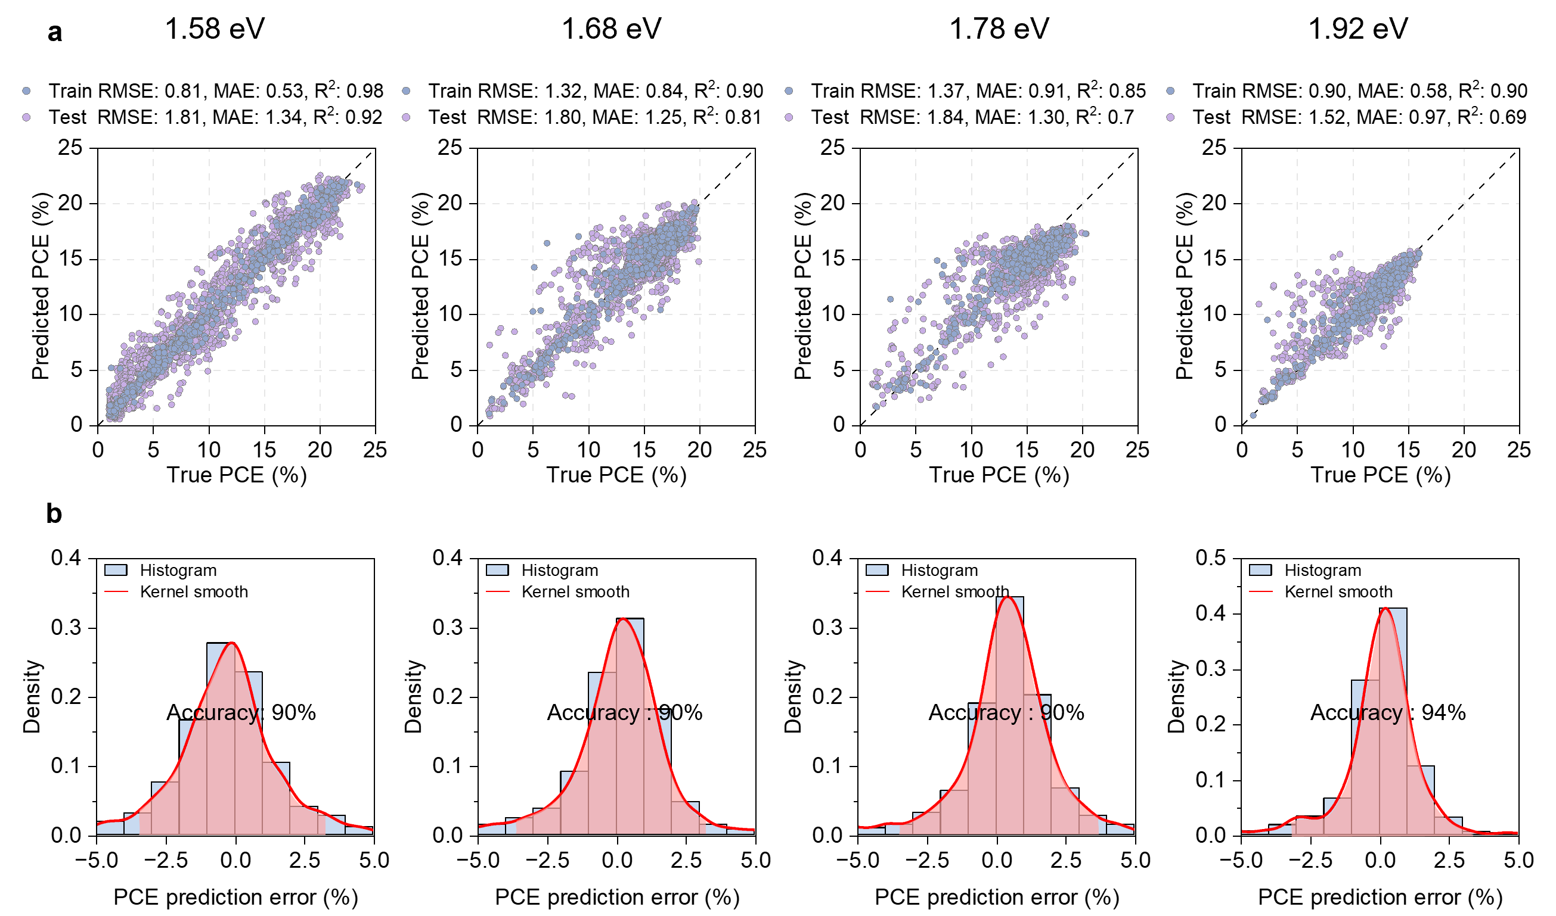
Supplementary Fig. 6. PCE prediction performance of the pre-trained model across four different bandgaps of 1.58 eV, 1.68 eV, 1.78 eV and 1.92 eV. a, Scatter plot of predicted versus actual PCE values. b, Distribution of prediction error. The model's accuracy is defined as the integral of the density function over the error range within [-3, 3]. (Training set: n = 500; test set: n = 1500)
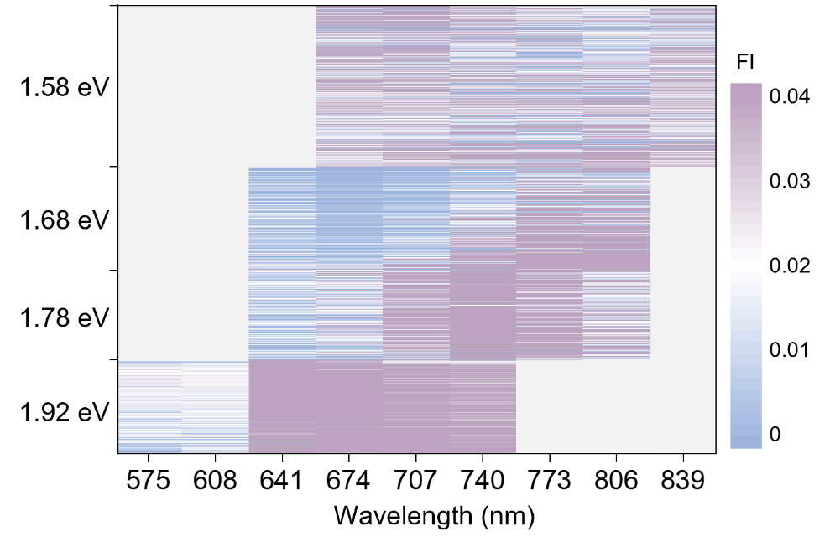
Supplementary Fig. 7. Feature importance heatmap of PL bottom features of the perovskite films for PCE prediction.
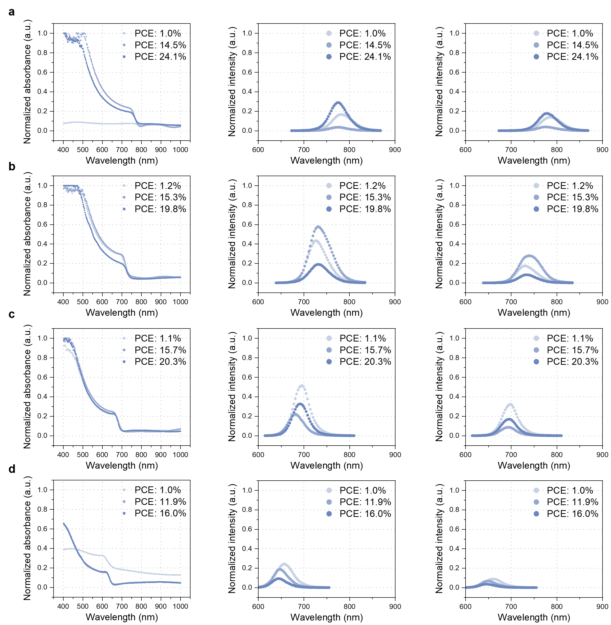
Supplementary Fig. 8. Comparison of absorption (left), top PL (middle) and bottom PL (right) spectra among perovskite films with relatively low, medium, and high experimental PCEs. a,b,c,d, The bandgaps for the perovskite films are (a) 1.58 eV, (b) 1.68 eV (c) 1.78 eV and (d) 1.92 eV, respectively. All absorption spectra are normalized by dividing by 4. Top PL spectra are normalized by dividing by 1.2×10⁵ for the 1.58 eV film and by 2.2×10⁴ for the others. Bottom PL spectra are normalized by dividing by 1.5×10⁵ for the 1.58 eV film and by 1.0×10⁵ for the other bandgap films. These data are randomly selected from our database, including devices based on anti-solvent quenching method.
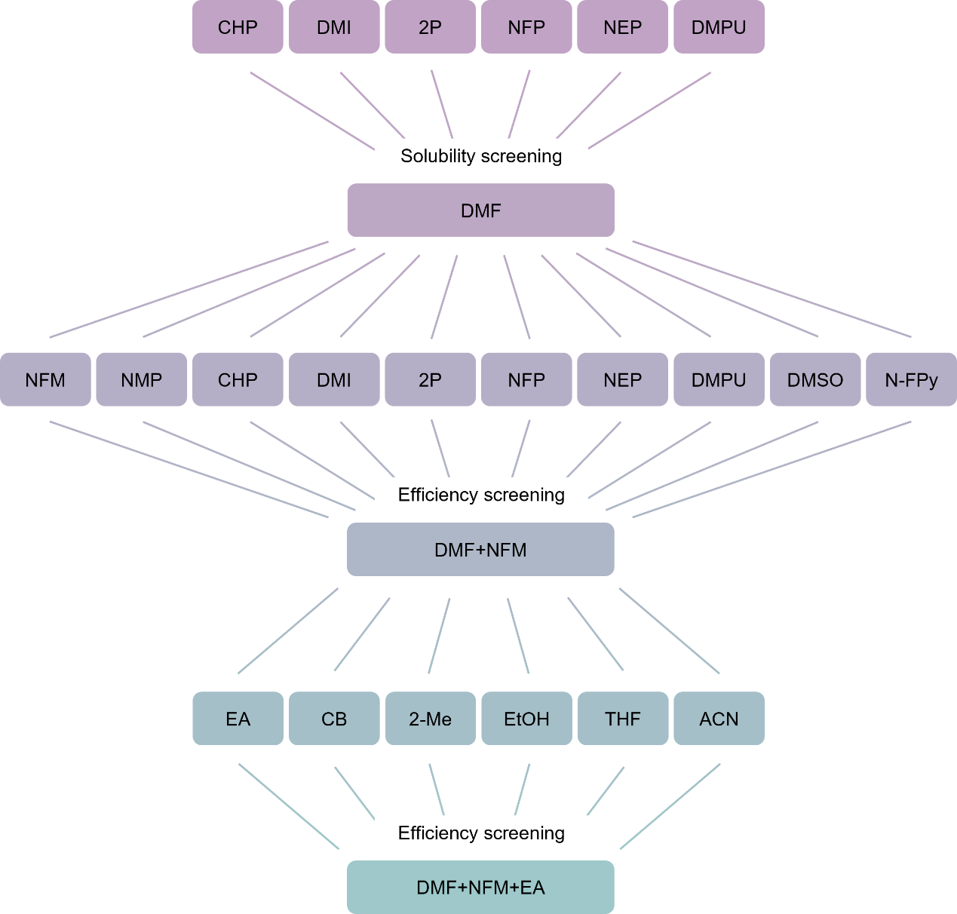
Supplementary Fig. 9. Flowchart of the ternary solvent screening process. The ternary solvent screening process commences with the selection of DMF, owing to its favorable solubility. Subsequent efficiency-guided evaluation leads to the identification of NFM and EA.
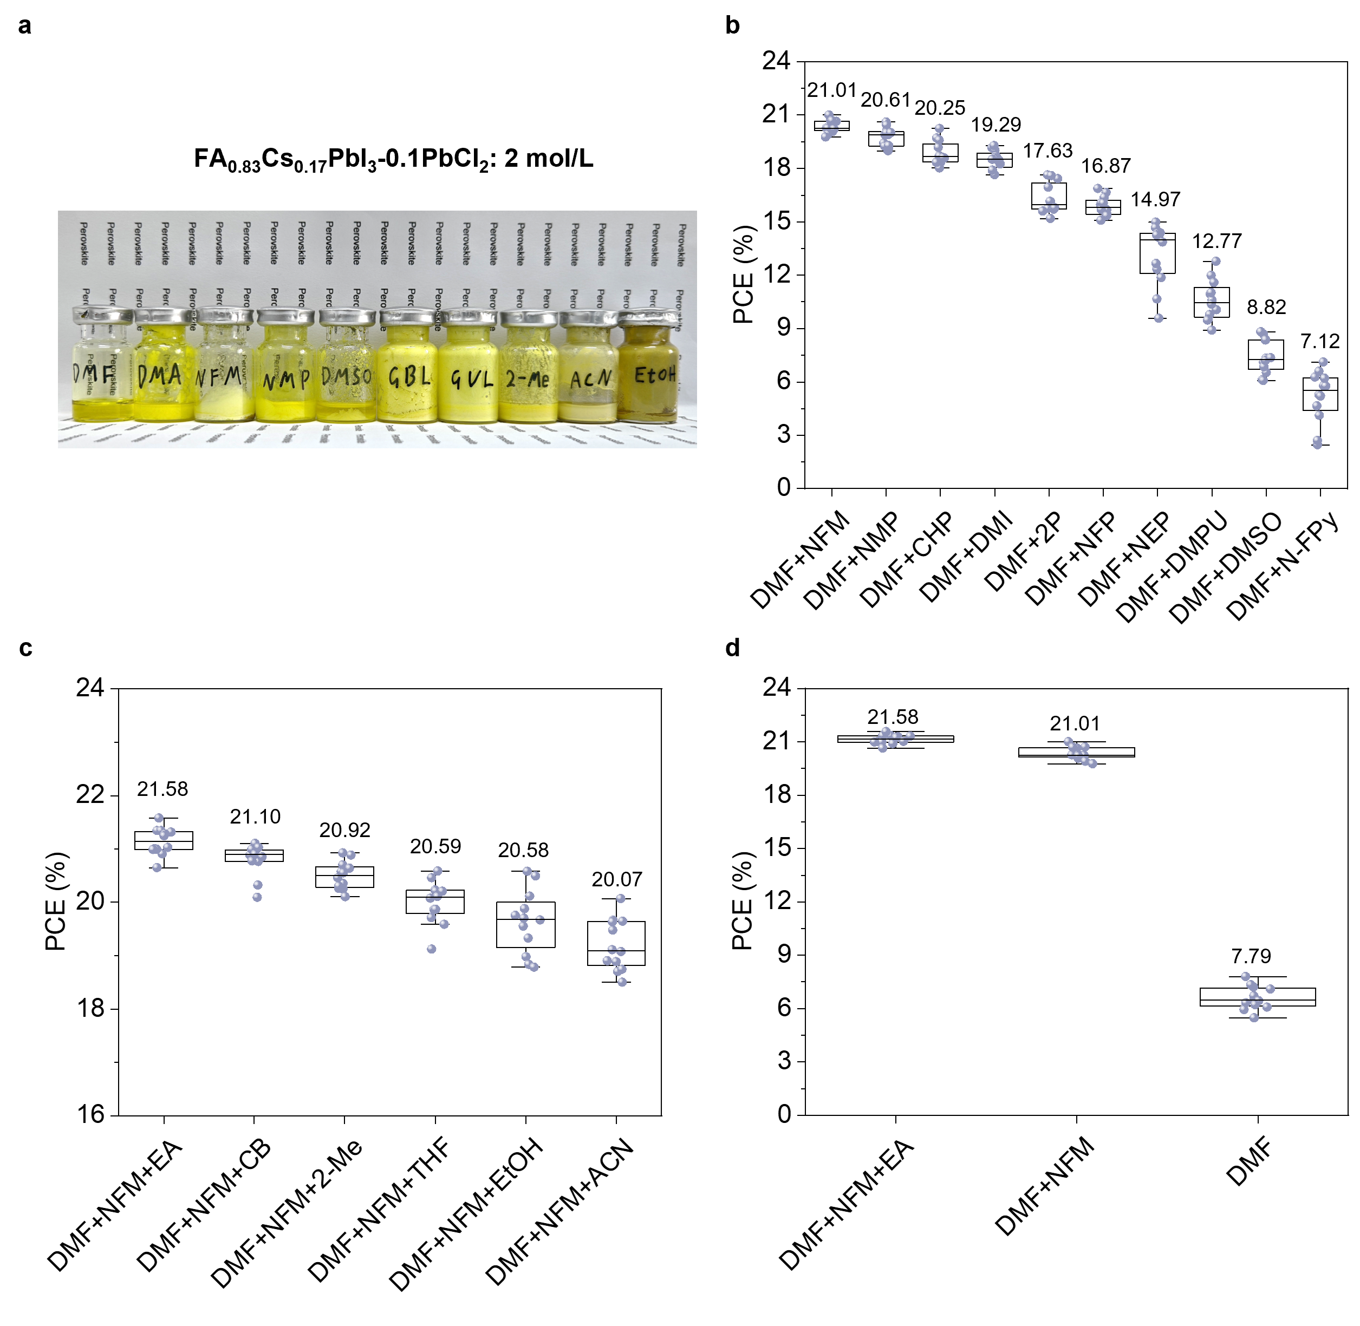
Supplementary Fig. 10. Solubility of perovskite precursors in different solvents and the corresponding efficiencies of fabricated solar cells. a, Solvent screening based on solubility of perovskite precursors. b,c, PCEs for different (b) binary and (c) ternary solvent systems. The specific ratios corresponding to each data point are listed in Tables S2 and S3. d, Comparison of the device efficiencies obtained using DMF, DMF+NFM binary solvent system, and DMF+NFM+EA ternary solvent system. The perovskite active layer is fabricated by diluting the 2 M FA_{0.83}Cs_{0.17}PbI₃‑0.1PbCl₂ precursor solution to 1.42 M. The complete device structure is ITO/Me‑4PACz/MHP/C₆₀/SnO_{x}/Ag.
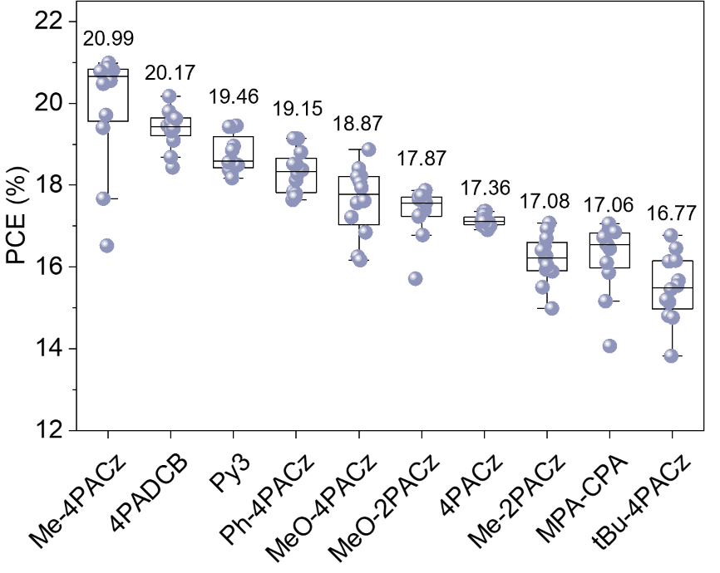
Supplementary Fig. 11. Screening process for the top three SAM molecules. Various SAMs are evaluated at gradient concentrations, and the three candidates yielding the highest PCE are selected. The perovskite active layer is fabricated from 1.42 M FA_{0.83}Cs_{0.17}PbI₃-0.1PbCl₂ precursor (different SAMs) in DMF: NFM: EA (85.7:10.7:3.6) mixed solvent. The complete device structure is ITO/MHP/C₆₀/SnO_{x}/Ag.
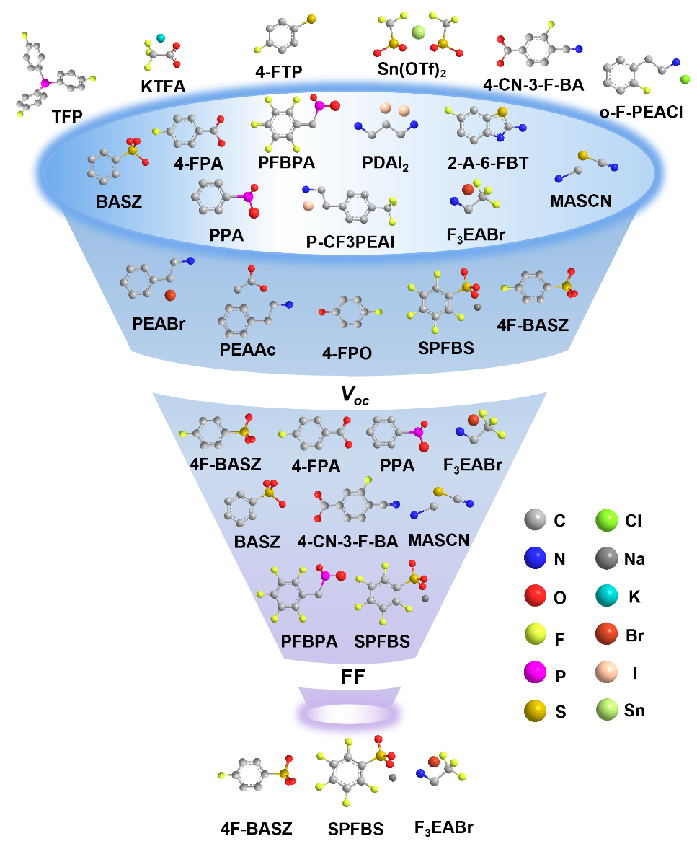
Supplementary Fig. 12. Screening process for the top three surface passivators. Passivators are evaluated at gradient concentrations in conjunction with 0.1 mol% Me-4PACz. Candidates are first selected for their ability to enhance the V_{OC}, and subsequently selected for maintaining a high FF. The perovskite active layer is fabricated from 1.42 M FA_{0.83}Cs_{0.17}PbI₃-0.1PbCl₂ precursor (0.1 mol% Me-4PACz and passivator) in DMF: NFM: EA (85.7:10.7:3.6) mixed solvent. The complete device structure is ITO/MHP/C₆₀/SnO_{x}/Ag.
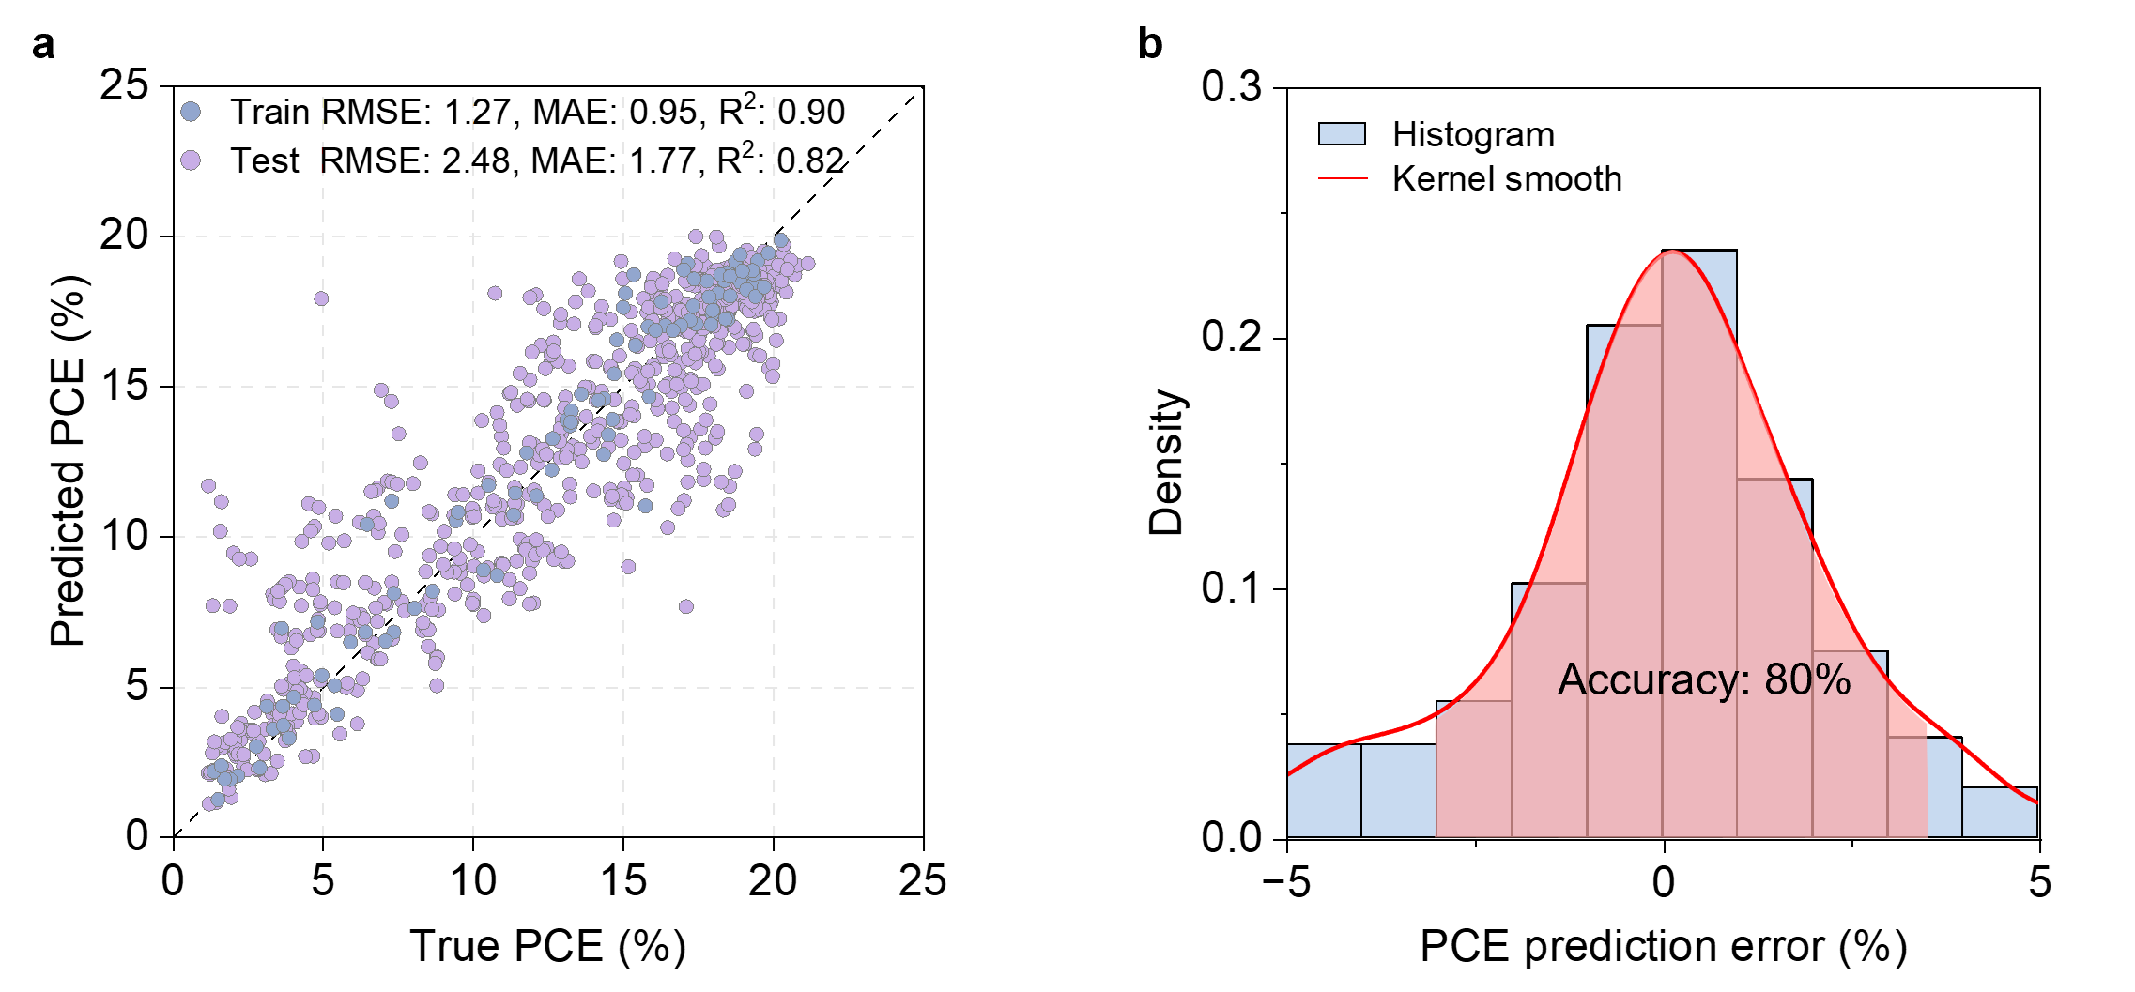
Supplementary Fig. 13. Prediction performance of the pre-trained model after fine-tuning on the AIO dataset. a, Scatter plot of predicted versus actual PCE values. b, Distribution of prediction error. (Training set: n = 100; test set: n = 700)
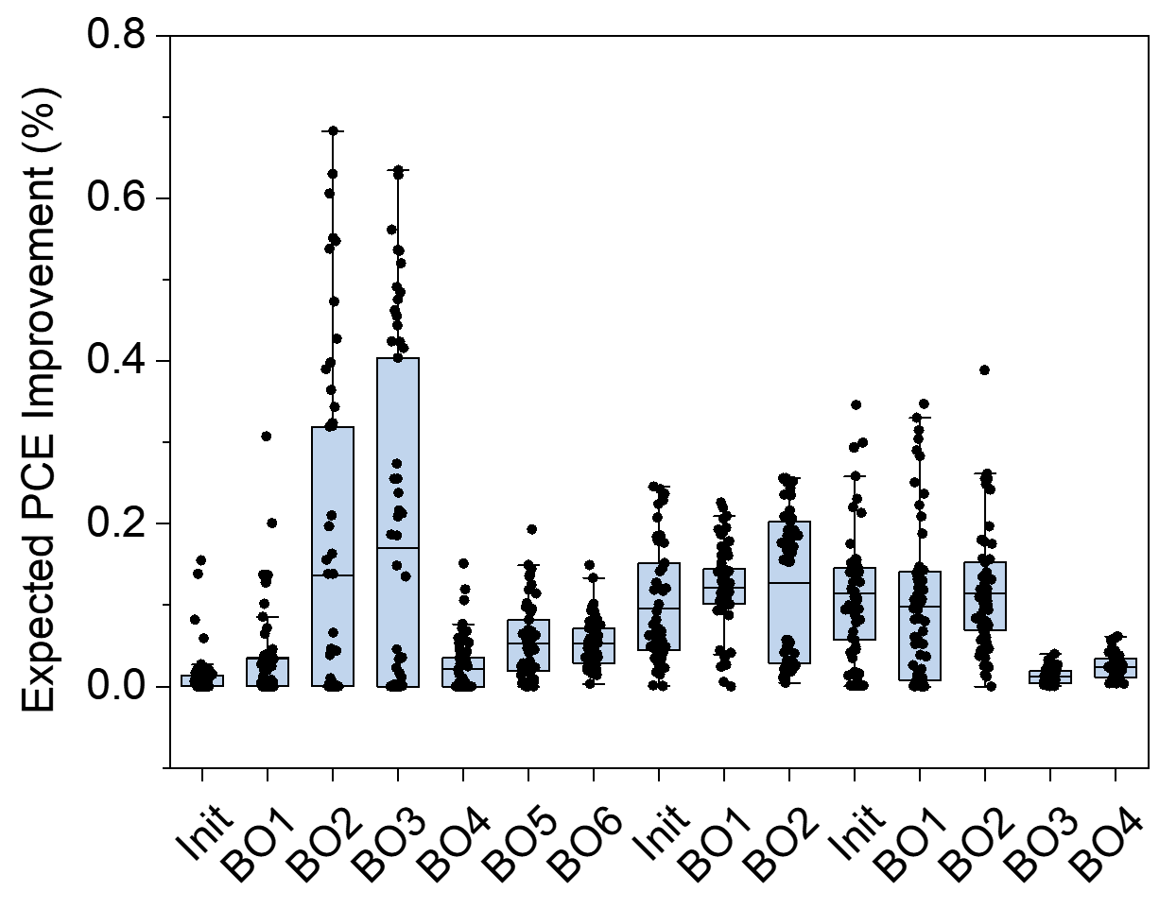
Supplementary Fig. 14. Expected PCE improvement per round. This metric, derived from the Expected-Improvement acquisition function, estimates the potential increase in PCE attainable by conducting the next batch of experiments.
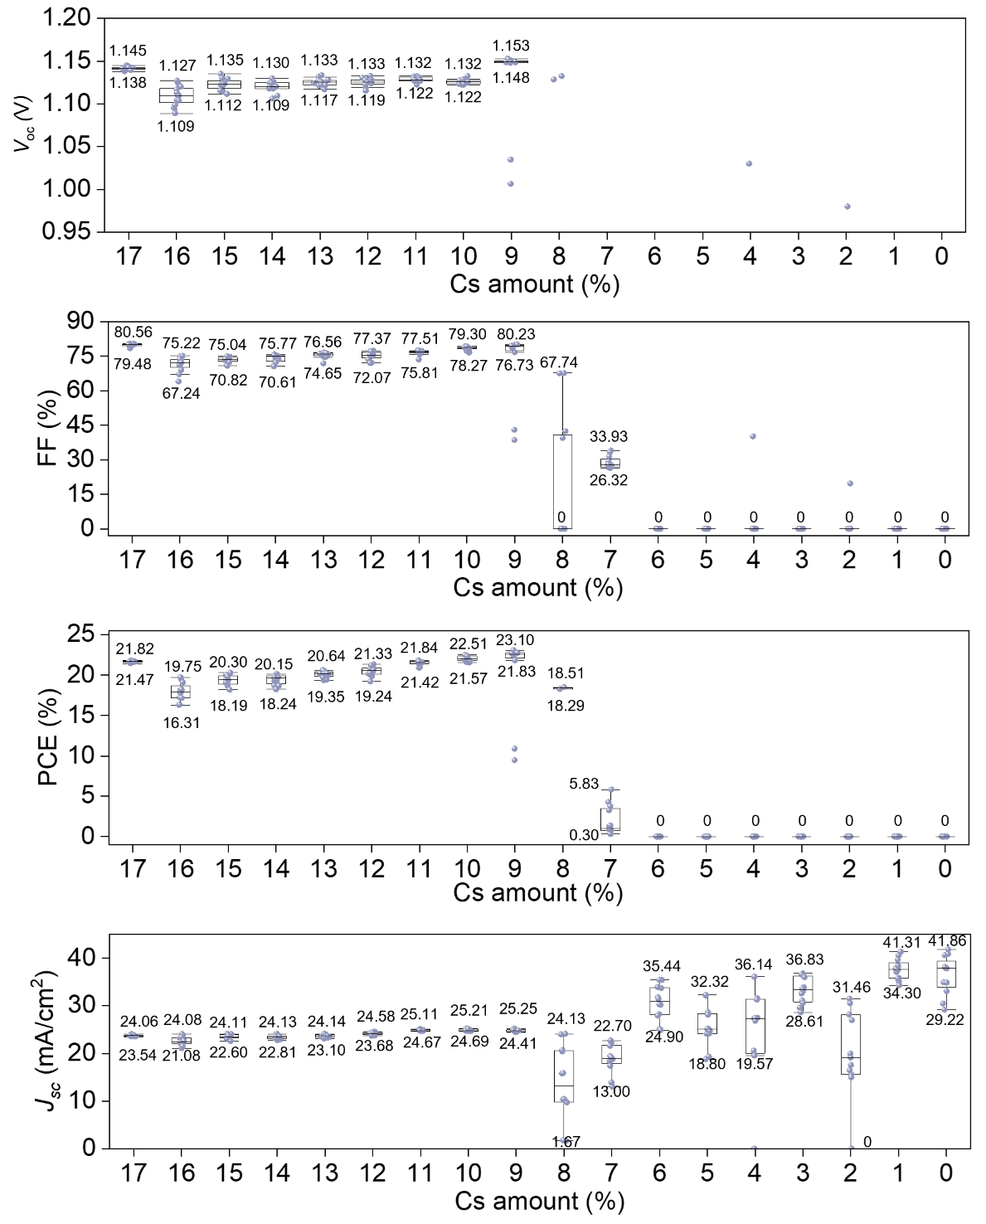
Supplementary Fig. 15. Effect of Cs doping on the photovoltaic parameters of
FA_{1-x}Cs_{x}PbI₃-0.1PbCl₂ based perovskite solar cells. The Cs content in the perovskite is controlled by blending 1.67 M FAPbI₃ and FA_{0.83}Cs_{0.17}PbI₃ precursor solutions. Both precursor systems contain 0.1 mol% PbCl₂, 0.1 mol% Me‑4PACz, and 0.2 mol% 4F‑BASZ, with DMF: NFM: EA (81:17:2, v/v/v) as the solvent. The complete device structure is ITO/AIO-ink/C₆₀/SnO_{x}/Ag.
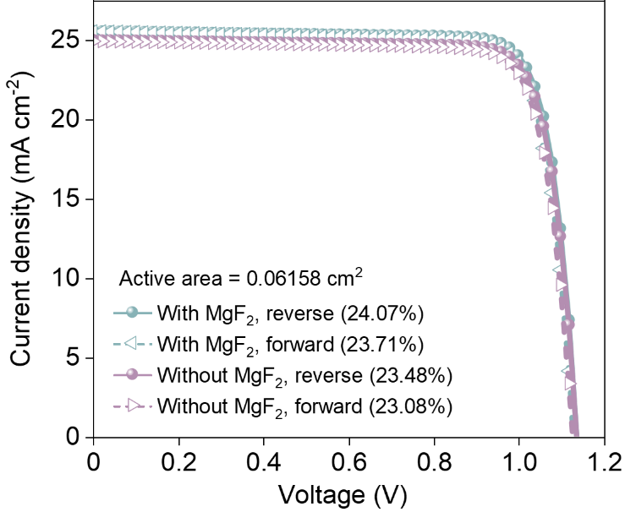
Supplementary Fig. 16. Comparison of J-V curves with and without an anti-reflection coating (MgF₂). The PCE increases from 23.48% to 24.07% after MgF₂ coating deposition. The measures are performed under both reverse (1.2 V to 0 V) and forward (0 V to 1.2 V) voltage scans with a step size of 20 mV and a delay time of 0.1 s.
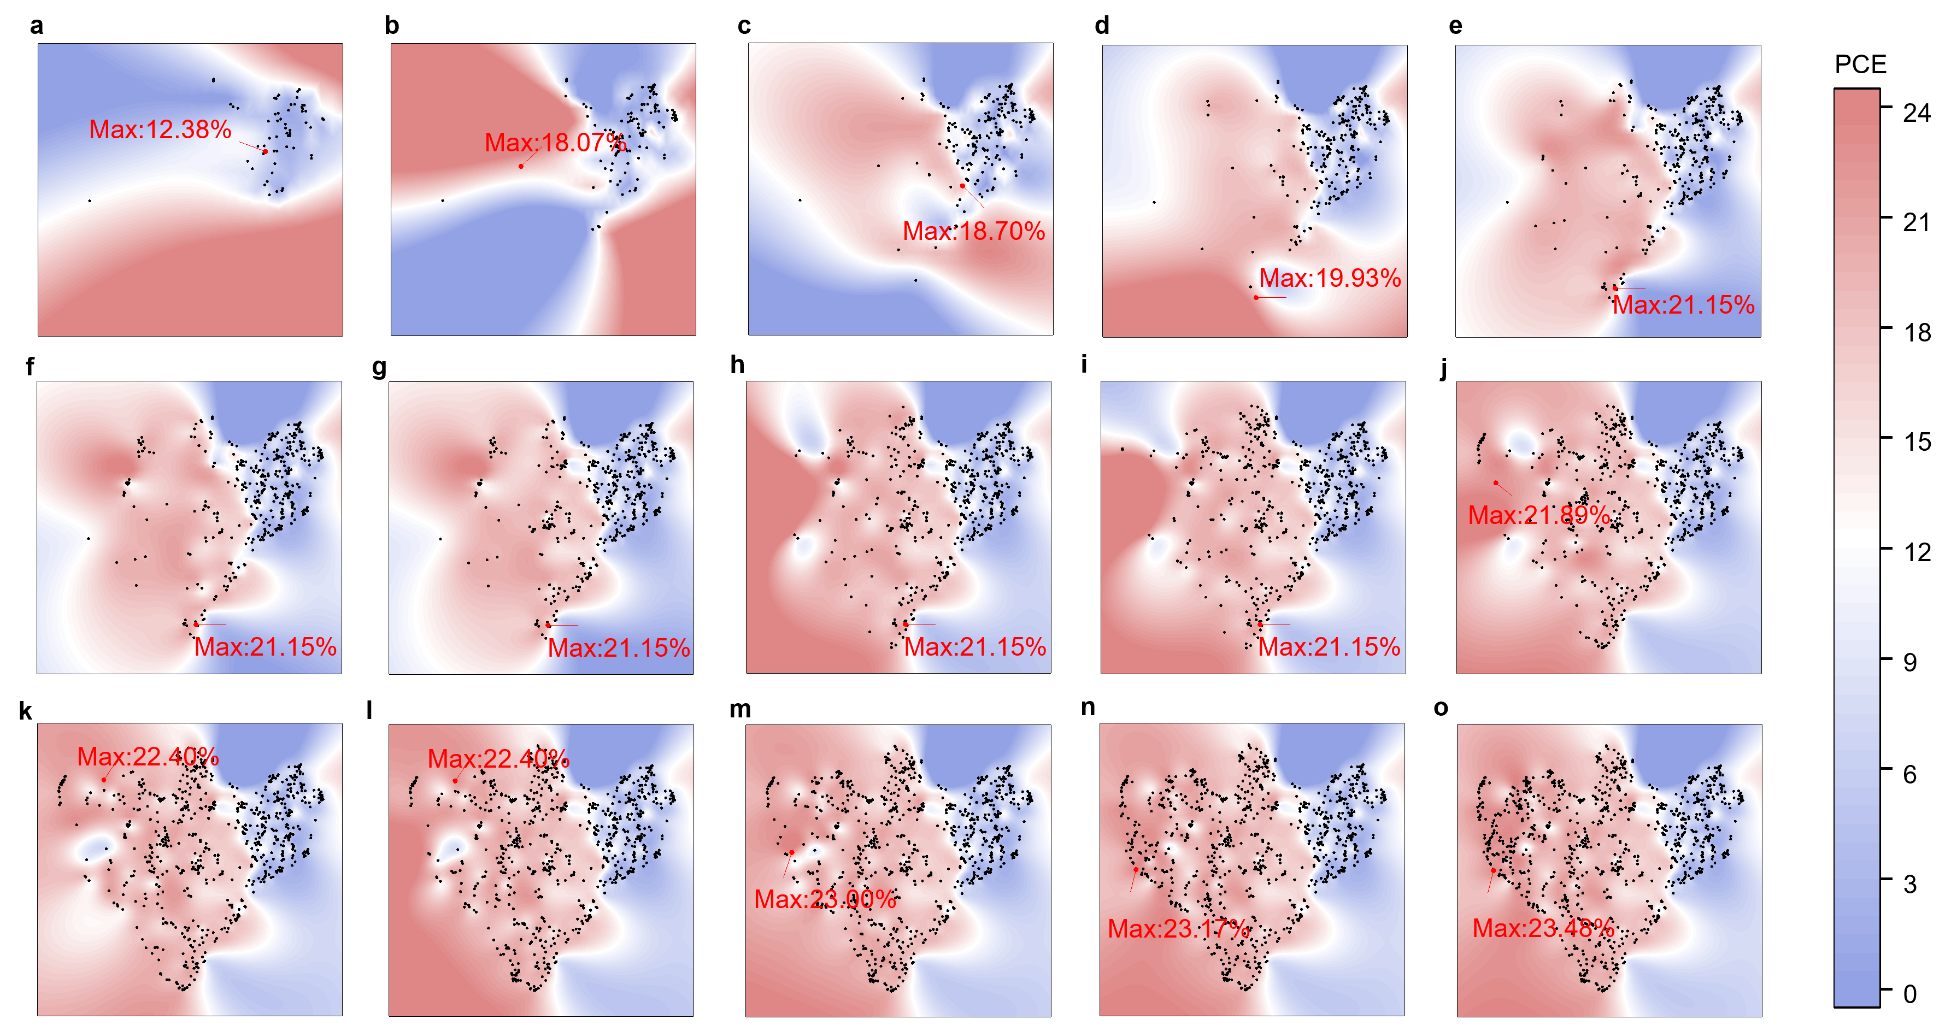
Supplementary Fig. 17. Uniform manifold approximation and projection (UMAP) plot with contour lines for the AIO perovskite ink formulation (DMF/NFM/EA/Me-4/Py3/4PADCB/4F-BASZ/F3EABr/SPFBS). The input data are normalized using min-max scaling prior to UMAP fitting. a, Orthogonal Design; b-e, Coarse Bayesian Optimization; f,g, Dimension Reduction; h-o, Fine Bayesian Optimization.
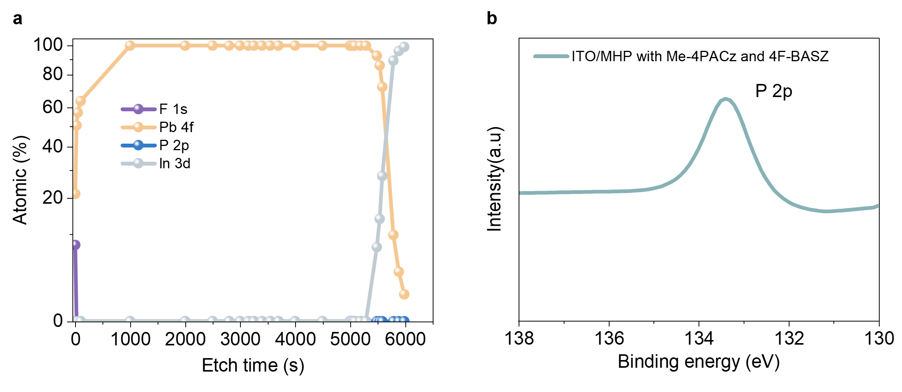
Supplementary Fig. 18. XPS depth profile analysis of the films fabricated by the AIO ink. a, Elemental depth distribution of F, Pb, P, and In of the film. b, High-resolution XPS spectrum of P 2p after the perovskite film is mechanically peeled off. The absence of the P signal within the bulk film during elemental depth profiling, contrasted with its clear appearance at the delaminated interface, confirms that Me-4PACz is located at the buried interface. During XPS depth profiling using Ar ion cluster sputtering, the F signal detected in the initial etching stage corresponds to the presence of 4F-BASZ. Throughout the entire sputtering process, no P signal is observed, which is likely attributed to the extremely thin layer of Me-4PACz, making its signal difficult to capture within the sputtering interval. Subsequently, P signal is successfully detected at the buried bottom interface exposed by UV-glue-assisted delamination.
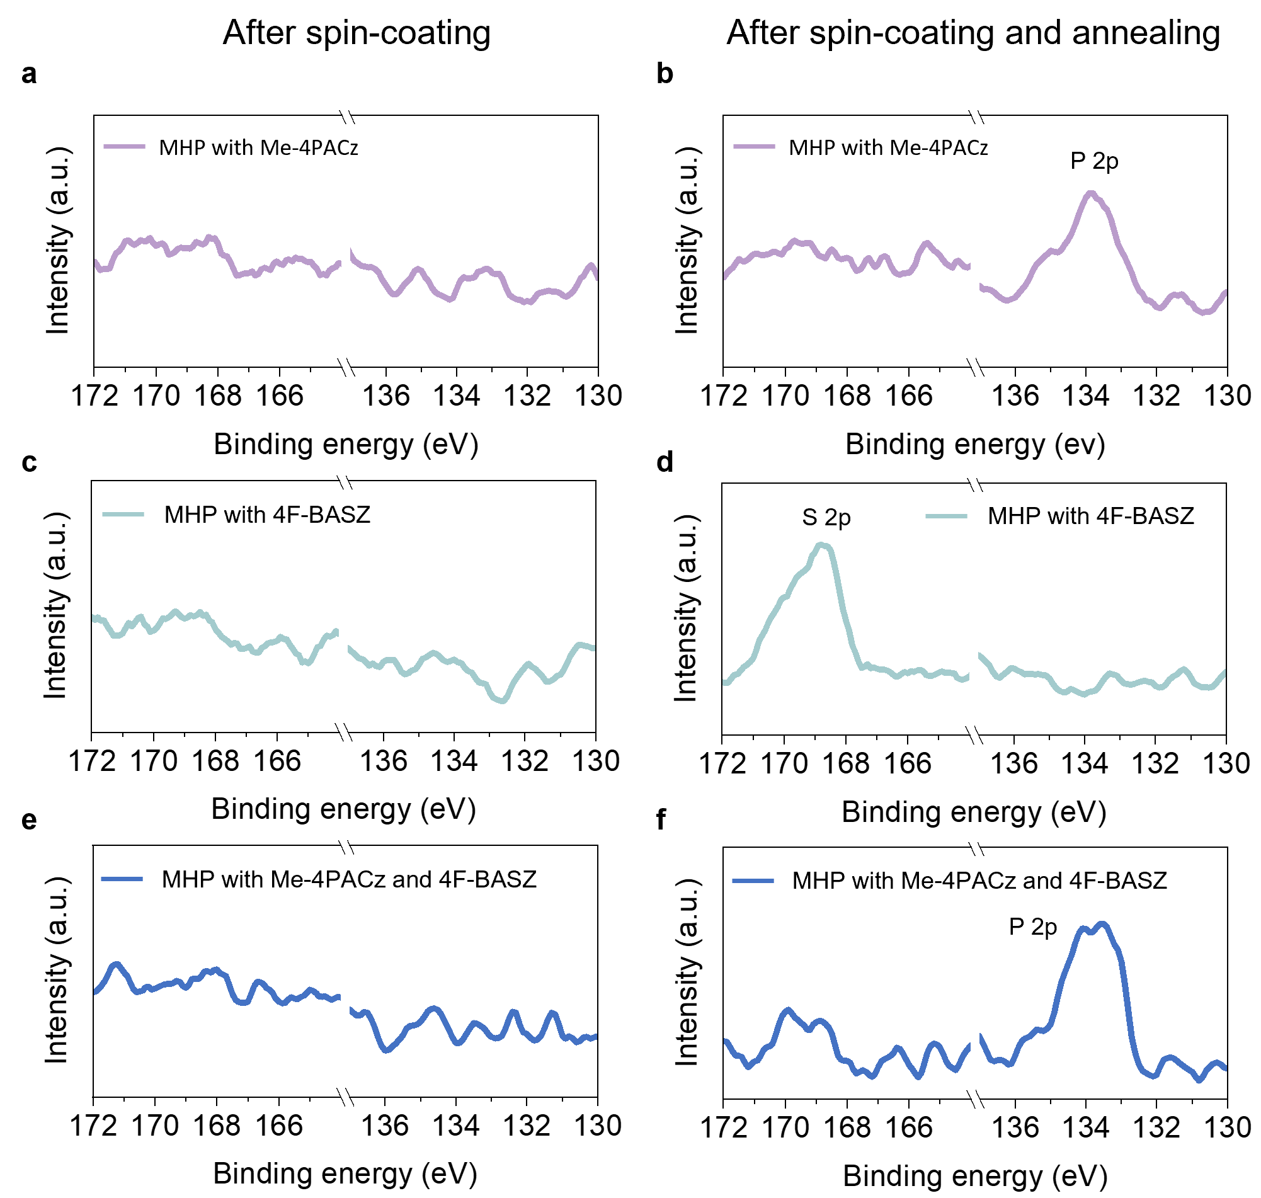
Supplementary Fig. 19. XPS spectra of the ITO substrate obtained after (a, c, e) spin-coating, (b, d, f) spin-coating and annealing of perovskite precursor containing (a, b) Me-4PACz; (c, d) 4F-BASZ; (e, f) Me-4PACz and 4F-BASZ, followed by DMF washing. (a) and the TOF-SIMS results show that although some functional molecules can adsorb onto the ITO surface after spin-coating, the adsorbed layer is loosely and prone to desorption during DMF rinsing. In contrast, (b) indicates that introducing perovskite annealing process after spin-coating enables the functional molecules to adhere firmly, remaining stable even after DMF washing. It is speculated that the perovskite crystallization plays an assisting role, promoting the loosely packed functional molecules.
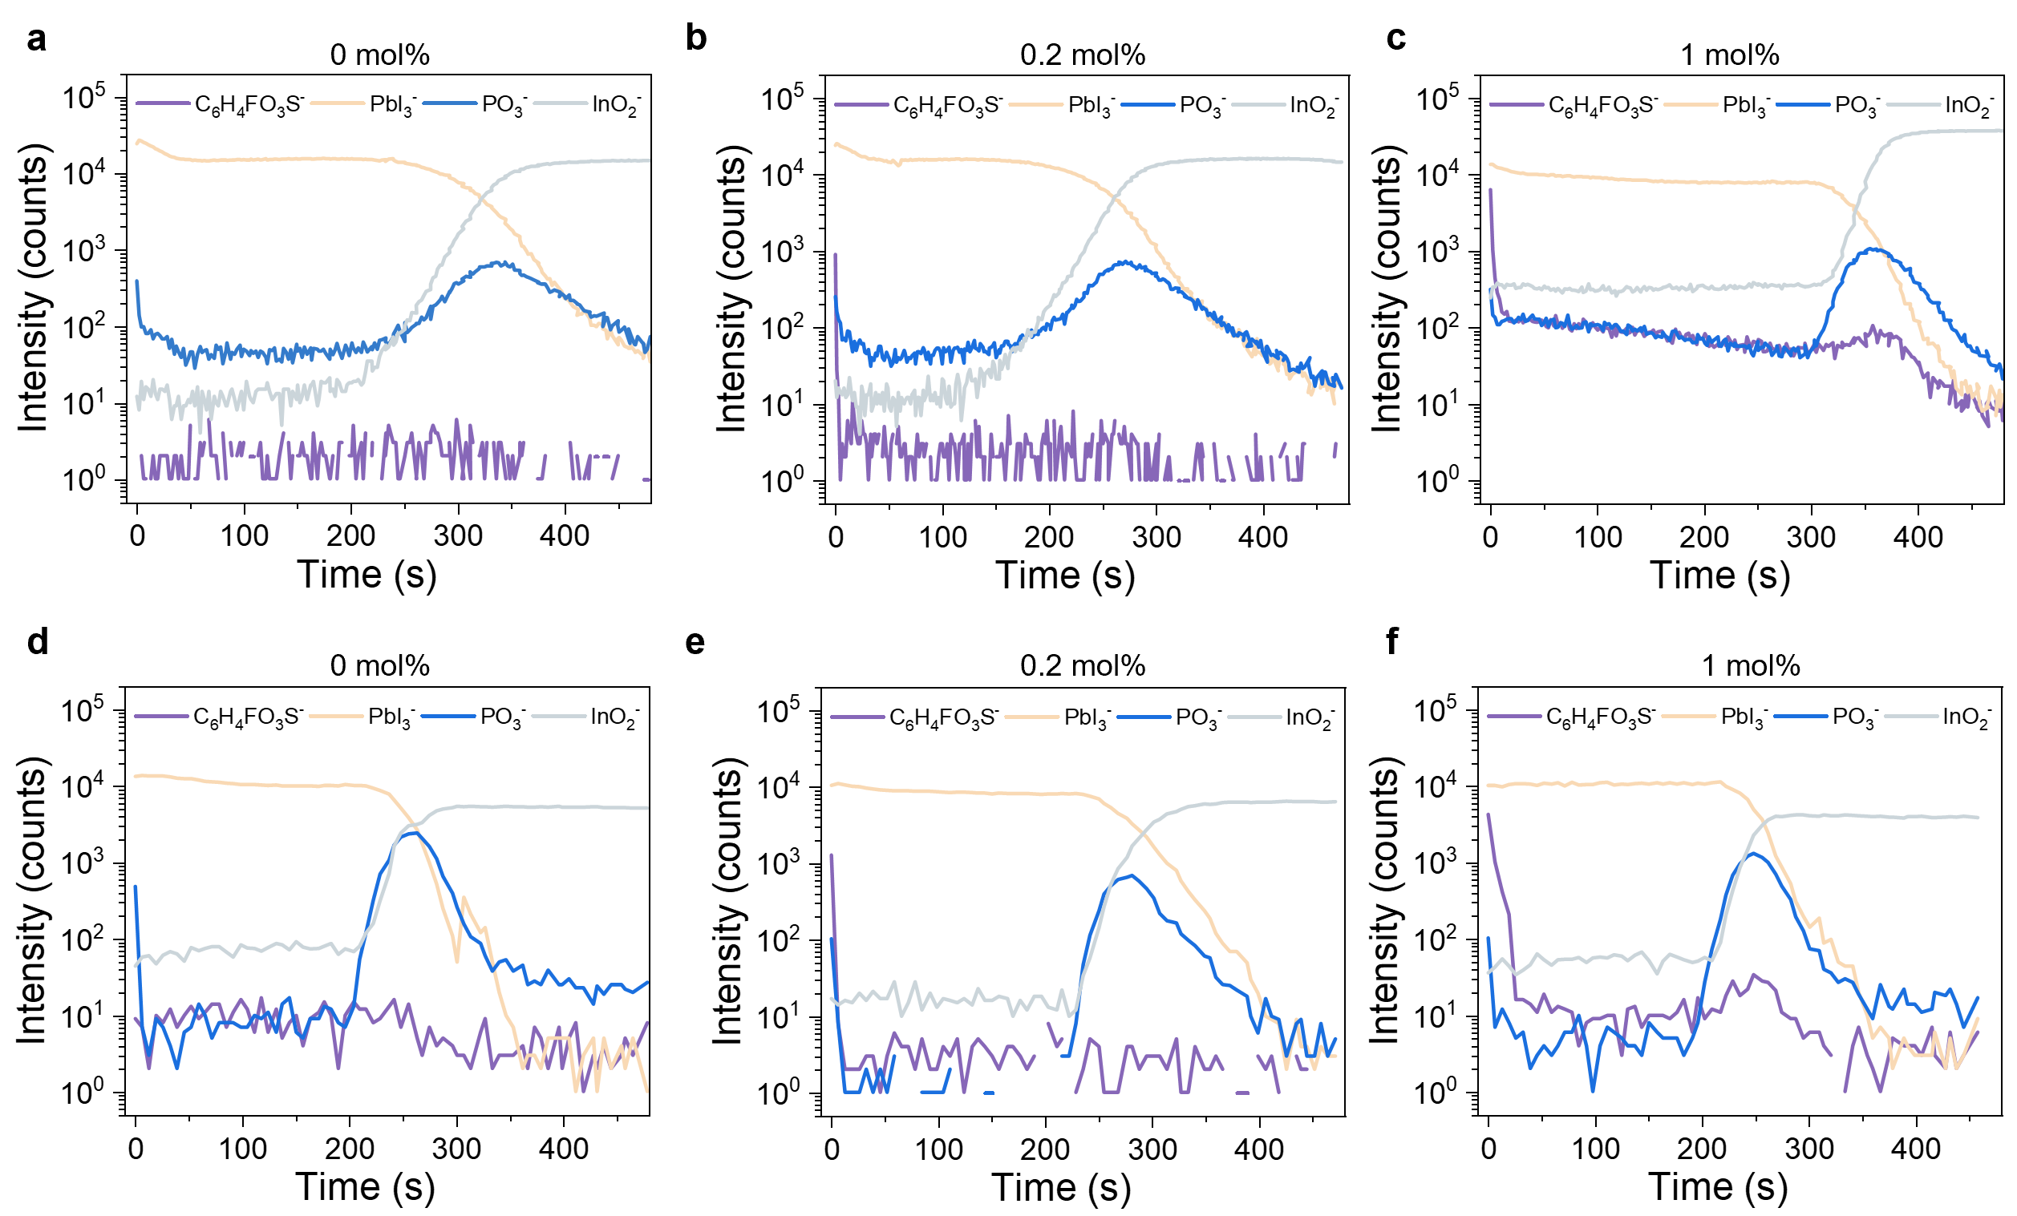
Supplementary Fig. 20. TOF-SIMS results of perovskite films with different concentrations of 4F-BASZ after (a-c) spin coating and (d-f) annealing. The concentration of Me-4PACz is fixed at 0.1 mol%. It is also found that the characteristic signal of 4F-BASZ can be detected at the buried interface as the concentration of 4F-BASZ further increases to 1 mol%.
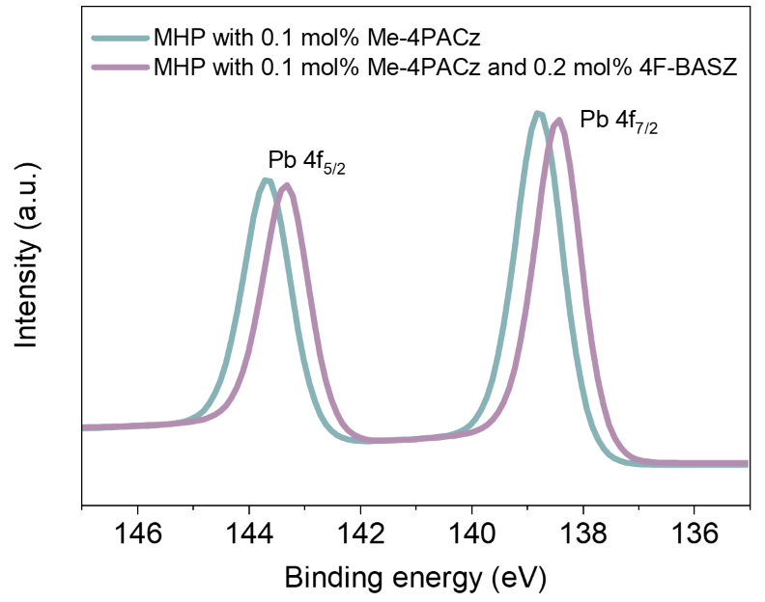
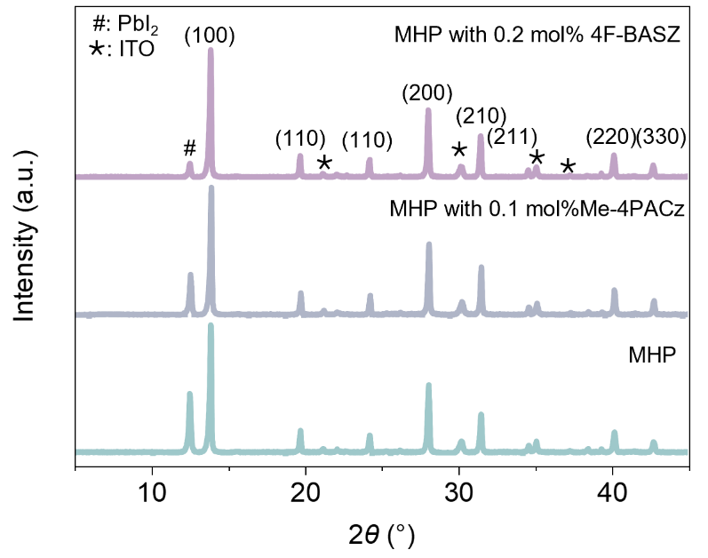
Supplementary Fig. 21. High-resolution XPS spectra of Pb 4f of perovskite films with and without 0.2 mol% 4F-BASZ.
Supplementary Fig. 22. XRD patterns for pristine perovskite films, and perovskite films with the additives of Me-4PACz or 4F-BASZ.
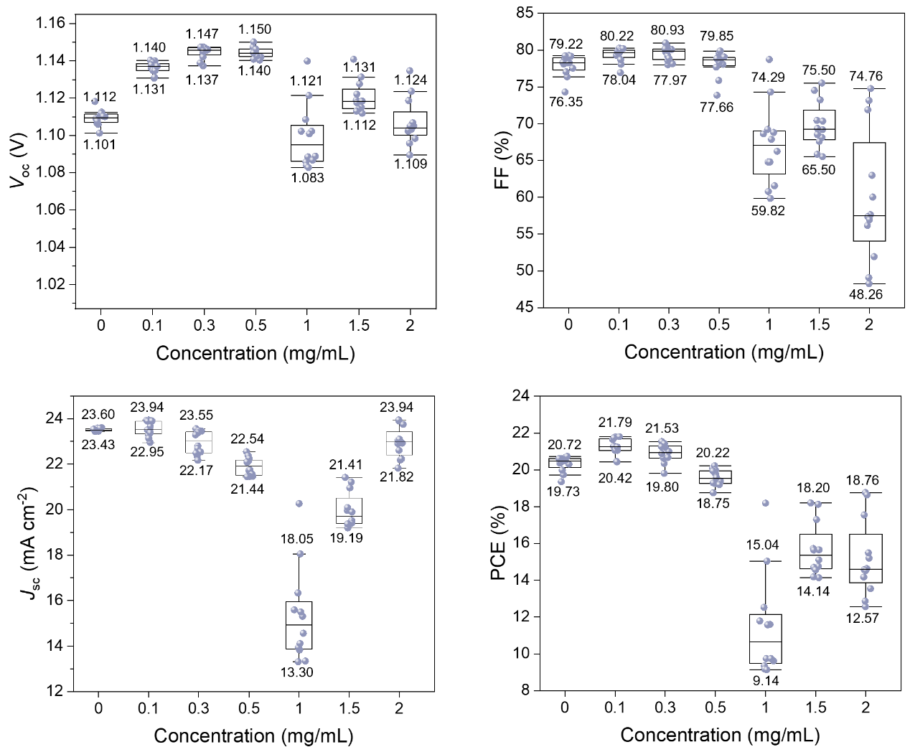
Supplementary Fig. 23. Photovoltaic performance of perovskite solar cells when different concentrations of 4F-BASZ (0-2 mg/mL) is spin-coated on the perovskite film surface. The perovskite active layer is fabricated from 1.42 M FA_{0.83}Cs_{0.17}PbI₃-0.1PbCl₂ precursor (0.1 mol% Me-4PACz) in DMF: NFM: EA (81:17:2, v/v/v) mixed solvent. The complete device structure is ITO/MHP/4F-BASZ/C₆₀/SnO_{x}/Ag.
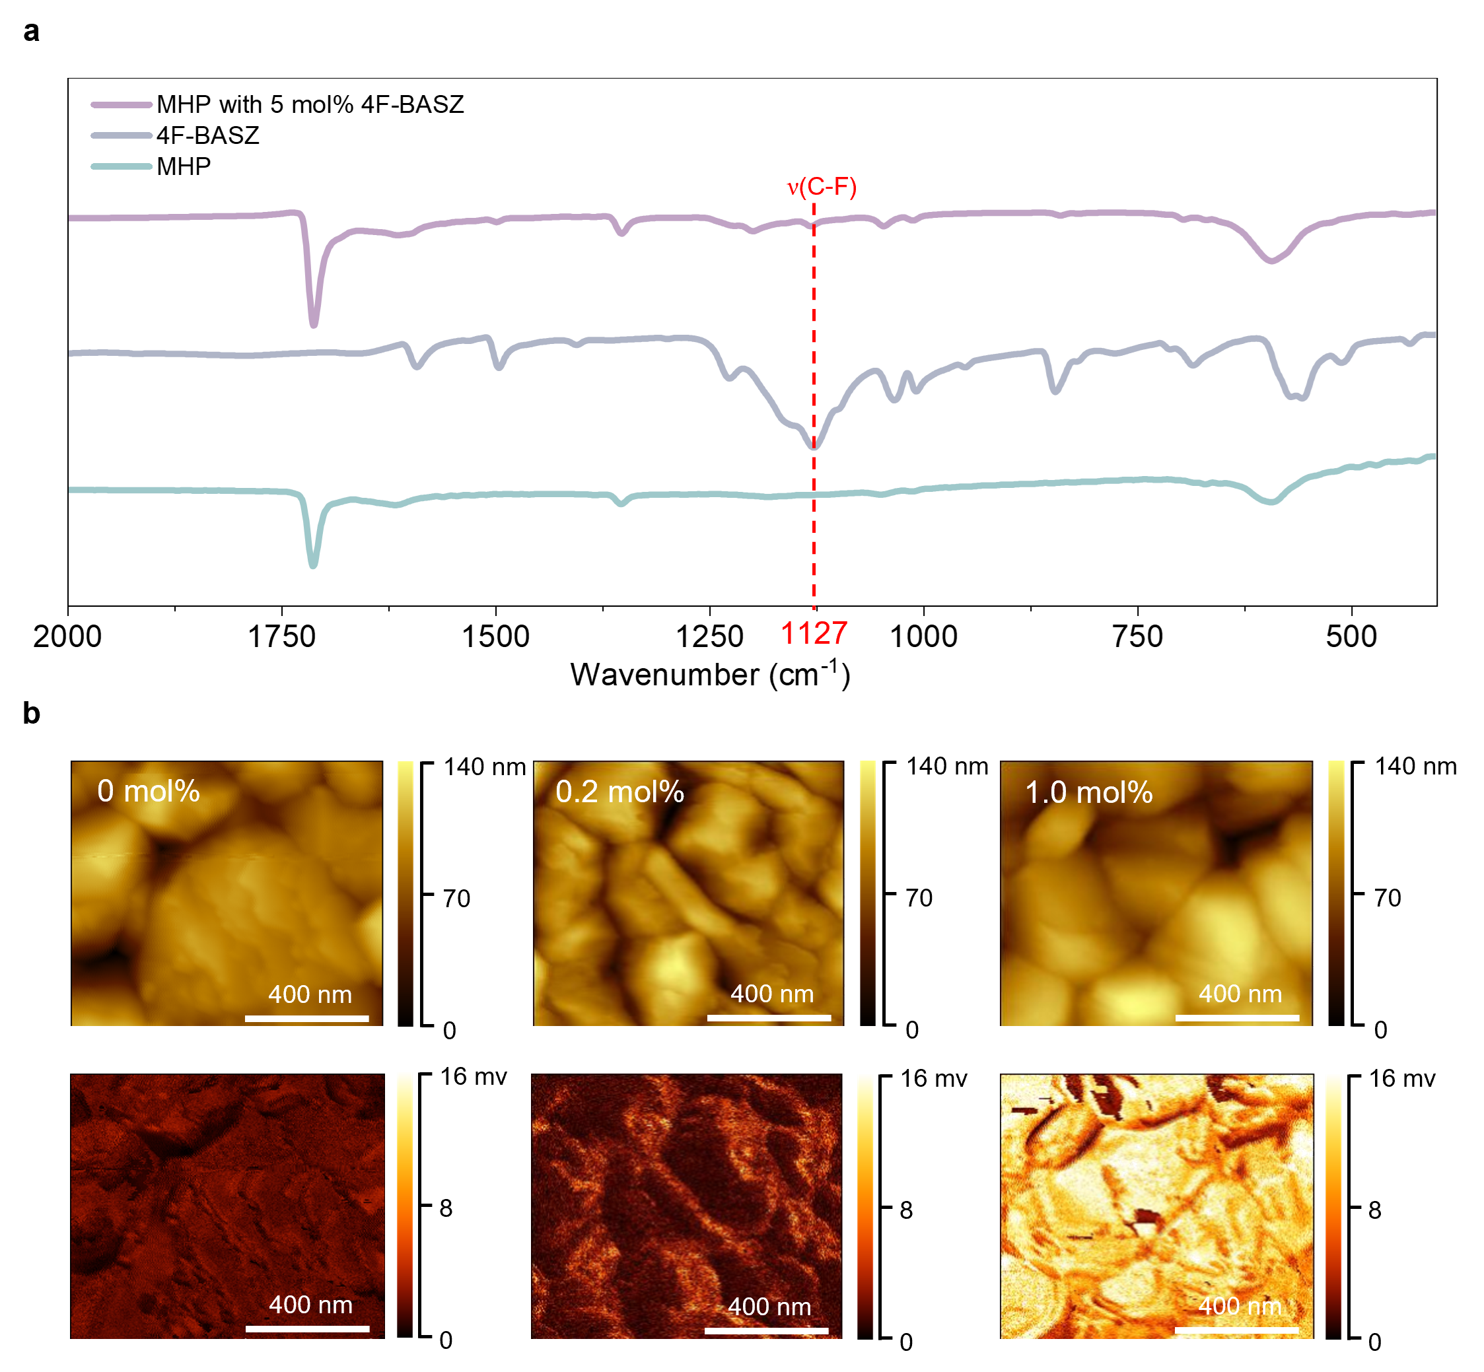
Supplementary Fig. 24. FTIR spectroscopy and nano-infrared imaging characterization of perovskite samples under different conditions. a, FTIR spectra for 4F-BASZ, pristine perovskite and perovskite+4F-BASZ. b, AFM (top) and AFM-IR (bottom) images for perovskite films with different concentrations of 4F-BASZ under the wavenumber of 1127 cm⁻¹. To investigate the distribution of 4F-BASZ in the film, this study employs AFM-IR technique by targeting the characteristic peak of the C-F stretching vibration (1127 cm⁻¹) on the aromatic ring of 4F-BASZ. When the doping concentration of 4F-BASZ is 0.2 mol%, a stronger C-F characteristic signal can be detected at the grain boundaries of perovskite, indicating that the molecules tend to accumulate at both the surface and the grain boundary regions; while when the doping concentration is increased to 1.0 mol%, 4F-BASZ can achieve uniform coverage of the entire perovskite surface, which explains the performance decrease of solar cells.
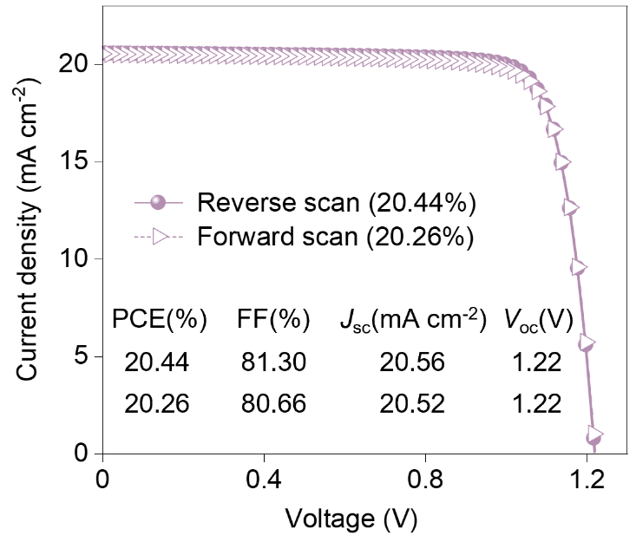
Supplementary Fig. 25. J-V curves of wide-bandgap (E_{g} = 1.68 eV) perovskite solar cells using the AIO ink. The measures are performed under both reverse (1.3 V to 0 V) and forward (0 V to 1.3 V) voltage scans with a step size of 20 mV and a delay time of 0.1 s.
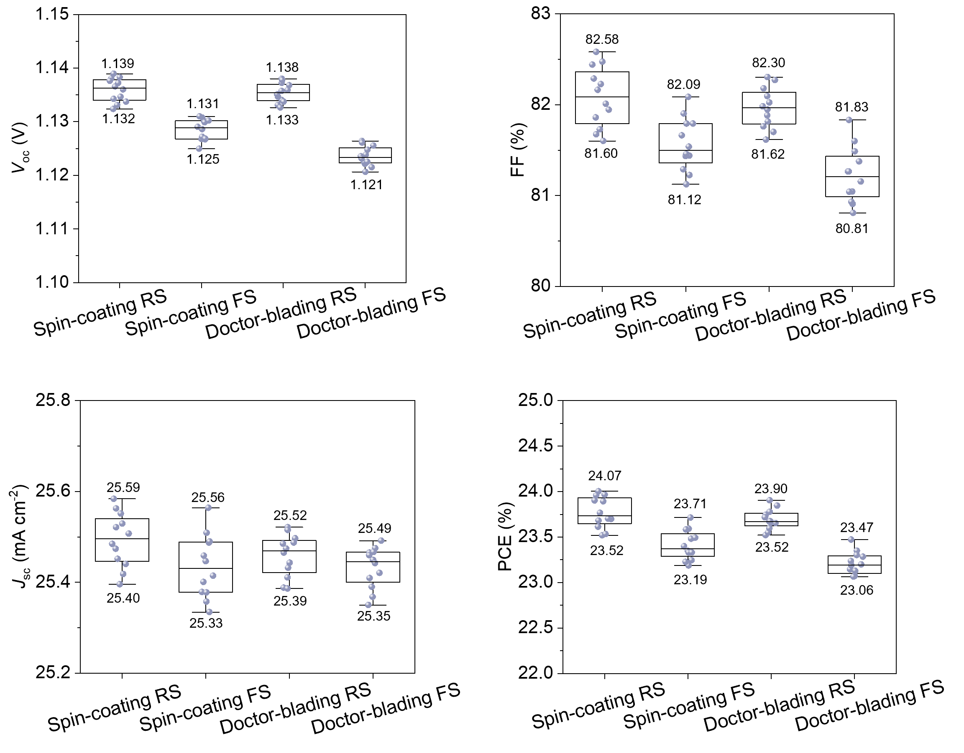
Supplementary Fig. 26. J-V statistics for spin-coated and doctor-blading small-area PSC. RS indicates reverse scan while FS indicates forward scan.
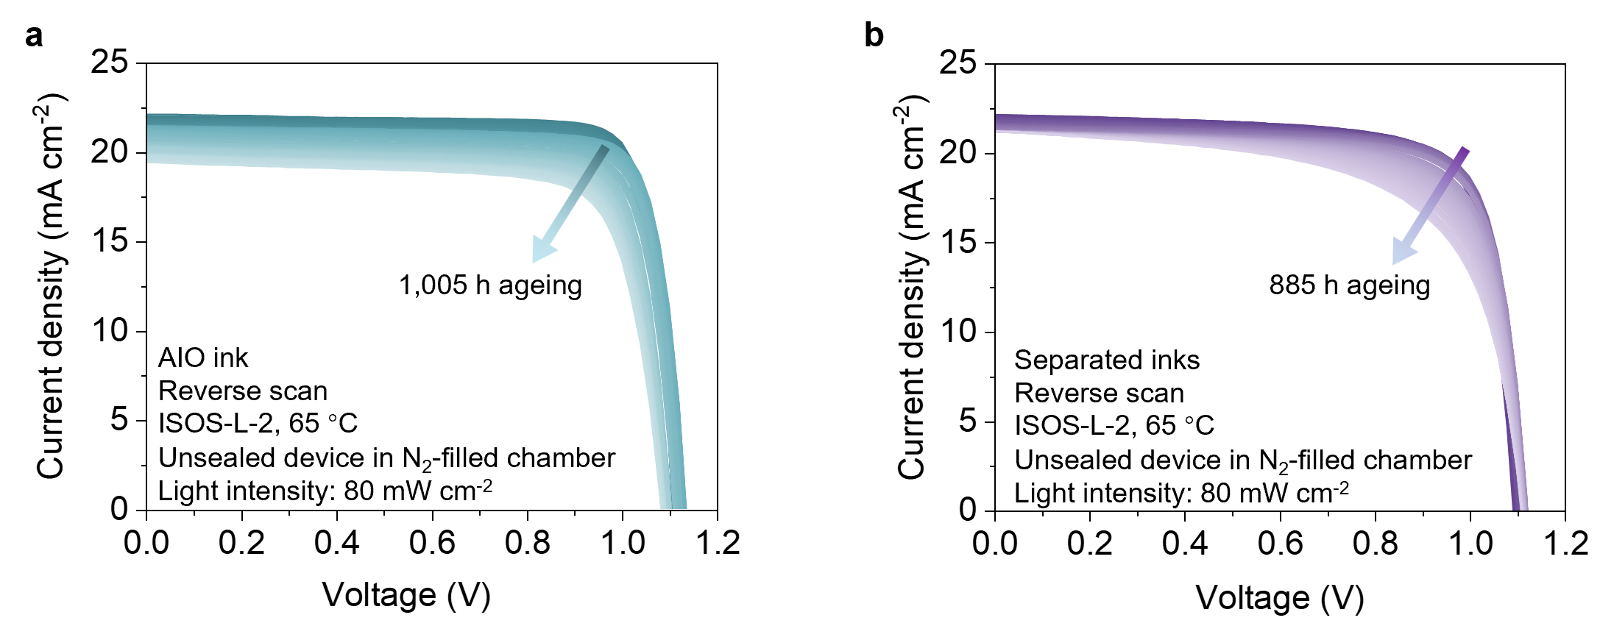
Supplementary Fig. 27. Stability test of PSCs fabricated using (a) the AIO ink and (b) separated inks. Device architectures: ITO/AIO ink (Me‑4PACz + MHP)/C₆₀/SnO₂/Ag for AIO ink; ITO/Me‑4PACz/MHP/C₆₀/SnO₂/Ag for separated inks. All stability measurements are carried out on unencapsulated devices under continuous illumination (80 mW cm⁻²) at 65 °C in an N₂ atmosphere. The measures are performed under reverse (1.2 V to 0 V) voltage scans with a step size of 20 mV and a delay time of 0.1 s.
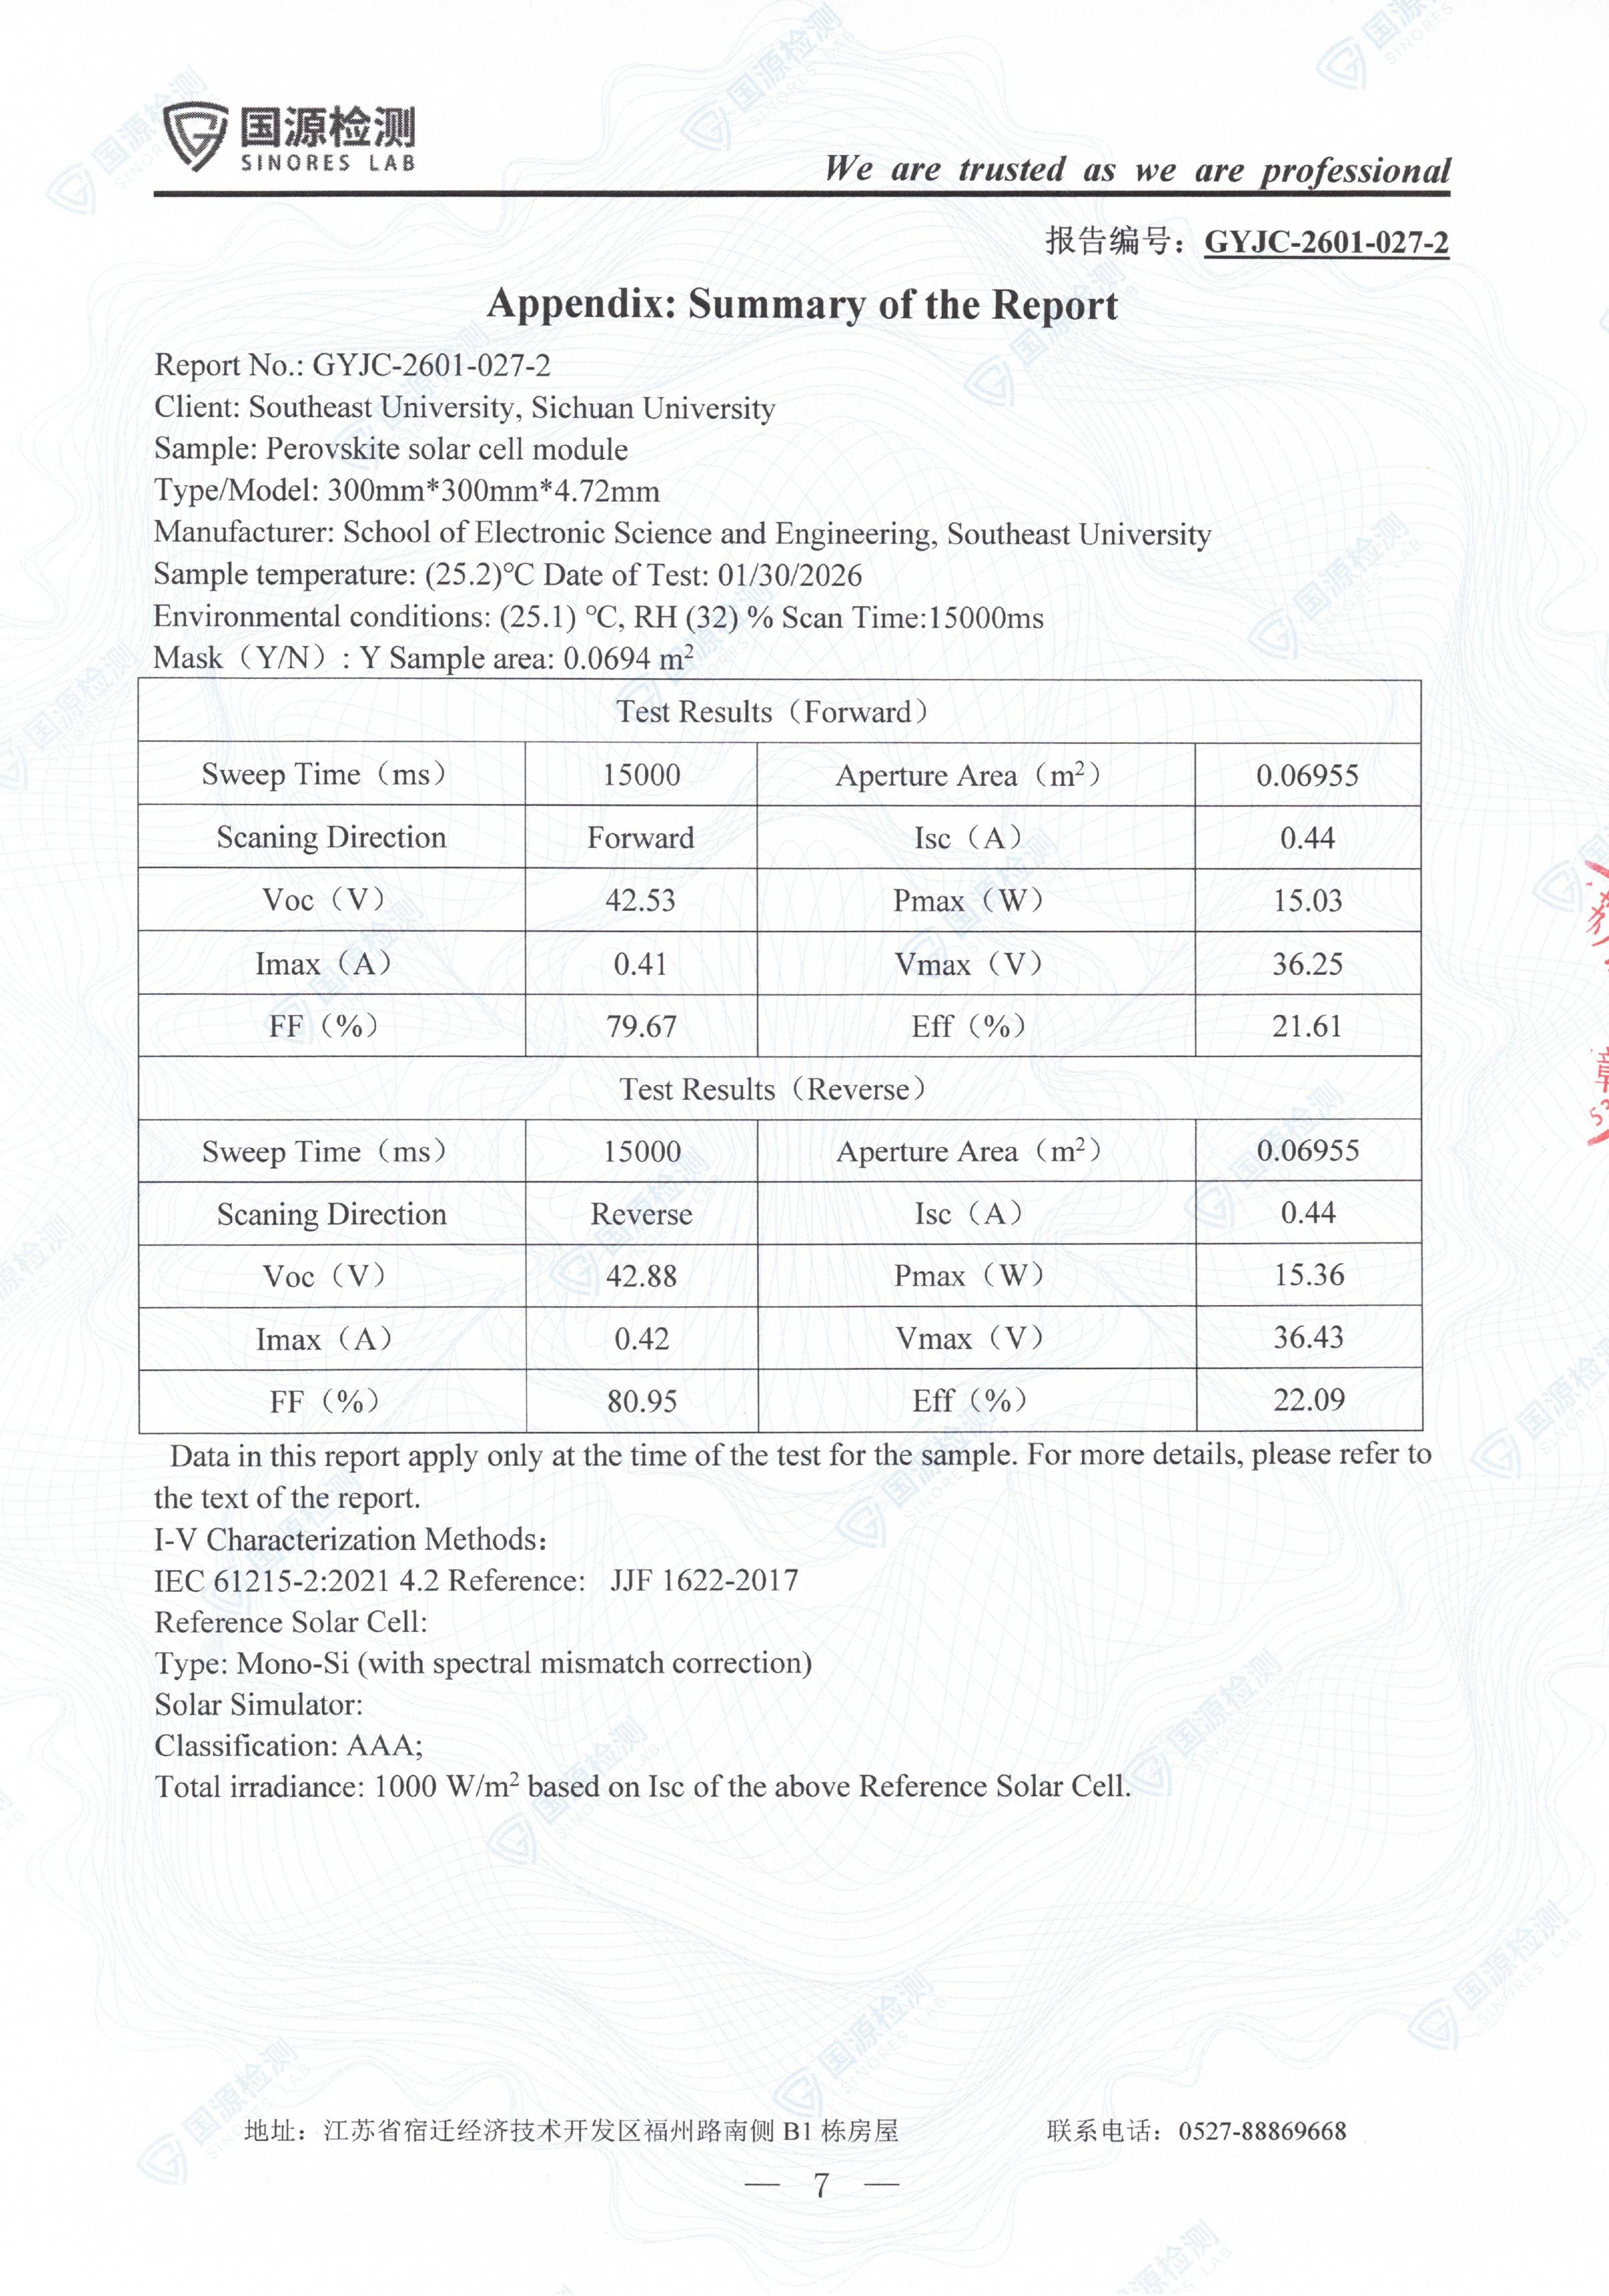
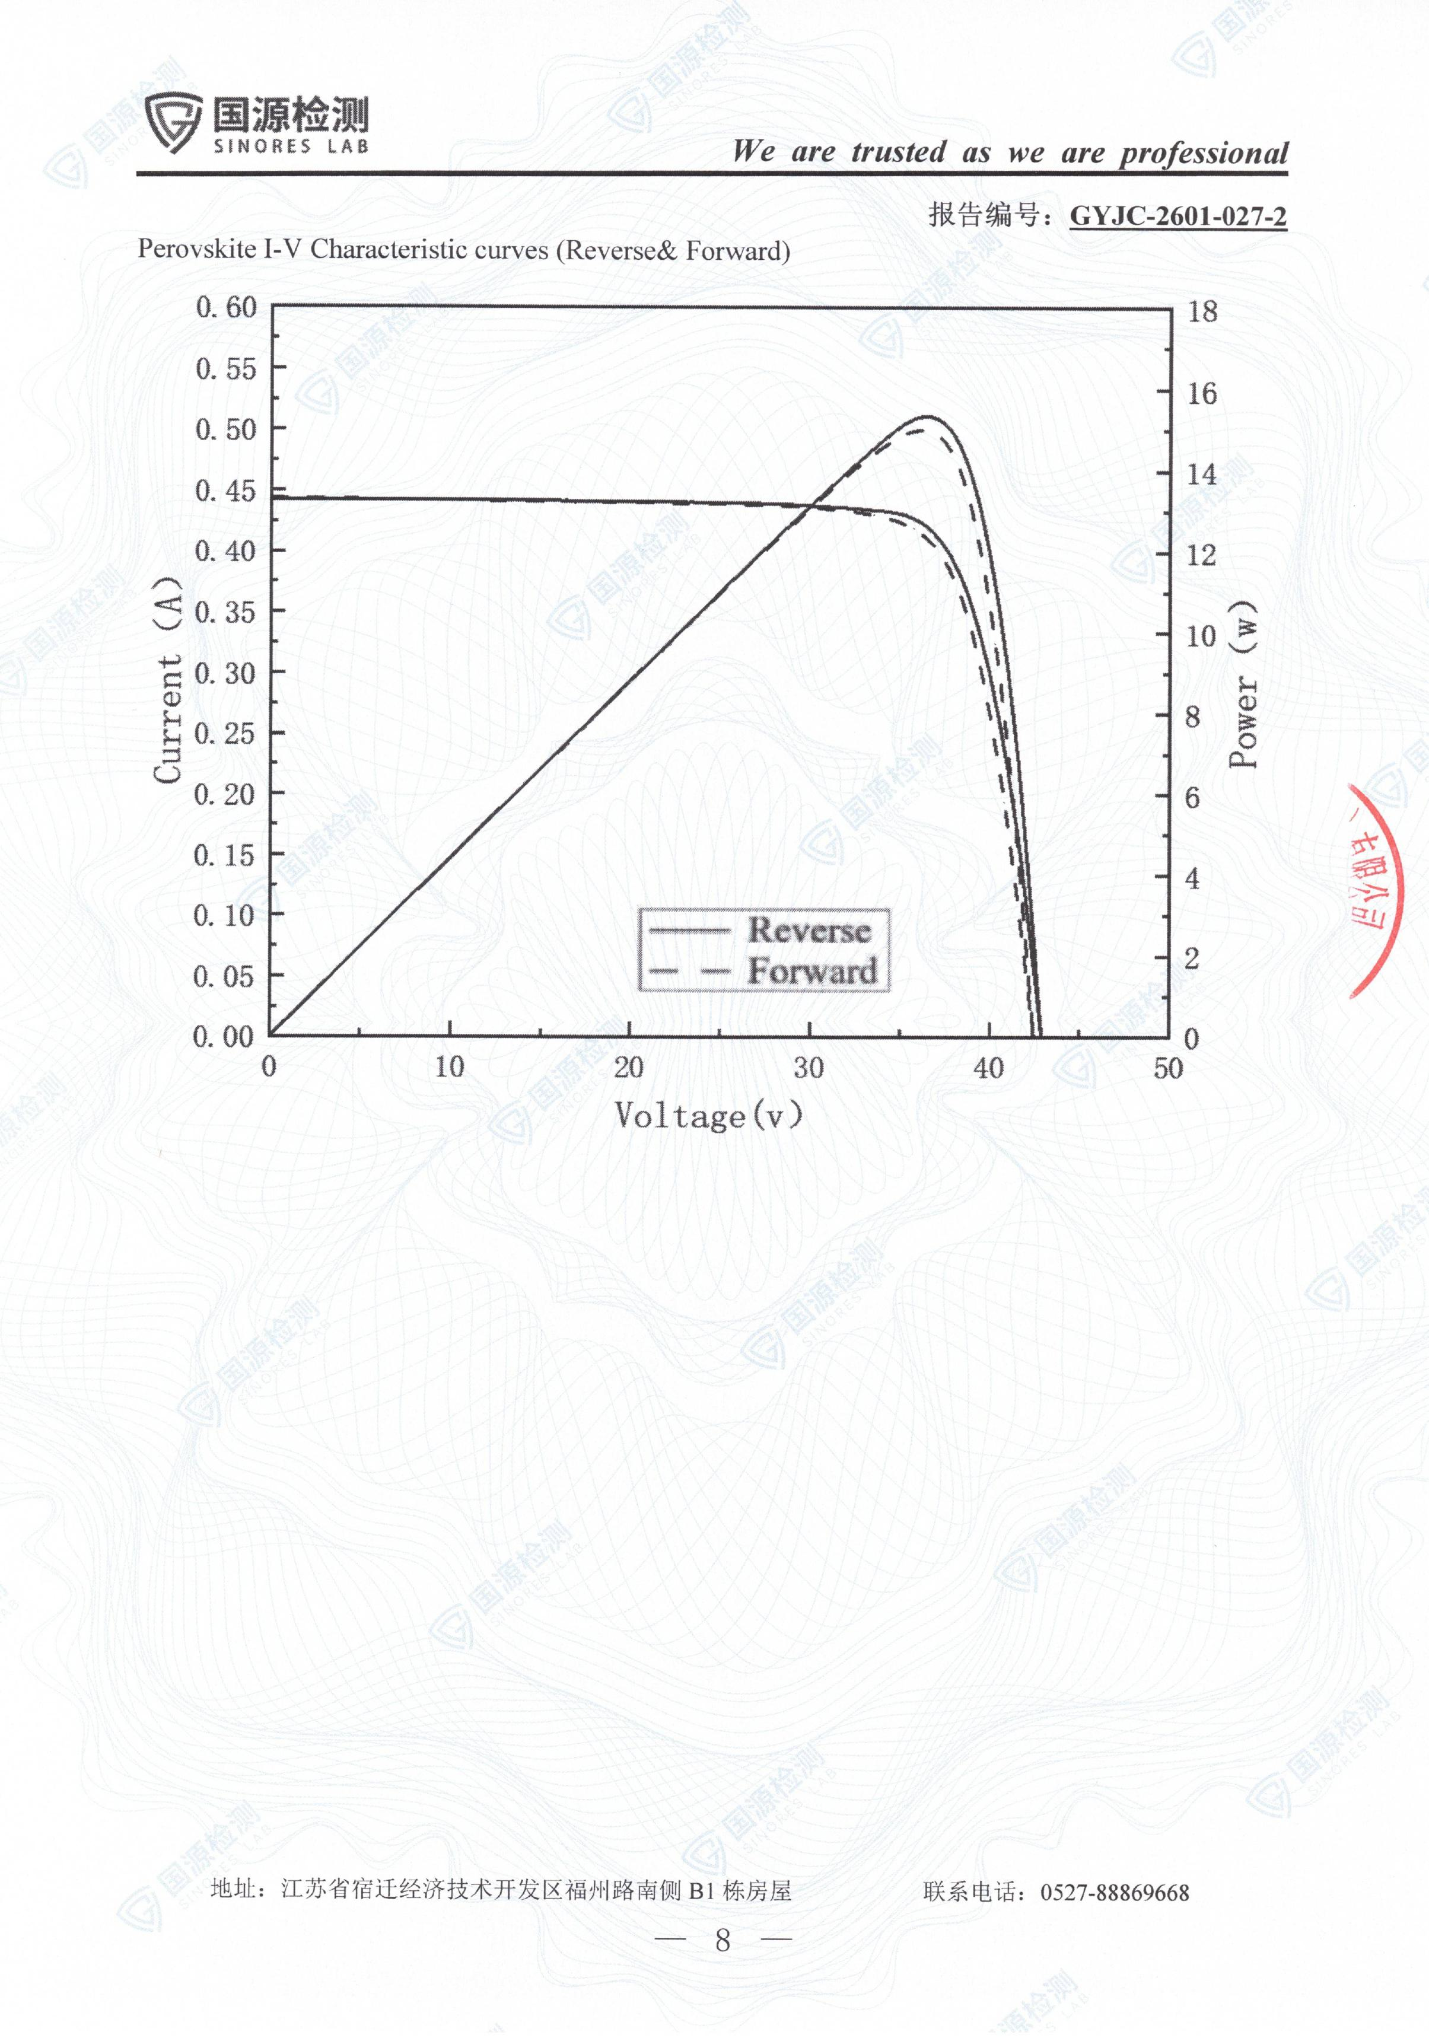
Supplementary Fig. 28. Certification report of a perovskite solar cell module made using AIO ink.

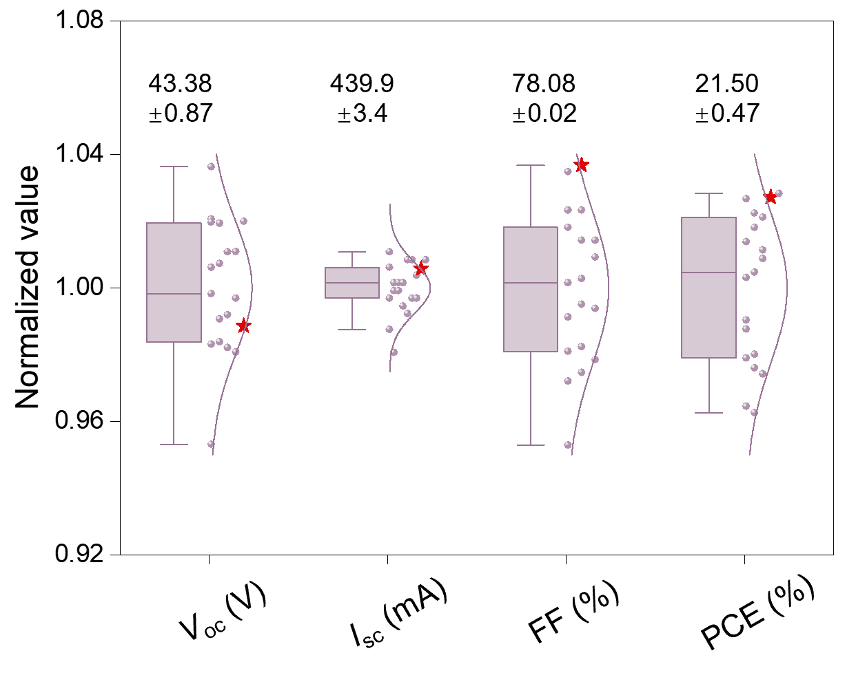
Supplementary Fig. 29. Statistical distribution of photovoltaic parameters in solar modules. The red points correspond to the I-V curve in Fig. 4d. The values of V_{OC}, J_{SC}, FF, and PCE are normalized to their respective averages.
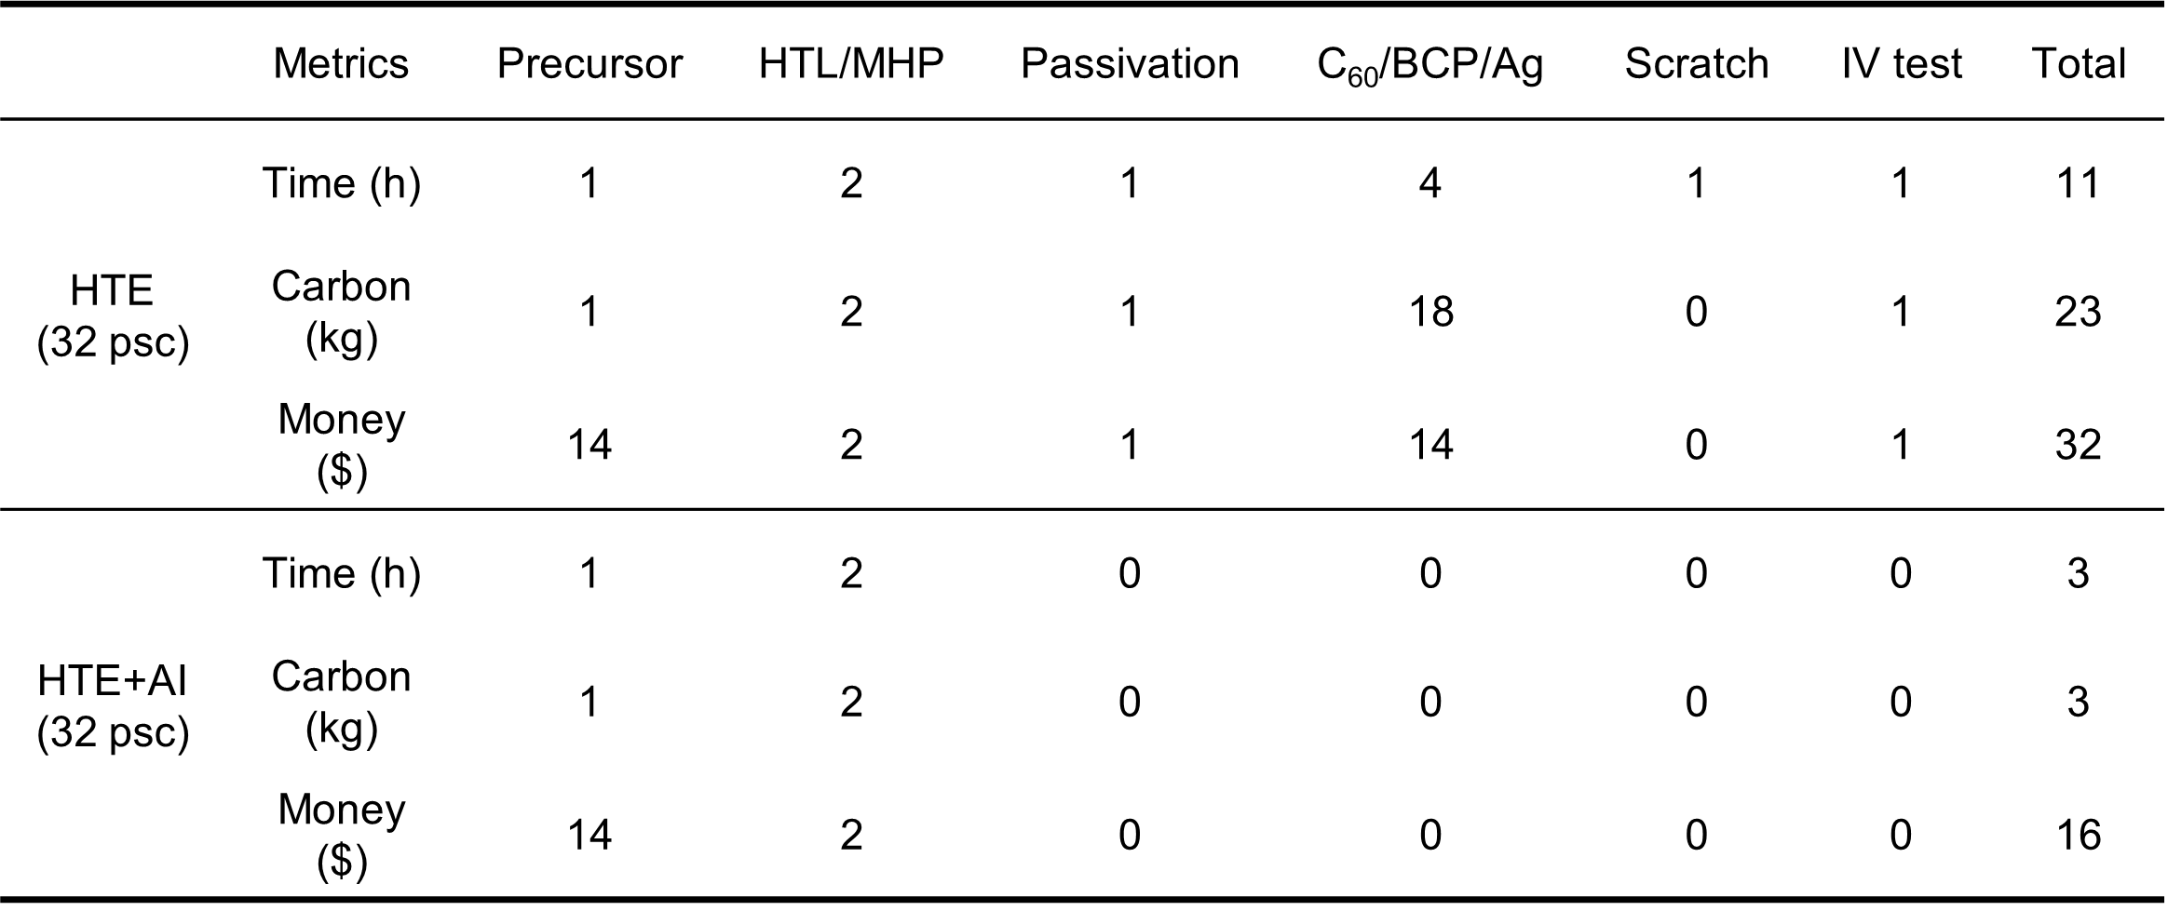
Supplementary Table. 1. Comparison of resource consumption between two methods: High-throughput experimentation (HTE) vs High-throughput experimentation enhanced with the pre-trained model (HTE+AI).

Supplementary Table. 2. Comparison of PCE in different binary solvent systems.
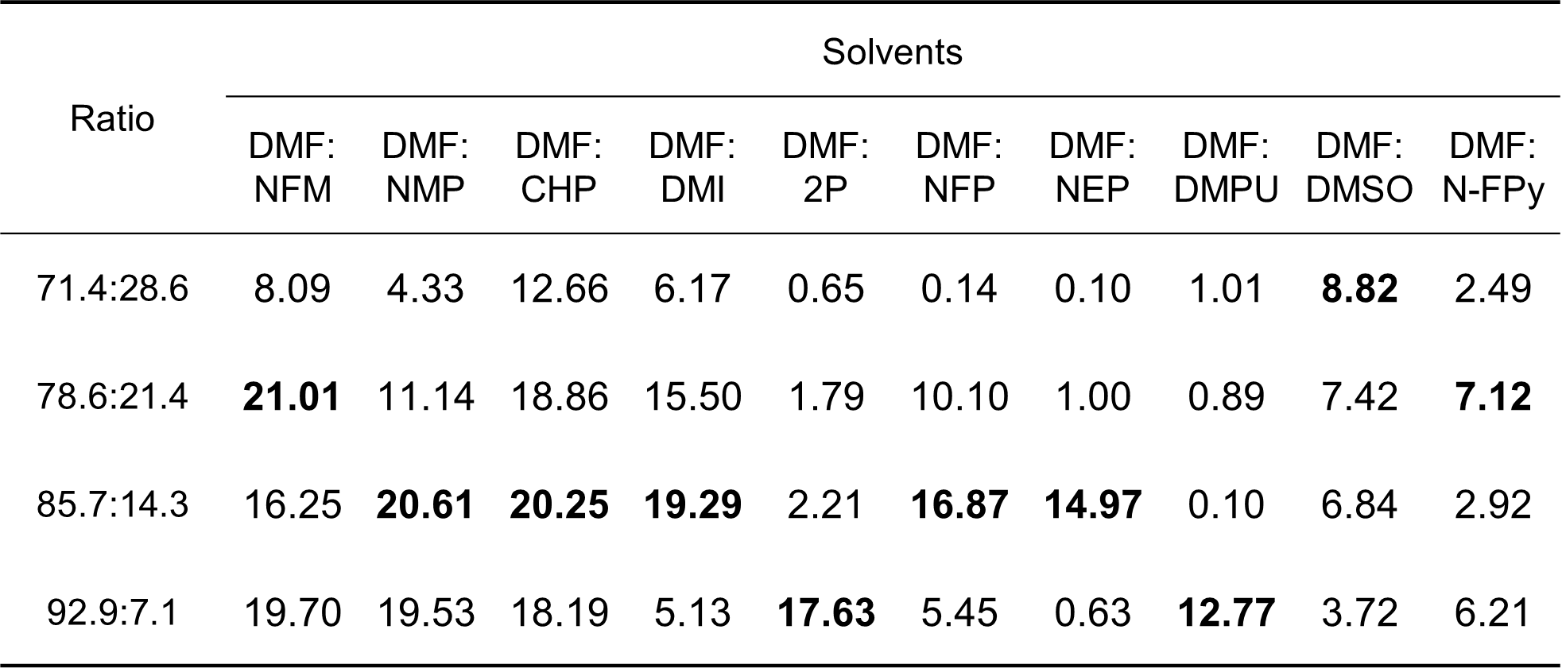
Supplementary Table. 3. Comparison of PCE in different ternary solvent systems.
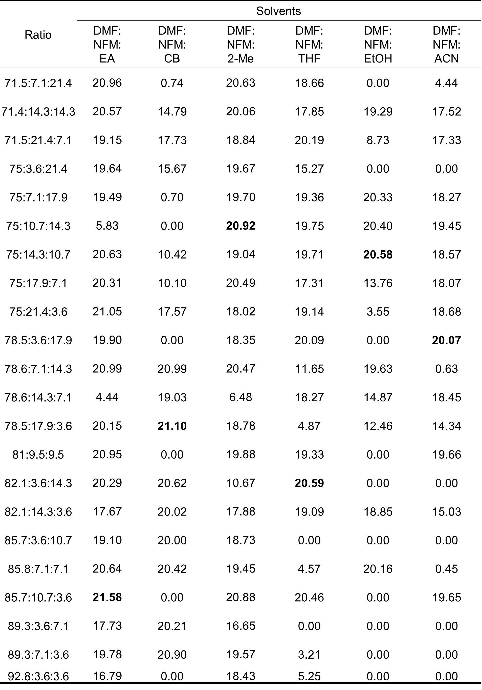
Supplementary Table. 4. Comparison of PCE for various SAMs at different gradient concentrations.
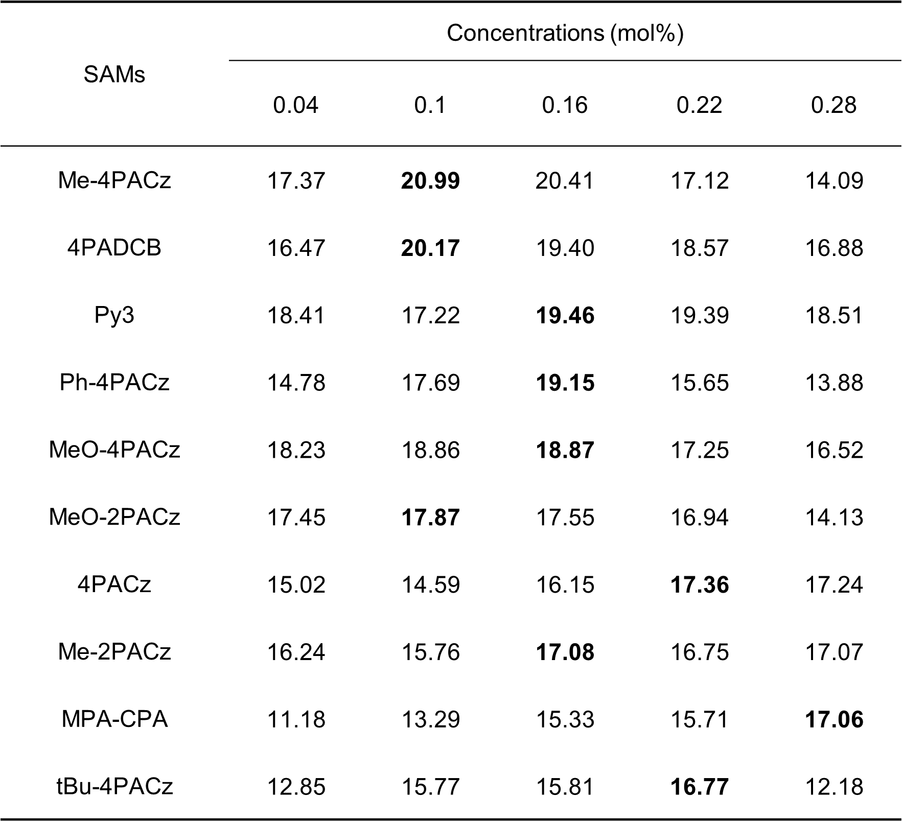
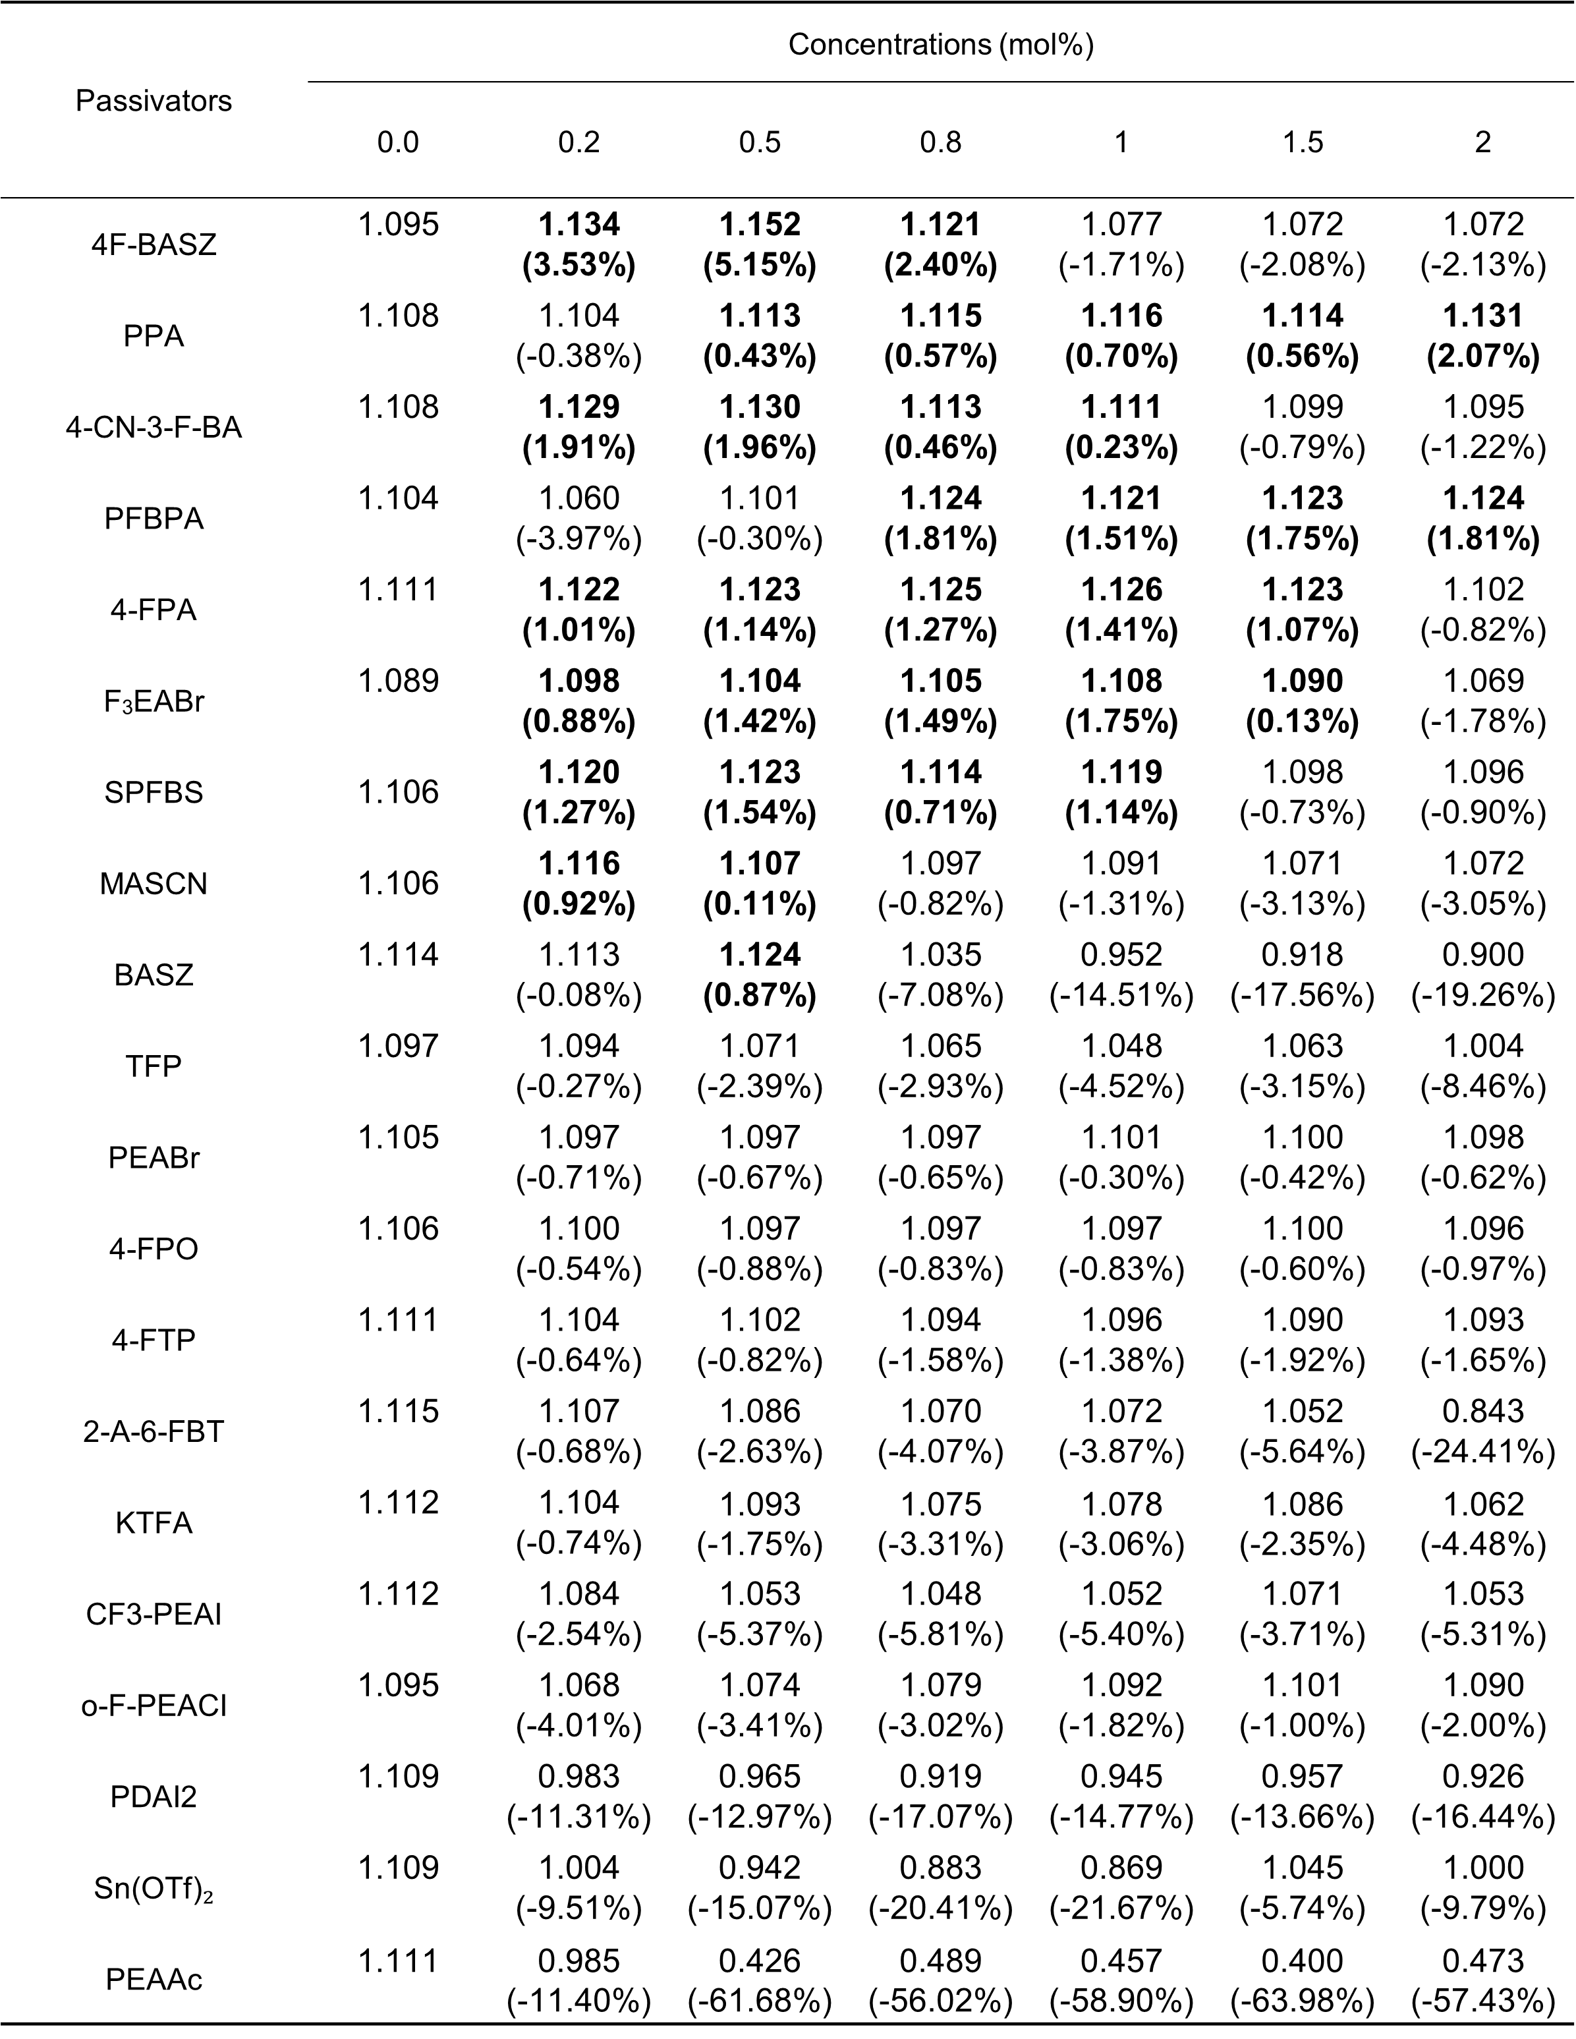
Supplementary Table. 5. Comparison of V_{OC} for various passivators at different gradient concentrations. In the table, the bold values indicate enhanced performance for V_{OC}. The numbers in parentheses represent the relative change in V_{OC} compared to the case without passivators.

Supplementary Table. 6. Comparison of FF for various passivators at different gradient concentrations. In the table, the bold values indicate enhanced performance for both V_{OC} and FF. The numbers in parentheses represent the relative change in FF compared to the case without passivators.
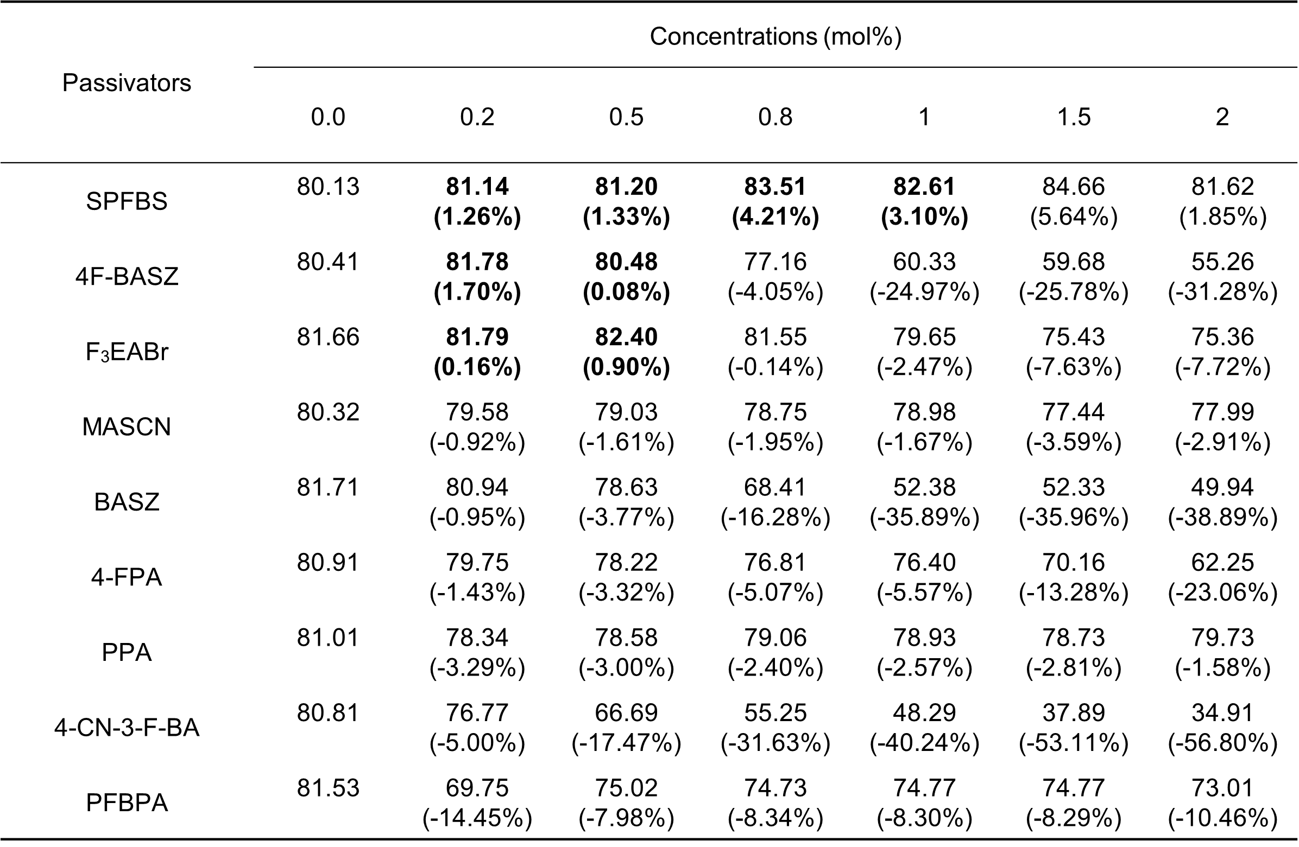

Supplementary Table. 7. Reported PCE and scaling-up loss for perovskite solar cells from small-area cells to large-area modules.
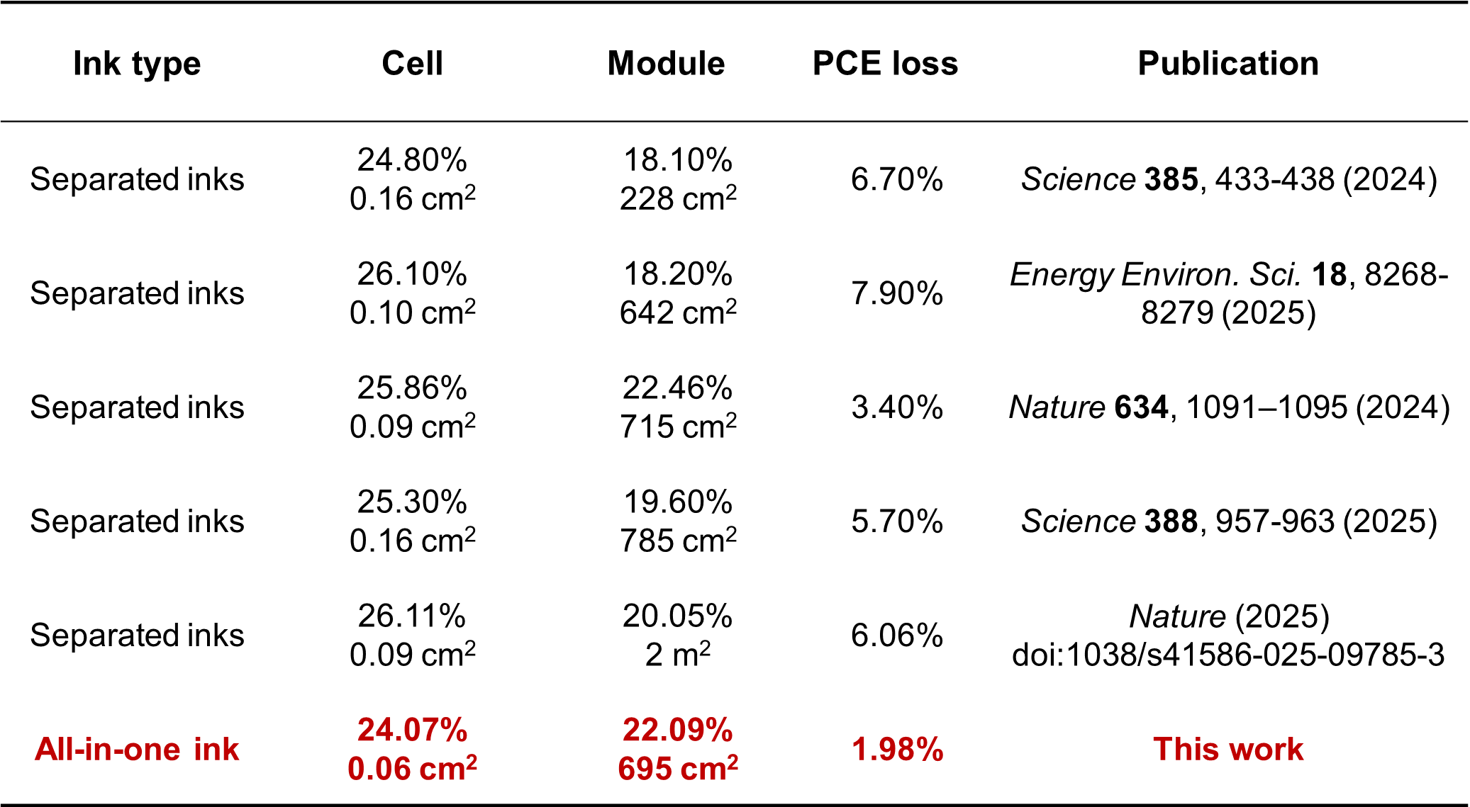

Reference
1 Sun, K. et al. Dynamic reconstruction of fluid interface manipulated by fluid balancing agent for scalable efficient perovskite solar cells. Adv. Mater. 37, 2419419 (2025).
2 Li, S. et al. In situ polymerization induced seed-root anchoring structure for enhancing stability and efficiency in perovskite solar modules. Angew. Chem. Int. Ed. 64, e202421174 (2025).
3 Xu, H. et al. Constructing robust heterointerfaces for carrier viaduct via interfacial molecular bridges enables efficient and stable inverted perovskite solar cells. Energy Environ. Sci. 16, 5792-5804 (2024).
4 Hao, C. et al. Employment of L-citrulline as an effective molecular bridge for regulating the buried interface of perovskite solar cells to achieve high efficiency and good stability. Angew. Chem. Int. Ed. 64, e202508169 (2025).
5 Zhang, J. et al. Engineering spacer conjugation for efficient and stable 2D/3D perovskite solar cells and modules. Angew. Chem. Int. Ed. 64, e202413303 (2025).
6 Urieta-Mora, J. et al. Spiro-phenothiazine hole-transporting materials: unlocking stability and scalability in perovskite solar cells. Adv. Mater. e05475 (2025).
7 Ren, Z. et al. Poly(carbazole phosphonic acid) as a versatile hole-transporting material for p-i-n perovskite solar cells and modules. Joule 7, 2894-2904 (2023).
8 Li, L. et al. Active passivation charge transport in n-i-p perovskite solar cells approaching 26% efficiency. Adv. Mater. 37, 2503903 (2025).
9 Lim, J. et al. Ultra-uniform perovskite crystals formed in the presence of tetrabutylammonium bistriflimide afford efficient and stable perovskite solar cells. Energy Environ. Sci. 17, 8209-8218 (2024).
10 Yang, Y. et al. A thermotropic liquid crystal enables efficient and stable perovskite solar modules. Nat. Energy 9, 316–323 (2024).
11 Kim, H. et al. Modulating molecular interaction of zwitterion toward rational interface engineering of perovskite solar cells. Adv. Energy Mater. 14, 2401263 (2024).
12 Guo, H. et al. In situ polymerization of cross-linked perovskite–polymer composites for highly stable and efficient perovskite solar cells. Adv. Energy Mater. 14, 2302743 (2024).
13 Sangale, S. S. et al. Colloidal ink engineering for slot-die processes to realize highly efficient and robust perovskite solar modules. Adv. Mater. 37, 2420093 (2025).
14 Guo, H. et al. Intermolecular interactions triggered crystallization phase transition regulation for efficient and stable perovskite photovoltaics. Energy Environ. Sci. 18, 7114-7123 (2025).
15 Gao, W. et al. Synergistic modulation of orientation and steric hindrance induced by alkyl chain length in ammonium salt passivator toward high-performance inverted perovskite solar cells and modules. Adv. Mater. 37, 2413304 (2025).
16 Wan, Z. et al. Efficient perovskite solar modules with an ultra-long processing window enabled by cooling stabilized intermediate phases. Energy Environ. Sci. 17, 6302-6313 (2024).
17 Li, X. et al. Modulating buried passivation and aligned interface toward high-performance perovskite modules. Adv. Funct. Mater. 35, 2506718 (2025).
18 Xu, B. et al. Reversing the reaction order between FA⁺ and Rb⁺ enhances the photovoltaic performance of blade-coated perovskite solar cells. Adv. Mater. 37, e06291 (2025).
19 Yun, S. et al. Dimensional engineering of interlayer for efficient large-area perovskite solar cells with high stability under ISOS-L-3 aging test. Sci. Adv. 11, eadp3112 (2025).
20 Chang, Q. et al. Highly efficient and stable perovskite solar modules based on FcPF₆ engineered Spiro-OMeTAD hole transporting layer. Adv. Mater. 36, 2406296 (2024).
21 Zhu, X. et al. Interfacial molecular anchor for ambient all-bladed perovskite solar modules. Joule 9, 101919 (2025).
22 Ma, M. et al. Efficient and stable perovskite solar cells and modules enabled by tailoring additive distribution according to the film growth dynamics. Nano-Micro Lett. 17, 39 (2025).
23 Zhang, Z. et al. Suppressing ion migration by synergistic engineering of anion and cation toward high-performance inverted perovskite solar cells and modules. Adv. Mater. 36, 2313860 (2024).
24 Song, H. et al. Supramolecular design principles in pseudohalides for high-performance perovskite solar mini modules. Joule 8, 2283-2303 (2024).
25 Wu, P. et al. In situ formation of high-pKa cations for perovskite solar cells. ACS Energy Lett. 9, 4526-4533 (2024).
26 Yang, W. et al. Charge polarization tunable interfaces for perovskite solar cells and modules. Adv. Mater. 37, 2502865 (2025).
27 Liu, H. et al. Simultaneous mechanical and chemical synthesis of long-range-ordered perovskites. Nat. Synth. 4, 196-208 (2024).
28 Suo, Z.-Y. et al. Organic emitters with near-unity photoluminescence to reinforce buried interface of perovskite solar cells and modules. Energy Environ. Sci. 17, 5115-5123 (2024).
29 Wang, Z. et al. Additive with multinary interactions to perovskite precursor species for catalyzed crystallization of antisolvent-free $α$-FAPbI₃ solar cells. Adv. Mater. 37, e02829 (2025).
30 Shin, Y. S. et al. Damp-heat stable and efficient perovskite solar cells and mini-modules with a tBP-free hole-transporting layer. Energy Environ. Sci. 18, 3269-3277 (2025).
31 Shao, W. et al. Tailoring perovskite surface potential and chelation advances efficient solar cells. Adv. Mater. 36, 2310080 (2024).
32 Xu, Z. et al. Double amidino-mediated multiple hydrogen-bonded Dion–Jacobson perovskites enable oriented crystallization for efficient inverted FAPbI₃ solar cells and modules (642 cm²). Energy Environ. Sci. 18, 8268-8279 (2025).
33 Wang, H. et al. Impurity-healing interface engineering for efficient perovskite submodules. Nature 634, 1091-1095 (2024).
34 Yoon, J. et al. Vapor-assisted surface reconstruction enables outdoor-stable perovskite solar modules. Science 388, 957–963 (2025).
35 Zhang, G. et al. Suppressing interfacial nucleation competition through supersaturation regulation for enhanced perovskite film quality and scalability. Sci. Adv. 10, eadl6398 (2024).
36 Sun, Y. et al. In situ coordinated HTL strategy for high-performance and scalable perovskite solar cells. Nat. Commun. 16, 9110 (2025).
37 Liang, Y. et al. A matrix-confined molecular layer for perovskite photovoltaic modules. Nature 648, 91-96 (2025).

