Decoupling exposure, risk perception, and preparedness in smallholder systems: Evidence from rural Madagascar

Jacob Emanuel Joseph*¹, Clarisse Umutoni¹, Joséa Raharison¹, Anthony M. Whitbread¹, Abdrahmane Wane¹.
1. International Livestock Research Institute (ILRI)

Household climate risk conceptual framework
The framework illustrates the relationships between climate hazards, household exposure, perceived risk, and structural preparedness capacity (Shock Readiness Index). Early warning systems are treated as a contextual information factor influencing preparedness.
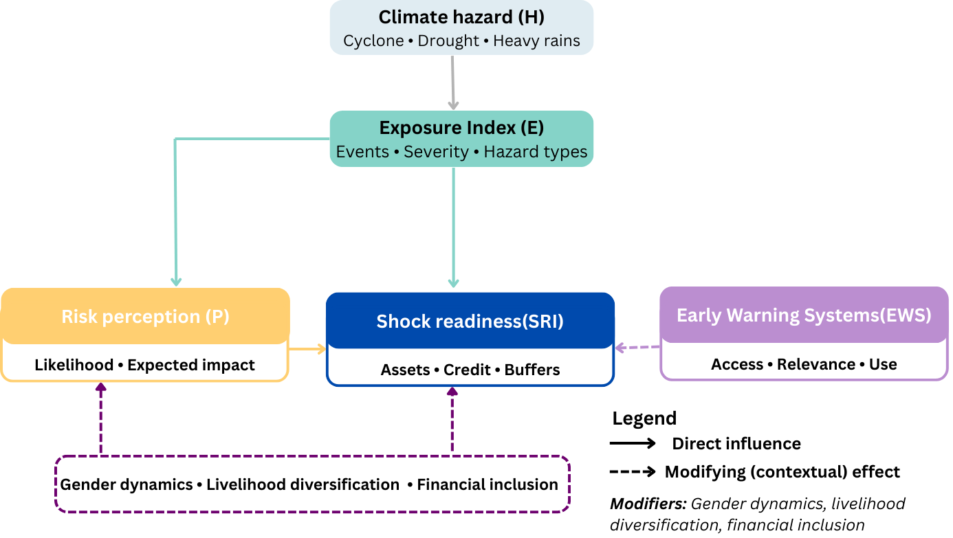
Figure S1: Conceptual framework of household climate risk pathways

Robustness check of the indices
This supplementary material provides robustness checks supporting the analytical results reported in the main manuscript. These checks evaluate the internal coherence of the composite indices, the sensitivity of the readiness index to alternative scaling, and the consistency of group differences under parametric and non-parametric testing. All findings confirm that the conclusions of the study are stable across methodological specifications.

Internal coherence of composite indices
Spearman rank correlations were computed between each component and its respective composite index (Figure S2). Results showed strong positive associations between exposure components and the Exposure Index (ρ = 0.58–0.82), as well as strong positive associations between SRI components and the composite SRI (ρ = 0.46–0.78). In contrast, perception components exhibited weak correlations with the structural indices, which are consistent with their conceptual role as cognitive rather than structural dimensions. These patterns confirm that each index captures a coherent underlying dimension of climate risk
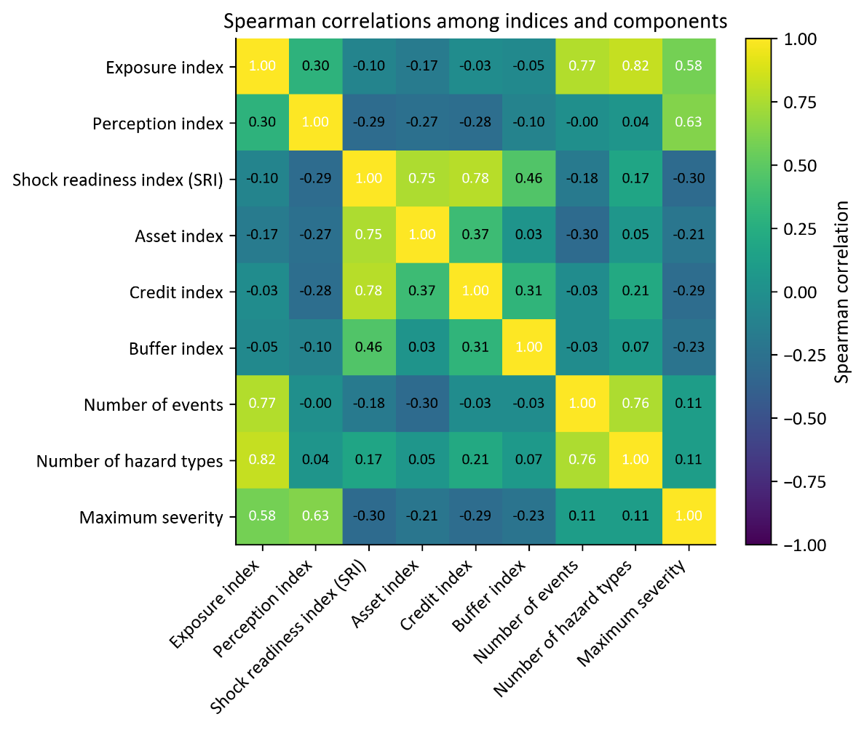
Figure S2: Spearman correlations among all index components and composite indices.

Distribution of indices by region
Supplementary Figure S3 presents histograms of Exposure, Perception, and Readiness indices by region. These illustrate the distinct hazard profiles of Sava (cyclone-exposed) and Atsimo Andrefana (drought-prone).
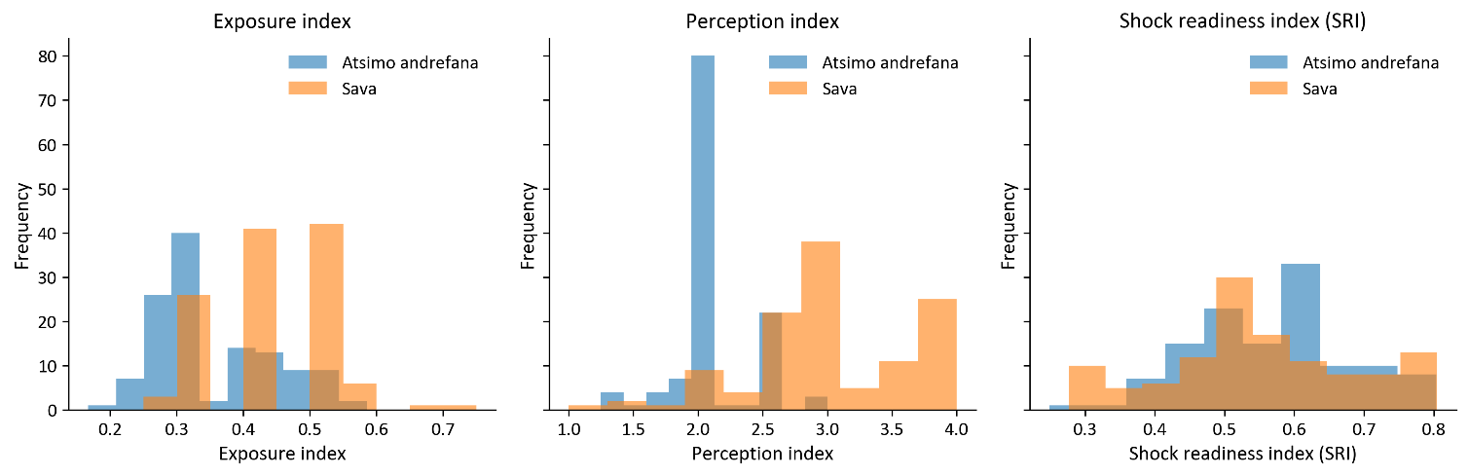
Figure S3. Distribution of Exposure, Perception, and Readiness indices by region.
Exposure distributions show distinct separation between regions, with Sava exhibiting substantially higher exposure values, consistent with its cyclone-prone environment. Perception scores display moderate overlap: although Sava shows greater variation and higher upper values, both regions share a common central tendency around 2.0. Readiness exhibits wide intra-regional variability and substantial overlap across regions, indicating that structural preparedness is influenced more by household-level socioeconomic factors than by agroecological context.

Sensitivity to scaling
To assess the sensitivity of the Structural Readiness Index (SRI) to alternative scaling, a standardized version of the index was created using z-scores of the three component variables (Asset Index, Credit Index, and Buffer Index). The correlation between the original SRI and the standardized SRI was 0.98 (Table S1), indicating that the scaling transformation produces virtually no change in the resulting household rankings.
Table S1: Pearson correlation matrix comparing the original SRI with the z-scaled SRI
 | SRI | Standardized SRI
SRI | 1 | 0.9754
Standardized SRI | 0.9754 | 1

Non-parametric group comparisons
Table S2: Mann–Whitney U tests for regional and gender differences
Comparison | Index | U | p-value | N1 | N2
Atsimo Andrefana vs Sava | Exposure index | 4993.5 | 0.000 | 123 | 120
Female-headed vs Male-headed | Exposure index | 4893.5 | 0.083 | 64 | 179
Atsimo Andrefana vs Sava | Perception index | 1447 | 0.000 | 123 | 118
Female-headed vs Male-headed | Perception index | 6251.5 | 0.163 | 63 | 178
Atsimo Andrefana vs Sava | SRI | 8146.5 | 0.161 | 123 | 120
Female-headed vs Male-headed | SRI | 6189.5 | 0.336 | 64 | 179
Note: The full analytic sample consists of 245 households. Sample sizes vary slightly across analyses (e.g., n = 243 for exposure and SRI and n = 241 for perception) due to item-level missing responses for specific variables. All statistics are calculated using available observations for each measure.
Non-parametric Mann–Whitney U tests were conducted as a robustness check to assess whether the regional and gender differences observed in the main manuscript were sensitive to distributional assumptions (Table S2). The results were consistent with the parametric analyses: regional differences in exposure and perception remained highly significant, while readiness (SRI) showed no significant regional difference. Gender comparisons were non-significant across all indices. These findings confirm that the main conclusions are robust to violations of normality and hold under both parametric and non-parametric testing approaches.

Household characteristics, livelihood, credit access
Table S3: Key household demographic characteristics in Atsimo Andrefana and Sava regions.
Indicator | Atsimo Andrefana | Sava |  | t |  | p
Household size | 5.00 |  | 4.00 |  | −6.24 |  | 0.0000
Dependency ratio | 0.74 |  | 0.58 |  | −3.88 |  | 0.0001
Mean years of education | 4.00 |  | 6.00 |  | 5.85 |  | 0.0000
Proportion female-headed households | 0.54 |  | 0.52 |  | −0.57 |  | 0.57

Table S4: Households (%) accessing each credit source, by region and household headship.
Region | Household | Bank | Community Savings/Credit Group | Family/ Friends | Microfinance Institution  (MFI) | Shopkeeper credit (input/food) | Other
Atsimo Andrefana | Male-HH | 5 | 16 | 57 | 12 | 7 | 3
Atsimo Andrefana | Female-HH | 19 | 13 | 50 | 13 | 0 | 6
Sava | Male-HH | 10 | 3 | 51 | 13 | 23 | 0
Sava | Female-HH | 0 | 5 | 74 | 16 | 5 | 0

Exposure and perception indices by region and gender
Table S5: Group statistics and pairwise comparisons for the Exposure and Perception indices by region and household headship.
A. Exposure index: group descriptive statistics
Region | HH Type | Mean | SD | 95% CI
Atsimo Andrefana | Male | 0.3612 | 0.0936 | (0.3423, 0.3801)
Atsimo Andrefana | Female | 0.3465 | 0.0838 | (0.3159, 0.3771)
Sava | Male | 0.4482 | 0.0875 | (0.4296, 0.4669)
Sava | Female | 0.4128 | 0.0733 | (0.3885, 0.4371)

B. Exposure index: Welch t-tests and effect sizes
Comparison | t | p-value | Cohen’s d
Atsimo – Male vs Female | 0.805 | 0.4247 | 0.161
Atsimo – Male vs Sava – Male | –6.424 | <0.001 | –0.958
Atsimo – Male vs Sava – Female | –3.285 | 0.0015 | –0.582
Atsimo – Female vs Sava – Male | –5.581 | <0.001 | –1.175
Atsimo – Female vs Sava – Female | –3.335 | 0.0015 | –0.848
Sava – Male vs Female | 2.266 | 0.0263 | 0.423

C. Perception index: group descriptive statistics
Region | HH Type | Mean | SD | 95% CI
Atsimo Andrefana | Male | 2.0444 | 0.3111 | (1.9815, 2.1073)
Atsimo Andrefana | Female | 2.1494 | 0.2648 | (2.0531, 2.2457)
Sava | Male | 3.0407 | 0.6822 | (2.8959, 3.1856)
Sava | Female | 2.9853 | 0.5399 | (2.8049, 3.1657)
D. Perception index: Welch t-tests and effect sizes
Comparison | t | p-value | Cohen’s d
Atsimo – Male vs Female | –1.788 | 0.0793 | –0.349
Atsimo – Male vs Sava – Male | –12.353 | <0.001 | –1.911
Atsimo – Male vs Sava – Female | –9.602 | <0.001 | –2.448
Atsimo – Female vs Sava – Male | –10.032 | <0.001 | –1.472
Atsimo – Female vs Sava – Female | –7.973 | <0.001 | –1.918
Sava – Male vs Female | 0.467 | 0.6416 | 0.086

E. SRI: descriptive statistics
Region | HH type | Mean | SD | 95% CI
Atsimo Andrefana | Female-headed | 0.60 | 0.15 | (0.545,0.646)
Atsimo Andrefana | Male-headed | 0.53 | 0.13 | (0.504,0.559)
Sava | Female-headed | 0.55 | 0.09 | (0.519,0.586)
Sava | Male-headed | 0.58 | 0.12 | (0.552,0.601)

F. SRI: Welch t-tests by region and gender
Comparison | Group 1 | Group 2 | Region(s) Compared | t | p | Cohen’s d
Within | Male-headed | Female-headed | Atsimo Andrefana | –1.567 | 0.12 | –0.317
Within | Male-headed | Female-headed | Sava | 0.904 | 0.37 | 0.162
Across | Male-headed (Atsimo) | Male-headed (Sava) | Atsimo Andrefana vs Sava | –2.369 | 0.02 | –0.357
Across | Female-headed (Atsimo) | Female-headed (Sava) | Atsimo Andrefana vs Sava | 1.382 | 0.17 | 0.332

Multivariate predictors of perceived risk and shock readiness
Table S6: Multivariate OLS models predicting perceived risk and shock readiness
A. Multivariate OLS model predicting perceived risk
Term | Coef | Std Err | t | p | 95% CI
Intercept | 1.679 | 0.142 | 11.843 | <0.001 | (1.400, 1.958)
Region | 0.8542 | 0.07 | 12.201 | <0.001 | (0.716, 0.992)
HH Type | –0.0558 | 0.072 | –0.771 | 0.441 | (–0.198, 0.087)
Exposure Index | 1.2007 | 0.364 | 3.295 | 0.001 | (0.483, 1.919)
Model fit: R² = 0.505, Adj. R² = 0.499, n = 243.
B. Multivariate OLS model predicting Shock Readiness Index (SRI)
Term | Coef | Std Err | t | p | 95% CI
Intercept | 0.7315 | 0.044 | 16.519 | <0.001 | (0.644, 0.819)
Region | 0.0457 | 0.022 | 2.038 | 0.043 | (0.002, 0.089)
HH Type | –0.0223 | 0.018 | –1.245 | 0.214 | (–0.058, 0.013)
Exposure Index | 0.0063 | 0.009 | 0.673 | 0.502 | (–0.012, 0.024)
Perceived Risk | –0.0796 | 0.016 | –4.960 | <0.001 | (–0.110, –0.048)
Model fit: R² = 0.107, Adj. R² = 0.092, n = 243.

Early warning access and household shock readiness

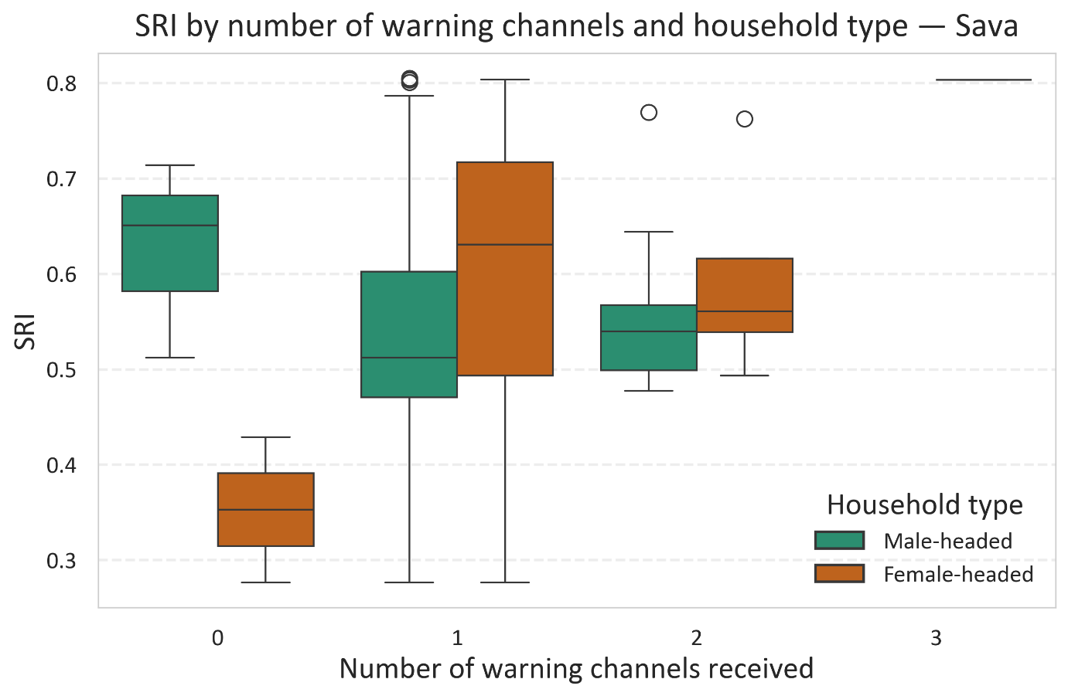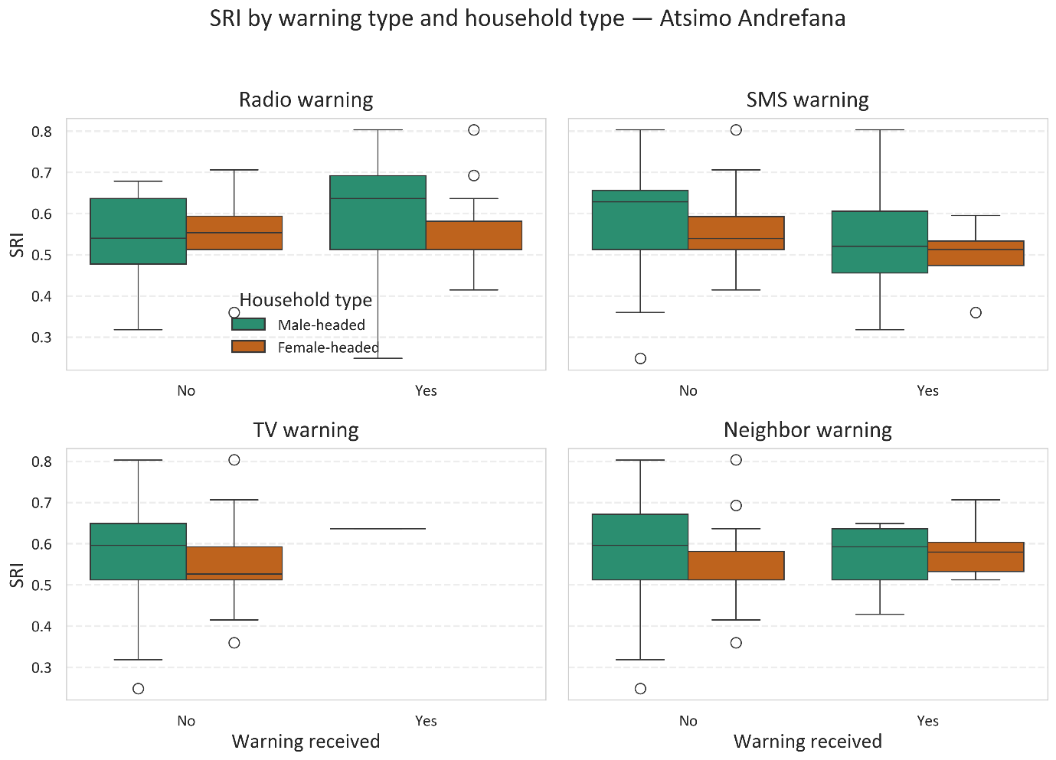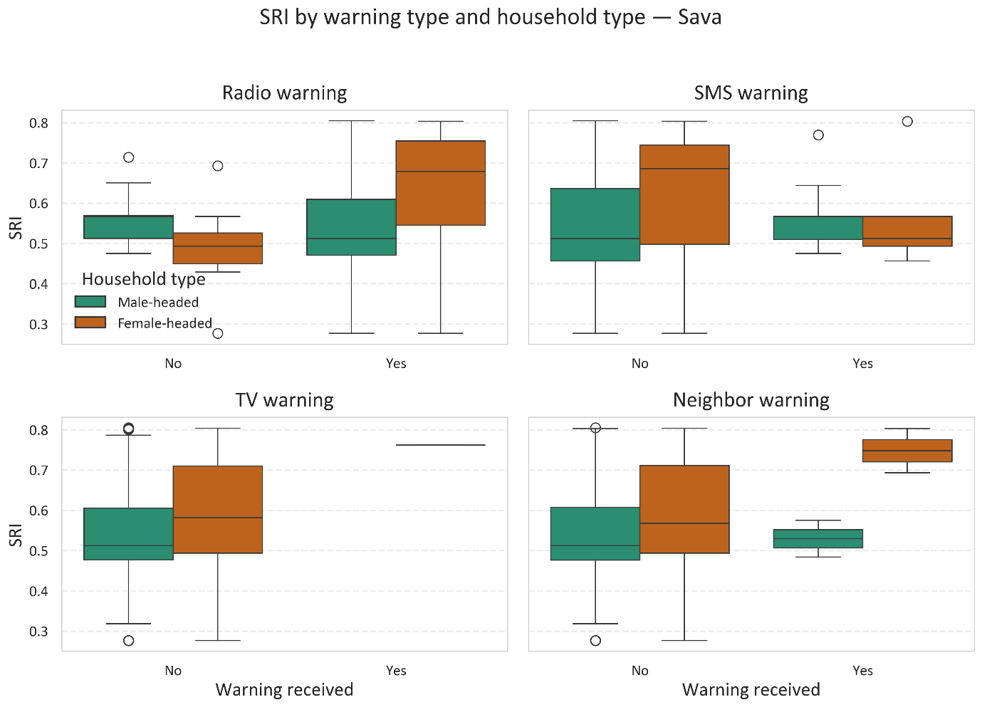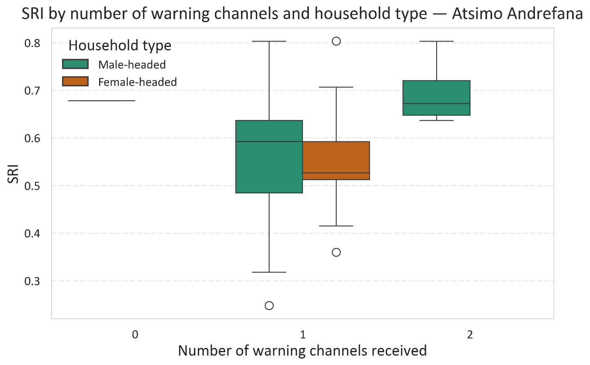
Figure S4. Early warning access and household SRI in different regions.

Table S7: Descriptive and regression results for early warning access and household shock readiness, including SRI by warning type, household headship, number of channels, and multivariate models.
A: Shock Readiness Index (SRI) by warning type, region, and receipt
Warning type | Region | Received | n | Mean | SD | 95% CI
Radio | Sava | Yes | 99 | 0.55 | 0.146 | (0.524, 0.583)
Radio | Sava | No | 21 | 0.53 | 0.093 | (0.491, 0.576)
Radio | Atsimo Andrefana | Yes | 80 | 0.59 | 0.123 | (0.559, 0.613)
Radio | Atsimo Andrefana | No | 43 | 0.54 | 0.094 | (0.513, 0.570)
SMS | Sava | Yes | 29 | 0.55 | 0.078 | (0.520, 0.579)
SMS | Sava | No | 91 | 0.55 | 0.153 | (0.518, 0.582)
SMS | Atsimo Andrefana | Yes | 20 | 0.52 | 0.122 | (0.465, 0.579)
SMS | Atsimo Andrefana | No | 103 | 0.58 | 0.112 | (0.558, 0.602)
Neighbour | Sava | Yes | 4 | 0.64 | 0.139 | (0.418, 0.860)
Neighbour | Sava | No | 116 | 0.55 | 0.138 | (0.521, 0.572)
Neighbour | Atsimo Andrefana | Yes | 25 | 0.57 | 0.076 | (0.541, 0.604)
Neighbour | Atsimo Andrefana | No | 98 | 0.57 | 0.123 | (0.545, 0.595)

B: SRI by warning type, household headship, and warning receipt
Warning type | Household type | Received | n | mean | SD | 95% CI
Radio | Male Headed | Yes | 135 | 0.56 | 0.136 | (0.535,0.582)
Radio | Male Headed | No | 44 | 0.54 | 0.089 | (0.517,0.571)
Radio | Female Headed | Yes | 44 | 0.60 | 0.135 | (0.556,0.639)
Radio | Female Headed | No | 20 | 0.53 | 0.102 | (0.481,0.576)
SMS | Male Headed | Yes | 36 | 0.54 | 0.099 | (0.507,0.574)
SMS | Male Headed | No | 143 | 0.56 | 0.132 | (0.536,0.58)
SMS | Female Headed | Yes | 13 | 0.53 | 0.101 | (0.472,0.593)
SMS | Female Headed | No | 51 | 0.59 | 0.134 | (0.549,0.625)
Neighbour | Male Headed | Yes | 19 | 0.56 | 0.079 | (0.526,0.602)
Neighbour | Male Headed | No | 160 | 0.55 | 0.131 | (0.533,0.574)
Neighbour | Female Headed | Yes | 10 | 0.62 | 0.095 | (0.548,0.683)
Neighbour | Female Headed | No | 54 | 0.57 | 0.134 | (0.532,0.605)

C: One-way ANOVA for number of channels
 | SS | df | F | PR(>F)
C(number of channels) | 0.0229 | 2 | 0.7129 | 0.4912
Residual | 3.8307 | 239
Effect size: η² = 0.006 (very small)
D: SRI by number of early warning channels (pooled sample)
N channels | n | mean | SD | 95% CI
0 | 6 | 0.54 | 0.170 | (0.365,0.722)
1 | 216 | 0.56 | 0.127 | (0.540,0.574)
2 | 20 | 0.59 | 0.101 | (0.544,0.638)
3 | 1 | 0.80

E: SRI by number of early warning channels (region-specific)
Region | N channels | n | mean | SD | 95% CI
Atsimo Andrefana | 0 | 1 | 0.68
Atsimo Andrefana | 1 | 118 | 0.57 | 0.114 | (0.545,0.586)
Atsimo Andrefana | 2 | 4 | 0.70 | 0.075 | (0.576,0.816)
Sava | 0 | 5 | 0.52 | 0.175 | (0.300,0.734)
Sava | 1 | 98 | 0.55 | 0.142 | (0.518,0.575)
Sava | 2 | 16 | 0.57 | 0.090 | (0.517,0.613)
Sava | 3 | 1 | 0.80

F: Multivariate OLS model predicting SRI
 | Coef | Std Error | p | 95% CI
const | 0.692 | 0.050 | 0.000 | (0.593,0.791)
Exposure index | 0.047 | 0.093 | 0.611 | (-0.135,0.23)
Perception score | -0.076 | 0.016 | 0.000 | (-0.108,-0.044)
Number of channels | 0.035 | 0.023 | 0.125 | (-0.01,0.08)
Region | 0.041 | 0.022 | 0.069 | (-0.003,0.085)
Household type | -0.023 | 0.018 | 0.195 | (-0.059,0.012)

G: Multivariate OLS model predicting SRI (warning types)
 | Coeff | Std Error | p | 95% CI
const | 0.673 | 0.051 | 0.000 | (0.573,0.773)
Exposure index | 0.011 | 0.095 | 0.910 | (-0.176,0.198)
Perception score | -0.074 | 0.016 | 0.000 | (-0.106,-0.042)
Number of channels | 0.151 | 0.087 | 0.083 | (-0.02,0.321)
Radio | -0.084 | 0.087 | 0.335 | (-0.254,0.087)
SMS | -0.139 | 0.087 | 0.110 | (-0.31,0.032)
Neighbour | -0.074 | 0.089 | 0.404 | (-0.25,0.101)
Region | 0.046 | 0.023 | 0.044 | (0.001,0.09)
Household type | -0.021 | 0.018 | 0.240 | (-0.056,0.014)

H: Multivariate OLS model predicting SRI (channels × region interaction)
 | Coeff | Std Error | p | 95% CI
const | 0.668 | 0.073 | 0.000 | (0.525,0.811)
Exposure index | 0.047 | 0.093 | 0.612 | (-0.136,0.230)
Perception score | -0.075 | 0.016 | 0.000 | (-0.107, -0.043)
Number of channels | 0.058 | 0.055 | 0.293 | (-0.05,0.166)
Region | 0.069 | 0.065 | 0.296 | (-0.06,0.198)
Household type | -0.024 | 0.018 | 0.190 | (-0.059,0.012)
Channel-region | -0.027 | 0.06 | 0.650 | (-0.146,0.091)

