NIR-Activated NO-Propelled Nanomotors for Deep Tumor Penetration and DNA-Repair Sensitized Photothermal Therapy of Prostate Cancer

Jie He^{a,c,1}, Xiaoli Zhang^{a,1}, Qiqi Yang^{e}, Ji Sun^{e}, Yu An^{c,d}, Kehua Jiang^{f}, Fa Sun^{a,}*, Janguo Zhu^{a,f,}*, and Kun Chen^{b,}*

ª Medical College, Guizhou University, Guizhou 550000, P. R. China
^{b} Department of Medical Genetics, Guizhou Provincial People’s Hospital, Guizhou 550000, P. R. China
^{c} Central Laboratory, Guizhou Provincial People’s Hospital, Guizhou 550000, P. R. China
^{d} NHC Key Laboratory of Pulmonary Immune-related Diseases, Guizhou Provincial People’s Hospital, Guizhou 550000, P. R. China
^{e}Guizhou Medical University, Guizhou 550000, P. R. China
^{f}Department of Urology, Guizhou Provincial People’s Hospital, Guizhou 550000, P. R. China

¹ These authors contributed equally to this work.
* Corresponding author. Guizhou Provincial People's Hospital, No. 83, Zhongshan East Road, Guiyang, Guizhou, 550002, P.R. China. Phone: 86-0851-85937212
E-mail Address: 44844956@qq.com (K. Chen); sfgmc@sina.com (F. Sun); doctorzhujianguo@163.com (J. Zhu).

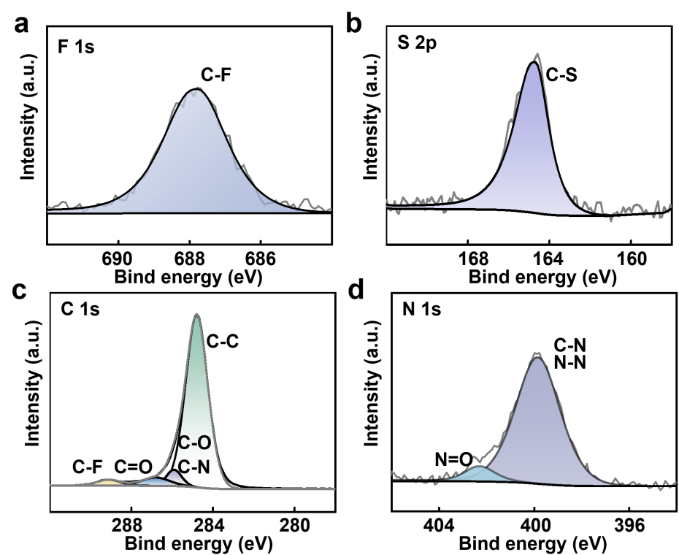

Fig. S1. (a) High-resolution XPS spectrum of (a) F1 s, (b)S 2p, (c)C 1s, (d) N 1s peaks of M/B@PDA-VHH NPs.
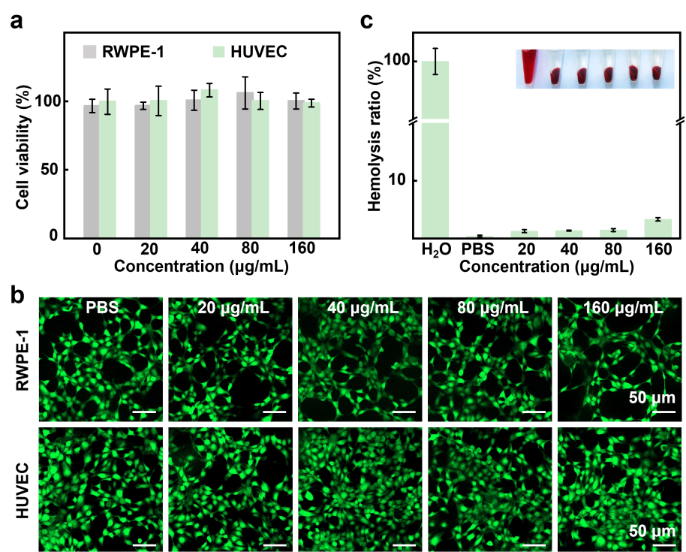

Fig. S2. (a) RWPE-1 and HUVEC viability after treatment with different concentrations of M/B@PDA-VHH NPs(n=3). (b) Hemolysis rate of RBC after incubation with M/B@PDA-VHH NPs with different concentrations(n=3).
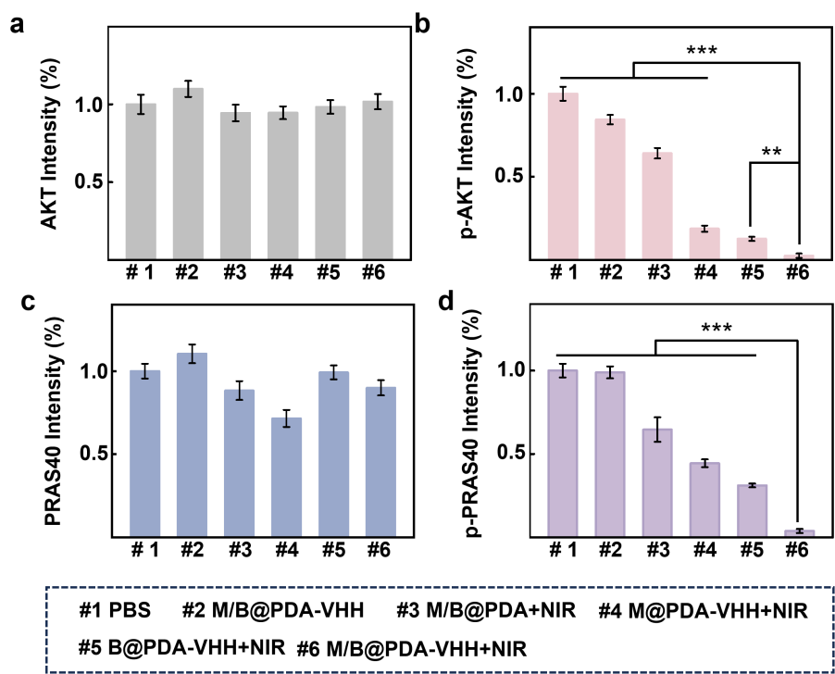

Fig. S3. (a) Quantitative immunofluorescence intensity of AKT, (b) p-AKT, (c) PRAS40 and (d) p-PRAS40 in tumor sections(n=3).
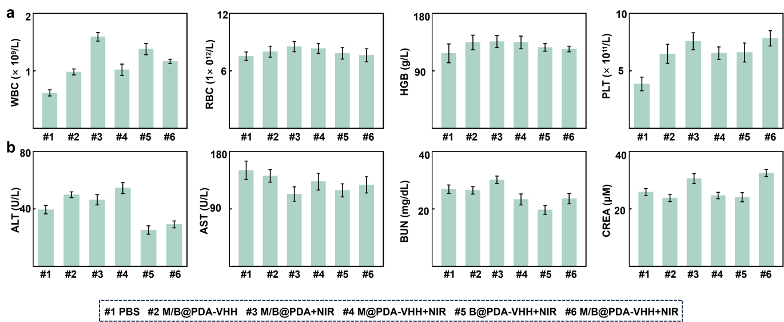

Fig. S4. (a) Hematological analysis of WBC, RBC, HGB and PLT count. (b) Biochemical analysis of ALT, AST, BUN, and CREA levels after PBS, M/B@PDA-VHH, M/B@PDA+NIR, M@PDA-VHH+NIR, B@PDA-VHH+NIR and M/B@PDA-VHH+NIR treatment (n = 6). The dashed lines indicate normal reference ranges.
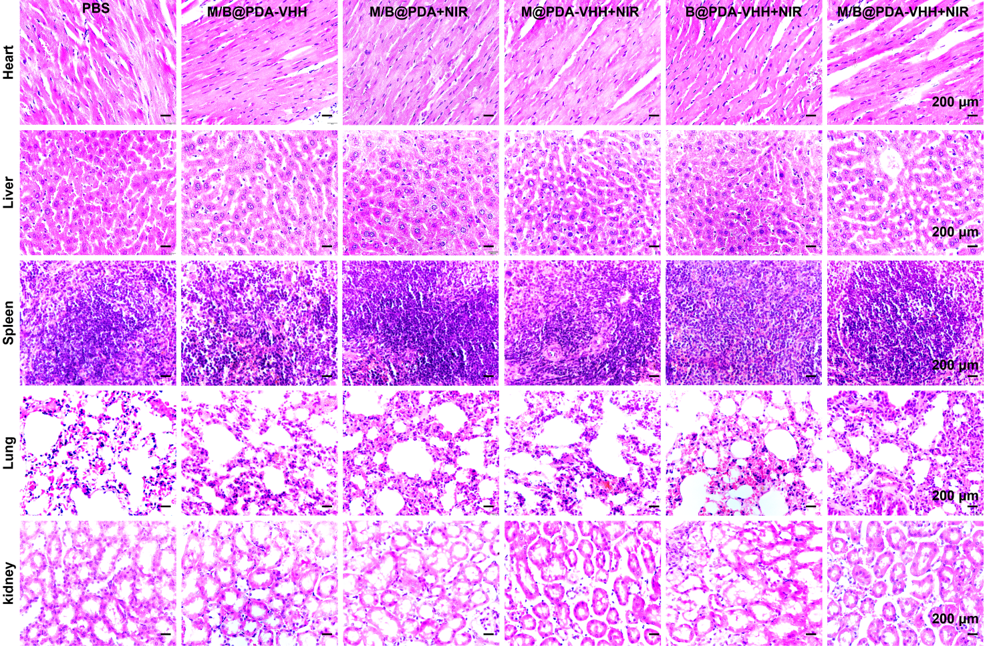

Fig. S5. H&E staining images of the heart, liver, spleen, lung, and kidney after different treatment.

