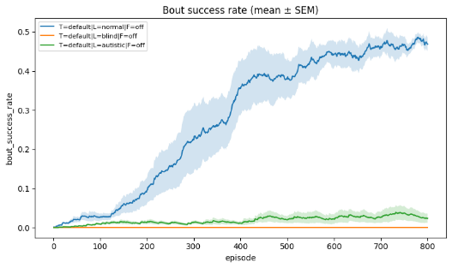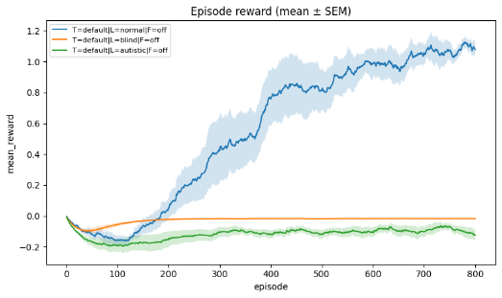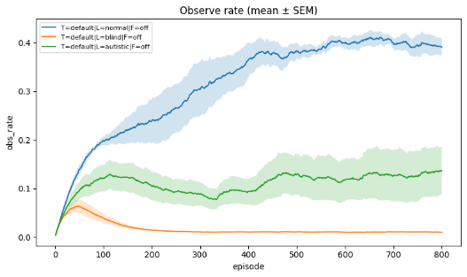
Supplementary Figure S1. Social-channel access manipulations. Learning curves for bout success, episode reward, and observation rate for normal observers (L=normal), social-blind observers (L=blind; cue unavailable), and impaired-tracking observers (L=impaired; probabilistic cue detection with increased noise). Social blindness abolishes learning, while tracking impairments reduce asymptotic performance.

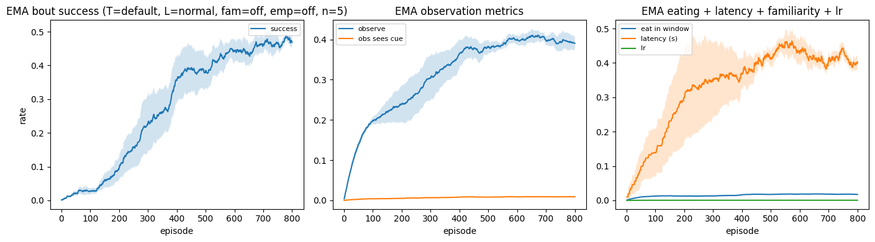
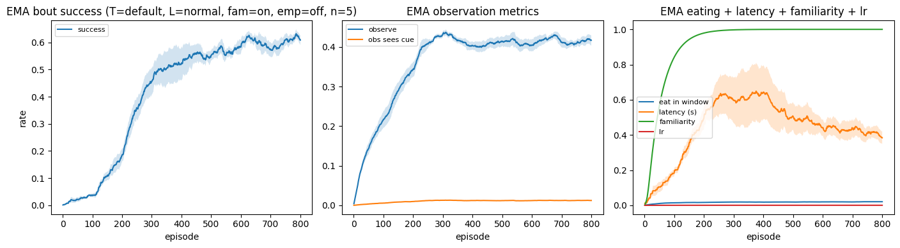
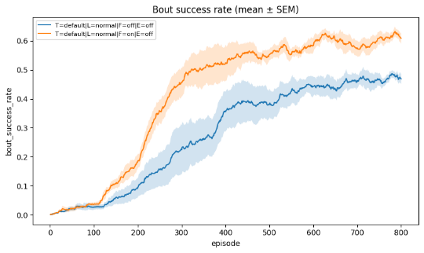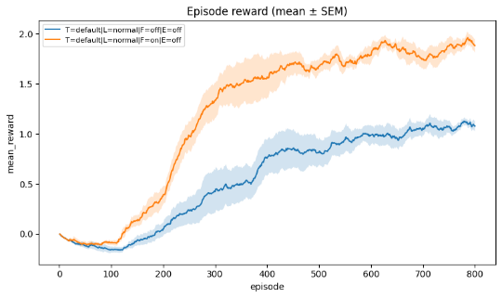

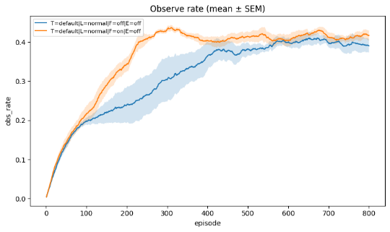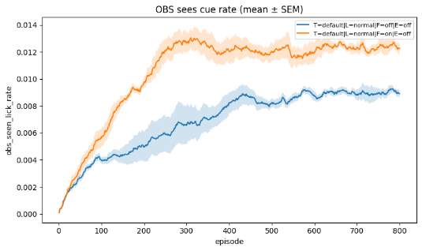

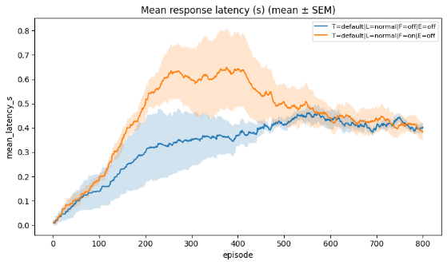
Supplementary Figure S2. Familiarity facilitates observational learning. When familiarity is enabled (F=on), repeated exposure improves cue detection and reduces the cost of attention, increasing bout-success learning rate and asymptotic performance, elevating episode reward, and altering cue-sighting and latency metrics relative to F=off.

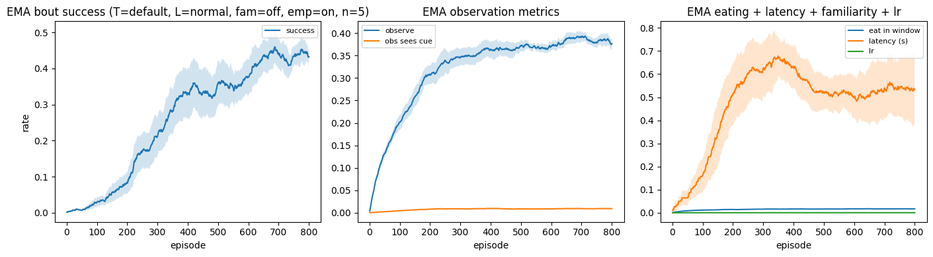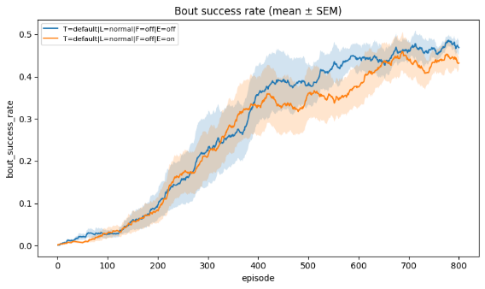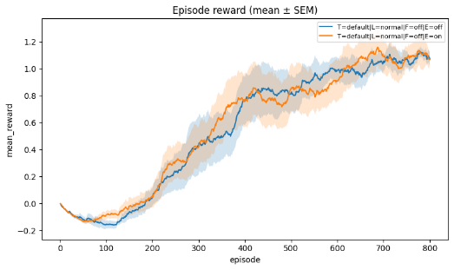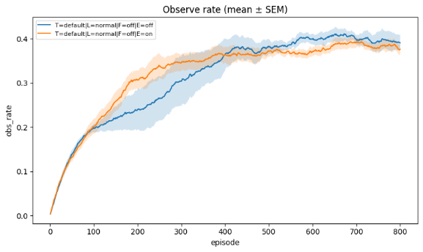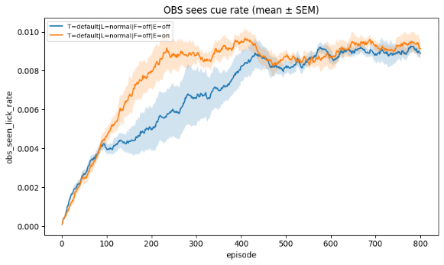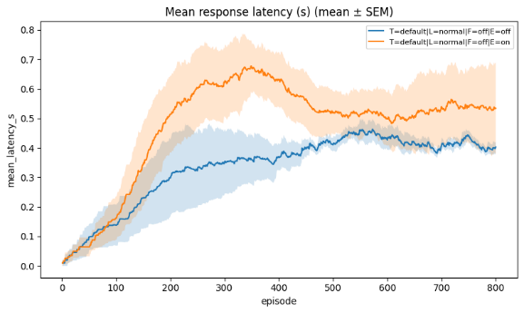
Supplementary Figure S3. Empathy-like intrinsic salience increases observation but can trade off with reward harvesting. When empathy is enabled (E=on), the learner receives a small intrinsic reward upon successfully seeing a cue during a bout, increasing observation and cue-sighting rates; depending on weighting, this can modestly reduce bout success by promoting over-attendance relative to timely consumption.

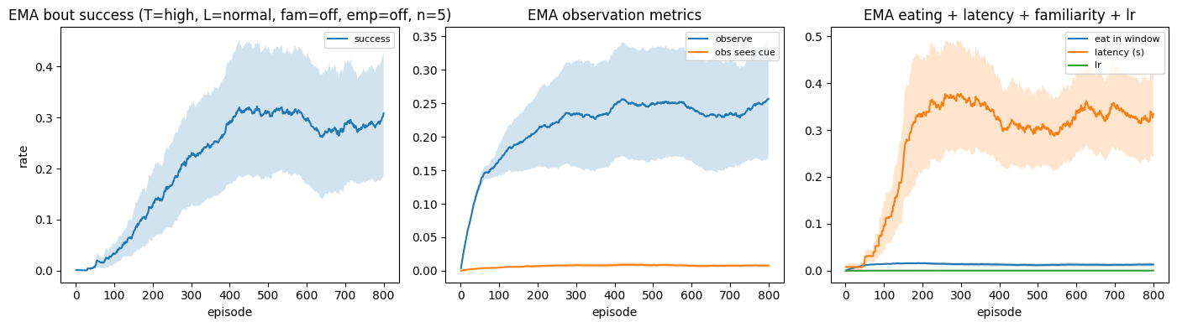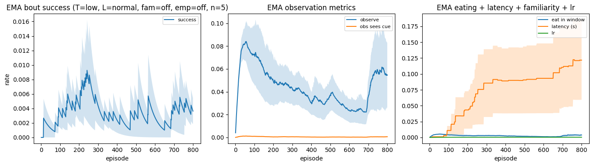
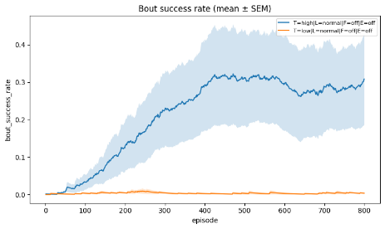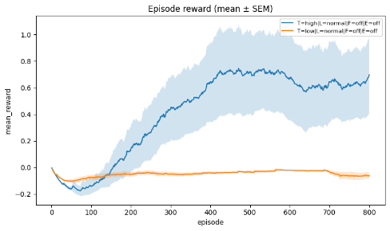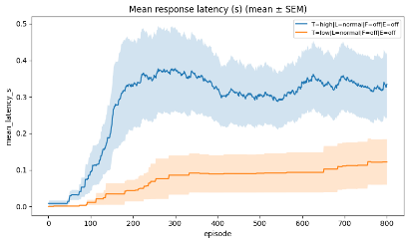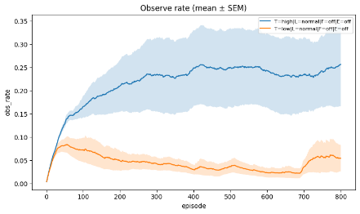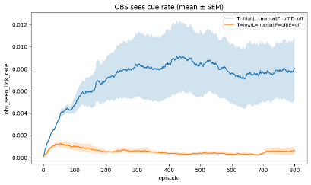
Supplementary Figure S4. Demonstrator palatability modulates the temporal opportunity to learn. High palatability (T=high) corresponds to longer mean lick bouts (longer cue bursts), whereas low palatability (T=low) corresponds to short bouts that make observation time-critical. Short bouts markedly suppress learning and increase latency.

