Supplementary materials

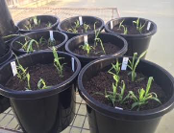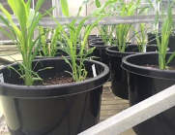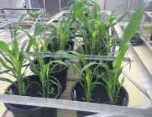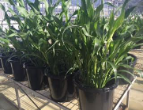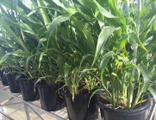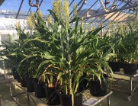
a
b
c
d
e
f

Fig. S1. Transgenic sorghum lines were grown in a PC2 glasshouse. (a) one week; (b) two weeks; (c) three weeks; (d) five weeks; (e) seven weeks; (f) ten weeks in the glasshouse.

Fig. S2. The Construct Used for Gene Transformation. Stem-specific Promoter: either A1 resulting in high gene expression in the mature stalk or LSG2 resulting in high gene expression in the loading sucrose section of the stalk. Vacuole leading: encoding a propeptide to guide SI gene products to vacuole where sucrose accumulates. Non-silence target gene: sucrose isomerase without motifs gene silencing in plants. Multiple terminators: three recombined terminators complex to guarantee the proper termination of gene transcription.

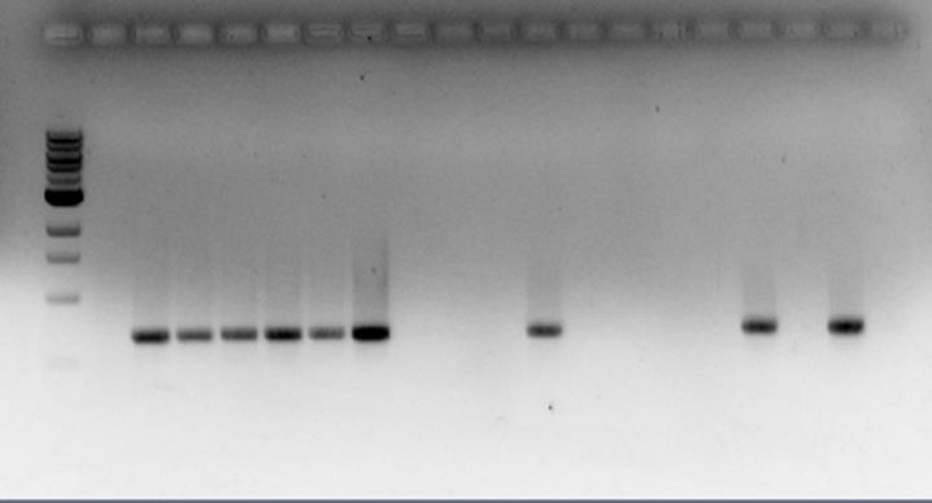
---1.0 kb
---0.5 kb

M NC 1 2 3 4 5 6 7 8 9 10 11 12 13 14 15 16 17 18
Fig. S3 PCR screening of sucrose isomerase gene in transgenic lines. An example of agarose gel running the genomic PCR products to test the sucrose isomerase genes in the transgenic plantlets. M: DNA ladder; NC: negative control; Number 1 to 18 are transgenic samples.

Table S1 Sugar profile of controls and positive transgenic lines with isomaltulose
Sample*  Name | Glucose  (µM) | Fructose  (µM) | Sucrose  (µM) | Trehalulose  (µM) | Isomaltulose  (µM) | Total sugar**  (µM)
T1 | 1.27 | 1.41 | 8.03 | n.a. | n.a. | 9.37
T2 | 3.11 | 1.29 | 9.20 | n.a. | n.a. | 11.4
T3 | 5.48 | 5.81 | 63.86 | n.a. | n.a. | 69.50
T4 | 33.52 | 32.90 | 70.19 | n.a. | n.a. | 103.4
T5 | 55.59 | 56.97 | 60.22 | n.a. | n.a. | 116.5
A131 | 71.91 | 61.08 | 578.17 | n.a. | 4.39 | 649.06
A13 | 32.61 | 23.29 | 498.41 | n.a. | 9.76 | 536.12
A11 | 40.92 | 8.07 | 195.74 | 2.54 | 40.82 | 263.60
A15 | 55.60 | 4.79 | 393.47 | 4.95 | 141.24 | 569.86
A5 | 17.37 | 34.66 | 382.09 | 14.63 | 329.06 | 751.80
A52 | 7.25 | 25.25 | 399.62 | 61.94 | 361.01 | 838.82
A51 | 8.38 | 17.64 | 527.30 | 26.15 | 446.34 | 1012.8
L1 | 67.93 | 64.19 | 121.36 | n.a. | 15.06 | 202.48
L2 | 1.52 | 0.78 | 14.45 | n.a. | 28.16 | 43.76
L24 | 1.21 | 0.80 | 14.75 | n.a. | 42.53 | 58.285
L14 | 45.24 | 46.96 | 475.61 | 1.97 | 56.13 | 579.81
L19 | 48.36 | 37.08 | 600.14 | 10.14 | 95.35 | 748.35
L3 | 39.08 | 34.50 | 629.87 | 8.80 | 130.36 | 805.82
L9 | 4.81 | 8.92 | 482.03 | 15.87 | 328.65 | 833.415
L16 | 52.45 | 62.59 | 295.34 | 18.01 | 384.80 | 755.67
L7 | 25.27 | 46.28 | 178.98 | 21.44 | 432.51 | 668.705
*: From T1 to T5 are samples of wildtype control Tx430. A and L lines are transgenic lines with different promoters.
**: Total sugar content = ½ (Glucose + Fructose) + Sucrose + Trehalulose + Isomaltulose

