Supplementary Information for
Field-channel synergistic engineering in gradient-doped 2D overlayers for high-efficiency solar water splitting
Xin Ding¹, Keng Chen¹, Hengjun Xie², Tongxin Tang¹, Wenhao Zou², Huashu Sun¹, Shuang Xiao³, Shanqing Zhang², Teng-Xiang Huang^{1,4}, Kai-Hang Ye*^{2,5}, Yang Cao*^{1,4}, Shihe Yang^{6,7}

1. State Key Laboratory of Physical Chemistry of Solid Surfaces, Collaborative Innovation Center of Chemistry for Energy Materials (iChEM), College of Chemistry and Chemical Engineering, Xiamen University, Xiamen, 361005, P. R. China
2. Institute for Sustainable Transformation, School of Chemical Engineering and Light Industry, Guangdong University of Technology, Guangzhou, 510006, China
3. Shenzhen Key Laboratory of Ultraintense Laser and Advanced Material Technology, Center for Intense Laser Application Technology (iLaT) and College of Engineering Physics, Shenzhen Technology University, Shenzhen 518118, China
4. Innovation Laboratory for Sciences and Technologies of Energy Materials of Fujian Province (IKKEM), Xiamen 361005, China
5. Huizhou Research Institute, Sun Yat-Sen University, 516081, Huizhou, China
6. School of Advanced Materials, Peking University Shenzhen Graduate School, Shenzhen 518055, China
7. Department of Chemistry, The Hong Kong University of Science and Technology, Clear Water Bay, Kowloon, Hong Kong, China; Institute of Biomedical Engineering, Shenzhen Bay Laboratory, Shenzhen 518107, China
* Corresponding authors:
yekh@gdut.edu.cn; yangcao@xmu.edu.cn;

The PDF file includes:
Figures S1 to S45
Tables S1 to S3
Supplementary Fig. 1. Catalyst microscopy. a, TEM image of C₃N₅. b, STEM image of C₃N₅. c, Elemental mappings of C acquired from b. d, AFM images of C₃N₅ on a silicon wafer, with the height profile determined along the line shown in the inset.

Supplementary Fig. 2. Catalyst microscopy. a-b, TEM images of B:C₃N_{5-x}. c, AFM images of B:C₃N_{5-x} on a silicon wafer, with the height profile determined along the line shown in the inset. d, STEM image of B:C₃N_{5-x} and elemental mappings of B, C, N. After further NaBH₄ heat treatment, the material maintained its nanosheet morphology with no significant change in thickness. Elemental mapping revealed homogeneous distribution of B atoms within the C₃N₅ nanosheets, further confirming the successful incorporation of B atoms.

Supplementary Fig. 3. XPS spectra of C₃N₅ and B:C₃N_{5-x}. Survey XPS spectra. Compared with pure C₃N₅, the XPS survey spectrum of B:C₃N_{5-x} exhibits distinct N 1s and C 1s peaks, along with an additional B 1s peak. Furthermore, the high-resolution B 1s spectrum reveals that its peak is located at 191.7 eV, which is consistent with recent study.

Supplementary Fig. 4. FTIR spectra of C₃N₅ and B:C₃N_{5-x}. A peak at 764 cm⁻¹ of C₃N₅ and B:C₃N_{5-x} correspond to the N-N bond of the triazole moiety, unlike C₃N₄ which only has a tri-s-triazine (heptazine) structure, thus proving the successful synthesis of C₃N₅. Both C₃N₅ and B:C₃N_{5-x} present a peak at 806 cm⁻¹ typical for the out-of-plane bending mode of tri-s-triazine (heptazine) rings. Additionally, whilst the peaks locating between 900 and 1800 cm⁻¹ originate from the stretching modes of aromatic C-N heterocycles. In comparison, B:C₃N_{5-x} displays a decrease in the intensity of the N-H stretching peaks between 3000 and 3500 cm⁻¹, and a new peak emerging at 2175 cm⁻¹, which should be corresponding to the asymmetric stretching vibration of cyano (-C≡N) groups. These observations suggest that the calcination treatment of NaBH₄ introduces more N vacancies into C₃N₅.

Supplementary Fig. 5. Light absorption capacity characterization. Corresponding Tauc plots for C₃N₅ and B:C₃N_{5-x} using (αhν)^{1/2} (Kubelka–Munk parameter) as a function versus the photon energy. The intrinsic bandgaps are 2.16 and 1.88 eV for C₃N₅ and B:C₃N_{5-x}, respectively.

Supplementary Fig. 6. Theoretical calculations of band structure. a, band structure of C₃N₅. b, PDOS plots of C₃N₅. c, band structure of B:C₃N_{5-x}. d, PDOS plots of B:C₃N_{5-x}.

Supplementary Fig. 7. MAS-NMR spectrum. Solid-state ¹³C MAS-NMR spectrum of B:C₃N_{5-x}.

Supplementary Fig. 8. Structural properties of Mo:BVO. a, XRD pattern of Mo:BVO. b, Top-view SEM image of Mo:BVO. c, cross-section SEM image of Mo:BVO. d TEM image of Mo:BVO.

Supplementary Fig. 9. Structural properties of Mo:BVO/B:C₃N_{5-x}. a, XRD pattern of Mo:BVO/C₃N₅ and Mo:BVO/B:C₃N_{5-x}. b, Top-view SEM images of Mo:BVO/B:C₃N_{5-x}. c, Side-view SEM images of Mo:BVO/B:C₃N_{5-x} d, TEM image of Mo:BVO/B:C₃N_{5-x}.

Supplementary Fig. 10. Structural properties of Mo:BVO/B:C₃N_{5-x}. EDX mapping images for Bi, V, O, C and B, respectively.

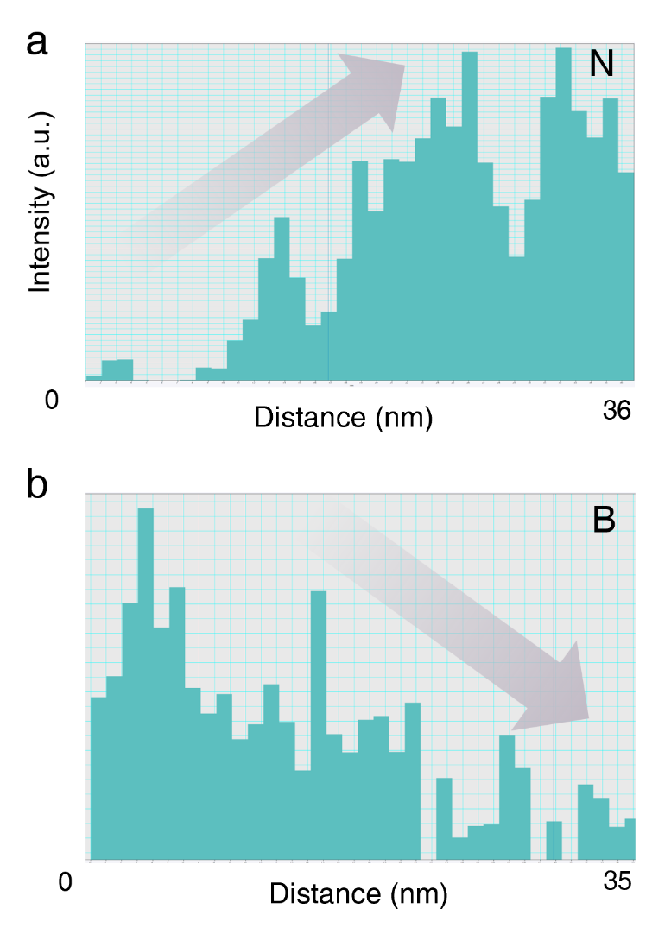
Supplementary Fig. 11. Strength of EELS line profiling. Intensity of elements of a, N and b, B under line profiling of Mo:BVO/B:C₃N_{5-x} with calcination.

Supplementary Fig. 12. Strength of EELS line profiling. Intensity of elements of a, N and b, B under line profiling of Mo:BVO/B:C₃N_{5-x} without calcination.

Supplementary Fig. 13. DFT calculation. The model of Mo:BVO/B:C₃N_{5-x}, where site1 and site 2 represent B atoms near and far from the Mo:BVO interface, respectively. The adsorption energy (E_{ads}) of Mo:BVO for B:C₃N_{5-x} is -1.21 eV. These remarkably high values indicate that B atoms near the interface are strongly bonded and unlikely to detach from the structure. However, moving just one layer away from the Mo:BVO interface, the B-atom detachment energy decreases by 3.91 eV. This significant reduction suggests that B atoms become increasingly prone to detachment as the distance from the interface increases, which explains the observed gradient decrease in boron concentration from the interface toward the surface.

Supplementary Fig. 14. Carrier separation capability characterization. PL spectra of C₃N₅, uncalcined B:C₃N_{5-x} and calcined B:C₃N_{5-x} by 340 nm excitation wavelength.

Supplementary Fig. 15. Vertical dipole field characterization. Phase hysteresis loop and amplitude butterfly loop of a, calcinated B:C₃N_{5-x} and b, C₃N₅.
Supplementary Fig. 16. Vertical dipole field characterization. a, AFM image of calcined B:C₃N_{5-x}. Scanning KPFM images of calcined B:C₃N_{5-x} without b and c with light illumination. d, The comparison calcined B:C₃N_{5-x} of the line-scanning surface potential with and without light illumination.

Supplementary Fig. 17. Vertical dipole field characterization. a, AFM image of uncalcined B:C₃N_{5-x}. Scanning KPFM images of uncalcined B:C₃N_{5-x} without b and c with light illumination. d, The uncalcined B:C₃N_{5-x} of the line-scanning surface potential with and without light illumination.

Supplementary Fig. 18. Vertical dipole field characterization. a, AFM image of C₃N₅. Scanning KPFM images of C₃N₅ without b and c with light illumination. d, The comparison C₃N₅ of the line-scanning surface potential with and without light illumination.

Supplementary Fig. 19. Optical properties of three samples. a, UV-visible DRS of Mo:BVO, Mo:BVO/C₃N₅ and Mo:BVO/B:C₃N_{5-x}. b, Light harvesting efficiency (LHE) of Mo:BVO, Mo:BVO/C₃N₅ and Mo:BVO/B:C₃N_{5-x}. c, Spectra of the solar irradiance of AM 1.5 G and those weighted by Figure b. The loading of C₃N₅ and B:C₃N_{5-x} significantly enhance the light absorption capacity in the visible light region (Benefiting from the absorption capacity of C₃N₅ and B:C₃N_{5-x} nanosheets in the visible light region). Light harvesting efficiency (LHE) can be expressed as: LHE = 1-10^{-A}, which is derived from a. This significant increase in visible light absorption can substantially enhance its J_{abs} (from 5.57 mA cm⁻² to 6.75 mA cm⁻²), giving it the potential to achieve higher photocurrent densities. Photocurrent assuming 100% absorbed photon-to-current efficiency J_{abs} can be expressed as follow equation:
$${\text{J}}_{\text{abs}}\text{ = }\frac{\text{e}}{\text{hc}}\int_{0}^{λ_{0}}{λI_{λ}}\left(\text{1 -}{\text{10}}^{\text{-A}}\right)dλ$$
where $I_{λ}$is the solar irradiance, e is the electron charge, $\text{h }$is the Planck constant, $\text{c }$is the speed of light, A is the absorbance. The electron-hole separation yield (Φ_{sep}) can be expressed as: Φ_{sep} = J_{HS}/J_{abs}, where J_{HS} is the photocurrent density of samples with Na₂SO₃ hole scavenger.

Supplementary Fig. 20. PEC performance containing Na₂SO₃. a, LSV curves of Mo:BVO, Mo:BVO/C₃N₅ and Mo:BVO/B:C₃N_{5-x} photoanodes under AM 1.5G simulated light with 0.2 M Na₂SO₃ as a hole scavenger. b, the Φ_{sep} of Mo:BVO, Mo:BVO/C₃N₅ and Mo:BVO/B:C₃N_{5-x}. photoanodes. c, LSV curves of Mo:BVO/C₃N₅ photoanodes with/without calcination under AM 1.5G simulated light with 0.2 M Na₂SO₃ as a hole scavenger. d, the Φ_{sep} of Mo:BVO/B:C₃N_{5-x} photoanodes with/without calcination.

Supplementary Fig. 21. Structure characterization of Mo:BVO/B:C₃N_{5-x}/NiFeBi. a, TOP-view SEM image of Mo:BVO/B:C₃N_{5-x}/NiFeBi. b, cross-section SEM image Mo:BVO/B:C₃N_{5-x}/NiFeBi. c, TEM image of Mo:BVO/B:C₃N_{5-x}/NiFeBi. d, STEM image of Mo:BVO/B:C₃N_{5-x}/NiFeBi and EDX mapping images for B, C, Bi, V, Ni, Fe and O, respectively.

Supplementary Fig. 22. XRD pattern of Mo:BVO/B:C₃N_{5-x}/NiFeBi.

Supplementary Fig. 23. a, LSV curve of the Mo:BVO photoanode recorded at a scan rate of 50 mV s⁻¹ in 0.5 M KBi solution. b, ABPE curve.

Supplementary Fig. 24. PEC water oxidation of photoanodes. Φ_{OX} of Mo:BVO, Mo:BVO/NiFeBi, Mo:BVO/C₃N₅/NiFeBi and Mo:BVO/B:C₃N_{5-x}/NiFeBi photoanodes. Φ_{OX}= J_{PEC}/J_{HS} where J_{PEC} is photocurrent density measured in 0.5 M KBi solution, and J_{HS} is photocurrent density measured in 0.5 M KBi solution with 0.2 M Na₂SO₃. The value of the Φ_{OX} reflects the ability of PEC water oxidation.

Supplementary Fig. 25. ABPE values compared to recent work. Comparison of ABPE values of the Mo:BVO/B:C₃N_{5-x}/NiFeBi photoanode with the previously reported BVO-based photoanodes. The photoanode we fabricated achieved an ABPE value of 2.89%, representing the highest level currently known in operation. This demonstrates the superiority of our dual-electric-field strategy for promoting charge carrier separation under low bias conditions.

Supplementary Fig. 26. OCP spectra of BVO-based photoanodes with hole scavenger. a, OCP spectra of Mo:BVO, Mo:BVO/NiFeBi, Mo:BVO/C₃N₅/NiFeBi and Mo:BVO/B:C₃N_{5-x}/NiFeBi photoanodes with hole scavenger. in KBi solution with the Na₂SO₃ hole scavenger (pH = 9.5) after testing 75 s. b, OCP values of four samples.

Supplementary Fig. 27. a, Transient time constant of photogenerated carriers of Mo:BVO, Mo:BVO/NiFeBi, Mo:BVO/C₃N₅/NiFeBi and Mo:BVO/B:C₃N_{5-x}/NiFeBi photoanodes. b, Definition of I_{in} and I_{st}.
D = exp$(-\frac{t}{τ_{1}})$=$\frac{I_{t}-I_{st}}{I_{in}-I_{st}}$
D (normalized parameter), the time corresponding to LnD = -1 is defined as the transient time constant ($τ_{1}$), where I_{t}, I_{in} and I_{st} are the photocurrent at t, initial state, and steady state, respectively.

Supplementary Fig. 28. Morphology property. a-b, SEM images of Mo:BVO/B:C₃N_{5-x}/NiFeBi photoanode after i-t test.

Supplementary Fig. 29. Electronic structure changes after stability testing characterized by XPS. XPS spectra of a, Bi 4f, b, V 2p, c, Fe 2p and d, Ni 2p of Mo:BVO/B:C₃N_{5-x}/NiFeBi before and after 45 h test.

Supplementary Fig. 30. Ion content in electrolyte after stability test. ICP-OES bar chart of Bi and V concentration for Mo:BVO and Mo:BVO/B:C₃N_{5-x}/NiFeBi.

Supplementary Fig. 31. Faraday efficiency test. H₂ and O₂ evolution of the Mo:BVO/B:C₃N_{5-x}/NiFeO_{x} photoanode at 1.23 V_{RHE}.

Supplementary Fig. 32. Structural properties of photoanodes. a, XRD pattern of TiO₂, TiO₂/NiFeBi and TiO₂/B:C₃N_{5-x}/NiFeBi photoanodes. b, SEM image of TiO₂. c, SEM image of TiO₂/ B:C₃N_{5-x}/NiFeBi.

Supplementary Fig. 33. PEC performance. a LSV curves of the TiO₂, TiO₂/NiFeBi and TiO₂/B:C₃N_{5-x}/NiFeBi photoanodes recorded at a scan rate of 50 mV s⁻¹ in 1 M NaOH solution. b, I-t test of TiO₂, TiO₂/NiFeBi, TiO₂/B:C₃N_{5-x}/NiFeBi photoanodes switching light. c, ABPE curves.

Supplementary Fig. 34. Structural properties of photoanodes. a, XRD pattern of Ti:Fe₂O₃, Ti:Fe₂O₃/NiFeBi and Ti:Fe₂O₃/B:C₃N_{5-x}/NiFeBi photoanodes. b, SEM image of Ti:Fe₂O₃. c, SEM image of Ti:Fe₂O₃/ B:C₃N_{5-x}/NiFeBi.

Supplementary Fig. 35. PEC performance. a LSV curves of the Ti:Fe₂O₃, Ti:Fe₂O₃/NiFeBi and Ti:Fe₂O₃/B:C₃N_{5-x}/NiFeBi photoanodes recorded at a scan rate of 50 mV s⁻¹ in 1 M NaOH solution. b, I-t test of Ti:Fe₂O₃, Ti:Fe₂O₃/NiFeBi, Ti:Fe₂O₃/B:C₃N_{5-x}/NiFeBi photoanodes switching light. c, ABPE curves.

Supplementary Fig. 36. Optical band gaps. The plot of transformed Kubelka–Munk function versus the photon energy of Mo: BVO.

Supplementary Fig. 37. UPS and XPS valence band spectra. a-c, UPS and d, XPS valence band spectra of Mo:BVO. According to the linear intersection method, the E_{VB} of Mo:BVO was calculated to be -6.9 eV (vs. vacuum) from E_{Cutoff} –hυ –E_{Fermi} (hυ of 21.22 eV: the excitation energy of the He I Source Gun). Then the E_{VB} of Mo:BVO vs. RHE, was converted to be 2.46 V, on the basis of the relationship between the vacuum energy (E_{vacuum}) and the RHE potential (E_{RHE}), E_{vacuum} = -E_{RHE}–4.44 eV. Finally, the E_{F} of Mo:BVO was calculated to be 1.18 V_{RHE}, on the basis of the formula E_{F} = E_{VB}- E_{Fermi}. XPS valence band spectra is used to correct E_{Fermi}.

Supplementary Fig. 38. UPS and XPS valence band spectra. a-c, UPS and d, XPS valence band spectra of B:C₃N_{5-x}.

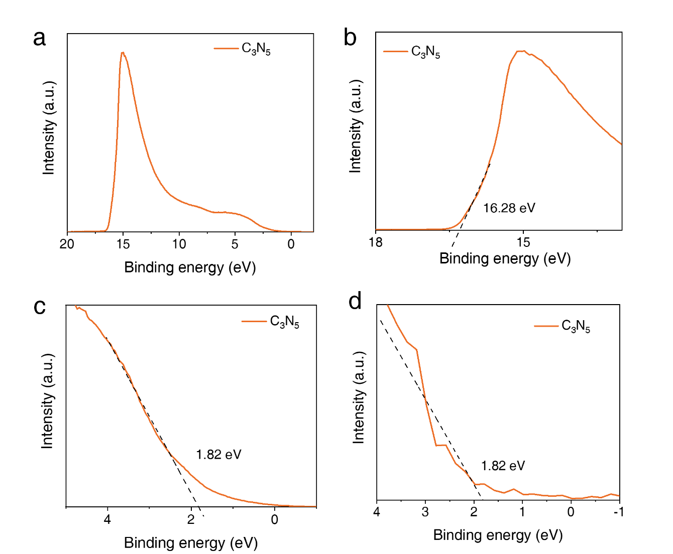
Supplementary Fig. 39. UPS and XPS valence band spectra. a-c, UPS and d, XPS valence band spectra of C₃N₅.

Supplementary Fig. 40. Band structure. Before and after contact of band structure. Due to the relatively high Fermi level of C₃N₅, when it contacts Mo:BVO, the valence band maximum (VBM) of Mo:BVO bends downwards, while the VBM on the C₃N₅ side bends upwards. This unfavorable band bending creates a significant energy barrier at the interface, impeding carrier transport. However, after introducing B doping and N vacancies, its Fermi level is significantly lowered and falls below that of Mo:BVO. Upon contact with Mo:BVO, a built-in electric field pointing from Mo:BVO towards B:C₃N_{5-x} is formed, resulting in favorable band bending.

Supplementary Fig. 41. Characterization of electronic structure. XPS spectra of V 2p 4f of Mo:BVO and Mo:BVO/B:C₃N_{5-x}.

Supplementary Fig. 42. Transient Spectroscopy variation over time. TA spectra measured after pulsed 400 nm excitation of a, Mo:BVO. b, Mo:BVO/NiFeBi. c, BVO/C₃N₅/NiFeBi. d, BVO/B:C₃N_{5-x}/NiFeBi.

Supplementary Fig. 43. Pseudocolor map. Pseudocolor map of the transient absorption spectra of a, Mo:BVO. b, Mo:BVO/NiFeBi. c, Mo:BVO/C₃N₅/NiFeBi in the ps-ns timescale.

Supplementary Fig. 44. The mechanism of carrier separation. a, Scanning KPFM images of Mo:BVO/B:C₃N_{5-x}/NiFeBi with and without light illumination. b, The comparison Mo:BVO/B:C₃N_{5-x}/NiFeBi of the line-scanning surface potential with and without light illumination. c, Scanning KPFM images of Mo:BVO/C₃N₅/NiFeBi with and without light illumination. d, The comparison Mo:BVO/C₃N₅/NiFeBi of the line-scanning surface potential with and without light illumination. e, Scanning KPFM images of Mo:BVO/NiFeBi with and without light illumination. f, The comparison Mo:BVO/NiFeBi of the line-scanning surface potential with and without light illumination.

Supplementary Fig. 45. Faraday efficiency test. H₂ and O₂ evolution of the Mo:BVO/B:C₃N_{5-x}/NiFeO_{x} photoanode at 1.23 V_{RHE}. The average Faradaic efficiency is approximately 99%. (area: 0.04 cm⁻²)

Table S1. The ABPE by state-of-the-art BVO photoanodes for low-bias PEC water splitting.
Photoanode | ABPE (%) | Potential (V_{RHE}) | Ref¹⁻¹³
Mo:BVO/B:C₃N_{5-x}/NiFeBi | 2.89 | 0.54 | This work
B-CN-Mo:BiVO₄ | 2.67 | 0.54 | Nat. Commun. 10, 3687 (2019)
P-BiVO₄ | 2.21 | 0.6 | Nat Commun. 13, 6231 (2022)
Co-Pi-BVO-VO | 1.55 | 0.7 | Adv. Mater. 31, 1807204 (2019)
Au/BVO-SMSI/FeOOH/NiOOH | 2.26 | 0.67 | Angew. Chem. Int. Ed. 63, e202402435 (2024)
BiVO₄/FeOOH/NiOOH | 1.75 | 0.6 | Science 343, 990–994 (2014)
BFC/PAAM-45 | 1.57 | 0.81 | Adv. Funct. Mater. 2314973 (2024)
BiVO₄/CuS/NiFeCoO_{x} | 2.46 | 0.64 | Angew. Chem. Int. Ed. 2025, 64, e202507259
BVO@ZCF(P)-O | 2.1 | 0.6 | Angew. Chem. Int. Ed. e202307246 (2023)
BiVO₄/NiFe-LDH/Co₃Ge₂O₅(OH)₄ | 1.85 | 0.63 | ACS Catal. 15,1 1293−11306 (2025)
BiVO₄/BiO_{x}/NiFeO_{x} | 2 | 0.72 | ACS Energy Lett. 10, 2162−2170 (2025)
O_{V}-BiVO₄/MIL-101 | 2.15 | 0.65 | Adv. Mater. 37, 2417589 (2025)
BV/Fe(OH)_{x}/FeNi-H | 0.88 | 0.85 | Adv. Energy Mater. 15, 2405137 (2025)
BiVO₄/Co-TCPP-FAA | 1.93 | 0.61 | Adv. Mater. 37, 2410632 (2025)
BVO/PFeMo/NiFeO_{x} | 2.27 | 0.6 | Chem Catal. 101605 (2026)

Table S2. Fitting results of EIS on Mo:BVO, Mo:BVO/NiFeBi, Mo:BVO/C₃N₅/NiFeBi and Mo:BVO/B:C₃N_{5-x}/NiFeBi photoanodes.
Samples | R_{s} |  | R_{ct} | CPE(×10⁻⁵F)
Mo:BVO/B:C₃N_{5-x}/NiFeBi | 34.65 | 29.7 |  | 12.5
Mo:BVO/C₃N₅/NiFeBi | 34.95 | 49.02 |  | 3.73
Mo:BVO/ NiFeBi | 35.37 | 58.45 |  | 2.92

Table S3. Recorded at 750 nm after excitation of a Mo:BVO, Mo:BVO/NiFeBi, Mo:BVO/C₃N₅/NiFeBi and Mo:BVO/B:C₃N_{5-x}/NiFeBi at 400 nm pump.
 | Mo:BVO/B:C₃N_{5-x}/NiFeBi | Mo:BVO/C₃N₅/NiFeBi | Mo:BVO/NiFeBi | Mo:BVO
A₁ | 5.9E-4 ± 1.2E-5 | 5.9E-4 ± 1.2E-5 | 6.7E-4 ± 1.3E-5 | 5.6E-4 ± 1.2E-5
$τ_{1}$ (ps) | 144.7 ± 7.5 | 102.1 ± 5.6 | 120.6 ± 6.1 | 97.5 ± 5.4
A₂ | 7.0E-4 ± 1.0E-5 | 7.0E-4± 1.0E-5 | 1.3E-3 ± 9.6E-6 | 9.9E-4 ± 8.3E-6
$τ_{2}$ (ns) | 13.3 ± 0.9 | 11.3 ± 1.0 | 11.7± 0.5 | 11.2± 0.6

1. Ye, K.-H. et al. Enhancing photoelectrochemical water splitting by combining work function tuning and heterojunction engineering. Nat. Commun. 10, 3687 (2019).
2. Wu, H. et al. Low-bias photoelectrochemical water splitting via mediating trap states and small polaron hopping. Nat. Commun. 13, 6231 (2022).
3. Ren, H. et al. Manipulation of Charge Transport by Metallic V₁₃O₁₆ Decorated on Bismuth Vanadate Photoelectrochemical Catalyst. Adv. Mater. 31, 1807204 (2019).
4. He, B. et al. Strong Interactions between Au Nanoparticles and BiVO₄ Photoanode Boosts Hole Extraction for Photoelectrochemical Water Splitting. Angew. Chem., Int. Ed. 63, e202402435 (2024).
5. Kim, T. W. et al. Nanoporous BiVO₄ Photoanodes with Dual-Layer Oxygen Evolution Catalysts for Solar Water Splitting. Science 343, 990-994 (2014).
6. Zhang, Q. et al. Hydrogel Enabled Dual-Shielding Improves Efficiency and Stability of BiVO₄ Based Photoanode for Solar Water Splitting. Adv. Funct. Mater. 34, 2314973 (2024).
7. Wang, J. et al. Photothermal CuS as a Hole Transfer Layer on BiVO₄ Photoanode for Efficient Solar Water Oxidation. Angew. Chem., Int. Ed. 64, e202507259 (2025).
8. Pan, J.-B. et al. Introducing Bidirectional Axial Coordination into BiVO₄@Metal Phthalocyanine Core–Shell Photoanodes for Efficient Water Oxidation. Angew. Chem., Int. Ed. 62, e202307246 (2023).
9. Chi, J. et al. Enhanced Photoelectrochemical Water Splitting on BiVO₄ Photoanode via Efficient Hole Transport Layers of NiFe-LDH. ACS Catal. 15, 11293-11306 (2025).
10. Li, N. et al. Boosting Oxygen Evolution Reaction Performance on BiVO₄ Photoanode via Gradient Oxygen Vacancies. ACS Energy Lett. 10, 2162-2170 (2025).
11. Ning, X. et al. In Operando Visualization of Charge Transfer Dynamics in Transition Metal Compounds on Water Splitting Photoanodes. Adv. Energy Mater. 15, 2405137 (2025).
12. Zhang, C. et al. Tailoring Non-Covalent Interaction Via Single Atom to Boost Interfacial Charge Transfer Toward Photoelectrochemical Water Oxidation. Adv. Mater. 37, 2410632 (2025).
13. Ding, X. et al. PFeMo polyoxometalate interlayer boosts BiVO₄ light harvesting and charge separation for tandem photoelectrochemical water splitting. Chem Catal., 101605 (2026).
References

