Impact of rhythm-control therapy for new-onset atrial fibrillation in critically ill patients: a post hoc analysis from the prospective observational AFTER-ICU study
Additional file
Table of Contents
Additional table 1………………………………………….……………………………...2
Additional table 2……………….………………………………………………………...4
Additional table 3………………………………………………………………..…..…....5

Additional fig. 1……………….……….…………………………………………..……...6
Additional fig. 2…..…..……………………………………………….…………….….…7

Additional fig. 3………..……………......................………..…………………………...8
Additional table 1: Data collection and definitions of variables and outcomes
Diabetes | Based on previous medications or hemoglobin A1c higher than 6.5%.
Hypertension | Determined based on previous medications.
Congestive heart failure | Having symptoms of heart failure, laboratory data indicating heart failure or medications for heart failure.
CHADS2 score [1] | One point for each of the following conditions: recent congestive heart failure, hypertension, age 75 years or older, or diabetes mellitus; two points for prior transient ischemic attack or stroke.
Infection | Based on the administration of antibiotics for infection at the AF onset.
Timing of rhythm control | Timing of first attempt for rhythm control therapy after the AF onset.
ICU length of stay | Duration from the onset of AF to ICU discharge.
Hospital length of stay | Duration from the onset of AF to hospital discharge.
Bleeding events | Based on Bleeding Academic Research Consortium definition for bleeding [2]. All other than type 0.
Arrythmia other than AF | Sustained ventricular arrhythmia requiring drug treatment or cardioversion or ablation, sustained supraventricular arrhythmia other than AF or AFL requiring drug treatment or cardioversion or ablation, cardiac conduction abnormalities requiring permanent pacemaker, QTc prolongation > 500ms [3].
AF duration | Sum of AF length within seven days after the AF onset or during ICU stay, whichever was shorter.

References
1. Gage BF, Waterman AD, Shannon W, Boechler M, Rich MW, Radford MJ. Validation of clinical classification schemes for predicting stroke: results from the National Registry of Atrial Fibrillation. JAMA [Internet]. 2001 [cited 2019 May 21];285:2864–70. Available from: http://www.ncbi.nlm.nih.gov/pubmed/11401607
2. Mehran R, Rao S V., Bhatt DL, Gibson CM, Caixeta A, Eikelboom J, et al. Standardized bleeding definitions for cardiovascular clinical trials: A consensus report from the bleeding academic research consortium. Circulation. 2011;123:2736–47.
3. Gillinov AM, Bagiella E, Moskowitz AJ, Raiten JM, Groh MA, Bowdish ME, et al. Rate Control versus Rhythm Control for Atrial Fibrillation after Cardiac Surgery. N Engl J Med [Internet]. 2016;374:1911–21. Available from: http://www.nejm.org/doi/10.1056/NEJMoa1602002

Additional table 2: Laboratory data at the onset of atrial fibrillation

 | Missing | Without rhythm control (n = 245) | With rhythm control (n = 178) | p value
White blood cells, 10³/μL | 3 | 10 (7 - 15) | 10 (6 - 16) | 0.89
Platelet, 10³/L | 3 | 118 (61 - 189) | 111 (52 - 186) | 0.37
PT-INR | 34 | 1.23 (1.09 - 1.42) | 1.25 (1.11 - 1.47) | 0.24
APTT, seconds | 36 | 41.5 (33.8 - 50.8) | 41.3 (33.0 - 55.0) | 0.62
CRP, mg/dL | 11 | 12.7 (4.9 - 21.9) | 14.3 (5.6 - 24.6) | 0.22
Total bilirubin, mg/dL | 7 | 0.9 (0.6 - 1.8) | 1.0 (0.6 - 2.0) | 0.26
Creatinine, mg/dL | 4 | 1.13 (0.72 - 2.08) | 1.34 (0.82 - 2.75) | 0.06
Blood urea nitrogen, mg/dL | 3 | 28 (18 - 47) | 37 (22 - 57) | 0.008
Sodium, mmol/L | 3 | 139 (136 - 143) | 140 (137 - 143) | 0.85
Potassium, mmol/L | 3 | 3.9 (3.6 - 4.4) | 4.2 (3.8 - 4.7) | 0.004
Chloride, mmol/L | 3 | 106 (102 - 109) | 107 (104 - 110) | 0.12
Magnesium, mmol/L | 191 | 2.1 (1.9 - 2.4) | 2.0 (1.8 - 2.3) | 0.30
Lactate, mmol/L | 5 | 1.5 (1.1 - 2.2) | 1.7 (1.2 - 2.5) | 0.03
Arterial blood gas
pH | 4 | 7.416 (7.361 - 7.460) | 7.398 (7.336 - 7.442) | 0.02
PaO2, Torr | 4 | 89 (76 - 110) | 93 (78 - 115) | 0.09
PaCO2, Torr | 4 | 38 (34 - 44) | 39 (34 - 46) | 0.51
PaO2 / FiO2 | 4 | 263 (194 - 343) | 270 (198 - 351) | 0.48
PT-INR: prothrombin time-international normalized ratio, APTT: activated partial thromboplastin time, CRP: C-reactive protein.

Additional table 3: Sensitivity analysis: multivariable Cox proportional hazard analysis for restoration of sinus rhythm

 | Adjusted hazard ratio (95% CI) | p value
Infection at AF onset | 0.86 (0.64 - 1.16) | 0.337
Inotropes ª | 0.74 (0.53 - 1.04) | 0.081
MV at AF onset | 0.91 (0.71 - 1.18) | 0.494
Vasopressors at AF onset ^{b} | 0.92 (0.73 - 1.17) | 0.505
RRT at AF onset | 1.01 (0.76 - 1.35) | 0.92
APACHE II, point | 1.01 (0.99 - 1.02) | 0.539
Patient category
Scheduled surgical | ref | -
Non-scheduled surgical | 1.07 (0.73 - 1.56) | 0.733
Medical | 1.22 (0.82 - 1.83) | 0.331
Congestive heart failure | 1.14 (0.79 - 1.66) | 0.488
Dexmedetomidine | 1.27 (0.97 - 1.67) | 0.087
Rhythm control drugs | 1.83 (1.45 - 2.32) | <0.001
Age, heart rate at AF onset, potassium and white blood cells were also included in this model as non-linear variables (supplemental figure).
CI: confidence interval, AF: atrial fibrillation, MV: mechanical ventilation, RRT: renal replacement therapy, APACHE II: Acute Physiology and Chronic Health Evaluation II.
ª Administrating any of the following inotropes at the onset of AF: dobutamine and phosphodiesterase inhibitors.
^{b} Administrating any of the following vasopressors at the onset of AF: noradrenaline, adrenaline, vasopressin, and dopamine.

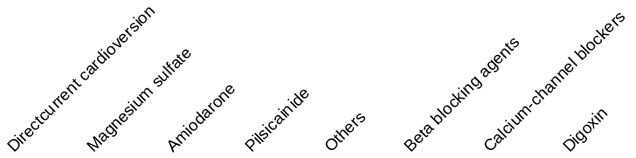
Additional fig. 1: Variation of combinations of the rhythm control therapy for each patient
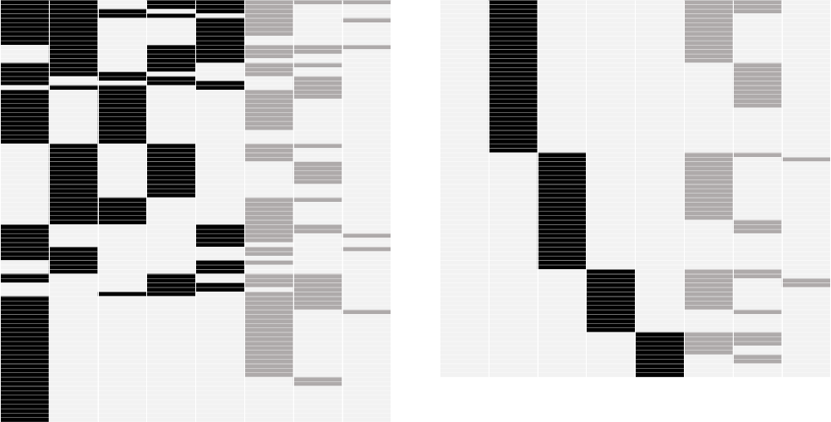

This figure shows the combinations of the interventions for new-onset atrial fibrillation in the rhythm control group. Each line shows the interventions for atrial fibrillation in each patient.

Additional fig. 2: Adjusted hazard ratios of variables as nonlinear estimation for rhythm control therapy
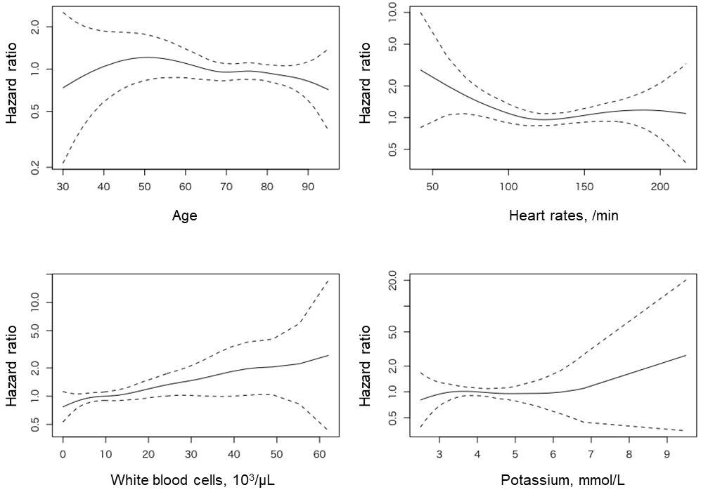

Solid lines with the 95% confidence intervals show adjusted hazard ratios by Cox proportional hazard regression analysis.
Additional fig. 3: Sensitivity analysis: adjusted hazard ratios of variables as nonlinear estimation for rhythm control drugs
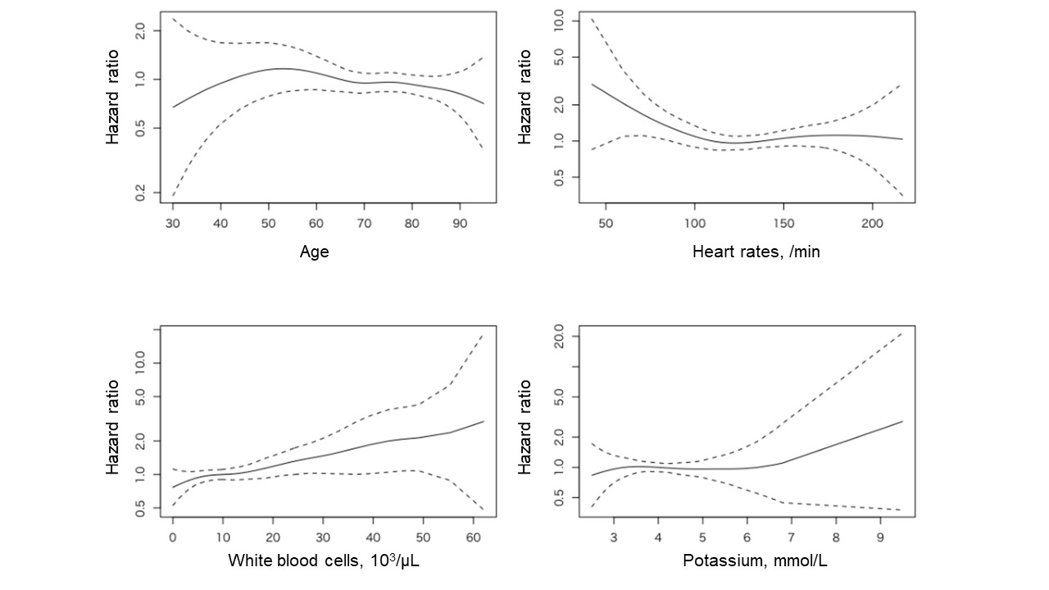
Solid lines with the 95% confidence intervals show adjusted hazard ratios by Cox proportional hazard regression analysis.

