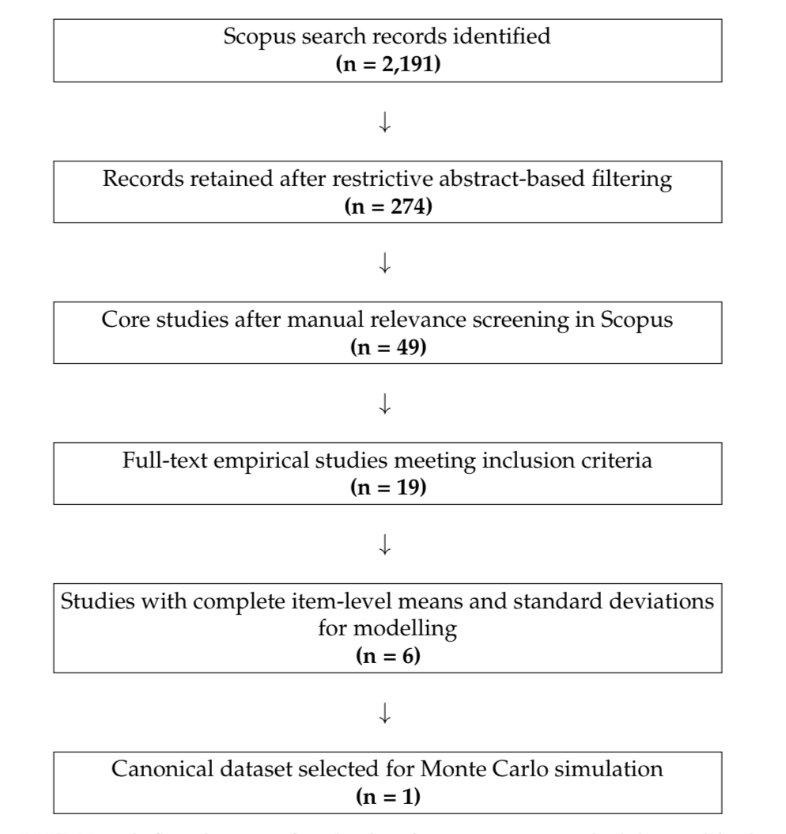

Figure 1. PRISMA-style flow diagram showing study identification, screening, eligibility, and final inclusion. From 2,191 Scopus records, 274 remained after restrictive abstract-based filtering, 49 were retained after manual relevance screening, 19 full-text empirical studies met the inclusion criteria, 6 provided item-level statistics suitable for modelling, and 1 canonical dataset was selected for Monte Carlo simulation.

Search Strategy

The literature search underlying the original simulation framework was conducted in Scopus. The search process was designed to identify empirical studies relevant to student perceptions, experiences, and evaluative dimensions of generative artificial intelligence in higher education.
The initial Scopus search identified 2,191 records. A restrictive abstract-based filtering stage was then applied, reducing the number of retained records to 274. These records were subsequently subjected to manual relevance screening, through which 49 core studies were retained for closer evaluation. Full-text assessment identified 19 empirical studies meeting the inclusion criteria. Among these, 6 studies reported complete item-level means and standard deviations suitable for modelling. From this subset, 1 canonical dataset was selected for the Monte Carlo simulation used in the present study.

Inclusion and Exclusion Criteria

Inclusion Criteria

Studies were included if they:
1. were empirical studies;
2. focused on generative artificial intelligence in higher education;
3. examined student perceptions, experiences, usability, or related evaluative dimensions;
4. met the relevance requirements during abstract-based and manual screening;
5. satisfied the full-text inclusion criteria; and
6. for modelling purposes, provided complete item-level means and standard deviations.

Exclusion Criteria

Studies were excluded if they:
1. were not empirical studies;
2. were not relevant to generative artificial intelligence in higher education;
3. did not focus on student-related perceptions, experiences, usability, or related evaluative dimensions;
4. were removed during restrictive abstract-based filtering or manual relevance screening; or
5. did not provide complete item-level means and standard deviations required for modelling.

Screening Summary

The search and screening process underlying the original simulation framework proceeded through multiple stages. The initial Scopus search identified 2,191 records. After restrictive abstract-based filtering, 274 records were retained. Manual relevance screening reduced this set to 49 core studies. Full-text assessment then identified 19 empirical studies meeting the inclusion criteria. Of these, 6 studies provided complete item-level means and standard deviations suitable for modelling. From this final subset, 1 canonical dataset was selected for the Monte Carlo simulation used as the empirical basis of the present article. This process is summarized in the accompanying PRISMA-style flow diagram.

