Decrease of soil total and organic phosphorus with ECM tree dominance in a subtropical mountainous forest
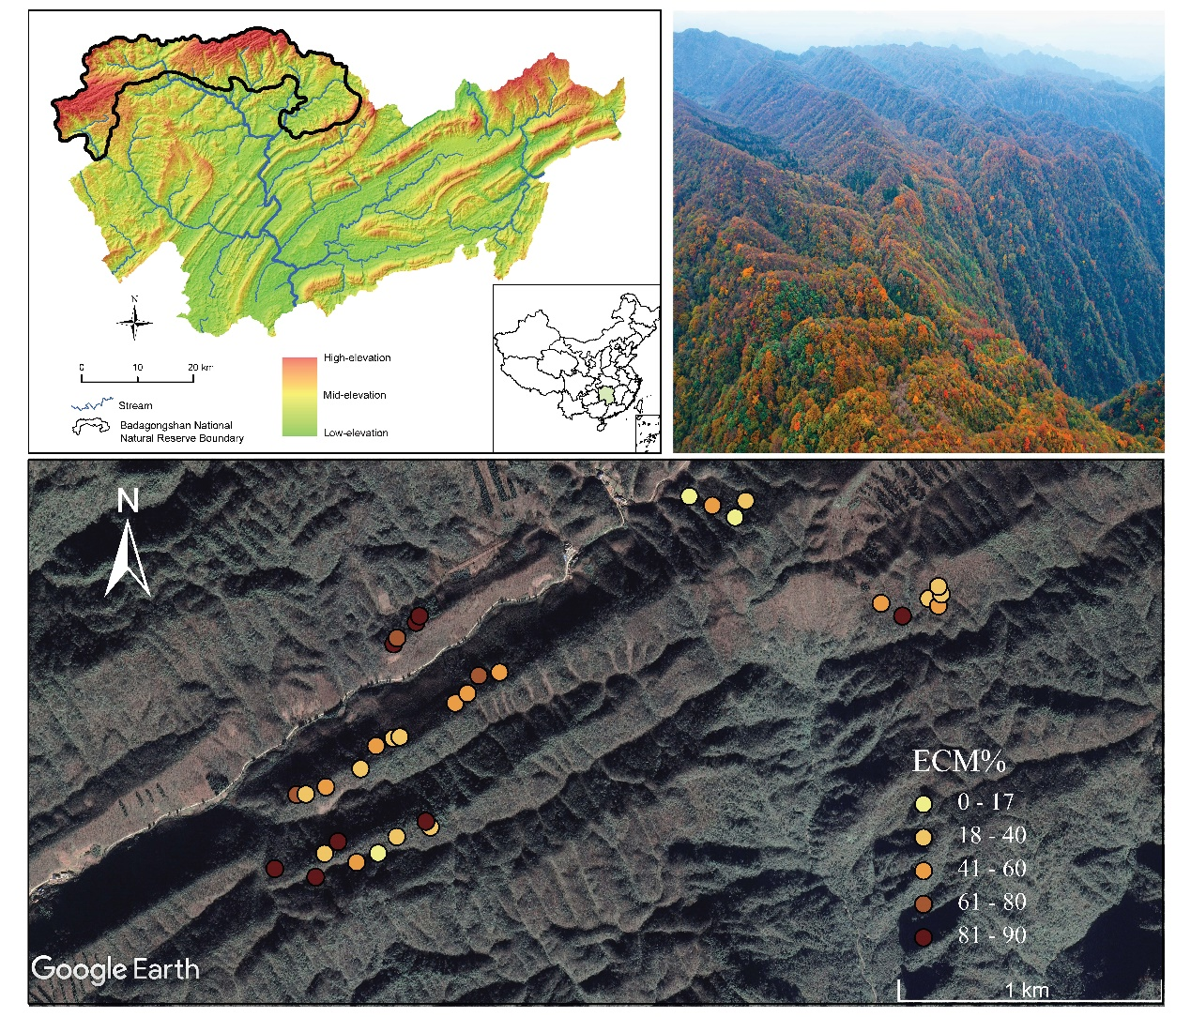
Fig. S1 Location of the 35 plots along the ECM tree dominance gradient in the subtropical mountainous forests.

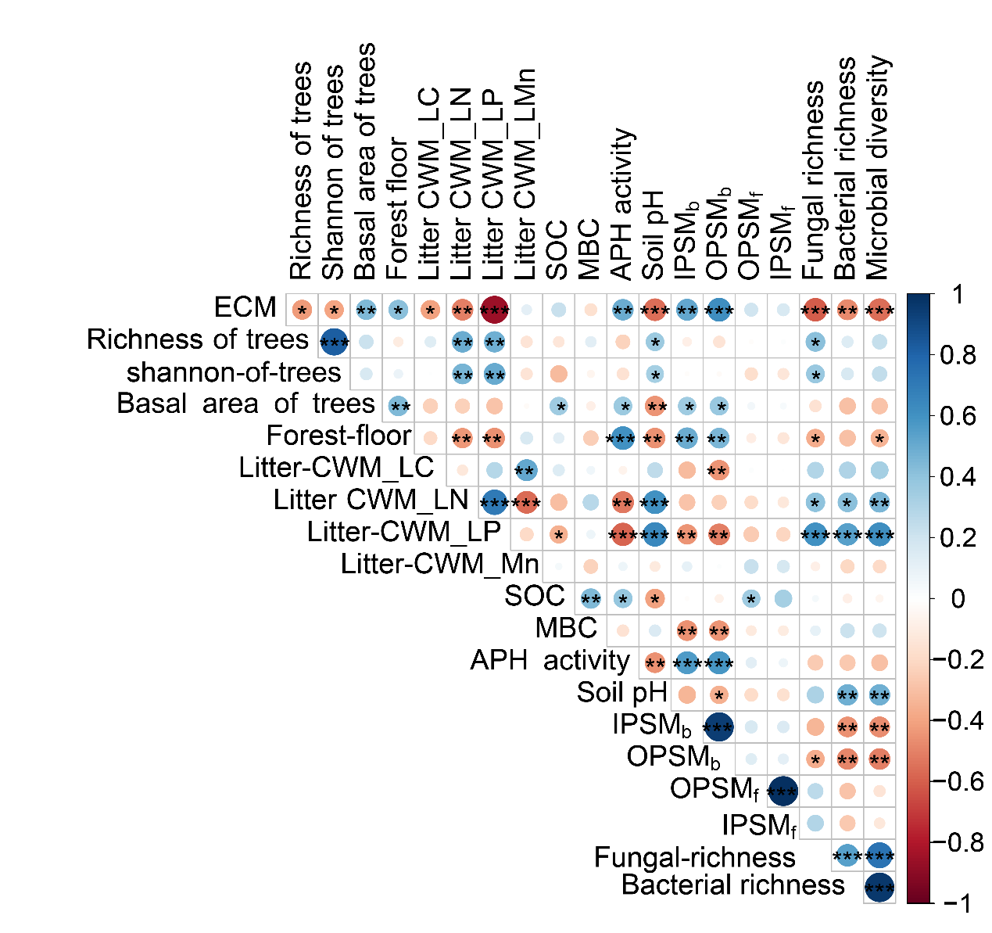
Fig. S2 Pearson’s correlation coefficient matrix among variables. The asterisk (*) denotes a significant difference between the corresponding variables at p < 0.05 level. Forest floor, the thickness of forest floor. Litter CWM_LC, Litter CWM_LN, Litter CWM_LP, Litter CWM_LMn, the community weighted mean litter C, N, P, and Mn. SOC, soil organic carbon. MBC, soil microbial biomass. APH activity, acid phosphatase activity. IPSM_{b} and OPSM_{b}, bacteria involved in inorganic P solubilization and organic P mineralization, respectively; IPSM_{f}, OPSM_{f}, fungi involved in inorganic P solubilization and organic P mineralization, respectively.

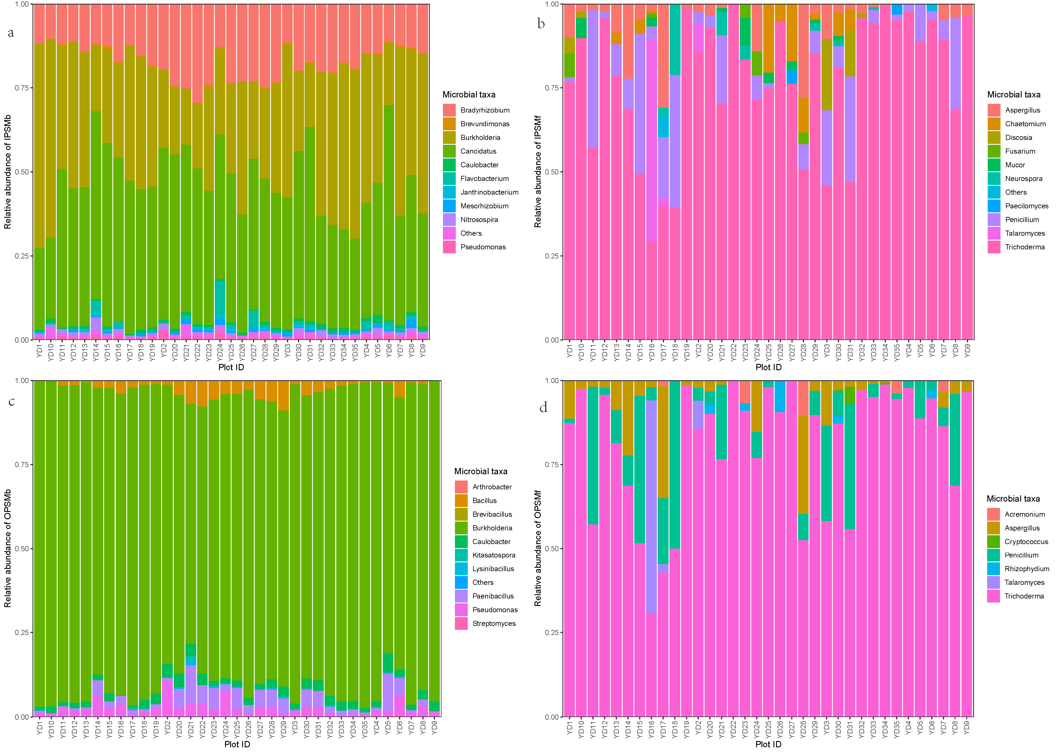
Fig. S3 Stacked bar chart of genus-level relative abundances for P cycling functional microbial groups. IPSM_{b} and OPSM_{b}, bacteria involved in inorganic P solubilization and organic P mineralization, respectively; IPSM_{f}, OPSM_{f}, fungi involved in inorganic P solubilization and organic P mineralization, respectively. Microbial community composition under different P degradation types (IPSM, OPSM) displays the relative abundance of the top 13 most abundant microbial genera (bacteria and fungi categorized by type). Each column represents one plot (YD1-YD35), with different colors corresponding to distinct microbial genera (specific taxa labeled in the legend), visually illustrating the relative abundance composition of each taxon across plots. The “Other” category denotes microorganisms not included among the top 10 most abundant genera.

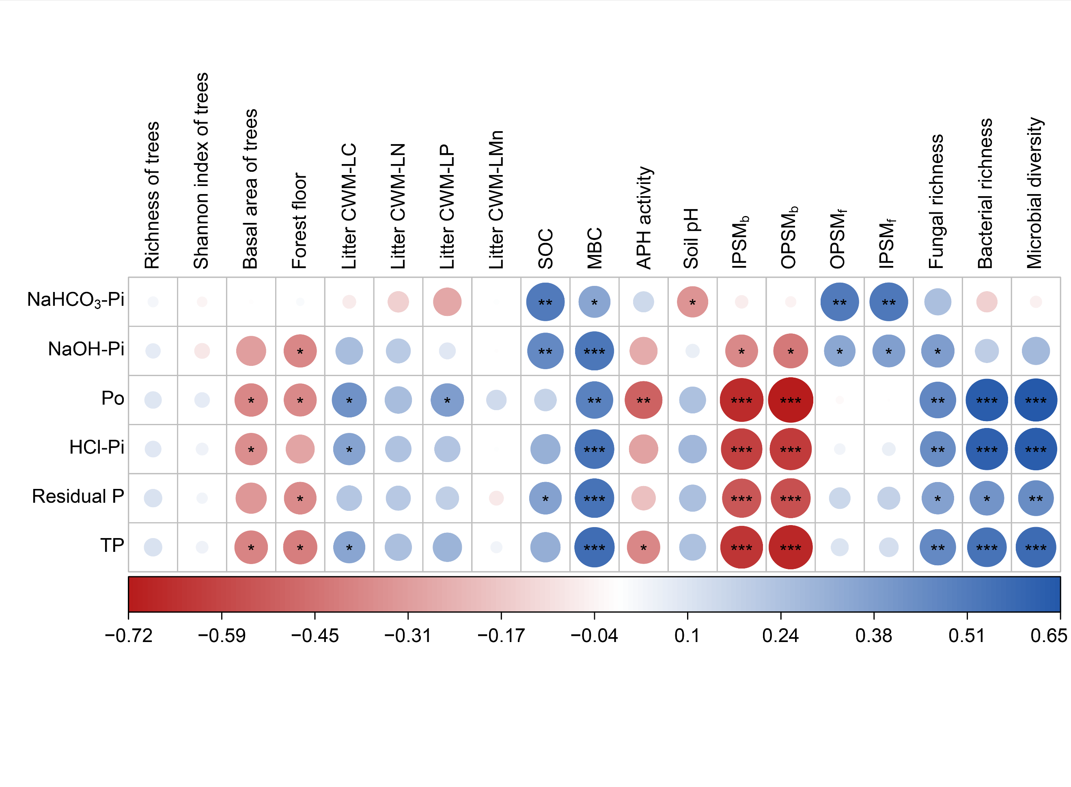Fig. S4 The Spearman correlation between biotic and abiotic variables and soil P fractions along the gradient of ECM tree dominance. *, ** and *** in the figure represent correlation levels p < 0.05, p < 0.01 and p < 0.001, respectively. Po, the sum of NaHCO₃-Po and NaOH-Po; Forest floor, the thickness of forest floor; Litter CWM-LC, Litter CWM-LN, Litter CWM-LP and Litter CWM-LMn, the community-weighted mean litter C, N, P, and Mn; SOC, soil organic carbon; MBC, microbial biomass carbon; APH activity, acid phosphatase activity; IPSM_{b} and OPSM_{b}, bacteria involved in inorganic P solubilization and organic P mineralization, respectively; IPSM_{f}, OPSM_{f}, fungi involved in inorganic P solubilization and organic P mineralization, respectively.

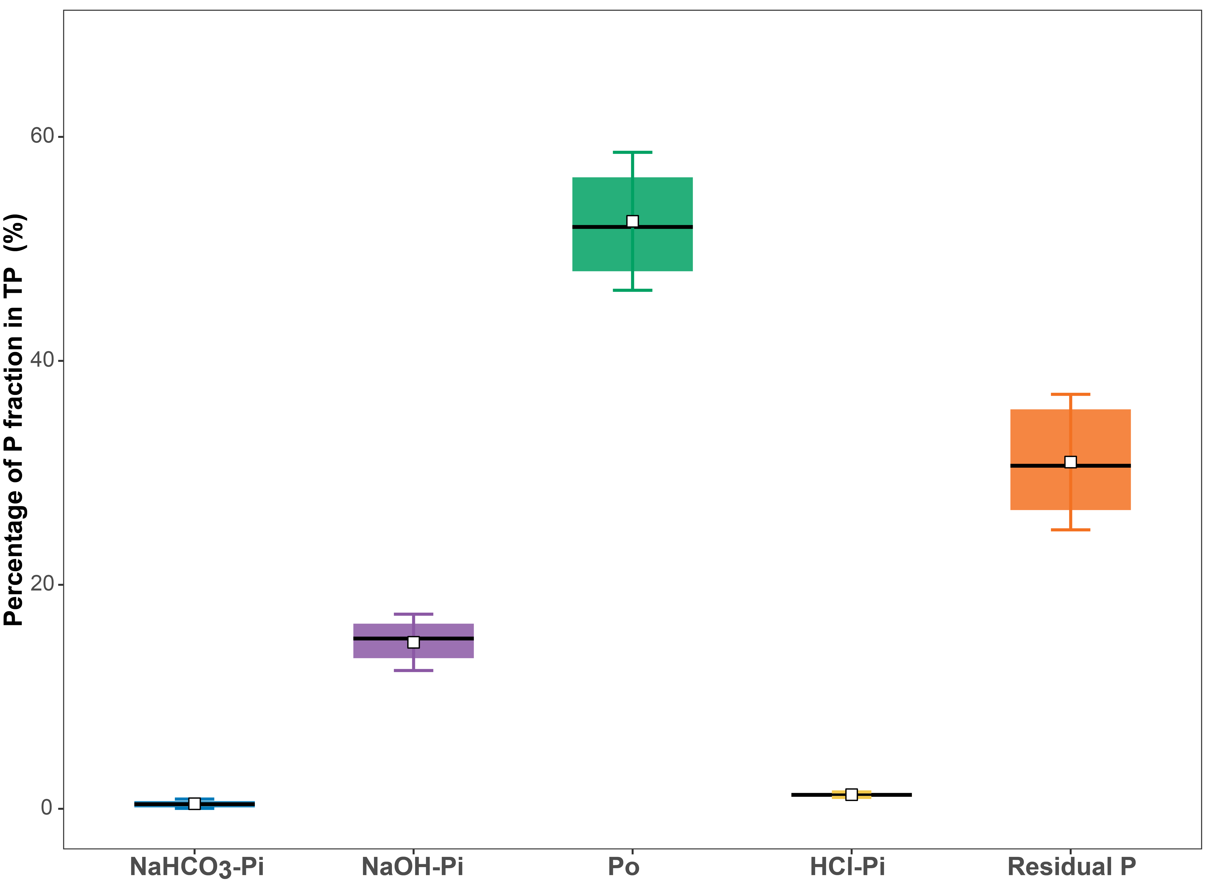
Fig. S5 Percentages of different P fractions in TP. Po, the sum of NaHCO₃-Po and NaOH-Po.

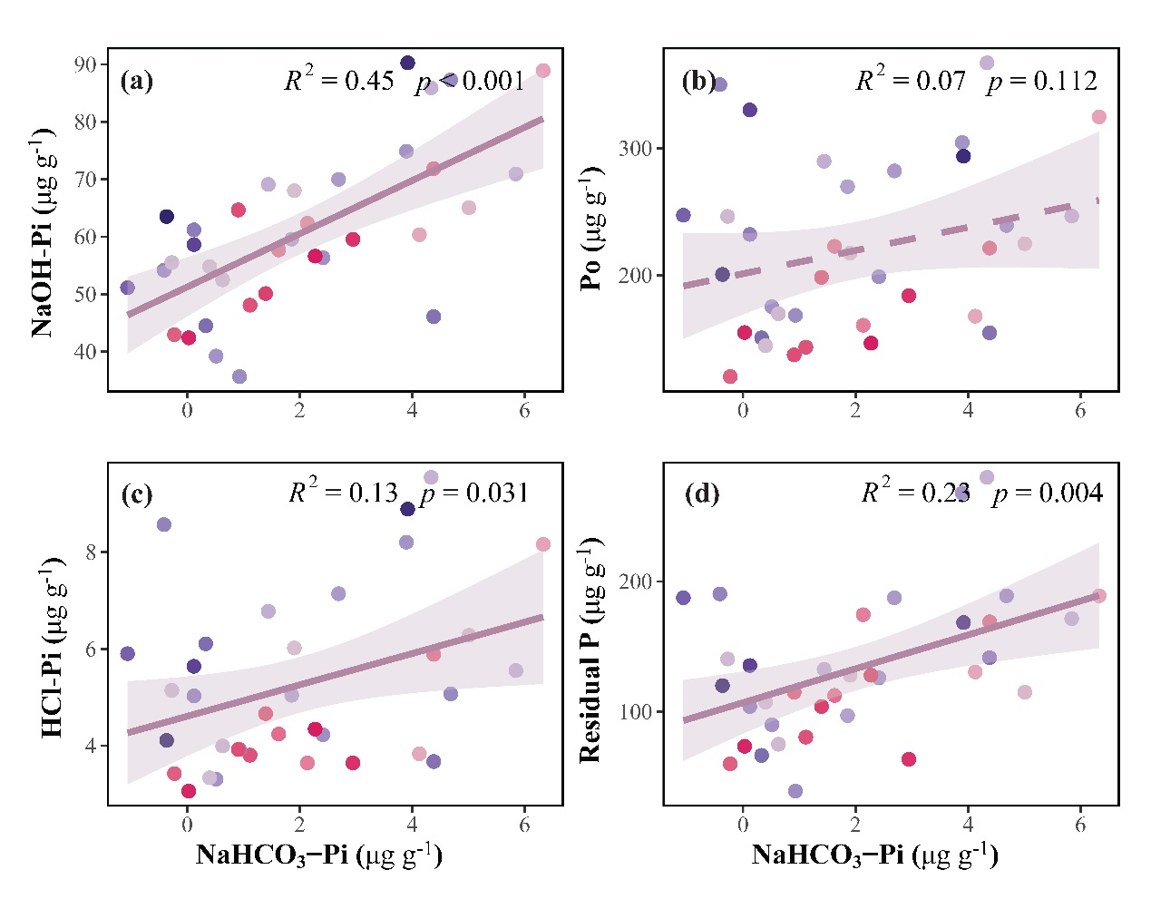
Fig. S6 Relationships between NaHCO₃-Pi content and the content of NaOH-Pi, Po, HCl-Pi, and residual P (n=35). Po, the sum of NaHCO₃-Po and NaOH-Po. Solid lines indicate significant correlation (p<0.05), and dashed lines indicate non-significant correlation.

Table S1 Listed the genus belongs to PSM
Group of PSM | Genus |  |  | Group of PSM | Genus
IPSM in bacterial community | Acetobacter |  |  | OPSM in bacterial community | Acinetobacter
 | Achromobacter |  |  |  | Arthrobacter
 | Acinetobacter |  |  |  | Bacillus
 | Actinomadura |  |  |  | Brevibacillus
 | Agromyces |  |  |  | Burkholderia
 | Aneurinibacillus |  |  |  | Caulobacter
 | Arthrobacter |  |  |  | Kitasatospora
 | Azospirillum |  |  |  | Lysinibacillus
 | Bradyrhizobium |  |  |  | Paenibacillus
 | Brevibacillus |  |  |  | Pseudomonas
 | Brevibacterium |  |  |  | Serratia
 | Brevundimonas |  |  |  | Streptomyces
 | Burkholderia
 | Candidatus
 | Caulobacter |  |  | IPSM in fungal community | Alternaria
 | Chryseobacterium |  |  |  | Aspergillus
 | Cupriavidus |  |  |  | Candida
 | Ensifer |  |  |  | Chaetomium
 | Erwinia |  |  |  | Discosia
 | Flavobacterium |  |  |  | Fusarium
 | Herbaspirillum |  |  |  | Mucor
 | Janthinobacterium |  |  |  | Neurospora
 | Kitasatospora |  |  |  | Paecilomyces
 | Leifsonia |  |  |  | Penicillium
 | Lysinibacillus |  |  |  | Piloderma
 | Mesorhizobium |  |  |  | Talaromyces
 | Microbacterium |  |  |  | Trichoderma
 | Microbispora
 | Micromonospora |  |  | OPSM in fungal community | Acremonium
 | Nitrosospira |  |  |  | Aspergillus
 | Nocardia |  |  |  | Cryptococcus
 | Novosphingobium |  |  |  | Penicillium
 | Pseudomonas |  |  |  | Rhizophydium
 | Ralstonia |  |  |  | Talaromyces
 | Rathayibacter |  |  |  | Trichoderma
 | Serratia
 | Sphingobium
 | Streptacidiophilus
 | Streptosporangium
 | Xanthomonas
(IPSM and OPSM, microorganisms involved in inorganic P solubilization and organic P mineralization, respectively)

