Supplementary Information

Electrically Driven Meron-Antimeron Pairs in a Magnetic Domain Wall
Jiseok Yang¹, Taekhyeon Lee¹, San Ko¹, Soogil Lee², Mincheol Shin³, Kyoung-Woong Moon^{4†}, Sanghoon Kim^{5†}, Se Kwon Kim^{1,6†}, and Kab-Jin Kim^{1,6†}

¹Department of Physics, KAIST, Daejeon 34141, Republic of Korea
²Department of Semiconductor Engineering, Gachon University, Seongnam 13120, Republic of Korea
³School of Electrical Engineering, KAIST, Daejeon 34141, Republic of Korea
⁴Quantum Spin Team, Korea Research Institute of Standards and Science, Daejeon 34113, Republic of Korea
⁵Department of Physics, University of Ulsan, Ulsan 44610, Republic of Korea
⁶Graduate School of Quantum Science and Technology, KAIST, Daejeon 34141, Republic of Korea

† Correspondence to: kwmoon@kriss.re.kr, sanghoon.kim@ulsan.ac.kr, sekwonkim@kaist.ac.kr, kabjin@kaist.ac.kr

The PDF file includes:
Supplementary Figures 1 to 4
Captions for supplementary movies
Other Supplementary Material for this manuscript includes the following:
Supplementary Movies S1 to S3

Supplementary figures

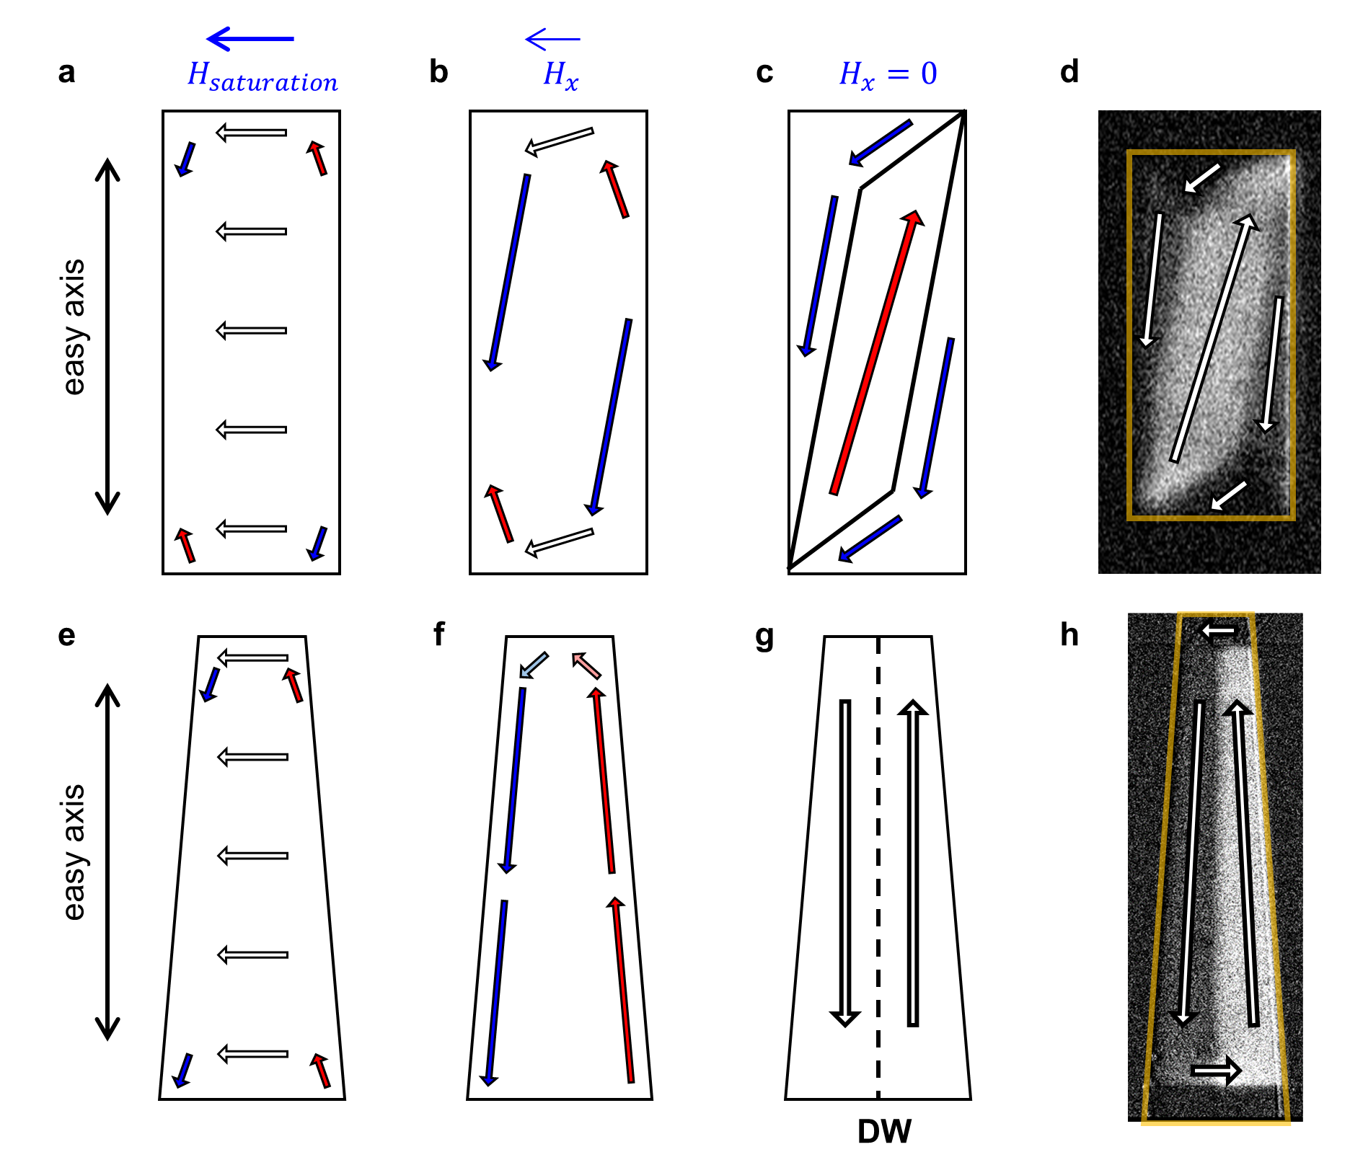
Fig. S1. Formation of Domain Walls in Rectangular and Trapezoidal Devices. a-c, Schematics illustrating domain configurations in a rectangular device: A diagonal domain pattern forms when a transverse field pulse ($H_{x}^{ini}$) is applied. d, L-MOKE image showing the resulting domain configuration in a rectangular device after the transverse field is removed. e-g, Schematics depicting domain configurations in a trapezoidal device: A central domain wall (DW) can be reliably formed due to the geometry's influence. h, L-MOKE image displaying a well-defined central DW in the trapezoidal device after a transverse field pulse.

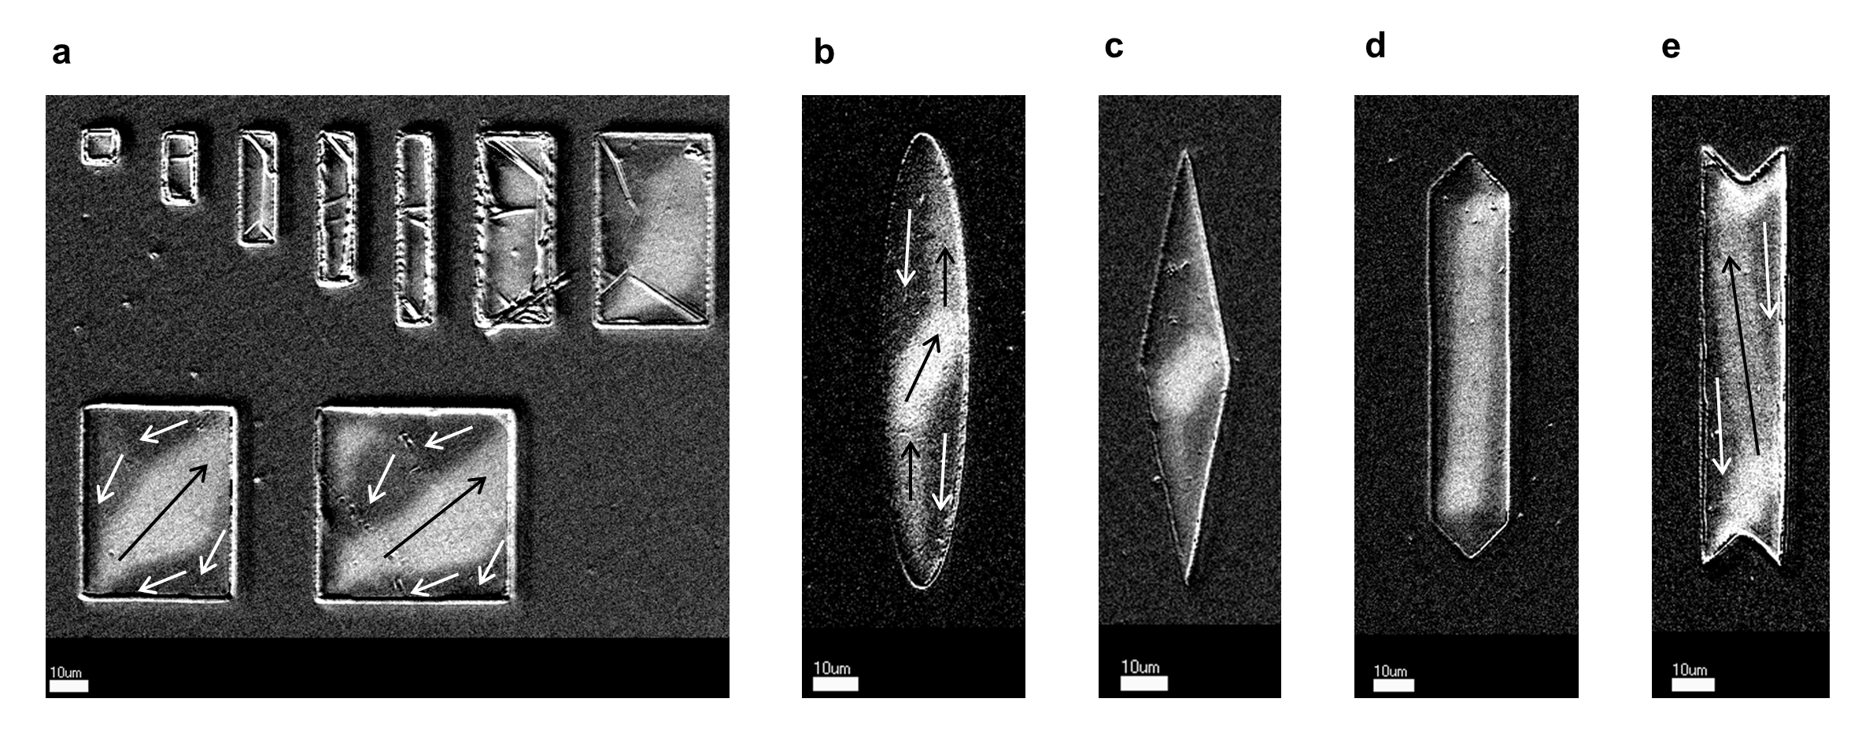
Fig. S2. L-MOKE images showing domain configurations observed in various device geometries. a, Rectangular devices with various dimensions. b, Elliptical devices. c, Diamond-shaped devices. d, Elongated hexagonal devices. e, Wedged wire devices. Each geometry demonstrates distinct domain formation patterns, illustrating the influence of device shape on magnetic domain configurations. The scale bar represents 10 µm.

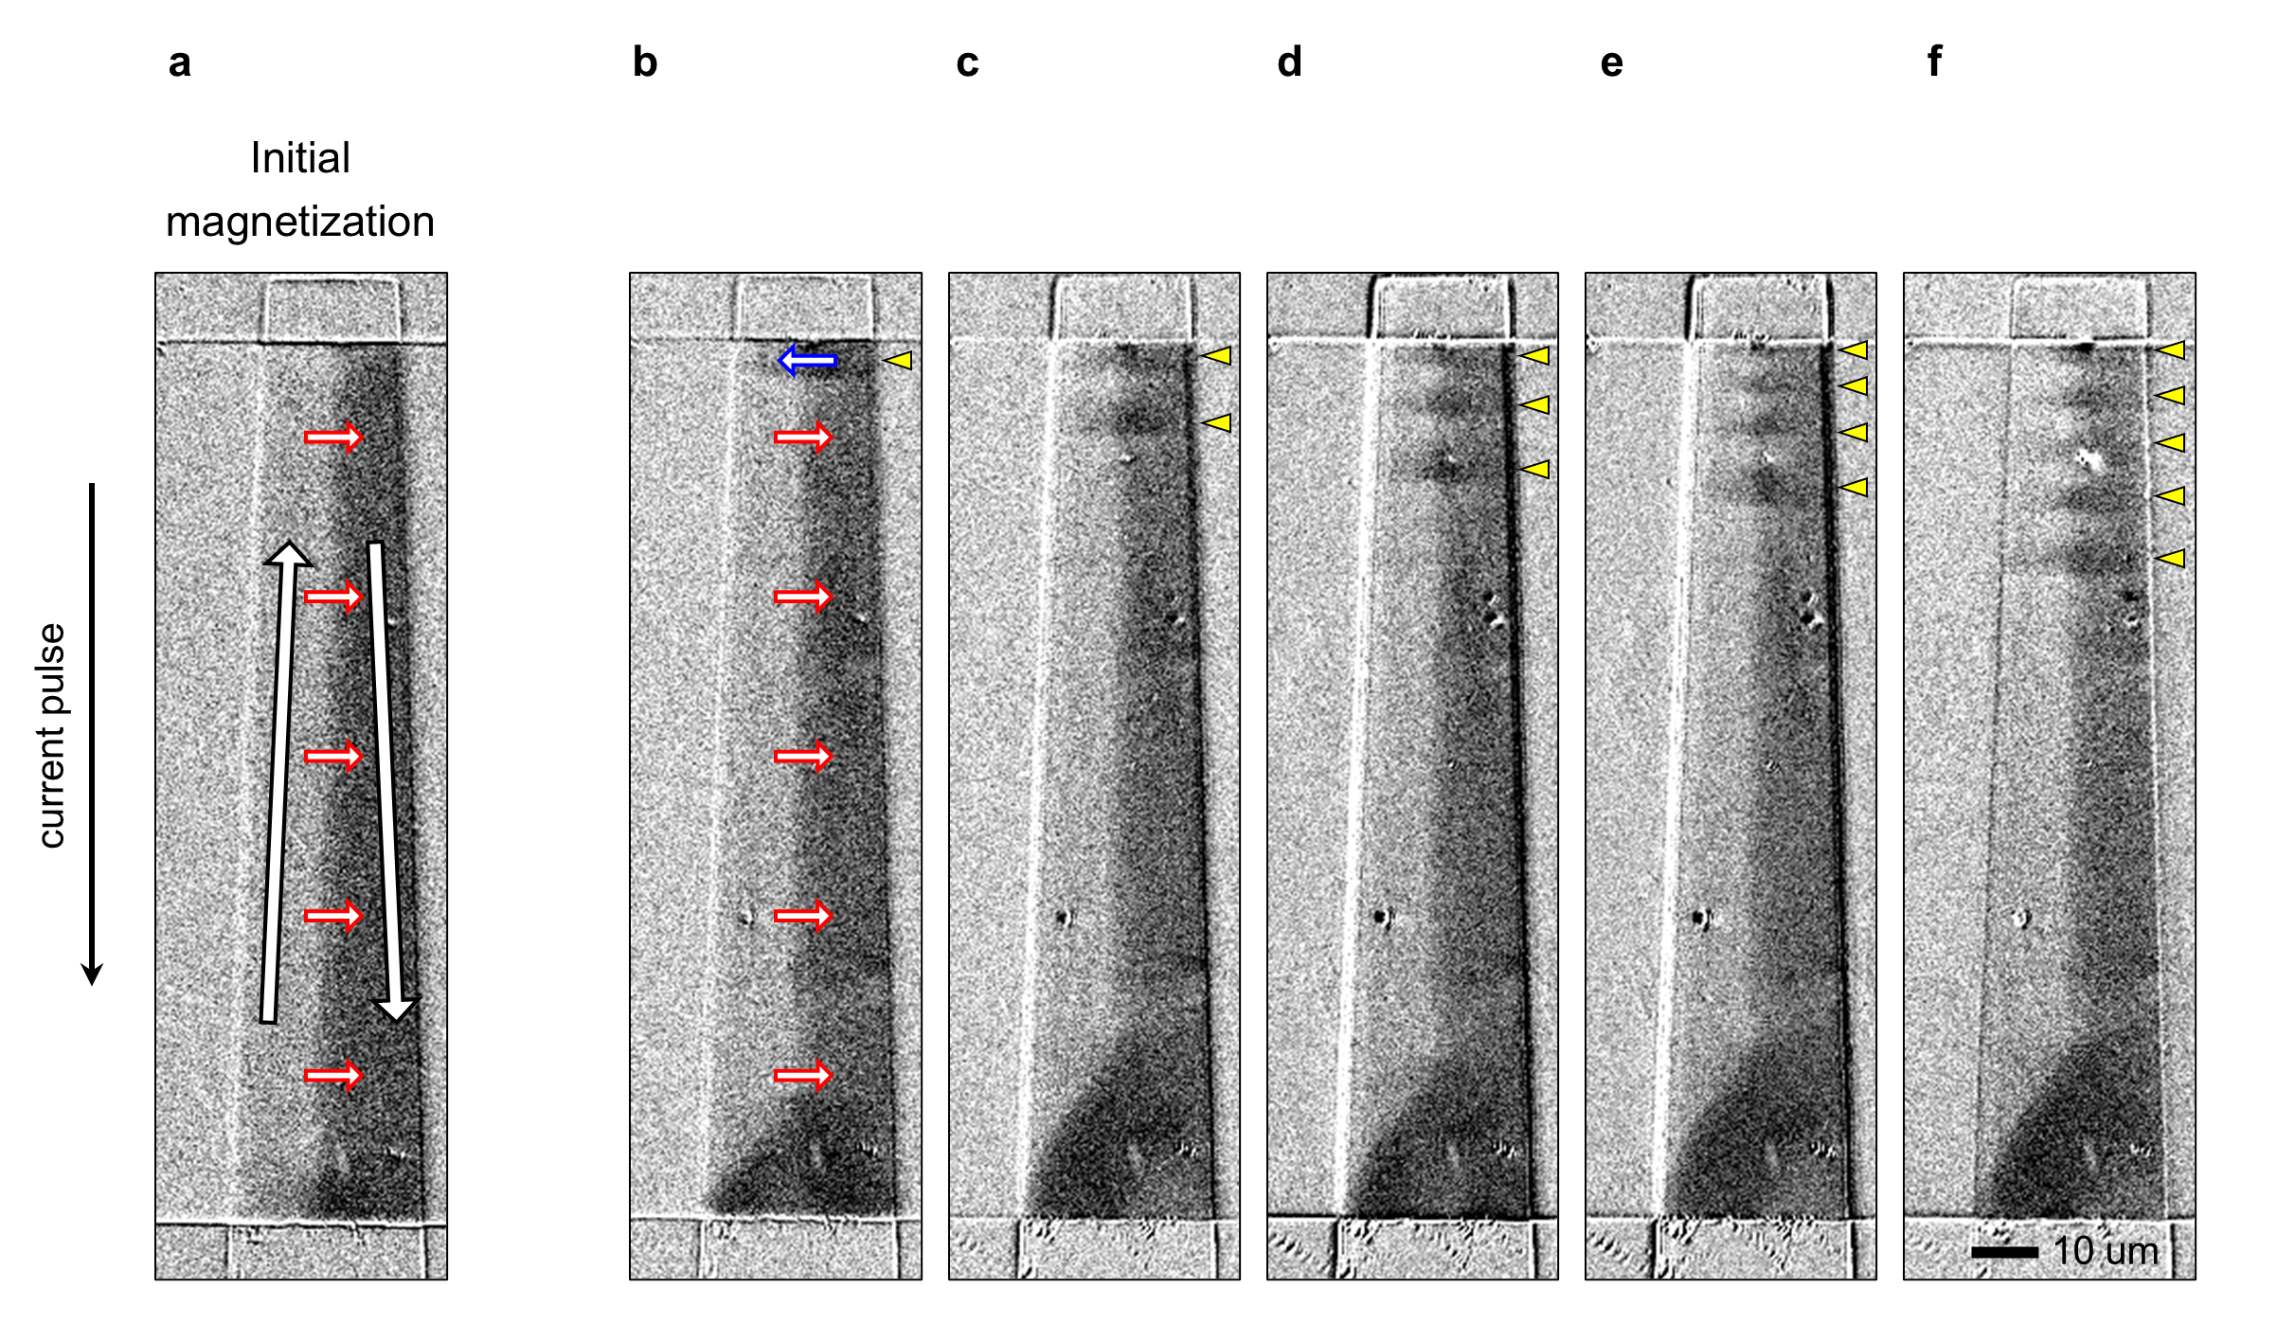
Fig. S3. Current-induced injection and propagation of meron-antimeron pairs, with an opposite domain configurations and current pulses from those of Figs. 3d-3i. a, L-MOKE image showing the initial magnetization direction after applying $H_{x}^{ini}=100 Oe$ along the $+x$ direction, which is opposite configuration compared to Fig. 3 of the main text. b-f, L-MOKE image sequence indicating the sequential injection and propagation of meron-antimeron pairs under repeated current pulses. Yellow arrowheads mark the locations of meron-antimeron pairs. The scale bar represents 10 µm.

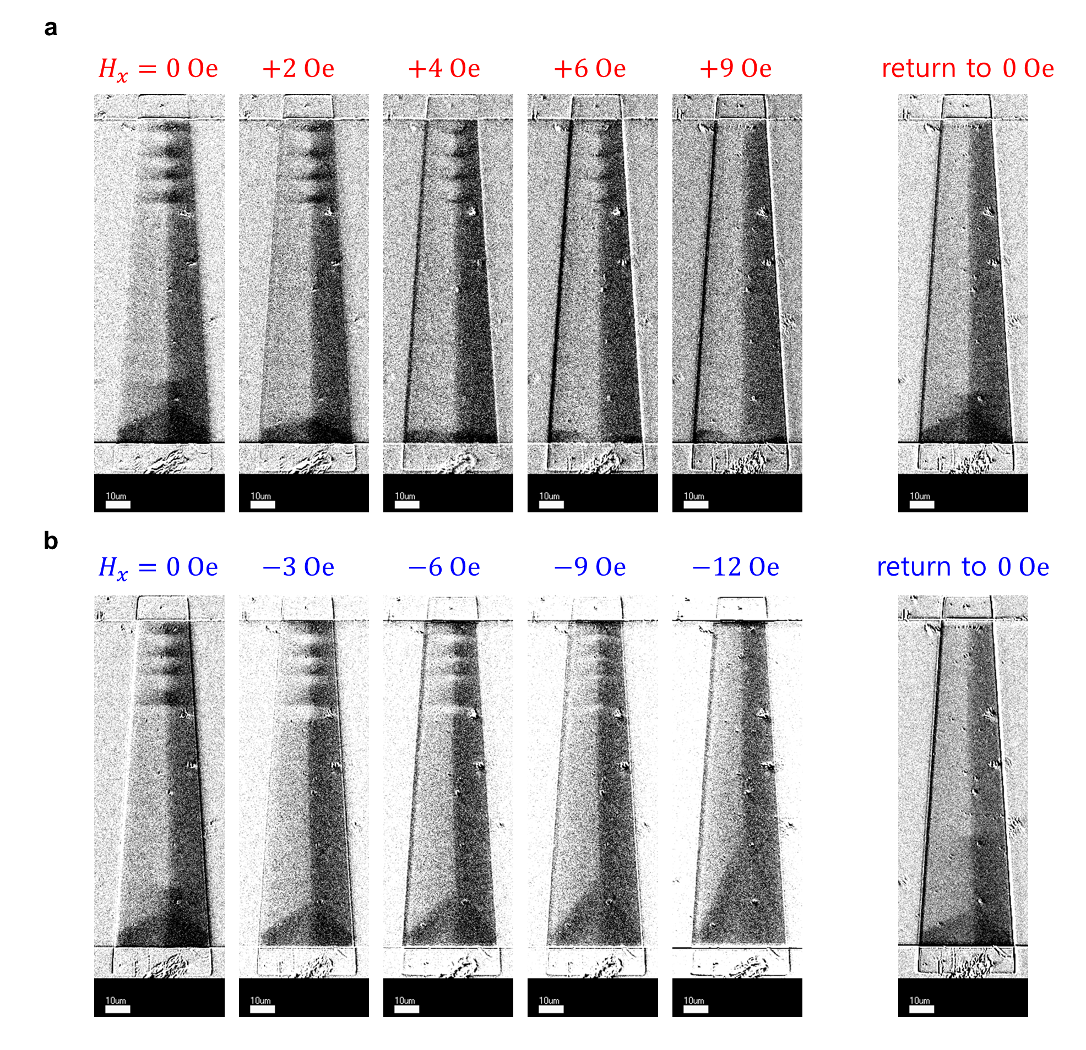
Fig. S4. Demonstration of topological energy barriers in meron-antimeron pair annihilation with opposite domain configurations. a, L-MOKE images showing the effect of a gradually increasing transverse magnetic field ($H_{x}$) from 0 Oe to +9 Oe, followed by a return to 0 Oe. b, L-MOKE images showing the effect of a decreasing transverse magnetic field ($H_{x}$) from 0 Oe to -12 Oe, followed by a return to 0 Oe. These results complement the observations in Fig. 4 of the main text with an opposite magnetization configuration.

Captions for supplementary movies
Movies S1. Meron_antimeron_formation.mp4 Micromagnetic simulations of the formation of a meron-antimeron pair. (left) Formation of antimeron (vortex with core up, $N=+1/2$)-meron (antivortex with core up, $N=-1/2$) pair. (right) Formation of meron (vortex with core down, $N=-1/2$)-antimeron (antivortex with core down, $N=+1/2$) pair. Both processes conserve the total topological number.
Movies S2. Sequential_injection_MUMAX.mp4 Micromagnetic simulations of the sequential injection of meron-antimeron pairs shown in Fig. 1b-1f in the main text. The total simulation time is 48 ns, consisting of a repeated 4 times of 12 ns process–2 ns for applying current-induced Oersted field to form a meron-antimeron pair, followed by 10 ns for relaxation without external field.
Movies S3. Sequential_injection_MOKE.mp4 L-MOKE image sequence of the sequential injection of meron-antimeron pairs shown in Fig. 3d-3i in the main text. MOKE images were taken one second after each current pulse was applied, with each image averaged over 100 frames.

