Table 3 Synthesis of benzimidazoles (3a-j) by the use of the Ni-supported nano-catalystª
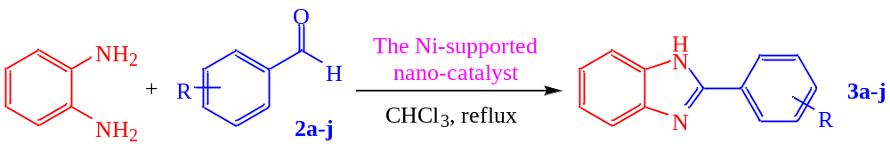
Entry | Aldehyde | Benzimidazole | Time  (min) | M.P.  (°C) | Yield (%)^{b} | TON^{c} | TOF^{d}
1 | 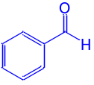2a | 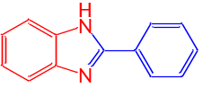3a | 30 | 290-292 | 95 | 25 | 0.83
2 | 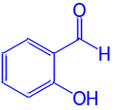2b | 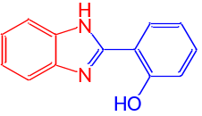3b | 60 | 200-202 | 92 | 25.87 | 0.43
3 | 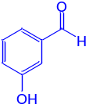2c | 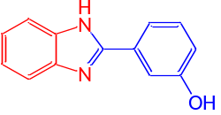3c | 40 | 228-230 | 92 | 25.87 | 0.64
4 | 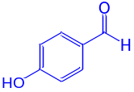2d | 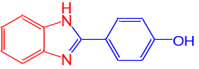3d | 60 | 250-252 | 89 | 26.75 | 0.44
5 | 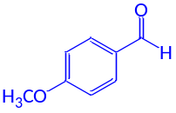2e | 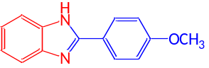3e | 40 | 207-209 | 87 | 27.36 | 0.68
6 | 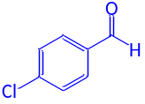2f | 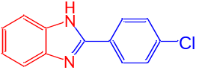3f | 60 | 210-213 | 91 | 26.16 | 0.43
7 | 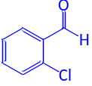2g | 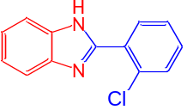3g | 60 | 231-234 | 93 | 25.6 | 0.42
8 | 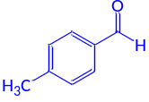2h | 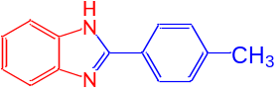3h | 60 | 271-274 | 90 | 26.45 | 0.44
9 | 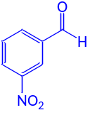2i | 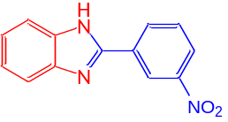3i | 40 | 217-220 | 89 | 26.75 | 0.66
10 | 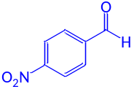2j | 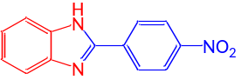3j | 30 | >350 | 91 | 26.16 | 0.87
ªReaction conditions: PhenDA (1.0 mmole), aldehyde (1.0 mmole) and the Ni-supported nano-catalyst (20 mg) in CHCl₃ at reflux conditions (3.0 mL).
^{b}Isolated yield.
^{c}TON (turn over number): moles of aldehyde (1.0 mmole) converted per mole of catalyst (20 mg). According to the ICP measurement, the content of Ni in the catalyst is about 49.7%, so the mmole of Ni in 20 mg of the catalyst is 49.7÷20=2.485÷58.7=0.042. For the entry 1, since the yield is about 95%, the effective mmole of Ni is about 0.042×0.95=0.04 and so the TON is 1÷0.04=25.
^{d}TOF (turn over frequency): TOF=TON÷time. For the entry 1, since the time is about 30 min, the TOF is 25÷30=0.83.

