Supporting Information

Medicinal Chemistry Research

The biological investigations of a benzoguanamine-based nickel complex and its application as a capable nano‐catalyst for the synthesis of benzimidazoles

Sajjad Oliaei,ª Davood Habibi,ª* Somayyeh Heydari,^{ab} Roya Karamian,^{c} Nika Ranjbar^{d}

ªDepartment of Organic Chemistry, Faculty of Chemistry, Bu-Ali Sina University, Hamedan 6517838683, Iran
^{b}Department of Research and Development of the Faran Shimi Pharmaceutical Company, Tuyserkan, Iran
^{c}Department of Biology, College of Science, Bu-Ali Sina University, Hamedan 6517838683, Iran
^{d}Department of Microbiology, School of Biology, College of Science, University of Tehran, Tehran, Iran
*Corresponding author email: davood.habibi@gmail.com, Tel: +98 81 38380922; Fax: +98 81 38380709

Contents Page

IR of 3a 2
HNMR of 3a 2
CNMR of 3a 3

IR of 3b 4
HNMR of 3b 4
CNMR of 3b 5

IR of 3c 6
HNMR of 3c 6
CNMR of 3c 7

IR of 3d 8
HNMR of 3d 8
CNMR of 3d 9

IR of 3e 10
HNMR of 3e 10
CNMR of 3e 11

IR of 3f 12
HNMR of 3f 12
CNMR of 3f 13

IR of 3g 14
HNMR of 3g 14
CNMR of 3g 15

IR of 3h 16
HNMR of 3h 16

IR of 3i 17
HNMR of 3i 17
CNMR of 3i 18
IR of 3j 17
HNMR of 3j 17
CNMR of 3j 18

IR of 3a
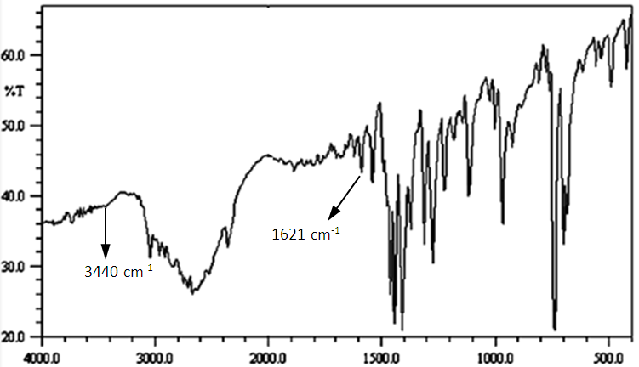

H NMR of 3a
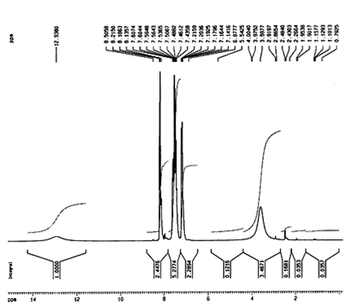

C NMR of 3a
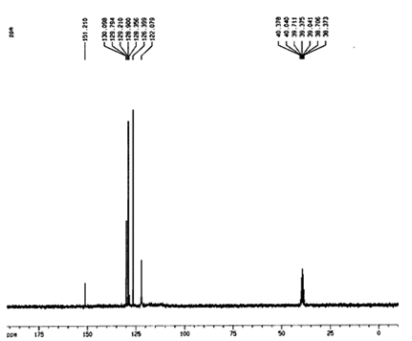

IR of 3b
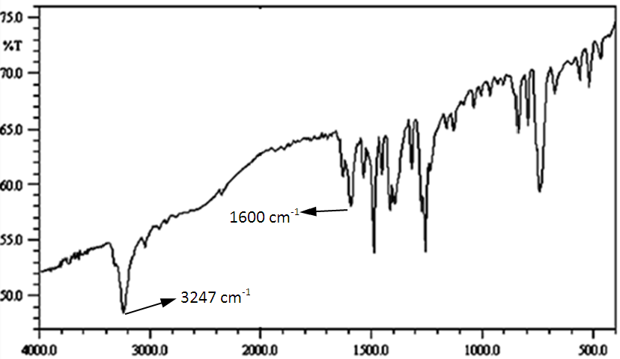

H NMR of 3b
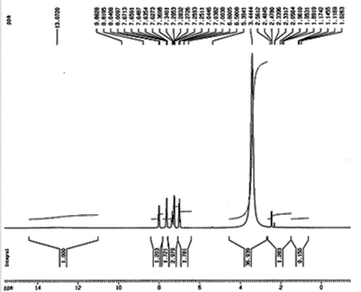

C NMR of 3b
0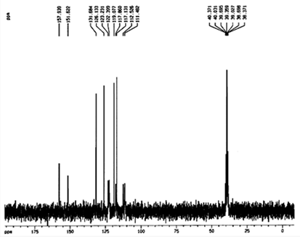

IR of 3c
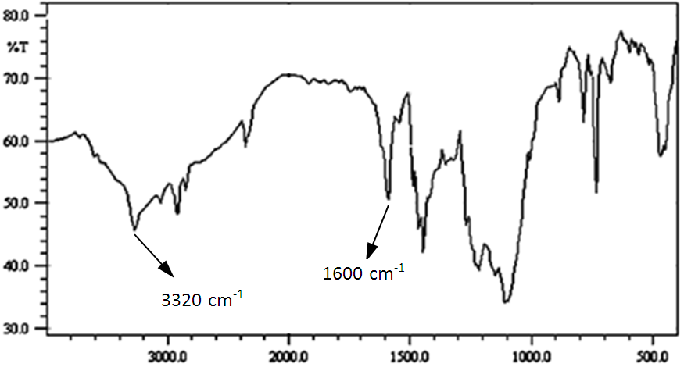

H NMR of 3c
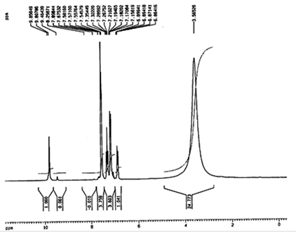

C NMR of 3c
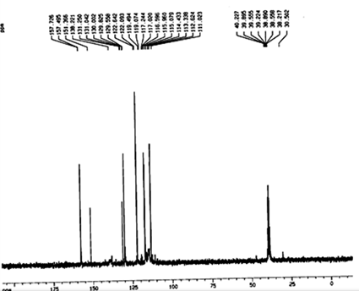

IR of 3d
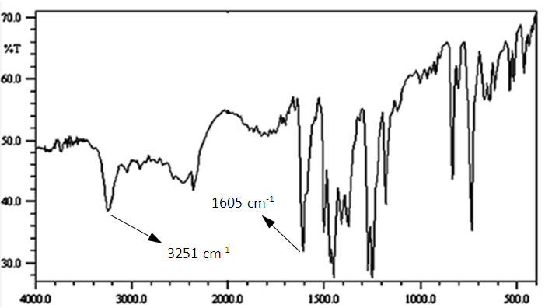

H NMR of 3d
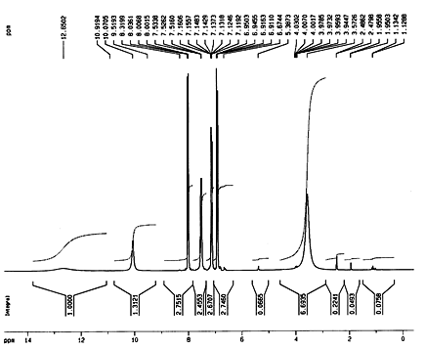

C NMR of 3d
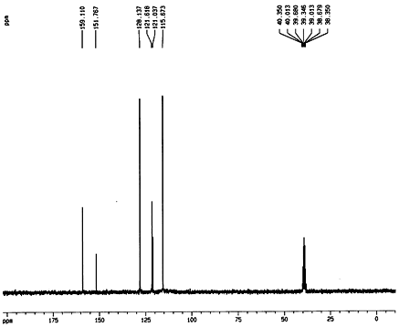

IR of 3e
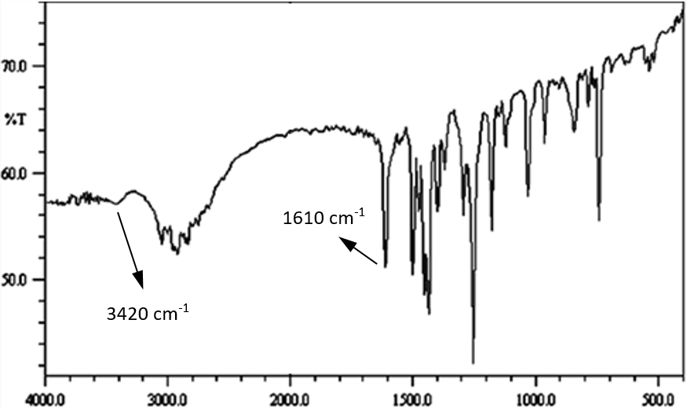

H NMR of 3e
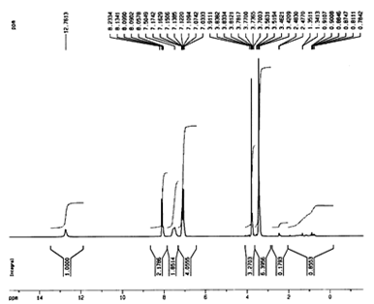

C NMR of 3e
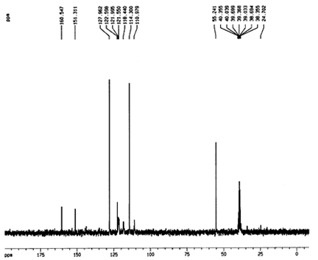

IR of 3f
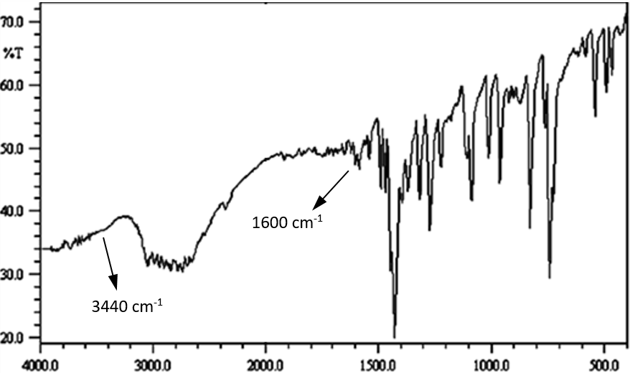

H NMR of 3f
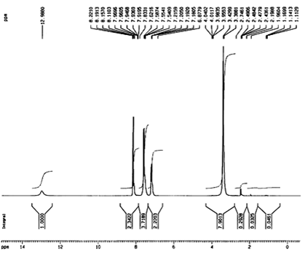

C NMR of 3f
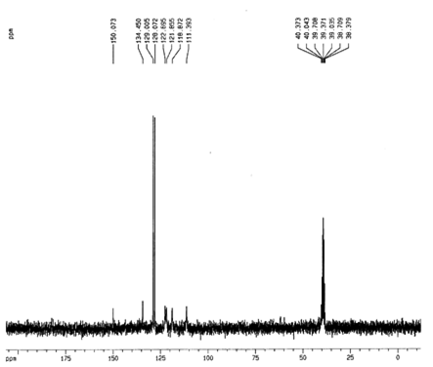

IR of 2h
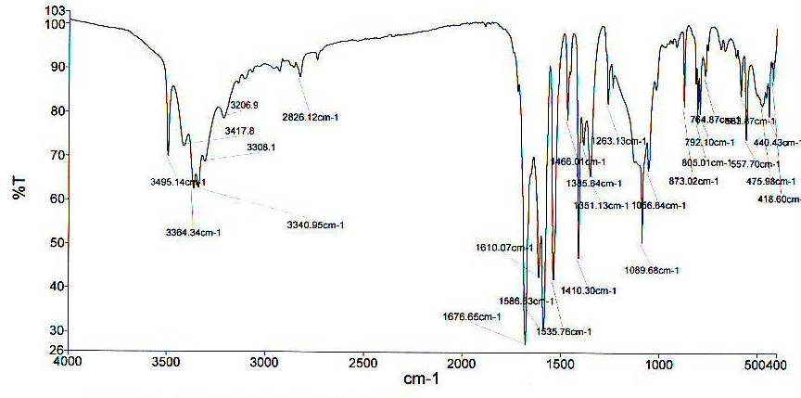

HNMR of 2h
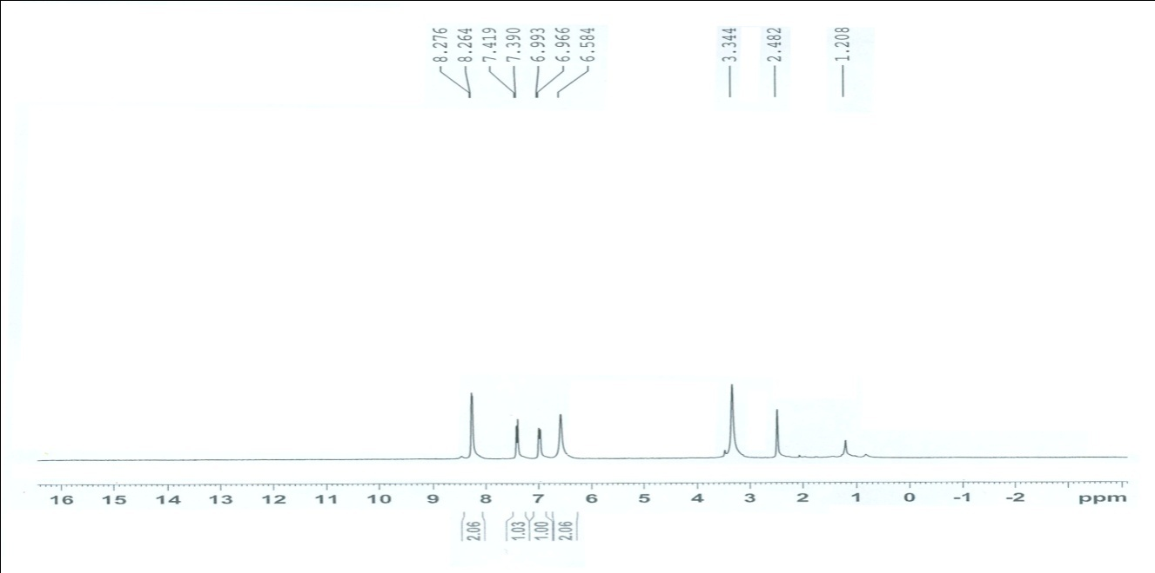

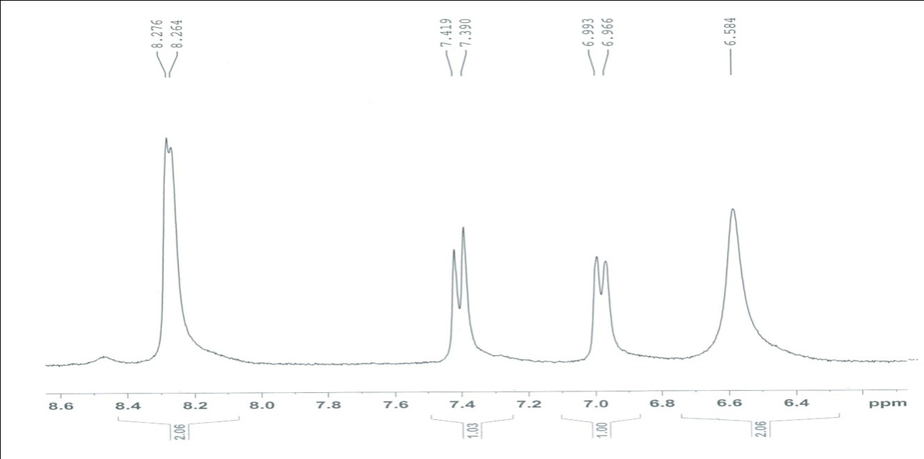

CNMR of 2h
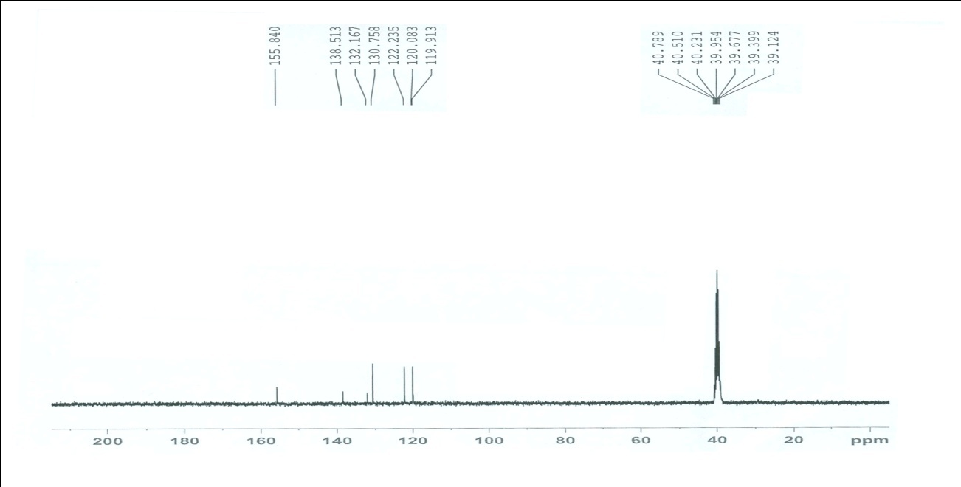

IR of 2i
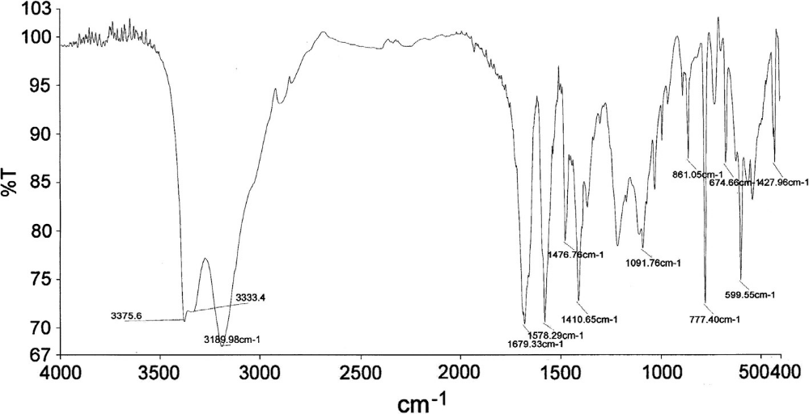

HNMR of 2i
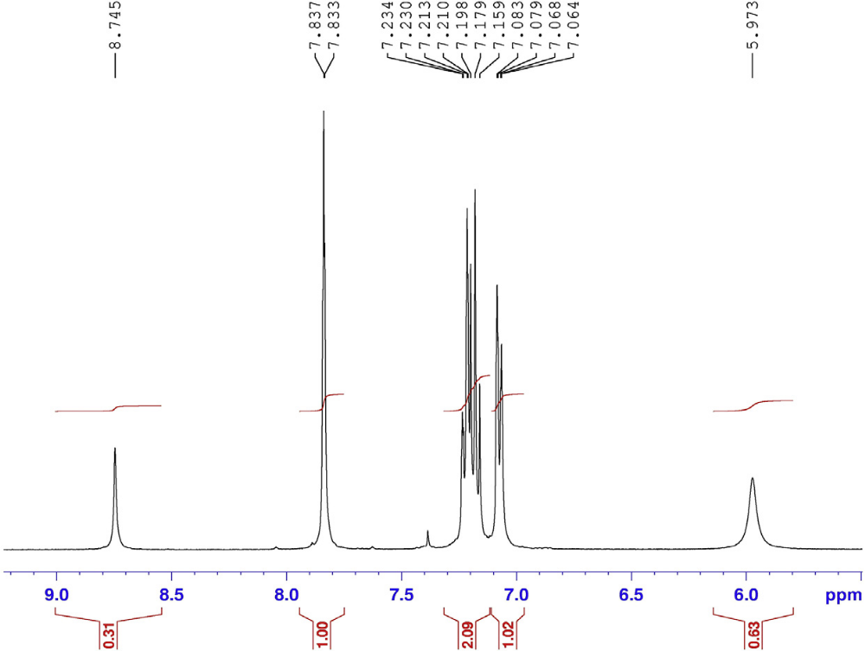

IR of 2j
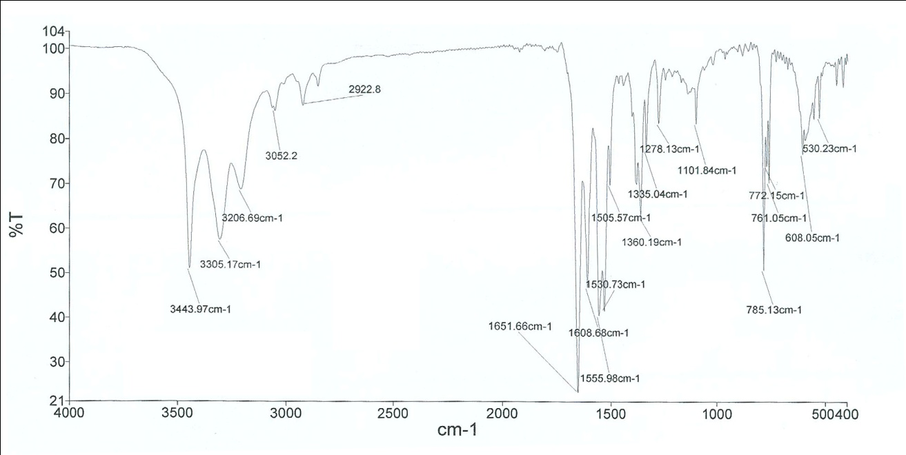

HNMR of 2j
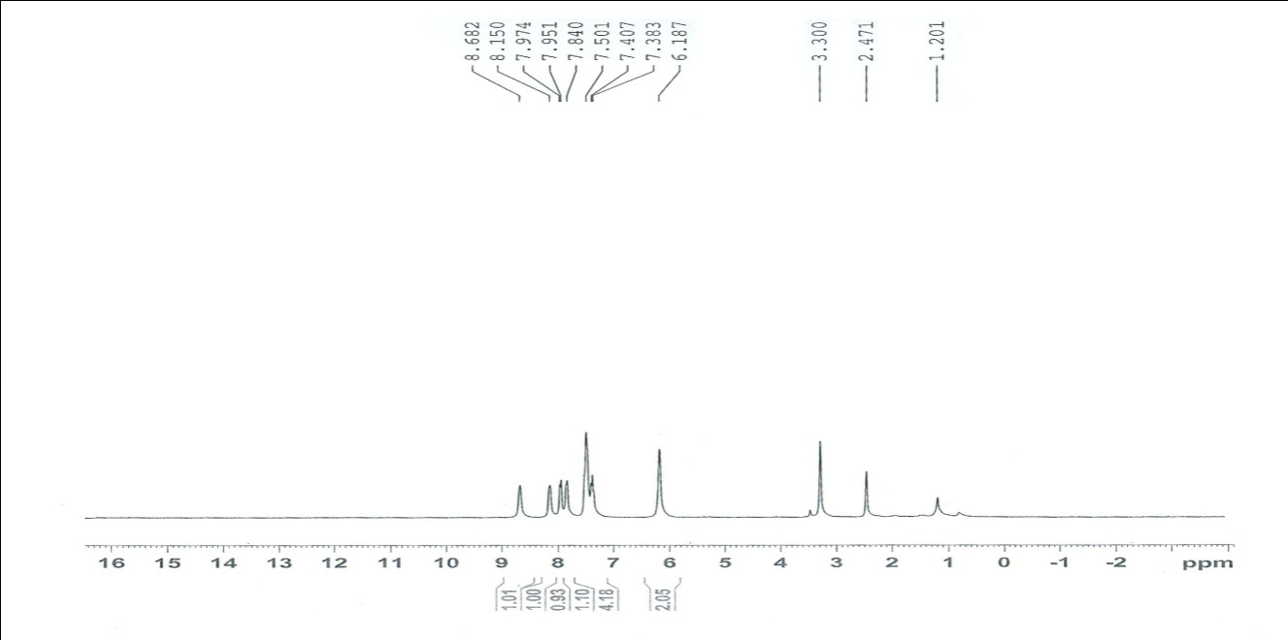

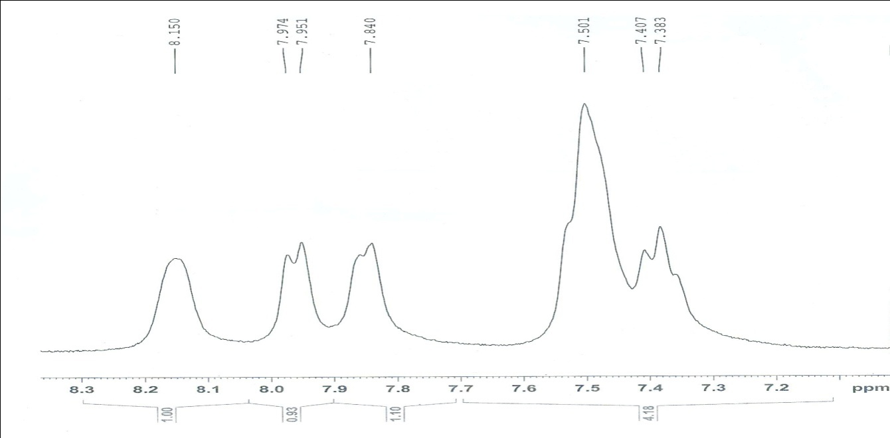

CNMR of 2j
