SUPPLEMENTARY FILE
Table S1. KR-20 reliability coefficients for the four BALSA instruments.
Instrument | No. of items | N | KR-20 | Mean inter-item r
Grade 2 Numeracy | 15 | 30392 | 0.87 | 0.32
Grade 4 Numeracy | 20 | 27081 | 0.86 | 0.23
Grade 2 Literacy | 15 | 30392 | 0.87 | 0.31
Grade 4 Literacy | 20 | 27081 | 0.86 | 0.24

Table S2. Item statistics for Grade 2 Numeracy (N = 30,392).
Item | Difficulty (p) | SD | Corrected r | α if deleted
NQ1 | 0.66 | 0.48 | 0.52 | 0.87
NQ2 | 0.59 | 0.49 | 0.54 | 0.87
NQ3 | 0.54 | 0.50 | 0.55 | 0.87
NQ4 | 0.57 | 0.50 | 0.61 | 0.87
NQ5 | 0.49 | 0.50 | 0.57 | 0.87
NQ6 | 0.51 | 0.50 | 0.61 | 0.87
NQ7 | 0.44 | 0.50 | 0.62 | 0.86
NQ8 | 0.49 | 0.50 | 0.65 | 0.86
NQ9 | 0.51 | 0.50 | 0.64 | 0.86
NQ10 | 0.35 | 0.48 | 0.48 | 0.87
NQ11 | 0.41 | 0.49 | 0.59 | 0.87
NQ12 | 0.32 | 0.47 | 0.46 | 0.87
NQ13 | 0.38 | 0.49 | 0.57 | 0.87
NQ14 | 0.37 | 0.48 | 0.56 | 0.87
NQ15 | 0.43 | 0.50 | 0.54 | 0.87

Table S3. Item statistics for Grade 4 Numeracy (N = 27,081).
Item | Difficulty (p) | SD | Corrected r | α if deleted
NQ1 | 0.56 | 0.50 | 0.41 | 0.86
NQ2 | 0.73 | 0.45 | 0.33 | 0.86
NQ3 | 0.53 | 0.50 | 0.52 | 0.85
NQ4 | 0.54 | 0.50 | 0.53 | 0.85
NQ5 | 0.47 | 0.50 | 0.47 | 0.85
NQ6 | 0.45 | 0.50 | 0.45 | 0.85
NQ7 | 0.49 | 0.50 | 0.57 | 0.85
NQ8 | 0.45 | 0.50 | 0.56 | 0.85
NQ9 | 0.37 | 0.48 | 0.56 | 0.85
NQ10 | 0.42 | 0.49 | 0.52 | 0.85
NQ11 | 0.30 | 0.46 | 0.36 | 0.86
NQ12 | 0.41 | 0.49 | 0.49 | 0.85
NQ13 | 0.37 | 0.48 | 0.48 | 0.85
NQ14 | 0.28 | 0.45 | 0.44 | 0.85
NQ15 | 0.44 | 0.50 | 0.57 | 0.85
NQ16 | 0.30 | 0.46 | 0.36 | 0.86
NQ17 | 0.31 | 0.46 | 0.53 | 0.85
NQ18 | 0.37 | 0.48 | 0.54 | 0.85
NQ19 | 0.41 | 0.49 | 0.50 | 0.85
NQ20 | 0.42 | 0.49 | 0.49 | 0.85

Table S4. Item statistics for Grade 2 Literacy (N = 30,392).
Item | Difficulty (p) | SD | Corrected r | α if deleted
LQ1 | 0.67 | 0.47 | 0.50 | 0.87
LQ2 | 0.60 | 0.49 | 0.51 | 0.87
LQ3 | 0.57 | 0.50 | 0.54 | 0.87
LQ4 | 0.52 | 0.50 | 0.57 | 0.87
LQ5 | 0.54 | 0.50 | 0.56 | 0.87
LQ6 | 0.56 | 0.50 | 0.59 | 0.86
LQ7 | 0.54 | 0.50 | 0.61 | 0.86
LQ8 | 0.46 | 0.50 | 0.60 | 0.86
LQ9 | 0.47 | 0.50 | 0.61 | 0.86
LQ10 | 0.47 | 0.50 | 0.56 | 0.87
LQ11 | 0.44 | 0.50 | 0.57 | 0.87
LQ12 | 0.48 | 0.50 | 0.55 | 0.87
LQ13 | 0.45 | 0.50 | 0.55 | 0.87
LQ14 | 0.43 | 0.50 | 0.58 | 0.87
LQ15 | 0.47 | 0.50 | 0.56 | 0.87

Table S5. Item statistics for Grade 4 Literacy (N = 27,081).
Item | Difficulty (p) | SD | Corrected r | α if deleted
LQ1 | 0.69 | 0.46 | 0.47 | 0.86
LQ2 | 0.63 | 0.48 | 0.49 | 0.86
LQ3 | 0.61 | 0.49 | 0.55 | 0.86
LQ4 | 0.55 | 0.50 | 0.52 | 0.86
LQ5 | 0.48 | 0.50 | 0.50 | 0.86
LQ6 | 0.62 | 0.49 | 0.56 | 0.86
LQ7 | 0.52 | 0.50 | 0.47 | 0.86
LQ8 | 0.43 | 0.50 | 0.47 | 0.86
LQ9 | 0.48 | 0.50 | 0.54 | 0.86
LQ10 | 0.50 | 0.50 | 0.52 | 0.86
LQ11 | 0.43 | 0.50 | 0.39 | 0.86
LQ12 | 0.37 | 0.48 | 0.45 | 0.86
LQ13 | 0.31 | 0.46 | 0.22 | 0.87
LQ14 | 0.48 | 0.50 | 0.60 | 0.85
LQ15 | 0.54 | 0.50 | 0.59 | 0.86
LQ16 | 0.50 | 0.50 | 0.50 | 0.86
LQ17 | 0.55 | 0.50 | 0.55 | 0.86
LQ18 | 0.55 | 0.50 | 0.50 | 0.86
LQ19 | 0.48 | 0.50 | 0.52 | 0.86
LQ20 | 0.55 | 0.50 | 0.51 | 0.86

Table S6. SENSE study participants across demographics

State/Location | Schools |  |  | Students
State/Location | Rural | Urban | Total | Female | Male | Primary 2 | Primary 4 | Total
Adamawa
Fufore | 131 (36.59) | 8 (22.22) | 139 | 4307 (35.91) | 5373 (35.56) | 5184 | 4496 | 9680
Madagali | 70 (19.55) | 6 (16.67) | 76 | 3169 (26.42) | 4032 (26.69) | 3626 | 3575 | 7201
Mubi South | 50 (13.97) | 16 (44.44) | 66 | 2001 (16.68) | 2337 (15.47) | 2110 | 2228 | 4338
Shelleng | 58 (16.20) | 3 (8.33) | 61 | 1311 (10.93) | 1724 (11.41) | 1675 | 1360 | 3035
Toungo | 49 (13.69) | 3 (8.33) | 52 | 1206 (10.06) | 1642 (10.87) | 1503 | 1345 | 2848
Total | 358 (53.51) | 36 (5.38) | 394 | 11994 (20.87) | 15108 (26.29) | 14098 | 13004 | 27102
Gombe
Akko | 89 (38.20) | 21 (50.00) | 110 | 7053 (53.39) | 8648 (50.39) | 8927 | 6774 | 15701
Nafada | 73 (31.33) | 11 (26.19) | 84 | 2835 (21.46) | 4239 (24.70) | 3528 | 3546 | 7074
Shongom | 71 (30.47) | 10 (23.81) | 81 | 3322 (25.15) | 4274 (24.91) | 3839 | 3757 | 7596
Total | 233 (34.83) | 42 (6.28) | 275 | 13210 (22.98) | 17161 (29.86) | 16294 | 14077 | 30371
Overall Total | 591 (88.34) | 78(11.66) | 669 | 25204 (43.85) | 32269 (56.15) | 30392 | 27081 | 57473

Table S7: Assessment of BALSA Scores

Numeracy | n | Mean (SD) |  |  |  | P-value
Numeracy | n | Basic Operations | Mensuration &  Statistics | Fractions | Geometry | P-value
Primary2 | 30392 | 50.47 (34.88) | 38.76 (34.63) | 52.25 (33.76) | NA | < 0.001
Gender
Male | 16902 | 51.15 (34.83) | 39.42 (34.54) | 52.70 (33.75) | NA | < 0.001
Female | 13490 | 49.62 (34.92) | 37.93 (34.73) | 51.69 (33.76) | NA
State
Gombe | 16,294 | 47.30 (34.74) | 32.94 (32.76) | 51.37 (33.68) | NA | < 0.001
Adamawa | 14,098 | 54.15 (34.67) | 45.48 (35.50) | 53.26 (33.81) | NA
Location
Rural | 22,817 | 52.90 (34.58) | 41.71 (34.76) | 53.73 (33.31) | NA | < 0.001
Urban | 7,575 | 43.18 (34.76) | 29.86(32.65) | 47.79 (34.70) | NA
Primary4 | 27,081 | 44.41 (31.09) | 44.02 (33.07) | 48.77 (29.56) | 31.14 (29.81)
Gender
Male | 15,367 | 45.08 (31.30) | 44.73 (33.14) | 49.24 (29.74) | 31.59 (29.82) | < 0.001
Female | 11,714 | 43.52 (30.80) | 43.010(32.96) | 48.15 (29.32) | 30.55 (29.79)
State
Gombe | 14,077 | 38.30 (28.70) | 37.02 (30.52) | 42.68 (28.34) | 26.51 (28.67) | < 0.001
Adamawa | 13,004 | 51.02 (32.22) | 51.60 (34.04) | 55.36 (29.45) | 36.15 (30.20)
Location
Rural | 20,270 | 46.60 (31.35) | 46.38 (33.20) | 51.28 (29.77) | 32.79 (30.18) | < 0.001
Urban | 6,811 | 37.89 (29.35) | 36.99 (31.67) | 41.30 (27.61) | 26.21 (28.10)
Literacy |  | Reading | Phonemic Awareness
Primary2 | 30,392 | 53.97 (31.76) | 45.37 (37.00) |  |  | < 0.001
Gender
Male | 16,902 | 54.65 (31.69) | 45.77 (36.86) |  |  | < 0.001
Female | 13,490 | 53.12 (31.83) | 44.84 (37.16)
State
Gombe | 16,294 | 51.20 (31.64) | 39.19 (36.35) |  |  | < 0.001
Adamawa | 14,098 | 57.17 (31.60) | 52.50 (36.46)
Location
Rural | 22,817 | 56.93 (31.15) | 47.93 (36.98) |  |  | < 0.001
Urban | 7,575 | 45.06 (31.92) | 37.65 (35.96)
Primary4 | 27,081 | 55.06 (30.95) | 47.60 (30.11)
Gender
Male | 15,367 | 55.10 (30.86) | 47.71 (30.08) |  |  | < 0.001
Female | 11,714 | 54.99 (31.08) | 47.45 (30.15)
State
Gombe | 14,077 | 52.36 (31.19) | 41.14 (29.95) |  |  | < 0.001
Adamawa | 13,004 | 57.97 (30.43) | 54.59 (28.68)
Location
Rural | 20,270 | 57.02 (30.58) | 49.68 (29.82) |  |  | < 0.001
Urban | 6,811 | 49.22 (31.32) | 41.39 (30.11)

A
B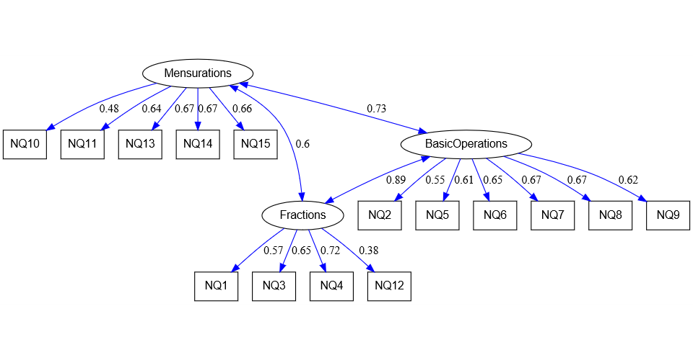
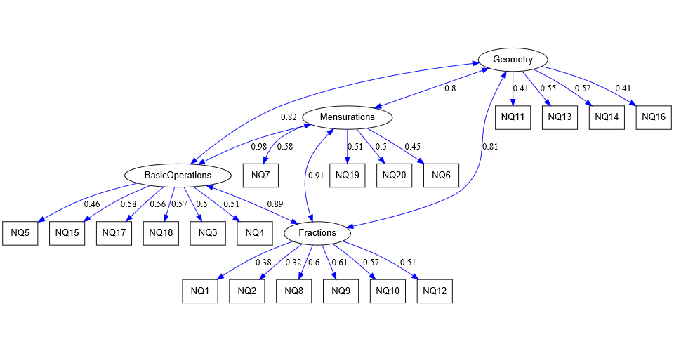

Figure S1. Complete standardized subscale loading for performance in Numeracy for (A) Primary 2, (B) Primary 4, pupils.

A
B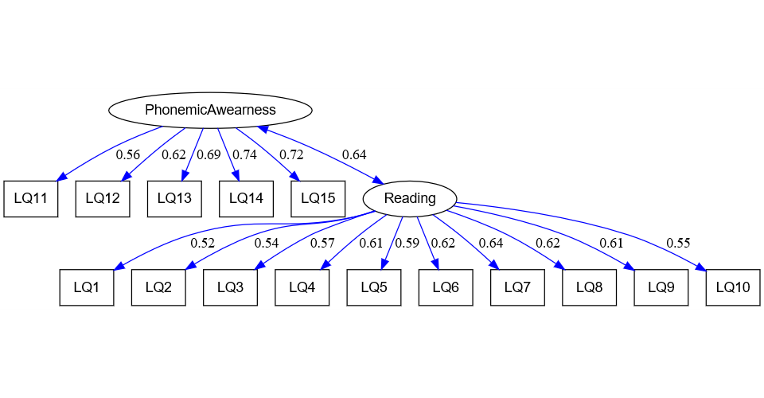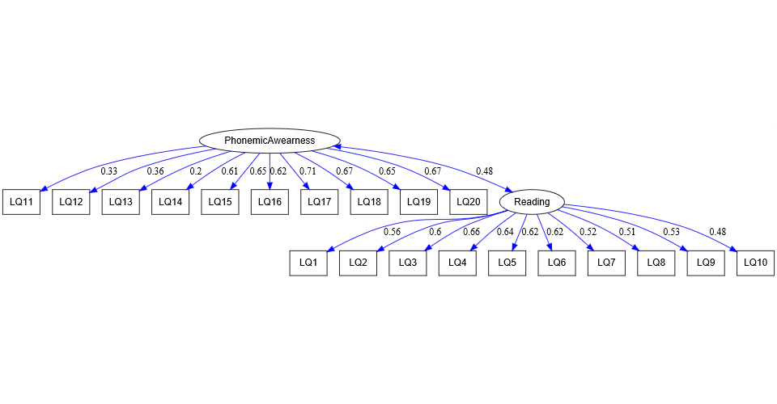
Figure S2. Complete standardized subskill loading for performance in Literacy, (A) Primary 2, (B) Primary 4.

