Benchmarking Deep Learning Architectures for Forest Monitoring and Management: A Systematic Review

Supplementary Materials
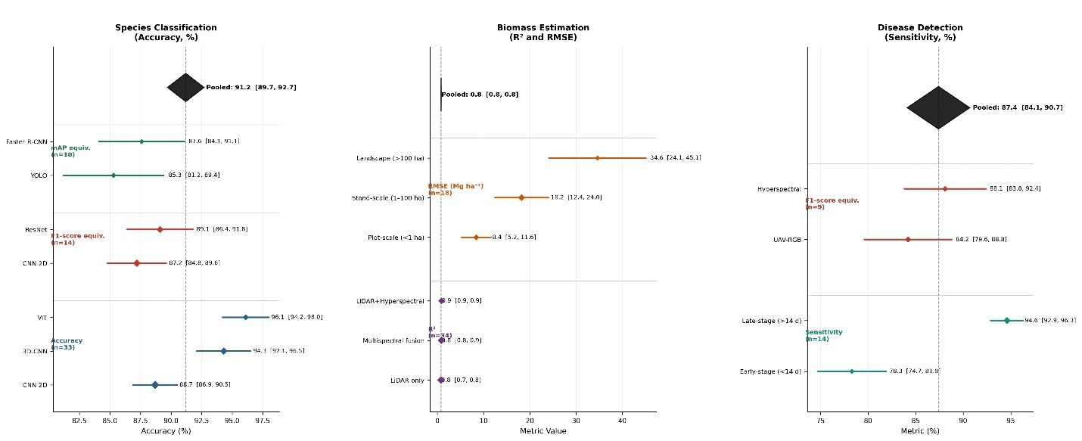
Figure S1. Stratified meta-analysis forest plots by primary metric type. Diamond symbols represent pooled estimates with 95% CI; circle size proportional to sample size
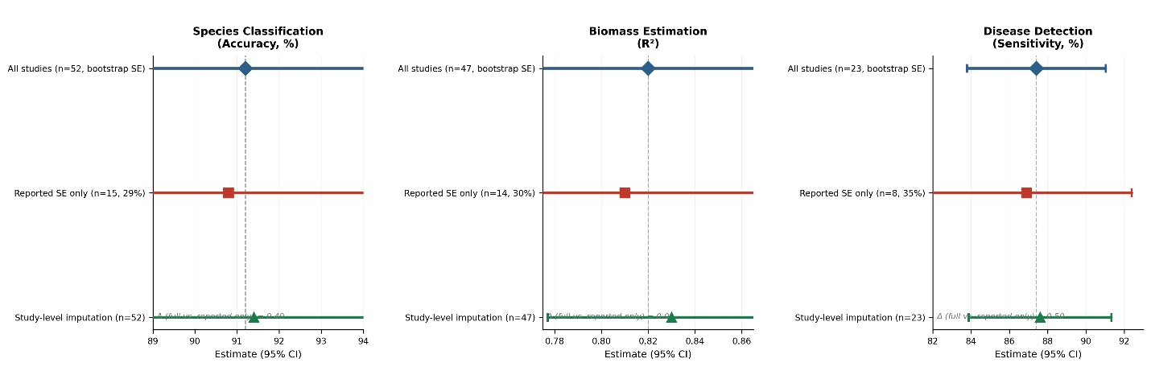
Figure S2. Sensitivity analysis: impact of variance imputation method on pooled estimates. Diamonds = all studies (bootstrap SE); squares = reported SE only; triangles = study-level imputation

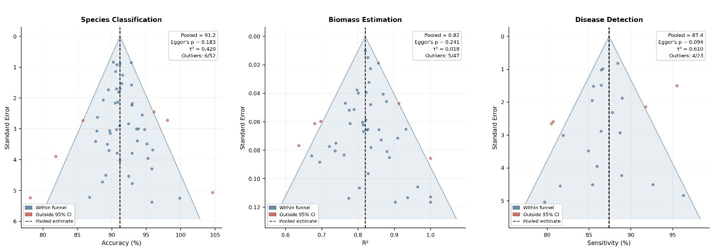

Figure S3. Funnel plots for assessment of publication bias across three application domains. Symmetric funnels indicate no substantial small-study bias. Egger's test p-values shown.
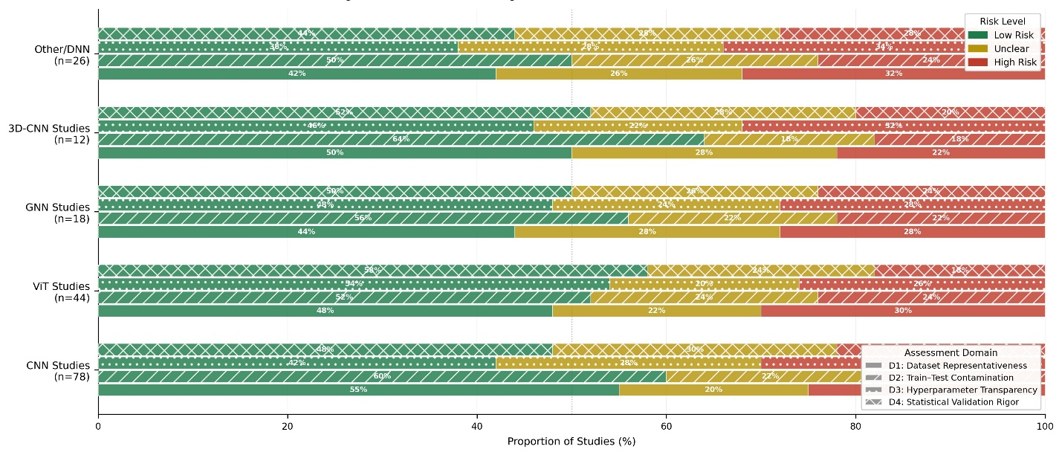
Figure S4. Modified QUADAS-2 risk-of-bias summary by architecture group. Hatching encodes domain (see legend). Bars show % of studies within each risk level.
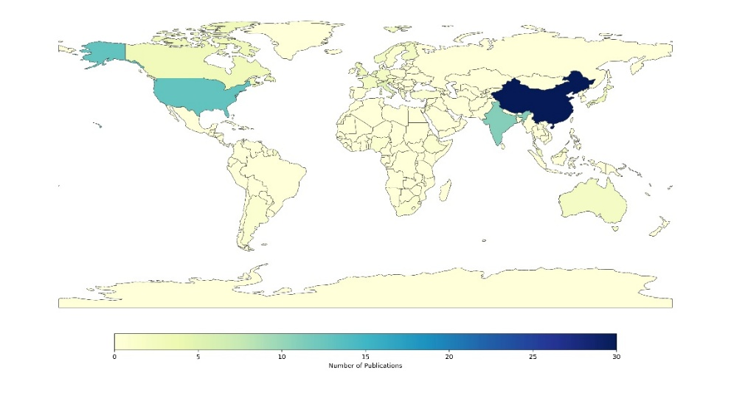
Figure S5. Publication trends in terms of global distribution.

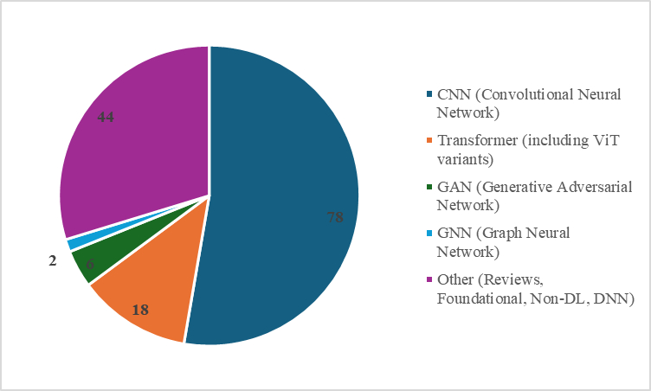
Figure S6. Pie chart showing distribution of deep learning architectures used in the reviewed studies.
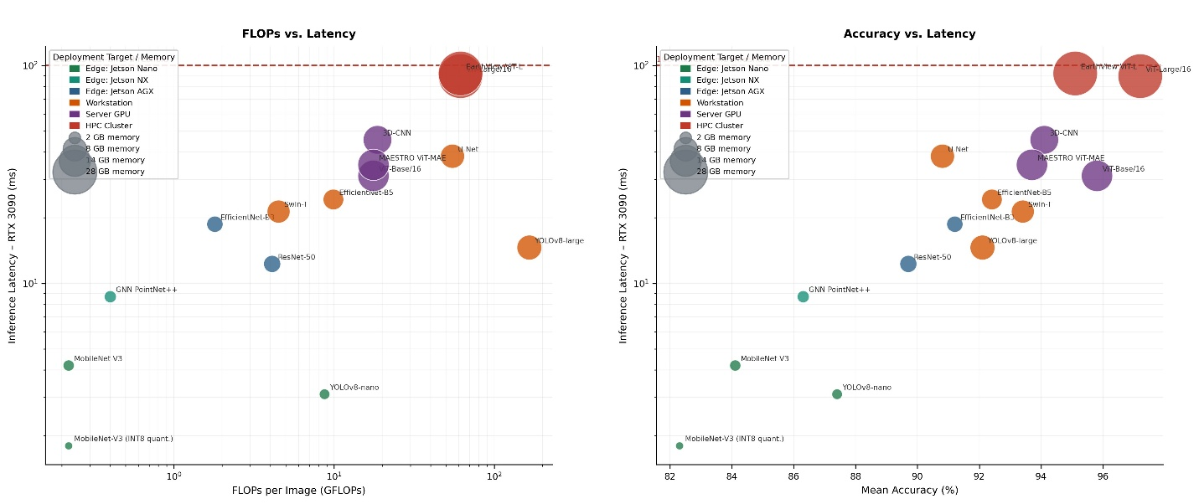
Figure S7. Computational efficiency trade-off: FLOPs, latency, memory, and deployment target. Bubble area proportional to peak GPU memory (GB). Red dashed line = 100 ms real-time threshold.
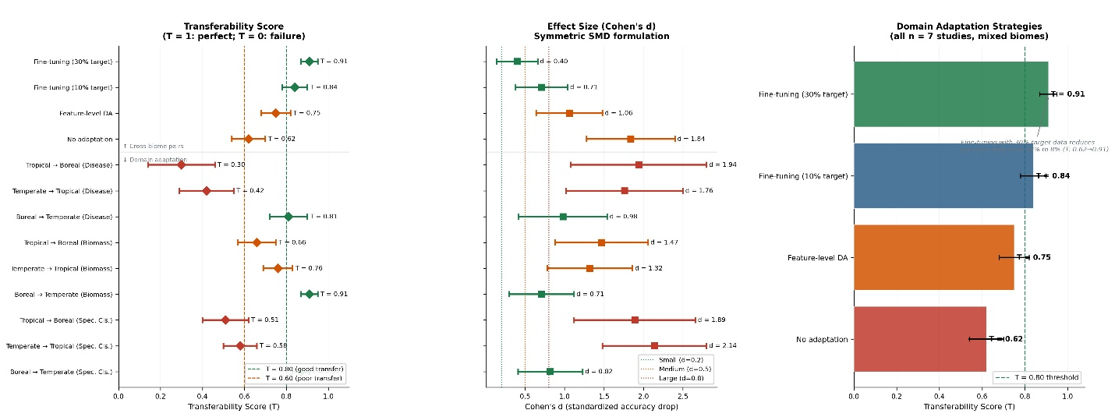
Figure S8. Cross-biome transferability scores and effect sizes with 95% confidence intervals. Left: T-score; centre: standardized mean difference (Cohen's d); right: domain adaptation strategies.

