Additional files

Additional file 1. List of primer sequences used for real-time quantitative PCR analysis.

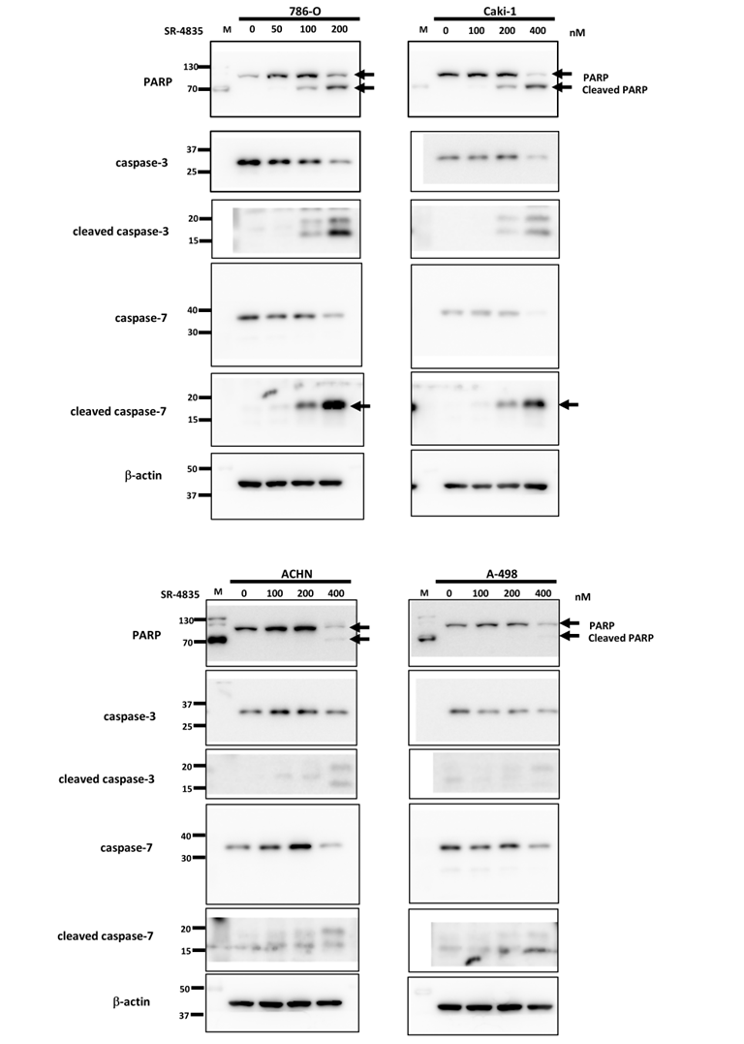
Additional file 2. The original full-length blots corresponding to the cropped images shown in Figure 2C.
Additional file 3. The original full-length blots corresponding to the cropped images shown in Figure 3A

Additional file 4. The original full-length blots corresponding to the cropped images shown in Figure 3B.

Additional file 5. The original full-length blots corresponding to the cropped images shown in Figure 4D.

Additional file 6. The original full-length blots corresponding to the cropped images shown in Figure 4E.

Additional file 7. The original full-length blots corresponding to the cropped images shown in Figure 5B.

Additional file 8. The original full-length blots corresponding to the cropped images shown in Figure 5D.

Additional file 9. The original full-length blots corresponding to the cropped images shown in Figure 6C.

