Table S1 Target polyphenols. CAS number, molecular mass, retention time and MS/MS transitions.
Polyphenols | CAS | Molecular mass  (g·mol⁻¹ ) | Retention time (min) | Precursor ion  (m/z)
Gallic acid | 149-91-7 | 170.1 | 2.35 | 169.0
2,4,6-trihydroxybenzoic acid | 71989-93-0 | 188.1 | 3.37 | 168.9
Gallocatechin | 970-73-0 | 306.3 | 3.80 | 305.0
3,4-dihydroxybenzoic acid | 99-50-3 | 154.1 | 3.88 | 152.9
2,4-dihydroxybenzoic acid | 89-86-1 | 154.1 | 4.41 | 153.0
2,5-dihydroxybenzoic acid | 490-79-9 |  | 4.44 | 153.0
Caftaric acid | 67879-58-7 | 312.2 | 4.48 | 310.9
2,5-dihydroxybenzaldehyde | 1194-98-5 | 138.1 | 4.63 | 136.9
3,4-dihydroxybenzaldehyde | 139-85-5 | 138.1 | 4.64 | 136.9
3-hydroxybenzoic acid | 99-06-9 | 138.1 | 5.15 | 137.0
4-hydroxybenzoic acid | 99-96-7 | 138.1 | 5.18 | 137.0
Procyanidin B1 | 20315-25-7 | 578.5 | 5.30 | 577.0
Catechin | 18829-70-4 | 290.3 | 5.34 | 289.0
2,6-dihydroxybenzoic acid | 303-07-1 | 154.1 | 5.54 | 153.0
3,5-dihydroxybenzoic acid | 99-10-5 | 154.1 | 5.54 | 153.0
3-hydroxybenzaldehyde | 100-83-4 | 122.1 | 5.67 | 121.0
4-hydroxybenzaldehyde | 123-08-0 | 122.1 | 5.67 | 121.0
3,4-dimethoxybenzoic acid | 93-07-2 | 1820 | 603 | 1829
Procyanidin B2 | 29106-49-8 | 5785 | 610 | 5770
Chlorogenic acid | 327-97-9 | 3543 | 612 | 3530
Ampelopsin | 27200-12-0 | 32025 | 620 | 3190
Caffeic acid | 331-39-5 | 1802 | 650 | 1788
Procyanidin C1 | 37064-30-5 | 8668 | 652 | 5770
Epicatechin | 35323-91-2 | 2903 | 656 | 2890
Epigallocatechingallate | 989-51-5 | 4584 | 679 | 4571
Procyanidin A1 | 12798-56-0 | 5765 | 680 | 5770
Gallocatechingallate | 84650-60-2 | 4584 | 729 | 4571
Procyanidin A2 | 41743-41-3 | 5765 | 732 | 5770
Orientine | 28608-75-5 | 4484 | 738 | 4771
7-hydroxycoumarin | 93-35-6 | 1621 | 780 | 1629
4-hydroxycinnamic acid | 501-98-4 | 1642 | 789 | 1630
Epicatechingallate | 1257-08-5 | 4424 | 792 | 4411
Polidatin | 27208-80-6 | 3904 | 798 | 3891
Taxifolin | 480-18-2 | 30425 | 806 | 3030
Catechingallate | 130405-40-2 | 4423 | 812 | 4411
3,4-dimethoxybenzaldehyde | 120-14-9 | 1662 | 833 | 1670
Trans-ferulic acid | 537-98-4 | 1942 | 892 | 1928
4-methoxybenzaldehyde | 123-11-5 | 1361 | 911 | 1369
Resveratrol | 501-36-0 | 22807 | 931 | 2271
Robinetin | 490-31-3 | 30223 | 950 | 3012
Quercetin-3-glucuronide | 22688-79-5 | 4784 | 954 | 4790
Quercetin-3-rutinoside | 153-18-4 | 6105 | 972 | 6091
Quercetin-3-glucoside | 482-35-9 | 4634 | 975 | 4650
Myricetin | 529-44-2 | 3182 | 1009 | 3190
Ellagic acid | 476-66-4 | 30219 | 1021 | 3010
Rosmarinic acid | 20283-92-5 | 3603 | 1037 | 3590
3,4,5-trimethoxycinnamic acid | 90-50-6 | 2382 | 1113 | 2390
Astragalin | 480-10-4 | 4484 | 1116 | 4470
3,5-dimethoxybenzaldehyde | 7311-34-4 | 1662 | 1126 | 1671
Fisetin | 528-48-3 | 2862 | 1150 | 2850
Daidzein | 486-66-8 | 2542 | 1153 | 2530
Epsilon-viniferin | 62218-08-0 | 4545 | 1182 | 4551
Quercetine | 117-39-5 | 3022 | 1183 | 3030
Naringenin | 67604-48-2 | 2722 | 1189 | 2720
Luteolin | 491-70-3 | 2862 | 1217 | 2850
Kaempferol | 520-18-3 | 2862 | 1235 | 2850
Isorhamnetin | 480-19-3 | 3163 | 1252 | 3170
Diosmetin | 520-34-3 | 30026 | 1264 | 2990
Apigenin | 520-36-5 | 2702 | 1263 | 2690
Chrysin | 480-40-0 | 2542 | 1324 | 2531

Section S1. Statistical study parameters via Metaboanalyst 6.0
The data underwent a preprocessing procedure that included a low-variance filter applied using the interquartile range (IQR), removing the 10% of variables with the lowest variability. Subsequently, the data were median-normalized and scaled using Pareto scaling (mean-centered and divided by the square root of each variable’s standard deviation).
After preprocessing, several statistical approaches were applied to explore and discriminate patterns within the dataset. First, Principal Component Analysis (PCA) was performed to assess the overall structure of the data. Group separation was then evaluated using Partial Least Squares–Discriminant Analysis (PLS-DA). Discriminant variables among groups were identified through one-way ANOVA.
Model quality was assessed using a five-component evaluation, selecting PC1 and PC2 as the dimensions with the highest discriminative ability. The goodness-of-fit (R²Y) and predictive ability (Q²) parameters were calculated to evaluate the robustness and reliability of the generated models.
Additionally, heatmaps were constructed using the normalized data, applying autoscaling for variable standardization. Hierarchical clustering was conducted using Euclidean distance as the dissimilarity measure and Ward’s linkage method as the clustering algorithm.

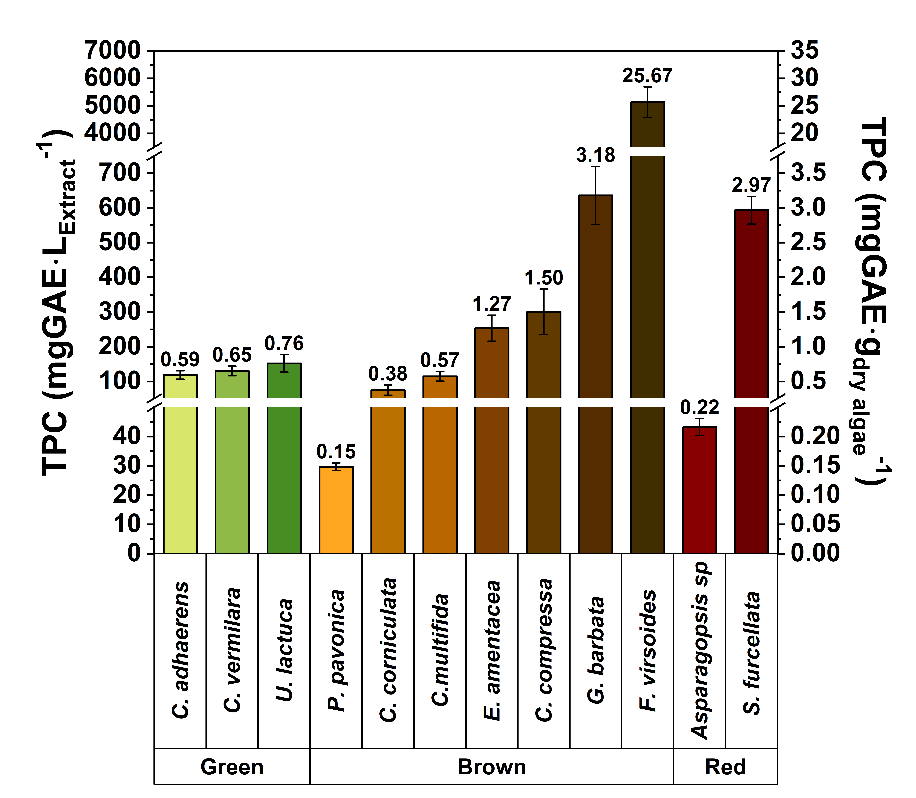 | 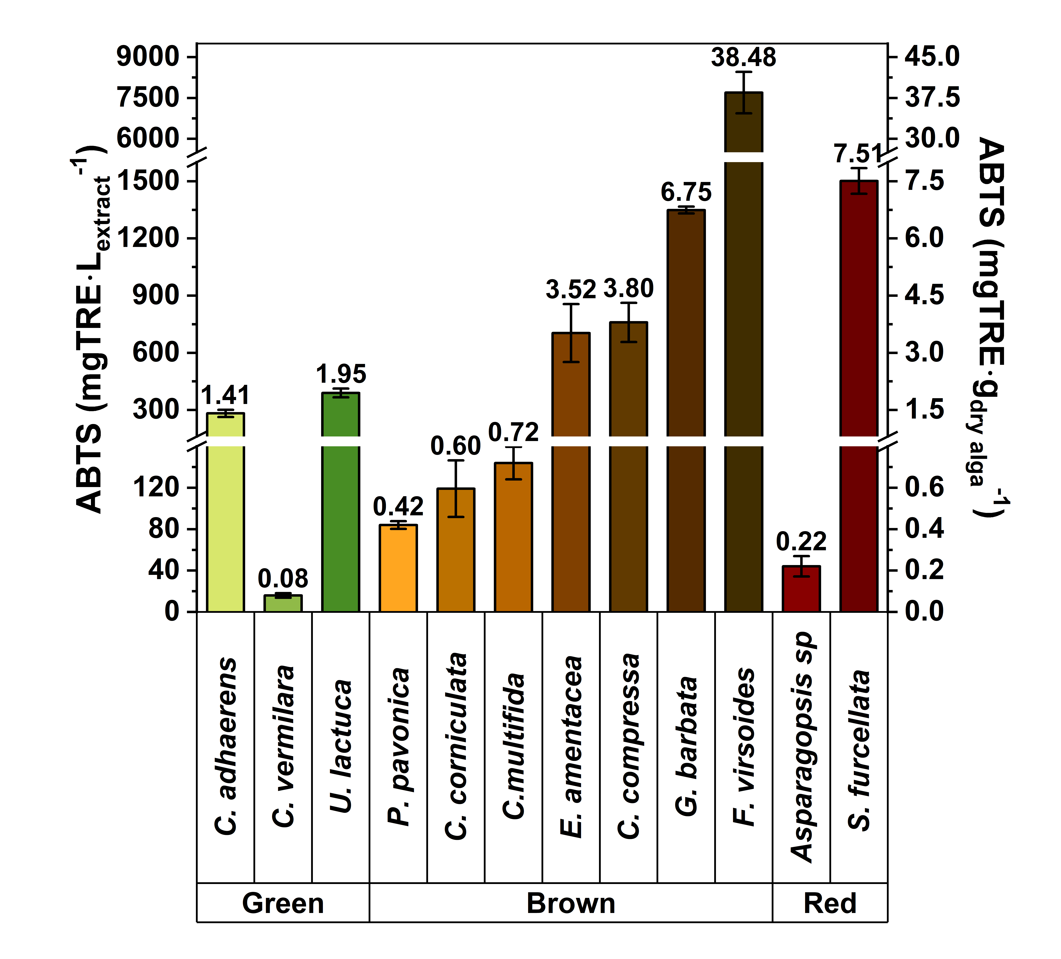
(A) | (B)
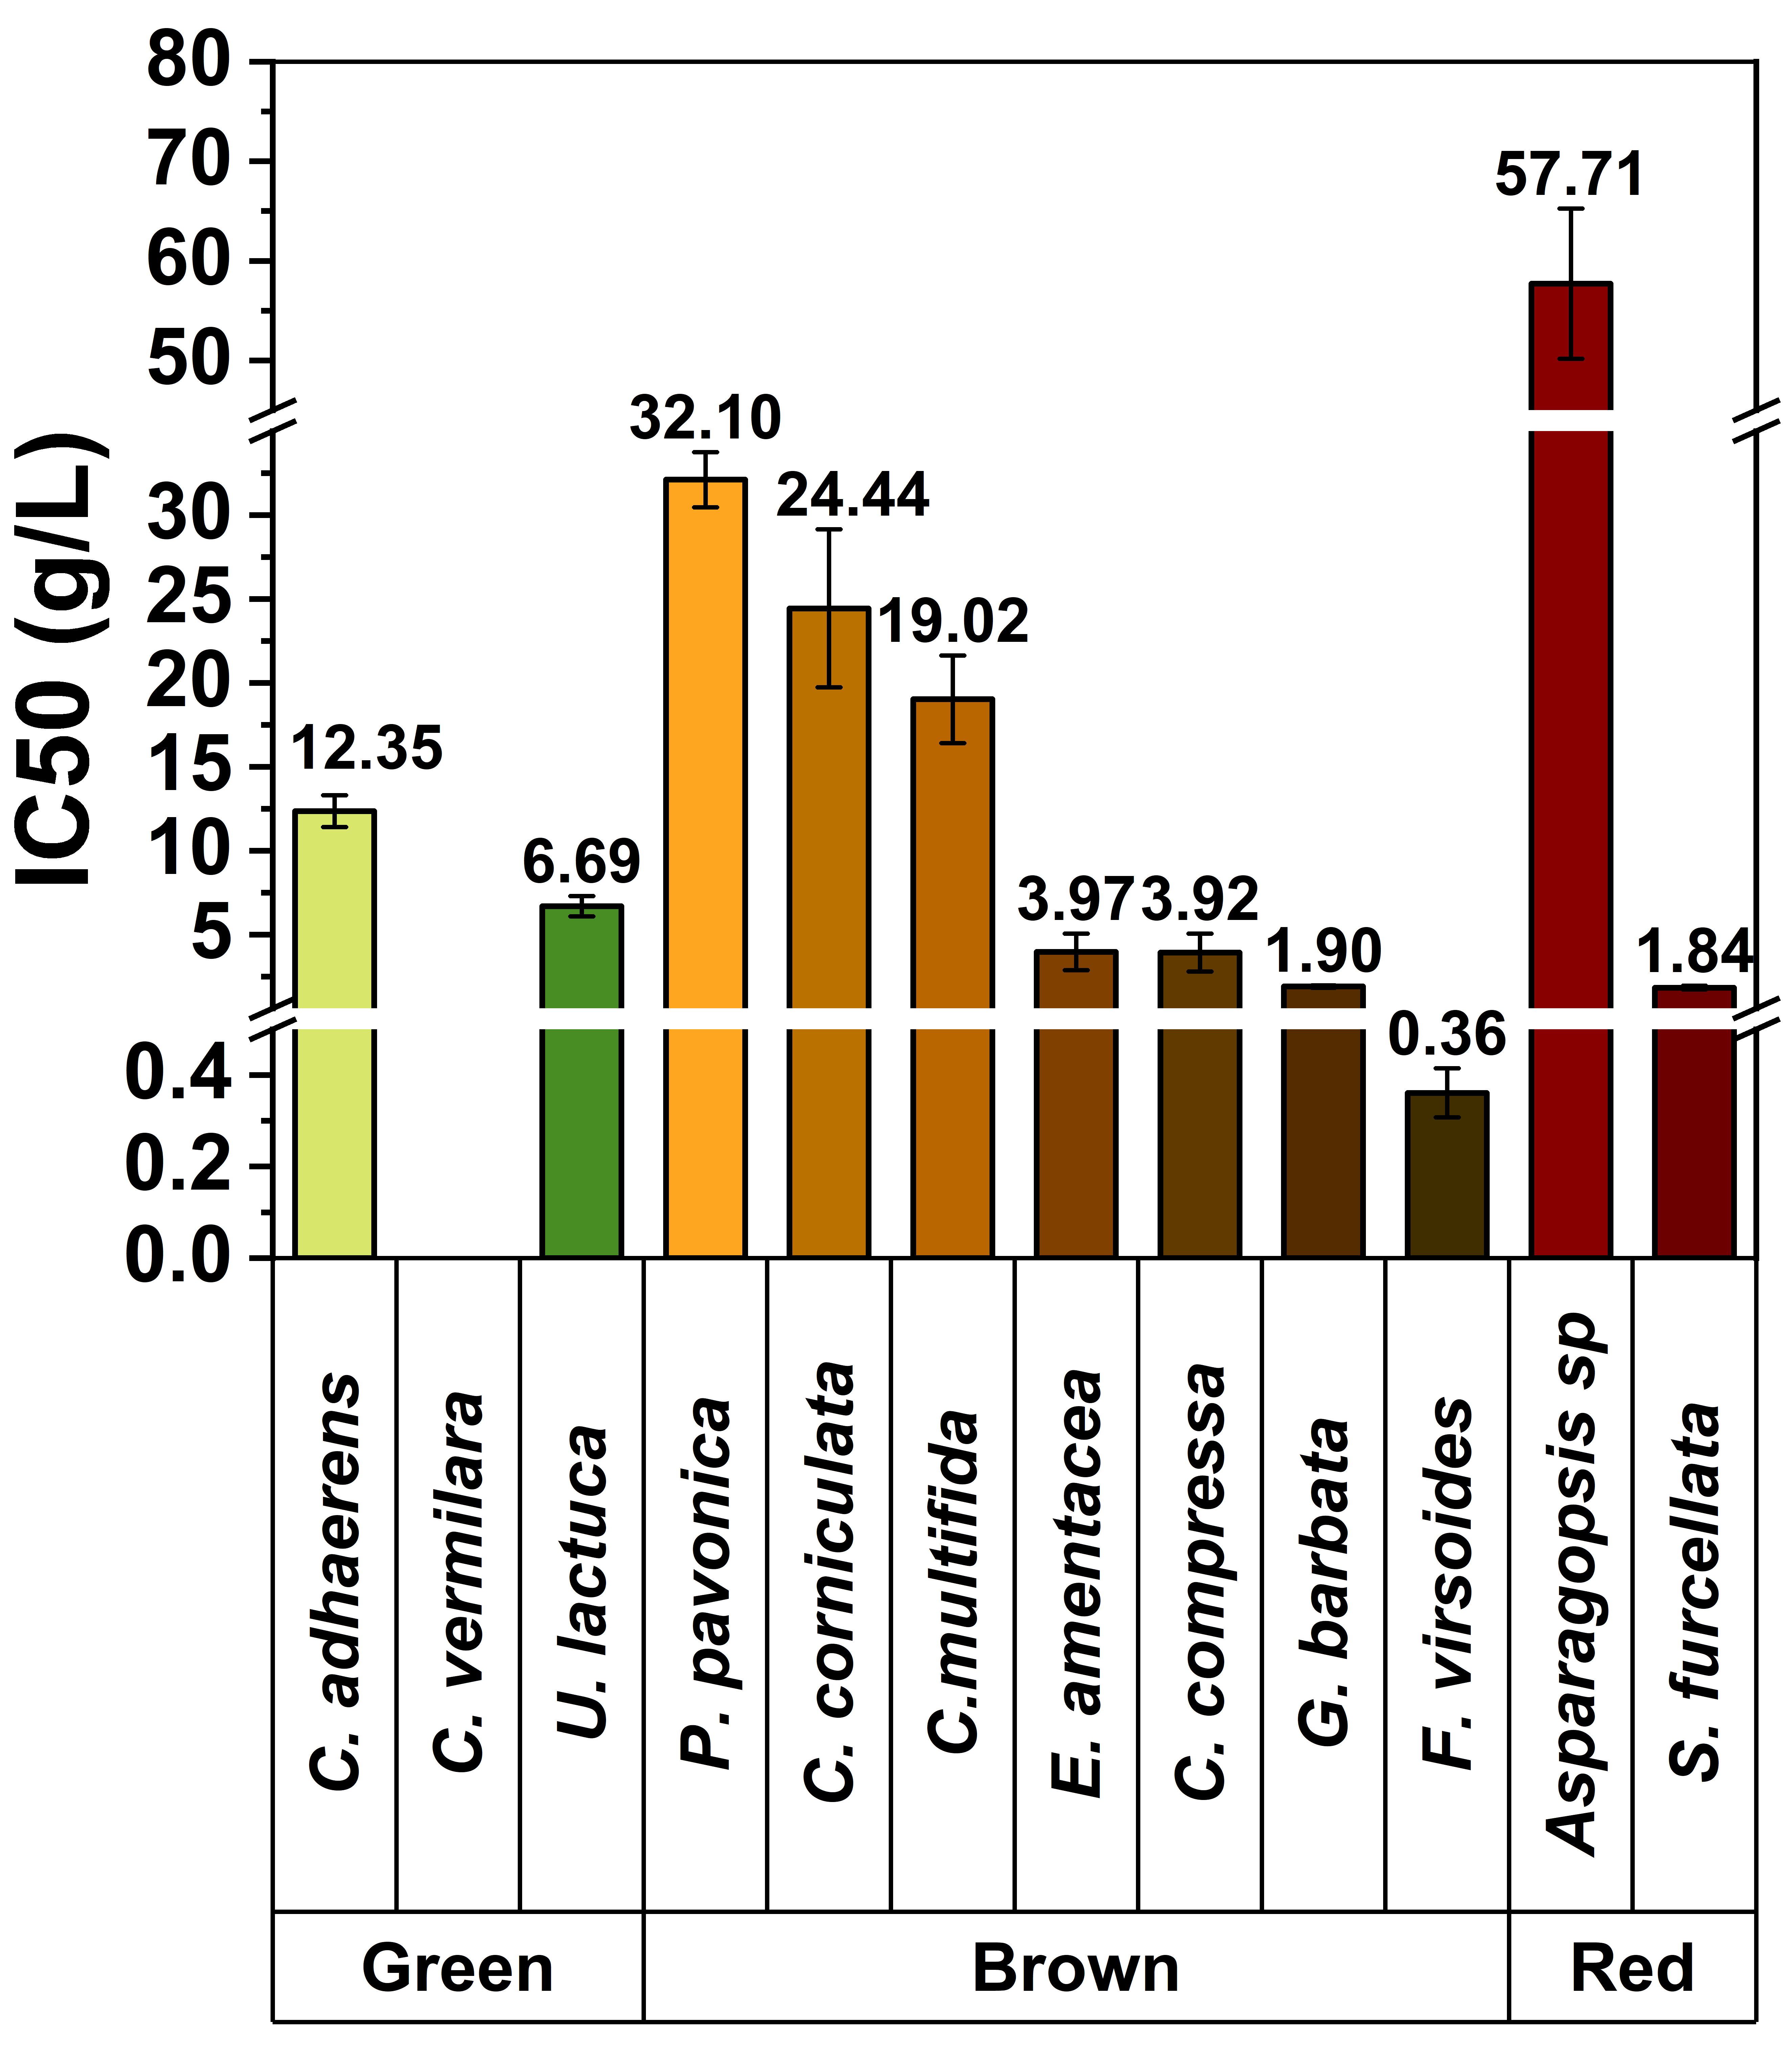
(C)
Fig. S1 Comparative evaluation of (A) total phenolic content (TPC), (B) antioxidant capacity (ABTS assay), and (C) inhibitory concentration (IC₅₀) in macroalgae extracts obtained by MSPD with ethanol/water (50:50, v/v).

