Supporting information
Development of Potential CDK9 Inhibitors through Pharmacophore-Based Virtual Screening, 3D-QSAR, Molecular Docking, MD Simulation, and In Vitro Anticancer Evaluation
Rajkumar Reddyrajula^{a,*}, Umadevi Etikyala^{b}, Dinesha P^{c}, Sampat P V^{c}, Shreeganesh Subraya Hedge^{c,d}, Mohammed Muzaffar-Ur-Rehman^{e}, Chandra Sekhar Kondapalli Venkata Gowri^{f}, Udayakumar D^{c}, Vijjulatha Manga^{b,*}
ªDepartment of Chemistry, School of Sciences, Woxsen University, Hyderabad -502345, Telangana, India.
^{b}Medicinal Chemistry Laboratory, Department of Chemistry, Osmania University, Hyderabad-500 076, Telangana, India.
^{c}Department of Chemistry, National Institute of Technology Karnataka, Surathkal-575025, Mangalore, Karnataka, India.
^{d}Department of Chemistry, School of Engineering, Dayananda Sagar University, Harohalli, Bengaluru -562112, Karnataka, India.
^{e}Medicinal Chemistry Research Laboratory, Department of Pharmacy, Birla Institute of Technology and Science Pilani, Pilani Campus, Pilani-333031, Rajasthan. India.
^{f}Department of Chemistry, Birla Institute of Technology and Science Pilani, Hyderabad Campus, Jawahar Nagar, Kapra Mandal, Hyderabad 500078, Telangana, India.
* Corresponding authors - rajkumar.reddyrajula111@gmail.com, Vijjulathamanga@gmail.com

Contents
1. Dataset.
2. Materials and instruments.
3. Cell lines and Culture Conditions
4. Cell viability assay.
5. Statistical analysis.
6. Molecular Docking
7. MD simulation.
8. Representative NMR and ESI-Mass spectra of final compounds.
1. Dataset
Table S1. Binding energy, experimental and predicted pIC₅₀ values of training and test set molecules of pyrimidine based CDK9 inhibitors.
Comp | R¹ | R² | Expt.  pIC₅₀ | Pred.  pIC₅₀ | Fitness Score | Binding energy (kcal/mol)
1 |  |  | 8.46 | 8.397 | 2.54 | -49.32
2* |  |  | 8.09 | 8.305 | 2.38 | -46.71
3* |  |  | 9.04 | 8.954 | 2.63 | -47.58
4 |  |  | 9.81 | 9.66 | 2.52 | -46.43
5 |  |  | 9.94 | 9.21 | 2.48 | -52.61
6 |  |  | 10.29 | 9.41 | 2.50 | -53.18
7 |  |  | 9.36 | 9.18 | 2.64 | -53.89
8 |  |  | 9.12 | 9.26 | 2.42 | -56.42
9 |  |  | 9.75 | 9.72 | 2.32 | -53.45
10 |  |  | 8.95 | 8.87 | 2.62 | -52.99
11* |  |  | 9.05 | 9.074 | 2.35 | -54.35
12 |  |  | 8.00 | 8.15 | 2.837 | -43.26
13* |  |  | 8.48 | 8.489 | 2.47 | -49.67
14 |  |  | 8.83 | 8.96 | 2.51 | -52.56
15 |  |  | 9.36 | 9.2 | 2.817 | -44.75
16 |  |  | 8.16 | 8.31 | 2.57 | -49.77
17 |  |  | 8.03 | 8.01 | 2.71 | -46.79
18 |  |  | 9.18 | 9.18 | 2.49 | -51.65
19 |  |  | 8.57 | 8.42 | 2.73 | -50.46
20 |  |  | 8.16 | 8.31 | 2.72 | -52.34
21* |  |  | 8.86 | 8.94 | 2.89 | -48.55
22 |  |  | 8.20 | 8.58 | 2.68 | -49.01
23 |  |  | 10.40 | 10.17 | 2.48 | -68.39
Expt. pIC₅₀ : Experimental pIC₅₀; Pred. pIC₅₀ : Predicted pIC₅₀.
Table S2. Binding energy, experimental and predicted pIC₅₀ values of training and test set molecules of benzotriazole based CDK9 inhibitors.
Comp | R₁ | R₂ | Expt.  pIC₅₀ | Pred.  pIC₅₀ | Fitness Score | Binding energy (Kcal/mol)
24 |  | H | 8.35 | 8.25 | 1.603 | -60.72
25 |  | H | 8.42 | 8.67 | 1.598 | -55.98
26 |  | H | 8.38 | 8.24 | 1.591 | -65.93
27 |  | H | 8.63 | 8.63 | 1.579 | -65.29
28* |  | H | 8.17 | 8.316 | 1.675 | -59.59
29 |  | H | 8.51 | 8.76 | 1.649 | -61.33
30 |  | H | 8.02 | 8.137 | 1.658 | -61.04
31 | H |  | 8.51 | 8.43 | 1.460 | -58.36
32 | H |  | 8.46 | 8.42 | 1.372 | -62.18Ex
33 | H |  | 8.4 | 8.41 | 1.262 | -64.83
34* | H |  | 8.47 | 8.45 | 1.258 | -65.33
35 | H |  | 8.71 | 8.78 | 1.210 | -65.24
36 | H |  | 8.87 | 8.88 | 1.474 | -59.19
37* | H |  | 8.53 | 8.5 | 1.191 | -60.56

Table S3. Binding energy, experimental and predicted pIC₅₀ values of training and test set molecules of pyrimidine-macrocycle based CDK9 inhibitors.
Comp | R | L | Expt.  pIC₅₀ | Pred.  pIC₅₀ | Fitness Score | Binding energy (Kcal/mol)
38 |  |  | 8.95 | 8.93 | 2.529 | -49.08
39 |  |  | 9.04 | 9.1 | 2.502 | -39.14
40* |  |  | 8.67 | 8.61 | 2.509 | -73.54
41 |  |  | 8.5 | 8.47 | 2.515 | -59.45
42 |  |  | 8.55 | 8.52 | 2.563 | -47.77
43* |  |  | 8.95 | 8.98 | 2.489 | -26.81
44 |  |  | 8.49 | 8.52 | 2.422 | -60.43
45* |  |  | 8.67 | 8.62 | 2.474 | -60.28
46 |  |  | 8.11 | 8.19 | 2.472 | -61.11
47 |  |  | 8.63 | 8.6 | 2.405 | -37.07
48 |  |  | 8.49 | 8.53 | 2.392 | -31.91
49 |  |  | 8.69 | 8.74 | 2.387 | -40.82
50 |  |  | 8.58 | 8.69 | 2.429 | -57.47

Table S4. Binding energy, experimental and predicted pIC₅₀ values of training and test set molecules of pyrimidine-ether based CDK9 inhibitors.
Comp | R¹ | R² | Expt.  pIC₅₀ | Pred.  pIC₅₀ | Fitness Score | Binding energy (Kcal/mol)
51 |  |  | 7.06 | 6.98 | 1.287 | -54.63
52* |  |  | 7.98 | 8.191 | 1.149 | -51.84
53 |  |  | 7.57 | 7.56 | 1.188 | -51.41
54 |  |  | 7.22 | 7.16 | 1.117 | -63.05
55 |  |  | 7.07 | 7.22 | 1.425 | -68.56
*Training set compounds.

2. Materials and instruments
All requisite reagents and solvents were procured from Sigma-Aldrich, Alfa Aesar, Merck, and Spectrochem and were used without further purification. Column chromatography was performed for product purification using silica gel (Merck, 60-120 mesh). Reaction progress was monitored via thin-layer chromatography (TLC) on 60 F254 silica gel-coated plates (Merck KGaA) under UV light. The ¹H NMR and ¹³C NMR spectra of the synthesized compounds were recorded on a Bruker spectrometer operating at 400 MHz for ¹H NMR and 100 MHz for ¹³C NMR, with tetramethylsilane (TMS) as the internal standard. Electrospray ionization (ESI) mass spectra were obtained using a Waters Micromass Q-Tof micro-spectrometer. Elemental analysis was performed using a Thermo Electron Corporation EA-112 Series C, H, N, S analyzer. The cancer cell lines (A549, SiHa, HeLa, MCF-7, MDA-MB-231, MDA-MB-T41, and MDA-MB-T32) and human embryonic kidney cells (HEK 293t) were obtained

3. Cell lines and Culture Conditions
The human cell lines A549 (lung carcinoma), SiHa and HeLa (cervical carcinoma), MCF-7 and MDA-MB-231 (breast carcinoma), and HEK-293T were obtained from authenticated cell repositories from the National Centre for Cell Sciences (NCCS) Pune, India. The cells were cultured under standard conditions in appropriate growth media supplemented with fetal bovine serum and antibiotics in a humidified incubator at 37 °C with 5% CO₂. All experiments were conducted using commercially available, established cell lines. Therefore, no human participants or freshly derived human tissues were involved, and specific ethical approval was not required according to institutional guidelines for in vitro studies using established cell lines.

4. Cell viability assay
The cancer cell lines (A549, SiHa, HeLa, MCF-7, MDA-MB-231, MDA-MB-T41, and MDA-MB-T32) and human embryonic kidney cells (HEK 293t) were grown in DMEM supplemented with 10% FBS and 1% penicillin and streptomycin antibiotics in 5% CO2 atmosphere at 37° C in an incubator. The anti-tumor activity of title compounds was tested by MTT assay. Briefly, the A549, SiHa, HeLa, MCF-7, MDA-MB-231 and HEK 293t cells were seeded in 96-well plates at a density of 3×10³ cells per well and incubated at 37° C in 5% CO2 incubator for overnight. The overnight grown cultured cells were treated with various concentrations (0, 5, 10, 20, 40, 80, 100 µM) of final compounds for 24 hours. After that 20 µl of MTT dye (5mg/ml in PBS) was added to each well and incubated for 4 hours at 37° C. Following that, the media was discarded and the plates were incubated for 30 minutes in a shaker incubator with 100 µl of DMSO. The absorbance was measured at a wavelength of 590 nm in an ELISA micro plate reader (Multiskan FC micro platereader-Thermo scientific). Data from three independent experiments is presented as the average value of triplicates and the inhibitory concentration (IC₅₀) of final compounds was calculated using Graph-pad Prism software.
5. Statistical analysis
The statistical analysis was performed using GraphPad Prism version 6.01. The data represented as the mean ±standard deviation (SD), statistical significance evaluated by one-way analysis of variance (ANOVA) followed by Tukey's tests. All the experiments were performed in triplicates and P value ≤ 0.05 is considered to be statistically significant.

6. Molecular Docking
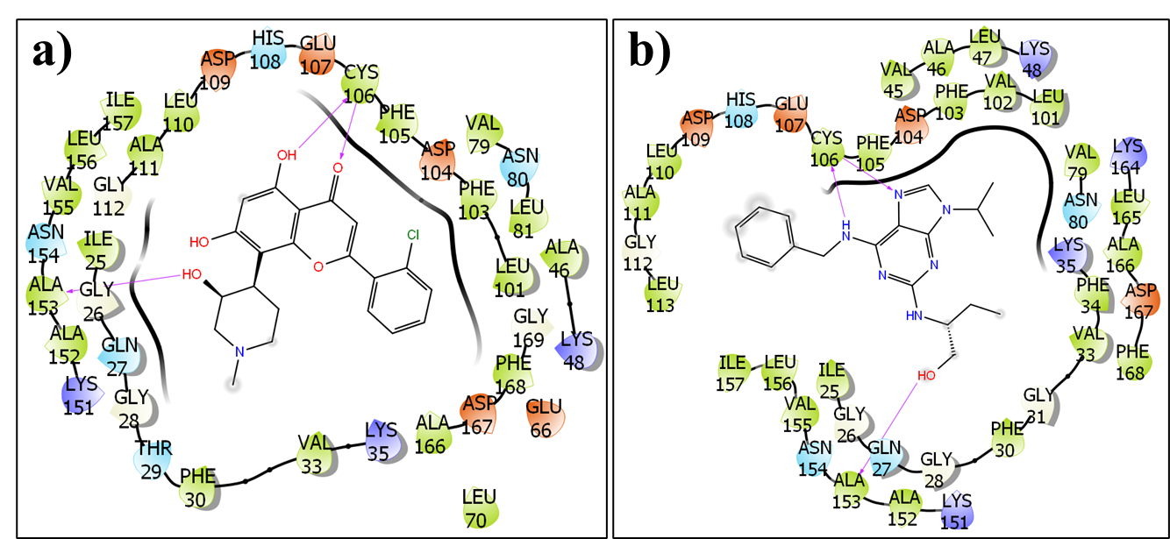
Figure S1. a) LID of Flavopiridol; b) LID of Roscovitine.
7. MD simulation.
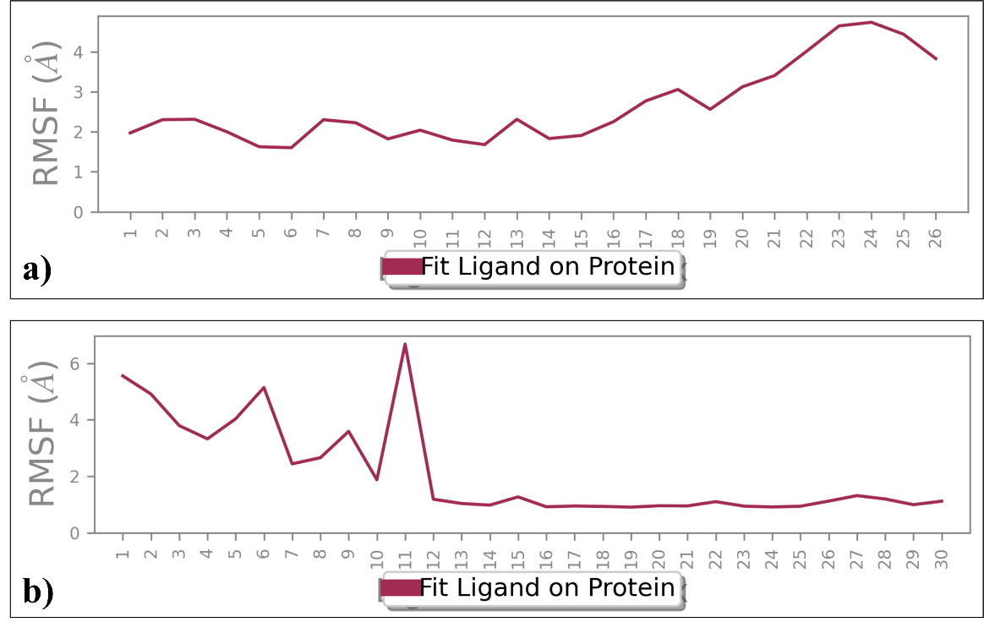
Figure S2. a) RMSF plot D3; b) RMSF plot of D6.
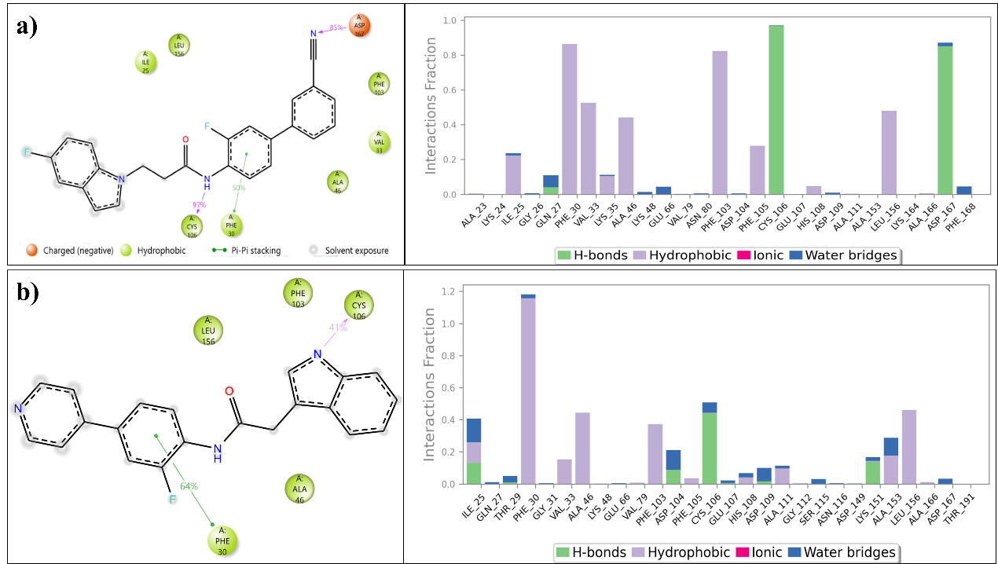
Figure S3. a) CDK9 + D3 interactions; b) CDK9 + D6 interactions.

8. Representative NMR and ESI-Mass spectra of final compounds.
Figure S4. ¹HNMR spectrum of D1.
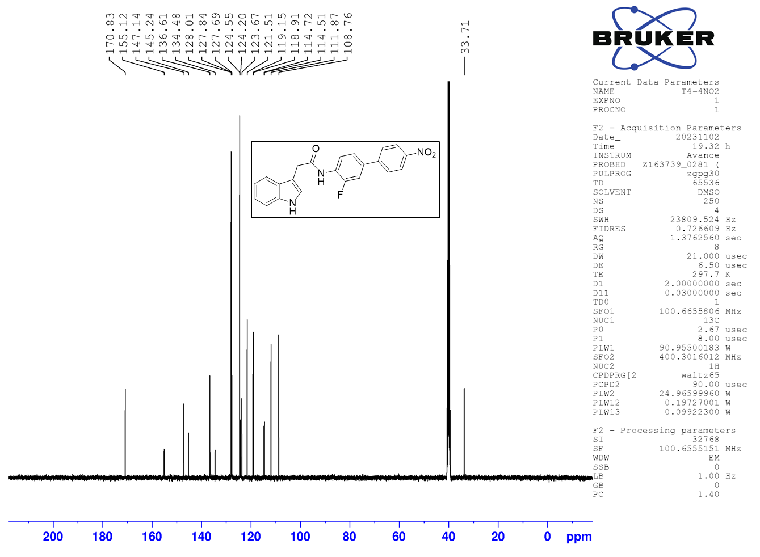
Figure S5. ¹³CNMR spectrum of D1.
Figure S6. ¹HNMR spectrum of D2.
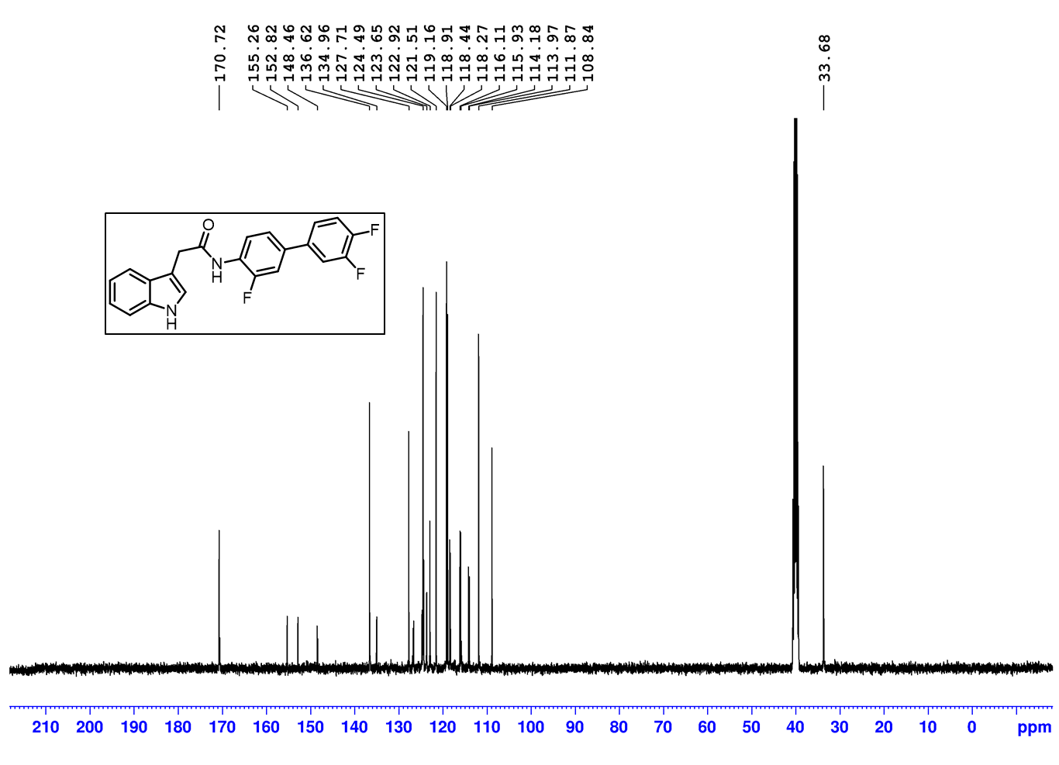
Figure S7. ¹³CNMR spectrum of D2.
Figure S8. ¹HNMR spectrum of D3.
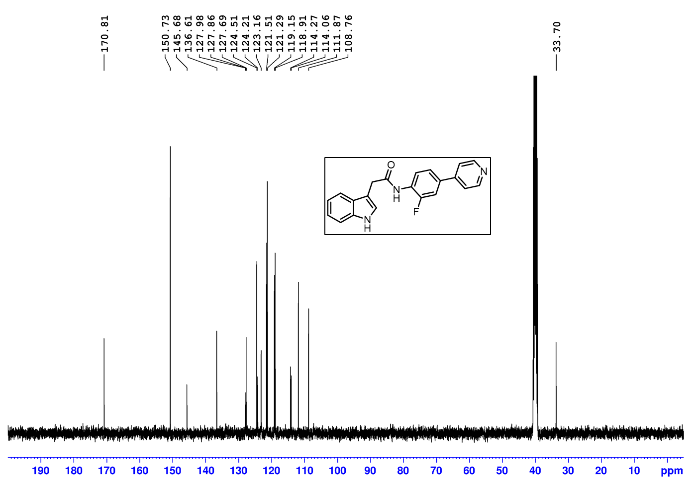
Figure S9. ¹³CNMR spectrum of D3.
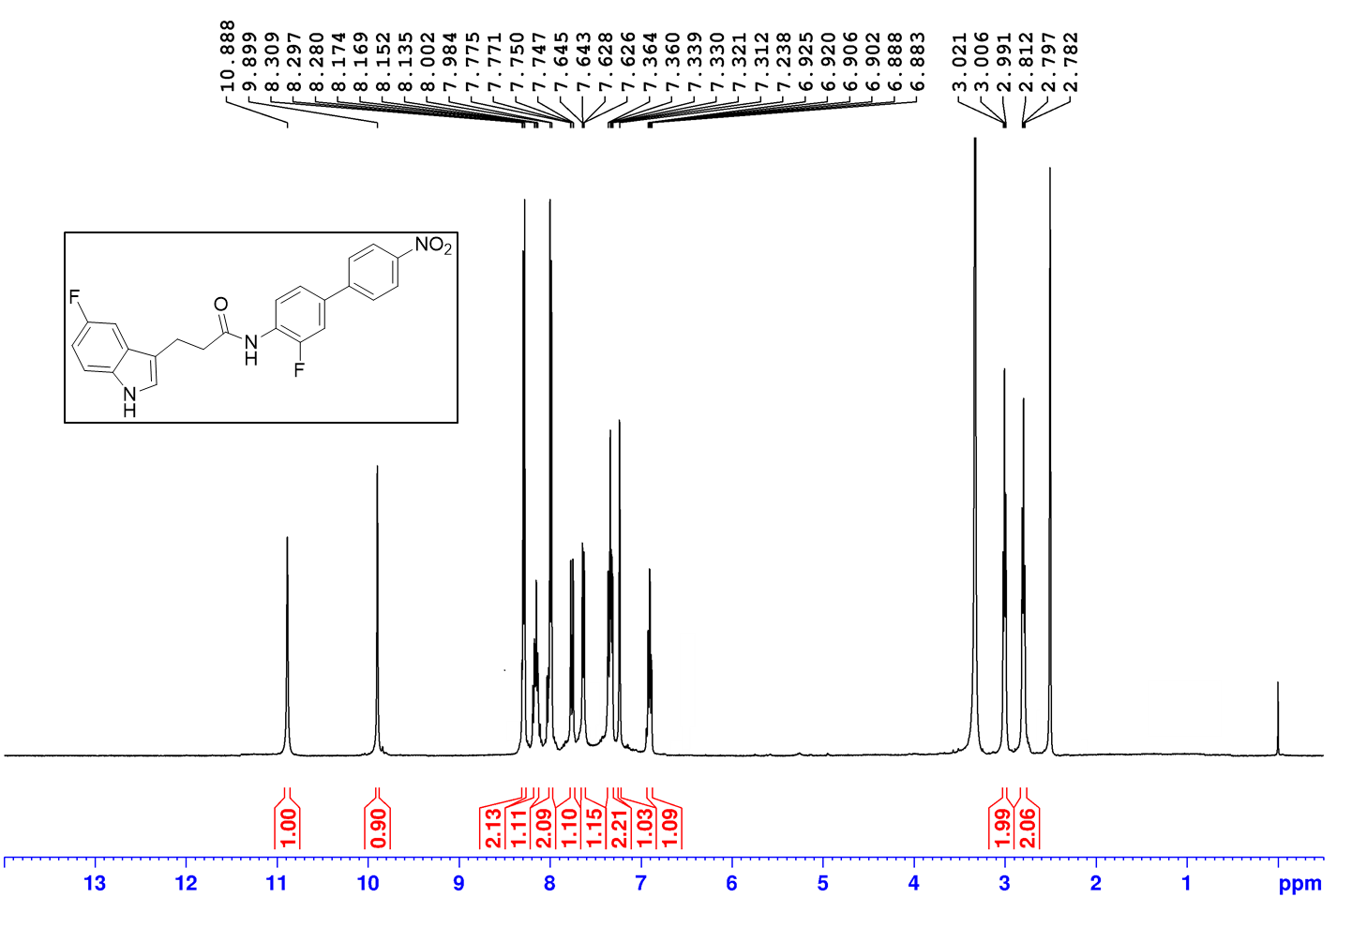
Figure S10. ¹HNMR spectrum of D4.
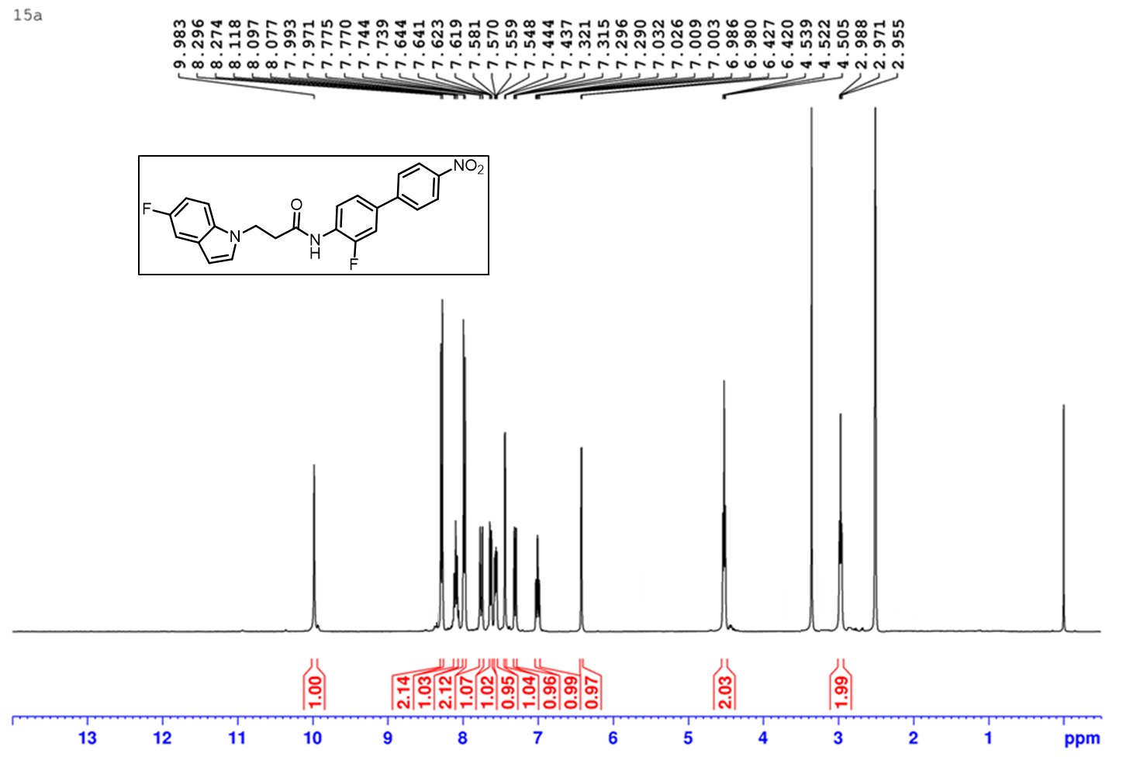
Figure S11. ¹HNMR spectrum of D5.
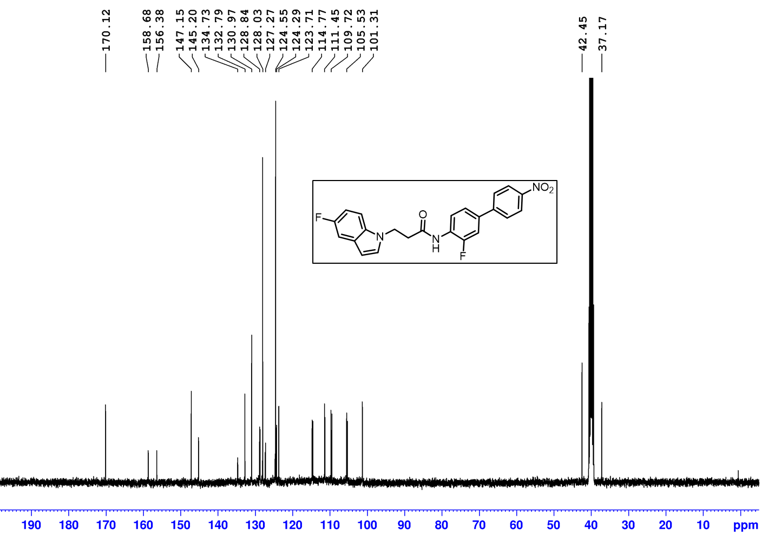
Figure S12. ¹³CNMR spectrum of D5.
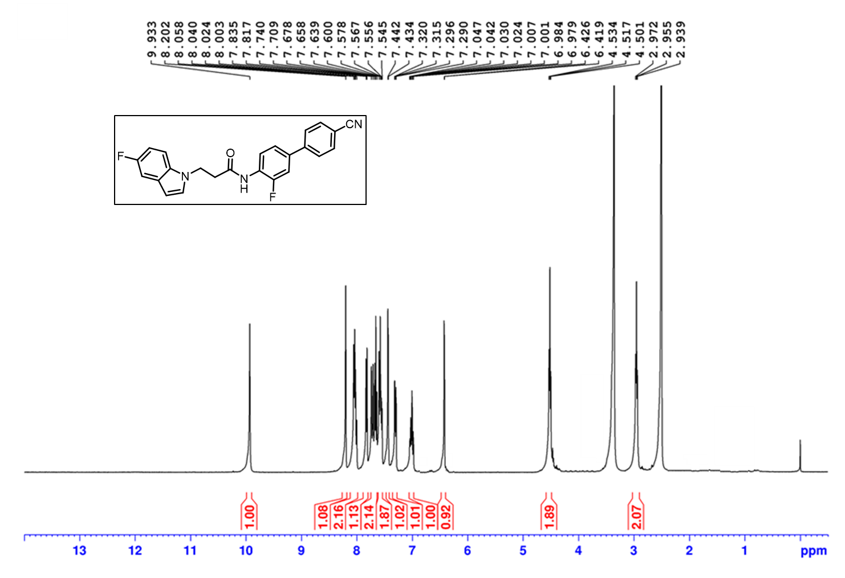
Figure S13. ¹HNMR spectrum of D6.
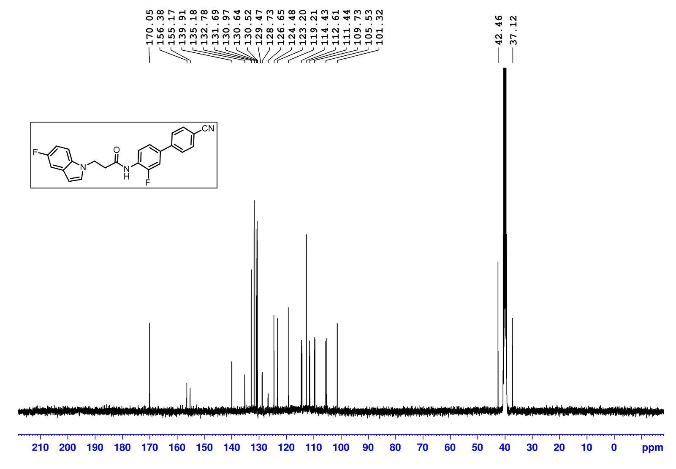
Figure S14. ¹³CNMR spectrum of D6.

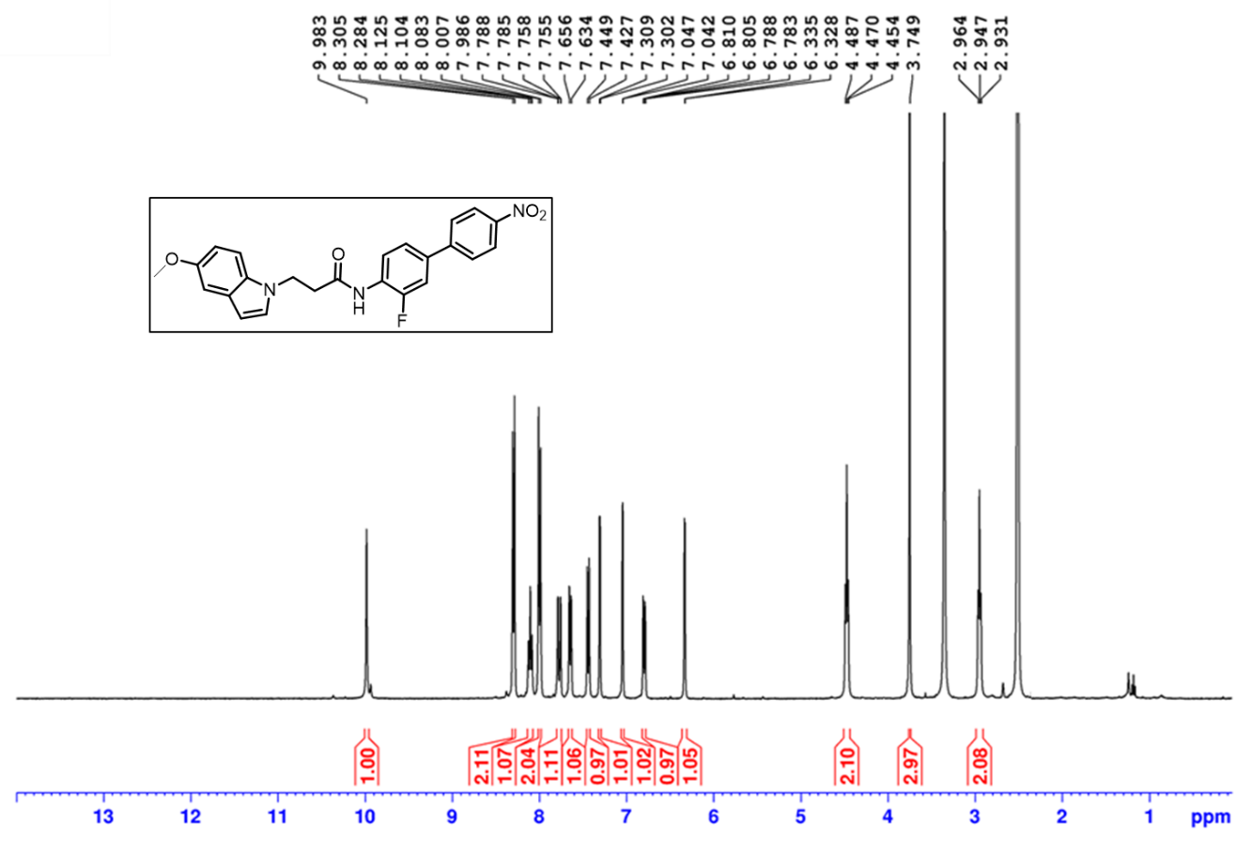
Figure S15. ¹HNMR spectrum of D7.
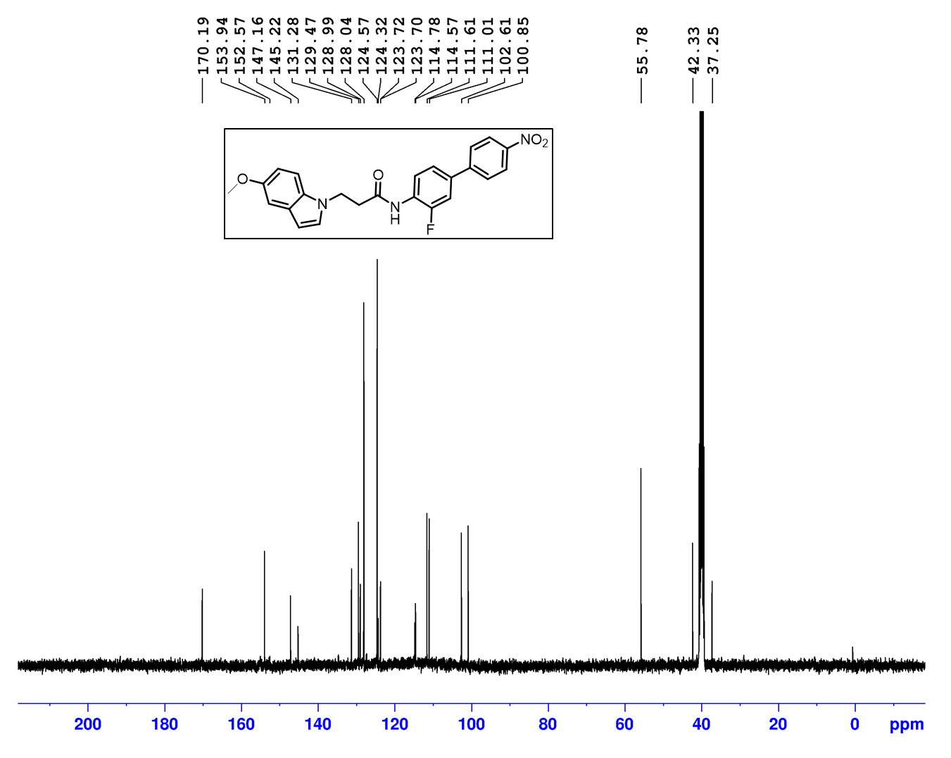
Figure S16. ¹³CNMR spectrum of D7.

