Reference -
- Tresch..S., Moretti, M., Le Bayon, R.-C., Mäder, P., Zanetta, A., Frey, D., & Fliessbach, A. (2018).A gardener’s influence on urban soil quality. Frontiers in Environmental Science, 6, Article 25. https://doi.org/10.3389/fenvs.2018.00025

- Ao, L., Shi, X., Liu, B., Lü, X., Wu, X., & Song, Y. (2022). Different urban forest tree species affect the assembly of the soil bacterial and fungal community. Microbial Ecology, 83(2), 447–458. https://doi.org/10.1007/s00248-021-01754-3

- Aponte, C., Livesley, S. J., Ossola, A., & Hahs, A. K. (2016). Contrasting effects of urban habitat complexity on metabolic functional diversity and composition of litter and soil bacterial communities. Urban Ecosystems. https://doi.org/10.1007/s11252-016-0617-2

- Baldi, D. S., Humphrey, C. E., Kyndt, J. A., & Moore, T. C. (2023). Native plant gardens support more microbial diversity and higher relative abundance of potentially beneficial taxa compared to adjacent turf grass lawns. Urban Ecosystems, 26(3), 807–820. https://doi.org/10.1007/s11252-022-01325-5

- Barrico, L., Castro, H., Coutinho, A. P., Gonçalves, M. T., Freitas, H., & Castro, P. (2018). Plant and microbial biodiversity in urban forests and public gardens: Insights for cities’ sustainable development. Urban Forestry & Urban Greening, 29, 19–27. https://doi.org/10.1016/j.ufug.2017.10.012

- Baruch, Z., Liddicoat, C., Cando-Dumancela, C., Laws, M., Morelli, H., Weinstein, P., Young, J. M., & Breed, M. F. (2021). Increased plant species richness associates with greater soil bacterial diversity in urban green spaces. Environmental Research, 196, 110425. https://doi.org/10.1016/j.envres.2020.110425

- Baruch, Z., Liddicoat, C., Laws, M., Marker, L., Morelli, H., Yan, D., Young, J. M., & Breed, M. F. (2020).Characterizing the soil fungal microbiome in metropolitan green spaces across a vegetation biodiversity gradient. Fungal Ecology, 47, 100939. https://doi.org/10.1016/j.funeco.2020.100939

- Beroigui, M., Naylo, A., Walczak, M., Hafidi, M., Charzyński, P., Świtoniak, M., Różański, S., & Boularbah, A. (2020). Physicochemical and microbial properties of urban park soils of the cities of Marrakech (Morocco) and Toruń (Poland): Human health risk assessment of fecal coliforms and trace elements. Catena, 194, 104673. https://doi.org/10.1016/j.catena.2020.104673

- Birt, H. W. G. (2017). Microbial mechanisms of carbon and nitrogen acquisition in urban soils (Doctoral dissertation, University of the West of England, Bristol). University of the West of England Repository. https://uwe-repository.worktribe.com/index.php/OutputFile/861977

- Bugiel, L. N., Livingstone, S. W., Isaac, M. E., Fulthorpe, R. R., Martin, A. R., & Lupwayi, N. Z. (2018). Impacts of invasive plant species on soil biodiversity: A case study of dog-strangling vine (Vincetoxicum rossicum) in a Canadian national park. Canadian Journal of Soil Science, 98(4), 716–730. https://doi.org/10.1139/cjss-2018-0093

- Cai, X., Yang, Y., Zhang, Y., et al. (2023). Linking the rhizosphere effects of 12 woody species on soil microbial activities with soil and root nitrogen status. Plant and Soil.

- Caron, S., Garvey, S. M., Gewirtzman, J., Schultz, K., Bhatnagar, J. M., Driscoll, C. T., Hutyra, L. R., & Templer, P. H. (2023). Urbanization and fragmentation have opposing effects on soil nitrogen availability in temperate forest ecosystems. Global Change Biology, 29(8), 2156–2171. https://doi.org/10.1111/gcb.16611

- Cen, C., Wang, W., Jian, M., Wang, Z., & Yang, J. (2025). Impact of habitat transformation on soil microbial diversity and functionality in karst mountainous parks: A comparative study of remnant forests and artificial green spaces. Ecology and Evolution, 15(8), e72021. https://doi.org/10.1002/ece3.72021

- Chen, F. S., Yavitt, J. B., & Hu, X. F. (2014). Phosphorus enrichment helps increase soil carbon mineralization in vegetation along an urban-to-rural gradient, Nanchang, China. Applied Soil Ecology, 75, 181–188. https://doi.org/10.1016/j.apsoil.2013.11.011

- Chen, R., Li, X., Meng, C., Lei, C., Haider, F. U., Liu, X.-J., Liu, J., & Zhou, S.-Y.-D. (2025). Elevated public health risks from changes in microbial communities mediated by moso bamboo invasion. Environmental Research, 284, 122215. https://doi.org/10.1016/j.envres.2025.122215
- Chen, Y., Martinez, A., Cleavenger, S., Rudolph, J., & Barberán, A. (2021).Changes in soil microbial communities across an urbanization gradient: A local-scale temporal study in the arid southwestern USA. Microorganisms, 9(7), 1470. https://doi.org/10.3390/microorganisms9071470

- Cioce, D. M., & Hedin, L. O. (2015).Biodegradable dissolved organic carbon in urban and remnant soils in southern California. Geoderma, 245–246, 122–130. https://doi.org/10.1016/j.geoderma.2015.01.013

- Delgado-Baquerizo, M., Eldridge, D. J., Liu, Y.-R., Sokoya, B., Wang, J.-T., Hu, H.-W., He, J.-Z., Bastida, F., Moreno, J. L., Bamigboye, A. R., Blanco-Pastor, J. L., Cano-Díaz, C., Illán, J. G., Makhalanyane, T. P., Siebe, C., Trivedi, P., Zaady, E., Verma, J. P., Wang, L., … Fierer, N. (2021). Global homogenization of the structure and function in the soil microbiome of urban greenspaces. Science Advances, 7(28), eabg5809. https://doi.org/10.1126/sciadv.abg5809

- Delgado-Baquerizo, M., Reich, P. B., Trivedi, C., Eldridge, D. J., Abades, S., Alfaro, F. D., Bastida, F., Berhe, A. A., Cutler, N. A., Gallardo, A., García-Velázquez, L., Hart, S. C., Hayes, P. E., He, J.-Z., Hseu, Z.-Y., Hu, H.-W., Kirchmair, M., Neuhauser, S., Pérez, C. A., … Singh, B. K. (2020). Multiple elements of soil biodiversity drive ecosystem functions across biomes. Nature Ecology & Evolution, 4(2), 210–220. https://doi.org/10.1038/s41559-019-1084-y

- Didur, O. O., Katsevych, V. V., Ivanko, I. A., Loza, I. M., Strepetova, K. V., Holoborodko, K. K., Lovynska, V. M., & Sytnyk, S. A. (2024). The influence of introduced tree species on the relationships between soil buffering capacity and ecological groups of microorganisms in urban park soils. Biosystems Diversity, 32(4), 512–517. https://doi.org/10.15421/012453

- Didur, O. O., Katsevych, V. V., Ivanko, I. A., Loza, I. M., Strepetova, K. V., Holoborodko, K. K., Lovynska, V. M., & Sytnyk, S. A. (2024). The influence of introduced tree species on the relationships between soil buffering capacity and ecological groups of microorganisms in urban park soils. Biosystems Diversity, 32(4), 512–517. https://doi.org/10.15421/012453

- Długoński, A., Łukaszkiewicz, J., Fortuna-Antoszkiewicz, B., Krych, J., Bernat, P., Paraszkiewicz, K., Walaszczyk, A., & Marchewka-Długońska, J. (2025). The impact of anthropopressure on the health condition of ancient roadside trees for a sustainable city: Example of the silver maples (Acer saccharinum L.) alley in Łódź (Central Poland). Sustainability, 17(8), 3724. https://doi.org/10.3390/su17083724

- Eldridge, D. J., Benham, M., Singh, B. K., & Delgado-Baquerizo, M. (2021). Ecosystem properties in urban areas vary with habitat type and settlement age. Plant and Soil, 461(1–2), 489–500. https://doi.org/10.1007/s11104-021-04836-w

- Fan, B., Shen, Y., Wang, Y., Yin, L., Palansooriya, K. N., Li, Y., Yu, B., Chang, S. X., & Cai, Y. (2025). Urbanization enhances soil nitrogen mineralization mainly by increasing particulate organic nitrogen fractions in urban park greenspaces: A case study in Hangzhou, China. Applied Soil Ecology, 210, 106098. https://doi.org/10.1016/j.apsoil.2025.106098

- Fan, K., Delgado-Baquerizo, M., Chu, H., & colleagues. (2023). Soil biodiversity supports the delivery of multiple ecosystem functions in urban greenspaces. Nature Ecology & Evolution, 7(1), 113–126. https://doi.org/10.1038/s41559-022-01935-4

- Farooq, T. H., Chen, X., Shakoor, A., Rashid, M. H. U., Kumar, U., Alhomrani, M., Alamri, A. S., Ravindran, B., & Yan, W. (2022). Unraveling the importance of forest structure and composition driving soil microbial and enzymatic responses in the subtropical forest soils. Forests, 13(10), 1535. https://doi.org/10.3390/f13101535

- Francini, G., Hui, N., Jumpponen, A., Kotze, D. J., Romantschuk, M., & Setälä, H. (2018). Soil biota in boreal urban greenspace: Responses to plant functional type. Soil Biology and Biochemistry, 118, 49–60. https://doi.org/10.1016/j.soilbio.2017.11.019

- Fu, Q., Wang, J., Jiang, C., Li, M., & Liu, Y. (2022). Soil microbial distribution depends on different types of vegetation in a temperate urban forest. Frontiers in Ecology and Evolution, 10, 858254. https://doi.org/10.3389/fevo.2022.858254

- Galle, N. J., Brinton, W., Vos, R., Basu, B., Duarte, F., Collier, M., Ratti, C., & Pilla, F. (2021). Correlation of WorldView-3 spectral vegetation indices and soil health indicators of individual urban trees with exceptions to topsoil disturbance. City and Environment Interactions, 11, 100068. https://doi.org/10.1016/j.cacint.2021.100068
- Gao, D., Zhang, N., Liu, S., Ning, C., Wang, X., & Feng, S. (2023). Urbanization imprint on soil bacterial communities in forests and grasslands. Forests, 14(1), 38. https://doi.org/10.3390/f14010038

- Gao, X., Li, X., Zhao, L., Minor, J., Coggins, C., Cheng, B., Zhang, J., & Yang, Y. (2020). Temperature induces soil organic carbon mineralization in urban soils with different land-use types. Urban Forestry & Urban Greening, 54, 126781. https://doi.org/10.1016/j.ufug.2020.126781

- Grierson, J., Flies, E. J., Bissett, A., Ammitzboll, H., & Jones, P. (2022). Soil microbiomes vary across public and private urban green spaces, and within parks according to intensity of use: A multi-kingdom study of bacteria, fungi and protozoa. figshare. https://doi.org/10.26181/23559399

- Groffman, P. M., Williams, C. O., Pouyat, R. V., Band, L. E., & Yesilonis, I. D. (2009). Nitrate leaching and nitrous oxide flux in urban forests and grasslands. Journal of Environmental Quality, 38(5), 1848–1860. https://doi.org/10.2134/jeq2008.0521

- Hallett, P. D., Ritz, K., Wheatley, R., & Young, I. M. (2022). Soil health indicators for sustainable soil management and ecosystem functioning. Soil Use and Management, 38(2), 911–923. https://doi.org/10.1111/sum.12761

- Han, X.-M., Hu, H.-W., Shi, X.-Z., Wang, J.-T., Han, L.-L., Chen, D., & He, J.-Z. (2016). Impacts of reclaimed water irrigation on soil antibiotic resistome in urban parks of Victoria, Australia. Environmental Pollution, 211, 48–57. https://doi.org/10.1016/j.envpol.2015.12.033

- Hu, H., Qu, L., Tao, S., & Zhang, N. (2024). Differential effects of urbanization-induced heavy metal pollution on soil microbial communities under evergreen and deciduous trees. Pedobiologia, 104, 150999. https://doi.org/10.1016/j.pedobi.2024.150999

- Hu, Y., Dou, X., Li, J., & Li, F. (2018). Impervious surfaces alter soil bacterial communities in urban areas: A case study in Beijing, China. Frontiers in Microbiology, 9, 226. https://doi.org/10.3389/fmicb.2018.00226

- Huang, J., Liu, J., Zhang, W., Cai, X., Liu, L., Zheng, M., & Mo, J. (2019). Effects of urbanization on plant phosphorus availability in broadleaf and needleleaf subtropical forests. Science of the Total Environment, 684, 50–57. https://doi.org/10.1016/j.scitotenv.2019.05.325

- Huang, R., Lan, T., Song, X., Li, J., Ling, J., Deng, O., Wang, C., Gao, X., Li, Q., Tang, X., Tao, Q., & Zeng, M. (2021). Soil labile organic carbon impacts C:N:P stoichiometry in urban park green spaces depending on vegetation types and time after planting. Applied Soil Ecology, 163, 103926. https://doi.org/10.1016/j.apsoil.2021.103926

- Huang, X., Peng, Y., Yan, W., Yan, T., Liang, X., Lei, J., Chen, X., & Qi, Y. (2025).
Aboveground and belowground input effects on soil health in urban Cinnamomum camphora forests. Sustainability, 17(14), 6358. https://doi.org/10.3390/su17146358

- Hui, N., Jumpponen, A., Francini, G., Kotze, D. J., Liu, X., Romantschuk, M., Strömmer, R., & Setälä, H. (2017). Soil microbial communities are shaped by vegetation type and park age in cities under cold climate. Environmental Microbiology, 19(3), 1281–1295. https://doi.org/10.1111/1462-2920.13660

- Hui, N., Jumpponen, A., Francini, G., Kotze, D. J., Liu, X., Romantschuk, M., Strömmer, R., & Setälä, H. (2017). Soil microbial communities are shaped by vegetation type and park age in cities under cold climate. Environmental Microbiology, 19(3), 1281–1295. https://doi.org/10.1111/1462-2920.13660

- Hui, N., Liu, X., Kotze, D. J., Jumpponen, A., Francini, G., & Setälä, H. (2017). Ectomycorrhizal fungal communities in urban parks are similar to those in natural forests but shaped by vegetation and park age. Applied and Environmental Microbiology, 83(17), e01797-17. https://doi.org/10.1128/AEM.01797-17

- Kachanova, J. P., Steppe, S. B., & Emery, S. M. (2025). Urban orchards provide important biodiversity and ecosystem services. Urban Ecosystems, 28, 127. https://doi.org/10.1007/s11252-025-01739-x

- Karliński, L., Jagodziński, A. M., Leski, T., Butkiewicz, P., Brosz, M., & Rudawska, M. (2014). Fine root parameters and mycorrhizal colonization of horse chestnut trees (Aesculus hippocastanum L.) in urban and rural environments. Landscape and Urban Planning, 127, 154–163. https://doi.org/10.1016/j.landurbplan.2014.04.014

- Kempf, P., Lasota, J., Kempf, M., & Błońska, E. (2023). Soil properties of Kraków's urban forests with selected alien tree species. Sylwan, 167(8), 521–534. https://doi.org/10.26202/sylwan.2023070

- Khalid, M., Liu, X., Zheng, B., Su, L., Kotze, D. J., Setälä, H., Ali, M., Rehman, A., Rahman, S., & Hui, N. (2023). Distinct climatic regions drive antibiotic resistance genes dynamics across public parks and pristine soil ecosystems. Journal of Cleaner Production, 409, 137275. https://doi.org/10.1016/j.jclepro.2023.137275

- Khalid, M., Rahman, S. U., Liu, X., Rehman, A., Jumpponen, A., Kotze, D. J., Setälä, H., & Hui, N. (2024). Exploring the impact of urbanization and vegetation type on fungal communities: Insights into divergent, mycorrhizal, and saprophytic associations driven by climate patterns. Catena, 238, 107860. https://doi.org/10.1016/j.catena.2024.107860

- Kim, Y. J., & Yoo, G. (2021). Suggested key variables for assessment of soil quality in urban roadside tree systems. Journal of Soils and Sediments, 21(5), 2130–2140. https://doi.org/10.1007/s11368-020-02844-1

- Kissling, M., Hegetschweiler, K. T., Rusterholz, H.-P., & Baur, B. (2009). Short-term and long-term effects of human trampling on above-ground vegetation, soil density, soil organic matter and soil microbial processes in suburban beech forests. Applied Soil Ecology, 42(3), 303–311. https://doi.org/10.1016/j.apsoil.2009.05.008

- Korhonen, A., Katavisto, O., Adamczyk, S., Adamczyk, B., & Hamberg, L. (2024). Uniqueness of tree stand composition and soil microbial communities are related across urban spruce-dominated forests. Landscape Ecology, 39, 142. https://doi.org/10.1007/s10980-024-01956-3

- Korneykova, M. V., Vasenev, V. I., Nikitin, D. A., Dolgikh, A. V., Soshina, A. S., Myazin, V. A., & Nakhaev, M. R. (2022). Soil microbial community of urban green infrastructures in a polar city. Urban Ecosystems, 25(6), 1399–1415. https://doi.org/10.1007/s11252-022-01233-8
- Kovacs, M. H., Nghia, N. K., & Kovacs, E. D. (2025). Urban forest fragmentation reshapes soil microbiome–carbon dynamics. Diversity, 17(8), 545. https://doi.org/10.3390/d17080545

- Li, L., Li, S., Ma, X., & Yan, Y. (2022). Effects of urban green infrastructure designs on soil bacterial community composition and function. Ecosystems. https://doi.org/10.1007/s10021-022-00753-8

- Li, S., Yan, X., Al, M. A., Ren, K., Tsyganov, A. N., Mazei, Y., Smirnov, A., Mazei, N., Zhang, Y., Rensing, C., & Yang, J. (2024). Ecological and evolutionary processes involved in shaping microbial habitat generalists and specialists in urban park ecosystems. mSystems, 9(6), e00469-24. https://doi.org/10.1128/msystems.00469-24

- Liu, Q., Li, W., Nie, H., Sun, X., Dong, L., Xiang, L., Zhang, J., & Liu, X. (2023). The effect of human trampling activity on a soil microbial community at the urban forest park. Forests, 14(4), 692. https://doi.org/10.3390/f14040692

- Liu, W., Zhang, X., Zhang, W., & Shen, D. (2023). Metal-driven bacterial community variation in urban and suburban park soils of Shanghai, China. European Journal of Soil Biology, 115, 103475. https://doi.org/10.1016/j.ejsobi.2023.103475

- Liu, Y.-R., van der Heijden, M. G. A., Riedo, J., Sanz-Lázaro, C., Eldridge, D. J., Bastida, F., Moreno-Jiménez, E., Zhou, X.-Q., Hu, H.-W., He, J.-Z., Moreno, J. L., Abades, S., Alfaro, F., Bamigboye, A. R., Berdugo, M., Blanco-Pastor, J. L., de los Ríos, A., Durán, J., Grebenc, T., … Delgado-Baquerizo, M. (2023). Soil contamination in nearby natural areas mirrors that in urban greenspaces worldwide. Nature Communications, 14, 1706. https://doi.org/10.1038/s41467-023-37428-6

- Lorenz, K., & Kandeler, E. (2006). Microbial biomass and activities in urban soils in two consecutive years. Journal of Plant Nutrition and Soil Science, 169(6), 799–808. https://doi.org/10.1002/jpln.200622001

- Lothamer, K., Brown, S. P., Mattox, J. D., & Jumpponen, A. (2014). Comparison of root-associated communities of native and non-native ectomycorrhizal hosts in an urban landscape. Mycorrhiza, 24(4), 267–280. https://doi.org/10.1007/s00572-013-0539-2

- Lu, C., Kotze, D. J., & Setälä, H. M. (2022). Plant functional type affects nitrogen dynamics in urban park soils similarly to boreal forest soils. Plant and Soil, 479, 573–587. https://doi.org/10.1007/s11104-022-05544-9

- Lu, C., Xiao, Z., Li, H., Han, R., Sun, A., Xiang, Q., Zhu, Z., Li, G., Yang, X., Zhu, Y.-G., & Chen, Q.-L. (2024).Aboveground plants determine the exchange of pathogens within air–phyllosphere–soil continuum in urban greenspaces. Journal of Hazardous Materials, 465, 133149. https://doi.org/10.1016/j.jhazmat.2023.133149

- Luo, S., Lin, Y., Chen, R., Han, J., & Liu, Y. (2025). Road density shapes soil fungal community composition in urban road green space. Diversity, 17(8), 539. https://doi.org/10.3390/d17080539

- Maehara, K., Iwachido, Y., Katsuhara, H., Tomitaka, M., Seto, K., Ushio, M., Kagami, M., & Sasaki, T. (2024). Plant and soil microbial community assembly processes across urban vacant lots. Journal of Vegetation Science, 35(3), e13262. https://doi.org/10.1111/jvs.13262

- Maehara, K., Iwachido, Y., Katsuhara, H., Tomitaka, M., Seto, K., Ushio, M., Kagami, M., & Sasaki, T. (2024). Plant and soil microbial community assembly processes across urban vacant lots. Journal of Vegetation Science, 35(3), e13262. https://doi.org/10.1111/jvs.13262

- Malmivaara-Lämsä, M., Hamberg, L., Haapamäki, E., Liski, J., Kotze, D. J., Lehvävirta, S., & Fritze, H. (2008). Edge effects and trampling in boreal urban forest fragments: Impacts on the soil microbial community. Soil Biology and Biochemistry, 40(7), 1612–1621. https://doi.org/10.1016/j.soilbio.2008.01.013

- Martínez-García, L. B., Pietrangelo, O., & Antunes, P. M. (2016). Parent tree distance-dependent recruitment limitation of native and exotic invasive seedlings in urban forests. Urban Ecosystems, 19(2), 969–981. https://doi.org/10.1007/s11252-015-0507-z
- Martinová, V., van Geel, M., Lievens, B., & Honnay, O. (2016). Strong differences in Quercus robur-associated ectomycorrhizal fungal communities along a forest–city soil sealing gradient. Fungal Ecology, 20, 88–96. https://doi.org/10.1016/j.funeco.2015.12.002

- Mejía, G. A., Groffman, P. M., Pouyat, R. V., & others. (2022). Nitrogen cycling and urban afforestation success in New York City. Ecological Applications, 32(2), e2535. https://doi.org/10.1002/eap.2535

- Mills, J. G., Bissett, A., Gellie, N. J. C., Lowe, A. J., Selway, C. A., Thomas, T., Weinstein, P., Weyrich, L. S., & Breed, M. F. (2020). Revegetation of urban green space rewilds soil microbiotas with implications for human health and urban design. Restoration Ecology, 28(S4), S322–S334. https://doi.org/10.1111/rec.13175

- Mills, J. G., Selway, C. A., Weinstein, P., Skelly, C., Yadav, S., Lowe, A. J., & Weyrich, L. S. (2022). Rare genera differentiate urban green space soil bacterial communities in three cities across the world. Microbial Genomics, 8(3), 000769. https://doi.org/10.1099/mgen.0.000769

- Mills, J. G., Weinstein, P., Gellie, N. J. C., Weyrich, L. S., Lowe, A. J., & Breed, M. F. (2017). Urban habitat restoration provides a human health benefit through microbiome rewilding: The microbiome rewilding hypothesis. Restoration Ecology, 25(6), 866–872. https://doi.org/10.1111/rec.12610

- Morzillo, A. T., Grove, J. M., Johnson, M. L., Svendsen, E. S., Campbell, L. K., & Locke, D. H. (2022). Urban forest patches: Multi-scalar governance and management in four U.S. cities. Urban Forestry & Urban Greening, 75, 127693. https://doi.org/10.1016/j.ufug.2022.127693

- Ndayishimiye, J. C., Mazei, Y., Babeshko, K., Tsyganov, A. N., Bobrov, A., Mazei, N., Smirnov, A., Ren, K., Al Abdullah, M., Chen, H., Wang, W., Saldaev, D., Ivanovskii, A., Nyirabuhoro, P., & Yang, J. (2023). Stochastic and deterministic processes shaping the testate amoeba communities across different biotopes of urban parks in Moscow and Xiamen cities. Urban Ecosystems, 26, 617–628. https://doi.org/10.1007/s11252-022-01306-8

- Oberle, B., Bressan, S., McWilliams, J., & Díaz-Almeyda, E. (2023). Urban food forestry transforms fine-scale soil function for rapid and uniform carbon sequestration. Urban Ecosystems, 26(5), 1239–1250. https://doi.org/10.1007/s11252-023-01384-2

- Olchowik, J., Suchocka, M., Malewski, T., Baczewska-Dąbrowska, A., Studnicki, M., & Hilszczańska, D. (2020). The ectomycorrhizal community of Crimean linden trees in Warsaw, Poland. Forests, 11(9), 926. https://doi.org/10.3390/f11090926

- Olchowik, J., Suchocka, M., Malewski, T., Baczewska-Dąbrowska, A., Studnicki, M., & Hilszczańska, D. (2023). The impact of anthropogenic transformation of urban soils on ectomycorrhizal communities of Betula pendula. Scientific Reports, 13, 20796. https://doi.org/10.1038/s41598-023-48015-8

- Ossola, A., Hahs, A. K., Nash, M. A., & Livesley, S. J. (2016). Habitat complexity enhances comminution and decomposition processes in urban ecosystems. Ecosystems, 19(5), 927–941. https://doi.org/10.1007/s10021-016-9976-z

- Panico, S. C., Memoli, V., Esposito, F., Maisto, G., & De Marco, A. (2018). Plant cover and management practices as drivers of soil quality. Applied Soil Ecology, 129, 34–42. https://doi.org/10.1016/j.apsoil.2018.05.003

- Pendall, E., Keith, H., Wardlaw, T., & others. (2022). Remarkable resilience of forest structure and biodiversity to fire frequency and time since fire in urban bushland near Sydney, Australia. Climate, 10(6), 86. https://doi.org/10.3390/cli10060086

- Pierre, S., Groffman, P. M., Yesilonis, I. D., & Pouyat, R. V. (2016). Soil microbial nitrogen cycling and nitrous oxide emissions from urban afforestation in the New York City Afforestation Project. Urban Forestry & Urban Greening, 20, 342–349. https://doi.org/10.1016/j.ufug.2015.11.003

- Qiao, H., Wu, L., Li, C., Yuan, T., & Gao, J. (2024). Microbial perspective on restoration of degraded urban soil using ornamental plants. Journal of Environmental Management, 359, 120920. https://doi.org/10.1016/j.jenvman.2024.120920
- Quintero, I. J., Castillo, A. M., & Mejía, L. C. (2022). Diversity and taxonomy of soil bacterial communities in urban and rural mangrove forests of the Panama Bay. Microorganisms, 10(11), 2191. https://doi.org/10.3390/microorganisms10112191

- Rahman, S. U., Liu, X., Khalid, M., Rehman, A., Cao, J., Zhao, C., Tan, H., Arif, S., Zheng, B., Bian, Y., Jumpponen, A., Kotze, D. J., Setälä, H., & Hui, N. (2025). Cross-climatic comparison of microbial stress-responsive genes in urban parks: A comparative analysis. Urban Forestry & Urban Greening, 103, 128595. https://doi.org/10.1016/j.ufug.2024.128595

- Ramette, A., & Tiedje, J. M. (2007). Multiscale responses of microbial life to spatial distance and environmental heterogeneity in a patchy ecosystem. Proceedings of the National Academy of Sciences of the United States of America, 104(8), 2761–2766. https://doi.org/10.1073/pnas.0610671104

- Ramirez, K. S., Leff, J. W., Barberán, A., Bates, S. T., Betley, J., Crowther, T. W., Kelly, E. F., Oldfield, E. E., Shaw, E. A., Steenbock, C., Bradford, M. A., Wall, D. H., & Fierer, N. (2014).Biogeographic patterns in below-ground diversity in New York City’s Central Park. Proceedings of the Royal Society B: Biological Sciences, 281(1795), 20141988. https://doi.org/10.1098/rspb.2014.1988

- Riit, T., Cleary, M., Adamson, K., Blomquist, M., Burokienė, D., Marčiulynienė, D., Oliva, J., Poimala, A., Redondo, M. A., Strømeng, G. M., Talgø, V., Tedersoo, L., Thomsen, I. M., Uimari, A., Witzell, J., & Drenkhan, R. (2023). Oomycete soil diversity associated with Betula and Alnus trees in park and natural forest ecosystems across Northern Europe. Journal of Fungi, 9(9), 926. https://doi.org/10.3390/jof9090926

- Rogers, K. M., Morgenstern, R., Rattenbury, M. S., Norton, K. P., Doogue, C., Kah, M., Sari, S. A., Turnbull, R. E., & Martin, A. P. (2025). The geochemical composition of Wellington soils and other New Zealand urban soils under different land-use. Applied Geochemistry, 190, 106485. https://doi.org/10.1016/j.apgeochem.2025.106485

- Rusterholz, H.-P., & Baur, B. (2023).Changes in soil fungal diversity and composition along a rural–urban gradient. Forests, 14(11), 2226. https://doi.org/10.3390/f14112226
- Saavedra-Romero, L. L., & Alvarado-Rosales, D. (2024). Tree health assessment in an institutional green space: INAOE case study. Agrociencia. https://doi.org/10.47163/agrociencia.v58i3.3034

- Sánchez-Tello, J. D., & Corrales, A. (2024). Ectomycorrhizal fungal communities in natural and urban ecosystems: Quercus humboldtii as a study case in the tropical Andes. Mycorrhiza, 34, 257–270. https://doi.org/10.1007/s00572-024-01140-0

- Schmidt, D. J. E., Pouyat, R., Szlavecz, K., Setälä, H., Kotze, D. J., Yesilonis, I., Cilliers, S., Hornung, E., Dombos, M., Yarwood, S. A., & Groffman, P. M. (2017). Urbanization erodes ectomycorrhizal fungal diversity and may cause microbial communities to converge. Nature Ecology & Evolution, 1(7), 0123. https://doi.org/10.1038/s41559-017-0123

- Sferra, G., Montagnoli, A., Bucci, A., Monaco, P., Agosto, G., Trupiano, D., & Scippa, G. S. (2025).An integrated perspective on the interactions between Quercus cerris fine roots and microbial community in top- and sub-layers of urban rhizosphere. Plant Biosystems. https://doi.org/10.1080/11263504.2025.2554074

- Shen, H., Yang, B., Wang, H., Sun, W., Jiao, K., & Qin, G. (2022).Changes in soil ectomycorrhizal fungi community in oak forests along the urban–rural gradient. Forests, 13(5), 675. https://doi.org/10.3390/f13050675

- Shen, Y., Fang, Y., Vancov, T., Sun, X., Du, H., Li, Y., Yu, B., Chang, S. X., & Cai, Y. (2025). Surface soil organic carbon accumulation in urban parks increases with urbanization intensity: A case study for Hangzhou, China. Plant and Soil, 513, 673–689. https://doi.org/10.1007/s11104-025-07207-x

- Sheng, H., Shahzad, B., Long, F., Haider, F. U., Li, X., Xian, L., Huang, C., Ma, Y., & Li, H. (2025). Plant diversity and microbial community drive ecosystem multifunctionality in Castanopsis hystrix plantations. Plants, 14(13), 1973. https://doi.org/10.3390/plants14131973

- Shetty, N. H., & Puzzio, A. K. (2021). Salt concentrations in Charleston city parks. In World Environmental and Water Resources Congress 2021 Proceedings (pp. 708–713). American Society of Civil Engineers. https://doi.org/10.1061/9780784483466.064
- Sirulnik, A. G., Allen, E. B., Meixner, T., Fenn, M. E., & Allen, M. F. (2007).Changes in N cycling and microbial N with elevated N in exotic annual grasslands of southern California. Applied Soil Ecology, 36(1), 1–9. https://doi.org/10.1016/j.apsoil.2006.12.004

- Stone, M. M., DeForest, J. L., & Plante, A. F. (2014). Changes in extracellular enzyme activity and microbial community structure with soil depth at the Luquillo Critical Zone Observatory. Soil Biology and Biochemistry, 75, 237–247. https://doi.org/10.1016/j.soilbio.2014.04.017

- Sukhacheva, E. Y., & colleagues. (2019). Microbiological indicators and heavy metal concentration in ecological assessment of urban soils of Saint Petersburg, Russia. Geography, Environment, Sustainability, 12(3), 138–149. https://doi.org/10.24057/2071-9388-2019-52

- Tan, X., Kan, L., Su, Z., Liu, X., & Zhu, J. (2019). The composition and diversity of soil bacterial and fungal communities along an urban-to-rural gradient in South China. Forests, 10(9), 797. https://doi.org/10.3390/f10090797

- Tao, X., Cui, J., Dai, Y., Wang, Z., & Xu, X. (2016). Soil respiration responses to soil physiochemical properties in urban different green-lands: A case study in Hefei, China. International Soil and Water Conservation Research, 4(3), 224–229. https://doi.org/10.1016/j.iswcr.2016.08.001

- Tatsumi, C., Atherton, K. F., Garvey, S. M., Conrad-Rooney, E., Morreale, L. L., Hutyra, L. R., Templer, P. H., & Bhatnagar, J. M. (2023). Urbanization and edge effects interact to drive mutualism breakdown and the rise of unstable pathogenic communities in forest soil. Proceedings of the National Academy of Sciences of the United States of America, 120(36), e2307519120. https://doi.org/10.1073/pnas.2307519120

- Tessler, M., David, F. J., Cunningham, S. W., & Herstoff, E. M. (2023). Rewilding in miniature: Suburban meadows can improve soil microbial biodiversity and soil health. Microbial Ecology, 85(3), 1077–1086. https://doi.org/10.1007/s00248-023-02171-4

- Teste, F. P., Kardol, P., Turner, B. L., Wardle, D. A., & Laliberté, E. (2023). Making partners in the city: Impact of urban soil P enrichment on the plant–arbuscular mycorrhizal fungi mutualism. Plant Biology, 25(3), 454–463. https://doi.org/10.1111/plb.13588

- Thompson, G. L., Broeckling, C. D., Kao-Kniffin, J., & Groffman, P. M. (2023). Soil microbiomes in lawns reveal land-use legacy impacts on urban soil biodiversity. Oecologia, 202, 405–420. https://doi.org/10.1007/s00442-023-05389-8

- Tkaczuk, C., Majchrowska-Safaryan, A., & Dadak, M. (2025). Comparative analysis of the occurrence of entomopathogenic fungi in soils from flower strips and lawns in urban space. Sustainability, 17(17), 7819. https://doi.org/10.3390/su17177819

- Tresch, S., Frey, D., Le Bayon, R. C., Mäder, P., Stehle, B., Fliessbach, A., & Moretti, M. (2019). Direct and indirect effects of urban gardening on aboveground and belowground diversity influencing soil multifunctionality. Scientific Reports, 9, 9769. https://doi.org/10.1038/s41598-019-46024-y

- Wan, S.-Z., Chen, F.-S., Hu, X.-F., Zhang, Y., & Fang, X.-M. (2020). Urbanization aggravates imbalances in the active C, N and P pools of terrestrial ecosystems. Global Ecology and Conservation, 21, e00831. https://doi.org/10.1016/j.gecco.2019.e00831

- Wan, X., Qiu, S., Zhou, R., Li, L., Xing, W., & Yuan, Y. (2025). Urban forest soil properties and microbial characteristics: Seasonal and stand-specific variations. Applied Soil Ecology, 209, 105995. https://doi.org/10.1016/j.apsoil.2025.105995

- Wan, X., Zhou, R., Liu, S., Xing, W., & Yuan, Y. (2024). Seasonal changes in the soil microbial community structure in urban forests. Biology, 13(1), 31. https://doi.org/10.3390/biology13010031

- Wan, X., Zhou, R., Yuan, Y., Xing, W., & Liu, S. (2024). Microbiota associated with urban forests. PeerJ, 12, e16987. https://doi.org/10.7717/peerj.16987

- Wang, C., Jiang, K., Zhou, J., & Wu, B. (2018). Solidago canadensis invasion affects soil N-fixing bacterial communities in heterogeneous landscapes in urban ecosystems in East China. Science of the Total Environment, 631–632, 702–713. https://doi.org/10.1016/j.scitotenv.2018.03.061

- Wang, C., Masoudi, A., Wang, M., Yang, J., Shen, R., Man, M., Wu, C., & Liu, J. (2020).
Community structure and diversity of the microbiomes of two microhabitats at the root–soil interface: Implications of meta-analysis of the root-zone soil and root endosphere microbial communities in Xiong’an New Area. Canadian Journal of Microbiology, 66(9), 605–622. https://doi.org/10.1139/cjm-2020-0061

- Wang, F.-H., Qiao, M., Su, J.-Q., Chen, Z., Zhou, X., & Zhu, Y.-G. (2014). High throughput profiling of antibiotic resistance genes in urban park soils with reclaimed water irrigation. Environmental Science & Technology, 48(16), 9079–9085. https://doi.org/10.1021/es502615e

- Wang, H., Cheng, M., Dsouza, M., Weisenhorn, P., Zheng, T., & Gilbert, J. A. (2018). Soil bacterial diversity is associated with human population density in urban greenspaces. Environmental Science & Technology, 52(9), 5115–5124. https://doi.org/10.1021/acs.est.7b06417

- Wang, M., Cui, J., Liu, H., & Xu, X. (2023).Characterization of soil microbial biomass carbon and nitrogen in four forest types of Shushan urban forest park. Forests, 14(7), 1498. https://doi.org/10.3390/f14071498

- Wang, M., Yu, S., Chen, X., Liu, X., Zeng, H., & Wu, W. (2022). Soil microbial community changes in response to the environmental gradients of urbanization in Guangzhou City. Urban Ecosystems, 25, 1865–1874. https://doi.org/10.1007/s11252-022-01279-8

- Wang, W., Haver, D., & Pataki, D. E. (2014). Nitrogen budgets of urban lawns under three different management regimes in southern California. Biogeochemistry, 121(1), 127–148. https://doi.org/10.1007/s10533-013-9942-1

- Wen, Z., Lin, C., Xu, X., Ma, S., Peng, Y., Sun, Y., Tang, B., & Shi, L. (2023). Ectomycorrhizal community associated with Cedrus deodara in four urban forests of Nantong in East China. Frontiers in Plant Science, 14, 1226720. https://doi.org/10.3389/fpls.2023.1226720

- Whitehead, J., Roy, J., Hempel, S., & Rillig, M. C. (2022). Soil microbial communities shift along an urban gradient in Berlin, Germany. Frontiers in Microbiology, 13, 972052. https://doi.org/10.3389/fmicb.2022.972052

- Wu, D. G., Zhang, H., Li, Y., & colleagues. (2024). Soil bacterial communities in urban deciduous forests are shaped by environmental factors and urbanization. PeerJ, 12, e18066. https://doi.org/10.7717/peerj.18066

- Xing, W., Qiu, S., & colleagues. (2025). Integrative analysis of soil–microbe–metabolite interactions in urban forests. Environmental Technology & Innovation, 40, 104435. https://doi.org/10.1016/j.eti.2025.104435

- Xu, X., Wang, C., Sun, Z., Hao, Z., & Day, S. (2023). How do urban forests with different land-use histories influence soil organic carbon? Urban Forestry & Urban Greening, 83, 127918. https://doi.org/10.1016/j.ufug.2023.127918

- Yadav, P., & Sharma, S. (2012). Habitat structure influences below-ground biocontrol services. Agriculture, Ecosystems & Environment, 156, 1–7. https://doi.org/10.1016/j.agee.2011.10.013

- Yan, B., Lu, Q., Liu, J., Wang, H., & Liu, Y. (2021). Composition and interaction frequencies in soil bacterial communities change in association with urban park age in Beijing. Pedobiologia, 84, 150711. https://doi.org/10.1016/j.pedobi.2020.150711

- Yan, Z.-Z., Chen, Q.-L., Zhang, Y.-J., He, J.-Z., & Hu, H.-W. (2019).Antibiotic resistance in urban green spaces mirrors the pattern of industrial distribution. Environment International, 132, 105106. https://doi.org/10.1016/j.envint.2019.105106

- Yan, Z.-Z., Hu, H.-W., Wang, J.-T., Li, J., Chen, D., & He, J.-Z. (2020). Industrial development as a key factor explaining variances in soil and grass phyllosphere microbiomes in urban green spaces. Environmental Pollution, 261, 114201. https://doi.org/10.1016/j.envpol.2020.114201
- Yang, J., & Wang, Z. (2024). Exploring urban remnant forest soil bacterial diversity responses to woody plant leaf functional traits. Plant and Soil, 494(1–2), 463–475. https://doi.org/10.1007/s11104-023-06292-0

- Yang, Y., Cheng, H., Gao, H., An, S., & Liu, K. (2021). Response of soil microbial communities to urbanization: Evidence from parks in Beijing, China. Environmental Technology & Innovation, 23, 101742. https://doi.org/10.1016/j

- Yao, H., Zhang, Y., Chen, W., Zhang, H., & Xu, J. (2023). Degree of urbanization and vegetation type shape soil biodiversity in urban park ecosystems. Science of the Total Environment, 889, 164187. https://doi.org/10.1016/j.scitotenv.2023.164187

- Zhang, C., Li, D., Liu, F., & Zhang, Q. (2020). Soil respiration and its responses to biotic and abiotic factors in patchy remnant forests and urban green landscapes of Tianjin, China. Urban Forestry & Urban Greening, 52, 126709. https://doi.org/10.1016/j.ufug.2020.126709

- Zhang, F., Zhong, J., Zhao, Y., Cai, C., Liu, W., Wang, Q., Wang, W., Wang, H., Jiang, X., & Yuan, R. (2024). Urbanization-induced soil organic carbon loss and microbial-enzymatic drivers: Insights from aggregate size classes in Nanchang city, China. Frontiers in Microbiology, 15, 1367725. https://doi.org/10.3389/fmicb.2024.1367725

- Zhang, J., Li, S., Sun, X., Tong, J., Fu, Z., & Li, J. (2019). Sustainability of urban soil management: Analysis of soil physicochemical properties and bacterial community structure under different green space types. Sustainability, 11(5), 1395. https://doi.org/10.3390/su11051395

- Zhang, J., Li, S., Sun, X., Tong, J., Fu, Z., & Li, J. (2019). Sustainability of urban soil management: Analysis of soil physicochemical properties and bacterial community structure under different green space types. Sustainability, 11(5), 1395. https://doi.org/10.3390/su11051395

- Zhang, J., Wang, X., Li, Y., & Zhang, H. (2019). Analysis of soil physicochemical properties and bacterial communities in different urban green space types. Sustainability, 11(5), 1395. https://doi.org/10.3390/su11051395
- Zhang, L., Liu, J., & Wang, Y. (2011). Humidifying effect of green space during spring in Yuxi Park of Shijiazhuang City of China. Journal of Arid Land Resources and Environment, 25(5), 135–139.

- Zhang, R., Cheng, X., Chen, W., Lu, F., Liu, S., Shi, H., Ni, Z., Chen, Y., Li, D., Zhou, Y., & Shi, Y. (2025). Effects of different urban vegetation cover and green space types on soil greenhouse gas emissions and carbon sequestration. Frontiers in Environmental Science, 13, 1555628. https://doi.org/10.3389/fenvs.2025.1555628

- Zhang, W., Li, Y., Xu, Z., Fan, H., Wang, X., & Han, S. (2021). Mixed plantations of Metasequoia glyptostroboides and Bischofia polycarpa change soil fungal and archaeal communities and enhance soil phosphorus availability. Frontiers in Microbiology, 12, 655263. https://doi.org/10.3389/fmicb.2021.655263

- Zhang, X., Du, W., Xu, Y., & Wang, Y. (2022). Soil bacterial diversity and function in a semi-arid forest park in Baotou City, China. Biodiversity Science, 30(7), 22245. https://doi.org/10.17520/biods.2022245

- Zhang, Y., Li, X., Wang, Y., & Liu, H. (2022). Soil quality in urban forests under different understory management practices. Urban Forestry & Urban Greening. https://doi.org/10.1016/j.ufug.2022.127608

- Zhang, Y., Wang, X., Li, Y., & Zhang, H. (2019). Carbon-source metabolic activity of soil microbial communities in urban park green spaces in Beijing. Research of Environmental Sciences, 32(9), 1587–1595. https://doi.org/10.13198/j.issn.1001-6929.2019.09.15

- Zhao, D., Li, F., Yang, Q., Wang, R., Song, Y., & Tao, Y. (2013). The influence of different types of urban land use on soil microbial biomass and functional diversity in Beijing, China. Soil Use and Management, 29(2), 230–239. https://doi.org/10.1111/sum.12034

- Zheng, B., Hui, N., Setälä, H., Kotze, D. J., Yesilonis, I., Pouyat, R. V., Wardle, D. A., Hutyra, L. R., & Szlavecz, K. (2025). Urbanization leads to asynchronous homogenization of soil bacterial and fungal communities across climatic regions. Environmental Science and Ecotechnology, 20, 100547. https://doi.org/10.1016/j.ese.2025.100547

- Zheng, B., Su, L., Hui, N., Jumpponen, A., Kotze, D. J., Lu, C., Pouyat, R., Szlavecz, K., Wardle, D. A., Yesilonis, I., & Setälä, H. (2024). Urbanisation shapes microbial community composition and functional attributes more so than vegetation type in urban greenspaces across climatic zones. Soil Biology and Biochemistry, 191, 109352. https://doi.org/10.1016/j.soilbio.2024.109352

- Zhou, Y., & Wang, J. (2023). The composition and assembly of soil microbial communities differ across vegetation cover types of urban green spaces. Sustainability, 15(17), 13105. https://doi.org/10.3390/su151713105

- Zhou, Y., Zhang, L., & colleagues. (2023). Plant species identity drives rhizosphere microbial community composition and nutrient cycling. Plant Biology, 25, 118–128. https://doi.org/10.1111/plb.13588

- Zuo, Y., Li, W., Zeng, Y., Xia, C., & Deng, H. (2024).Changes in the soil microenvironment during ecological restoration of forest parks in megacities. Ecological Indicators, 166, 112261. https://doi.org/10.1016/j.ecolind.2024.112261

Supplementary Figures -
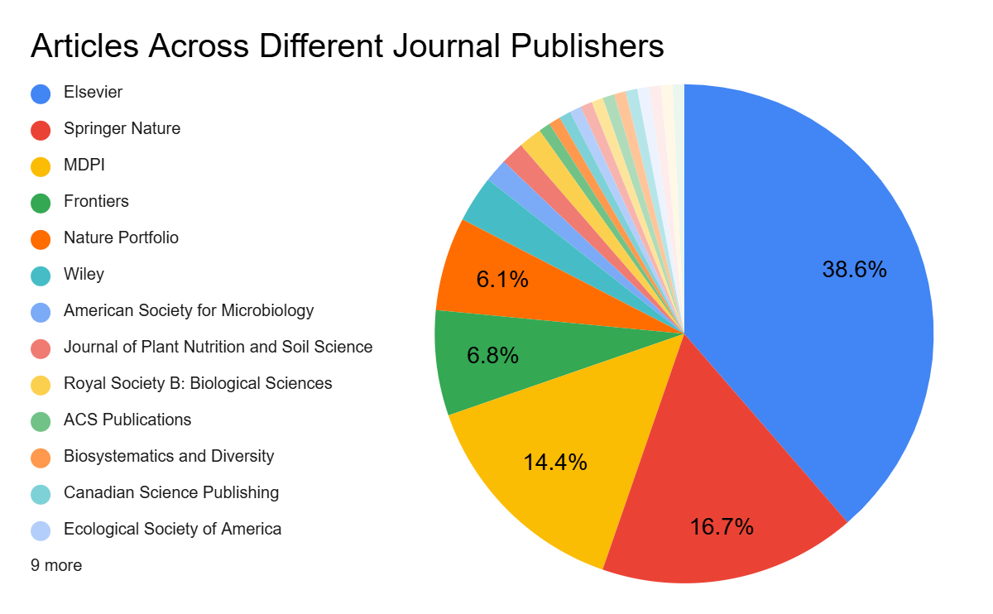
Fig. S1 : Pie chart showing the distribution of articles across different electronic journal publishers. Chart highlights the dominance of major publishers, with larger segments indicating publishers with higher publication counts.

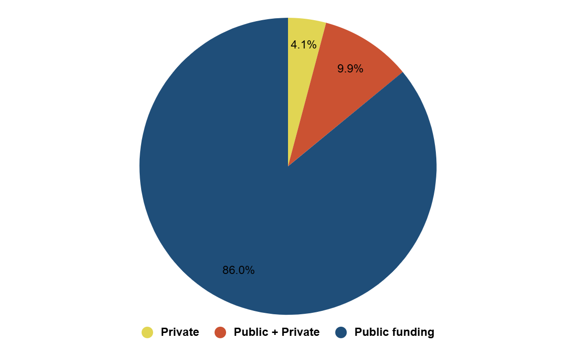
Fig. S2 : Proportion of studies by funding source.
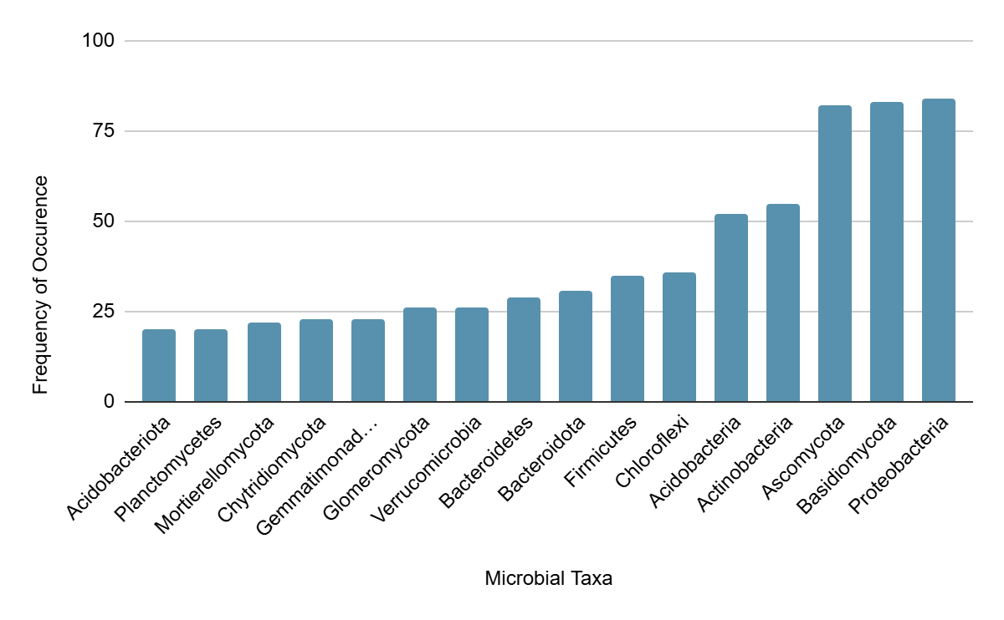
Fig. S3: Frequency of occurrence of the 16 most frequently reported microbial taxa across the included studies.

