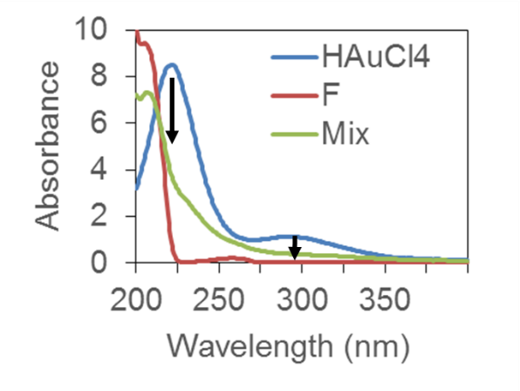
Fig. S1. The absorbance spectra of HAuCl₄ (1 mM), Phe (1 mM) and the mixture: The arrows show the decreased points (220 nm and 293 nm) in the presence of Phe (F) indicating the ligand exchange.

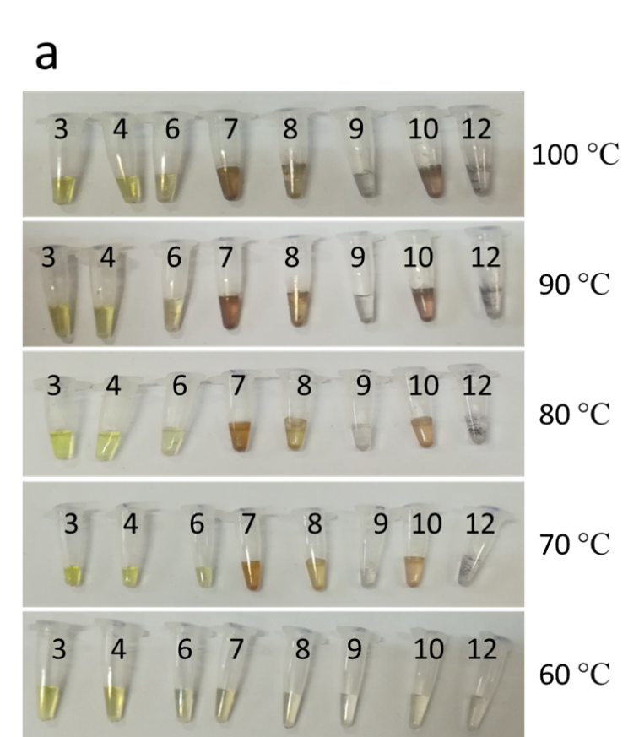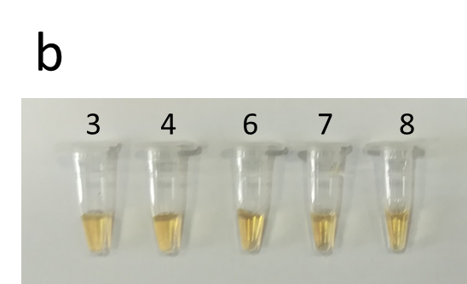
Fig S2. a: Gold ions are reduced by water in 30 minutes where pH ≥7 and temperature > 60 °C. b: The prolonged incubation of 4 hours at 60 °C and pH values ≤ 8 shows the absence of visible particle formation due to hydrothermal reduction.

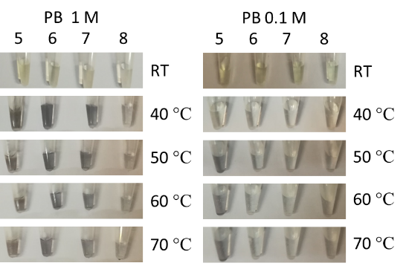
Fig. S3. The reduction of gold in PB. Left: at temperatures 40 °C to 70 °C the precipitates of gold were observed in pHs of 5, 6, 7, and 8 in PB (1 M). Right: With 0.1M PB, the precipitates were observed only in pH= 5 in examined temperatures higher than 50 °C.

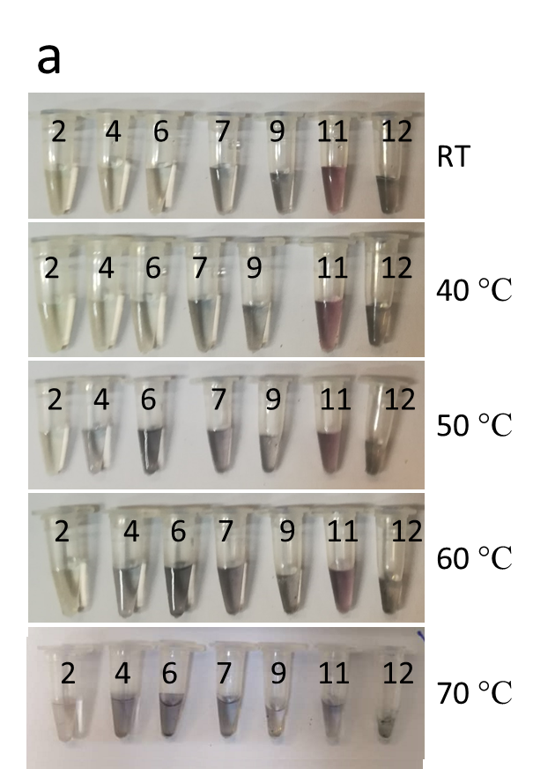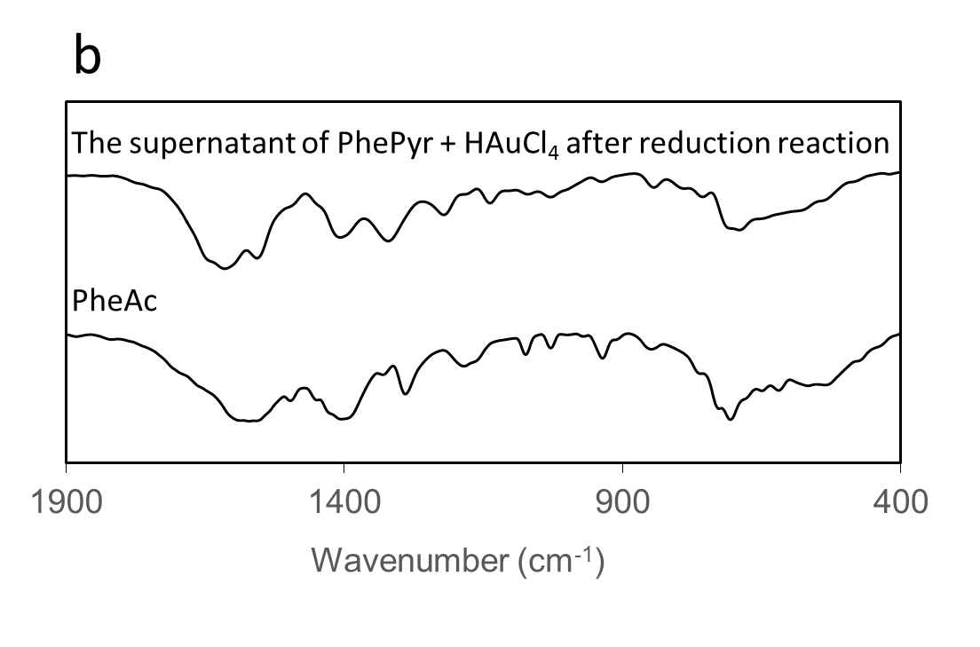

Fig. S4. Gold reduction by PhePyr. a: At room temperature (RT) the reduction takes place in pHs ≥7, by increasing the temperature, reduction can happen in lower pHs also. b: FTIR spectra of air-dried dissolved PheAc and air-dried supernatant of PhePyr and chloroauric acid reaction at pH=6 and 60 °C for 4 hours that shows the production of PheAc by oxidation of PhePyr.

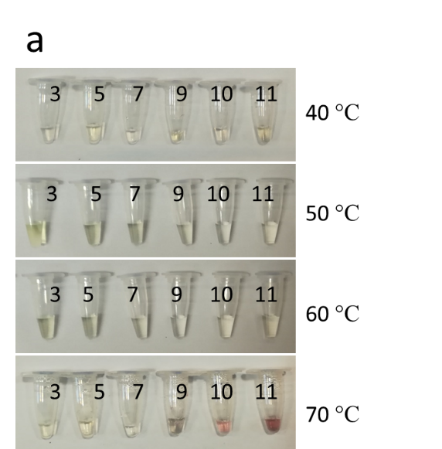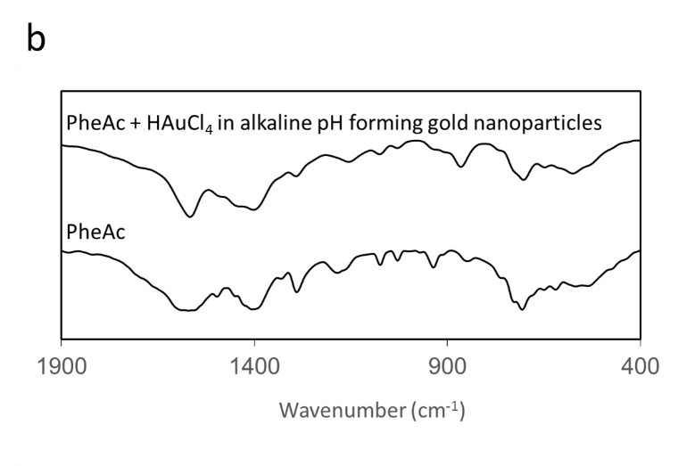

Fig. S5. PheAc and HAuCl₄ reaction a: No visible particle formation was detected in temperatures of 60 °C and lower. b: FTIR spectra of the air-dried supernatant of pH=10 at 70 °C that shows PheAc is not oxidized in higher pHs also in which hydrothermal reduction of gold ions takes place and gold nanoparticles are formed.

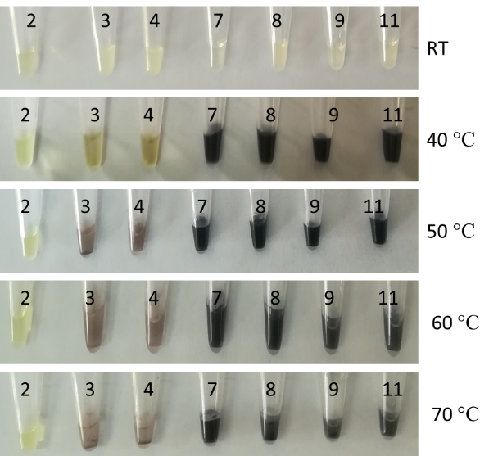

Fig. S6. Gold reduction by phenylalanine. Heating increases the reduction velocity, and higher pHs facilitate it.

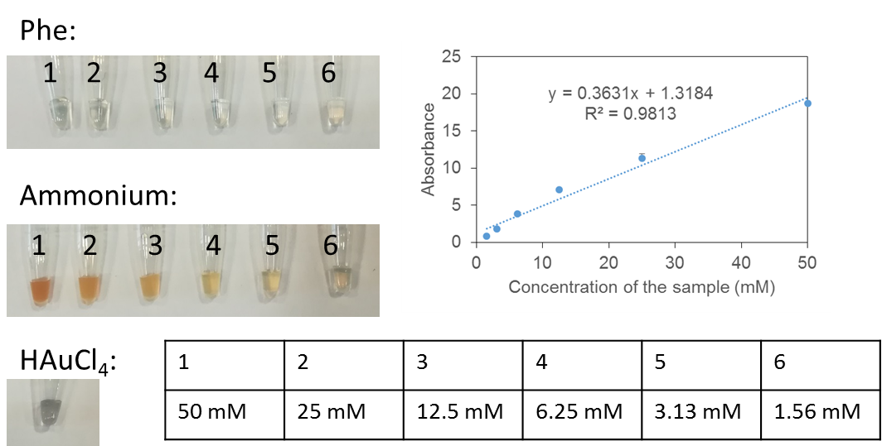

Fig. S7. Nessler’s reaction with various concentrations of Phe, ammonium, and HAuCl₄. The linear relation of the absorbance at 420 nm with ammonium in the range of 1.5 to 50 mM. HAuCl₄ reacts with Nessler’s reagent and produced black precipitates. After centrifuging, the supernatant was clear.

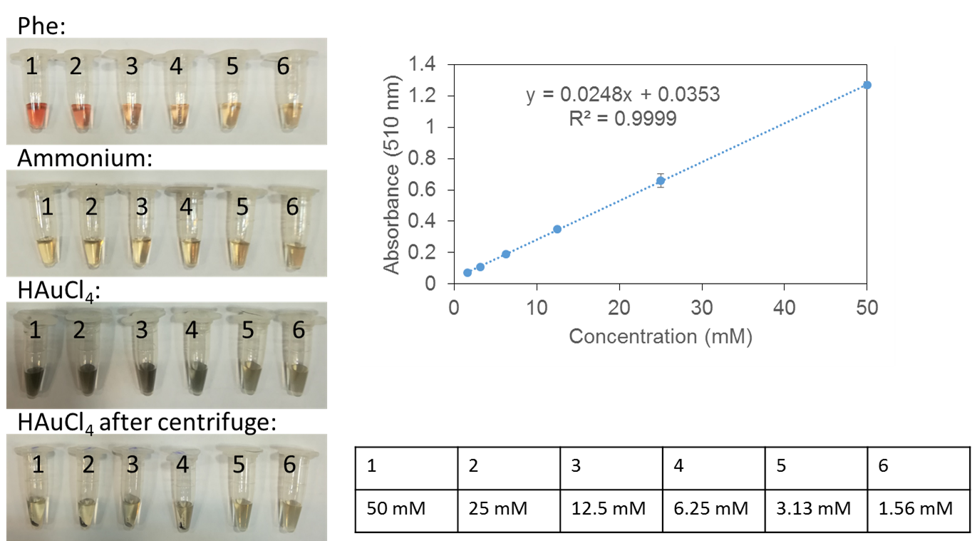

Fig. S8. Benzoquinone reaction with Phe, ammonium, and HAuCl₄ at RT for 30 minutes. Various concentrations of Phe, ammonium, and HAuCl₄ were treated with benzoquinone reagent that reacts with amine functional group. The calibration curve of Phe that shows a linear relationship in the applied concentration range. The absorbance at 510 nm for ammonium were similar to blank. HAuCl₄ forms precipitates that can be removed easily by centrifugation at maximum speed for 30 seconds. The absorbance of the supernatants was similar to the blank.

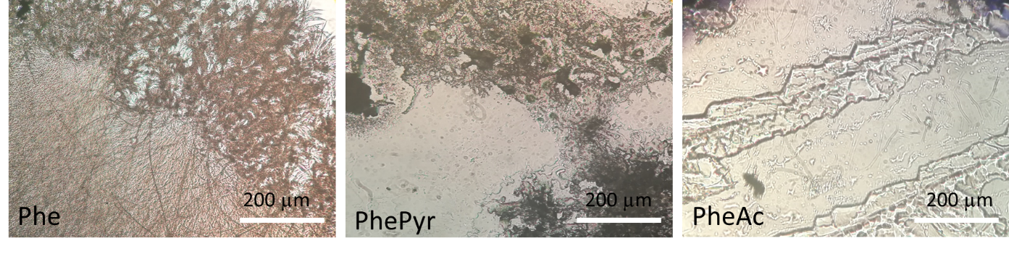
Fig. S9. The microscopic images of air-dried spots of Phe, PhePyr and PheAc on glass slide shows that the self-assembled structures are different

Table S1. The slopes of Stern-Volmer equation and the corresponding coefficient of determination of various synthesis conditions in various working buffers.
