Supplementary Figures
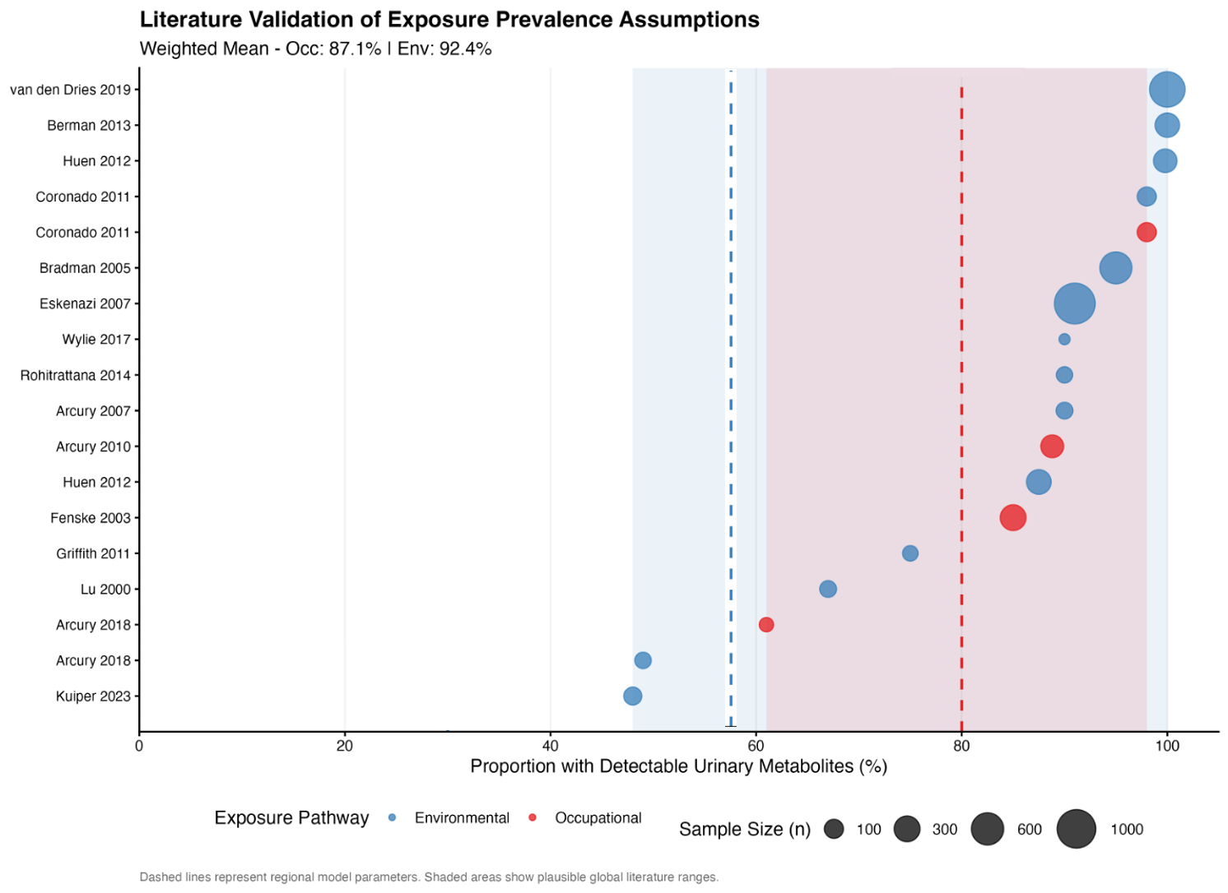
Supplementary Figure 1. Literature validation of pesticide exposure prevalence assumptions using biomonitoring studies. Dot plot shows proportion of individuals with detectable urinary organophosphate metabolites in 18 estimates from 15 published studies (2000-2023), stratified by exposure pathway. Point size scaled by sample size (n=17-1,163). Occupational pathway (red, n=5 estimates): farmworkers and agricultural workers. Environmental pathway (blue, n=13 estimates): rural residents, pregnant women in agricultural areas, children in farmworker households. Vertical dashed lines indicate study assumptions: 80% occupational exposure (red) and 58% environmental exposure (blue). Shaded background regions represent observed ranges from literature (red: 61-98%; blue: 48-100%). Weighted means (by sample size): occupational 83.9%, environmental 85.1%.
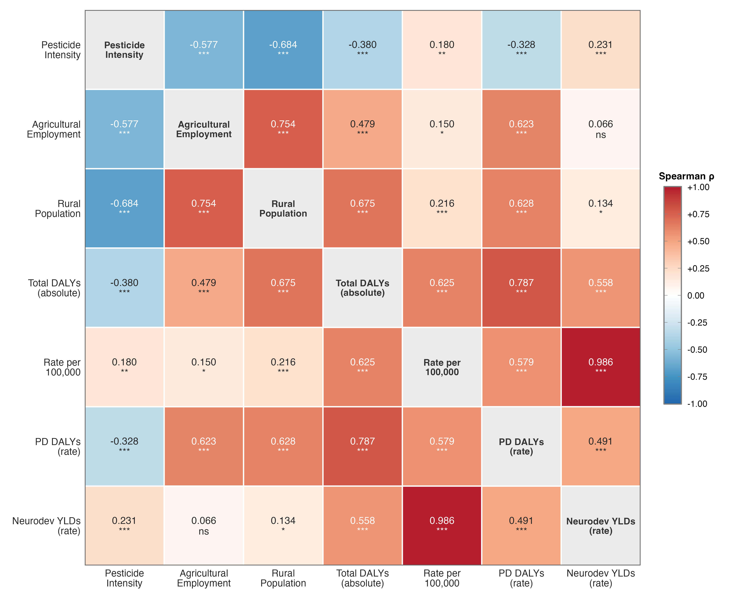
Supplementary Figure 2. Spearman Rank Correlations Among Independent Pesticide Exposure and Burden Metrics Across MENA Countries, 2010–2023. Full 7×7 symmetric heatmap of pairwise Spearman rank correlation coefficients (ρ) computed from 252 country-year observations (18 MENA countries × 14 years). Colour intensity represents correlation strength and direction: red indicates positive associations, blue indicates negative associations, and white indicates near-zero correlation. Numeric values show Spearman ρ with significance indicators (*** p < 0.001, ** p < 0.01, * p < 0.05, ns = not significant). Diagonal cells display variable names. All burden metrics are population-normalized rates per 100,000 to control for country size differences.

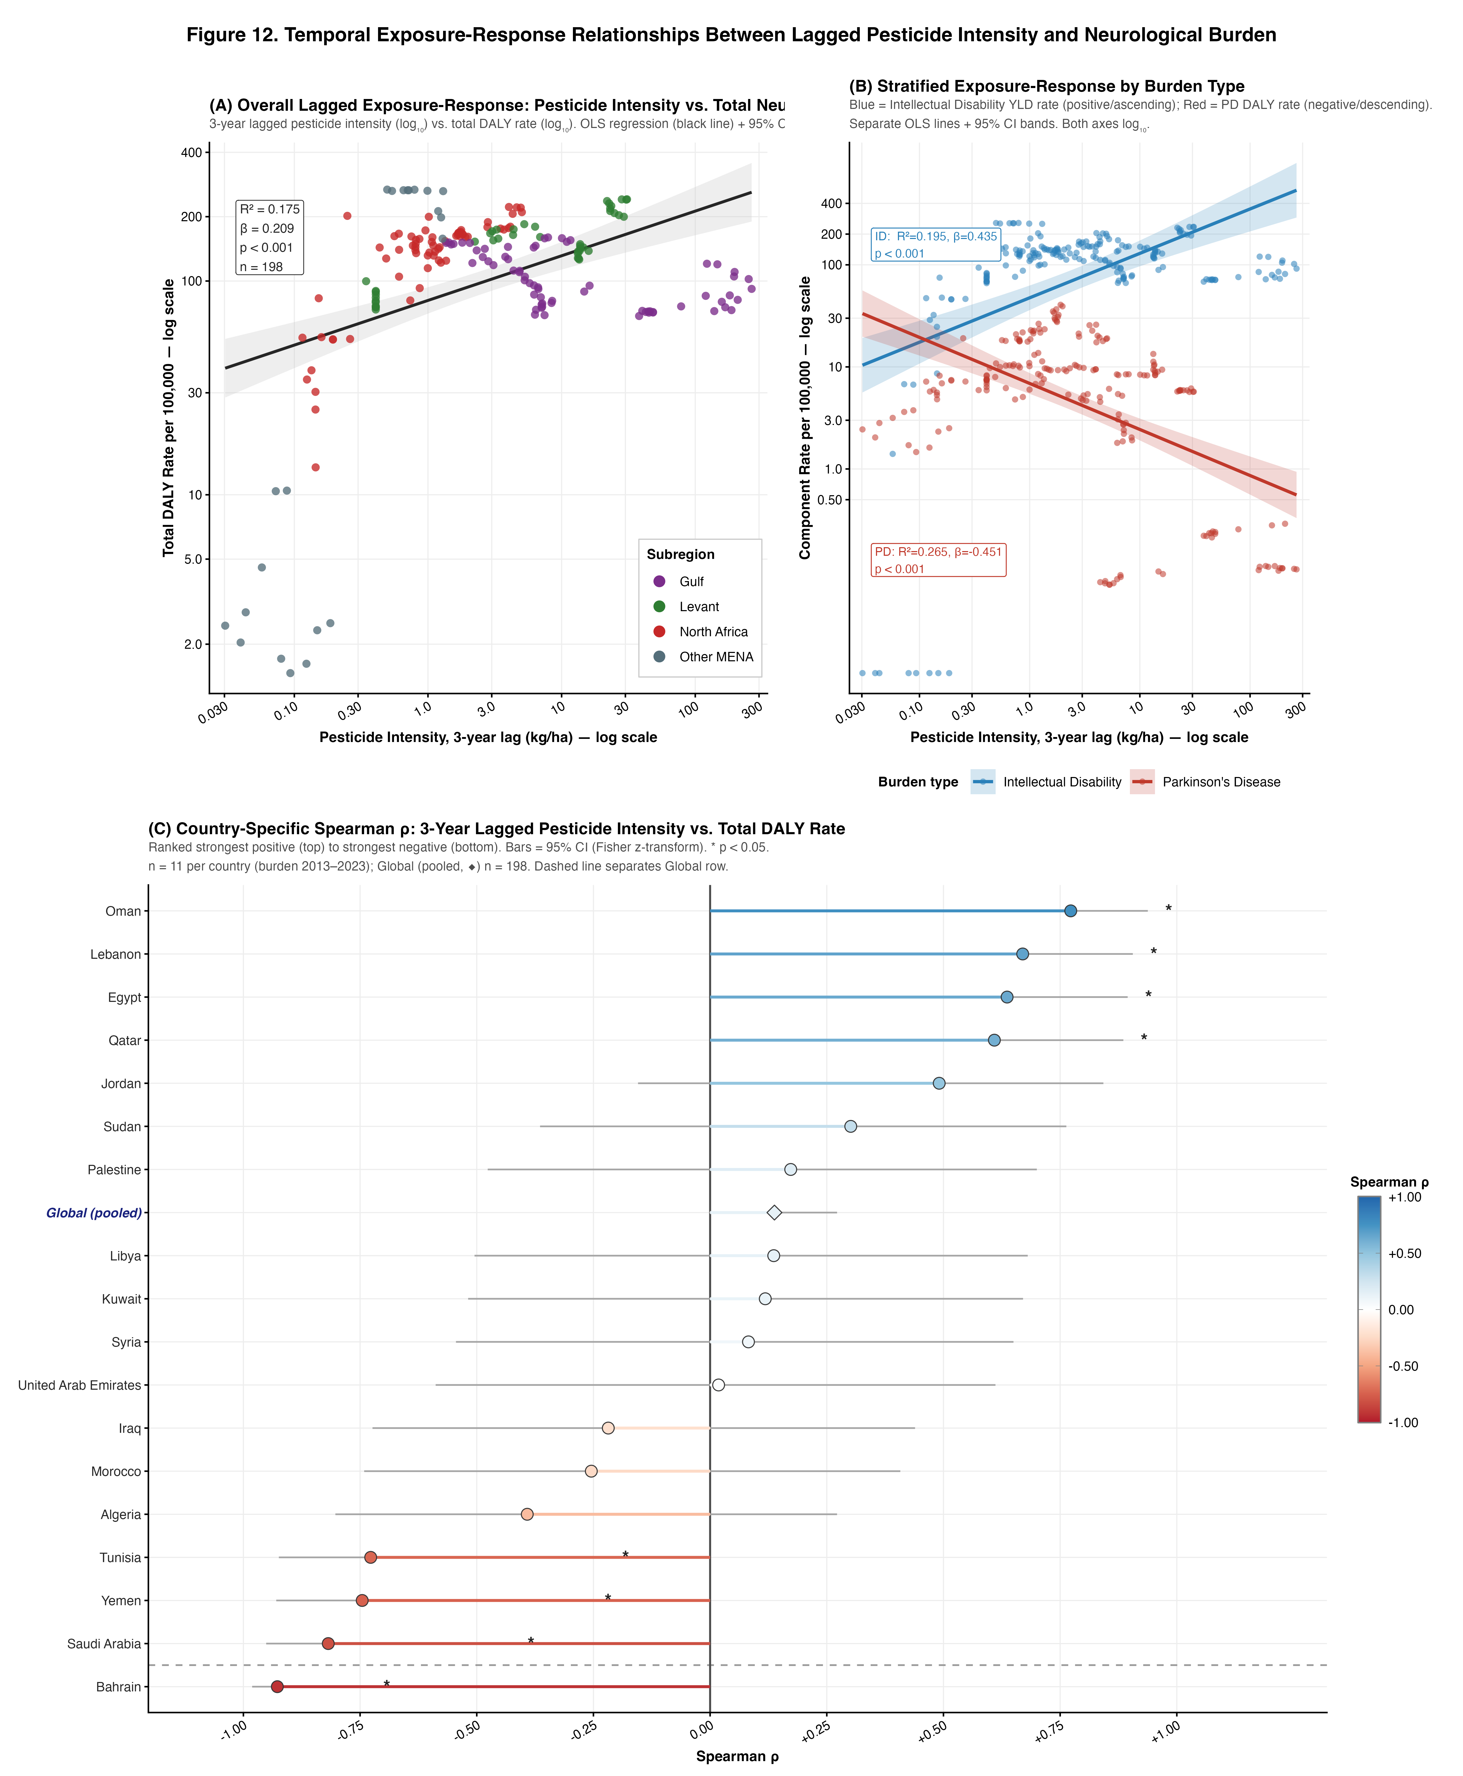
Supplementary Figure 3. Temporal Exposure-Response Relationships Between 3-Year Lagged Pesticide Intensity and Neurological Burden Across MENA Countries, 2010–2023. (A) Overall log-log scatter plot of 3-year lagged pesticide application intensity (kg/ha) versus total age-standardized neurological DALY rate per 100,000, across 198 country-year observations (18 MENA countries, burden years 2013–2023). Points are coloured by subregion; the black line represents the OLS log-linear regression fit with 95% confidence interval (grey shading). (B) Stratified exposure-response relationships for the two neurological burden components: intellectual disability YLD rate (blue, positive slope) and Parkinson's disease DALY rate (red, negative slope), each with separate OLS regression lines and 95% confidence bands on log-log axes. (C) Country-specific Spearman rank correlations (ρ) between 3-year lagged pesticide intensity and total DALY rate, computed within each country across 11 year-pairs (burden 2013–2023); the Global (pooled) row uses all 198 observations. Countries are ranked from strongest positive (top) to strongest negative (bottom); horizontal bars represent 95% confidence intervals via Fisher z-transformation; points are coloured by ρ value (red = positive, blue = negative). * p < 0.05 (two-sided). The dashed horizontal line separates individual country rows from the Global (pooled) row (diamond symbol).

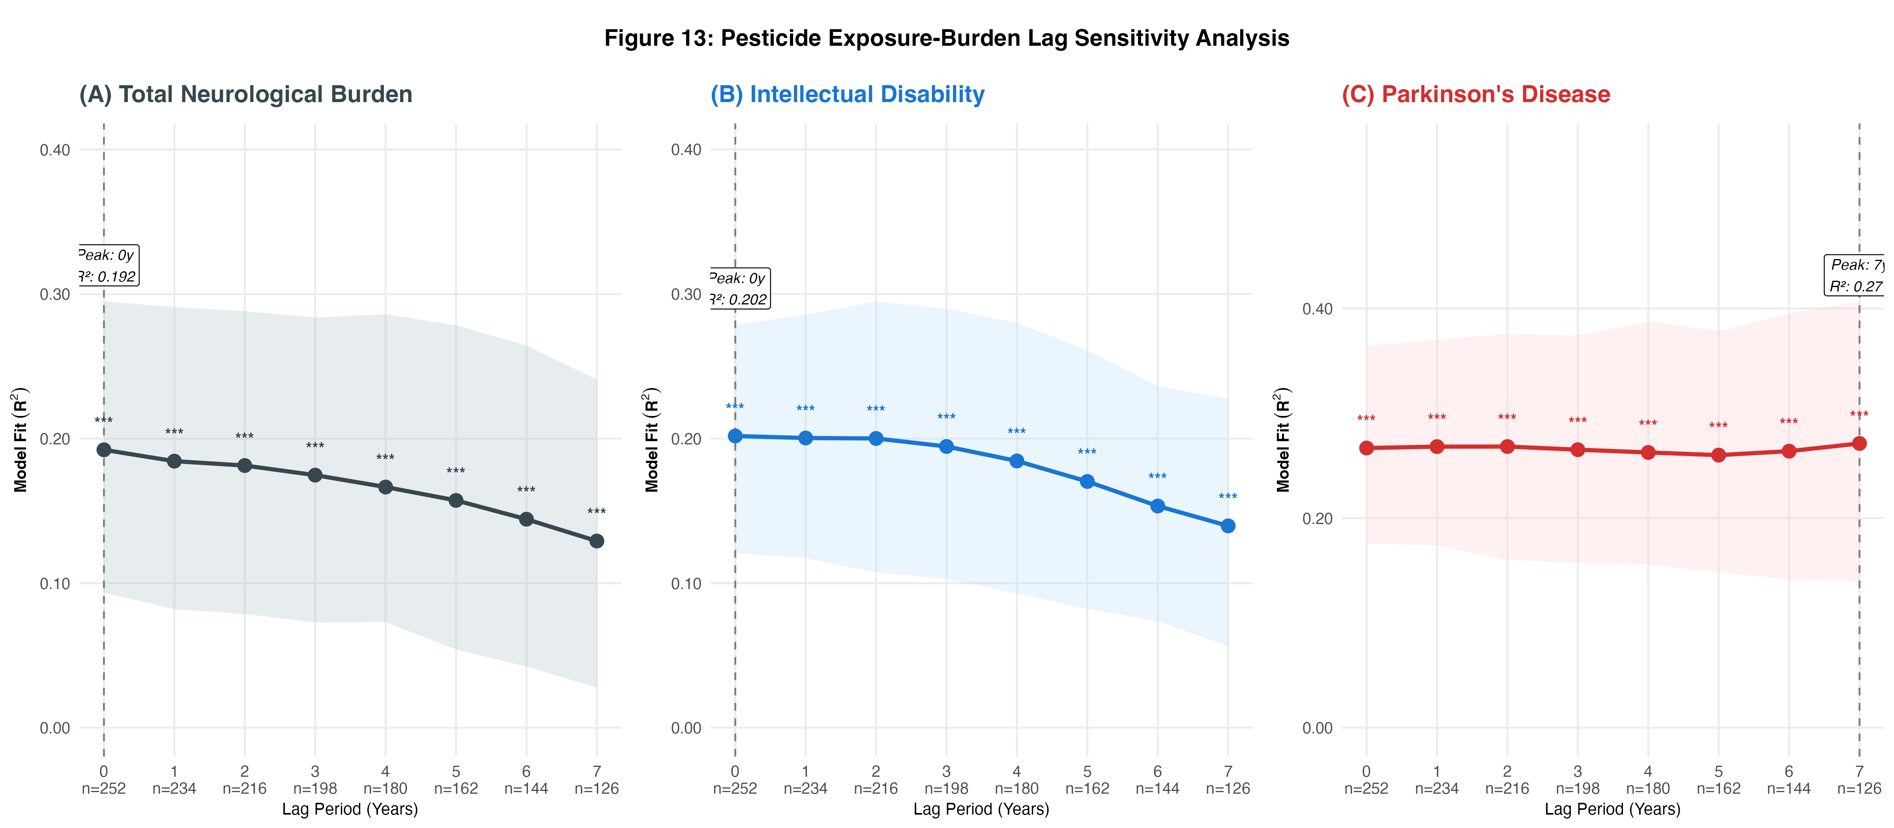

Supplementary Figure 4. Lag Sensitivity Analysis: Model Fit (R²) by Exposure Lag Period. R² from log-linear OLS regression of lagged pesticide application intensity versus neurological burden rate across 18 MENA countries, 2010–2023, for three burden outcomes: (A) total neurological DALY rate (dark grey), (B) intellectual disability YLD rate (blue), and (C) Parkinson's disease DALY rate (red). Each point represents the R² at a given lag (0–7 years), with shaded bands showing 95% bootstrap confidence intervals (B = 999, seed = 2024). Sample sizes decrease with increasing lag (n = 252 at lag 0 to n = 126 at lag 7) as matched country-year pairs are lost at each end of the study window. Dashed vertical lines mark the lag period yielding maximum R² for each outcome. Significance of each regression: *** p < 0.001, ** p < 0.01, * p < 0.05.

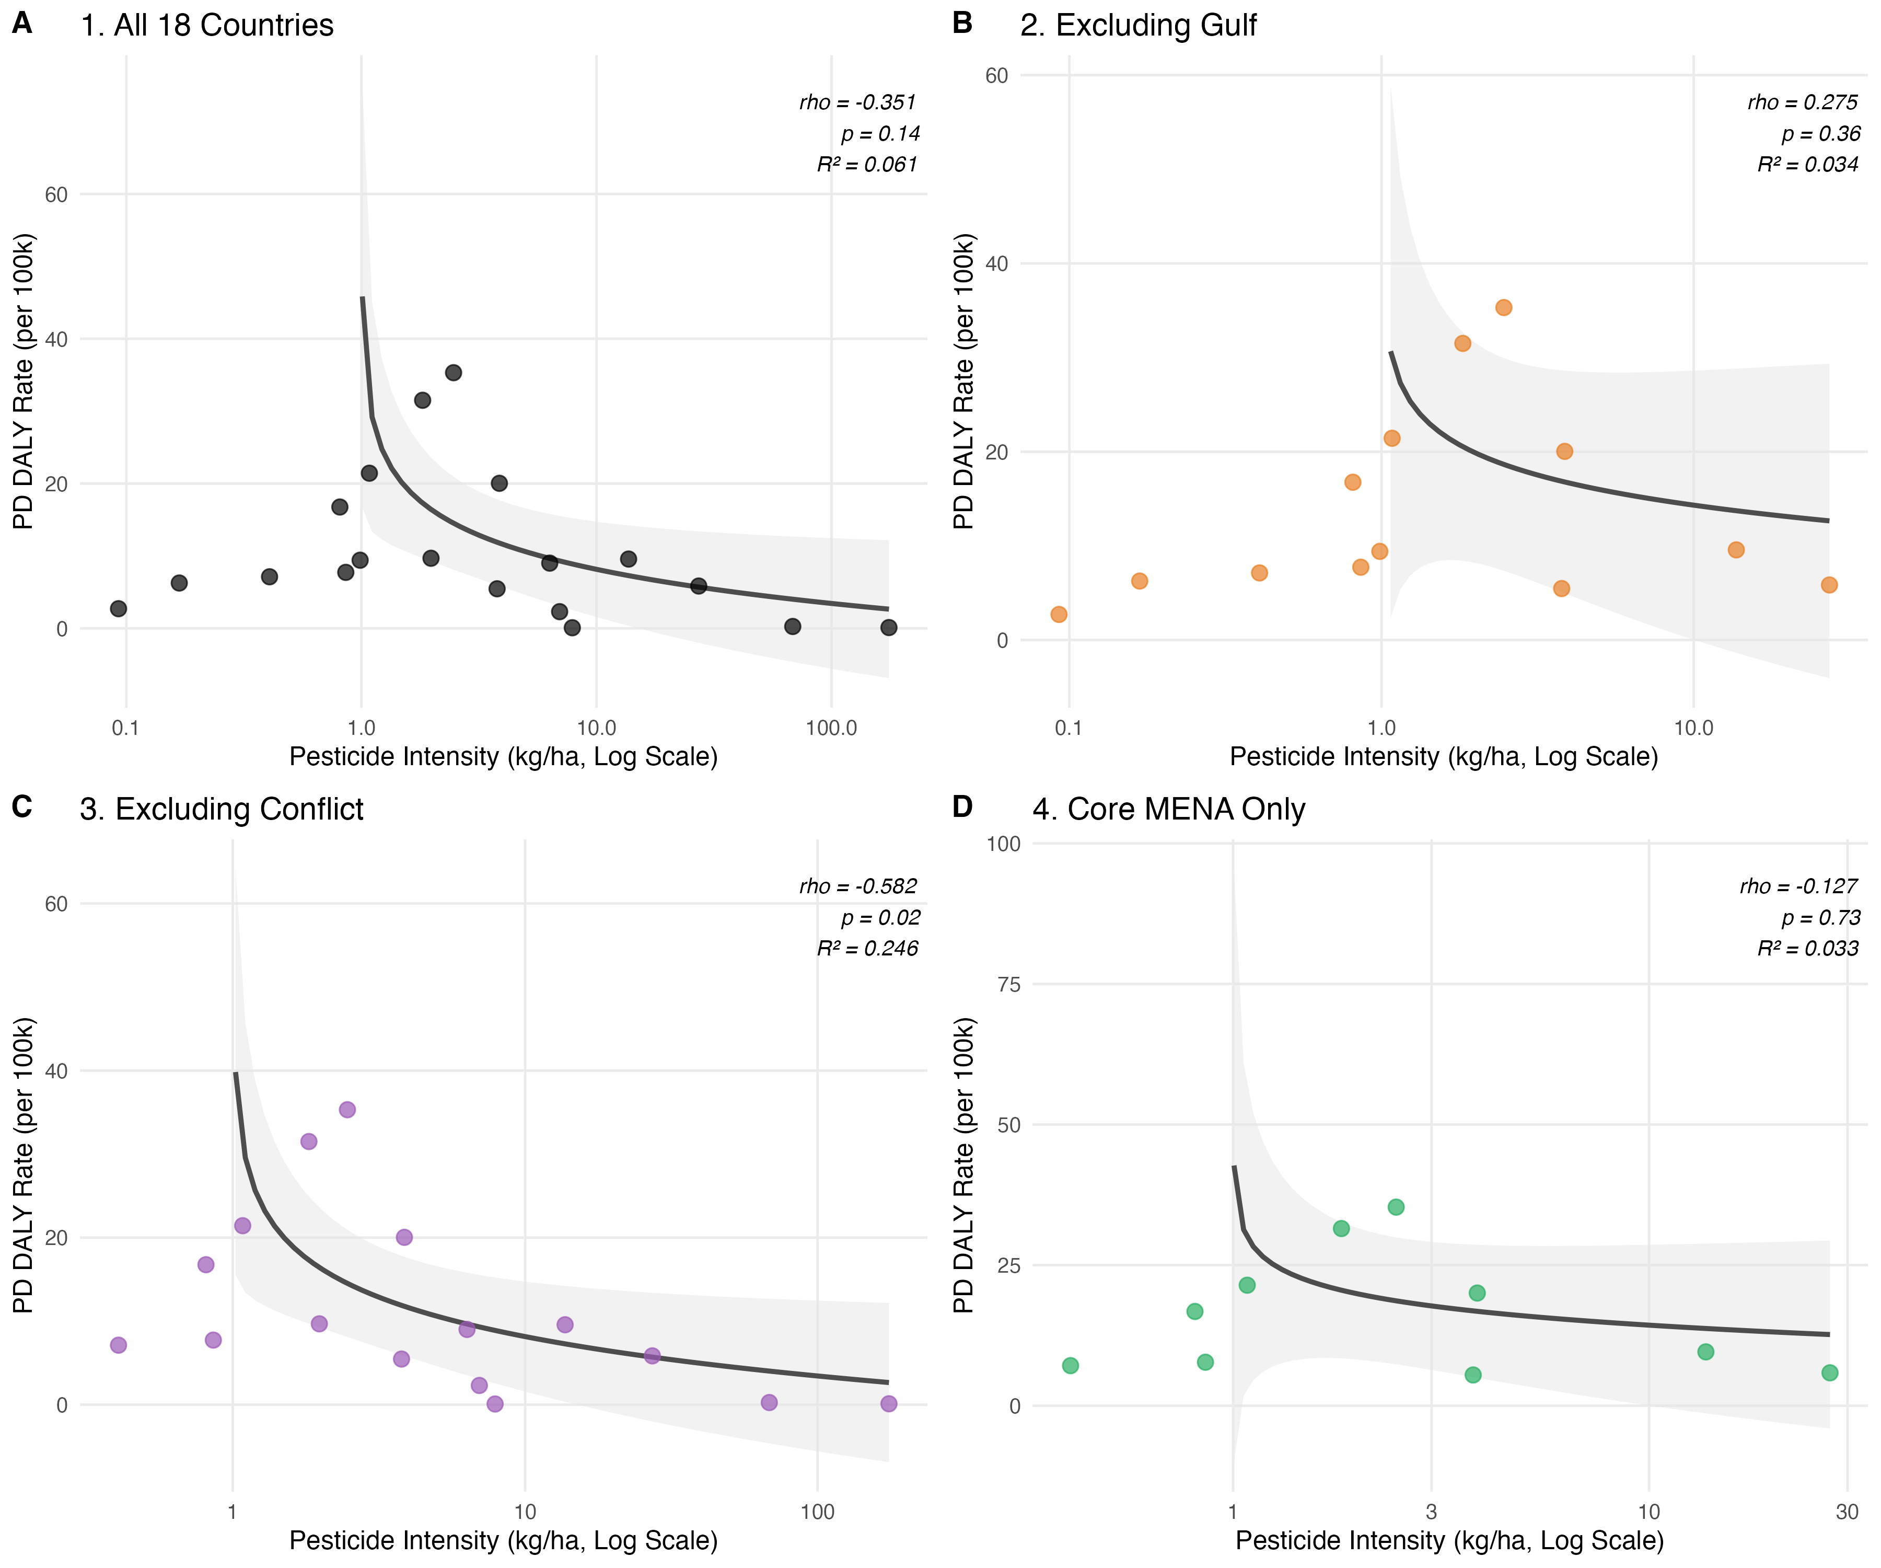
Supplementary Figure 5. Sensitivity Analysis of Parkinson's Disease-Pesticide Intensity Relationship Across MENA Countries, 2010-2023. Scatter plots display mean pesticide application intensity (kg/ha, logarithmic scale) versus mean PD burden rate (DALYs per 100,000 population) under four analysis scenarios: (A) All 18 MENA countries (n=18, ρ=-0.35, p=0.14); (B) Excluding Gulf countries (n=12, ρ=+0.28, p=0.36); (C) Excluding conflict-affected countries (n=15, ρ=-0.58, p=0.02); (D) Core MENA only—excluding both Gulf and conflict countries (n=9, ρ=-0.13, p=0.73). Points color-coded by analysis subset. Dashed trend lines show OLS regression with 95% confidence intervals (gray shading). The reversal from negative to positive correlation when excluding Gulf countries demonstrates that the inverse relationship is an artifact of agricultural mechanization patterns rather than a biological dose-response phenomenon.

