Supplementary Fig. and Tables

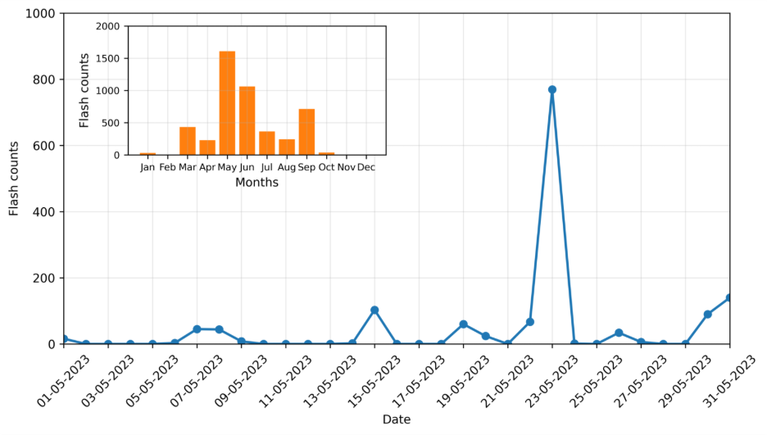Fig. S1 Daily and monthly variations of flash counts during the May and year 2023 using the ISS-LIS dataset over the study region
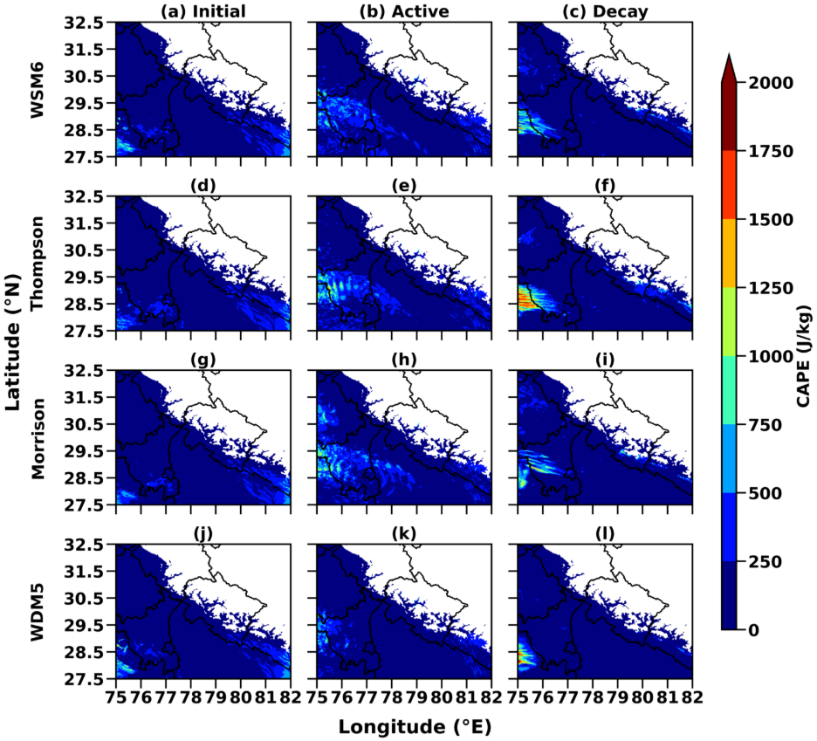
Fig. S2 Spatial distribution of hourly CAPE simulated by WSM6 (a, b & c), Thompson (d, e & f), Morrison (g, h & i), WDM5 (j, k & i) during initial (22 May 2023-18:00 to 23 May 2023 07:00 UTC), active (23 May 2023-8:00 to 23 May 2023-20:00 UTC) and decay (23 May 2023-21:00 to 24 May 2023-6:00 UTC) phase of lightning activities at 850 hPa

.

Table S1 Key elements of contingency table.
Contingency Table |  | Observation
 |  | Yes | No
WRF Simulations | Yes | Hit (A) | False Alarm (B)
WRF Simulations | No | Miss (C) | Correct  Rejection (D)

Table S2 Significance, Range and Skill Score of different evaluations tools.
FSS | Significance/Definitions | Range
POD= $\frac{A}{A+C}$ | Indicates the fraction of correct forecast | 0-1
FAR =$\frac{ B}{B+A}$ | Indicates the proportion of forecasted events that did not occur. | 0-1
BIAS=$\frac{ A+B}{C+A}$ | Compares the frequency of forecasted events to the observed events. | <1: More miss counts  >1: False alarm  1: Best score
CSI=$\frac{ A}{A+B+C}$ | Evaluates the accuracy of forecasts, considering both misses and false alarms. | 0 – 1
Accuracy  = $\frac{ A+D}{A+B+C+D}$ | Fraction of predicted events that were correct. | Between 0 to 1

