Supplemental Materials
eMethod 1. Algorithm to Identify screen-detected breast cancer
eTable 1. CPT/HCPCS and ICD9/10 Codes used to identify screening modality and primary care use
eFigure 1. Sensitivity analysis: associations between screening modality and tumor characteristics without adjustment for other tumor features
eMethod 1. Algorithm to Identify screen-detected breast cancer
We used a validated claims-based algorithm developed by Fenton et al. (2014) to classify mammograms as screening versus diagnostic.¹ Because our cohort was restricted to women with breast cancer, we adapted this approach by incorporating a second validated algorithm developed by Fenton et al. (2016) to identify cancers detected at screening mammography.²
Specifically, among women with breast cancer, we identified mammograms occurring within 123 days prior to diagnosis. We then applied the 2014 algorithm to classify mammograms within this window as screening or diagnostic. If a mammogram within 123 days of diagnosis was classified as a screening mammogram, we considered the cancer to be screen-detected. This approach distinguishes screening mammograms that initiated a diagnostic workup from diagnostic mammograms prompted by symptoms and has been used in our prior works.^{3,4}
eTable 1. Codes used to identify screening modality and primary care use
Codes to identify screening modality and distinguish screen-detected vs non-screen detected breast cancers
Detection Mode |  | CPT/HCPCS Codes (Unless otherwise noted)
Screening Mammography |  | '76092','G0202','G0203','77057','77067','77052','76083','76085'  DBT¹: '77063'
Diagnostic Mammography |  | '76091','G0204','G0205','77056','77066','76090','77055','77065','G0206','G0207','76082','77051','G0279','G0236'  DBT: '77061','77062','G0279'
Breast Symptoms |  | ‘6117’, 'N644','N6451','N6452','N6453','N6459'
Codes to identify primary care use
Type of Primary Care | HCPCS |  | CPT | ICD-9/10
Annual Wellness Visit² | G0402, G0468, G0438, G0439
Flu Shot | G0008, Q2034, Q2035, Q2036, Q2037,  Q2038, Q2039 |  | 90658, 90661,90660,90662,  90653,90654,90655, 90657,90656,90630,90664,  90666,90672,90673,90674,  90682,90685, 90687,90686, 90688,90689 | 9952, 3E01340, 3E02340
Primary Care Physician Visit | G0402, G0468, G0438, G0439 |  | 99202, 99203, 99204, 99205, 99212, 99213, 99214, 99215, 99387, 99397
Footnotes:
¹ Digital breast tomosynthesis.
² Annual wellness visit is a yearly preventive benefit of Medicare created in 2011.⁵

eFigure 1. Sensitivity analysis: associations between screening modality and tumor characteristics without adjustment for other tumor features
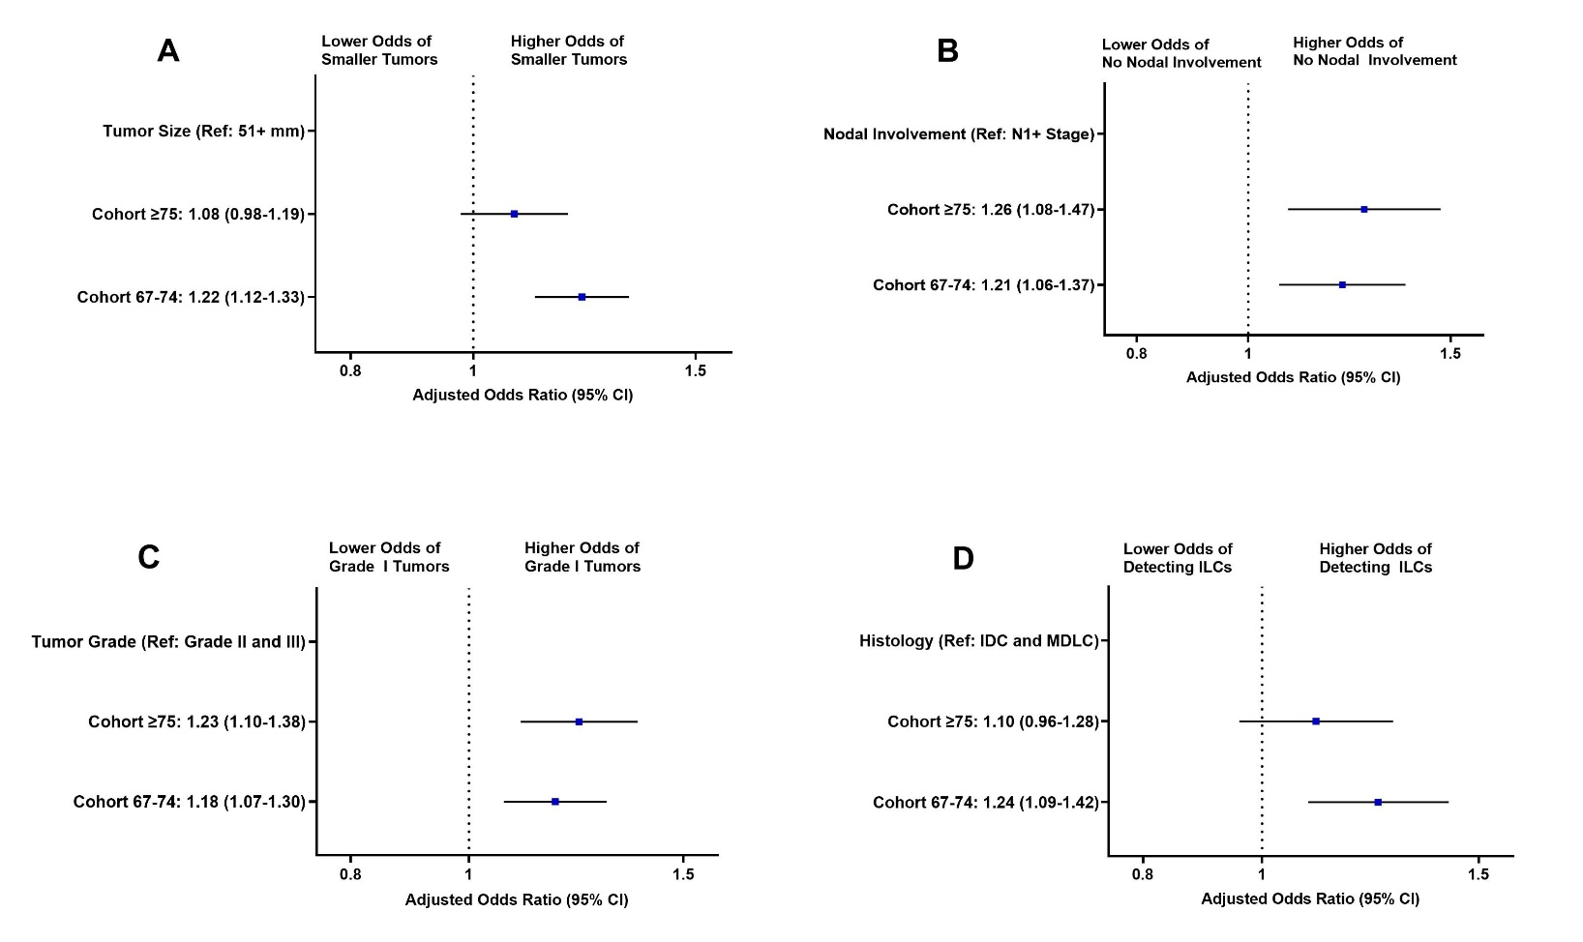
*None of the models were adjusted for tumor characteristics. Models were adjusted for demographic factors (age, race/ethnicity, marital status); socioeconomic indicators (Medicare and Medicaid dual eligibility; area-level percentage Black residents, urbanicity, median household income); year of diagnosis; clinical factors (claims-based frailty index, Elixhauser comorbidities); healthcare utilization in the prior 2 years (prior screening mammogram, primary care visit, flu vaccination, Annual Wellness Visit).

References
1. Fenton JJ, Zhu W, Balch S, Smith-Bindman R, Fishman P, Hubbard RA. Distinguishing screening from diagnostic mammograms using Medicare claims data. Med Care. Jul 2014;52(7):e44-51. doi:10.1097/MLR.0b013e318269e0f5
2. Fenton JJ, Onega T, Zhu W, et al. Validation of a Medicare Claims-based Algorithm for Identifying Breast Cancers Detected at Screening Mammography. Med Care. Mar 2016;54(3):e15-22. doi:10.1097/MLR.0b013e3182a303d7
3. Robinson TJ, Wilson LE, Marcom PK, et al. Analysis of Sociodemographic, Clinical, and Genomic Factors Associated With Breast Cancer Mortality in the Linked Surveillance, Epidemiology, and End Results and Medicare Database. JAMA Netw Open. Oct 1 2021;4(10):e2131020. doi:10.1001/jamanetworkopen.2021.31020
4. Huang S, Westvold SJ, Soulos PR, et al. Screening History, Stage at Diagnosis, and Mortality in Screen-Detected Breast Cancer. JAMA Network Open. 2025;8(4):e255322-e255322. doi:10.1001/jamanetworkopen.2025.5322
5. Colburn JL, Nothelle S. The Medicare Annual Wellness Visit. Clin Geriatr Med. Feb 2018;34(1):1-10. doi:10.1016/j.cger.2017.09.001

