Supplementary Material

Co-production and participant engagement
Before the prospective study, young person advisory groups (YPAG) were established to co-produce elements of the study design. Twelve young people were grouped into three YPAGs, see Supplementary Table 1 for participant demographics and see protocol paper (Caddick et al., 2024) for details on the YPAG sessions.

Supplementary Table 1: Young Person Advisory Group Demographics
 | YPAG 1 | YPAG 2 | YPAG 3
N | 4 | 4 | 4
Sex, Female, N (%) | 2 (50%) | 1 (25%) | 2 (50%)
Age, years, mean (SD) | 9.5 (1.91) | 10.75 (1.5) | 16 (1.15)

As a result of the pre-study co-production, young people were keen to be engaged more frequently through-out the study. Therefore, participants were invited to check-in calls in each week of their data collection on the Ambient-Teens study. These were short, 15–30-minute, online calls, held on Microsoft Teams, between the participant and a member of the research team. Parents/caregivers of participants < 16 years-old were also invited to attend. Check-in calls started with an opportunity for the young person to feedback any information about the study methods (bedside radar sleep sensor, accelerometer and sleep diary). Participants then received basic sleep education, such as definitions of sleep terms, e.g. sleep onset, onset latency and sleep efficiency, and what happens when we sleep and enter different sleep stages. Then, using the online dashboard for the radar sensor, participants could compare an entry in their sleep diary with the time-points of the radar sensor. Finally, participants and their parents/caregivers could ask questions related to the study protocol or methods.

At the end of their data collection, participants were invited to take part in a citizen science engagement activity. This was an optional component of the study. Two engagement activities were created, based on feedback from the pre-study YPAGs. A citizen scientist activity for older participants, in which they could generate their own research question about sleep. Initially, they completed a research plan (following examples), then they were given the required data and completed the citizen scientist sleep report. The other engagement activity was aimed at younger participants, called ‘Product Reviewers’. This activity invited participants to compare, in their own creative way, their experiences with the accelerometer and the contactless radar sensor. Different methods of completion were encouraged such as posters, videos or presentation slides. Participants were invited for their completed activities to be posted on the Ambient-Teens study website, with their name or anonymously.

Once all participants completed data collection, those that completed the citizen science engagement activities were invited to a post-study YPAG. The aim of the post-study YPAG was to include young people in the knowledge exchange and create outputs aimed at other young people. Six young people took part in two online sessions. The YPAG decided to create a short video series in which they would each create a video that could be posted online. In the first session, YPAG members decided the different topics to cover in the videos, these included: describing the methods, sharing why they took part in the research study, comparing the wearable and contactless devices and an overall summary about why this sleep study is important for young people. The YPAG members decided who would do each video and then were given access to a Canva account to create their videos. In the second session, the young people brought draft ideas for their video to share with the researcher and YPAG members for feedback. The young people created the videos in their own time, with technical support from the research team if needed. The final video series is posted on Youtube.

Young people that took part in the YPAG sessions were offered additional incentives. These included a certificate and £20 voucher for the pre-study YPAG, and a £20 voucher for the post-study YPAG.
Supplementary Methods
Questionnaires
Revised Children’s Anxiety and Depression Scale (RCADS)
The RCADS is commonly used to assess anxiety and depression symptoms in adolescents. It includes 47-items and covers 6 subscales: major depressive disorder (MDD), panic disorder (PD), social phobia (SP), generalised anxiety disorder (GAD), separation anxiety disorder (SAD) and obsessive-compulsive disorder (OCD), as well as total scores for anxiety and combined total for anxiety and depression. Participants were prompted to select the most appropriate option: never, sometimes, often or always.

Sleep Disturbance Scale for Children (SDSC)
SDSC was scored for a total score and 6 subscales: disorders of initiating and maintaining sleep, sleep breathing disorders, disorders of arousal, sleep-wake transition disorders, disorders of excessive somnolence and sleep hyperhydrosis. The first questions ask about sleep timing (total duration and time taken to fall asleep) and the remaining questions ask about the frequency of sleep difficulties with response options: never, occasionally (once or twice per month or less), sometimes (once or twice per week), often (3 or 5 times per week) or always (daily).
Young people also completed the Munich Chronotype Questionnaire (MCTQ) and Pubertal Development Scale (PDS). However, analysis of these questionnaires was not included in this paper.

Munich Chronotype Questionnaire (MCTQ)
All young people (aged 8-18) completed the MCTQ. This asked questions about adolescent’s sleep timings on school days and free days, over the past 4 weeks. It also asked about time spent outdoors, school schedules, travel to and from school and stimulant use. MCTQ determined self-reported variables such as chronotype and midsleep, scored using R package, mctq (Vartanian, 2021).

Pubertal Development Scale (PDS)
The PDS is used to determine pubertal stage. Participants complete 6 (female) or 5 (male) short questions relating to their development such as growth in height, skin changes and body hair, with response options: has not yet begun, has barely started, is definitely underway, seems complete or don’t know. Females are also asked if they have begun to menstruate and at what age they got their first period. Responses are scored to categorise if participants are prepubertal, early pubertal, midpubertal, late pubertal or postpubertal.

Radar-based sleep sensor setup
The radar sensor was pre-paired with a Wi-Fi modem and sent to participants’ home or school. Participants plugged in the device and placed it next to their bed, angled at their chest. Settings for the radar sensor were consulted with the pre-study YPAG to include minimal audio and visual displays. This allowed participants to be instructed through the setup process with audio and visual feedback but to reduce light and sound stimulus during sleep. Participants measured the distance between the radar sensor and the far edge of their sleeping area. The device settings were modified by the research team so that the furthest distance that the device could measure within, default 2 metres, covered the sleeping area but was not too large that others in a shared room could be detected. Participants were able to contact the research team via phone or email for support during device setup.

The disabled sleep tracking feature was implemented for one rotation of participants (N=6) which only recorded sessions within pre-defined hours. These were individualised according to each participant's earliest time to fall asleep and latest time to wake up. The disabled sleep tracking feature resulted in data loss and so was not continued for subsequent groups.

Data cleaning
Radar sensor sessions were recorded based on time spent in close proximity to the sensor, often capturing multiple sessions per day, unlike the typical 24-hour analysis using standard methods. Therefore, additional data cleaning steps were necessary. Supplementary Figure 1 shows the total number of sessions at each step of data cleaning, including how many and what percentage of sessions were removed, as well as across how many participants these removed sessions were distributed.
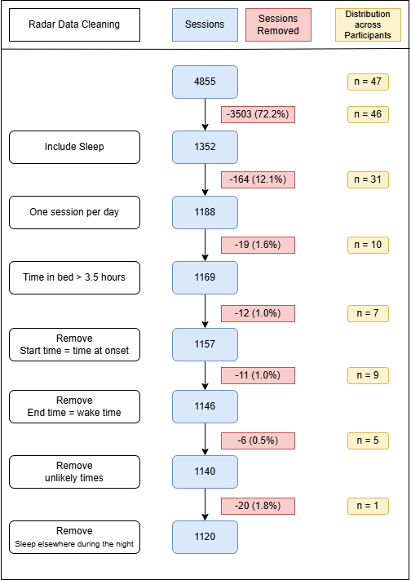
Supplementary Figure 1: Data cleaning steps for the bedside radar sensor.
Almost all participants had sessions recorded that did not contain sleep (N = 46). Twelve percent of sleep sessions were removed as they were additional recordings to the nocturnal sleep session. It is likely these were naps or time in bed with little movement imitating sleep. It is expected to record time awake in bed before and after the sleep session, hence sessions start/end times that were exactly the same as sleep onset or wake time were removed. Although small percentages of data were excluded in the later steps, it is worth noting that these sessions were spread across multiple participants. One participant did not routinely sleep in their bed the full night and therefore the correct start and end times of their sleep were not captured within the radar zone of the sleep sensor and so their radar data was removed.
Supplementary Results

Sleep Timing and Duration
TST, sleep onset and wake time were not significantly associated with sex, SIMD score or location (Supplementary Table 2). TST and sleep onset were significantly associated with age-range, with 16–18-year-olds displaying on average 1 hour and 27 minutes less time asleep and sleep onset on average 1 hour and 49 minutes later than 8–11-year-olds. However, wake time was not significantly associated with age-range. TST was significantly associated with method, with the accelerometer measuring time asleep on average 43 minutes less and the diary on average 12 minutes less than the radar sensor. Sleep timings were also significantly associated with method, with the accelerometer showing wake time on average 7 minutes earlier and the diary on average 6 minutes earlier than the radar sensor. The diary reported sleep onset on average 10 minutes later than the radar sensor, but there was no significant difference between the radar and accelerometer for time at sleep onset. TST, sleep onset and wake time were significantly associated with day of the week, with sleep times at the weekend showing on average 26 minutes more time asleep, onset 29 minutes later and wake time 1 hour later.

Supplementary Table 2: Linear mixed-effect model for covariate fixed effects on key sleep variables
 | TST (mins) |  | Sleep Onset (mins) |  | Wake Time (mins)
 | B (CI) | p | B (CI) | p | B (CI) | p
Age Range
12-15 | -16.42  (-38.68, 5.93) | 0.177 | 26.06  (-7.71, 59.74) | 0.157 | 10.28  (-19.18, 39.92) | 0.521
16-18 | -86.59  (-107.64, -65.52) | < 0.001* | 108.95  (76.76, 141.23) | < 0.001* | 14.65  (-13.45, 42.97) | 0.339
Sex | -13.11  (-30.08, 3.80) | 0.156 | 1.68  (-24.37, 27.84) | 0.905 | -4.70  (-27.50, 18.18) | 0.704
Day | 26.19  (18.67, 33.70) | < 0.001* | 28.78  (22.28, 35.26) | < 0.001* | 59.67  (52.57, 66.75) | < 0.001*
SIMD | 2.02  (-2.04, 6.09) | 0.359 | -5.25  (-11.40, 0.91) | 0.119 | -3.35  (-8.71, 2.06) | 0.253
Location | 5.36  (-16.81, 27.48) | 0.654 | -10.72  (-44.93, 23.60) | 0.562 | -4.80  (-34.70, 25.19) | 0.767
Method
Acc | -43.10  (-49.20, -37.07) | < 0.001* | 2.96  (-2.83, 8.72) | 0.315 | -6.74  (-10.84, -2.67) | 0.01*
Diary | -12.02  (6.40, 17.67) | < 0.001* | 9.90  (4.60, 15.17) | < 0.001* | -6.01  (-9.69, -2.32) | 0.01*
Reference categories: age-range = 8-11, Sex = female, Day = weekday, Location = Urban, Method = radar. *p <0.05. Note: small sample size limited power to detect small effects.

Comparison of sleep timing across age range
Sleep onset, wake time and TST are summarised by method and day, to compare across age ranges in Supplementary Table 3. 16-18-year-olds had significantly later sleep onset compared to the other age ranges, across all methods and days. Sleep onset was significantly earlier for 8-11-year-olds compared to 12-15-year-olds only when measured by the accelerometer and grouped by all nights. All other measures of sleep onset were not significantly different between 8-11- and 12–15-year-olds. Wake time was significantly later for 16-18-year-olds compared to 8-11-year-olds only when measured by the radar sensor and grouped by all nights. All other measures of wake time were not significantly different between age groups. TST measured on weekends by the accelerometer and by the diary were not significantly different across age groups. All other TST measures were of significantly shorter duration for 16–18-year-olds compared to 8-11-year-olds and 12-15-year-olds. TST was not significantly different between 8-11 and 12–15-year-olds across all methods and days.

Supplementary Table 3: Average sleep timing hh:mm (SD in mins) and sleep duration (in hours) comparing across age ranges for all nights, weekdays and weekends from the radar sensor, accelerometer and sleep diary.
 | Age Range (years)
 | 8-11 | 12-15 | 16-18 | p
Sleep Onset
Radar – all nights | 22:17ª (36.37) | 22:47ª (43.06) | 00:07^{b} (48.31) | <0.001*
Radar – weekdays | 22:09ª (36.84) | 22:40ª (44.08) | 00:04^{b} (51.04) | <0.001*
Radar – weekends | 22:40ª (40.81) | 23:04ª (45.10) | 00:19^{b} (53.95) | <0.001*
Acc – all nights | 22:02ª (39.87) | 22:44^{b} (36.82) | 00:06^{c} (58.50) | <0.001*
Acc – weekdays | 21:54ª (36.51) | 22:27ª (54.01) | 23:56^{b} (65.89) | <0.001*
Acc – weekends | 22:24ª (66.11) | 23:19ª (46.11) | 00:43^{b} (60.21) | <0.001*
Diary – all nights | 22:19ª (53.33) | 23:06ª (56.35) | 00:07^{b} (60.73) | <0.001*
Diary – weekdays | 22:13ª (50.14) | 22:58ª (56.23) | 00:00^{b} (65.41) | <0.001*
Diary – weekends | 22:38ª (72.26) | 23:21^{ab} (68.05) | 00:16^{b} (46.50) | 0.002*
Wake Time
Radar – all nights | 07:12ª (31.56) | 07:35^{ab} (28.87) | 07:47^{b} (40.14) | 0.025*
Radar – weekdays | 06:57 (29.30) | 07:18 (25.48) | 07:21 (36.70) | 0.063
Radar – weekends | 07:53 (51.12) | 08:23 (58.24) | 08:41 (59.96) | 0.110
Acc – all nights | 07:01 (32.50) | 07:32 (48.31) | 07:21 (46.18) | 0.223
Acc – weekdays | 06:53 (27.41) | 07:20 (46.77) | 07:03 (43.13) | 0.272
Acc – weekends | 07:32 (83.82) | 08:12 (61.80) | 08:14 (71.54) | 0.219
Diary – all nights | 07:22 (52.64) | 07:32 (36.37) | 07:20 (34.30) | 0.647
Diary – weekdays | 07:12 (53.27) | 07:17 (41.73) | 07:00 (35.76) | 0.499
Diary – weekends | 07:46 (63.97) | 08:09 (42.50) | 08:17 (67.08) | 0.360
Total Sleep Time
Radar – all nights | 8.41ª (0.48) | 8.14ª (0.55) | 7.17^{b} (0.54) | <0.001*
Radar – weekdays | 8.32ª (0.45) | 8.02ª (0.56) | 6.82^{b} (0.62) | <0.001*
Radar – weekends | 8.67ª (0.76) | 8.53ª (0.90) | 7.78^{b} (0.94) | 0.003*
Acc – all nights | 7.67ª (0.73) | 7.72ª (0.78) | 6.35^{b} (0.56) | <0.001*
Acc – weekdays | 7.61ª (0.68) | 7.80ª (1.08) | 6.25^{b} (0.76) | <0.001*
Acc – weekends | 7.87 (1.30) | 7.78 (0.81) | 6.63 (0.95) | 0.050
Diary – all nights | 8.87ª (0.71) | 8.33ª (1.12) | 7.17^{b} (0.63) | <0.001*
Diary – weekdays | 8.85ª (0.66) | 8.27ª (1.22) | 6.90^{b} (0.74) | <0.001*
Diary – weekends | 8.94 (1.03) | 8.69 (1.25) | 8.05 (0.94) | 0.069
Global p-values from Kenward-Roger approximation for degrees of freedom. Groups that share the same letter are not significantly different (Tukey-adjusted pairwise comparisons, *p < 0.05).

References
Caddick, L., Gaggioni, G., Haughton, D., Brown, J., Inchley, J., Simpson, S. A., Lyall, L. M., Murray, A., Romaniuk, L., Krondorf, L., Lopez, L. M., Smith, D. J., Wyse, C., & Whalley, H. (2024). Ambient Teens Sleep Study: Protocol for a co-produced feasibility study in adolescents using a contactless radar-based sleep sensor. PLOS ONE, 19(11), e0313286. https://doi.org/10.1371/journal.pone.0313286
Vartanian, D. (2021). mctq: Tools to Process the Munich ChronoType Questionnaire (MCTQ) [Dataset]. The R Foundation. https://doi.org/10.32614/cran.package.mctq

Documents
Citizen scientist task:
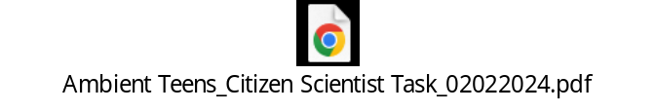

Product Reviewer task:
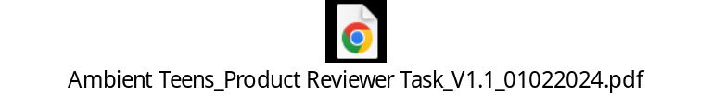

Demographic questionnaire:
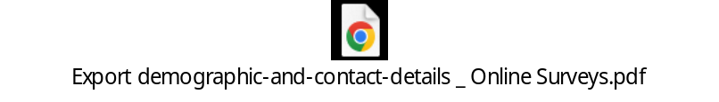

Revised Children’s Anxiety and Depression Scale (RCADS):
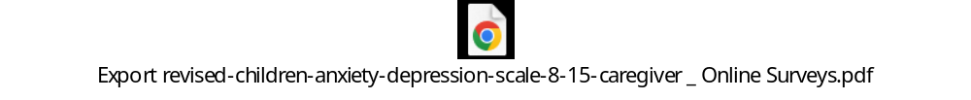

Sleep Disturbance Scale for Children (SDSC):



Munich Chronotype Questionnaire (MCTQ):
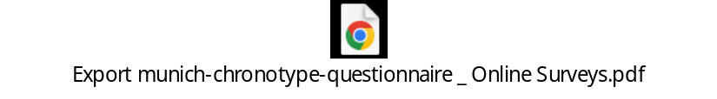

Pubertal Development Scale (PDS):
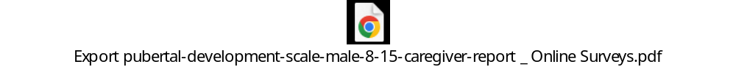




Feedback questionnaire:


