Supplementary materials
Not all heads are the same: species- and sex-specific differences in eye and postocular area morphology of burying beetles (Nicrophorus spp.)
Daria Bajerlein¹, Julian Katzke², Edward Baraniak³, Arkadiusz Urbański^{4*}
¹ Department of Animal Taxonomy and Ecology, Faculty of Biology, Adam Mickiewicz University, Poznań, Poland,
² Okinawa Institute of Science and Technology
³ Department of Systematic Zoology, Faculty of Biology, Adam Mickiewicz University, Poznań, Poland
⁴ Department of Animal Physiology and Developmental Biology, Adam Mickiewicz University, Poznań, Poland

Tab S1. Summary of the linear regression model estimating the effect of log-transformed left eye length on the log-transformed left eye width. Based on the combine data from four burying beetles species (Nicrophorus spp.). *** p ≤ 0.001.
 |  | Term | Estimate | Std. Error | t value | p value | Significance
 |  | Intercept | 0.503 | 0.002 | 218.8 | <2e-16 | ***
 |  | log_left eye width | 0.797 | 0.007 | 109.9 | <2e-16 | ***
Fig. S1. Allometric relationships between eye aspect ratio (length/width) and eye square root (width x length) in four burying beetles species (Nicrophorus spp.). Lines represent ordinary least squares regression models based on log–log transformed data, with 95% confidence intervals.
Tab. S2. Summary of the linear regression model estimating the effect of log-transformed left eye length on the log-transformed left eye width in four different Nicrophorus species (Nicrophorus humator, Nicrophorus interruptus, Nicrophorus vespillo and Nicrophorus vespilloides). ** p ≤ 0.01; *** p ≤ 0.001.
 |  | Term | Estimate | Std. Error | t value | p value | Significance
 |  | (Intercept) | 0,504 | 0,006 | 81,365 | < 2e-16 | ***
 |  | log_left eye width (Nicrophorus humator) | 0,907 | 0,030 | 30,090 | < 2e-16 | ***
 |  | speciesNicrophorus interruptus | -0,033 | 0,009 | -3,447 | 0,001 | ***
 |  | speciesNicrophorus vespillo | -0,038 | 0,010 | -3,933 | 0,000 | ***
 |  | speciesNicrophorus vespilloides | -0,004 | 0,016 | -0,239 | 0,811
 |  | log_left eye width:speciesNicrophorus interruptus | -0,129 | 0,040 | -3,245 | 0,001 | **
 |  | log_left eye width:speciesNicrophorus vespillo | -0,147 | 0,043 | -3,444 | 0,001 | ***
 |  | log_left eye width:speciesNicrophorus vespilloides | -0,193 | 0,043 | -4,494 | 8,06E-06 | ***

Tab S3. Summary of the linear regression model estimating the effect of log-transformed different morphological parameters associated with eye morphology on log-transformed pronotum width in four different burying beetles species (Nicrophorus humator, Nicrophorus interruptus, Nicrophorus vespillo and Nicrophorus vespilloides). * p ≤ 0.05; *** p ≤ 0.001.
 |  | Term | Estimate | Std, Error | t value | p value | Significance
 |  | eye length vs pronotum width
 |  | (Intercept) | -0,919 | 0,042 | -21,906 | < 2e-16 | ***
 |  | log_pronotum width (Nicrophorus humator) | 0,827 | 0,022 | 37,829 | < 2e-16 | ***
 |  | speciesNicrophorus interruptus | -0,360 | 0,059 | -6,064 | 2,06E-09 | ***
 |  | speciesNicrophorus vespillo | -0,268 | 0,063 | -4,272 | 0,0000217 | ***
 |  | speciesNicrophorus vespilloides | -0,272 | 0,060 | -4,515 | 7,31E-06 | ***
 |  | log_pronotum width:speciesNicrophorus interruptus | 0,080 | 0,033 | 2,443 | 0,0148 | *
 |  | log_pronotum width:speciesNicrophorus vespillo | -0,009 | 0,034 | -0,266 | 0,7906
 |  | log_pronotum width:speciesNicrophorus vespilloides | 0,054 | 0,035 | 1,508 | 0,132
 |  | eye width vs pronotum width
 |  | (Intercept) | -1,373 | 0,060 | -23,059 | < 2e-16 | ***
 |  | log_pronotum width (Nicrophorus humator) | 0,810 | 0,031 | 26,102 | < 2e-16 | ***
 |  | speciesNicrophorus interruptus | -0,672 | 0,084 | -7,976 | 5,36E-15 | ***
 |  | speciesNicrophorus vespillo | -0,436 | 0,089 | -4,901 | 1,16E-06 | ***
 |  | speciesNicrophorus vespilloides | -0,530 | 0,086 | -6,193 | 9,52E-10 | ***
 |  | log_pronotum width:speciesNicrophorus interruptus | 0,237 | 0,046 | 5,098 | 4,31E-07 | ***
 |  | log_pronotum width:speciesNicrophorus vespillo | 0,065 | 0,048 | 1,363 | 0,1731
 |  | log_pronotum width:speciesNicrophorus vespilloides | 0,122 | 0,050 | 2,425 | 0,0155 | *
 |  | eye aspect ratio (length/width) vs pronotum width
 |  | (Intercept) | 1,574 | 0,100 | 15,731 | < 2e-16 | ***
 |  | log_pronotum width (Nicrophorus humator) | 0,029 | 0,052 | 0,547 | 0,585
 |  | speciesNicrophorus interruptus | 0,526 | 0,142 | 3,718 | 0,000 | ***
 |  | speciesNicrophorus vespillo | 0,290 | 0,150 | 1,939 | 0,053
 |  | speciesNicrophorus vespilloides | 0,467 | 0,144 | 3,248 | 0,001 | **
 |  | log_pronotum width:speciesNicrophorus interruptus | -0,265 | 0,078 | -3,393 | 0,001 | ***
 |  | log_pronotum width:speciesNicrophorus vespillo | -0,129 | 0,080 | -1,603 | 0,109
 |  | log_pronotum width:speciesNicrophorus vespilloides | -0,130 | 0,085 | -1,533 | 0,126

Fig S2. Correlations between square root of eye (width x length) and pronotum width in four Nicrophorus species. Lines represent ordinary least squares regression models based on log–log transformed data, with 95% confidence intervals.
Table S4. Summary of ANOVA analysis performed for chosen morphological parameters in terms of analysis of differences between species and sexes. ** p ≤ 0.01; *** p ≤ 0.001
 |  | Term | Df | Sum Sq | Mean Sq | F value | p value | Significance
 |  | pronotum width
 |  | species | 3 | 14.845 | 4.948 | 488.431 | < 2e-16 | ***
 |  | beetle sex | 1 | 0.007 | 0.007 | 0.712 | 0.399
 |  | species:beetle sex | 3 | 0.160 | 0.053 | 5.275 | 0.001 | **
 |  | square root of eye (width x length)
 |  | species | 3 | 34.458 | 11.486 | 1269.151 | < 2.2e-16 | ***
 |  | beetle sex | 1 | 0.027 | 0.027 | 3.016 | 0.083
 |  | species:beetle sex | 3 | 0.230 | 0.077 | 8.461 | 1.548e-05 | ***
 |  | eye width
 |  | species | 3 | 42.417 | 14.139 | 1301.263 | < 2.2e-16 | ***
 |  | beetle sex | 1 | 0.028 | 0.028 | 2.597 | 0.107475
 |  | species:beetle sex | 3 | 0.174 | 0.058 | 5.337 | 0.001211 | **
 |  | eye length
 |  | species | 3 | 27.679 | 9.226 | 1096.929 | < 2.2e-16 | ***
 |  | beetle sex | 1 | 0.026 | 0.026 | 3.138 | 0.077
 |  | species:beetle sex | 3 | 0.299 | 0.100 | 11.861 | 1.329e-07 | ***

Table S5. Summary of the linear regression model estimating the effect of eye aspect ratio (length/width) with pronotum size in females and males of different burying beetles species (Nicrophorus humator, Nicrophorus interruptus, Nicrophorus vespillo and Nicrophorus vespilloides). F -females, M – males; *** p ≤ 0.001.
 |  | Term | Estimate | Std. Error | t value | p value | Significance
 |  | Nicrophorus humator
 |  | (Intercept) | 1,651 | 0,115 | 14,411 | <2e-16 | ***
 |  | log_pronotum width (F) | -0,018 | 0,060 | -0,300 | 0,764
 |  | beetle sex M | -0,096 | 0,153 | -0,629 | 0,530
 |  | log_pronotum width:beetle sex M | 0,063 | 0,080 | 0,787 | 0,432
 |  | Nicrophorus interruptus
 |  | (Intercept) | 2,175 | 0,142 | 15,269 | <2e-16 | ***
 |  | log_pronotum width (F) | -0,285 | 0,084 | -3,403 | 0,001 | ***
 |  | beetle sex M | -0,094 | 0,198 | -0,476 | 0,635
 |  | log_pronotum width:beetle sex M | 0,064 | 0,115 | 0,555 | 0,579
 |  | Nicrophorus vespillo
 |  | (Intercept) | 2,000 | 0,165 | 12,138 | <2e-16 | ***
 |  | log_pronotum width (F) | -0,165 | 0,090 | -1,840 | 0,067
 |  | beetle sex M | -0,140 | 0,217 | -0,644 | 0,520
 |  | log_pronotum width:beetle sex M | 0,058 | 0,119 | 0,484 | 0,629
 |  | Nicrophorus vespilloides
 |  | (Intercept) | 1,822 | 0,179 | 10,173 | <2e-16 | ***
 |  | log_pronotum width (F) | 0,041 | 0,116 | 0,352 | 0,725
 |  | beetle sex M | 0,445 | 0,255 | 1,744 | 0,083
 |  | log_pronotum width:beetle sex M | -0,290 | 0,165 | -1,757 | 0,081

Fig. S3. Allometric relationships between square root of eye area (length x width) and pronotum width in males and females of different burying beetle species. Lines represent ordinary least squares regression models based on log–log transformed data, with 95% confidence intervals. Solid lines with circles represent females, and dashed lines with triangles represent males.
Fig. S4. Allometric relationships between log transformed eye width and pronotum width in males and females of different burying beetle species. Lines represent ordinary least squares regression models based on log–log transformed data, with 95% confidence intervals. The slope value for these two variables is shown in the upper left corner.

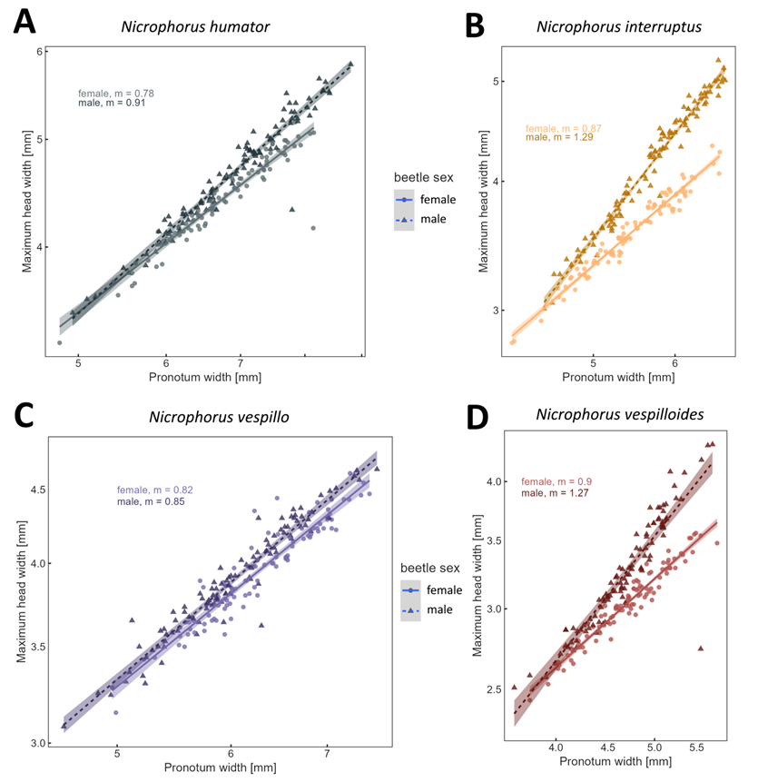
Fig. S5. Graphical presentation of statistical analyses related to the allometry of maximum head width and pronotum width in the tested burying beetle species. Lines represent ordinary least squares regression models based on log–log transformed data, with 95% confidence intervals. Sex‑specific slope values for the two variables tested are shown in the upper or lower corner of each graph. Solid lines with circles represent females, and dashed lines with triangles represent males.

Table S6. Linear model summary for the relationship between postocular area and pronotum width across four Nicrophorus species, including sex differences. *** p < 0.001, ** p < 0.01, * p < 0.05. F – females, M – males.
 |  | Term | Estimate | Std. Error | t value | p value | Significance
 |  | postocular area vs pronotum width
 |  | (Intercept) | -2,900 | 0,167 | -17,341 | 0,000 | ***
 |  | `log_pronotum width` (Nicrophorus humator F) | 0,967 | 0,088 | 11,026 | 0,000 | ***
 |  | speciesNicrophorus interruptus F | 0,081 | 0,233 | 0,349 | 0,727
 |  | speciesNicrophorus vespillo F | 0,989 | 0,255 | 3,883 | 0,000 | **
 |  | speciesNicrophorus vespilloides F | 0,381 | 0,231 | 1,647 | 0,100
 |  | `beetle sex`M | -1,405 | 0,224 | -6,277 | 0,000 | ***
 |  | `log_pronotum width`:speciesNicrophorus interruptus F | 0,274 | 0,130 | 2,111 | 0,035 | *
 |  | `log_pronotum width`:speciesNicrophorus vespillo F | -0,121 | 0,137 | -0,887 | 0,375
 |  | `log_pronotum width`:speciesNicrophorus vespilloides F | 0,240 | 0,135 | 1,776 | 0,076
 |  | `log_pronotum width`:`beetle sex`M | 0,906 | 0,117 | 7,758 | 0,000 | ***
 |  | speciesNicrophorus interruptus:`beetle sex`M | 0,365 | 0,318 | 1,148 | 0,251
 |  | speciesNicrophorus vespillo:`beetle sex`M | 1,116 | 0,337 | 3,309 | 0,001 | **
 |  | speciesNicrophorus vespilloides:`beetle sex`M | 0,178 | 0,319 | 0,558 | 0,577
 |  | `log_pronotum width`:speciesNicrophorus interruptus:`beetle sex`M | -0,040 | 0,176 | -0,226 | 0,821
 |  | `log_pronotum width`:speciesNicrophorus vespillo:`beetle sex`M | -0,660 | 0,181 | -3,638 | 0,000 | **
 |  | `log_pronotum width`:speciesNicrophorus vespilloides:`beetle sex`M | 0,123 | 0,188 | 0,653 | 0,514

Table S7. Summary of the linear regression model estimating the effect of interocular distance and pronotum width width across four Nicrophorus species, including sex differences, *** p < 0.001, ** p < 0.01, * p < 0.05. F – females, M – males.

 |  | Term | Estimate | Std. Error | t value | p value | Significance
 |  | interocular distance vs pronotum width
 |  | (Intercept) | -0,667 | 0,064 | -10,416 | 0,000 | ***
 |  | `log_pronotum width` (Nicrophorus humator F) | 0,723 | 0,034 | 21,538 | 0,000 | ***
 |  | speciesNicrophorus interruptus F | 0,053 | 0,089 | 0,594 | 0,552
 |  | speciesNicrophorus vespillo F | 0,237 | 0,097 | 2,432 | 0,015 | *
 |  | speciesNicrophorus vespilloides F | -0,157 | 0,089 | -1,777 | 0,076 | .
 |  | `beetle sex`M | -0,434 | 0,086 | -5,060 | 0,000 | ***
 |  | `log_pronotum width`:speciesNicrophorus interruptus F | 0,065 | 0,050 | 1,312 | 0,190
 |  | `log_pronotum width`:speciesNicrophorus vespillo F | -0,038 | 0,052 | -0,728 | 0,467
 |  | `log_pronotum width`:speciesNicrophorus vespilloides F | 0,180 | 0,052 | 3,470 | 0,001 | **
 |  | `log_pronotum width`:`beetle sex`M (Nicrophorus humator M) | 0,261 | 0,045 | 5,839 | 0,000 | ***
 |  | speciesNicrophorus interruptus:`beetle sex`M | -0,057 | 0,122 | -0,468 | 0,640
 |  | speciesNicrophorus vespillo:`beetle sex`M | 0,317 | 0,129 | 2,457 | 0,014 | *
 |  | speciesNicrophorus vespilloides:`beetle sex`M | -0,012 | 0,122 | -0,102 | 0,919
 |  | `log_pronotum width`:speciesNicrophorus interruptus:`beetle sex`M | 0,087 | 0,067 | 1,293 | 0,197
 |  | `log_pronotum width`:speciesNicrophorus vespillo:`beetle sex`M | -0,177 | 0,069 | -2,552 | 0,011 | *
 |  | `log_pronotum width`:speciesNicrophorus vespilloides:`beetle sex`M | 0,092 | 0,072 | 1,277 | 0,202

