Table 1: Molecular Docking Result
PubChem ID | Compound Name | XP-Docking Score | MMGBSA dG Bind | Binding Side
443651 | Petunidin 3-o-glucosides | -9.553 | -36.93 | LYS 213, ASP 290,GLU 284, HIE 283
5281654 | Isorhamnetin | -8.915 | -56.08 | LYS213, ASP 351 HIE 283, ASP281
5280343 | Quercetin | -8.864 | -34.61 | ARG 203
44257023 | Hirsutidin 3-glucoside | -8.561 | -34.08 | ASP 351, LYS 213, GLU 218
5280863 | Kaempferol | -9.364 | -43.61 | LYS 213, HIE 283, ASP 281
5282230 | Tranilast | -4.153 | -22.74 | GLU 245,GLU 218, ASP 351, HIE 283
443955 | Vinpocetine | -7.096 | -13.02 | ASP 351, GLU245, TYR249,
8468 | Vanillic acid | -6.551 | -23.62 | ASP 351, GLU 245, TYR 249, LYS 232, HIE 283
82755 | Hydroxytyrosol | -7.116 | -36.03 | GLU 245, TYR 249, HIE 283, LEU 352

Table 2. 2D and 3D molecular interaction analysis of selected compounds with TGF-β receptor I
PubChem ID | 2D Interaction Diagram | 3D Representation
443651 | 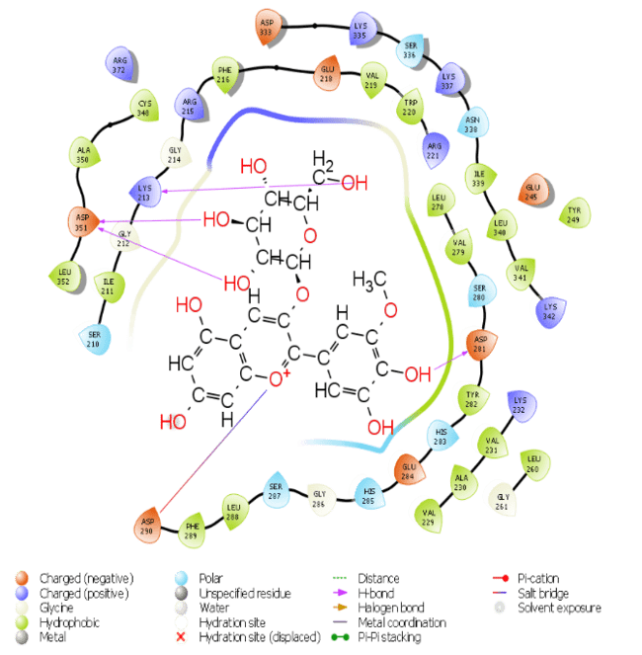 | 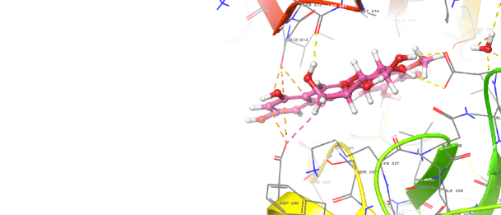
5280863 | 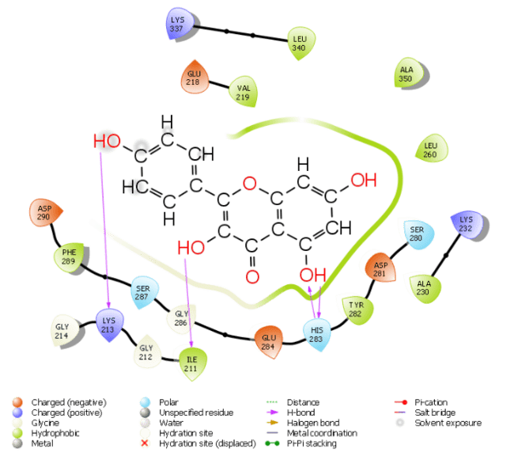 | 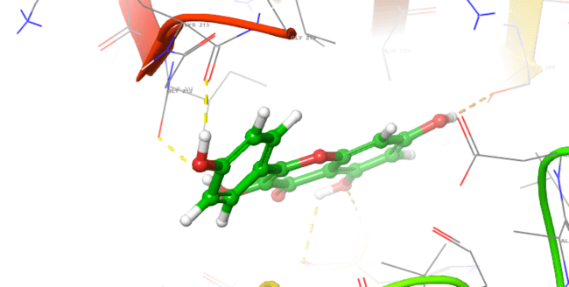
5281654 | 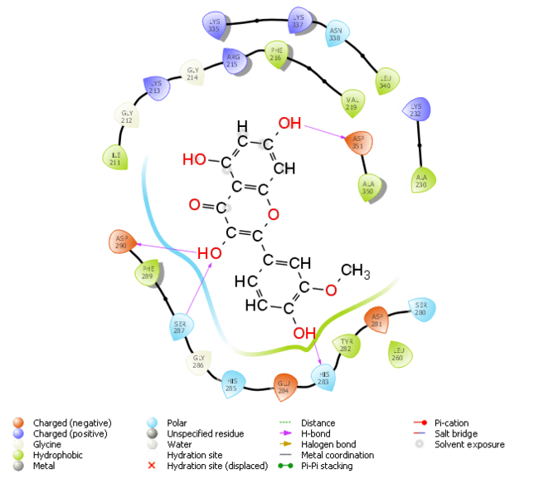 | 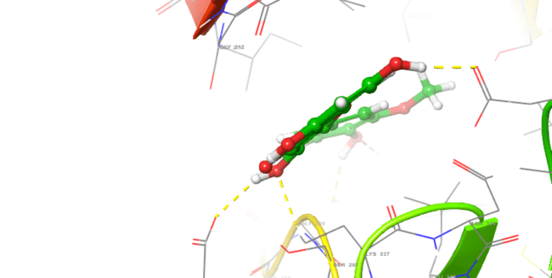
5280343 | 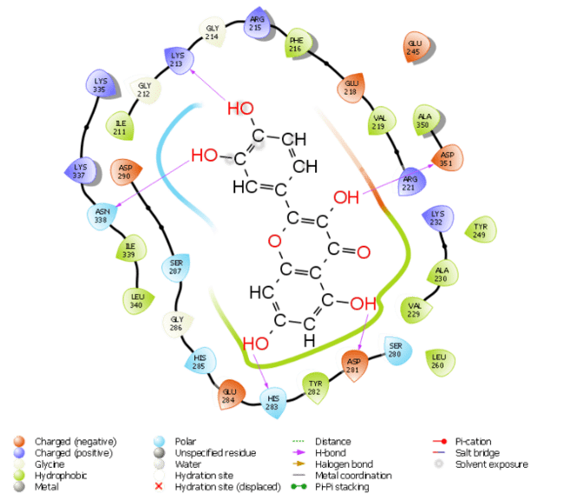 | 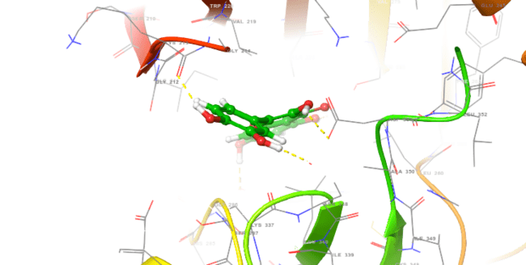
44257023 | 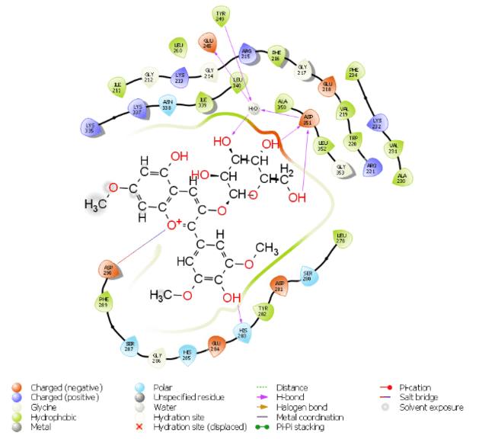 | 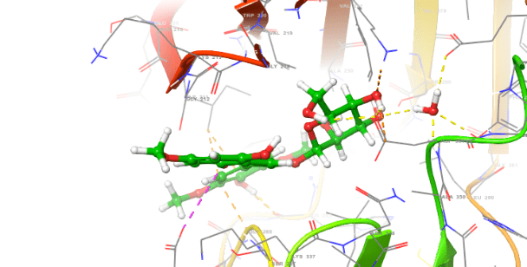
443955 | 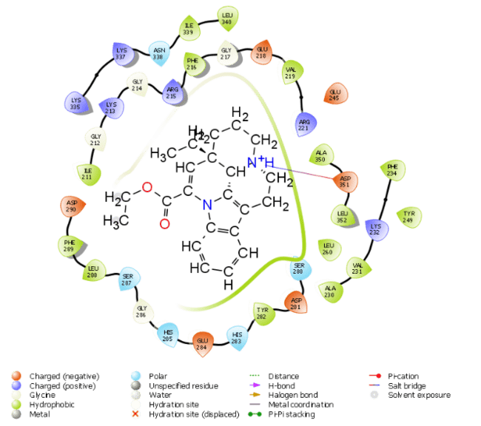 | 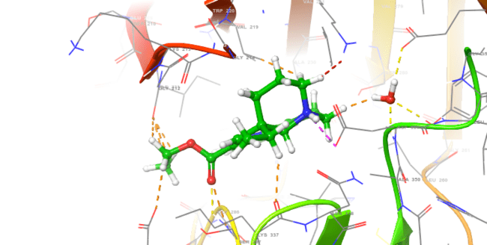
5282230 | 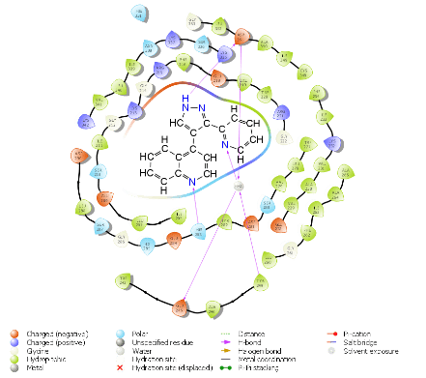 | 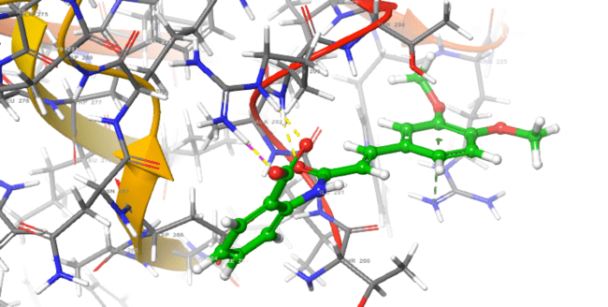
8468 | 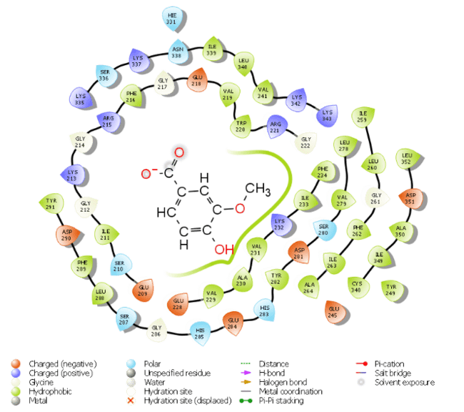 | 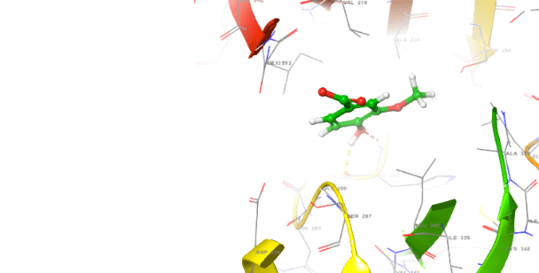
82755 | 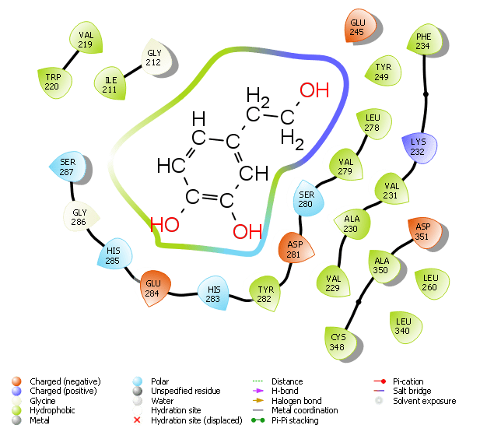 | 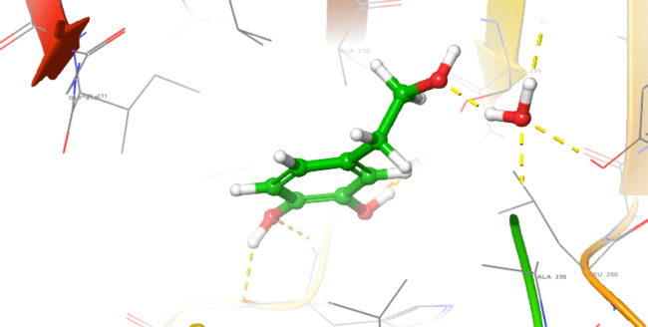

Table 3: ADMET and drug-likeness properties of selected compounds evaluated using SwissADME
Molecule | Petunidin 3-o-glucosides | Isorhamnetin | Quercetin | Hirsutidin 3-glucoside | Kaempferol | Tranilast | Vinpocetine | Vanillic acid | Hydroxytyrosol
Formula | C22H23O12+ | C16H12O7 | C15H10O7 | C24H27O12+ | C15H10O6 | C18H17NO5 | C22H26N2O2 | C8H8O4 | C8H10O3
MW | 479.41 | 316.26 | 302.24 | 507.46 | 286.24 | 327.33 | 350.45 | 168.15 | 154.16 g/mol
H-bond acceptors | 12 | 7 | 7 | 12 | 6 | 5 | 3 | 4 | 3
H-bond donors | 8 | 4 | 5 | 6 | 4 | 2 | 0 | 2 | 3
TPSA | 202.67 | 120.36 | 131.36 | 180.67 | 111.13 | 84.86 | 34.47 | 66.76 | 60.69
iLOGP | -1.39 | 2.35 | 1.63 | -0.9 | 1.7 | 2.68 | 3.28 | 1.4 | 1.28
XLOGP3 | 0.11 | 1.87 | 1.54 | 0.76 | 1.9 | 3.2 | 4.12 | 1.43 | -0.72
WLOGP | 0.39 | 2.29 | 1.99 | 1 | 2.28 | 2.75 | 3.44 | 1.1 | 0.63
MLOGP | -2.03 | -0.31 | -0.56 | -1.6 | -0.03 | 2.08 | 3.18 | 0.74 | 0.60
GI absorption | Low | High | High | Low | High | High | High | High | High
BBB permeant | No | No | No | No | No | No | Yes | No | No
Pgp substrate | No | No | No | No | No | No | No | No | No
CYP3A4 inhibitor | No | Yes | Yes | Yes | Yes | No | Yes | No | NO
log Kp (cm/s) | -9.15 | -6.9 | -7.05 | -8.86 | -6.7 | -6.02 | -5.51 | -6.31 | -7.75
Lipinski #violations | 2 | 0 | 0 | 3 | 0 | 0 | 0 | 0 | 0
Ghose #violations | 0 | 0 | 0 | 1 | 0 | 0 | 0 | 0 | 1
Bioavailability Score | 0.17 | 0.55 | 0.55 | 0.17 | 0.55 | 0.56 | 0.55 | 0.85 | 0.55
Table 4: Predicted toxicity profiles of selected compounds using ProTox-III
Compound(Molecule) | Predicted Toxicity Class | Hepatotoxicity | Neurotoxicity | Nephrotoxicity | Carcinogenicity | Mutagenicity | Cytotoxicity | Predicted LD50
Petunidin 3-o-glucosides | Class 5 | Inactive | Inactive | Active | Inactive | Inactive | Active | 5000mg/kg
Isorhamnetin | Class 5 | Inactive | Inactive | Active | Active | Inactive | Inactive | 5000mg/kg
Quercetin | Class 3 | Inactive | Inactive | Active | Active | Active | Inactive | 159mg/kg
Hirsutidin 3-glucoside | Class 5 | Inactive | Inactive | Active | Inactive | Inactive | Active | 5000mg/kg
Kaempferol | Class 5 | Inactive | Inactive | Active | Inactive | Inactive | Inactive | 3919mg/kg
Tranilast | Class 4 | Active | Active | Inactive | Inactive | Inactive | Inactive | 1190mg/kg
Vinpocetine | class 4 | Inactive | Active | Inactive | Inactive | Inactive | Inactive | 503mg/kg
Vanillic acid | Class 4 | Inactive | Inactive | Active | Inactive | Inactive | Inactive | 2000mg/kg
Hydroxytyrosol | Class 5 | inactive | inactive | inactive | inactive | Inactive | Inactive | 2820mg/kg

