Supplementary Material

Supplementary Figures and Tables

Supplementary Figures
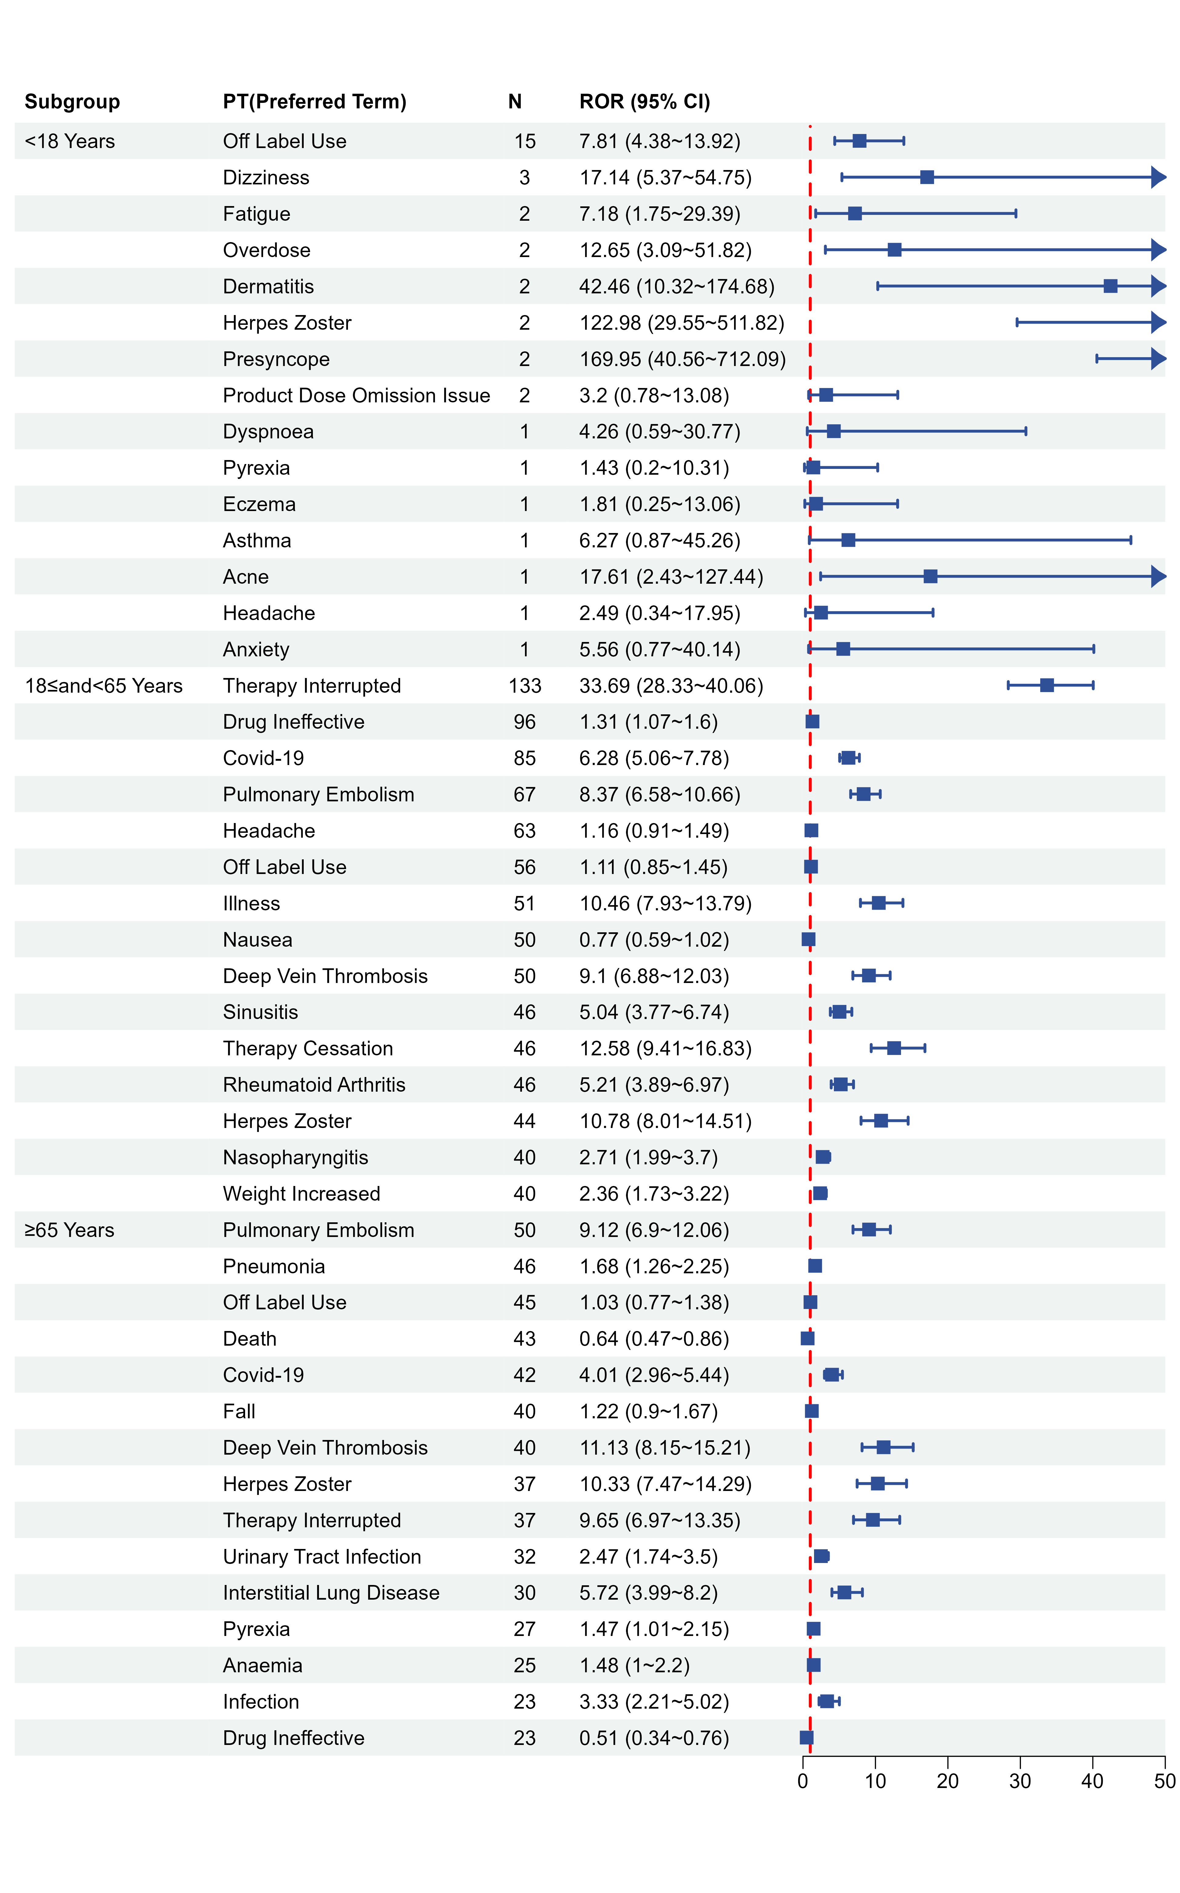
Supplementary Figure 1. Forest plots of age-specific reporting odds ratios for preferred terms-level adverse events associated with Baricitinib.

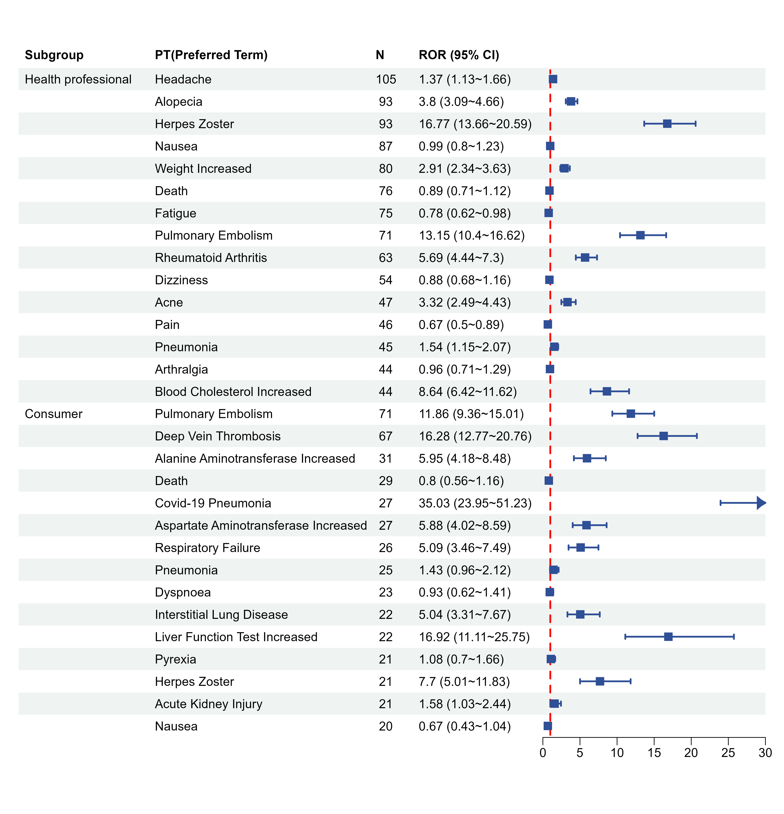
Supplementary Figure 2. Forest plots of reports-specific reporting odds ratios for preferred terms-level adverse events associated with Baricitinib.

Supplementary Tables.
 | Target AEs | Non-Target AEs | Total
Baricitinib | a | b | a+b
Non-Baricitinib | c | d | c+d
Total | a+c | b+d | N=a+b+c+d

AEs, adverse events
Supplementary Table 1. Disproportionality analysis 2×2 contingency table for Baricitinib-related adverse events in FAERS.

Algorithms | Equation | Criteria
ROR | ROR = (a/c)/(b/d)  95% CI = e^(ln(ROR) ± 1.96√(1/a + 1/b + 1/c + 1/d)) | 95% CI (lower limit) > 1, a ≥ 3
PRR | PRR = [a/(a+b)] / [c/(c+d)]  95% CI = e^(ln(PRR) ± 1.96√(1/a − 1/(a+b) + 1/c − 1/(c+d))) | 95% CI (lower limit) > 1, a ≥ 3
BCPNN | IC = log₂( (a+b+c+d) / ((a+c)(a+b)) )  IC25 = e^(ln(IC) − 1.96√(1/a + 1/b + 1/c + 1/d)) | IC25 > 0, a ≥ 3
MGPS | EBGM = (a+b+c+d) / ((a+c)(a+b))  EBGM05 = e^(ln(EBGM) − 1.64√(1/a + 1/b + 1/c + 1/d)) | EBGM05 > 2, a > 0
ROR, reporting odds ratio; CI, confidence interval; PRR, proportional reporting ratio; BCPNN, Bayesian confidence propagation neural network; IC, information component; IC025, the lower limit of the 95% CI of the IC; MGPS, multiple gamma Poisson shrinkage; EBGM, empirical Bayesian geometric mean; EBGM05, empirical Bayesian geometric mean lower 95% CI for the posterior distribution.
Supplementary Table 2. Signal detection algorithms applied in the disproportionality analysis of Baricitinib-related adverse events, with equations and criteria.

