A novel method to extract lipid from liquid microalgae without dewatering

Quan Wangª, Kazuyuki Oshita^{a,}*, Masaki Takaokaª
ª Department of Environmental Engineering, Graduate School of Engineering, Kyoto University, Nishikyo-ku, Kyoto, Japan

*Corresponding author

Tel: +81-75-383-3336; Fax: +81-75-383-3338;

E-mail: oshita@epsehost.env.kyoto-u.ac.jp

Address: Cluster C, Kyoto Daigaku-Katsura, Nishikyo-ku, Kyoto 615-8540, Japan

Table S1. The component of ESM for cultivating Nannochloropsis oculate.

Items | Content
NaNO₃ | 120 mg/L
K₂HPO₄ | 5 mg/L
Vitamin B₁₂ | 1 μg/L
Biotin | 1 μg/L
Thiamine HCl | 100 μg/L
Fe-EDTA | 259 μg/L
Mn-EDTA | 332 μg/L
Tris (hydroxymethyl) aminomethane | 1 g/L
Soil extract | 25 mL/L
Artificial seawater (33.4 g salts per liter) | 975 mL/L
pH 8.0

Table S2. The Elemental composition of extracted raw lipids by the 4 methods.
 | H (%) | C (%) | N (%) | O (%)
Soxhlet extraction (HE) | 10.44±1.09 | 68.76±8.17 | 0.11±0.01 | 20.69±4.76
DME | 11.59±0.50 | 71.09±2.70 | 0.23±0.06 | 17.09±1.59
B&D (dry) | 9.87±2.01 | 65.52±8.10 | 0.09±0.03 | 24.52±4.82
B&D (wet) | 12.30±0.34 | 76.21±2.22 | 0.13±0.01 | 11.36±1.30

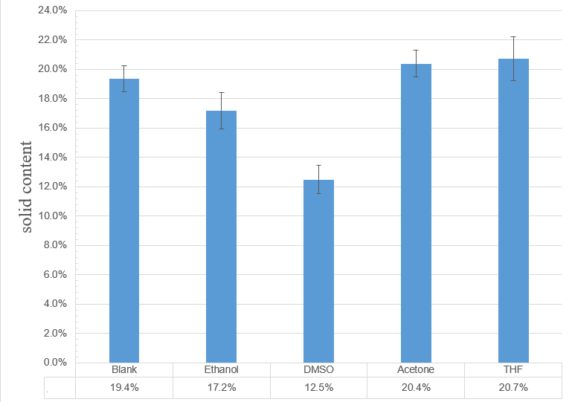
Figure S1. Solid content of microalgae after lipid extraction by DME with 4 kinds of additive agents added.

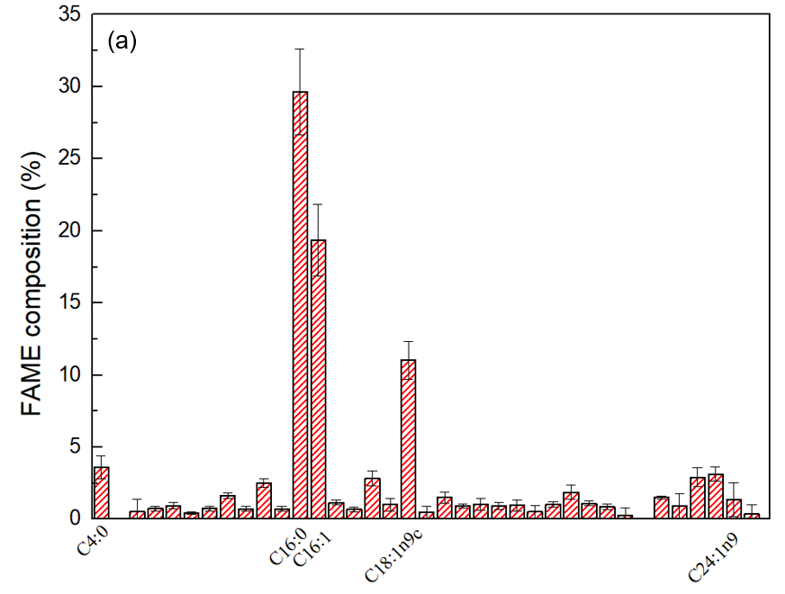

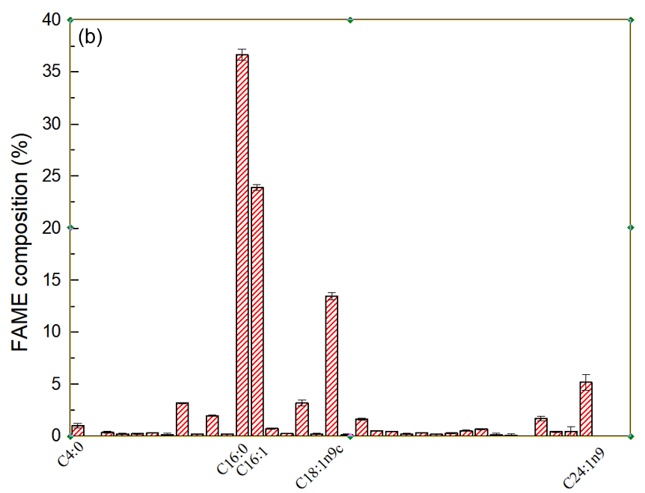
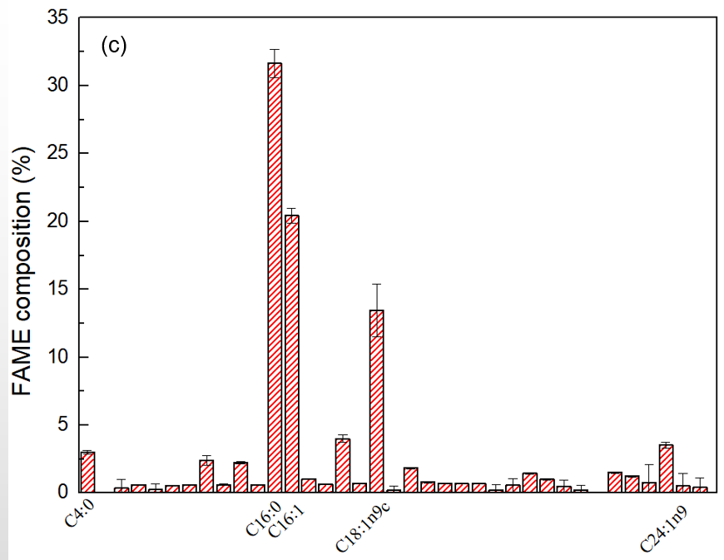

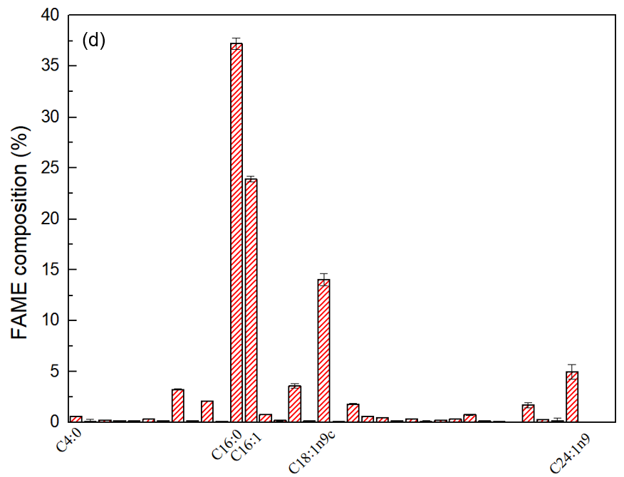
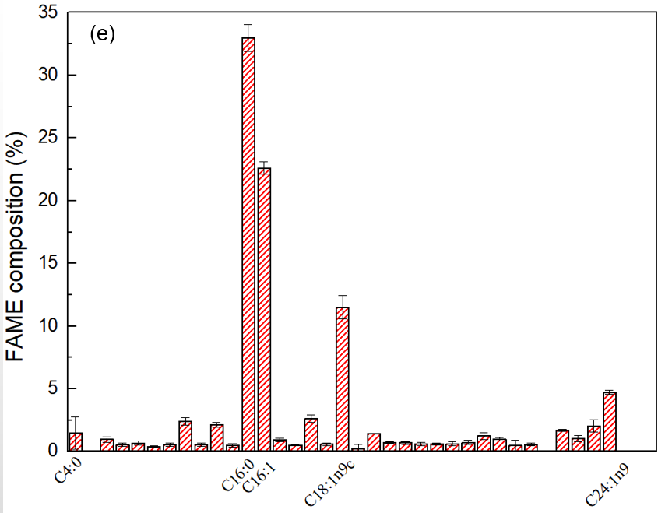
Figure S2. FAMEs composition of extracted lipid with 4 kinds of additive agents added, a) blank, b) ethanol, c) DMSO, d) acetone, e) THF.

