Figure 5A
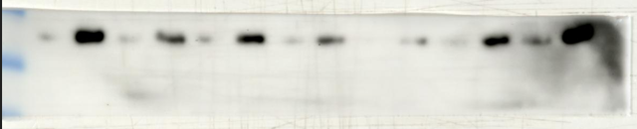 SH2D2A
43kDa
124kDa
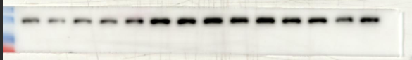 Vinculin
Figure5C
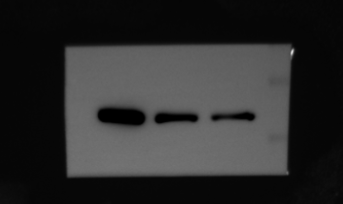DLD1 SH2D2A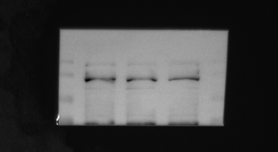 DLD1 Vinculin
124kDa
43kDa
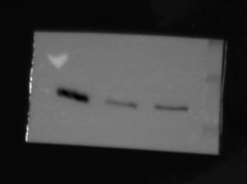HCT116 SH2D2A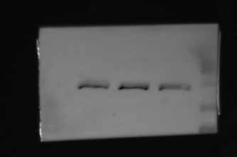HCT116 Vinculin
124kDa
43kDa
Figure5H
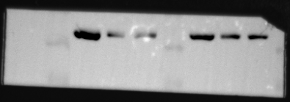 left DLD1 SH2D2A right HCT116 SH2D2A
43kDa
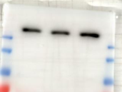 DLD1 mtor 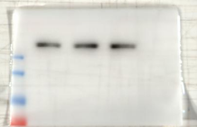 HCT116 mtor
289 kDa
289 kDa
289 kDa
289 kDa
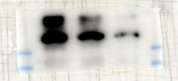DLD1 p-mtor 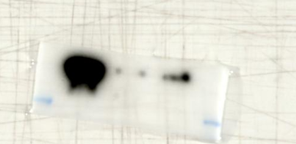 HCT116 p-mtor
56 kDa
56 kDa
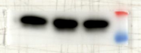 DLD1 AKT 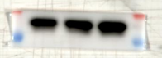 HCT116 AKT
56 kDa
56 kDa
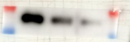 DLD1 AKT 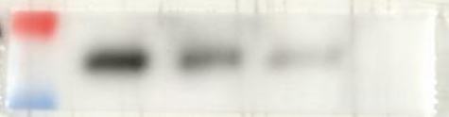 HCT116 p-AKT
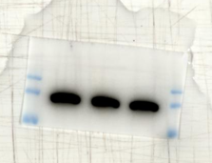 DLD1 Vinculin 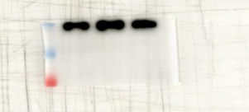 HCT116 Vinculin

Figure5J
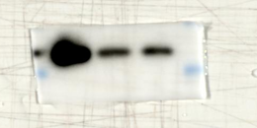DLD1 SH2D2A 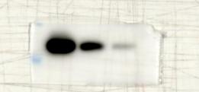HCT116 SH2D2A
43 kDa
43 kDa
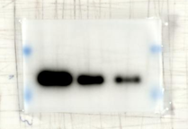 DLD1 VEGFA 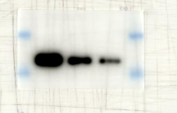 HCT116 VEGFA
120 kDa
120 kDa
40 kDa
40 kDa
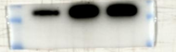DLD1 Ecad 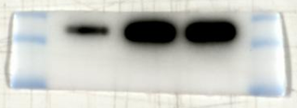HCT116 Ecad
130 kDa
130 kDa
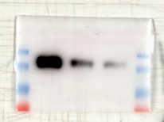DLD1 Ncad 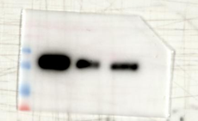HCT116 Ncad
124 kDa
124 kDa
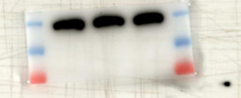 DLD1 Vinculin 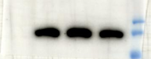 HCT16 Vincu 1lin
Figure6A
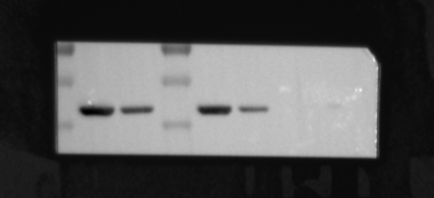SH2D2A left DLD1 right HCT116
43 kDa
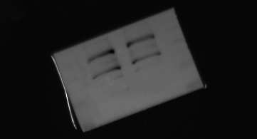DLD1 Vinculin 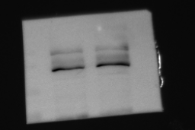 HCT116 Vinculin
124 kDa
124 kDa
Figure6E
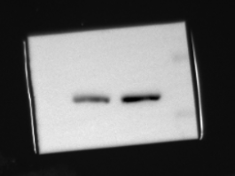 DLD1 SH2D2A 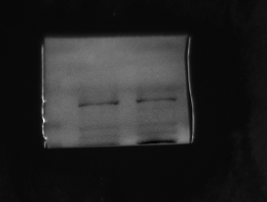 DLD1 Vinculin
124 kDa
43 kDa
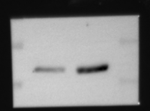 HCT116 SH2D2A 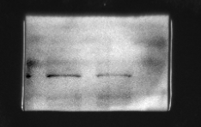 HCT116 Vinculin
124 kDa
43 kDa

