Supplementary Information for: “Probing mesoscopic nonlocal screening in van der Waals heterostructures with polaritons”
Xuezhi Ma^{1,2*†}, Zhipeng Li^{1†}, Ruihuan Duan^{3†}, Zeyu Deng^{4†}, Hao Hu^{5†}, Mengting Jiang¹, Yueqian Zhang⁶, Xiaoyuan He⁶,Qiushi Liu⁷, Qiyao Liu¹, Yuan Ma⁸, Fengxia Wei¹, Jiayu Shi³, Chunqi Zheng⁴, Guangwei Hu³, Ping Koy Lam^{1,2}, Chengwei Qiu⁴, Yu Luo^{5*}, Zheng Liu^{3*}, Qian Wang^{1*}
Affiliations:
¹ Institute of Materials Research and Engineering (IMRE), Agency for Science, Technology and Research (A*STAR), 2 Fusionopolis Way, Innovis, #08-03, Singapore 138634, Republic of Singapore
² Quantum Innovation Centre (Q. InC), Agency for Science, Technology and Research (A*STAR), 4 Fusionopolis Way, Kinesis, #05, Singapore 138635, Republic of Singapore
³ School of Materials Science and Engineering, Nanyang Technological University, Singapore 639798, Singapore
⁴ Department of Materials Science and Engineering, National University of Singapore, Singapore 117575, Singapore
⁵ National Key Laboratory of Microwave Photonics & College of Electronic and Information Engineering, Nanjing University of Aeronautics and Astronautics, Nanjing 211106, China
⁶ School of Electrical and Electronic Engineering, Nanyang Technological University, 50 Nanyang Avenue, Singapore 639798, Singapore
⁷ Shanghai Institute of Optics and Fine Mechanics, Chinese Academy of Sciences, Shanghai, 201800, China
⁸ Department of Mechanical Engineering, The Hong Kong Polytechnic University, Hong Kong 999077, China
†These authors contributed equally to this work.
*Corresponding author. Email: ma_xuezhi@a-star.edu.sg (X.M.); yu.luo@nuaa.edu.cn (Y.L.); z.liu@ntu.edu.sg (Z.L.); wang_qian@a-star.edu.sg (Q.W.)

Table of Contents

Supplementary Information for: “Probing mesoscopic nonlocal screening in van der Waals heterostructures with polaritons” 1
1. The non-local model and spatial-dispersion parameter $d⊥$ 3
2. Nonlocal-to-local mapping and effective participating TMDC thickness 5
3. Raman spectroscopy to exclude the phonon-phonon coupling between TMDC and α-MoO₃ 7
4. Comparisons between graphene/α-MoO₃ and TMDC/α-MoO₃ heterostructures. 7
5. Comparison of empirical data and DFT calculated TMDC work function 9
6. In-plane phonon polariton wavelength fitting and lifetime extraction 10
7. α-MoO₃ thicknesses calibration by AFM and confinement factors 12
8. Calibration of confinement factor vs. thickness 13
9. WSe₂ and PdSe₂ thicknesses calibration by AFM. 15
10. KPFM raw data 17
11. Microscopic physical picture of the non-trivial saturation and trivial depletion phenomenon 21
12. PhP Raw data 22
References 37

The non-local model and spatial-dispersion parameter $d_{⊥}$
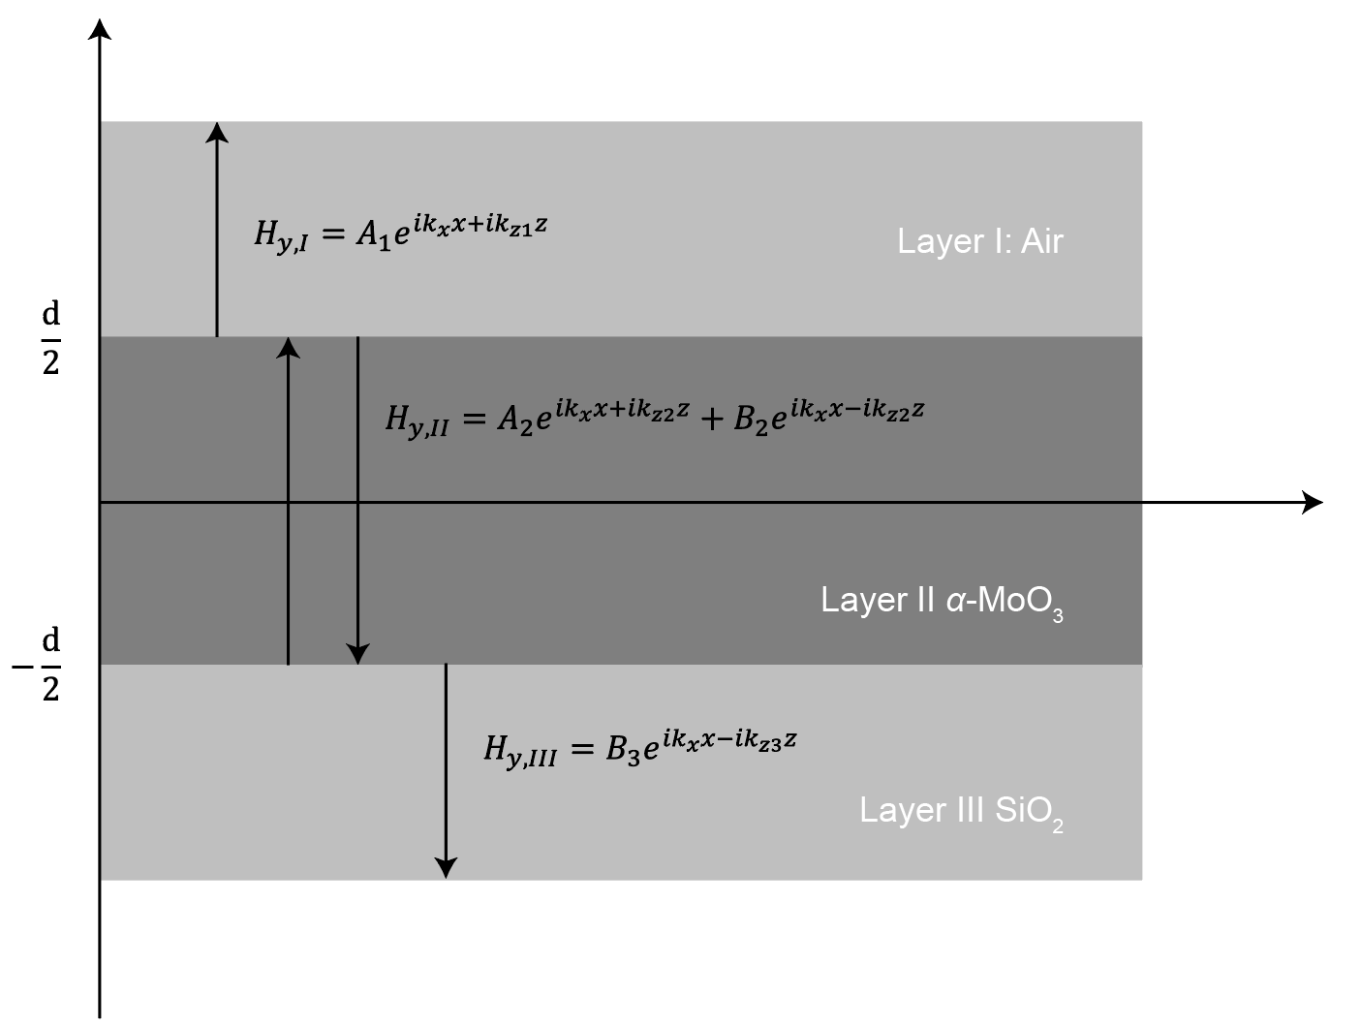
Supplementary Fig. 1 Schematic diagram of a non-local model structure.
In a three-layer TM-mode configuration (Region I: air above, Region II: α-MoO₃ slab of thickness d, Region III: SiO₂ substrate below, see Supplementary Fig. 1), the local dispersion relation follows from the transfer-matrix condition. Enforcing Maxwell’s boundary conditions (continuous $E_{∥}$ and $H_{∥}$, and continuous $D_{⊥}$ in the local limit) at the two interfaces yields a dispersion equation:
$e^{-i2k_{z2}d}=\frac{\left(\frac{k_{z2}}{ε_{x,\text{II}}}-k_{z1}\right)}{\left(\frac{k_{z2}}{ε_{x,\text{II}}}+k_{z1}\right)}\frac{\left(\frac{k_{z2}}{ε_{x,\text{II}}}-\frac{k_{z3}}{ε_{\text{III}}}\right)}{\left(\frac{k_{z2}}{ε_{x,\text{II}}}+\frac{k_{z3}}{ε_{\text{III}}}\right)}$ eq. 1
which equates the round-trip phase $e^{-i2k_{z2}d}$ in the α-MoO₃ layer to the product of Fresnel reflection factors at the top (I–II) and bottom (II–III) interfaces. Here $k_{zj}$ is the out-of-plane wavevector component in region j (for the given in-plane propagation constant $k_{x}$), and $ε_{x,\text{II}}$ denotes the in-plane permittivity of the anisotropic α-MoO₃ (similarly, $ε_{x,I}$ and $ε_{\text{III}}$ are the permittivities of regions I and III). The numerator of the fraction comes from the TM-mode reflection condition $\frac{k_{z2}}{ε_{x,\text{II}}}-\frac{k_{zj}}{ε_{\text{xj}}}$ at each interface ($k_{z}$ of region I or III accordingly), while the denominator uses $\frac{k_{z2}}{ε_{x,\text{II}}}+\frac{k_{zj}}{ε_{\text{x}}j}$, enforcing $D_{⊥}$ continuity in the local model.
To accurately capture the phonon-polariton dispersion in ultra-thin α-MoO₃ films and heterostructures, it is essential to extend beyond the local-response approximation by incorporating non-local saturation effects. Specifically, we introduce spatial-dispersion parameters $d_{⊥}$ and $d_{∥}$ in the α-MoO₃ layer, explicitly accounting for spatially dependent polarization responses. Physically, a finite $d_{⊥}$ reflects the dependence of the polarization in α-MoO₃ on the in-plane electric field gradients $∇E_{∥}$. This non-local polarization response induces longitudinal polarization currents parallel to the interfaces, thereby modifying the usual continuity of the normal electric displacement field $D_{⊥}$ at boundaries. Conversely, a finite $d_{∥}$ captures polarization dependence on out-of-plane gradients ($∂E_{⊥}/∂$z), effectively allowing polarization to “spill over” beyond the geometric boundaries of the slab.
As a result, the normal displacement field $D_{⊥}$ is no longer strictly continuous across the interfaces. In essence, the interface boundary conditions acquire additional terms proportional to $d_{⊥}$ and $d_{∥}$ that quantify these small non-locality-induced discontinuities, replacing the ideal equalities from the local model. Formally, one finds modified interface conditions of the form $k_{x}^{2}$ , resulting from induced longitudinal polarization currents at the interfaces.
To account for non-local spatial dispersion effects, we adopt generalized interface conditions inspired by Feibelman-like surface-response models: $D_{⊥,II}-D_{⊥,j}=d_{∥}∂_{x}(D_{∥,II}-D_{∥,j})$ and $E_{∥,II}-E_{∥,j}=d_{⊥}∂_{x}(E_{⊥,II}-E_{⊥,j})$ (with $j= I or III$), rather than $D_{⊥,II}$ = $D_{⊥,j}$​ or $E_{∥,II}$ = $E_{∥,j}$. Here, the right-hand side explicitly represents the displacement-field discontinuity arising from non-local response at the interfaces.
These non-local corrections consequently modify both the numerator and denominator in the Fresnel reflection factors within the dispersion relation. Specifically, each local term of the form $\frac{k_{z2}}{ε_{x,\text{II}}}$ is replaced by the corrected non-local term: $\frac{k_{z2}}{ε_{x,\text{II}}}-id_{⊥}\frac{k_{x}^{2}}{ε_{x,\text{II}}}$ and similarly, the term $k_{z1}$ in the reflection factor for region I is substituted by $k_{z1}-id_{⊥}k_{x}^{2}$ , thus incorporating the finite polarization penetration from α-MoO₃ into the adjacent air region.
By embedding these refined interface conditions into the transfer-matrix formalism, we derive a generalized dispersion relation that explicitly includes non-local spatial dispersion effects, yielding the non-local dispersion relation as shown as:
$e^{-i2k_{z2}d}=\frac{\left[β_{2}\left(-\frac{k_{z3}}{ε_{\text{III}}}-d_{⊥}\frac{i{k_{x}}^{2}}{ε_{\text{III}}}\right)-\left(-\frac{k_{z2}}{ε_{x,\text{II}}}-d_{⊥}\frac{i{k_{x}}^{2}}{ε_{z,\text{II}}}\right)\right]\left[\left(k_{z1}-id_{⊥}{k_{x}}^{2}\right)α_{1}-\left(\frac{k_{z2}}{ε_{x,\text{II}}}-d_{⊥}\frac{i{k_{x}}^{2}}{ε_{z,\text{II}}}\right)\right]}{\left[α_{2}\left(-\frac{k_{z3}}{ε_{\text{III}}}-d_{⊥}\frac{i{k_{x}}^{2}}{ε_{\text{III}}}\right)-\left(\frac{k_{z2}}{ε_{x,\text{II}}}-d_{⊥}\frac{i{k_{x}}^{2}}{ε_{z,\text{II}}}\right)\right]\left[\left(k_{z1}-id_{⊥}{k_{x}}^{2}\right)β_{1}-\left(-\frac{k_{z2}}{ε_{x,\text{II}}}-d_{⊥}\frac{i{k_{x}}^{2}}{ε_{z,\text{II}}}\right)\right]}$ eq. 2
with the factors defined as:
$α_{2}=\frac{\left(1+id_{||}k_{z2}\right)}{\left(1-id_{||}k_{z3}\right)},β_{2}=\frac{\left(1-id_{||}k_{z2}\right)}{\left(1-id_{||}k_{z3}\right)},α_{1}=\frac{\left(1+id_{||}k_{z2}\right)}{\left(1+id_{||}k_{z1}\right)},β_{1}=\frac{\left(1-id_{||}k_{z2}\right)}{\left(1+id_{||}k_{z1}\right)}$ eq. 3
We neglect in-plane nonlocality (setting $d_{∥}=0$), retaining only the out-of-plane nonlocal length $d_{⊥}$​. This simplification is physically justified by two key considerations. Firstly, due to the very low in-plane conductivity of α-MoO₃, the induced surface currents remain negligible, significantly reducing any potential in-plane nonlocal contributions. Secondly, since our focus lies on probing the charge-transfer processes in the out-of-plane direction via the in-plane propagation characteristics of phonon polaritons, the heterostructure is effectively approximated as a continuous medium in-plane. Consequently, the mesoscopic nonlocal corrections arising from in-plane spatial dispersion become negligible.
In the above expressions, $k_{x}$ is the in-plane wavevector (parallel to the layers), and $k_{z1}$, $k_{z2}$, $k_{z3}$ are the z-components of the wavevector in region I (air superstrate), region II (α-MoO₃ slab), and region III (SiO₂ substrate), respectively. $ε_{x,\text{II}}$ is the α-MoO₃ permittivity for field polarized along x (in-plane permittivity), while $ε_{\text{III}}$ are isotropic dielectric constants of SiO₂. The introduction of $d_{⊥}$ clearly adjusts both numerator and denominator of the dispersion relation by adding the $-id_{⊥}k_{x}^{2}$ terms, which represent the mesoscopic (nonlocal) corrections to $D_{⊥}$ continuity at the interfaces. As a result, the non-local dispersion formula above generalizes the local model by accounting for spatial dispersion.

Nonlocal-to-local mapping and effective participating TMDC thickness
Extended Data Fig. 3 reports an effective TMDC thickness $t_{eff}\left(d\right)$ that recasts the mesoscopic nonlocal saturation into an intuitive local‑stack quantity. The key idea is to map the nonlocal polariton wavevector $q_{NL}(d)$, obtained from the Feibelman d⊥ dispersion of the real device, onto the thickness of a hypothetical TMDC layer in a purely local multilayer model.
We consider a local air/TMDC(t)/α-MoO₃/SiO₂ stack at fixed frequency ω. For TM polarization, the local dispersion of the α-MoO₃ slab can be written in a compact ‘round‑trip’ form:
$D_{loc}(d) = 1 - r_{t}^{loc}r_{b}^{loc}e^{2ik_{2z}d}= 0,$ eq. 4
where $k_{2z}$ is the out‑of‑plane wavevector component in α-MoO₃, $r_{b}^{loc}$ is the local TM reflection coefficient at the α-MoO₃/SiO₂ interface, $d$ is the thickness of α-MoO₃, and $r_{t}^{loc}$ is the effective local TM reflection coefficient of the upper stack (air/TMDC) seen from α-MoO₃, t refers to TMDC layer and its thickness.
The top reflection coefficient $r_{t}^{loc}$ follows from standard thin‑film recursion:
$r_{t}^{loc}(t) = \frac{r_{2t}+r_{t1}e^{2ik_{tz}t}}{1+r_{2t}r_{t1}e^{2ik_{tz}t}}$ eq. 5
where $r_{2t}$ and $r_{t1}$ are the local TM Fresnel reflection coefficients at the α-MoO₃/TMDC and TMDC/air interfaces, respectively, and $k_{tz}$ is the TMDC out‑of‑plane wavevector component.
We then define $t_{eff}\left(d\right)$ by matching the nonlocal and local wavevectors at the same α‑MoO3 thickness d: $D_{loc}\left(d\right)=0$. Equivalently, the local upper‑stack reflection is required to satisfy $r_{t}^{loc}\left(t_{eff}\right)=r_{2t}^{*}(d)$, with$r_{2t}^{*}(d)≡\frac{e^{-2ik_{2z}(q_{NL}\left(d\right)d)}}{r_{b}^{loc}(q_{NL}\left(d\right))}$.
Solving for t_eff yields a closed form:
$t_{eff}\left(d\right)=\frac{i}{2k_{z1}(q_{NL}\left(d\right))}\ln{[\frac{r_{21}{(q}_{NL}\left(d\right))-r_{2t}^{*}(d)}{r_{10}{(q}_{NL}(d))(r_{2t}^{*}(d)r_{21}(q_{NL}\left(d\right))-1))}]}$ eq. 6
This expression provides an explicit relationship between the effective TMDC participating thickness and the α-MoO₃ thickness through the nonlocal wavevector $q_{NL}\left(d\right)$.

Raman spectroscopy to exclude the phonon-phonon coupling between TMDC and α-MoO₃
In our theory, charge transfer and charge redistribution are the key factors in how TMDC layers affect the permittivity of the α-MoO₃ layer. The electrons mediate the coupling between the two layers via charge transfer. Interlayer interactions include the phonon-phonon coupling in many cases^{1,2}, and we performed Raman spectroscopy to exclude the phonon-phonon coupling between the TMDC and α-MoO₃ layers. Supplementary Fig. 2 shows the Raman spectra of the WSe₂/α-MoO₃ and PdSe₂/α-MoO₃ heterostructure devices. There is no obvious Raman shift between heterostructure-modified α-MoO₃ and pristine α-MoO₃, indicating the absence of the phonon-phonon coupling.
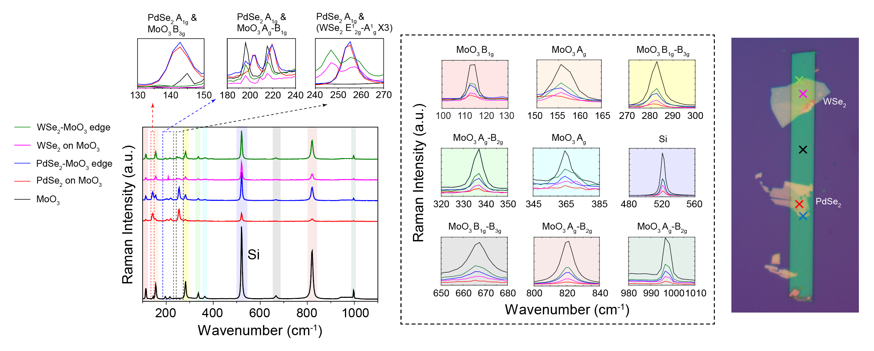
Supplementary Fig. 2. Raman spectroscopy of original α-MoO₃, WSe₂/α-MoO₃ and PdSe₂/α-MoO₃ heterostructures.

Comparisons between graphene/α-MoO₃ and TMDC/α-MoO₃ heterostructures.
We directly compare the interfacial charge redistribution for monolayer graphene (Supplementary Fig. 3a) and monolayer MoS₂ (Supplementary Fig. 3b) on α‑MoO₃, as revealed by DFT calculations. In both cases, the work-function disparity drives electrons to transfer from the 2D layer into α‑MoO₃, which has a high electron affinity, establishing an interfacial dipole with electrons accumulating on the oxide side and corresponding holes left in the 2D layer. Supplementary Fig. 3 shows the plane-averaged $Δρ(z)$ profiles that plot the change in electron density along the out-of-plane c-axis, with yellow indicating regions of electron depletion and purple indicating accumulation.
For graphene/α-MoO₃ (Supplementary Fig. 3a), $Δρ$ is sharply peaked at the interface, showing that charge redistribution is highly localized. Electron density builds up only at the topmost atomic layer of α-MoO₃, while the graphene’s carbon layer correspondingly loses electron density. The $Δρ$ isosurface confirms that the transferred charge is confined to the immediate interface, a narrow sheet of negative charge on the α-MoO₃ surface facing a layer of positive charge on graphene, with negligible penetration of screening charge into deeper α-MoO₃ layers.
By contrast, the MoS₂/α-MoO₃ heterostructure (Supplementary Fig. 3b) exhibits a much broader charge redistribution profile. The $Δρ(z)$ curve for MoS₂ shows electron accumulation spreading beyond the first O-Mo bilayer of α-MoO₃, decaying gradually over several atomic layers into the bulk, with a complementary extended region of electron depletion in the MoS₂ layer. In other words, electrons transferred from MoS₂ penetrate deeper into α-MoO₃, populating not only the interface oxygen layer but also sub-surface O and Mo planes, while the MoS₂ is left positively charged over its entire monolayer. This deeper, more diffuse screening in the TMDC/α-MoO₃ system contrasts sharply with the ultra-shallow screening in graphene/α-MoO₃.
Crucially, these microscopic differences in charge-transfer screening directly govern the phonon–polaritonic response. In MoS₂/α-MoO₃, the extended interfacial polarization pulls the field into the substrate more effectively, yielding stronger polariton confinement upon TMDC coverage. In the graphene case, however, the screening is concentrated in an ultrathin layer at the surface, which increases phonon–polariton wavelength.
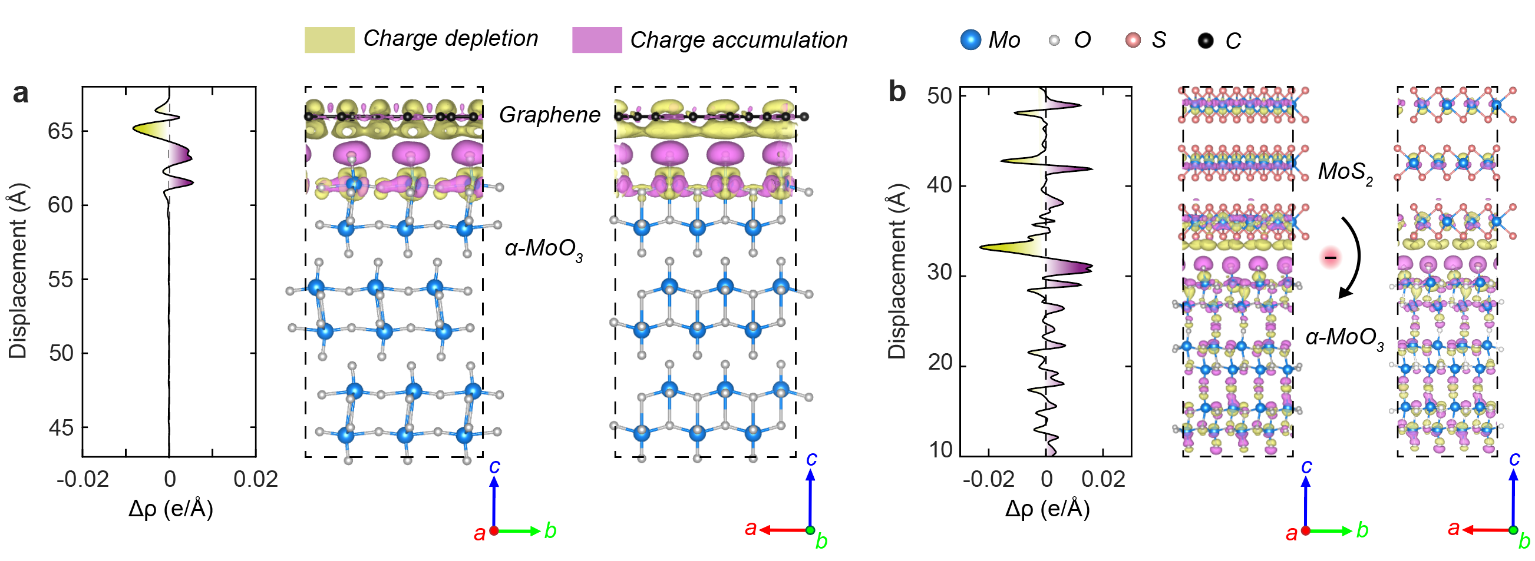
Supplementary Fig. 3 DFT calculated charge transfer and charge redistribution comparison of Graphene/α-MoO₃ and TMDC/α-MoO₃ heterostructures. a, Plane-averaged charge density difference (Δρ) and corresponding three-dimensional charge distribution at the graphene/α-MoO₃ interface. Electron depletion (yellow) and accumulation (purple) regions show that charge transfer is highly localized at the interface, confined to the topmost atomic layers of α-MoO₃ and graphene. b, Δρ profile and isosurface plots for the MoS₂/α-MoO₃ heterostructure, revealing a broader spatial redistribution of charge extending several atomic layers into both materials. Color code: Mo (blue), O (white), S (orange), and C (black).

Comparison of empirical data and DFT calculated TMDC work function
In the manuscript, we used KPFM to measure the thickness-dependent work function of TMDC flakes (Supplementary Fig. 4). We also used DFT to calculate thickness-dependent work functions. Supplementary Fig. 4e and f show the calculated thickness-dependent work functions of WSe₂ and PdSe₂, respectively. It is worth noting that DFT systematically underestimates the layers number of TMDCs, and we calibrated the thickness using an effective layer-number mapping, indicating that the 20 nm in empirical data is equivalent to 6 layers in DFT. Despite these thickness mismatches, the data trends are clearly correlated, marked by purple and red for WSe₂, and blue for PdSe₂.
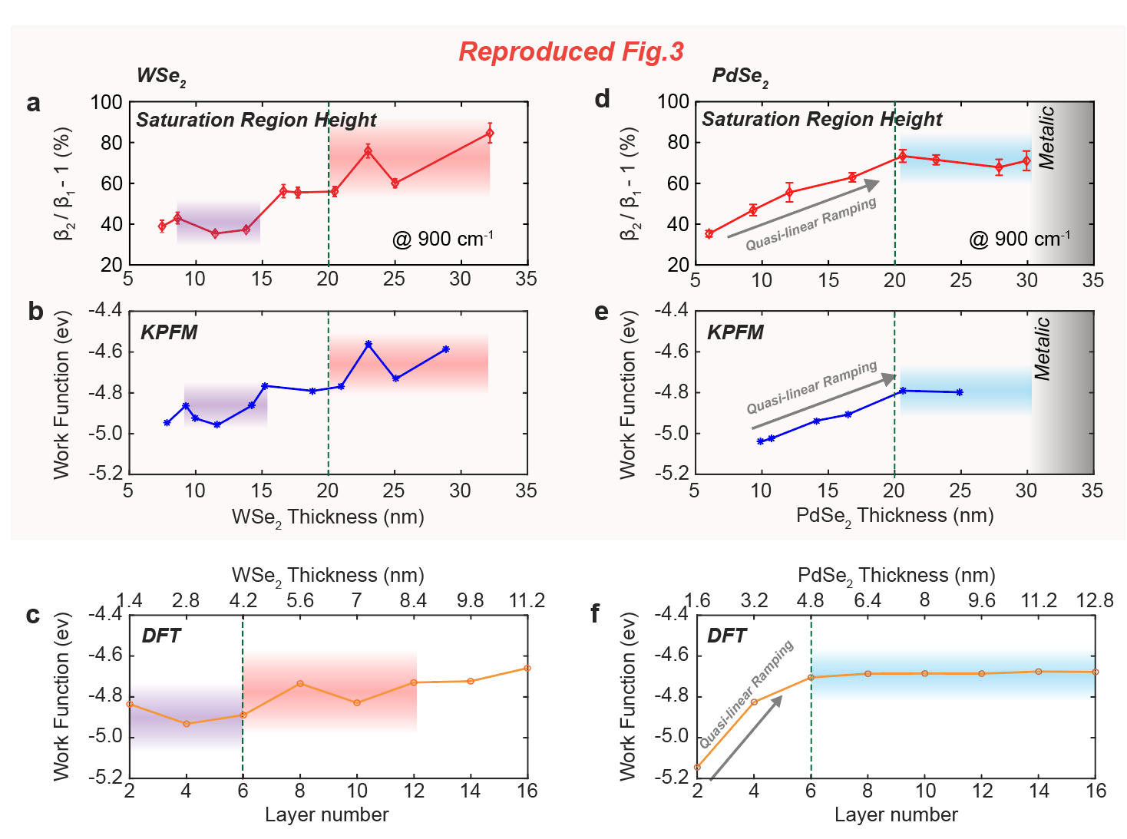
Supplementary Fig. 4 Comparison of empirical data and DFT calculated TMDC work function. a, b Experimentally measured saturation readout $\frac{λ_{1}}{λ_{2}} -1$ extracted from near-field polariton imaging at 900 cm⁻¹ for WSe₂ (a) and PdSe₂ (b) on α-MoO₃. c, d KPFM measurements of work function versus layer thickness for WSe₂ (c) and PdSe₂ (d), revealing consistent thickness-dependent behaviour that correlates with the observed polariton modulation trends. e, f Density functional theory (DFT)-calculated work functions of WSe₂ (e) and PdSe₂ (f) as a function of layer number, validating the experimental observations and confirming the transition from semiconducting to quasi-metallic electronic structures in PdSe₂. Error bars represent standard deviations from multiple measurements.

In-plane phonon polariton wavelength fitting and lifetime extraction
The confinement factor is fitted and extracted from profile along α-MoO₃ [001] crystal direction in the SNOM data as phonon polariton dispersion wave, as shown in Supplementary Fig. 5. We assumed an oscillating signal $ξ$, with parameters A, B, $q_{p}$ and $a$ as:
$ξ\left(x\right)=ξ_{0}+A\frac{e^{i2q_{p}x}}{\sqrt{x}}+B\frac{e^{iq_{p}x}}{x^{a}}$ eq. 7
The lifetime of α-MoO₃ PhPs was calculated according to $τ_{x}= L_{x}/v_{g}$, where the L_{x} stands for the decay length along x axis ([001] direction, from 1 to 1/e of intensity at x=0), and $v_{g}$ is the group velocity. The group velocities were extracted by multi-layer reflection models, as shown in Supplementary Fig. 5f. To extract the group velocity of α-MoO₃ PhPs, which is defined as $v_{g}=\frac{∂ω}{ ∂kx}$ (along [001])

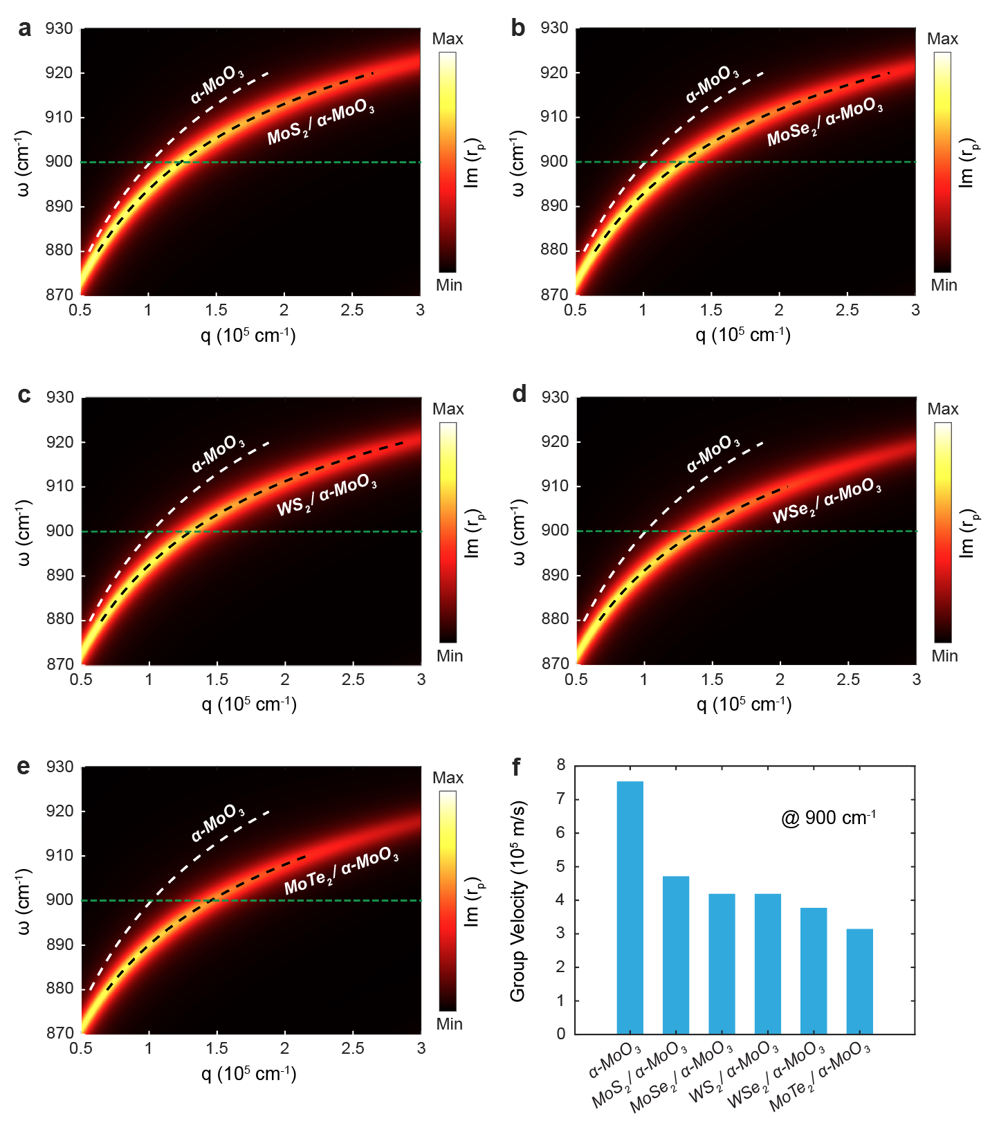
Supplementary Fig. 5 Calculated dispersion of TMDC/α-MoO₃, showing that the group velocity is reduced compared with original α-MoO₃. a-e, Calculated dispersion relations (imaginary part of reflection coefficient, Im(r_{p})) for α-MoO₃ and TMDC/α-MoO₃ heterostructures, showing the evolution of phonon-polariton modes upon coupling with different transition metal dichalcogenides (TMDCs): MoS₂ (a), MoSe₂ (b), WS₂ (c), WSe₂ (d), and MoTe₂ (e). f, Extracted polariton group velocities at 900 cm⁻¹ for the corresponding heterostructures.

α-MoO₃ thicknesses calibration by AFM and confinement factors
The thickness of eight α-MoO₃ flakes used through this work was calibrated using AFM and optical method. Supplementary Fig. 6 shows the eight AFM maps and their corresponding profiles, respectively.
With model mentioned in eq. 8, wavelength can be obtained from above mentioned fitting wave curve from the periodic $ω$ factor, and the ratio between the wavelength of incident light and wavelength of generated phonon polariton is commonly defined as confinement factor^{3,4}
$β= \frac{k_{p}}{k}= \frac{λ}{λ_{p}}$ eq. 8
With polariton dispersion expressed as: $q\left(ω\right)+iκ\left(ω\right)=-\frac{ψ}{d}\left[\arctan\left(\frac{ε_{3}}{ε_{2z}ψ}\right)+\arctan\left(\frac{ε_{1}}{ε_{2z}ψ}\right)+ πl\right]$ , $ψ= \frac{\sqrt{ε_{2x}}}{i\sqrt{ε_{2z}}}$ ⁵, a simplified expression for the complex confinement factor ($β$) of three-layer interface from an implicit general dispersion relation of transverse magnetic polarized surface waves is derived as⁶:
$β≈ \frac{iλψ}{4πd}ln⁡[\frac{1-iψ\left(\frac{ε_{2x}}{ε_{1}}\right)+iβ\left(\frac{Z_{0}σ}{ε_{1}}\right) }{1+iψ\left(\frac{ε_{2x}}{ε_{1}}\right)+iβ\left(\frac{Z_{0}σ}{ε_{1}}\right)}·\frac{1-iψ\left(\frac{ε_{2x}}{ε_{3}}\right)}{1+iψ\left(\frac{ε_{2x}}{ε_{3}}\right)}]$, $ψ= \frac{\sqrt{ε_{2x}}}{i\sqrt{ε_{2z}}}$ eq. 9
where the $ε_{1}$ and $ε_{3}$ are the dielectric function of bottom layer (e.g. substrate) and upper layer (e.g. air) and $ε_{2x}$ and $ε_{2z}$ are the dielectric function along horizontal and vertical direction. $λ$ is the incident wavelength and the d denotes the thickness of α-MoO₃ flakes.

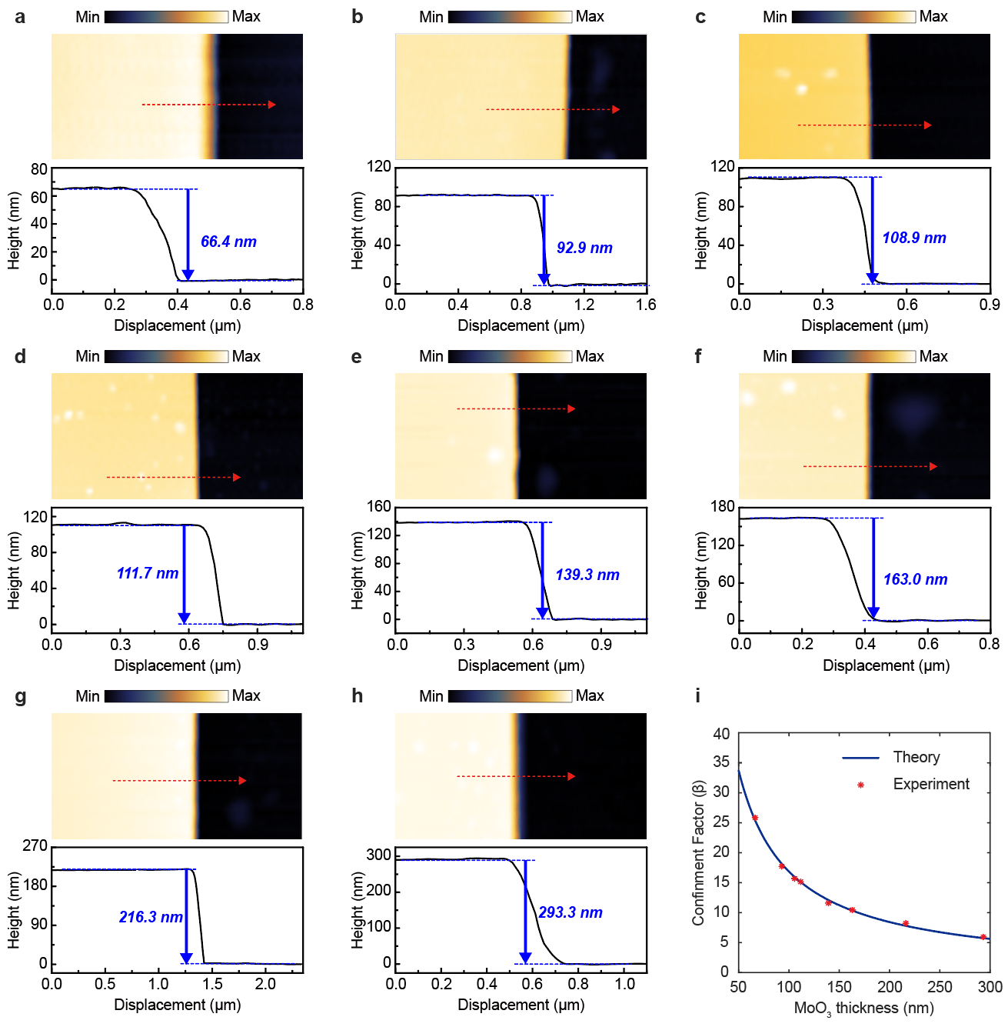
Supplementary Fig. 6 α-MoO₃ thicknesses calibration by AFM and confinement factors. a-h, AFM topography maps (upper panels) and corresponding height profiles (lower panels) of α-MoO₃ flakes with different thicknesses: 66.4 nm (a), 92.9 nm (b), 108.9 nm (c), 111.7 nm (d), 139.3 nm (e), 163.0 nm (f), 216.3 nm (g), and 293.3 nm (h). i, Experimental and theoretical correlation between α-MoO₃ thickness and the phonon-polariton confinement factor (β).

Calibration of confinement factor vs. thickness
From eq. 9, we can ascertain that the confinement factor of PhP materials is contingent upon the material itself, the dielectric constants of the substrate and the overlaying medium, the thickness of the material, and the wavelength of the incident light. In the case of α-MoO₃, a material capable of generating PhP signals under mid-infrared incident light, a series of experiments were conducted. These experiments involved measuring the PhP signal for each wavenumber within the interval of 895 cm⁻¹ to 930 cm⁻¹ and calculating the corresponding confinement factors. Additionally, by incorporating known material parameters into the equation, we validated its applicability to α-MoO₃ material. This supplementary section further explores the interrelation between these variables, providing a comprehensive understanding of the dynamics influencing PhP material performance in mid-infrared regions.
As illustrated in Supplementary Fig. 7a, the measured PhP signals on a strip of α-MoO₃ with a thickness of 162 nm for incident light wavenumbers of 895 cm⁻¹, 900 cm⁻¹, 905 cm⁻¹, 910 cm⁻¹, 915 cm⁻¹, and 920 cm⁻¹ are shown. It is observable that as the incident wavenumber increases, the extracted phonon–polaritonic wavelength becomes progressively shorter, indicating an increased confinement factor, indicating an increase in the confinement factor. This observation is in concordance with eq. 9, demonstrating the relationship between the wavenumber of incident light and the confinement efficiency of PhP signals in α-MoO₃. This supplementary section elucidates the dependency of PhP signal characteristics on the incident light's wavenumber, further substantiating the theoretical framework presented in Supplementary Section 1.
Supplementary Fig. 7b presents a comparison between experimental data and simulations calculated based on eq. 9. The dots represent our experimental data, while the lines are the results obtained through calculations using the equation. The dielectric constants ($ε_{2x} \& ε_{2z}$) of α-MoO₃ used in the formula is derived from the Lorentz oscillator model⁷, assuming a substrate of silicon dioxide ($ε_{1}= 4.0101 + 0.16969i$)⁸ and an overlaying medium of air ($ε_{3}=1$). Given that α-MoO₃ is considered an insulator, we set σ​ to 0. This approach yielded a close match between the experimental data points and the lines representing the simulation results, illustrating the equation's robust applicability to the α-MoO₃ system. This supplementary section validates the theoretical model's effectiveness in predicting PhP signal characteristics in α-MoO₃, with the experimental observations and simulation outcomes demonstrating a high degree of congruence with an average discrepancy of about 1.7 cm⁻¹.
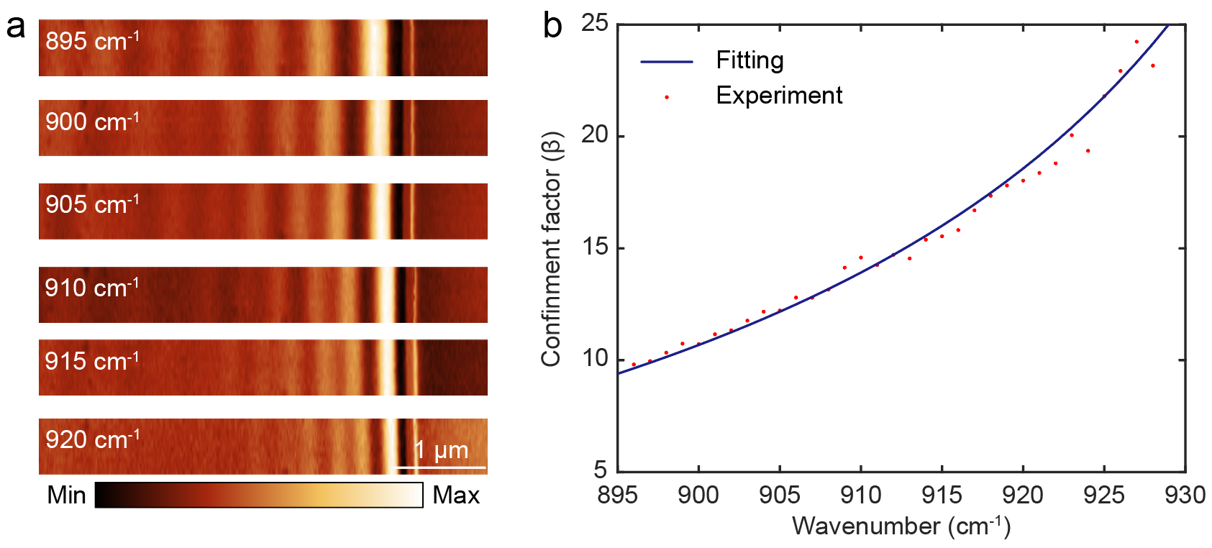
Supplementary Fig. 7 Calibration of permittivity of α-MoO₃ by near-field extracted confinement factor. a, Near-field optical images of α-MoO₃ recorded at incident wavenumbers ranging from 895 to 920 cm⁻¹, showing progressively shorter phonon-polariton wavelengths at higher frequencies. The increasing fringe density indicates enhanced mode confinement as the excitation frequency approaches the upper Reststrahlen band edge. b, Experimental confinement factor (β) as a function of wavenumber (red dots) fitted with a theoretical dispersion model (blue line), demonstrating the strong frequency dependence of polariton confinement in anisotropic α-MoO₃. Scale bar, 1 μm.

WSe₂ and PdSe₂ thicknesses calibration by AFM.
The WSe₂ and PdSe₂ flakes demonstrated in Fig. 3 were calibrated by AFM, as shown in Supplementary Fig. 8 and 9 respectively.
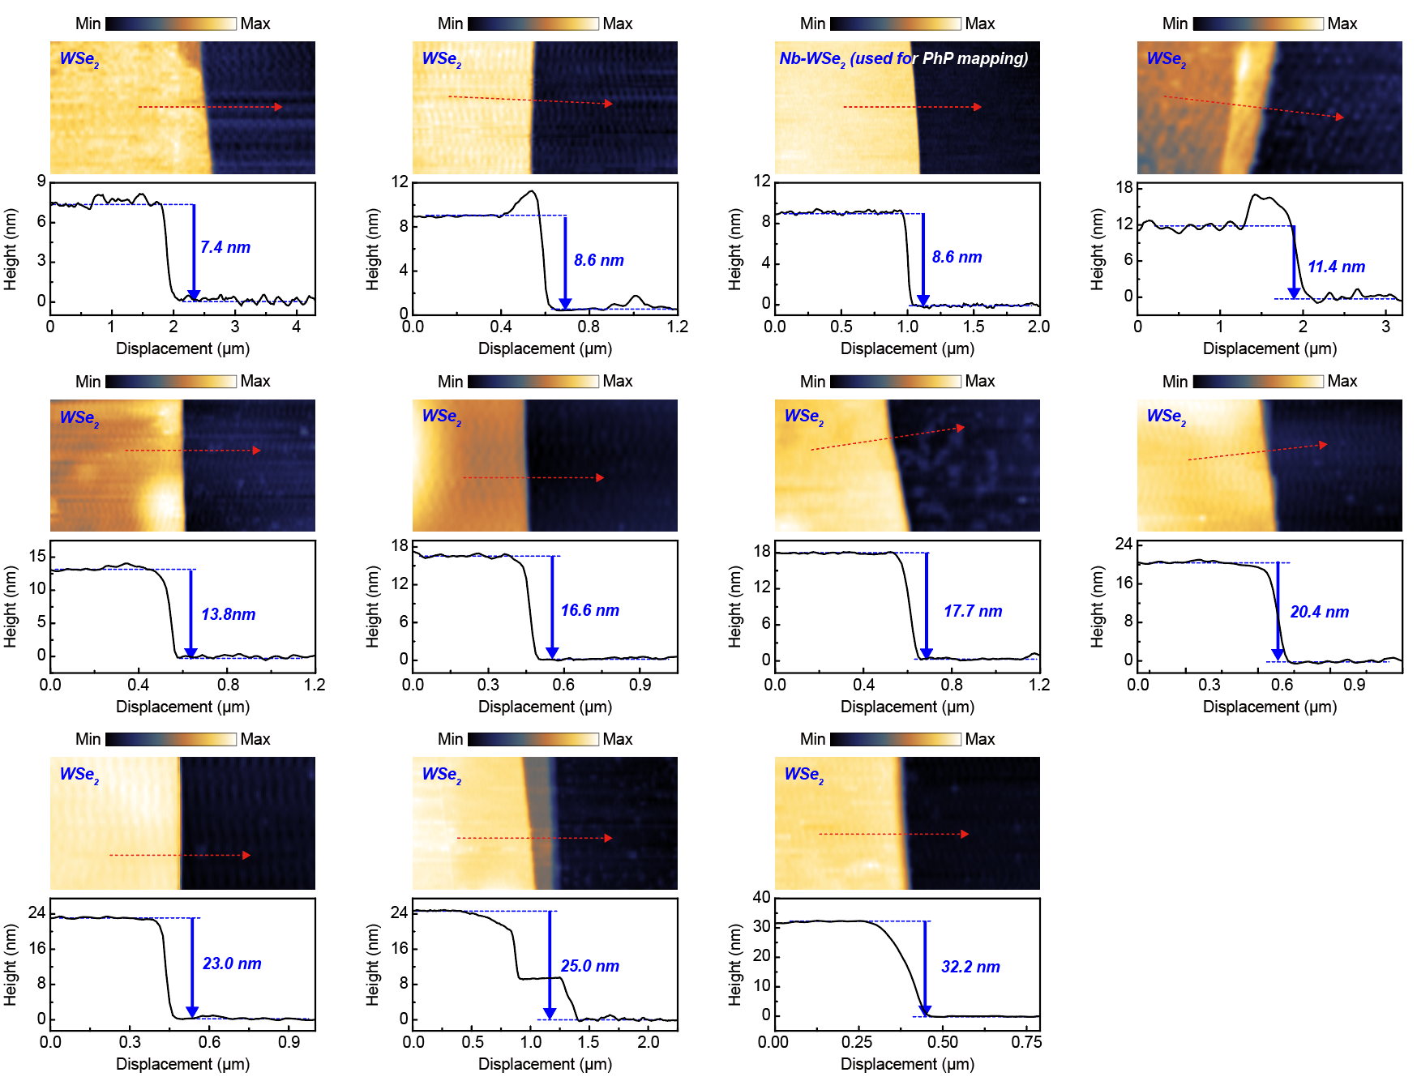
Supplementary Fig. 8 WSe₂ thicknesses calibration by AFM. a-k, Atomic force microscopy (AFM) topography maps (upper panels) and corresponding height profiles (lower panels) of exfoliated WSe₂ flakes with different measured thicknesses: 7.4 nm (a), 8.6 nm (b), 8.6 nm Nb-doped WSe₂ used for phonon-polariton mapping (c), 11.4 nm (d), 13.8 nm (e), 16.6 nm (f), 17.7 nm (g), 20.4 nm (h), 23.0 nm (i), 25.0 nm (j), and 32.2 nm (k).
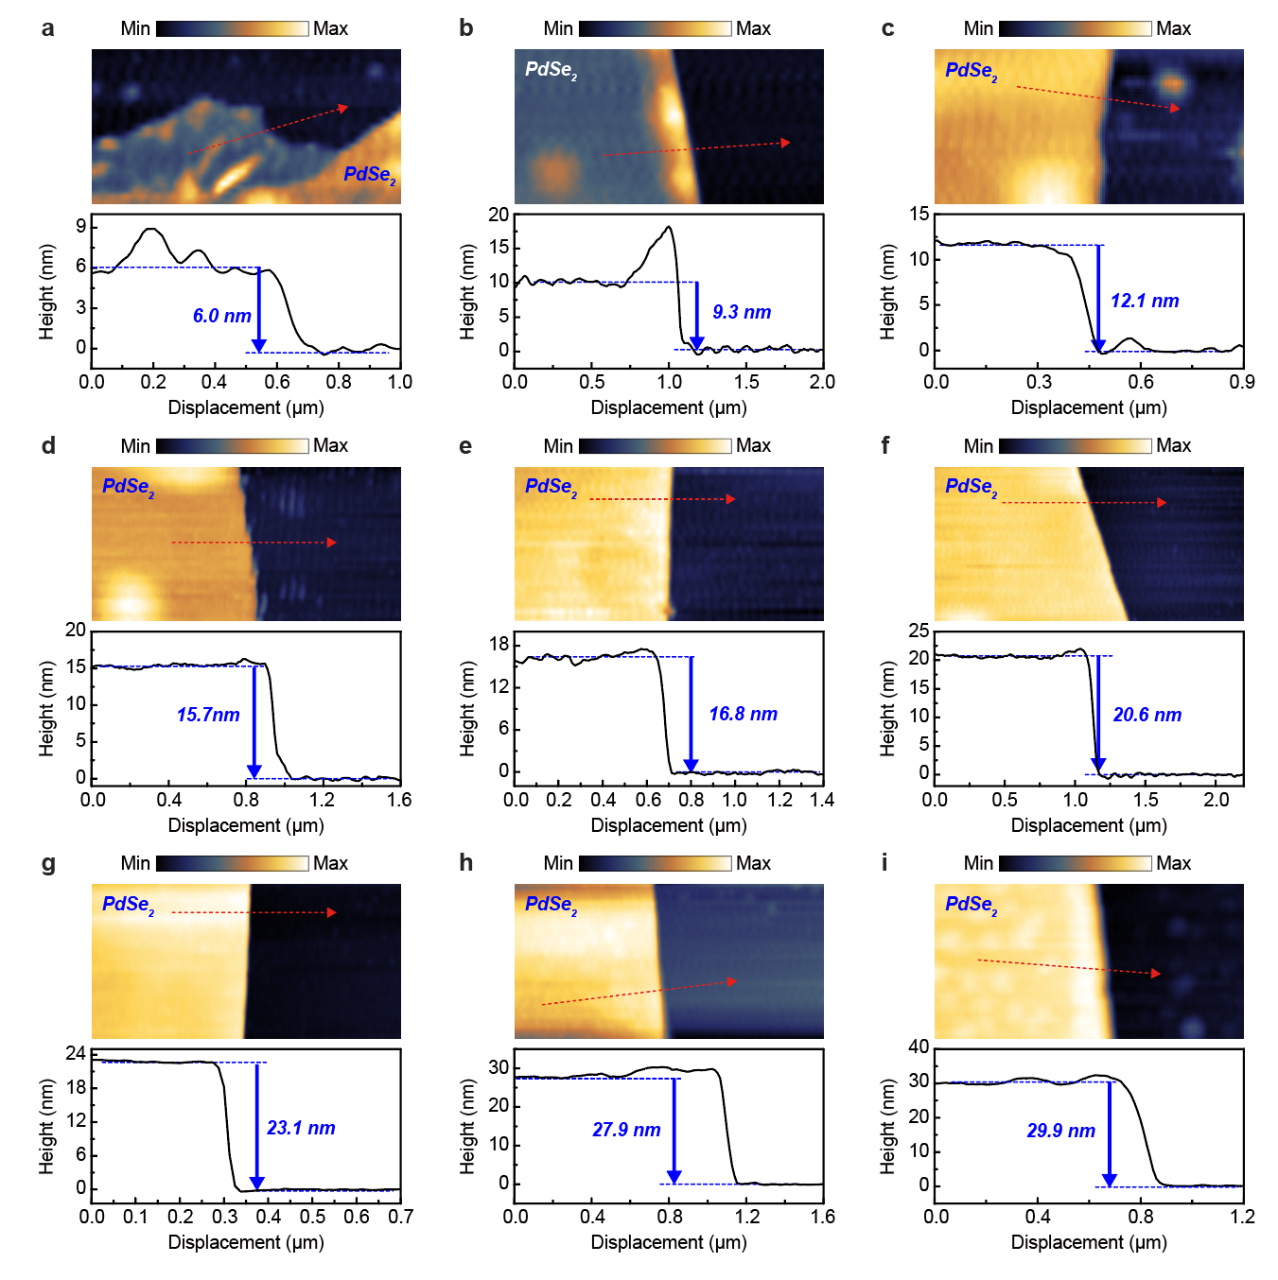
Supplementary Fig. 9 PdSe₂ thicknesses calibration by AFM. a-i, AFM topography images (upper panels) and corresponding height profiles (lower panels) of exfoliated PdSe₂ flakes with measured thicknesses of 6.0 nm (a), 9.3 nm (b), 12.1 nm (c), 15.7 nm (d), 16.8 nm (e), 20.6 nm (f), 23.1 nm (g), 27.9 nm (h), and 29.9 nm (i).

KPFM raw data
All KPFM data for TMDC flakes that presented in this article are provided in Supplementary Figs. 10-12.
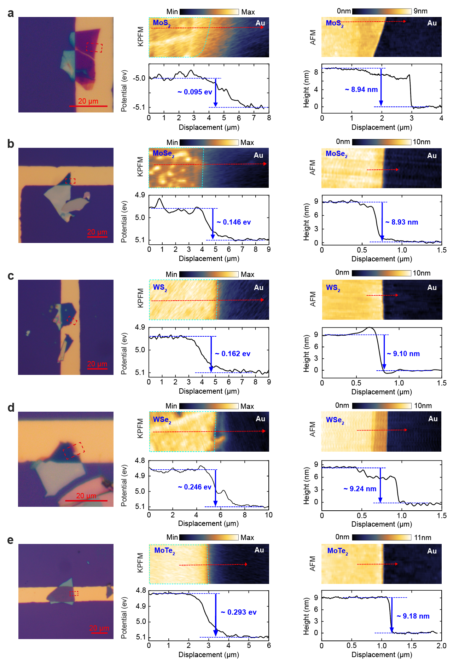
Supplementary Fig. 10 Around 9 nm thick MX₂ thicknesses and work function calibration by AFM and KPFM. a-e, Optical micrographs (left), KPFM maps with potential line profiles (middle), and AFM height maps with thickness profiles (right) for MoS₂ (a), MoSe₂ (b), WS₂ (c), WSe₂ (d), and MoTe₂ (e) flakes deposited on Au substrates. KPFM measurements reveal increasing surface potential differences (ΔΦ) from MoS₂ (~0.095 eV) to MoTe₂ (~0.293 eV).

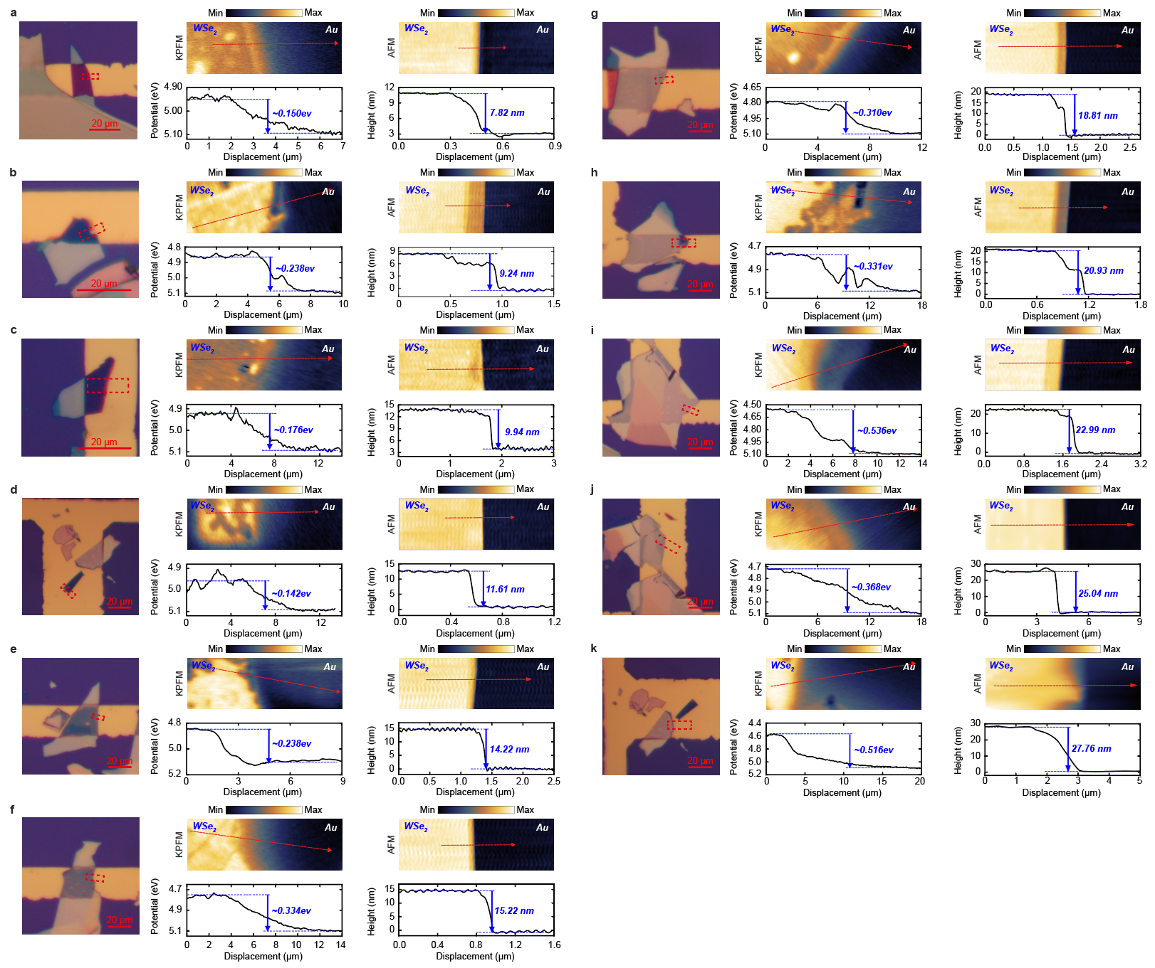
Supplementary Fig. 11 WSe₂ thicknesses and work function calibration by AFM and KPFM. a-k, Optical micrographs (left), KPFM potential maps and line profiles (middle), and AFM topography maps with corresponding height profiles (right) for exfoliated WSe₂ flakes of increasing thicknesses: 7.8 nm (a), 9.2 nm (b), 9.9 nm (c), 11.6 nm (d), 14.2 nm (e), 15.2 nm (f), 18.8 nm (g), 20.9 nm (h), 23.0 nm (i), 25.0 nm (j), and 27.8 nm (k).

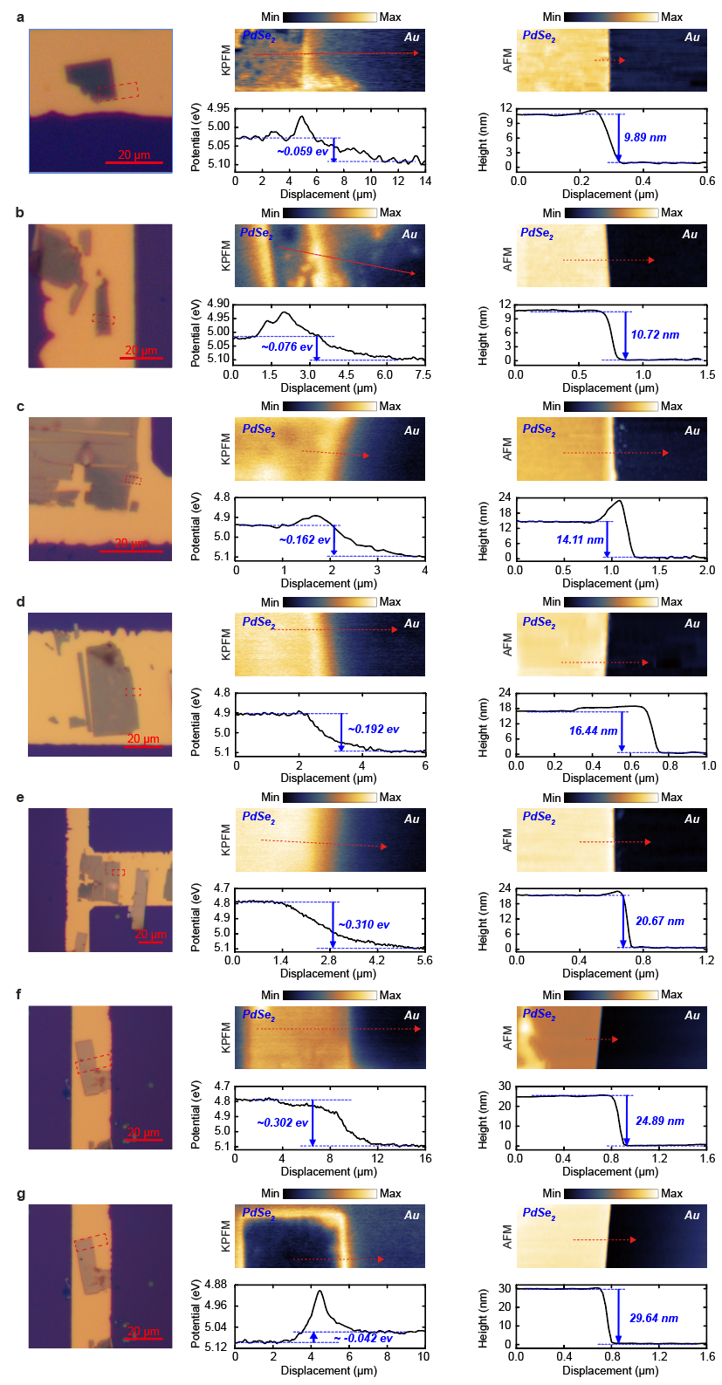
Supplementary Fig. 12 PdSe₂ thicknesses and work function calibration by AFM and KPFM. Device optical microscope images library and the near field scanning raw data. a-g, Optical micrographs (left), KPFM potential maps with corresponding potential line profiles (middle), and AFM topography maps with height profiles (right) for PdSe₂ flakes of varying thicknesses: 9.9 nm (a), 10.7 nm (b), 14.1 nm (c), 16.4 nm (d), 20.7 nm (e), 24.9 nm (f), and 29.6 nm (g).

Microscopic physical picture of the non-trivial saturation and trivial depletion phenomenon
In this work, we elucidate the microscopic mechanisms underlying the phenomena of non-trivial saturation and trivial depletion regions of the optical readout $\frac{λ_{1}}{λ_{2}}-1$ observed in TMDC/ α-MoO₃ heterostructures. Specifically, we report that a TMDC flake can saturate α-MoO₃ layers thinner than a critical threshold, typically on the order of ~100 nm. This critical thickness demarcates the regime where mesoscopic non-local screening effects become significant at the scale of hundreds of nanometres. Prior to interfacing TMDC and α-MoO₃, the TMDC flakes possess electrons amenable to transfer, while α-MoO₃ contains available electron acceptors. Upon contact, electron transfer from TMDC to α-MoO₃ is facilitated by the lower work function of the TMDC flakes relative to α-MoO₃. Our experimental investigation, encompassing eight α-MoO₃ flakes of varying thicknesses, implied that thicker α-MoO₃ layers possess sufficient acceptors to accommodate all transferable electrons from TMDC, leading to subsequent charge redistribution. However, as the α-MoO₃ thickness decreased, the number of acceptors decreased, reaching a critical thickness where the acceptor count aligns with the electron supply from TMDC. Beyond this point, α-MoO₃ layers thinner than the critical thickness cannot accommodate all transferable electrons, leading to saturation. It is noteworthy that the electron density in saturated α-MoO₃ remains constant, as reflected by the stable value of the readout $\frac{λ_{1}}{λ_{2}}-1$ in the non-trivial saturation domain. This model offers a refined understanding of the interplay between electron transfer dynamics and material thickness in TMDC/α-MoO₃ heterostructures.

PhP Raw data
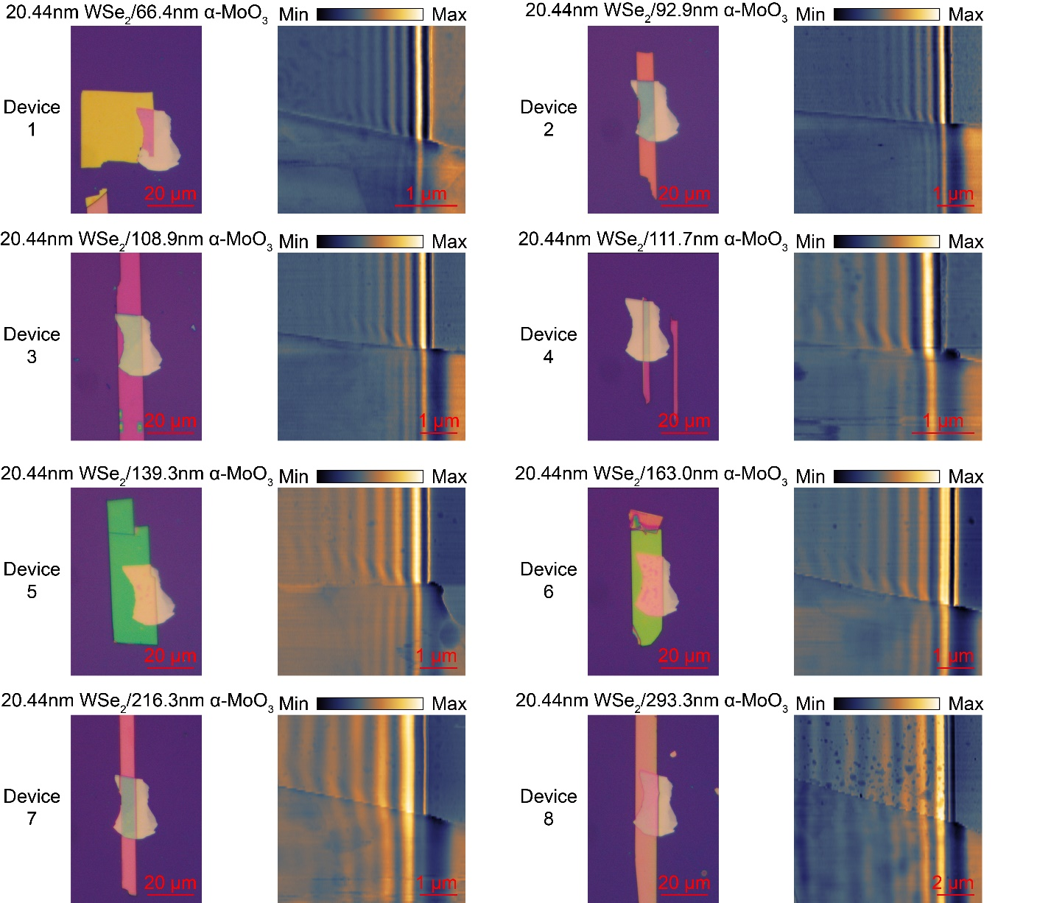
Supplementary Fig. 13 Raw data set 1.
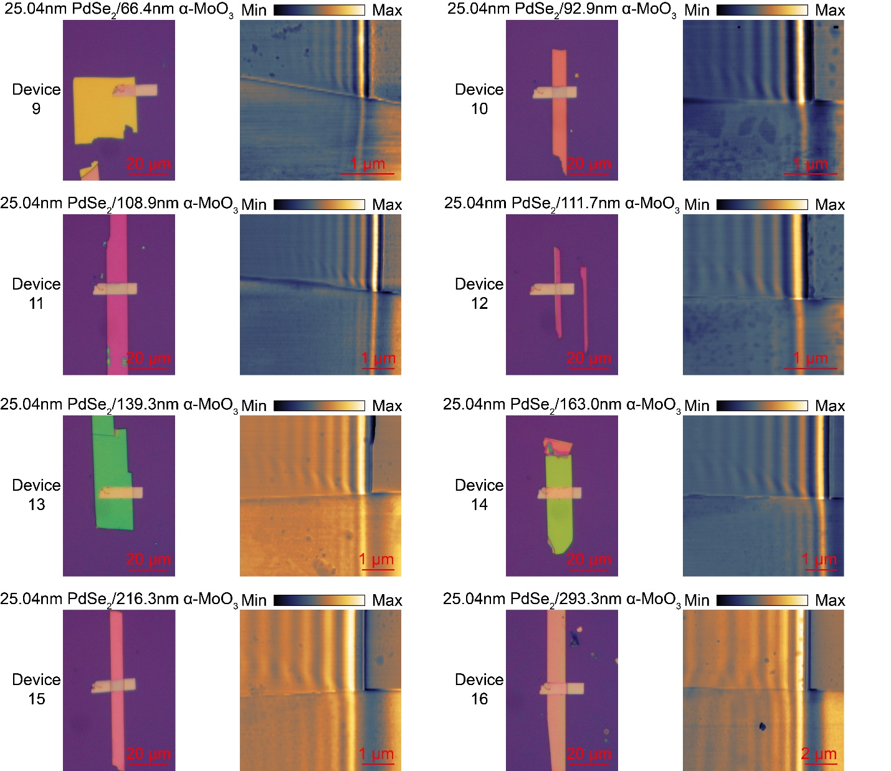
Supplementary Fig. 14 Raw data set 2.

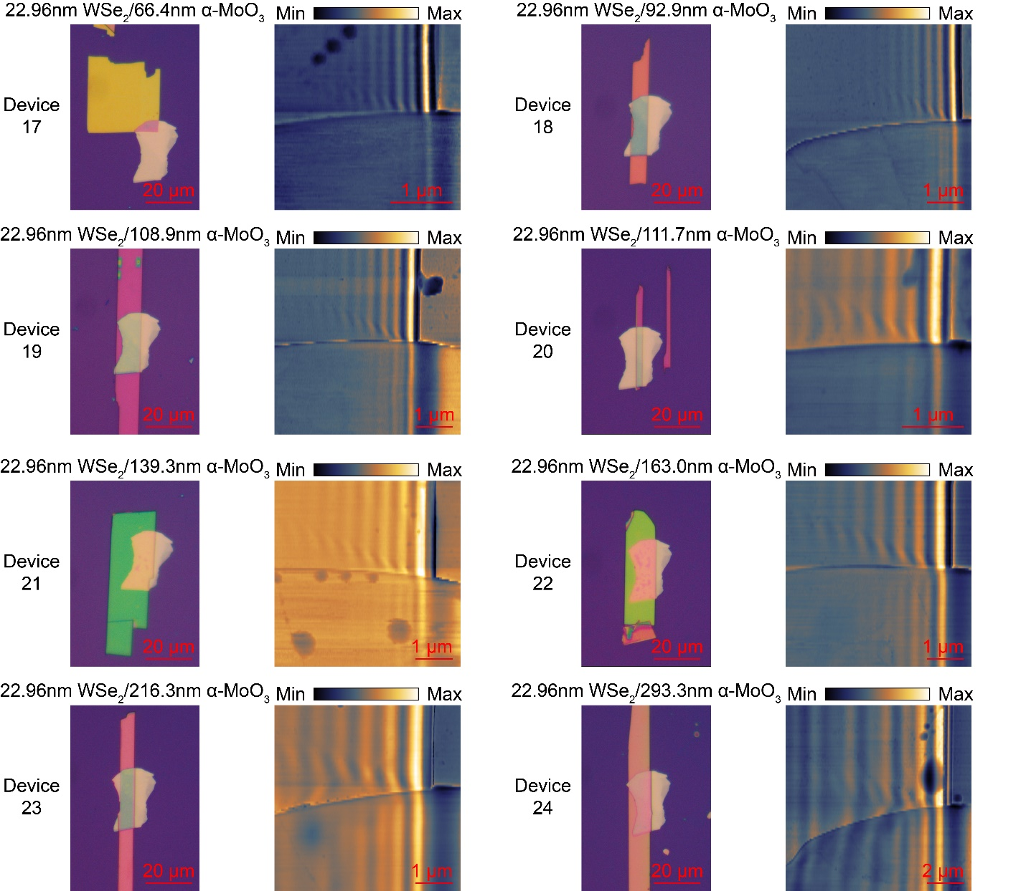
Supplementary Fig. 15 Raw data set 3.

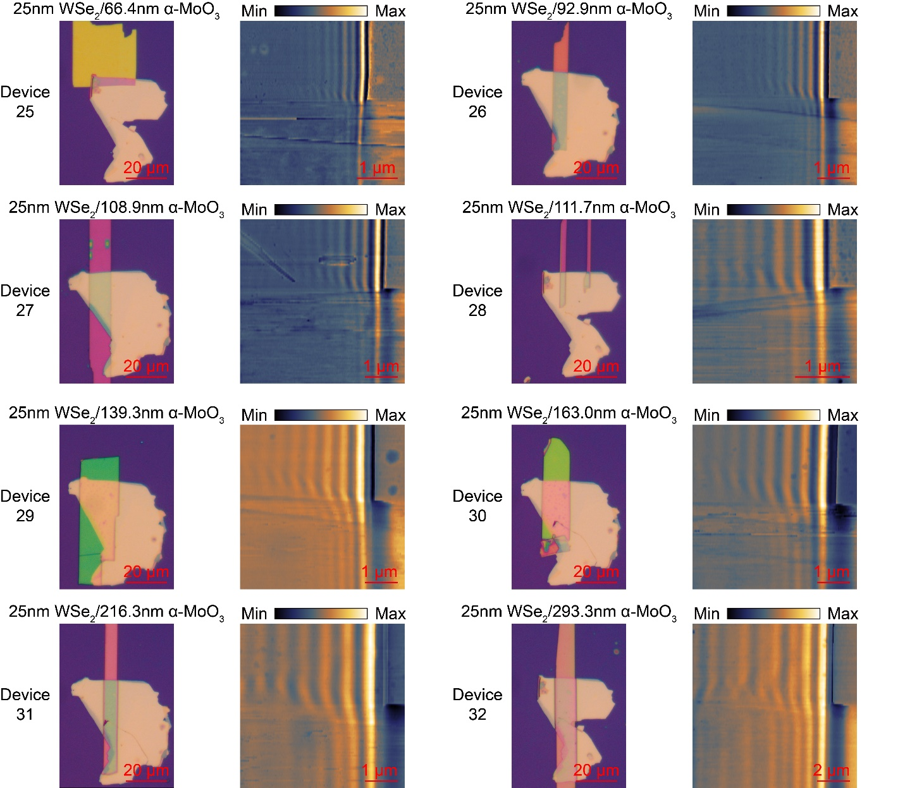
Supplementary Fig. 16 Raw data set 4.

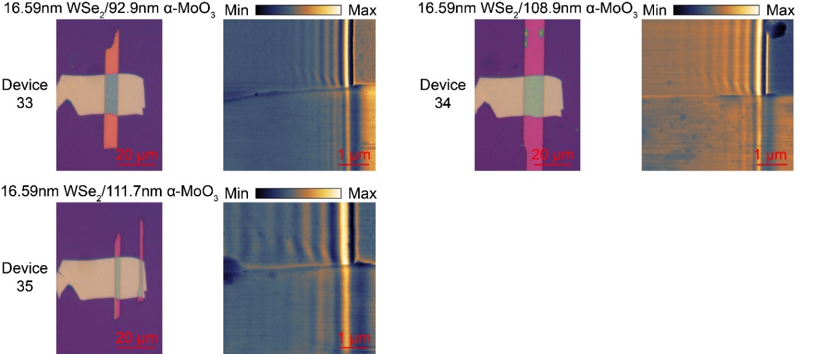
Supplementary Fig. 17 Raw data set 5.

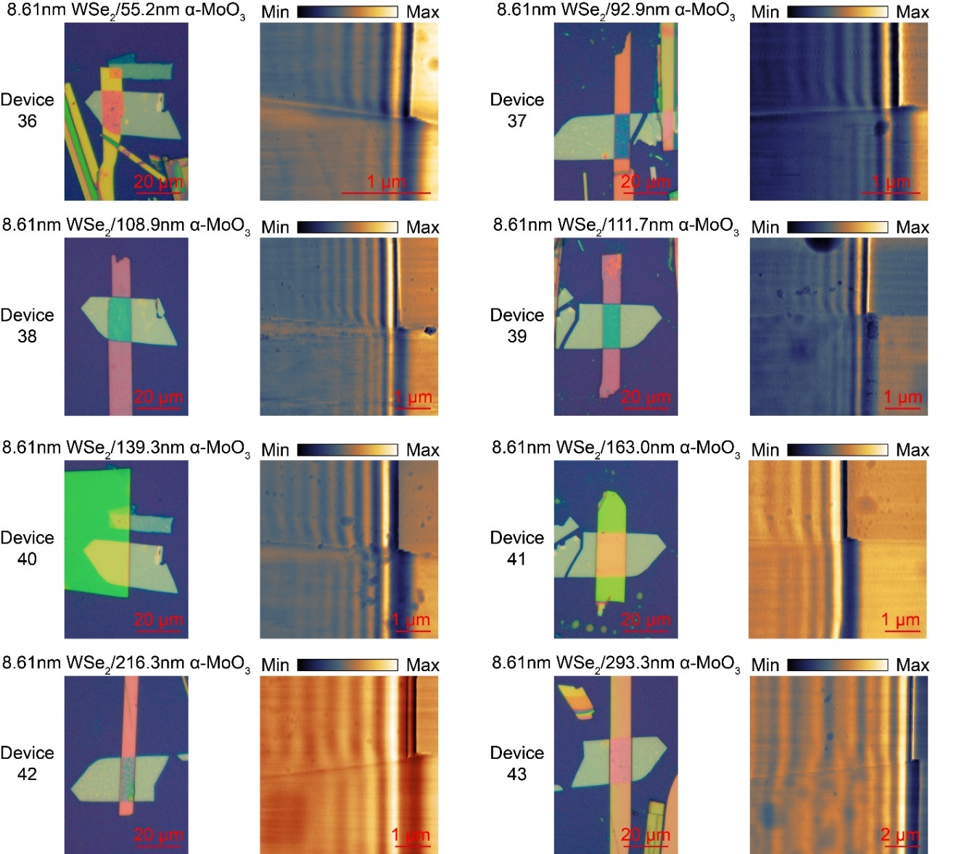
Supplementary Fig. 18 Raw data set 6.
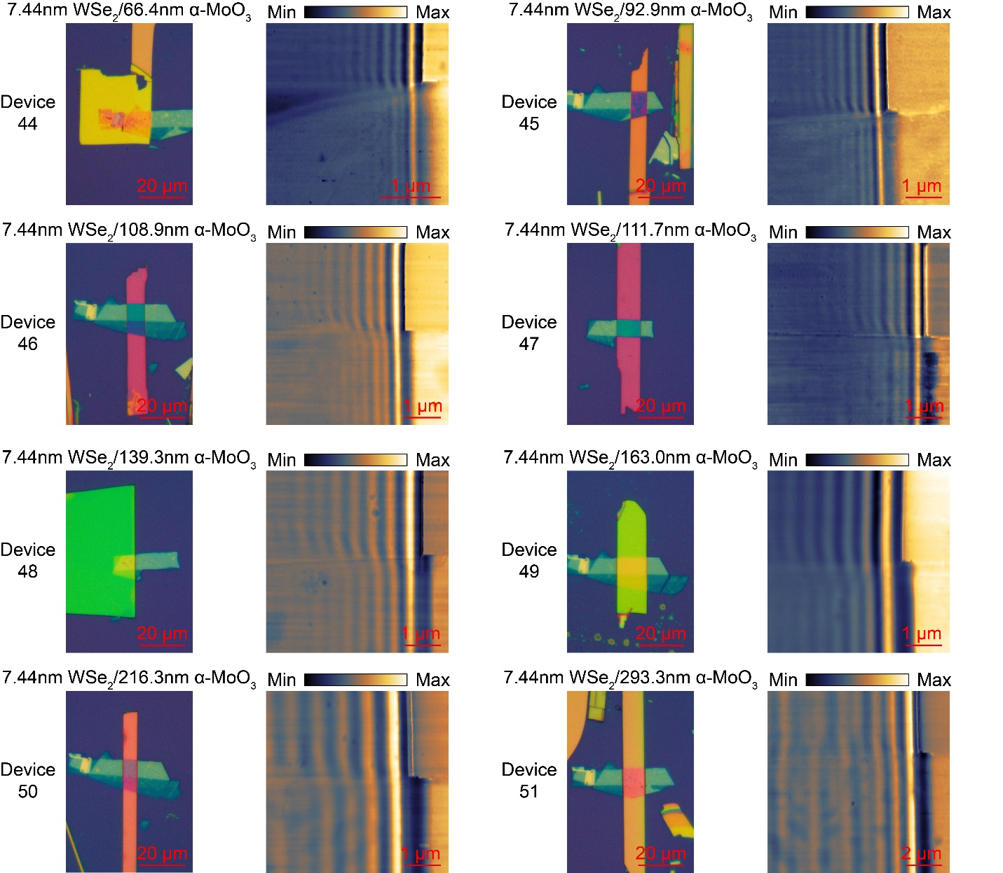
Supplementary Fig. 19 Raw data set 7.

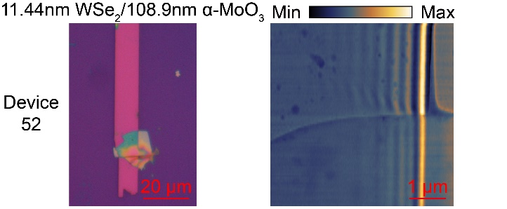
Supplementary Fig. 20 Raw data set 8.

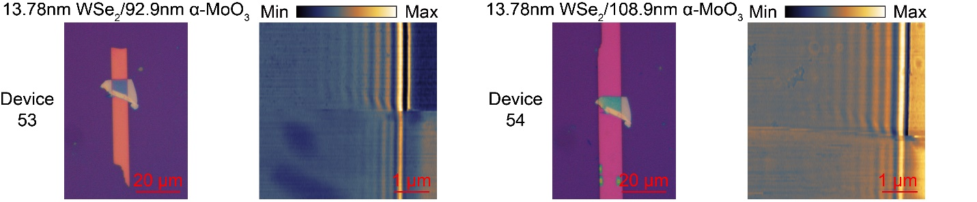

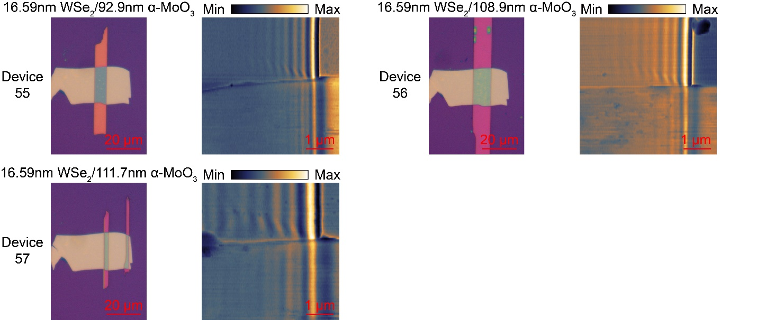
Supplementary Fig. 21 Raw data set 9.

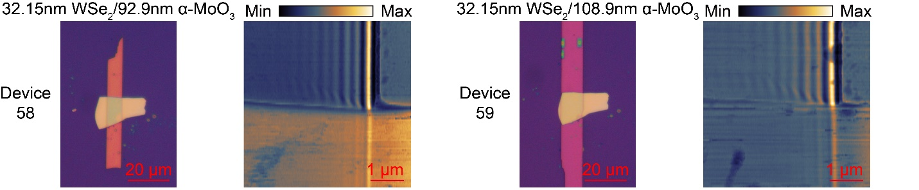
Supplementary Fig. 22 Raw data set 10.

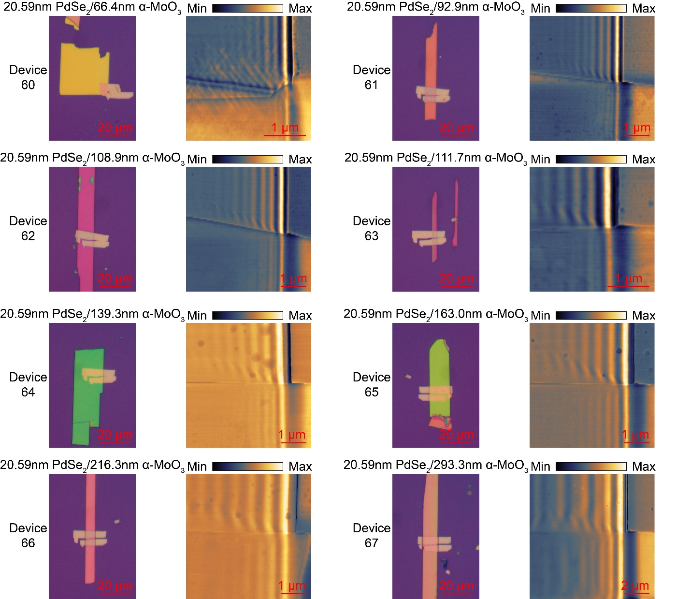
Supplementary Fig. 23 Raw data set 11.

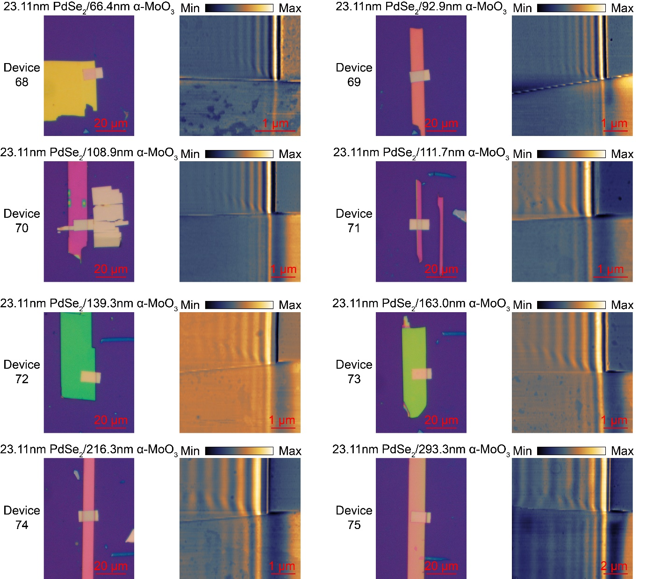
Supplementary Fig. 24 Raw data set 12.

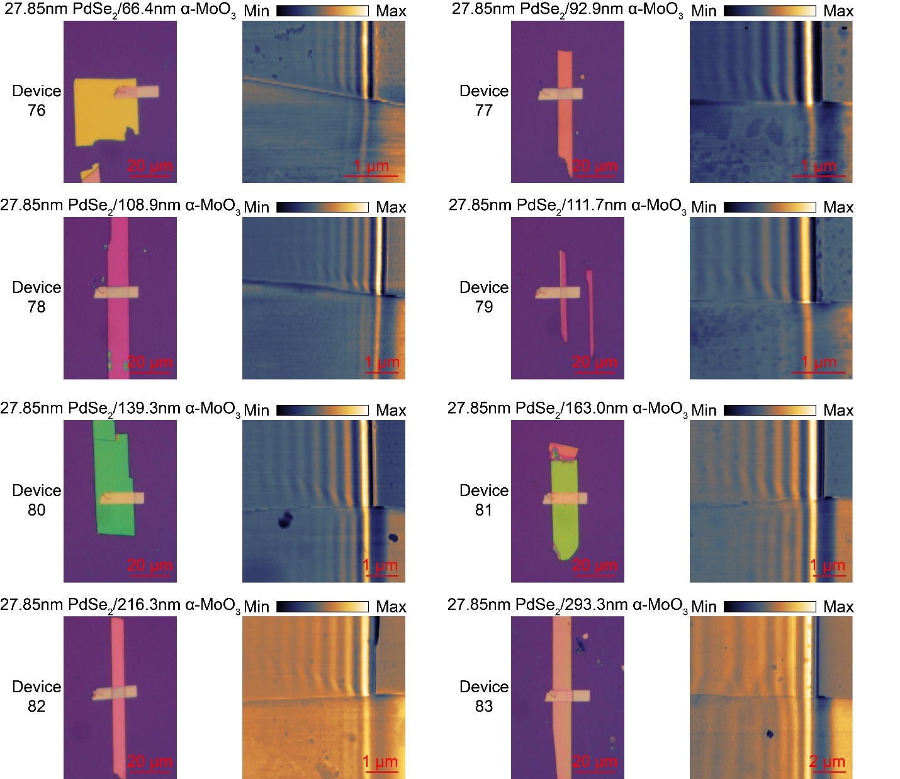
Supplementary Fig. 25 Raw data set 13.

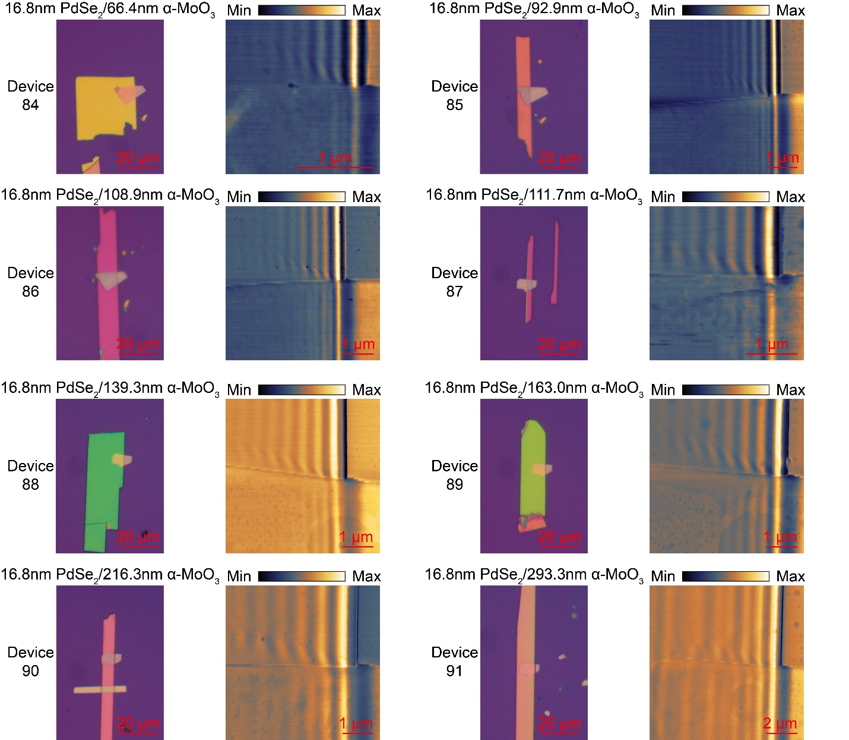
Supplementary Fig. 26 Raw data set 14.

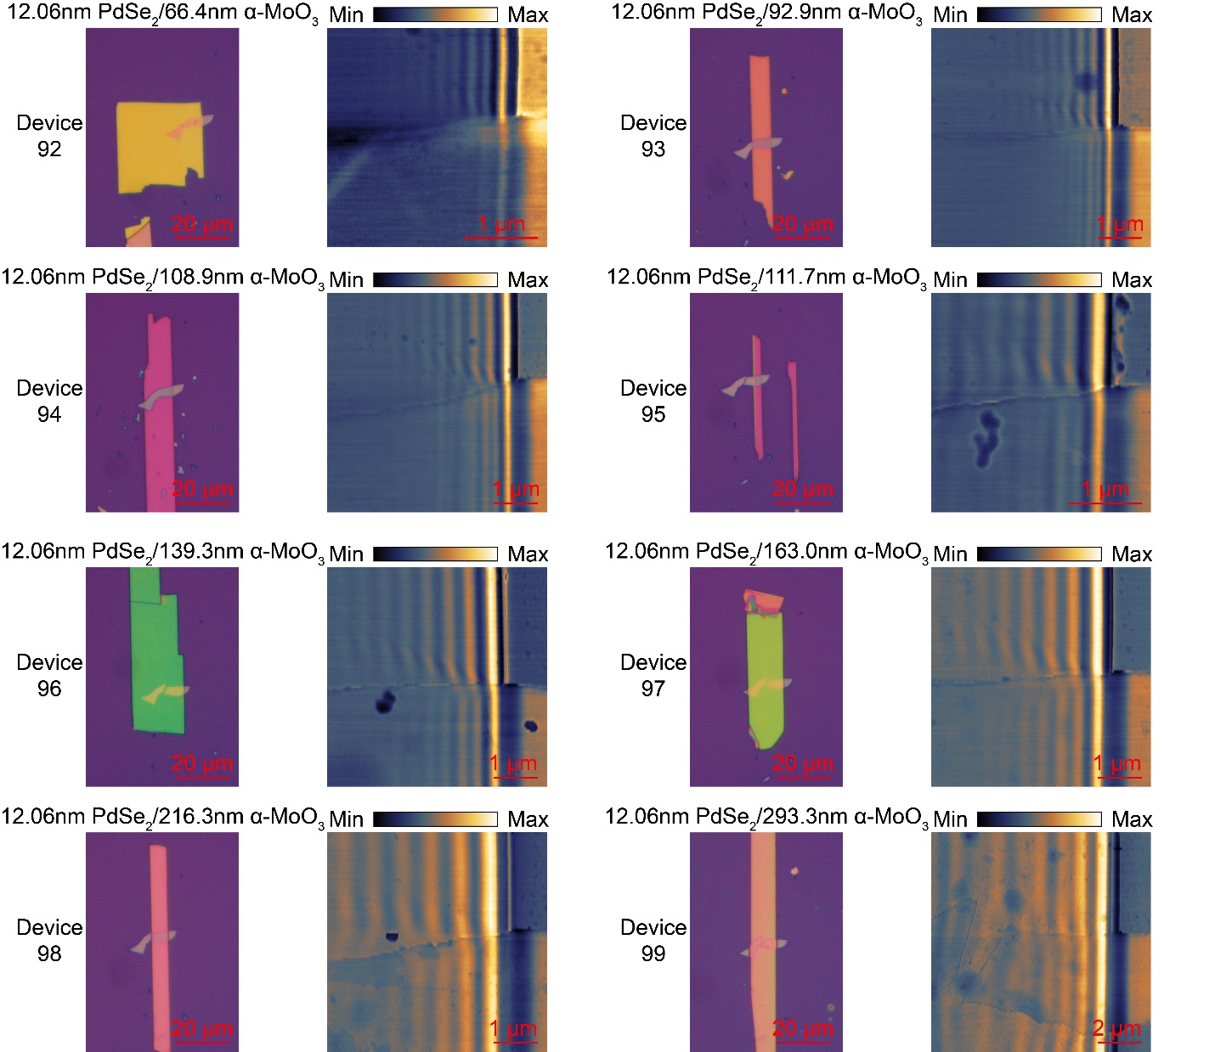
Supplementary Fig. 27 Raw data set 15.

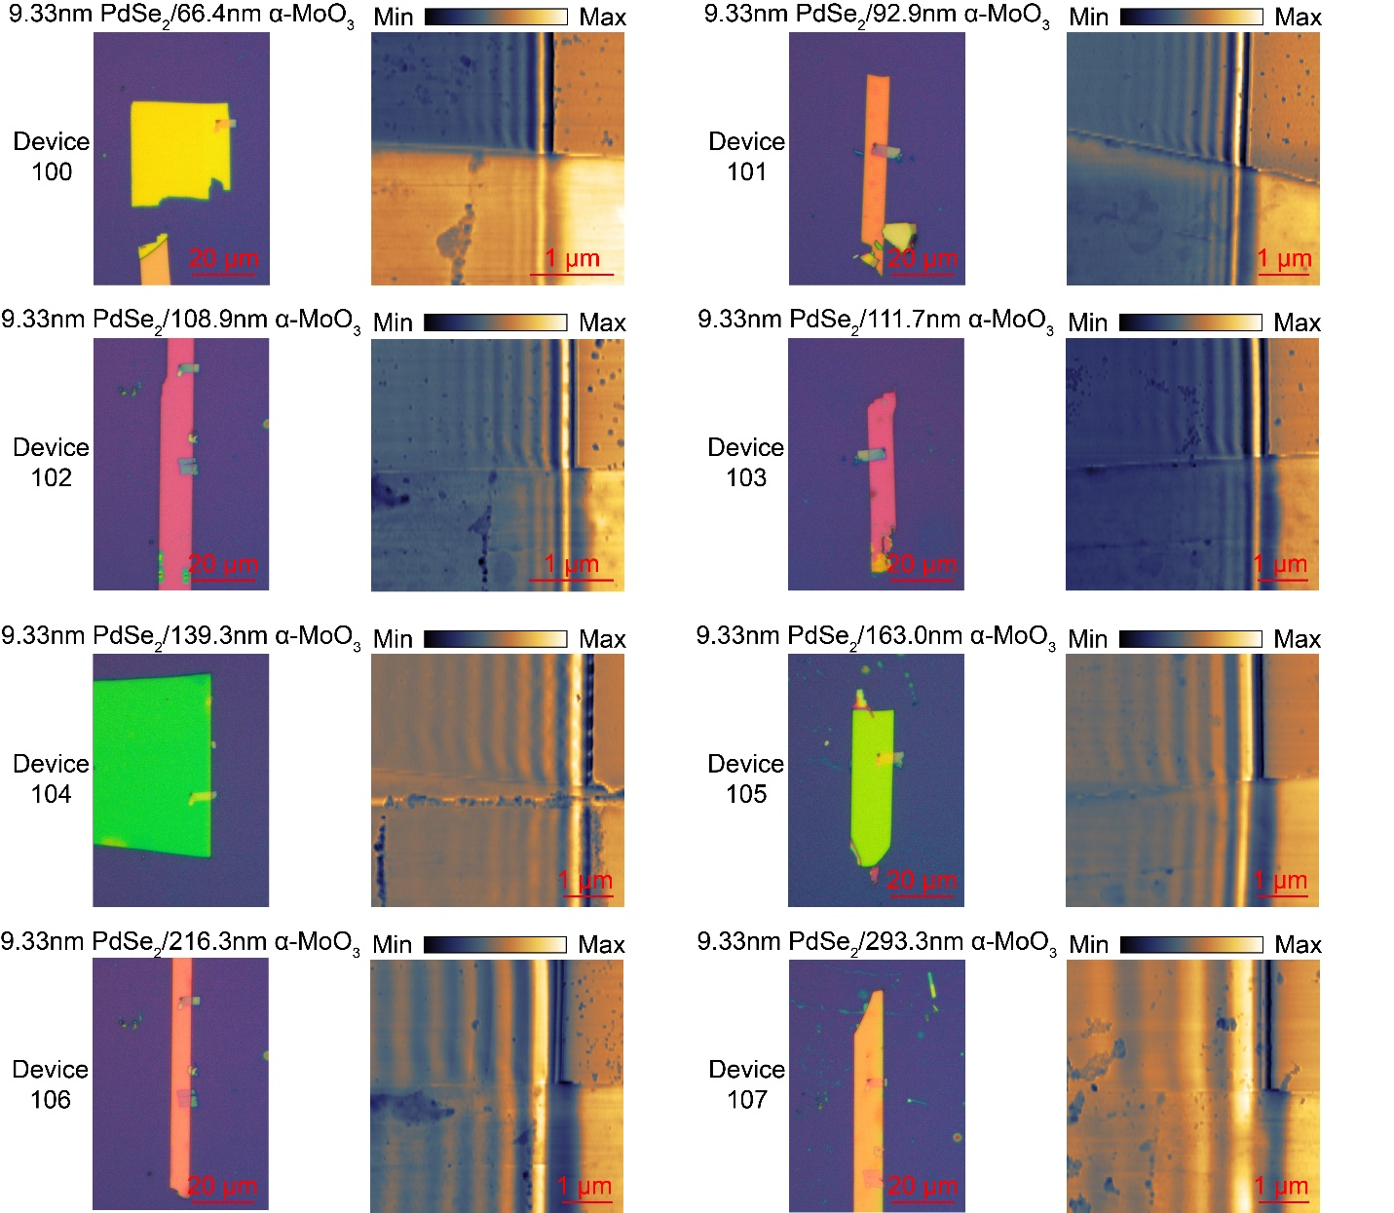
Supplementary Fig. 28 Raw data set 16.

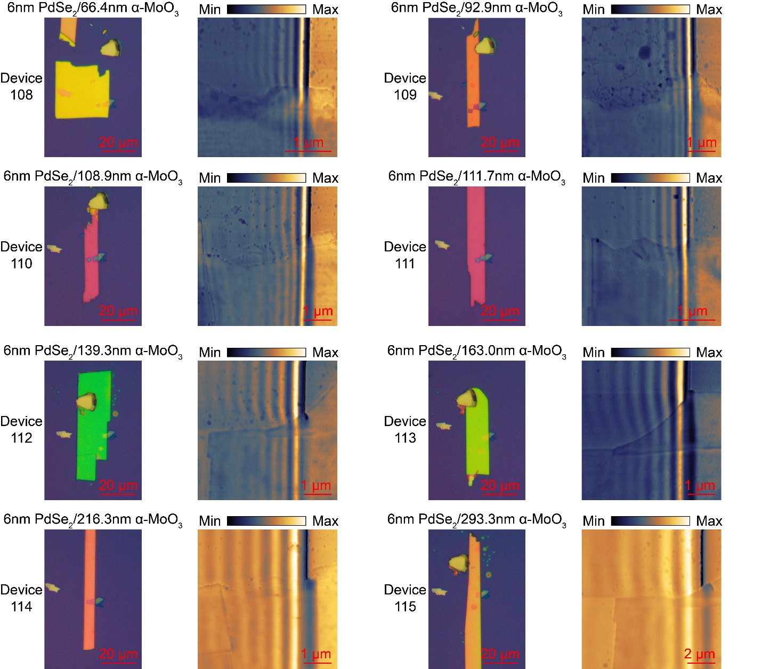
Supplementary Fig. 29 Raw data set 17.

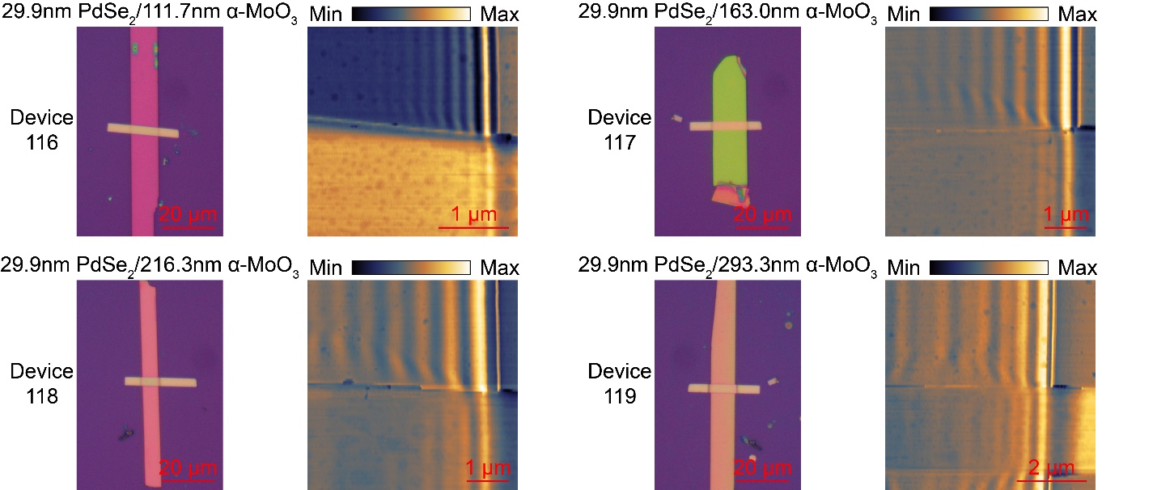
Supplementary Fig. 30 Raw data set 18.

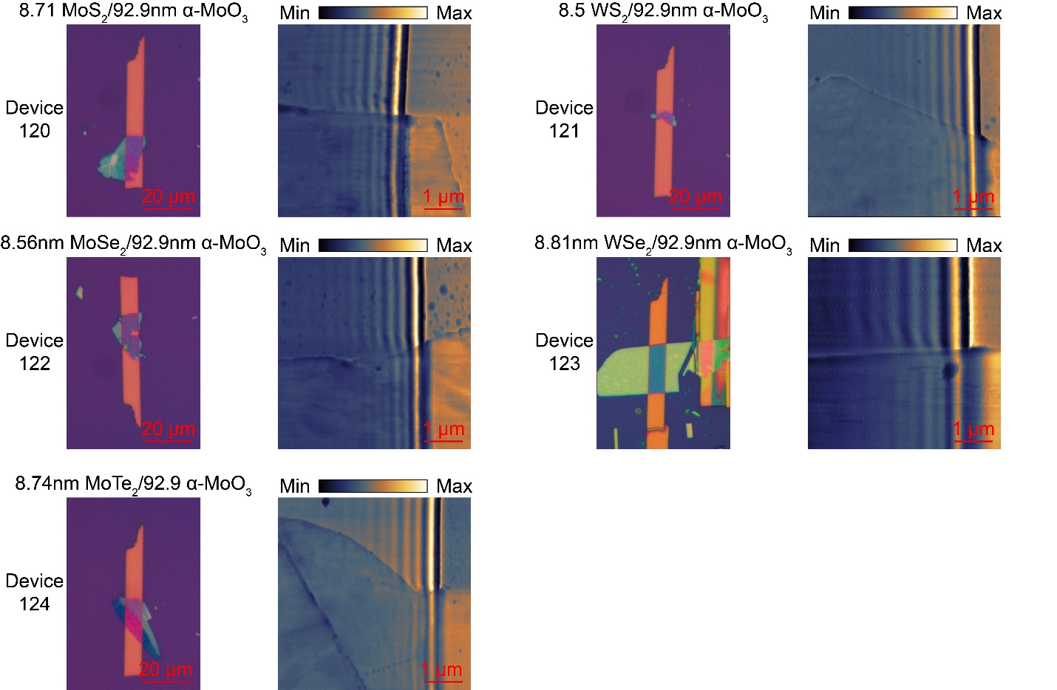
Supplementary Fig. 31 Raw data set 19.

References
1 Jin, C. et al. Interlayer electron–phonon coupling in WSe₂/hBN heterostructures. Nat. Phys. 13, 127-131 (2017).
2 Hu, G. et al. Topological polaritons and photonic magic angles in twisted α-MoO₃ bilayers. Nature 582, 209-213 (2020).
3 Ma, W. et al. In-plane anisotropic and ultra-low-loss polaritons in a natural van der Waals crystal. Nature 562, 557-562 (2018).
4 Nikitin, A. et al. Real-space mapping of tailored sheet and edge plasmons in graphene nanoresonators. Nat. Photon. 10, 239-243 (2016).
5 Dai, S. et al. Tunable phonon polaritons in atomically thin van der Waals crystals of boron nitride. Science 343, 1125-1129 (2014).
6 Zhu, B. et al. Nanofocusing of hybrid plasmons-phonons-polaritons in a graphene-hexagonal boron nitride heterostructure. Opt. Lett. 41, 4578-4581 (2016).
7 Álvarez‐Pérez, G. et al. Infrared permittivity of the biaxial van der waals semiconductor α‐MoO₃ from near‐and far‐field correlative studies. Adv. Mater. 32, 1908176 (2020).
8 Kischkat, J. et al. Mid-infrared optical properties of thin films of aluminum oxide, titanium dioxide, silicon dioxide, aluminum nitride, and silicon nitride. Appl. Opt. 51, 6789-6798 (2012).

