Supplementary File 1

Pictures of the game L’Arbre

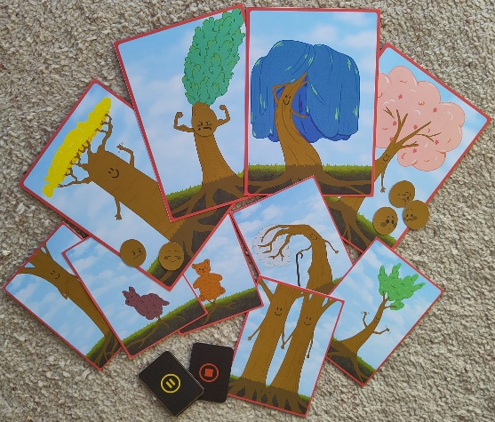
FigS1. Material for Chapter 1-v1: The tree and its forest. Activity: choosing preferred trees and explaining why. ACP goal: getting to know children's family environment (e.g. their preferred caregivers). Illustrations by Savannah lngwersen
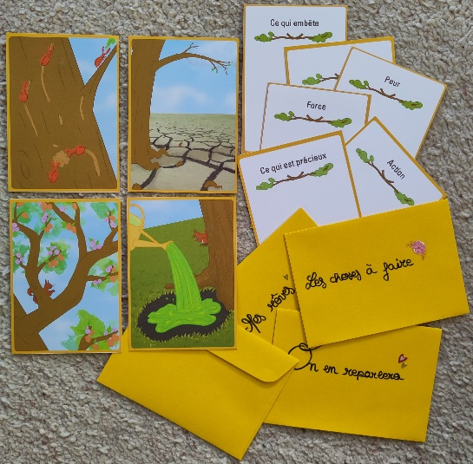
FigS2. Material for Chapter 2-v1: The tree’s adventures. Activity: choosing an adventure for the tree and relating it to personal experience. ACP goal: understanding children’s fears and hopes related to their illness. Illustrations by Savannah lngwersen
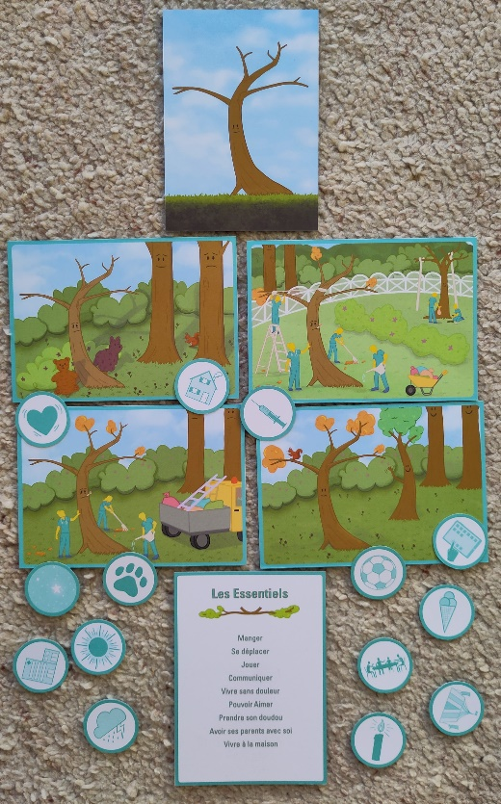
FigS3. Material for Chapter 3-v1: The future of the tree. Activity: in a matching task, explaining why different health trajectories make one think of specific health trajectories. ACP goal: exploring possible illness trajectories and perceptions of death, and preferences for care in the event of deteriorating health. Illustrations by Savannah lngwersen
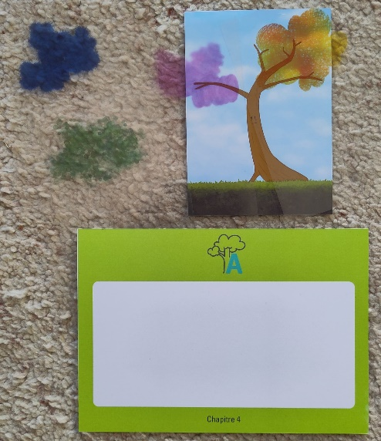
FigS4. Material for Chapter 4-v1: The happy ending. Activity: choosing of new leaves for the tree as it recovers and relating them to personal experience. ACP goal: exploring children’s internal and external resources. Illustrations by Savannah lngwersen

Content of observation grid & questionnaires

Five-second Rapid Desirability Test
After viewing the game on a A3 size picture (Fig1) for 5 second, participants answer four questions:
- What general impression did this game give you? (on a 5-point scale ranging from very bad to very good)
- Overall, how would you rate the aesthetic of this game? (on a 5-point scale ranging from very bad to very good)
- What do you remember about the visual elements?
- What do you think are the objectives of the game?

Think-aloud tasks & questions
The game is composed of four chapters which correspond to the four tasks of the think-aloud procedure. Participants played one chapter after the other. At the end of each chapter, participants answered to the following questions:
- Single Ease Question (SEQ): Overall, how difficult or easy was the task to complete? (on a 7-point scale ranging from very difficult to very easy)
- What was easy or difficult?
- Do you have any suggestions for improvement?
The Single Ease Question metric helps to assess how easy each task was for the user to complete. Average SEQ scores in published usability tests correspond to 5.5.

Endorsement on several parameters
To observe whether participants endorsed the game, the following 1-5 Likert questions were asked after the game play.
- What is your overall rating (in stars) for this game?
- Overall, how would you assess the difficulty of understanding the rules and the logic of the game?
- If you were asked to play this game again in a month's time, would you remember the rules?
- In your opinion, is this discussion experience appropriate for children with serious illnesses and their families?
- Is this game suitable for our target audience (6-12 years old)?
Results can be interpreted as 1 = inadequate/very negative and 5 = excellent/very positive.

Relevance for ACP
Participant also evaluated the relevance of the game with the six “perceived impact” items (section F) of the Mobile App Rating Scale (MARS) questionnaire. It is particularly interesting as it was developed on the basis of the transtheoretical model of behaviour change by Prochaska, which is commonly used in ACP literature to evaluate participants’ change in ACP engagement. The questions allow to obtain participants’ evaluation of the impact of the game on user’s awareness, knowledge, attitudes, intentions to change, and likelihood of actual change in advance planning behaviour. Participants answered on a 5-point scale ranging from 1=fully disagree to 5=fully agree.
- Awareness: This game is likely to increase awareness of the importance of addressing issues related to ACP for children
- Knowledge: This game is likely to increase knowledge/understanding of ACP for children
- Attitude: This game is likely to change attitudes toward improving ACP for children
- Intention change: This game is likely to increase motivation to address ACP for children
- Help seeking: Use of this game is likely to encourage further help seeking regarding ACP for children.
- Behaviour change: Use of this game is likely to increase ACP for children
An overall mean 5-point Likert scores can be calculated and interpreted as follows: 1) inadequate; 2) poor; 3) acceptable; 4) good, 5) excellent. These questionnaire items were translated in French following the good practices described in Wild et al. 2005.

Perceived Attractiveness
The AttrakDiff questionnaire includes 28 pairs of contrasting words. It allows to evaluate participants’ experience across four dimensions (pragmatic quality, hedonic-stimulation quality, hedonic-identity quality and overall attractiveness), each containing 7 items rated on a 7-point scale ranging from -3 to +3:
human – technical // simple – complicated // practical – impractical // cumbersome – straightforward // predictable – unpredictable // confusing – clearly structured // unruly – manageable // pleasant – unpleasant // ugly – attractive // likeable – disagreeable // rejecting – inviting // good – bad // repelling – appealing // motivating – discouraging // isolating – connective // professional – unprofessional // stylish – tacky // cheap – premium // alienating – integrating // brings me closer to people – separates me from people // unpresentable – presentable // inventive – conventional // unimaginative – creative // bold – cautious // innovative – conservative // dull – captivating // undemanding – challenging // novel – ordinary
The shorter10-item version for the children includes the pairs of words that are underscored in the above list.
Scores close to the mean (between 0 and 1) indicate that the product achieves its objectives without any significant negative impact, although improvements could be made to create a more positive user experience or attractiveness. Scores outside the neutral zone should be interpreted as either positive (from 1 to 3) or negative (from -1 to -3).

Discussion grid for participants’ final qualitative feed-back
- Tell me how the test went, how you experienced it.
  - Follow-up: Why? How? Did you encounter any difficulties? Was there anything that didn't go as you had imagined or wanted?
- What is your overall impression of this game?
  - Follow-up: What did you like most and least about this game? Were you bothered by anything at any point during the game? What do you think of the game's aesthetic (the drawings, the appearance)? Did this game make you want to play? What do you think of the choice of trees as the main theme of the game? And the cards, were they easy to handle? Did you find the language appropriate for a 6-year-old and a 12-year-old?
- If you could change something about this game, what would it be?
  - Follow-up: Was there anything missing from this game? (Something about the design? The content? The rules?)

Usability issues

Table S1. Description of problems encountered by participants. Classification of the problems according to the Bastien & Scapin categories, and evaluation of their severity using Nielsen’s 1–4 rating scale (1 = cosmetic issue that does not necessarily require correction; 2 = minor usability issue with low priority for resolution; 3 = major usability issue that should be resolved with high priority; 4 = usability catastrophe that must be resolved before finalizing the product). Description of the changes implemented in the new version of the game.
Task | Item | Problems encountered | Category | Severity | Modifications decided for new version
 |  |  | Bastien & Scapin | Nielsen | Type | Description
Overall | 0.1 | Gameplay duration was much longer than expected with adults and shorter than expected with children. | Guidance | 3 | Rewording of labels or instructions within game  +  2x Modification of game rules | 1) Add instructions in the rulebook to adjust the duration and number of sessions according to the clinical context.  2) Do not play Chapters 2 and 4 with adults; instead, explain what will be done with the child.  3) Schedule the feedback session with the adult only after gameplay with the child.
 | 0.2 | It was unclear whether (and when) adults should play as if they were the child or play as themselves. | Compatibility | 4 | Rewording of labels or instructions within game  +  Modification of game rules | 4) Clarify in the rulebook that in Chapter 1 adults choose trees as if they were the child, and in Chapter 3 they complete the matching task as themselves.  2) Do not play Chapters 2 and 4 with adults (as in 0.1).
 | 0.3 | Difficulty understanding the meaning of the double-sided “pause–stop” card. | Significance of codes | 3 | Changes to the design of the game | 5) Create three separate cards: “pause,” “play,” and “stop.”
 | 0.4 | One health professional appreciated the suggested verbatim prompts but found them too restrictive in this chapter (they limited the discussion too much). | Guidance: readability | 1 | Rewording of labels or instructions within game | 6) Review all verbatim prompts to avoid closed-ended questions.
 | 0.5 | Health professionals found it difficult to adapt the verbatim prompts when presenting the game to adults, as they were originally designed for discussions with children. | Compatibility, Guidance | 3 | Rewording of labels or instructions within game | 7) Include verbatim prompts specifically designed for presenting the game rules to adults.
Chap 1 | 1.1 | Misunderstandings about the symbolic meaning of the child-trees: do they represent characteristics (e.g., strength, beauty) or the child? | Guidance, significance of codes | 4 | Rewording of labels or instructions within game | 8) Clarify in the rulebook that trees may represent people (e.g., the chosen child-tree represents the child) and provide example prompts (e.g., “If you were a tree, which one would you be?”).
 | 1.2 | Misunderstandings about the symbolic meaning of the forest trees (e.g., a child chose them “because she likes very green trees”). | Guidance, significance of codes | 4 | Rewording of labels or instructions within game | 9) Specify in the rulebook that forest trees represent people surrounding the child (family members, friends, etc.), and provide example prompts to support discussion of relationships (e.g., “Who is important in your life? Could this tree represent them? Shall we place it next to your tree?”).
 | 1.3 | At the end of Chapter 1, health professionals were unsure whether parents should use the stickers and whether the remaining stickers could be given to the child. | Compatibility, Guidance, Workload: information density | 2 | Added content to training for health professional  +  Rewording of labels or instructions within game  +  Modification of game rules | 10) Specify in the training materials what items can be given to the child (stickers, chosen child-tree).  11) Clarify in the rulebook which materials are required for each chapter (with pictures).  12) Do not conduct the sticker activity with parents.
 | 1.4 | At the end of Chapter 1, health professionals were unsure whether they could remove the forest. | Guidance, Workload: information density | 2 | Rewording of labels or instructions within game  +  Changes to the design of the game | 11) Clarify required materials for each chapter (as in 1.3).  13) Make each chapter and its materials more visually distinct using specific colours.
 | 1.5 | Parents struggled to choose a single emotion face for the tree and asked whether multiple emotion faces could be selected. | Adaptability: flexibility | 3 | Modification of game rules | 14) Do not conduct this activity with adults.
Chap 2 | 2.1 | Health professionals found it difficult to remember the rules. | Workload: information density | 2 | Added content to training for health professional  +  Rewording of labels or instructions within game | 15) Organize a simulated gameplay session during professional training.  16) Simplify the rule documents by merging the two booklets into one for health professionals.
 | 2.2 | A health professional was unsure which “resonance card” to use during gameplay. | Workload: information density, guidance | 2 | Added content to training for health professional  +  Changes to the design of the game | 15) Organize a simulated gameplay session (as in 2.1).  17) Remove titles from the “resonance cards” and envelopes; instead, provide example titles in the rulebook.
 | 2.3 | Health professionals were confused about what to do with parents in this chapter. | Adaptability: flexibility | 4 | Modification of game rules | 2) Do not play Chapter 2 with adults (as in 0.1).
 | 2.4 | A health professional was unsure what to do after a parent told a story and used the stop card to review the rules but could not find the answer. | Workload: information density, guidance | 2 | Modification of game rules | 2) Do not play Chapter 2 with adults (as in 0.1).
 | 2.5 | a health professional is unsure whether to ask the parent to draw on the “resonance card” | Workload: information density | 2 | Modification of game rules | 2) Do not play Chapter 2 with adults (as in 0.1).
 | 2.6 | A health professional was unsure whether to ask the parent to draw on the “resonance card”. | Workload: information density | 2 | Added content to training for health professional | 15) organise a simulated gameplay during training session (as in 2.1)
 | 2.7 | A health professional forgot to ask the child to tell a personal story related to the card. | Workload: information density | 3 | Added content to training for health professional | 15) Organize a simulated gameplay session (as in 2.1).
Chap 3 | 3.1 | Health professionals were unsure whether to stop the game at this point or continue, as the rules suggest playing in two sessions with the child. | Guidance | 2 | Modification of game rules | 18) Set playing the entire game in one session with children as the default.
 | 3.2 | One child incorrectly believed that the tree in Chapter 3 was different from the one in Chapter 1. | Consistency | 4 | Changes to the design of the game | 19) Standardize the trunks of the four child-trees in Chapter 1 and increase variation in the foliage.
 | 3.3 | Critical feedback on certain pictograms: the family-at-the-table and iPad images were unclear; the needle and black sun were perceived as too frightening; the soccer ball was too strongly associated with toys. | Guidance: readability | 2 | Changes to the design of the game | 20) Revise pictograms: use clearer images for family and iPad; draw the sun lighter and the needle less sharp; replace the soccer ball with a beach ball.
 | 3.4 | One child was unable to associate pictograms with scenario cards and appeared overwhelmed by the information. | Workload: information density, compatibility, guidance | 3 | Modification of game rules | 21) Do not present all scenario cards simultaneously; ask the child to match pictograms to one card at a time.
 | 3.5 | A health professional arranged the scenario cards from best-case (remission) to worst-case (end-of-life palliative care); the parent found this emotionally difficult. | Adaptability: flexibility | 2 | Changes to the design of the game  +  Added content to training for health professional | 22) Reinforce the use of conditional wording on the palliative scenario card.  23) Address this issue during training and suggest presenting scenario cards in random order.
 | 3.6 | After using the “essential” card, the parent was surprised to see in the next chapter that the tree recovered, creating a perceived inconsistency in the storyline. | Homogeneity: coherence | 4 | Modification of game rules | 24) Since the “essential” card is only played with the parent, this inconsistency will not affect children; therefore, keep the storyline but do not play the final chapter with the parent. Only explain what will be done with the child.
 | 3.7 | One parent struggled to understand the meaning of the “essential” card. | Guidance: readability | 1 | No modification | 25) This misunderstanding may be due to the child being healthy during usability testing; parents of seriously ill children may more readily understand the card’s meaning.meaning of this card
Chap 4 | 4.1. | The word “luck” in the introduction triggered sensitive reactions, particularly for children who may not feel as fortunate as the tree in the game. | Significance of codes | 4 | Rewording of labels or instructions within game | 26) Rephrase the sentence to remove the word “luck.”
 | 4.2 | The different foliage versions were judged to lack aesthetic diversity. | Guidance: readability | 3 | Changes to the design of the game | 27) Create new, more diverse foliage designs.
 | 4.3 | One health professional was unsure what to ask the parent (e.g., whether to ask for a story the child could tell). | Workload: information density, compatibility | 2 | Modification of game rules | 2) Do not play Chapter 4 with adults (as in 0.1).

