Appendix
Appendix 1: Partial and semi-partial correlations of the main factors with OFATR
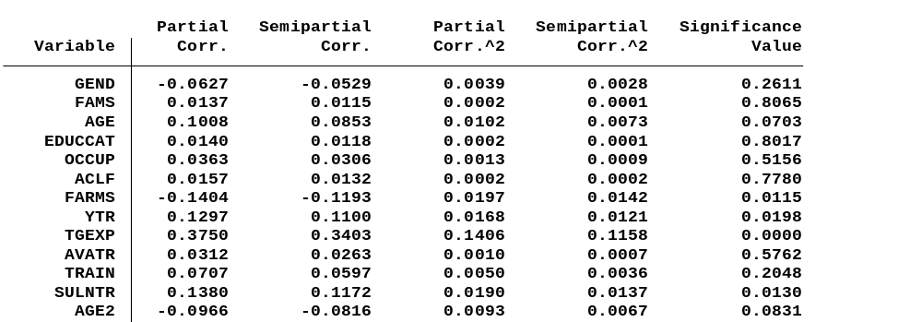
Source: Authors’ computation based on field survey
Appendix 2: Descriptive statistics of households adopted OFATR in the study year
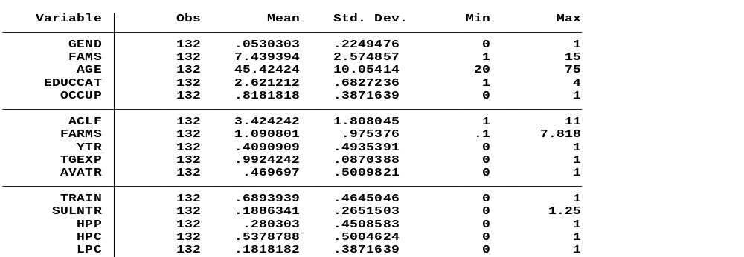
Source: Authors’ computation based onfield survey

Appendix 3: Descriptive statistics of households did not adopt OFATR in the study year
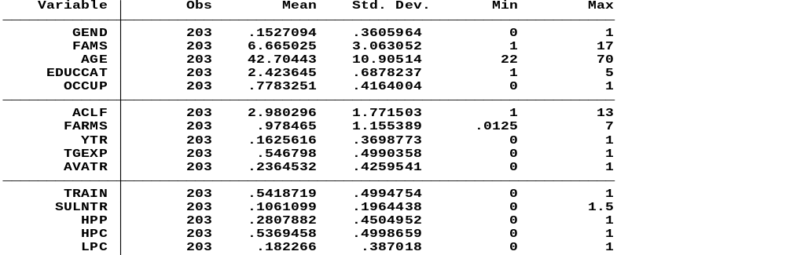
Source: Authors’ computation based onfield survey
Appendix 4: Estimates of logistic regression withoutagro-ecological dummies
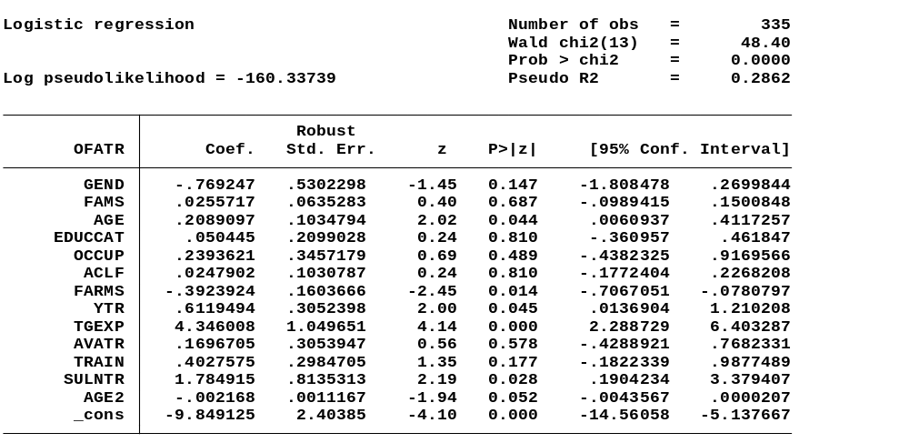
Source: Authors’ computation based on field survey

Appendix 5: Estimates of logistic regression agro-ecological dummies

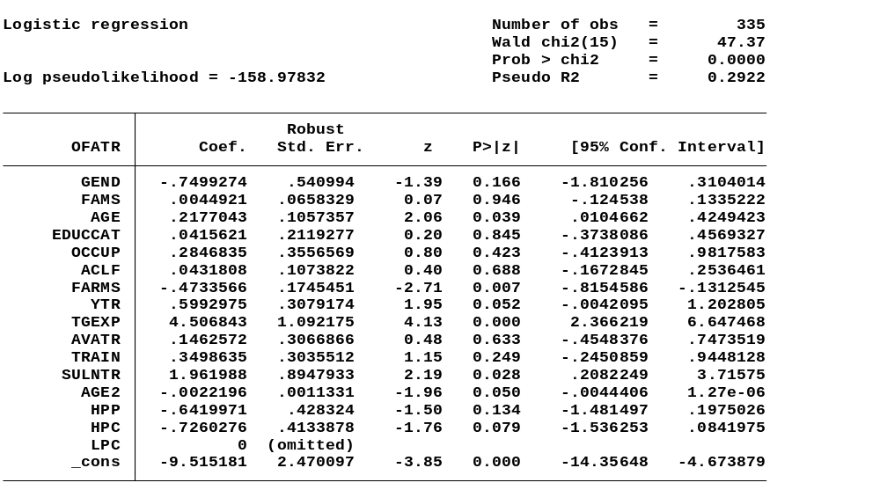
Source: Authors’ computation based on field survey

