Supplementary Information

Bioinspired in-sensor orthogonal adaptation for robust all-weather multispectral vision

Zhuangmiao Wang†, Songsong Li†*, Yu Tang, Jiayin Han, Mingsheng Gao, Xuanyu Chen, and Furong Zhu*

Department of Physics, Research Centre of Excellence for Organic Electronics, Institute of Advanced Materials, Hong Kong Baptist University, Kowloon Tong, Hong Kong, China

*Email: song2li@hkbu.edu.hk, frzhu@hkbu.edu.hku
†These authors contributed equally to this work.

This Supplementary Information includes:
Supplementary Text: pages S4-S7
Supplementary Figures 1-23: pages S8-S22
Supplementary Tables 1-2: pages S22-S23
References: pages S24- S25

Content
Supplementary Text 3
Supplementary Fig. 1. Molecular structures and absorption spectrum of photoactive layers 7
Supplementary Fig. 2. Optical constants of the functional materials and optical field distribution 7
Supplementary Fig. 3. EQE spectra of PBDB-T:Y6-based PM-OPDs 8
Supplementary Fig. 4. Characterization of discrete PV- and PM-based control OPDs 8
Supplementary Fig. 5. Characteristics of P3HT:PC₇₁BM/P3HT:PTB7-Th:PC₇₁BM-based PV/PM-OPD 9
Supplementary Fig. 6. Detectivity spectra. 9
Supplementary Fig. 7. Photoresponses under PV mode and PM mode 10
Supplementary Fig. 8. -3dB cutoff spectrum 10
Supplementary Fig. 9. Zoomed stability test 11
Supplementary Fig. 10. Illumination-dependent contrast analysis 11
Supplementary Fig. 11. Stability test and uniformity of the 4×4 array 12
Supplementary Fig. 12. Evaluation of the uniformity of the 4×4 array device. 13
Supplementary Fig. 13. Photocurrent mapping for pixel crosstalk evaluation 13
Supplementary Fig. 14. SNR characteristics under fixed background illuminations 14
Supplementary Fig. 15. RMS contrast of the sensor images as a function of signal light intensity measured for PV and PM modes. 15
Supplementary Fig. 16. RMS contrast characteristics under fixed background illuminations 15
Supplementary Fig. 17. Experimental mapping of the “H” pattern under different signals and background combinations 16
Supplementary Fig. 18. Train and test accuracy curve during the training of machine learning classifier 16
Supplementary Fig. 19. Confusion matrices of object recognition under simulated night vision conditions 17
Supplementary Fig. 20. Confusion matrices of object recognition under simulated daylight vision conditions 17
Supplementary Fig. 21. Photocurrent through different Si-NPs concentrations 18
Supplementary Fig. 22. Measured RMS contrast of the images as a function of the concentration of Si-NPs in the scattering medium. 18
Supplementary Fig. 23. Normalized current maps of the 4 × 4 vision sensor array 19
Supplementary Table 1. Optical response through varying concentrations of Si-NPs 19
Supplementary Table 2. Overview of existing photodetectors designed for spectral or illumination adaptation, reported by different groups, in comparison with the bioinspired dual-mode PV/PM-OPD developed in this work 20

Supplementary Text
Photoactive materials
Copper thiocyanate (CuSCN) was obtained from Liaoning Youxuan New Energy Technology Co., Ltd. Zinc Oxide (ZnO)) was purchased from Sigma-Aldrich. Poly(3-hexylthiophene-2,5-diyl) (P3HT) and ([6,6]-phenyl-C₇₁-butyric acid methyl ester (PC₇₁BM) were supplied by Luminescence Technology Corp. Poly[(2,6-(4,8-bis(5-(2-ethylhexyl)thiophen-2-yl)-benzo[1,2-b:4,5-b′]dithiophene))-alt-(5,5-(1′,3′ -di-2-thienyl-5′,7′-bis(2-ethylhexyl) benzo[1′,2′-c:4′,5′-c′]dithiophene-4,8-dione)] (PBDB-T) was purchased from Solarmer Beijing, Inc. 2,2’-((2Z,2’Z)-((12,13-bis(2-ethylhexyl)-3,9-diundecyl-12,13-dihydro-[1,2,5]thiadiazolo [3,4-e]thieno[2”,3’‘:4’, 5’]thieno[2’,3’:4,5]pyrrolo[3,2-g]thieno[2’,3’:4,5] thieno[3,2-b]indole-2,10-diyl)bis(methanylylidene))bis(5,6-difluoro-3-oxo-2,3-dihydro-1H-indene-2,1-diylidene)) dimalononitrile (Y6) was obtained from Intelligent sensing limited. Poly[4,8-bis(5-(2-ethylhexyl)thiophen-2-yl)benzo[1,2-b;4,5-b’] dithiophene-2,6-diyl-alt-(4-(2-ethylhexyl)-3-fluorothieno[3,4-b] thiophene-)-2-carboxylate-2-6-diyl)] (PTB7-Th) was purchased from 1-material.
Device fabrication
The back-to-back stacked photovoltaic (PV)/photomultiplication (PM) double bulk heterojunction organic photodetector (PV/PM-OPD) arrays have a layer configuration of indium tin oxide (ITO)/ETL (ZnO)/visible light absorbing P3HT: PC₇₁BM (1:1)/CuSCN/NIR-absorbing PBDB-T:Y6 (100:3)/Ag. ITO/glass substrates with a sheet resistance of 10 Ω/square were cleaned by ultrasonication sequentially with detergent, deionized water, acetone, and 2-propanol each for 30 min, and then blow dried with a pure N₂ gas stream and stored in an oven at 60 °C for device fabrication. The wet-cleaned ITO/glass substrates were treated with UV-ozone plasma for 10 min prior to the device fabrication. A 10 nm-thick ZnO ETL was deposited on the glass/ITO substrates using spin-coating at a rotation speed of 2500 rpm for 50 s. A 450 nm-thick P3HT:PC₇₁BM photoactive layer was formed on the ZnO ETL, prepared using PTB7-Th and PC₇₁BM mixed solution with a weight ratio of PTB7-Th to PC₇₁BM of 1:1. A 60 nm-thick CuSCN interlayer is deposited on the front PV layer by spinning coating. A 500 nm-thick PBDB-T:Y6 was deposited on the precleaned silicon (Si) wafer by spin-coating, using PBDB-T and Y6 mixed solution with a weight ratio of PBDB-T to Y6 of 100:3. The 500 nm-thick PBDB-T:Y6 layer was formed on the surface of glass/ITO/ZnO/P3HT:PC₇₁BM/CuSCN by transfer process following an annealing at 100 °C for 10 min in the glove box. The glass/ITO/ZnO/P3HT:PC₇₁BM/CuSCN/ PBDB-T:Y6 samples were then transferred to an adjacent vacuum chamber, with a base pressure of < 5×10⁻⁴ Pa, for depositing a 100 nm thick upper Ag electrode. P3HT:PC₇₁BM (1:1, 600 nm)/P3HT:PTB7-Th:PC₇₁BM(70:30:1, 500 nm)-based PV/PM-OPDs were prepared using the same fabrication processes.

Device characterization
The EQE spectra of the OPDs were measured using an EQE system comprising a xenon lamp, a Bentham TMc300 monochromator and a source measure unit (Keithley 2400). J−V characteristics and frequency-dependent photoresponses of the OPDs were measured using a Keithley 2636B source meter and LED light sources (LED 515 E and LED 810 E), controlled by an SRS model function generator (DS335). The response speed of the OPDs was measured used a functional generator (Rigol DG4062), Amplifier (LM358), and oscilloscope (Tektronix MDO3052), LED and halogen light sources (LED 515 E, 810 E and a halogen lamp)
Characterization of 4 × 4 vision sensor array
The spectral imaging capabilities of the organic vision sensor were evaluated using a 4 × 4-organic vision sensor array. Each pixel has an active area of 1.0×1.0 mm², with a total effective sensor area of approximately 49 mm². A halogen lamp served as the broadband light source, calibrated to provide six discrete illuminance levels of dark (0 lux), 4.4 × 10⁻², 0.5, 6.3, 2.8 × 10², and 1.4 × 10³ lux. An 'H'-shaped mask was used to define the signal pattern (pattern=1) against the background (pattern=0). A testing protocol consisting of five distinct imaging scenarios was adopted to simulate realistic environmental dynamics with varying contrasts. In each scenario, the signal intensity was paired with the background intensity from the immediately preceding illuminance level. The five specific (background, signal) pairs of (dark, 4.4 × 10⁻² lux), (4.4 × 10⁻² lux, 0.5 lux), (0.5 lux, 6.3 lux), (6.3 lux, 2.8 × 10² lux), and (2.8 × 10² lux, 1.4 × 10³ lux) were used in the study. For each scenario, the image was reconstructed by assigning the current measured at I_{signal} to the 'H' pattern pixels and the current measured at I_{background} to the background pixels.
The signal-to-noise ratio (SNR) of the images was calculated based on the statistical separation between the signal and background regions. It is defined as the difference between the mean signal current and the mean background current, normalized by the noise (standard deviation) of the background.
$$SNR=\frac{\overline{I_{\text{signal}}}-\overline{I_{\text{background}}}}{σ_{\text{background}}} (1)$$
where $\overline{I_{signal}}$ is the mean current of the pixels in the bright region ('H' pattern), $\overline{I_{background}}$ is the mean current of the pixels in the dark region, and $σ_{background}$ is the standard deviation of the currents in the background pixels, representing the noise floor.
The root mean square (RMS) contrast (C_{RMS}) quantifies the overall variability of the signal current relative to the mean current. It was calculated using the statistics of all 16 pixels in the reconstructed array (both signal and background):
$C_{RMS}=\frac{σ_{I}}{μ_{I}}$ (2)
where $μ_{I}$ is the mean current of all 16 pixels, and $σ_{I}$ is the population standard deviation of all 16 pixels, calculated as:
$μ_{I}=\frac{1}{N}\sum_{i=1}^{N}{I_{i}}, σ_{I}=\sqrt{\frac{1}{N}\sum_{i=1}^{N}{{\left(I_{i}-μ_{I}\right)}^{2}}}$ (3)
Here, N is16, representing the total number of pixels, and $I_{i}$ is the current value of the i-th pixel.

Measurement of 4 × 4-vision sensor array under varying visibility conditions
To validate the spectral adaptation capability of the sensor in low-visibility environments, a scattering simulation was conducted using silica nanoparticle (Si-NP) suspensions. Different visibility, such as fog or haze, conditions were simulated by dispersing silica nanoparticles (Si-NPs) with an average diameter of approximately 1 μm, at four different concentrations of 0, 0.5, 5, and 25 mg/mL. These solutions were contained in a quartz cuvette with a path length of 2.0 mm, positioned directly between the light source and the 4×4-organic vision sensor array. This setup ensured that the incident light fully passed through the scattering medium before reaching the device active area.
Two monochromatic light sources were calibrated to an incident intensity of 0.018 mW/cm² at the surface of the cuvette: a 515 nm source representing the visible spectrum and an 810 nm source representing the near-infrared (NIR) spectrum. For the visible light characterization, the array was illuminated with the 515 nm source while the sensors were biased at 5 V to operate in the PV mode. Conversely, for the NIR characterization, the array was illuminated with the 810 nm source while the sensors were biased at -10 V to operate in the PM mode. For each concentration and wavelength combination, the 'H'-shaped pattern was projected through the scattering medium, and the resulting current matrix was recorded. To quantitatively evaluate the image degradation caused by scattering and the recovery capability of the PM mode, SNR and RMS contrast were calculated for the reconstructed images.

Machine vision simulation for pattern recognition
To evaluate the performance of the sensor’s adaptation on pattern recognition tasks, a system-level simulation was performed using the ‘Quick Draw!’ dataset. Five object classes relevant to traffic scenarios, e.g., bicycle, vehicle, face, barrier, and streetlight, were selected for the study. The raw 28 × 28-pixel binary images were flattened into 784-dimensional vectors and normalized to the range [0, 1] for processing. A multilayer perceptron (MLP) neural network was constructed as the classifier, featuring an input layer of 784 neurons, a single hidden layer of 200 neurons with ReLU activation, and an output layer of 5 neurons corresponding to the target classes. The model was trained using the cross-entropy loss function and the Adam optimizer (learning rate = 0.001). An 80/20 train-test split was employed to ensure robust model convergence and generalization capability prior to the hardware simulation.
To simulate the imaging performance of the sensor under realistic environmental conditions, synthetic test datasets were created by mapping the binary pixel values of the original test images to the experimental photocurrent distributions measured from our 4 × 4 sensor array. For each specific illumination scenario (defined by a pair of signal and background light intensities), pixels corresponding to the object (binary 1) were assigned current values randomly sampled from the experimental signal current distribution, while background pixels (binary 0) were assigned values sampled from the experimental background current distribution. This process generated noisy, physically realistic image sets that reflected the specific SNR of the PV and PM modes across the dynamic range (from dark to 1.4 × 10³lux). The pre-trained MLP classifier was then deployed to perform inference on these simulated datasets without fine-tuning. The recognition performance was quantified using overall classification accuracy and normalized confusion matrices, which illustrate the distinct dominance of the PM mode in dark-adaptive vision conditions and the PV mode in light-adaptive vision environments.

Machine vision simulation for low visibility vision
To quantify the performance of spectral adaptation on low-visibility vision, we first transform high-visibility images into foggy scenes. The degradation process was modeled using the Koschmieder’s light scattering model¹:
$I\left(x\right)=J\left(x\right)t\left(x\right)+A\left(1-t\left(x\right)\right)$ (4)
where $J\left(x\right)$ is the original scene radiance, A is the global background light, and t(x) is the transmission. The transmission is defined as:
$t\left(x\right)=e^{-βd\left(x\right)}$ (5)
where d(x) represents the scene depth, and β is the wavelength-dependent scattering coefficient. The depth map d(x) was modeled using a uniform depth scaling factor to simulate a top-down aerial view. Crucially, to accurately reflect the advantage of the orthogonal adaptation of the dual-mode vision sensor, β was modeled using the Ångström Power Law.² While this law is formally defined for optical thickness (τ) as $\frac{τ_{λ}}{τ_{λ_{0}}}={\left(\frac{λ}{λ_{0}}\right)}^{-α}$, for a homogeneous scattering medium with a constant path length d, the optical thickness is directly proportional to the extinction coefficient ($τ= βd$). Consequently, the ratio of optical thicknesses is equivalent to the ratio of extinction coefficients, allowing us to derive the following relationship:
$\frac{β_{NIR}}{β_{VIS}}=\frac{τ_{NIR}/d}{τ_{VIS}/d}={\left(\frac{λ_{NIR}}{λ_{VIS}}\right)}^{-α}$ (6)
where $λ_{VIS}$ = 515 nm and $λ_{NIR}$ = 810 nm are the wavelengths used in the PV and PM modes, respectively. The Ångström exponent, α, depends on the particle size distribution. For the simulated scattering conditions, we set α = 1, which is consistent with a scattering regime dominated by larger particles.³ Therefore, the NIR scattering coefficient (β_{NIR}) was calculated using $β_{NIR}=β_{VIS}×\left(\frac{515}{810}\right)$, ensuring that the simulated PM mode images exhibit reduced attenuation compared to the PV mode images.
The synthesized image datasets, covering a range of scattering coefficients ($β_{VIS}$ from 0.02 to 0.1), were processed using the YOLOv8 object detection algorithm to evaluate machine vision performance.⁴ The model was initialized with pre-trained weights (yolov8s) to ensure generalization.⁵ The detection accuracy for each scattering condition was calculated as the ratio of correctly identified vehicles to the ground truth count.

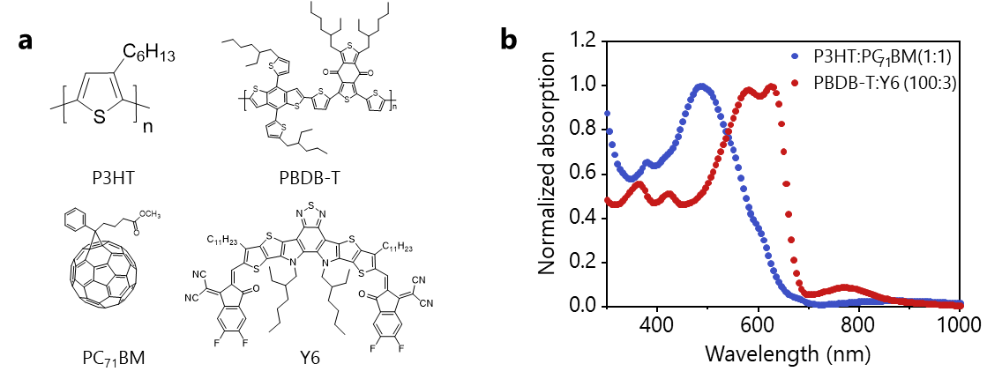

Supplementary Fig. 1. The molecular structures and the absorption spectrum of photoactive layers. (a) Molecular structures of the functional materials (P3HT, PC₇₁BM, PBDB-T and Y6) used in this work. (b) Normalized absorption spectra measured for the thin films of P3HT:PC₇₁BM and PBDB-T:Y6 (100:3).

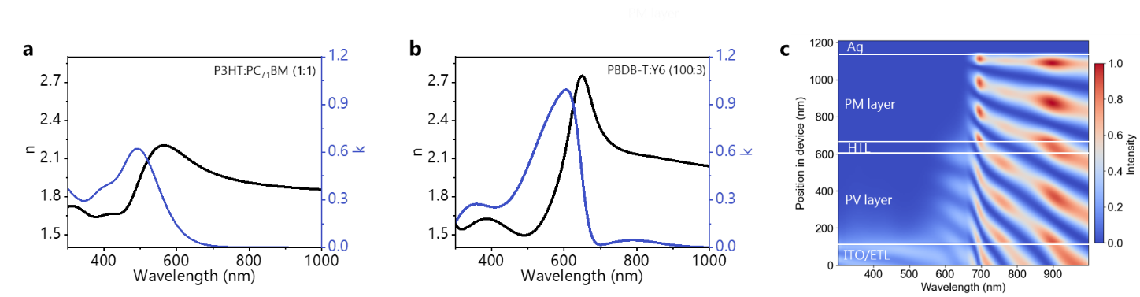

Supplementary Fig. 2. Optical constants of the functional materials and optical field distribution. Wavelength-dependent refractive indexes, n(λ), and extinction coefficients, k(λ), measured for the thin films of (a) P3HT:PC₇₁BM and (b) PBDB-T:Y6 (100:3). (c) Calculated optical field distribution in the P3HT:PC₇₁BM/PBDB-T:Y6-based PV/PM-OPD.
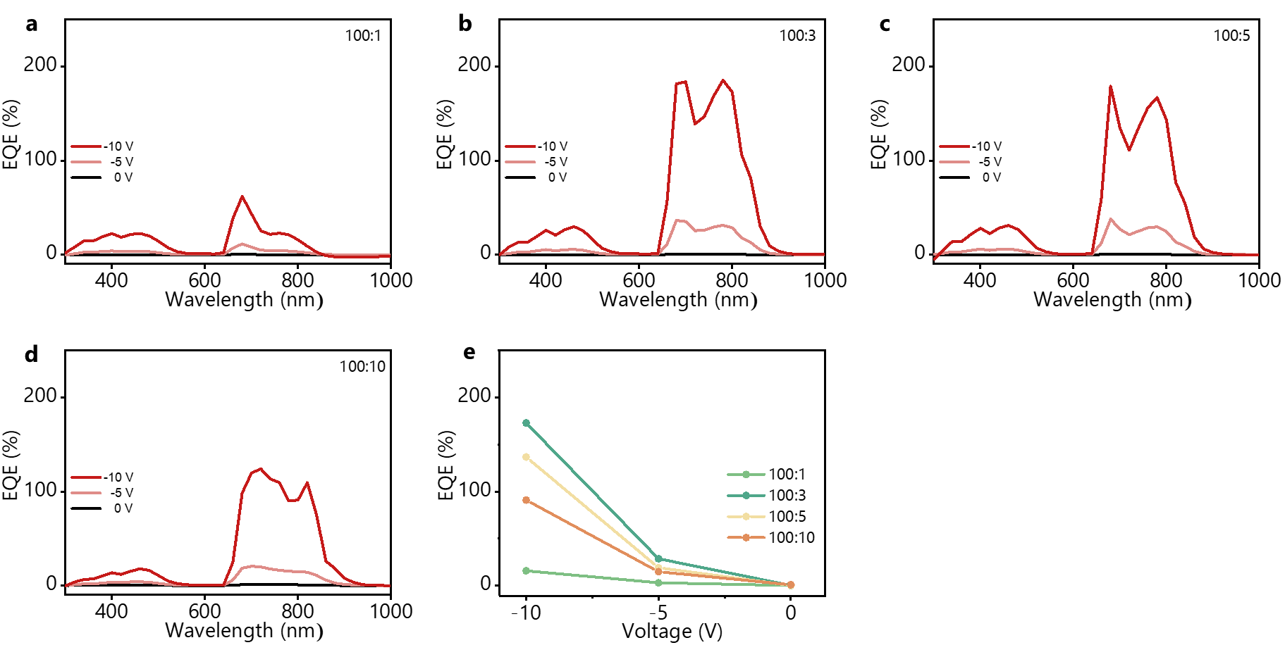

Supplementary Fig. 3. EQE spectra of PBDB-T:Y6-based PM-OPDs. EQE spectra measured for the discrete PBDB-T:Y6-based PM-OPDs, having a layer configuration of ITO/CuSCN/PBDB-T:Y6/Ag, prepared using PBDB-T:Y6 mixed solutions with different weight ratios of PBDB-T to Y6 of (a) 100:1, (b) 100:3, (c) 100:5, and (d) 100:10. (e) Values of EQE (810 nm) obtained for these PM-OPDs under different biases of -5 V and -10 V.

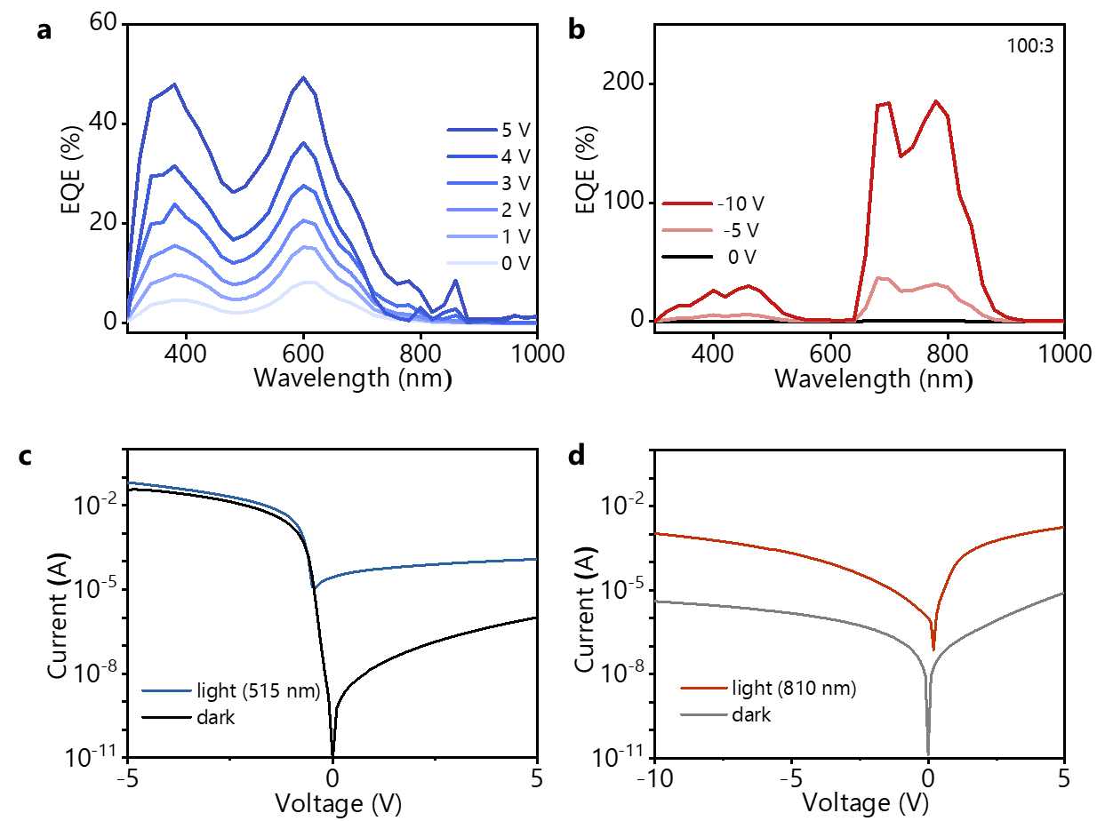

Supplementary Fig. 4. Characterization of discrete PV- and PM-based control OPDs. (a) EQE spectra measured for (a) the discrete PV-OPD with a layer configuration of ITO/ZnO/P3HT:PC₇₁BM (1:1)/CuSCN/Ag, under different forward biases of 1.0, 2.0, 3.0, 4.0 and 5.0 V, EQE of the control PV OPD is also presented for comparison study. (b) EQE spectra measured for the discrete PM-OPD with a layer configuration of ITO/CuSCN/PBDB-T:Y6 (100:3)/Ag, under different reverse biases of -5.0V and -10 V. (c) Current−voltage (I−V) characteristics measured for the discrete (c) PV-OPD in the dark and under illumination of visible (515 nm), and (d) PM-OPD in the dark and under illumination of NIR (810 nm).
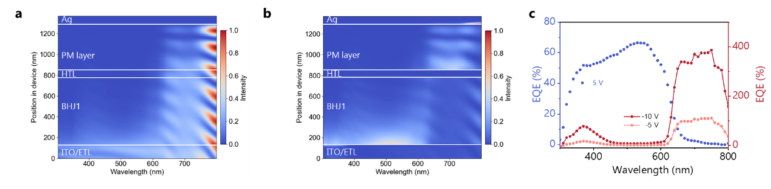

Supplementary Fig. 5. Characteristics of P3HT:PC₇₁BM/ P3HT:PTB7-Th:PC₇₁BM-based PV/PM-OPD. The profiles of (a) optical field distribution and (b) absorbed photon distribution calculated for P3HT:PC₇₁BM/P3HT:PTB7-Th:PC₇₁BM-based PV/PM-OPD with a layer configuration of ITO/ZnO (10 nm)/P3HT:PC₇₁BM (600 nm)/CuSCN (60 nm)/P3HT:PTB7-Th:PC₇₁BM(30:70:1) (500 nm)/Ag. (c) EQE (λ) spectra measured for the P3HT:PC₇₁BM/P3HT:PTB7-Th:PC₇₁BM-based PV/PM OPD under a forward bias of 5V and reverse biases of -5 and-10V.

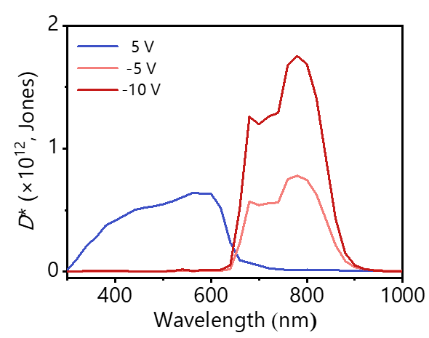

Supplementary Fig. 6. Detectivity spectra. D* spectra measured for the P3HT:PC₇₁BM/P3HT:PTB7-Th:PC₇₁BM-based PV/PM-OPD under a forward bias of 5 V and reverse biases of -5 and -10 V.

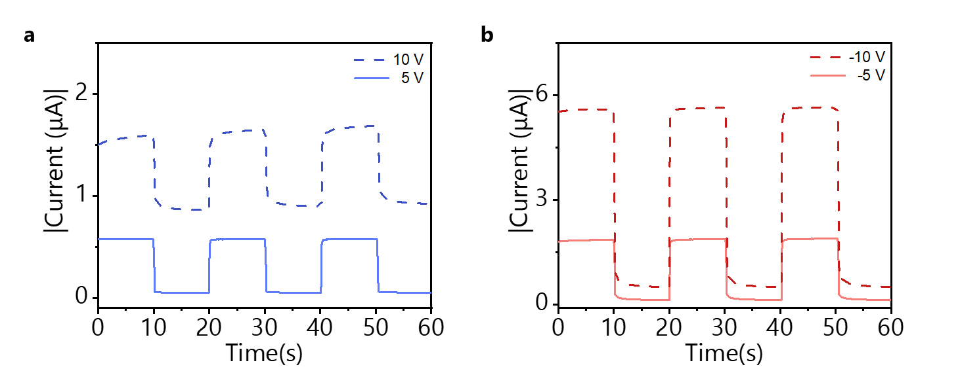

Supplementary Fig. 7. Photoresponses under PV mode and PM mode. Photoresponses measured for the P3HT:PC₇₁BM/PBDB-T:Y6-based PV/PM-OPD (a) in PV mode (5 and 10 V) under illumination of visible light (515 nm, 6.3 μW) and (b) in PM mode (-5 and -10V) under illumination of NIR light (810 nm,1.4 μW)

Supplementary Fig. 8. -3dB cutoff spectrum. Relative photoresponses−light frequency characteristics measured for the P3HT:PC₇₁BM/PBDB-T:Y6-based PV/PM OPD in PV mode (5 V) under illumination of modulated visible light (515 nm) and in PM mode (-10 V) under illumination of modulated NIR light (810 nm).

Supplementary Fig. 9. Zoomed stability test. Representative photoresponses measured for the P3HT:PC₇₁BM/PBDB-T:Y6-based PV/PM-OPD in PV mode (5 V) under illumination of frequency modulated visible light (515 nm) and in PM mode (-10 V) under illumination of frequency modulated NIR light (810 nm), revealing its operational stability.

Supplementary Fig. 10. Illumination-dependent contrast analysis. J_{light}/J_{dark}−V characteristics measured for the P3HT:PC₇₁BM/PBDB-T:Y6-based PV/PM-OPD as a function of halogen lamp illuminance, ranging from 4.4×10⁻² to 1.4×10³ lux.
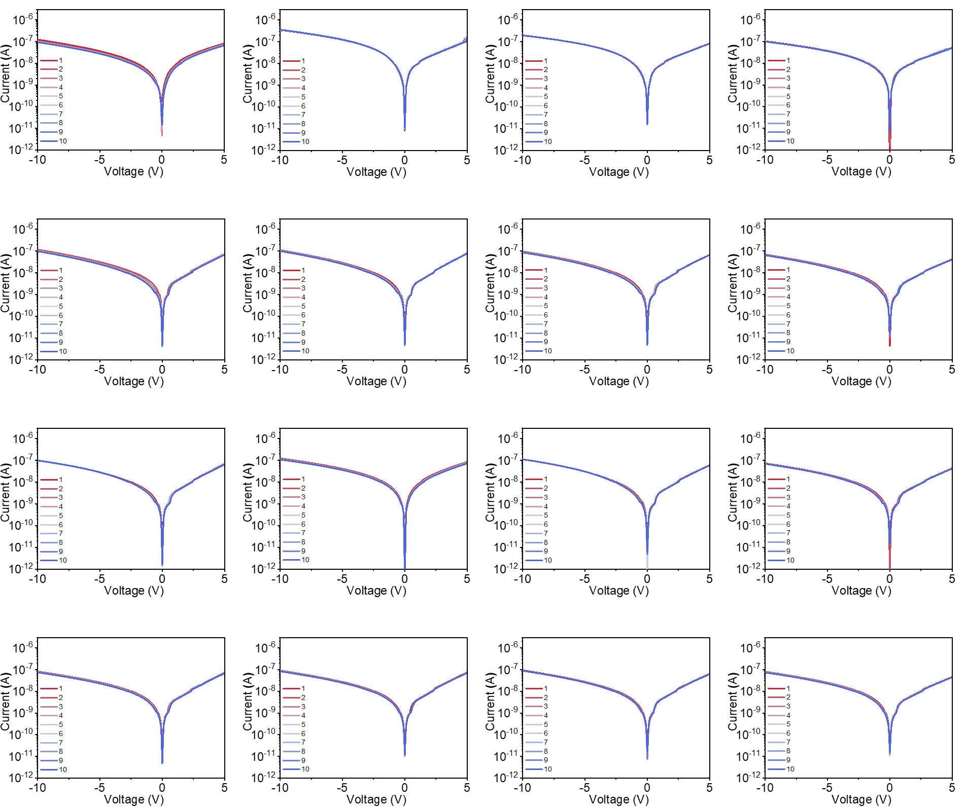

Supplementary Fig. 11. Stability test and uniformity of the 4×4 array. Dark I–V characteristics of 16 P3HT:PC₇₁BM/PBDB-T:Y6-based PV/PM-OPD pixels in the 4×4 vision sensor array, measured over ten consecutive scans. The consistent results demonstrate the excellent stability and uniformity of the OPD pixels across the sensor array.

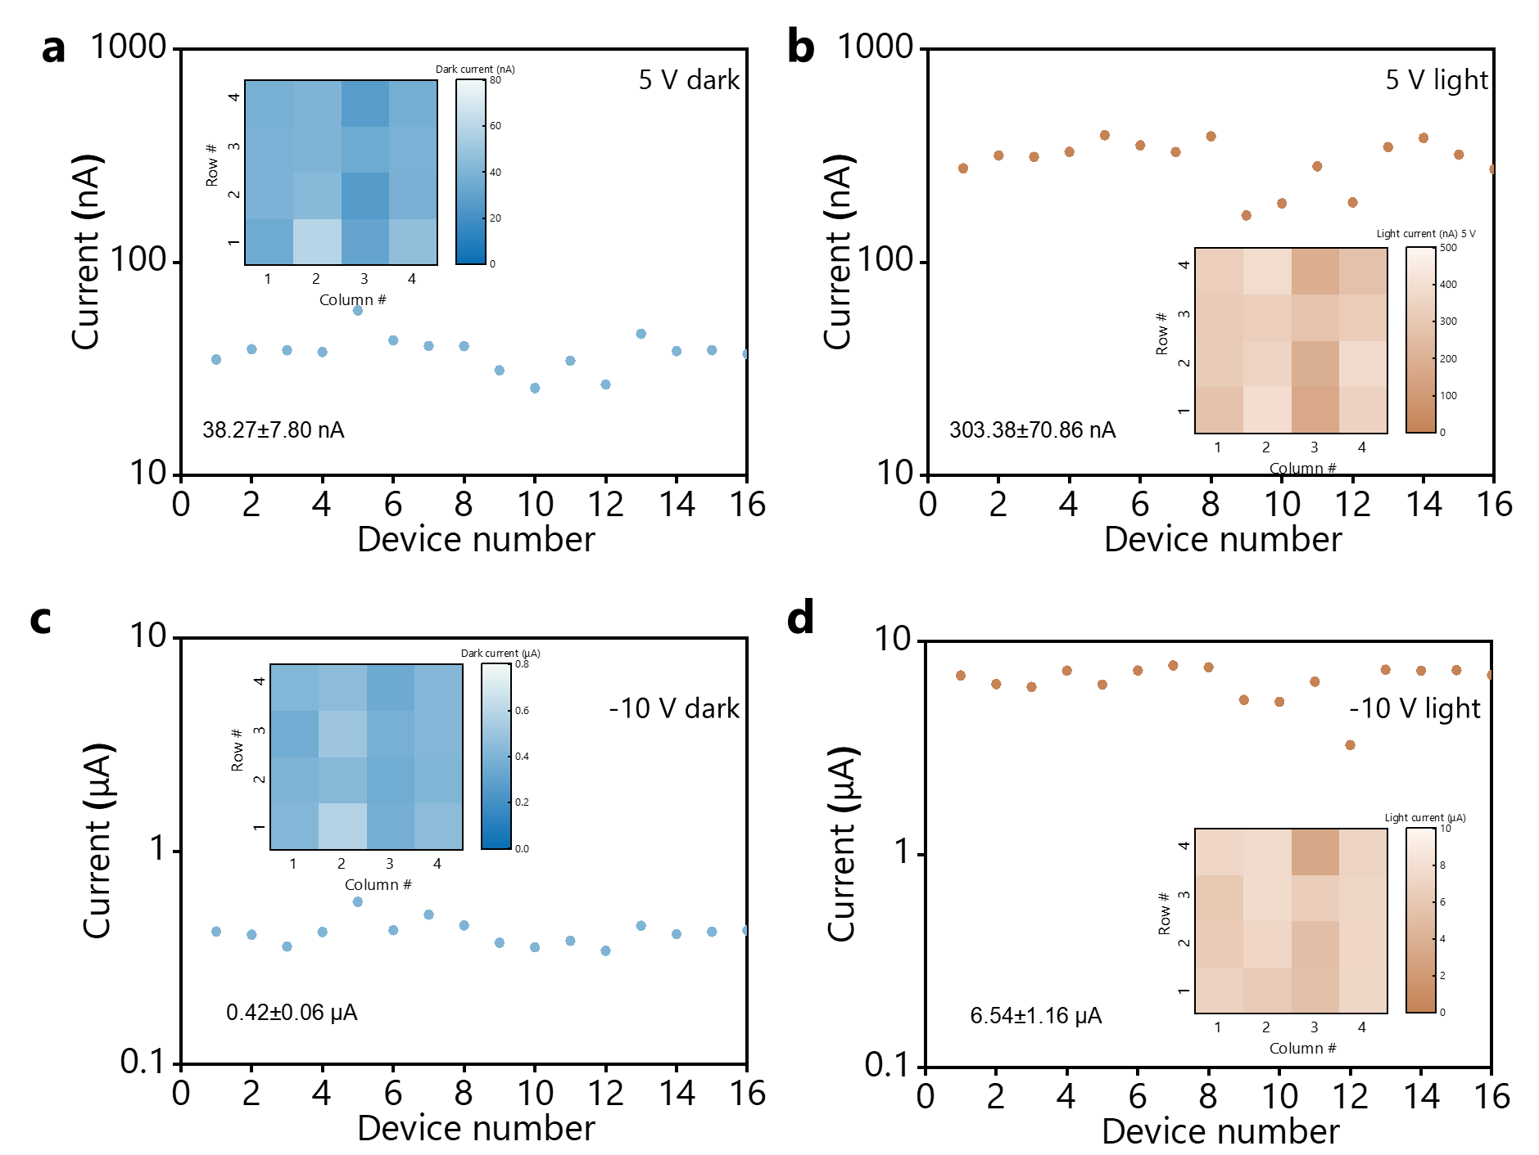

Supplementary Fig. 12. Evaluation of the uniformity of the 4×4 array device. Distributions of (a) dark current and (b) photocurrent for 16 pixels operating in PV mode (5 V), and (c) dark current and (d) photocurrent distribution for the same pixels in PM mode (-10 V).

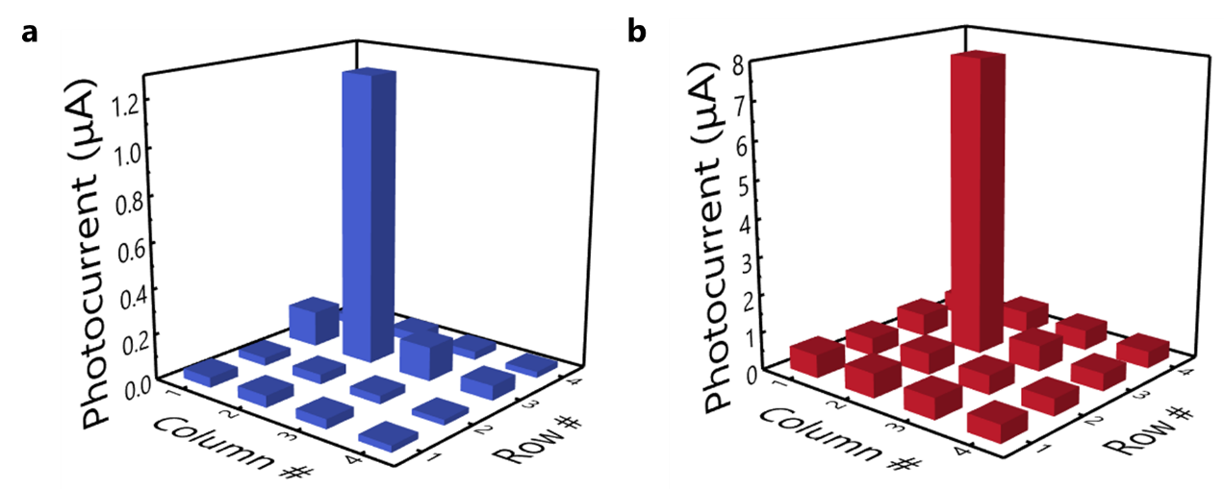

Supplementary Fig. 13. Photocurrent mapping for pixel crosstalk evaluation. A circular light spot with a diameter of 1.0 mm was used to illuminate the pixel at position (3,2) for evaluating the crosstalk. (a) PV mode (5 V) under visible light illumination (515 nm, 4.4 μW/cm²), and (b) PM mode (–10 V) under NIR illumination (810 nm, 1.0 μW/cm²). In both modes, the measured crosstalk in adjacent pixels was approximately 7.8 %, which can be attributed to the limited lateral transport of photogenerated carriers.
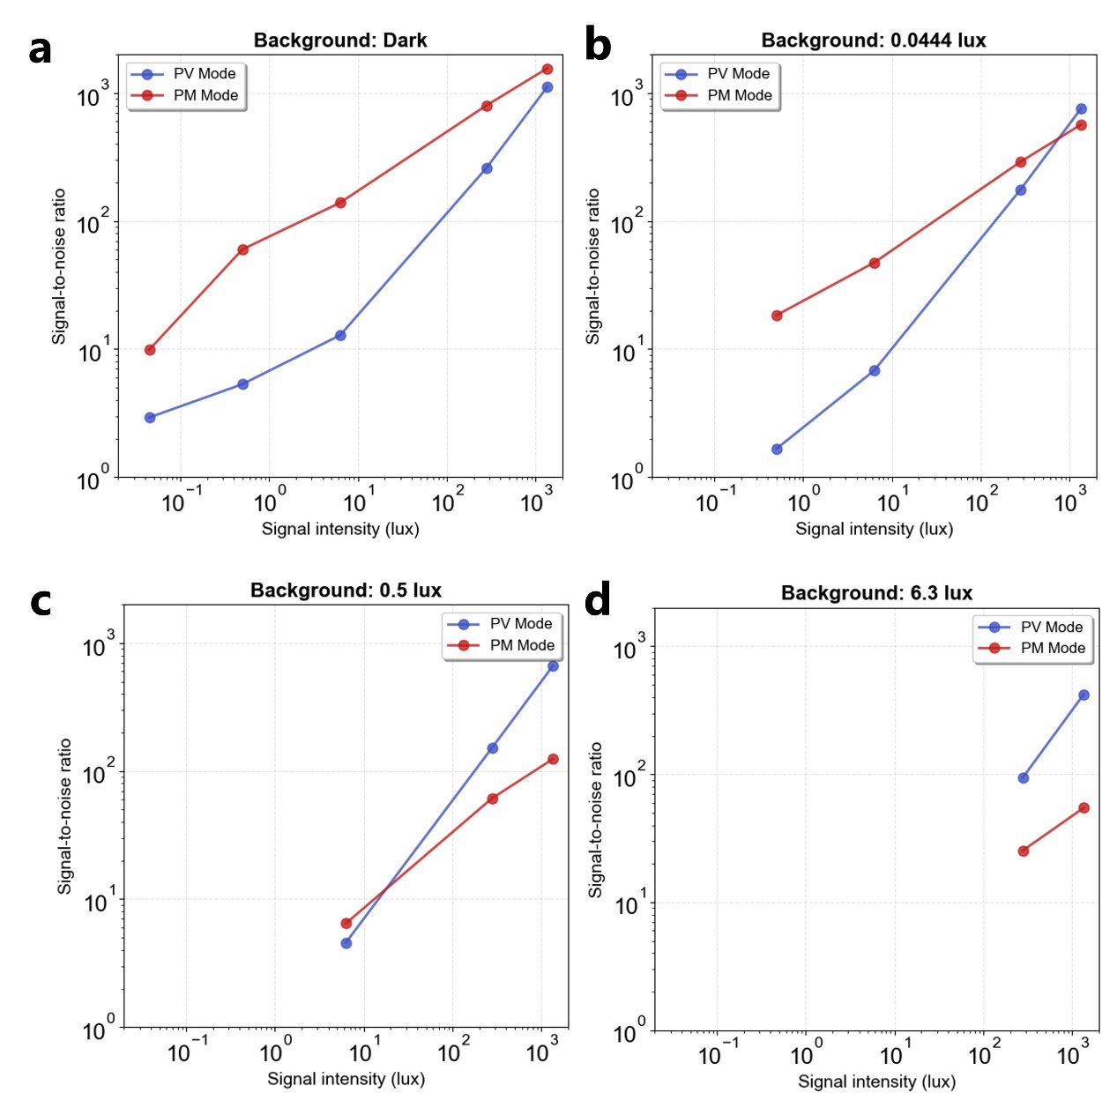

Supplementary Fig. 14. SNR characteristics under fixed background illuminations. Measured SNR of the sensor pixels as a function of signal light intensity under four distinct background conditions of (a) dark, (b) 4.4 × 10⁻²lux, (c) 0.5 lux, and (d) 6.3 lux. The plots demonstrate that the PM mode (red dots) exhibits superior SNR in low-background regimes (dark to 4.4 × 10⁻² lux), effectively amplifying weak signals. Conversely, as the background illuminance increases (0.5 lux to 6.3 lux), the PV mode (blue dots) begins to outperform the PM mode, validating the necessity of switching to PV mode to maintain high contrast in brighter environments.

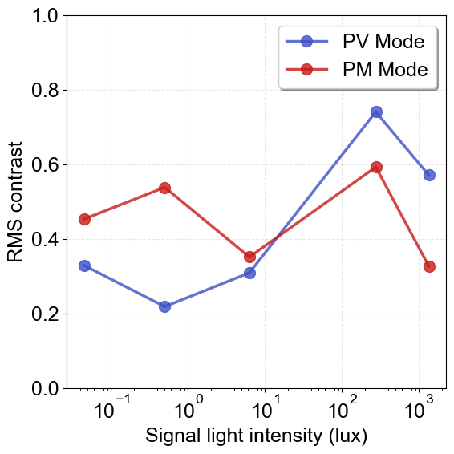

Supplementary Fig. 15. RMS contrast of the sensor images as a function of signal light intensity measured for PV and PM modes.
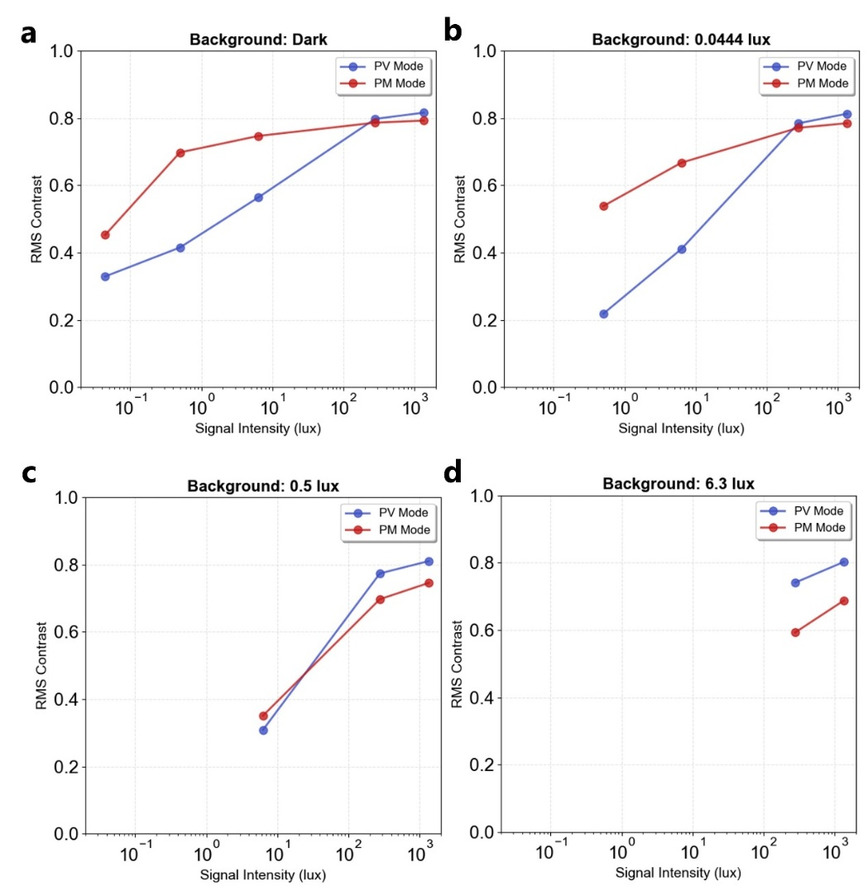

Supplementary Fig. 16. RMS contrast characteristics under fixed background illuminations. Measured RMS contrast of the sensor images as a function of signal light intensity under four distinct background conditions of (a) dark, (b) 4.4 × 10⁻² lux, (c) 0.5 lux, and (d) 6.3 lux for PV and PM modes.
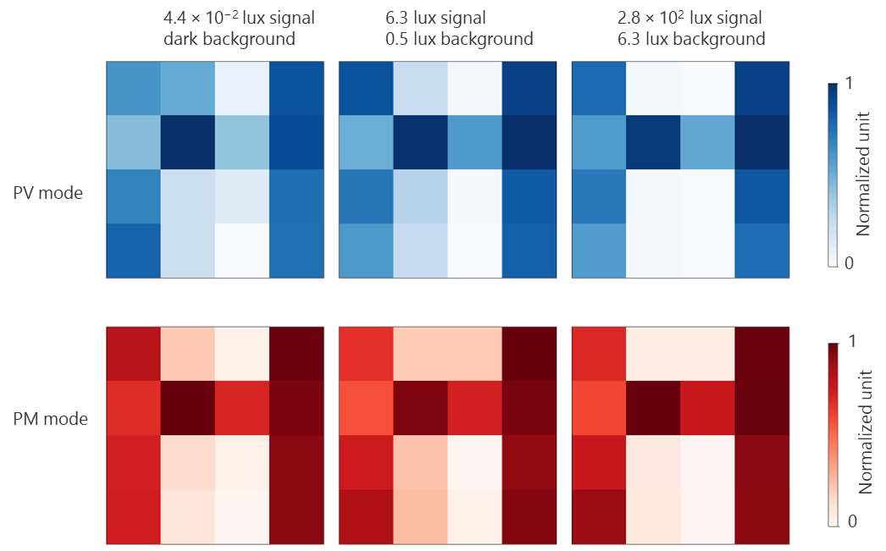

Supplementary Fig. 17. Experimental mapping of the 'H' pattern under different signals and background combinations.

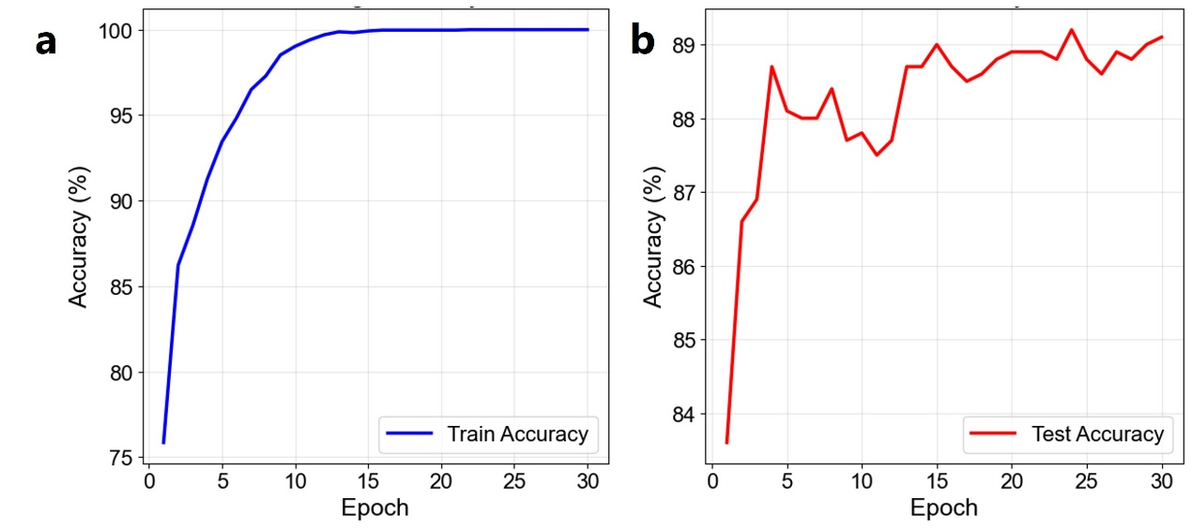

Supplementary Fig. 18. Train and test accuracy curve during the training of machine learning classifier.

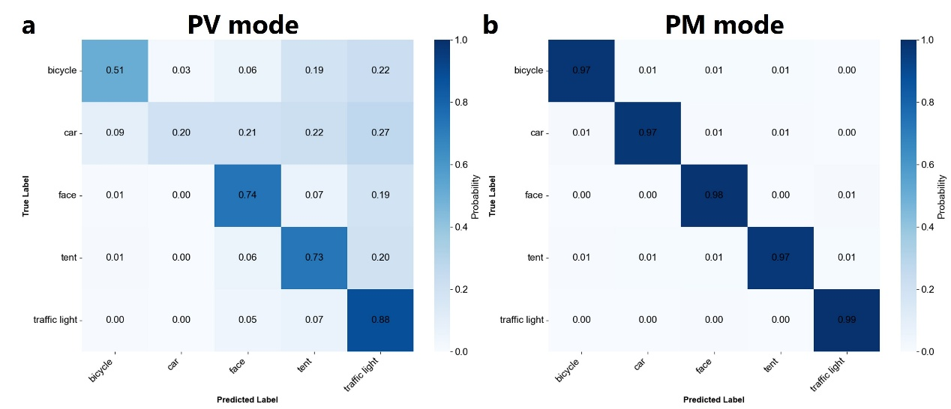

Supplementary Fig. 19. Confusion matrices of object recognition under simulated night vision conditions. The matrices display the normalized classification inference results for (a) PV mode and (b) PM mode using the five target classes (bicycle, car, face, tent, traffic light) under a background illuminance of 4.4 × 10⁻² lux and a signal intensity of 0.5 lux.

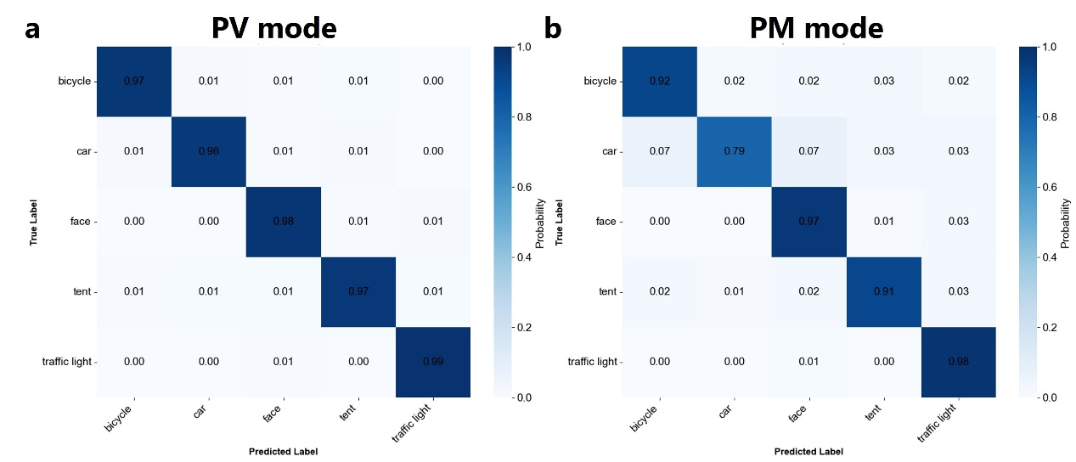

Supplementary Fig. 20. Confusion matrices of object recognition under simulated daylight vision conditions. The matrices display the normalized classification inference results for (a) PV and (b) PM mode using the five target classes (bicycle, car, face, tent, traffic light) under a background illuminance of 2.8 × 10² and a signal intensity of 1.4×10³ lux.

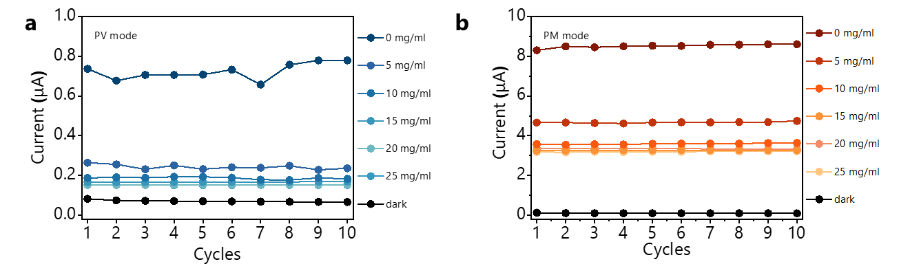

Supplementary Fig. 21. Photocurrent through different Si-NPs concentrations. The current response was measured over 10 repeated scans under different conventions of Si-NPs, demonstrating high device stability. The responses of the OPD in (a) PV mode (5 V) under visible light illumination (515 nm) and (b) PM mode (-10 V) under NIR illumination (810 nm). Notably, the 515 nm signal exhibited more pronounced attenuation with increasing Si-NP concentration.

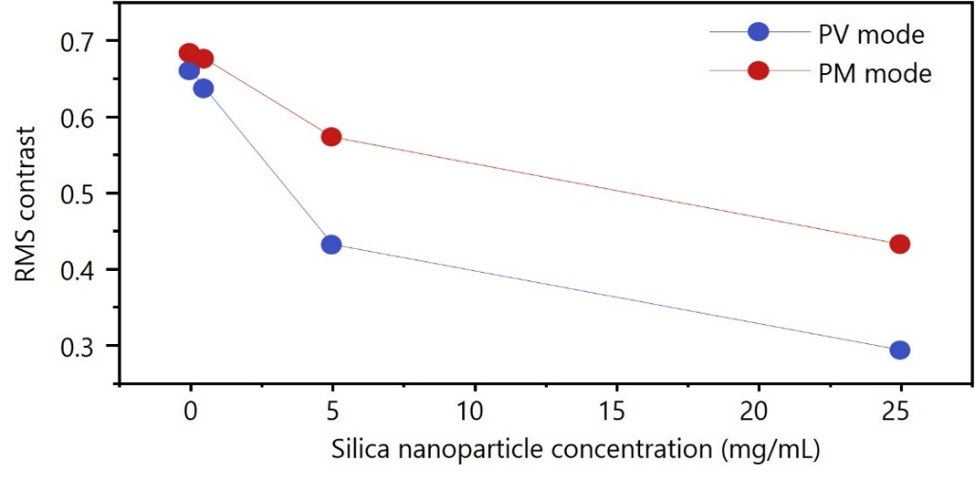

Supplementary Fig. 22. Measured RMS contrast of the images as a function of the concentration of Si-NPs in the scattering medium.

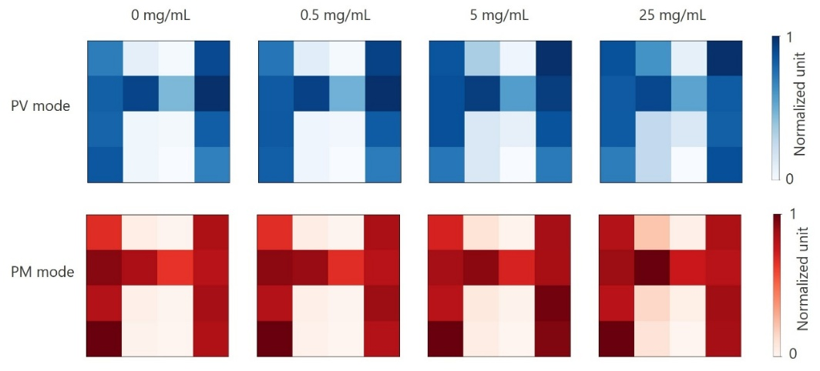

Supplementary Fig. 23. Normalized current maps of the 4 × 4 vision sensor array, showing detection of the “H” pattern in PV and PM modes. Measurements were performed under varying concentrations of Si-NPs (0, 0.5, 5, and 25 mg/mL) dispersed in the scattering medium.

Supplementary Table 1. Optical response through varying concentrations of Si-NPs. Photocurrent measurements of the PV/PM-OPD in PV mode (5 V) under visible light illumination (515 nm, 0.018 mW/cm²) and in PM mode (-10 V) under NIR illumination (810 nm, 0.018 mW/cm²), for varying concentrations of Si-NPs (0, 0.5, 5, and 25 mg/mL) dispersed in the scattering medium. The corresponding transparency values of the scattering medium at 515 nm and 810 nm are also included.

 | Concentration of Si-NPs (mg/mL)
 | 0 | 0.5 | 5 | 25
J_{ph} (515 nm) (mA/cm²) | 3.45×10⁻² | 2.89×10⁻² | 8.09×10⁻³ | 3.23×10⁻³
J_{ph} (810 nm) (mA/cm²) | 6.85×10⁻¹ | 6.46×10⁻¹ | 3.48×10⁻¹ | 1.81×10⁻¹
Transmittance (515 nm) | 100.00% | 78.71% | 14.09% | 4.07%
Transmittance (810 nm) | 100.00% | 91.12% | 34.13% | 12.09%

Supplementary Table 2. Overview of existing photodetectors designed for spectral or illumination adaptation, reported by different groups, in comparison with the bioinspired dual-mode PV/PM-OPD developed in this work.
Year | Device  configuration | Spectral adaptation |  | Illumination adaptation | References
Spectral adaptation
2019 | ITO/Bi₂Be₃/HgTe-CQDs/Ag₂Te/  HgTe-CQDs/Bi₂Be₃/Au |  | √ | × | 6
2019 | P-Si/i-Si/n-Si/i-Ge/p-Ge |  | √ | × | 7
2020 | ITO/P3HT:PC₇₀BM/P3HT/P3HT:PTB7-Th:PC₇₀BM/Al |  | √ | × | 8
2020 | p-Si/SiO₂/Ti/Au/MoS₂/Perovskite |  | √ | × | 9
2021 | ITO/ZnO/F8T2:PC₆₁BM/MoO₃/  P3HT:PC₆₁BM/ZnO/Ag |  | √ | × | 10
2022 | ITO/ZnO/PTB7-Th:PC₇₁BM/ MoO₃/PTB7-Th:CO_{i}i8DFIC: PC₇₁BM/ZnO/Ag |  | √ | × | 11
2022 | Si/SiO₂/PtSe₂/Cr/Au |  | √ | × | 12
2024 | ITO/TiO₂/Sb₂Se₃/Si/Ag |  | √ | × | 13
2024 | ITO/PeDOT:PSS/FA_{1.05}PbBr₃/PCBM/MAPbI₃/Spiro-OMeTAD/Au |  | √ | × | 14
2025 | ITO/ZnO/P3HT:ICBA/HTL/PM6:Y6/PDINO/Ag |  | √ | × | 15
2025 | ITO/ZnO/PM6:IT-4F/MoO₃/ PTB7-Th:COTIC-4Cl:Y6/ZnO/ Ag |  | √ | × | 16
2025 | ITO/MoO_{x}/donor/acceptor/C₆₀:  LiF/C₆₀/Ag |  | √ | × | 17
Illumination adaptation
2019 | IGZO/Cr/SAO/CdSe |  | × | √ | 18
2021 | Gate/PVCN/P3HT:PCBM/PVA/  PVCN/PDPP3T:PCBM/PVA |  | × | √ | 19
2022 | Cr/Au/Al₂O₃/Cr/Au/MoS₂/Al₂O₃ |  | × | √ | 20
2022 | Si/SiO₂/PbS QDs/Au |  | × | √ | 21
2024 | ITO/MAPbI₃/P3HT/Au |  | × | √ | 22
2024 | Si/SiO₂/MoS₂/GDY/Electrolyte |  | × | √ | 23
2024 | ITO/PEDOT:PSS/Viscoelastic PQD films/MoO₃/Ag |  | × | √ | 24
2024 | Si/SiO2/MoS₂/WSe₂ |  | × | √ | 25
2025 | Si/SiO₂/CuInP₂S₆/Cr/Au |  | × | √ | 26
Bias-switchable in-sensor orthogonal adaptation
2026 | ITO/ZnO/P3HT:PC₇₀BM(1:1)/  CuSCN/PBDB-T:Y6(100:3)/Ag |  | √ | √ | This work
References
1 Kar, A., Dhara, S. K., Sen, D. & Biswas, P. K. in Proceedings of the IEEE/CVF Conference on Computer Vision and Pattern Recognition. 16205-16215.
2 Wagner, F. & Silva, A. Some considerations about Ångström exponent distributions. Atmospheric Chemistry and Physics 8, 481-489 (2008).
3 Schuster, G. L., Dubovik, O. & Holben, B. N. Angstrom exponent and bimodal aerosol size distributions. Journal of Geophysical Research: Atmospheres 111 (2006).
4 Ultralytics YOLO (2023).
5 Silva, M. YOLO-Parking-Spot: Parking Spot Detection using YOLOv8, <https://github.com/math-silva/YOLO-Parking-Spot> (2024).
6 Tang, X., Ackerman, M. M., Chen, M. & Guyot-Sionnest, P. Dual-band infrared imaging using stacked colloidal quantum dot photodiodes. Nat. Photonics 13, 277-282 (2019).
7 Simola, E. T. et al. Voltage-tunable dual-band Ge/Si photodetector operating in VIS and NIR spectral range. Opt. Express 27, 8529-8539 (2019).
8 Lan, Z. et al. Near-infrared and visible light dual-mode organic photodetectors. Sci. Adv. 6, eaaw8065 (2020).
9 Hong, S. et al. Sensory Adaptation and Neuromorphic Phototransistors Based on CsPb(Br(1-x)I(x))(3) Perovskite and MoS(2) Hybrid Structure. ACS Nano 14, 9796-9806 (2020).
10 Lan, Z. & Zhu, F. Electrically switchable color-selective organic photodetectors for full-color imaging. ACS Nano 15, 13674-13682 (2021).
11 Lan, Z. et al. Dual‐band organic photodetectors for dual‐channel optical communications. Laser Photonics Rev. 16, 2100602 (2022).
12 Tan, Y. et al. A Bioinspired Retinomorphic Device for Spontaneous Chromatic Adaptation. Adv Mater 34, e2206816 (2022).
13 Ouyang, B. et al. Bioinspired in-sensor spectral adaptation for perceiving spectrally distinctive features. Nat. Electron. 7, 705-713 (2024).
14 Ng, S. E. et al. Retinomorphic Color Perception Based on Opponent Process Enabled by Perovskite Bipolar Photodetectors. Adv Mater 36, e2406568 (2024).
15 Kang, Y., Kim, T. H., Lee, M. J. & Shim, J. W. Dual-Mode Organic Photodetectors with Optimized Charge Dynamics and Barrier Modulation for Superior Spectral Selectivity. Small 21, e2503701 (2025).
16 Tang, Y. et al. Dual-mode narrowband organic photodetectors for self-aligned imaging in NIR-I and NIR-II. Nat Commun 16, 7144 (2025).
17 Tan, Z. et al. Bias-Switchable Dual-Mode Organic Photodetectors for Spectrally Adaptive Vision and Secure Encoding. Materials Today 90, 343-352 (2025).
18 Kwon, S. M. et al. Environment-Adaptable Artificial Visual Perception Behaviors Using a Light-Adjustable Optoelectronic Neuromorphic Device Array. Adv Mater 31, e1906433 (2019).
19 He, Z. et al. An organic transistor with light intensity-dependent active photoadaptation. Nat. Electron. 4, 522-529 (2021).
20 Liao, F. et al. Bioinspired in-sensor visual adaptation for accurate perception. Nat. Electron. 5, 84-91 (2022).
21 Zhang, M. et al. An Irradiance-Adaptable Near-Infrared Vertical Heterojunction Phototransistor. Adv Mater 34, e2205679 (2022).
22 Gong, G. et al. An Antagonistic Photovoltaic Memristor for Bioinspired Active Contrast Adaptation. Adv Mater 36, e2409844 (2024).
23 Shi, L. et al. Flexible retinomorphic vision sensors with scotopic and photopic adaptation for a fully flexible neuromorphic machine vision system. SmartMat 5 (2024).
24 Wang, C. et al. Strain-insensitive viscoelastic perovskite film for intrinsically stretchable neuromorphic vision-adaptive transistors. Nat Commun 15, 3123 (2024).
25 Li, L. et al. Adaptative machine vision with microsecond-level accurate perception beyond human retina. Nat Commun 15, 6261 (2024).
26 Zhong, Z. et al. Ionic-electronic photodetector for vision assistance with in-sensor image processing. Nat Commun 16, 7096 (2025).

