Supplementary information
S1. Overview of the MF–EC modelling framework
This Supplementary Information provides the complete analytical foundation, numerical analyses, and robustness checks underlying the results presented in the main text. Its purpose is to document all modelling assumptions, mathematical derivations, invasion analyses, and dynamical evaluations in full detail, ensuring transparency, reproducibility, and interpretability in accordance with best practices for theoretical and modelling research in evolutionary biology.
The Molecular Fidelity-Encounter Competition (MF–EC) framework models evolution along a single continuous heritable trait axis, denoted n, which represents parental reproductive deployment. This trait is interpreted as a genetically encoded reproductive program governing how reproductive effort is allocated across gamete production, rather than as a passive demographic consequence of life history. In this formulation, reproductive strategies are heritable and subject to selection through their effects on both encounter success and informational integrity.
The MF–EC framework integrates two antagonistic evolutionary currencies. First, encounter–competition efficiency captures the reproductive advantage of producing more gametes, reflecting increased opportunities for fertilization in shared reproductive environments. This component increases with reproductive deployment but exhibits diminishing returns due to encounter saturation and competitive interference. Second, molecular fidelity allocation captures the constraint imposed by finite parental capacity for genome replication, DNA repair, chromatin assembly, and epigenetic maintenance. As reproductive deployment increases, this finite machinery must be partitioned across a larger number of gametes, leading to dilution of per-gamete fidelity.
Evolutionary dynamics arise from the interaction between these two opposing forces. By explicitly modelling both encounter gains and fidelity dilution, the MF–EC framework isolates informational constraints on genome transmission as an independent driver of selection on reproductive strategies. The framework is analysed using standard tools from Adaptive Dynamics and evolutionary game theory, allowing rigorous characterization of singular strategies, convergence stability, evolutionary stability, disruptive branching, and long-term frequency dynamics.
All analytical steps, including derivation of the selection gradient, curvature analysis, invasion fitness calculations, and replicator dynamics, are presented in the sections that follow. Numerical evaluations and robustness analyses are included to demonstrate that the qualitative outcomes do not depend on fine-tuned parameter values or specific functional forms. Together, these Supplementary materials provide the full theoretical basis for the MF–EC results reported in the main text.

S2. Strategy crowding and frequency-dependent encounter interference
Gametes interact within a shared fertilization environment, where reproductive success depends not only on the absolute number of gametes produced by an individual but also on the distribution of reproductive strategies present in the population. In such environments, encounter success is inherently frequency dependent: when many gametes adopt similar reproductive programs, they compete more directly for fertilization opportunities, leading to crowding and interference effects.
This phenomenon is well documented in fertilization ecology and frequency-dependent selection theory, where similarity in traits or strategies reduces individual payoff through local competition, interference, or saturation effects (Maynard Smith 1982; Parker et al. 1972; Dieckmann & Law 1996; Geritz et al. 1998). In the context of the MF–EC framework, this means that reproductive strategies that cluster tightly in trait space experience reduced marginal encounter success relative to rarer or divergent strategies.
To capture this effect, we introduce a strategy crowding pressure (SCP) kernel, which quantifies the degree of interference experienced by a focal strategy due to the presence of nearby strategies in the population:
$$SCP\left(s,t\right)=\frac{1}{N\left(t\right)}\sum_{j=1}^{N\left(t\right)}{}exp\left(-β\left|s - s_{j}\right|\right)$$
where s denotes the focal reproductive strategy, s_{j​} are the strategies of other gametes present at time t, and N(t) is the total size of the gamete pool. The parameter β>0 controls the sensitivity of interference to strategy similarity: larger values of β imply stronger interference among strategies that are close in trait space, whereas smaller values correspond to broader interaction ranges.
This kernel is conceptually analogous to niche overlap functions used in adaptive dynamics and ecological competition models, where similarity in trait space leads to increased competitive pressure and reduced fitness (Dieckmann & Law 1996; Geritz et al. 1998; Rueffler et al. 2006; Kisdi 2006). Here, strategy similarity reflects similarity in reproductive deployment programs, leading to crowding within the fertilization arena rather than resource competition per se.
The crowding pressure modifies the effective encounter payoff experienced by a strategy according to:
$$E\left(s,t\right)= E_{0}- η⋅SCP\left(s,t\right),$$
where E₀ represents baseline encounter success in the absence of interference, and η>0 scales the strength of frequency-dependent reduction in encounter efficiency. This formulation ensures that encounter success declines as strategies become locally crowded, introducing explicit frequency dependence into the reproductive payoff.
Incorporating strategy crowding serves two important purposes. First, it reflects biologically realistic fertilization dynamics in which encounter success is shaped by the competitive context rather than by absolute gamete number alone. Second, it prevents trivial fixation at the population mean when that point is invasion-unstable, thereby allowing disruptive selection and evolutionary branching to manifest when predicted by curvature analysis. This role is standard in adaptive dynamics models, where frequency-dependent interactions are necessary to translate local fitness minima into stable diversification outcomes (Eshel 1983; Geritz et al. 1998; Rueffler et al. 2006).
S3. Encounter–competition efficiency
Encounter–competition efficiency describes how reproductive success increases with the number of gametes deployed into a fertilization environment. In many reproductive systems, producing more gametes increases the probability of encountering compatible partners and securing fertilization. However, this increase is not linear: as gamete number rises, encounter success experiences diminishing returns due to saturation effects, interference among gametes, and finite opportunities for successful fertilization.
Such diminishing returns are a cornerstone of classical fertilization ecology and sexual selection theory. Early work by Bateman and later formalizations by Parker and colleagues showed that reproductive success typically increases with mating or gamete number, but at a decelerating rate as encounters become limiting or competitive (Bateman 1948; Parker et al. 1972; Parker 1982; Lehtonen & Parker 2014). These effects arise from ecological constraints such as limited mating opportunities, spatial crowding, and competition among conspecific gametes.
To capture this general property in a simple and analytically tractable manner, we model encounter–competition efficiency as a concave increasing function of reproductive deployment:
$$EC\left(n\right)=\ln\left(1+n\right).$$
where n denotes the heritable reproductive deployment trait. This functional form ensures that encounter success increases monotonically with gamete number, while imposing diminishing marginal gains as n becomes large.
The first and second derivatives of this function are:
$$\frac{d EC}{dn}=\frac{1}{1+n}> 0,\frac{d^{2}EC}{dn^{2}}= -\frac{1}{{\left(1+n\right)}^{2}}< 0.$$
The positive first derivative indicates that increasing reproductive deployment always confers some encounter advantage, whereas the negative second derivative confirms concavity and thus diminishing returns. Biologically, this reflects the fact that additional gametes contribute progressively less to reproductive success as encounter opportunities become saturated.
The specific logarithmic form is not intended to represent a precise mechanistic model of fertilization, but rather a minimal representation of concave encounter gains. Importantly, the qualitative results of the MF–EC framework do not depend on this particular choice: any monotonically increasing, concave encounter function yields the same evolutionary behaviour when opposed by convex fidelity dilution (see Supplementary Section S13). The logarithmic form is used here because it is smooth, analytically convenient, and widely employed in evolutionary and ecological models to represent saturating benefits (Maynard Smith 1982; Hofbauer & Sigmund 1998; Otto & Day 2007).
By combining concave encounter–competition efficiency with convex molecular fidelity loss, the MF–EC framework generates the curvature conditions necessary for evolutionary branching, linking classical encounter dynamics to informational constraints in genome transmission.
S4. Molecular fidelity dilution under finite parental budgets
Successful reproduction requires the accurate transmission of genetic and epigenetic information from parent to offspring. This process depends on a finite pool of molecular machinery involved in genome replication, DNA damage repair, chromatin assembly, and epigenetic maintenance. These processes rely on coordinated cellular systems—including DNA polymerases, repair enzymes, histone chaperones, chromatin remodellers, and regulatory factors—that cannot be scaled arbitrarily without incurring pleiotropic costs or regulatory constraints (Eigen 1971; Eigen & Schuster 1979; Drake et al. 1998; Lynch 2010; Haig 2010).
During gametogenesis, this molecular machinery must be partitioned across all gametes produced. As reproductive deployment increases, the effective amount of fidelity-maintaining machinery available per gamete necessarily declines. This creates a non-scalable fidelity constraint: even in the absence of energetic limitation, increasing the number of gametes produced reduces the capacity to maintain high per-gamete genomic fidelity. Empirical evidence consistent with such constraints includes the well-documented increase in de novo mutation burden with paternal age and the substantial heterogeneity in mutation counts among offspring (Makova & Li 2002; Ellegren 2007; Kong et al. 2012; Jónsson et al. 2017).
To capture this effect in a minimal and analytically tractable manner, we model per-gamete molecular fidelity as a decreasing function of reproductive deployment:
$$MF\left(n\right)=\frac{1}{1 + θn},$$
where n denotes the heritable reproductive deployment trait, and θ>0 quantifies the sensitivity of fidelity dilution to increasing deployment. Larger values of θ correspond to stronger constraints on fidelity scalability, reflecting systems in which repair and maintenance processes are more limiting.
The first and second derivatives of this function are:
$$\frac{d MF}{dn}= -\frac{θ}{{\left(1+θn\right)}^{2}}< 0,\frac{d^{2}MF}{dn^{2}}=\frac{2θ^{2}}{{\left(1+θn\right)}^{3}}> 0.$$
The negative first derivative confirms that per-gamete fidelity decreases monotonically with increasing reproductive deployment, while the positive second derivative demonstrates convexity: fidelity loss accelerates as deployment increases. Biologically, this reflects the increasing difficulty of maintaining genomic integrity as fidelity-maintenance resources are spread ever more thinly across gametes.
This convex structure is a critical component of the MF–EC framework. When opposed by concave encounter–competition gains, convex fidelity dilution generates the curvature conditions necessary for evolutionary instability of intermediate strategies. Specifically, it allows the combined payoff landscape to transition from stabilizing to disruptive, enabling evolutionary branching once fidelity dilution pressure exceeds a threshold. Importantly, the qualitative behaviour of the model does not depend on the exact functional form chosen here; any smooth, monotonically decreasing, and convex fidelity function produces the same evolutionary outcome (see Supplementary Section S13).
By explicitly modelling molecular fidelity as a constrained evolutionary currency, the MF–EC framework extends classical mutation-load and error-threshold concepts into the context of reproductive strategy evolution, highlighting the role of informational limitations in shaping major evolutionary transitions.
S5. Combined payoff function
The reproductive payoff associated with a heritable reproductive deployment strategy n is defined as the product of encounter–competition efficiency and molecular fidelity, minus a background implementation cost:
$$P\left(n\right)=\frac{\left(n\ln\left(1+n\right)\right)}{}\left(1 + θn\right)- cI^{2}$$
The first term captures the effective reproductive return generated by a given strategy. Specifically, $n\ln\left(1+n\right)$represents the total encounter–competition gain associated with deploying n gametes, incorporating both increasing encounter probability and diminishing returns due to saturation. This gain is modulated by the molecular fidelity factor${\left(1+θ n\right)}^{-1}$, which reflects dilution of finite fidelity-maintenance machinery across gametes. Together, these terms formalize the core MF–EC trade-off between reproductive deployment and informational integrity.
The second term represents a baseline implementation cost associated with maintaining the parental fidelity machinery itself. Here, I denote the finite parental budget allocated to genome replication, DNA repair, chromatin organization, and epigenetic maintenance, and c>0 scales the cost of sustaining this machinery. This cost term captures the idea that fidelity-maintenance systems are themselves biologically costly, independent of how they are partitioned across gametes.
Importantly, this cost term depends on the total fidelity budget I rather than directly on the reproductive deployment trait n. As a result, it does not alter the shape of the payoff landscape with respect to n in the vicinity of the singular strategy. In particular, it does not suppress divergence or eliminate curvature-driven instability once the singular strategy becomes a fitness minimum. This separation ensures that the emergence of disruptive selection and evolutionary branching is driven by the antagonistic interaction between encounter gains and fidelity dilution, rather than by ad hoc stabilizing costs.
This formulation follows standard practice in evolutionary game theory and adaptive dynamics, where constant or background costs are included to reflect biological realism without artificially constraining diversification (Eshel 1983; Hofbauer & Sigmund 1998; Kisdi 2006). The combined payoff function thus isolates the informational–encounter conflict as the primary driver of evolutionary dynamics, while retaining a biologically motivated cost structure.
S6. Selection gradient and existence of a singular strategy
Evolutionary equilibria in the MF–EC framework are identified by analysing the selection gradient, which quantifies the direction and magnitude of selection acting on small mutational changes in the reproductive deployment trait n. In Adaptive Dynamics, singular strategies correspond to trait values at which the selection gradient vanishes, indicating a balance between opposing selective forces (Eshel 1983; Dieckmann & Law 1996; Geritz et al. 1998).
Given the combined payoff function P(n), the selection gradient can be expressed as:
$$\frac{dP}{dn}=\frac{MF\left(n\right)\left(d EC\right)}{dn}+\frac{EC\left(n\right)\left(d MF\right)}{dn}$$
where EC(n) denotes encounter–competition efficiency and MF(n) denotes per-gamete molecular fidelity. This decomposition highlights that selection on reproductive deployment reflects the direct encounter benefit of producing additional gametes as well as the indirect cost arising from fidelity dilution.
Substituting the functional forms used in the model,
$$EC\left(n\right)=\ln\left(1+n\right), MF\left(n\right)=\frac{1}{1 + θn},$$
yields the explicit expression:

$$\frac{dP}{dn}=\frac{ln\left(1+n\right)}{\left(1+θn\right)\left(1+n\right)}-\frac{θ\ln\left(1+n\right)}{{\left(1+θn\right)}^{2}}$$

Setting this gradient equal to zero defines the equilibrium condition for evolutionary stasis. After algebraic rearrangement, this condition can be written in the compact transcendental form:
$$n^{*}e^{n^{*}}=\frac{1}{θ},$$
This equation admits a unique positive solution for all biologically meaningful values of θ>0. The solution can be expressed exactly using the Lambert W function, defined implicitly by $W\left(x\right)e^{W\left(x\right)}= x$ (Corless et al. 1996):
$$n^{*}= W\left(\frac{1}{θ}\right),$$
The existence of a closed-form analytical solution is notable because it demonstrates that the singular strategy is not imposed by assumption or numerical tuning, but instead emerges directly from the antagonistic balance between concave encounter gains and convex fidelity dilution. Moreover, the dependence of n∗ on θ makes explicit how biological constraints on fidelity scalability determine the location of the evolutionary equilibrium: stronger fidelity dilution (larger θ) shifts the equilibrium toward lower reproductive deployment.
This analytical result provides a clear foundation for subsequent analyses of convergence stability, evolutionary stability, and disruptive branching.
S7. Convergence stability
After identifying the singular reproductive strategy n∗, we evaluated whether evolutionary trajectories are expected to converge toward this equilibrium under gradual mutational change. Convergence stability addresses the directional component of evolution: it determines whether small mutational deviations from the singular strategy are favoured or disfavoured by selection when the population is close to equilibrium (Eshel 1983; Dieckmann & Law 1996; Geritz et al. 1998; Kisdi 2006).
Following standard Adaptive Dynamics theory, convergence stability was assessed by analysing the local behaviour of invasion fitness near the singular strategy. Specifically, we examined the derivative of invasion fitness with respect to the mutant trait value, evaluated at the point where mutant and resident strategies coincide:
$$\frac{∂W_{\text{inv}\left(n_{m}, n_{r}\right)}}{∂n_{m}}{\left.​\right|}_{n^{*}}< 0$$
A negative value of this derivative indicates that selection acts to restore the population toward the singular strategy following small perturbations, such that mutants deviating slightly above or below n* are selectively disfavoured.
This condition is satisfied in the MF–EC framework, confirming that the singular strategy n* is convergence-stable. Consequently, populations evolving under MF–EC trade-offs are expected to approach n* gradually through successive small mutations rather than diverging away from it immediately.
Importantly, convergence stability does not imply that the singular strategy is evolutionarily stable in the long term. Rather, it establishes that the population will first evolve toward n*, creating the conditions under which subsequent analyses of evolutionary stability and disruptive selection become relevant (see Supplementary Section S8).
S8. Curvature and evolutionary instability
While convergence stability determines whether evolutionary trajectories approach the singular strategy, evolutionary stability depends on the local curvature of the payoff landscape at that point. Curvature analysis addresses whether the singular strategy corresponds to a local fitness maximum, which resists invasion, or a local fitness minimum, which promotes diversification (Eshel 1983; Geritz et al. 1998; Rueffler et al. 2006).
Formally, evolutionary stability is assessed by evaluating the second derivative of the payoff function with respect to the reproductive deployment trait, taken at the singular strategy:
$$\frac{d^{2P}}{dn^{2}}{\left.​\right|}_{n^{*}}.$$
The sign of this second derivative determines the nature of selection acting on nearby strategies. A negative curvature indicates that the singular strategy is a local fitness maximum and therefore evolutionarily stable under small perturbations, leading to stabilizing selection. In contrast, a positive curvature indicates that the singular strategy is a local fitness minimum, such that nearby mutant strategies experience higher fitness than the resident, satisfying the necessary condition for evolutionary branching.
In the MF–EC framework, the sign of curvature emerges from the interaction of two opposing components. Encounter–competition efficiency contributes a concave effect, reflecting diminishing returns as reproductive deployment increases, whereas molecular fidelity allocation contributes a convex effect, reflecting accelerating fidelity loss as finite maintenance machinery is increasingly diluted across gametes. As the strength of fidelity dilution increases, quantified by the parameter θ, the convex contribution progressively dominates the local curvature.
Once θ exceeds a biologically meaningful threshold, the combined payoff landscape at n* becomes positively curved. Under this condition, the singular strategy is transformed from a fitness maximum into a fitness minimum, rendering it invasion-unstable despite remaining convergence-stable. This combination of properties-convergence stability coupled with evolutionary instability—constitutes the formal hallmark of evolutionary branching in Adaptive Dynamics (Eshel 1983; Geritz et al. 1998; Rueffler et al. 2006).
Thus, curvature analysis demonstrates that non-scalable molecular fidelity constraints are sufficient to destabilize intermediate reproductive strategies and initiate disruptive selection, setting the stage for divergence into distinct reproductive strategy classes.
S9. Invasion fitness and minimality of the two-cluster outcome
To characterize evolutionary stability following disruptive branching, we analysed invasion fitness, which measures whether a rare mutant strategy can increase in frequency when introduced into a population dominated by a resident strategy. In Adaptive Dynamics, invasion fitness provides the appropriate criterion for determining both evolutionary stability and coexistence under frequency-dependent selection (Maynard Smith 1982; Eshel 1983; Dieckmann & Law 1996; Geritz et al. 1998).
Invasion fitness of a mutant strategy n_{m} in a resident population characterized by strategy n_{r} is defined as:
$$W_{\text{inv}\left(n_{m}, n_{r}\right)}= P\left(n_{m}\right)- P\left(n_{r}\right).$$
where P(n) denotes the reproductive payoff associated with strategy n. A positive value of W_{inv}​ indicates that the mutant can invade when rare, whereas a negative value indicates that the mutant is selectively disfavoured.
Following evolutionary branching, two divergent strategy classes emerge on either side of the singular strategy, denoted n₁​ and n₂​. To determine whether these strategies constitute a protected dimorphic evolutionary stable strategy (ESS), we evaluated mutual invasion conditions. Specifically, both strategies satisfy:
$$W_{\text{inv}\left(n_{1}, n_{2}\right)}< 0, { W}_{\text{inv}\left(n_{2}, n_{1}\right)}< 0.$$
These inequalities indicate that neither strategy can invade the other when rare, confirming that the two-strategy combination is evolutionarily stable under frequency-dependent selection (Maynard Smith 1982; Eshel 1983; Hofbauer & Sigmund 1998; Kisdi 2006).
To assess whether more than two strategies could coexist on the same adaptive axis, we explicitly examined the invasion potential of intermediate strategies n_{C} such that n₁<n_{C}<n₂​. For all such intermediate strategies, payoff comparisons satisfy:
$$P\left(n_{C}\right)<\min\left[P\left(n_{1}\right), P\left(n_{2}\right)\right],$$
As a consequence, intermediate strategies fail invasion tests against both resident extremes and are eliminated under selection. Biologically, these “generalist” strategies suffer both encounter saturation and fidelity dilution simultaneously, making them inferior to either extreme specialization.
This analysis establishes the minimality of the evolutionary outcome: on a one-dimensional fidelity–deployment axis, the adaptive landscape supports exactly two coexisting evolutionary stable strategies and no additional stable clusters. This result follows directly from the structure of the MF–EC trade-off and does not depend on parameter fine-tuning or specific functional forms (Geritz et al. 1998; Rueffler et al. 2006; Kisdi 2006).
S10. Replicator dynamics and frequency stability
Following evolutionary branching and the establishment of two divergent reproductive strategies, we examined the population-level dynamics of strategy frequencies to assess the long-term stability of the dimorphic outcome. While invasion fitness analyses determine whether strategies can invade when rare, they do not describe how the frequencies of coexisting strategies change once multiple strategies are present. To address this, we employed replicator dynamics, a standard framework in evolutionary game theory for modelling frequency-dependent selection (Maynard Smith 1982; Hofbauer & Sigmund 1998).
Let x_{i} denote the frequency of strategy i in the population, and let P_{i} denote the payoff associated with that strategy. The temporal change in strategy frequency is given by the replicator equation:
$$\frac{dx_{i}}{dt}= x_{i\left(P_{i}- \overline{P}\right)}, \overline{P}= \sum_{i}{x_{i}P_{i}}$$
where Pˉ is the mean population payoff. Under this formulation, strategies with payoffs exceeding the population average increase in frequency, whereas strategies with below-average payoffs decline.
We used replicator dynamics to examine the fate of strategies following evolutionary branching. Numerical evaluation of these dynamics confirms that the two extreme strategies generated by disruptive selection are amplified and maintained over time, whereas intermediate strategies progressively decline in frequency and are eliminated. This outcome reflects the fact that intermediate strategies experience both fidelity dilution and encounter saturation, resulting in consistently lower payoffs relative to either extreme.
These results demonstrate that the dimorphic evolutionary stable strategy identified through invasion analysis is not only invasion-resistant but also dynamically stable at the population level. Replicator dynamics therefore provide an independent line of evidence confirming that the MF–EC framework produces a robust, persistent two-strategy outcome once evolutionary branching has occurred.
S11. Empirical motivation: human parent–offspring trio mutation data
Although the MF–EC framework is theoretical, its central assumption that molecular fidelity cannot scale indefinitely with reproductive deployment is grounded in well-established empirical observations. To motivate the biological plausibility of fidelity dilution, we examined published data on coding de novo mutations (DNMs) from 78 human parent–offspring trios reported in large-scale sequencing studies (Makova & Li 2002; Ellegren 2007; Kong et al. 2012; Jónsson et al. 2017).
Across these datasets, offspring mutation burden μ_{i} exhibits substantial inter-individual heterogeneity and increases monotonically with paternal age. Paternal age is widely accepted as a proxy for cumulative germline replication intensity, reflecting the number of cell divisions and replication events experienced by the male germline prior to conception (Kong et al. 2012; Jónsson et al. 2017). The observed increase in mutation burden with paternal age, together with pronounced variance among offspring of similar age parents, indicates that fidelity-maintenance processes are both finite and heterogeneously allocated.
We emphasize that these empirical data are not used to parameterize, fit, or validate the MF–EC model quantitatively. Instead, they serve a qualitative role: demonstrating that increased reproductive deployment is associated with fidelity costs and that per-offspring fidelity is not uniform. This empirical grounding supports the key biological premise of the MF–EC framework—that fidelity allocation is constrained and subject to dilution—without implying direct reconstruction of the evolutionary origin of reproductive dimorphism.
S12. Compatibility-driven multi-mating-type systems
Some eukaryotic lineages, notably fungi and ciliates, exhibit more than two mating types, raising the question of whether such systems contradict the MF-EC prediction of a two-strategy outcome. To address this, we situate the MF-EC framework relative to well-characterized multi-mating-type systems (Nanney 1953; Kües 2000; Billiard et al. 2011).
In these systems, diversification occurs along multidimensional compatibility axes, where reproductive success depends on molecular recognition and compatibility between mating partners rather than on parental investment in gamete deployment or fidelity maintenance. Novel mating types gain an immediate selective advantage by increasing the pool of compatible partners, allowing many stable mating types to coexist without incurring additional costs associated with genome replication fidelity.
By contrast, the MF–EC framework models evolution along a single continuous adaptive axis defined by the antagonistic relationship between copy-dependent encounter success and non-scalable molecular fidelity allocation. On such a one-dimensional axis, evolutionary theory predicts a strict limit on the number of mutually protected strategies that can coexist. The emergence of exactly two stable strategies therefore reflects a constraint imposed by the dimensionality of the underlying evolutionary trade-off, rather than by taxonomic identity or reproductive mode.
This distinction clarifies that multi-mating-type systems do not contradict the MF–EC prediction of stable reproductive dimorphism. Instead, they illustrate how fundamentally different selective constraints—compatibility optimization versus fidelity partitioning—can give rise to distinct patterns of reproductive diversification.
S13. Robustness analyses
To assess the generality of the MF-EC predictions, we conducted robustness analyses across a range of alternative functional forms for fidelity dilution, including linear, sigmoidal, inverse-sigmoidal, and piecewise relationships between reproductive deployment and per-gamete fidelity. These alternative formulations were chosen to span a biologically plausible range of fidelity-scaling behaviours without assuming a specific mechanistic model.
Across all functional forms examined, the qualitative evolutionary outcomes were preserved. In particular, the model consistently exhibited: (i) existence of a unique singular strategy, (ii) convergence stability of that strategy under directional selection, (iii) a curvature sign-flip at sufficiently strong fidelity dilution, (iv) disruptive evolutionary branching, and (v) emergence of exactly two mutually invasion-resistant strategy clusters.
These results demonstrate that the MF-EC mechanism does not rely on fine-tuned parameter values or a specific mathematical formulation of fidelity dilution. Instead, the emergence of reproductive dimorphism follows generically from the interaction between concave encounter–competition gains and convex fidelity loss, irrespective of the precise shape of the fidelity function. This robustness supports the interpretation of MF–EC as a general evolutionary principle rather than a model-specific artifact (Geritz et al. 1998; Rueffler et al. 2006; Kisdi 2006).

Supplementary Figures
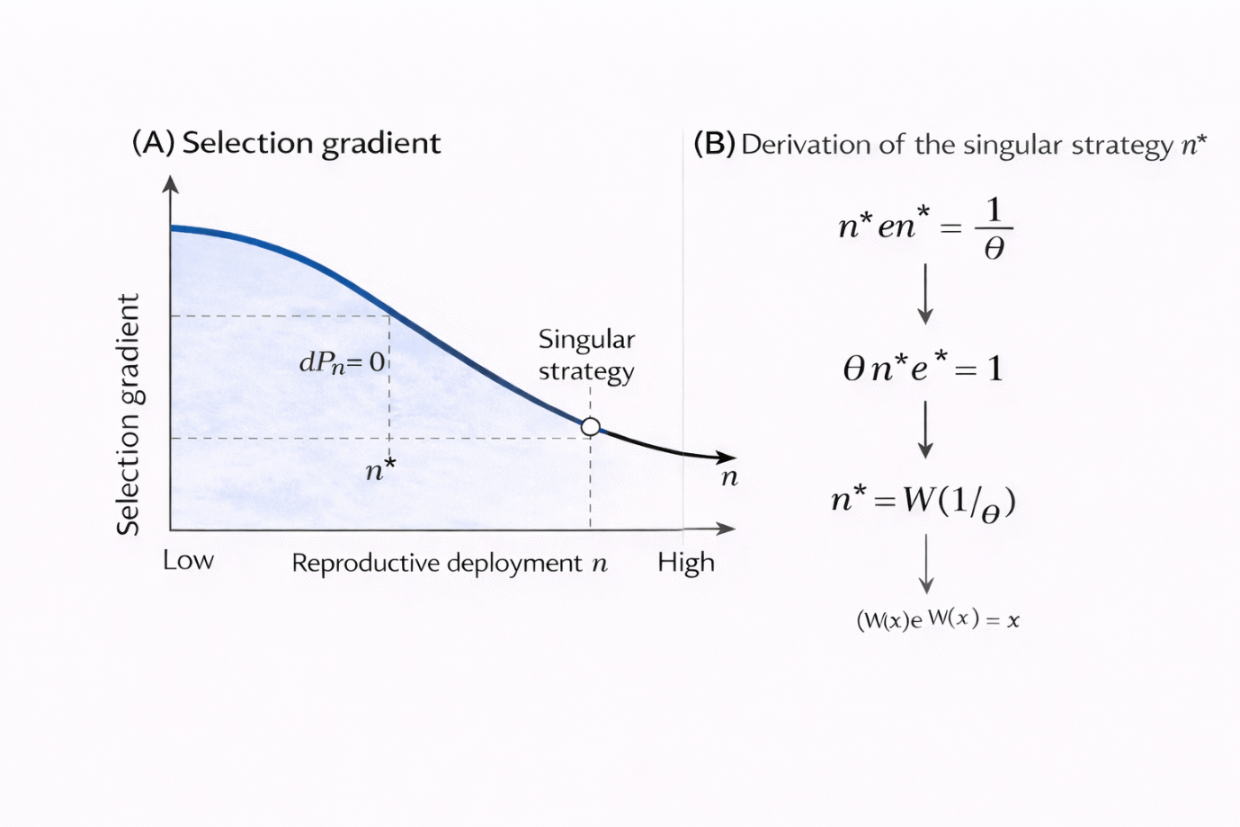
Fig. S1: Identification of the singular evolutionary strategy using selection gradient analysis and the Lambert W function.
(A) Selection gradient of the payoff function P(n) as a function of reproductive deployment n. The gradient crosses zero at the singular strategy n*, indicating an evolutionary equilibrium where directional selection vanishes. Arrows indicate the direction of selection toward the singular point from both lower and higher deployment values.
(B) Analytical derivation of the singular strategy. Solving the condition $\frac{dP}{dn}= 0$ yields the transcendental equation $n^{*}e^{n^{*}}=\frac{1}{θ}$, which admits a unique positive solution expressed using the Lambert W function as $n^{*}= W\left(\frac{1}{θ}\right)$. This demonstrates that the singular strategy emerges analytically from the molecular fidelity–encounter competition trade-off rather than being imposed ad hoc.
Fig. S2: Curvature sign-flip at the singular strategy determines the transition from stabilizing to disruptive selection.
The figure shows how the curvature of the fitness landscape at the singular strategy varies as a function of fidelity dilution strength (θ). The x-axis represents the strength of fidelity dilution, and the y-axis represents the second derivative of fitness with respect to reproductive deployment, evaluated at the singular strategy ($\frac{d^{2P}}{dn^{2}}{\left.​\right|}_{n^{*}}< 0$​).
At low θ, curvature is negative, indicating stabilizing selection and evolutionary stability of a monomorphic strategy. As θ increases, curvature rises and crosses zero at a critical threshold (θc​), where $\frac{d^{2P}}{dn^{2}}= 0$. Beyond this point, curvature becomes positive, converting the singular strategy into a fitness minimum and satisfying the formal condition for evolutionary branching.
The star marks the critical fidelity dilution threshold at which the curvature sign-flip occurs. Dashed lines indicate the zero-curvature boundary and the corresponding critical value of θ. This transition explains why increasing fidelity dilution pressure destabilizes isogamy and promotes disruptive divergence into distinct reproductive strategies.


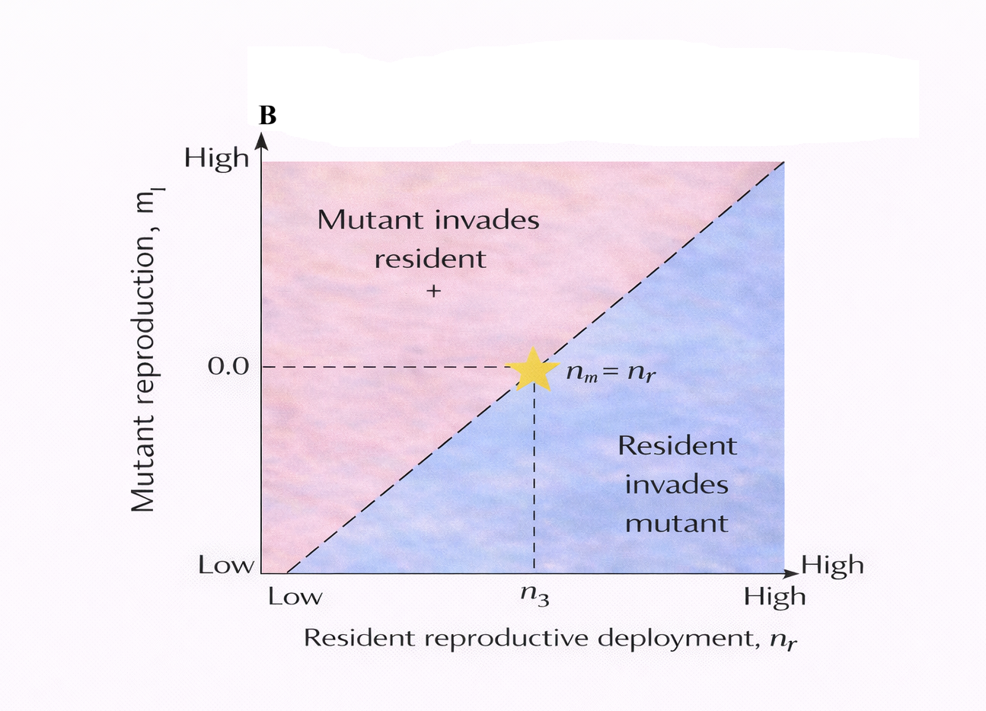
Fig. S3: Pairwise invasibility analysis demonstrating mutual invasion resistance of the dimorphic evolutionary stable strategy.
Pairwise invasibility plots (PIPs) showing invasion fitness of a mutant strategy n_{m}​ in a resident population characterized by reproductive deployment n_{r}​.
(A) Low-copy, high-fidelity strategy (n₁). The blue region indicates parameter combinations for which the resident strategy invades the mutant $\left( W_{inv}< 0\right)$, whereas the red region indicates mutant invasion $\left( W_{\text{inv}}> 0 \right)$. The diagonal dashed line denotes strategy equality (n_{m} = n_{r}​​). The star marks the equilibrium point, where mutant and resident strategies are identical. Mutants on either side of this point are unable to invade, indicating evolutionary stability.
(B) High-copy, encounter-optimized strategy (n₂). Shading is as in panel A. Here, the invasion structure is reversed: mutants with higher deployment can invade residents below the diagonal, while residents resist invasion above it. The star again denotes the equilibrium condition n_{m} = n_{r}​​​. Together, panels A and B demonstrate mutual invasion resistance of the two extreme strategies, confirming a protected dimorphic evolutionary stable strategy under frequency-dependent selection.
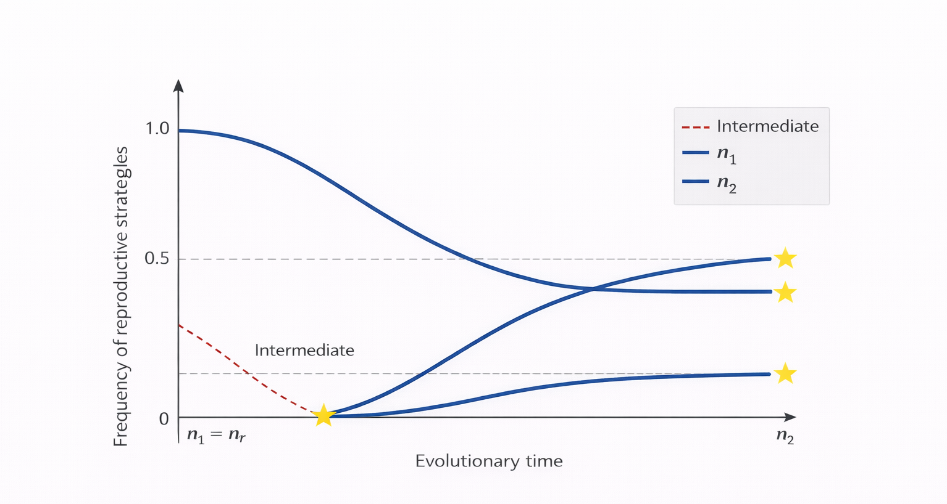Fig. S4: Replicator dynamics demonstrating long-term frequency stability of the dimorphic outcome.
Replicator dynamics describing the temporal evolution of reproductive strategies following evolutionary branching. The y-axis shows the frequency of reproductive strategies in the population, and the x-axis represents evolutionary time.
The intermediate strategy (dashed red line) declines and is eliminated, whereas the two extreme strategies—a low-copy, high-fidelity strategy (n₁​) and a high-copy, encounter-optimized strategy (n2​)—increase in frequency and converge to stable equilibrium values. Yellow stars indicate stable equilibrium frequencies corresponding to a protected dimorphic evolutionary stable strategy.
This dynamic confirms that the two-strategy outcome is not only invasion-resistant but also stable under frequency-dependent selection, with intermediate strategies unable to persist.

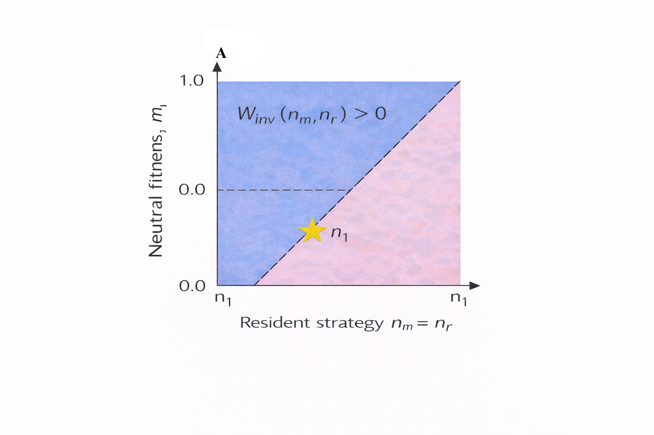
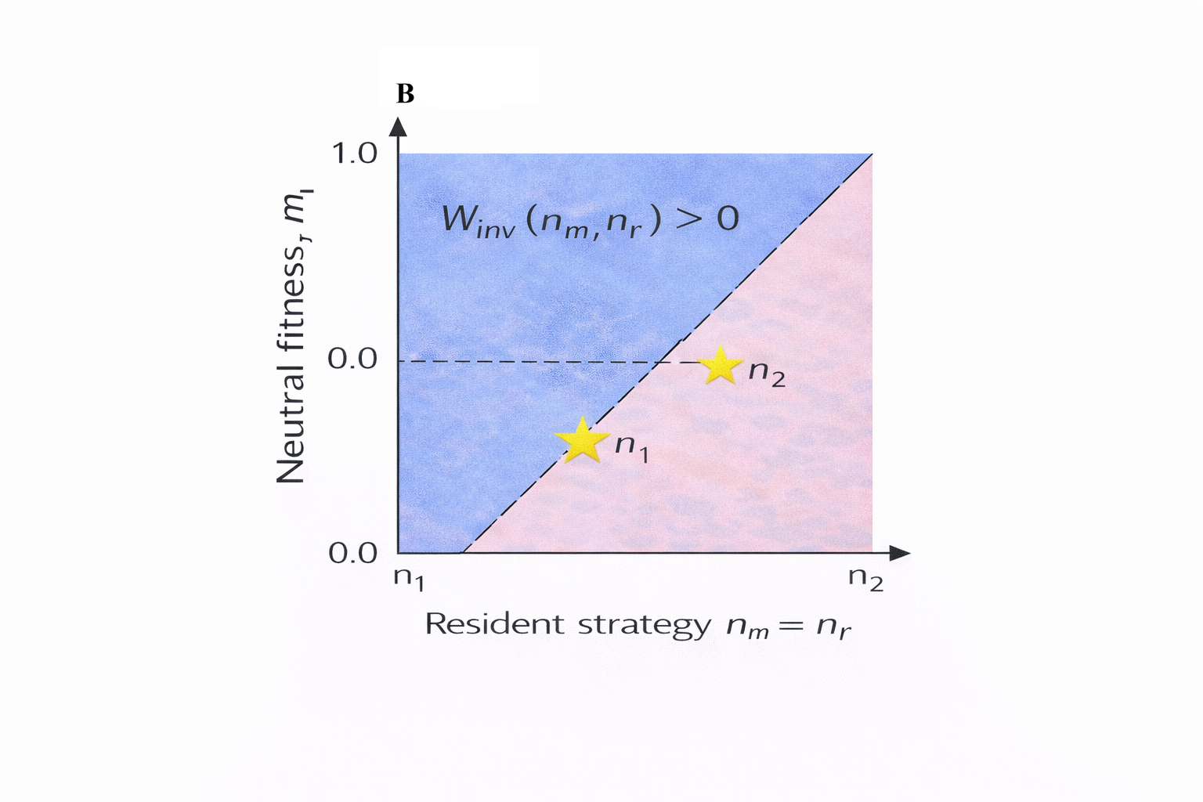
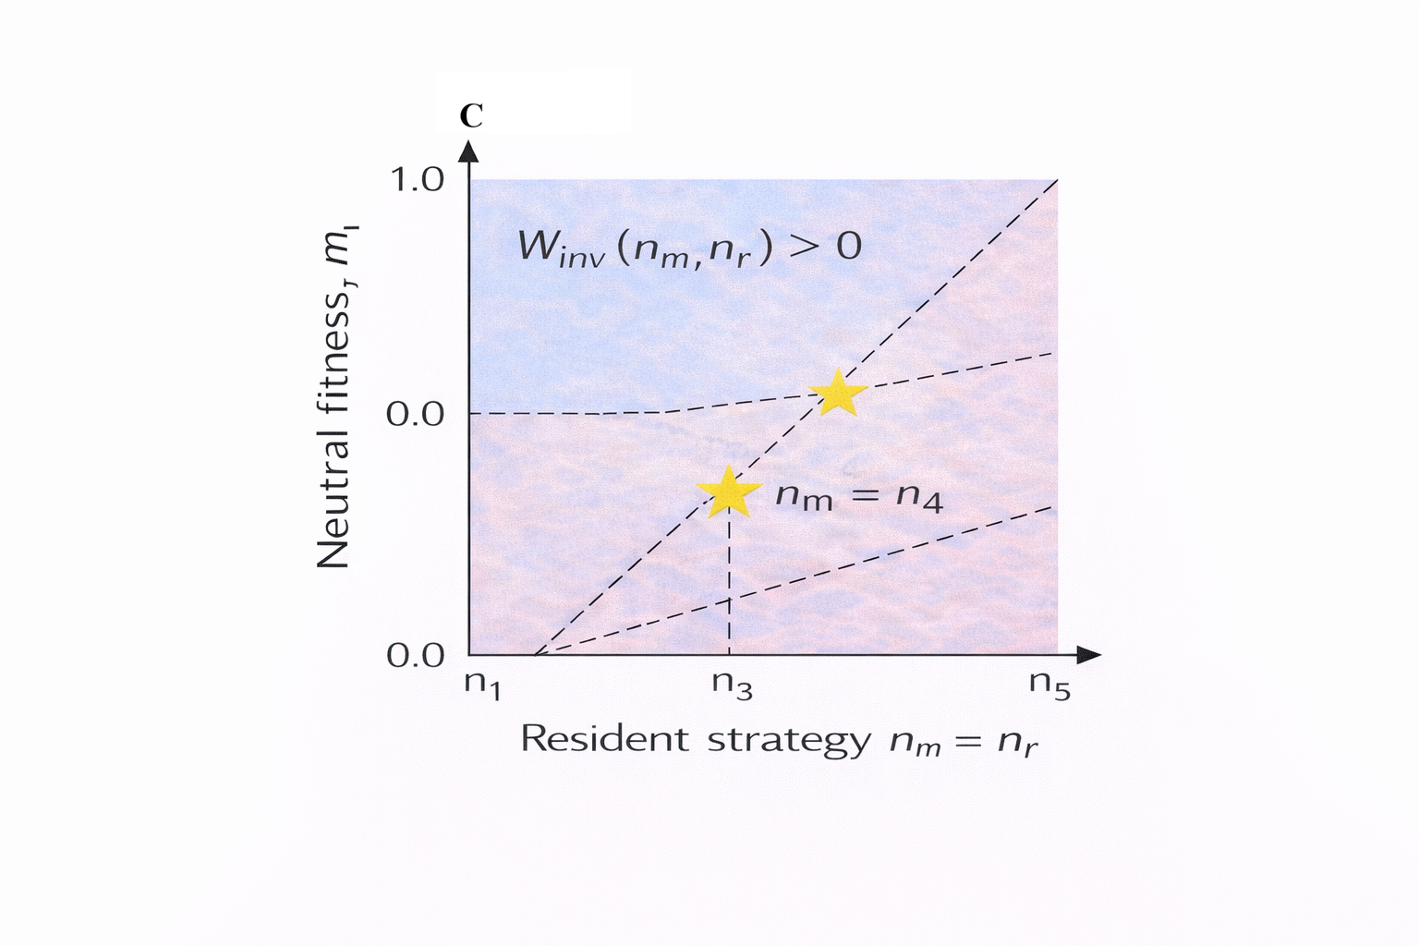Fig. S5: Alternative invasion structures and conditions for recurrent reproductive branching.
Pairwise invasion fitness landscapes illustrating how different invasion geometries shape the number and stability of coexisting reproductive strategies. In all panels, the x-axis denotes the resident reproductive strategy (n_{r}​), and the y-axis denotes mutant fitness relative to neutrality ($W_{\text{inv}}$ (n_{m}, n_{r})). Blue regions indicate positive invasion fitness $\left( W_{\text{inv}}> 0 \right)$, whereas red regions indicate negative invasion fitness $\left( W_{inv}< 0\right)$. Dashed diagonals denote strategy equality (n_{m} = n_{r}​​). Yellow stars mark evolutionary equilibria.
(A) Single-strategy evolutionary stable state. A single resident strategy (n₁​) is locally invasion-resistant: mutants on either side fail to invade, yielding a monomorphic ESS.
(B) Protected dimorphic ESS. Two distinct strategies (n₁ and n₂) are mutually non-invasible. Each strategy resists invasion by the other, producing a stable dimorphic outcome under frequency-dependent selection.
(C) Recurrent branching regime. When invasion boundaries intersect multiple times, additional branching points emerge. Intermediate strategies (e.g. n₃​) can undergo secondary diversification, leading to repeated evolutionary branching events and the coexistence of multiple reproductive strategies under local competitive interactions. Panel C illustrates a hypothetical recurrent branching regime under alternative invasion geometries not generated by the one-dimensional MF–EC framework, included for contrast

