Supplementary appendix
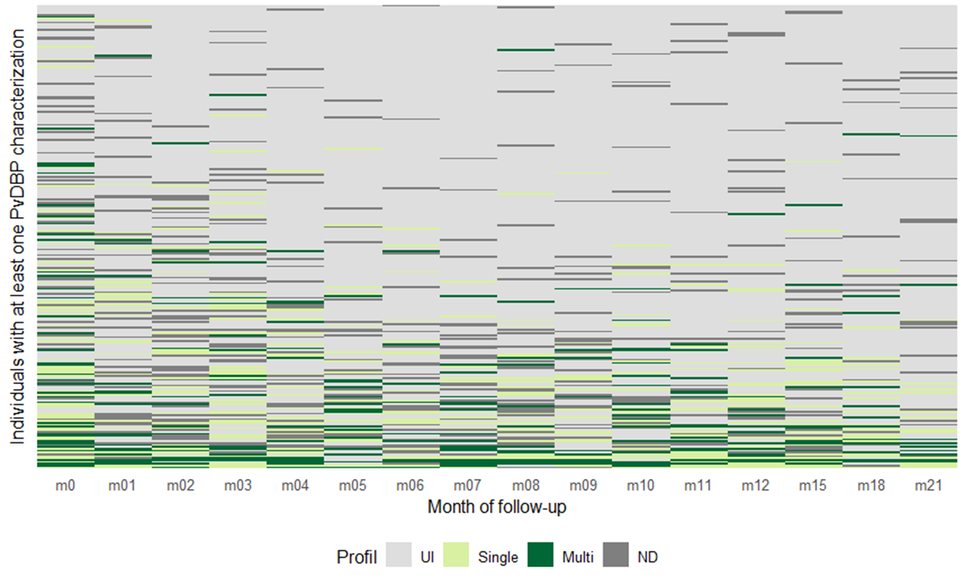
Appendix 1. Heatmap of PvDBP parasite profiles per individual presenting at least one P. vivax infection during the 21-month follow-up. UI: un-infected, ND: non-determined.

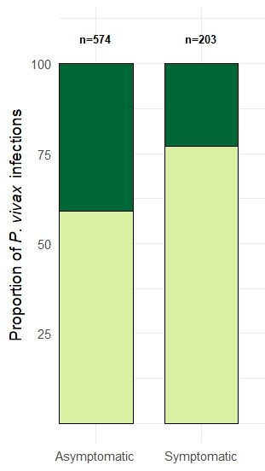
Appendix 2. Proportion of infections by single (light green) or multi-copy parasites (dark green) in asymptomatic and symptomatic individuals.

