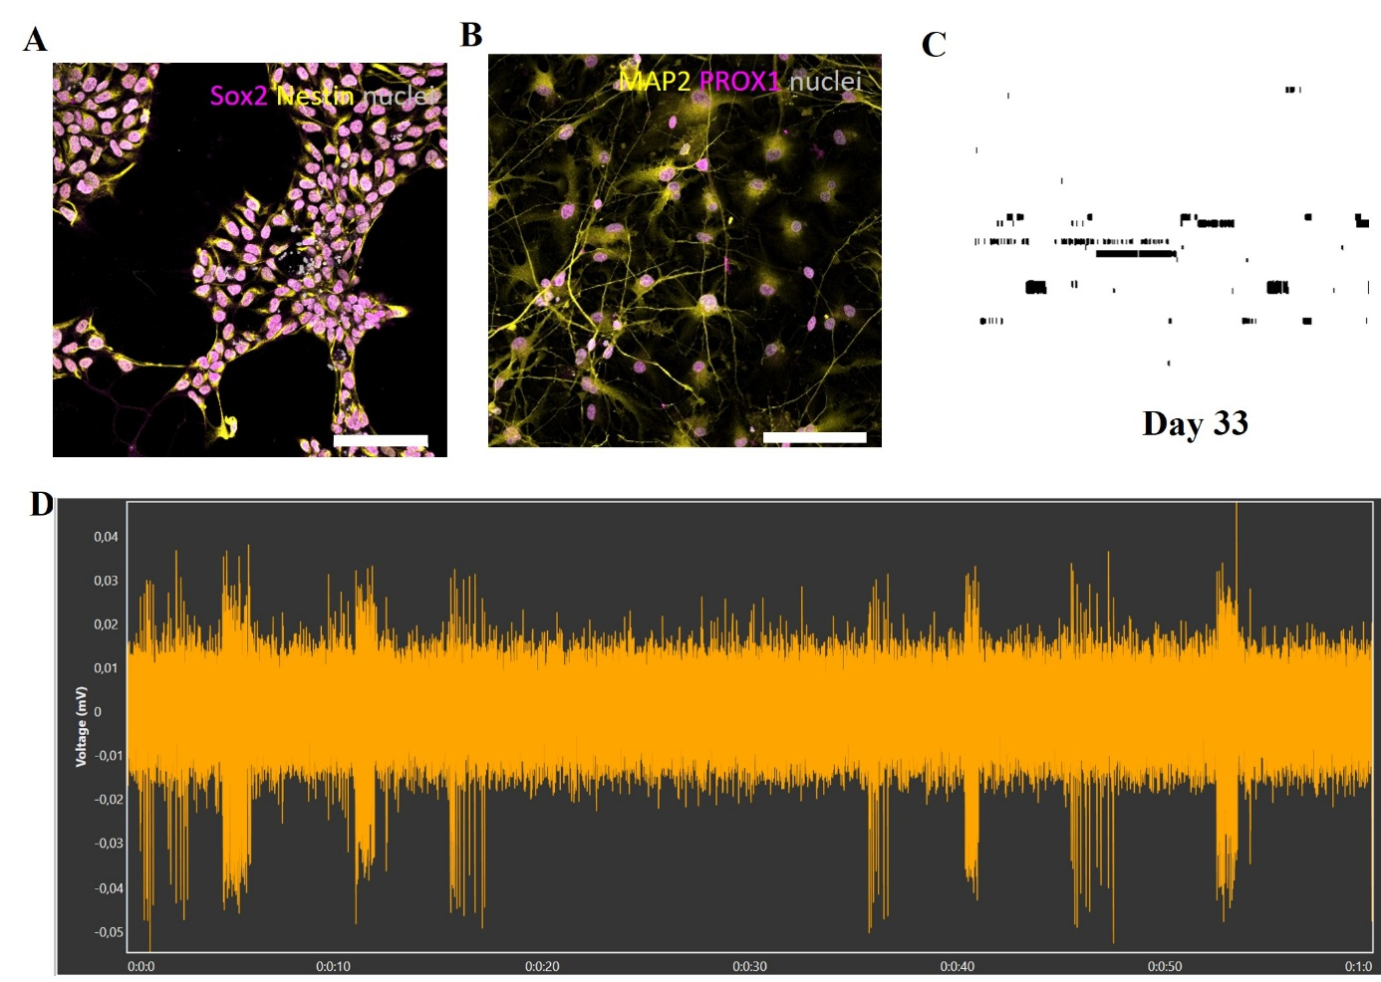
Supplementary material: Supplementary figures and figure captions
Supplementary figure 1. Characterization of alpha7 nAChRs in XCl1-derived DG granule cells .
(A) Representative immunocytochemistry image of XCL1-derived NPC-s (SOX2-magenta and Nestin-yellow). The nuclei were counterstained by DAPI-grey (scale bar = 100 μm). (B) Representative immunocytochemistry image of the XCL1-derived 41-days-old DG granule cells (MAP2-yellow and Prox1-magenta). The nuclei were counterstained by DAPI-grey (scale bar = 100 μm). (C ) Raster plot at 33 days of differentiation, Each row represents an electrode, and each vertical line represents a spike, duration: 1 minute. (D) Representative single-electrode recording 33 days of differentiation. Recording time: 1 minute.

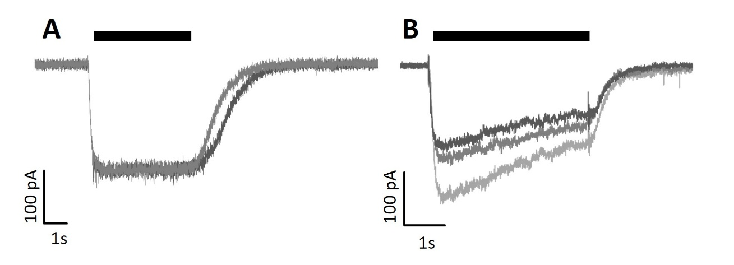
Supplementary figure 2. Ligand gated ion channel mediated responses. (A) 100 uM Kainate evoked AMPA receptor responses. (B) 100 uM GABA evoked GABAAR responses.

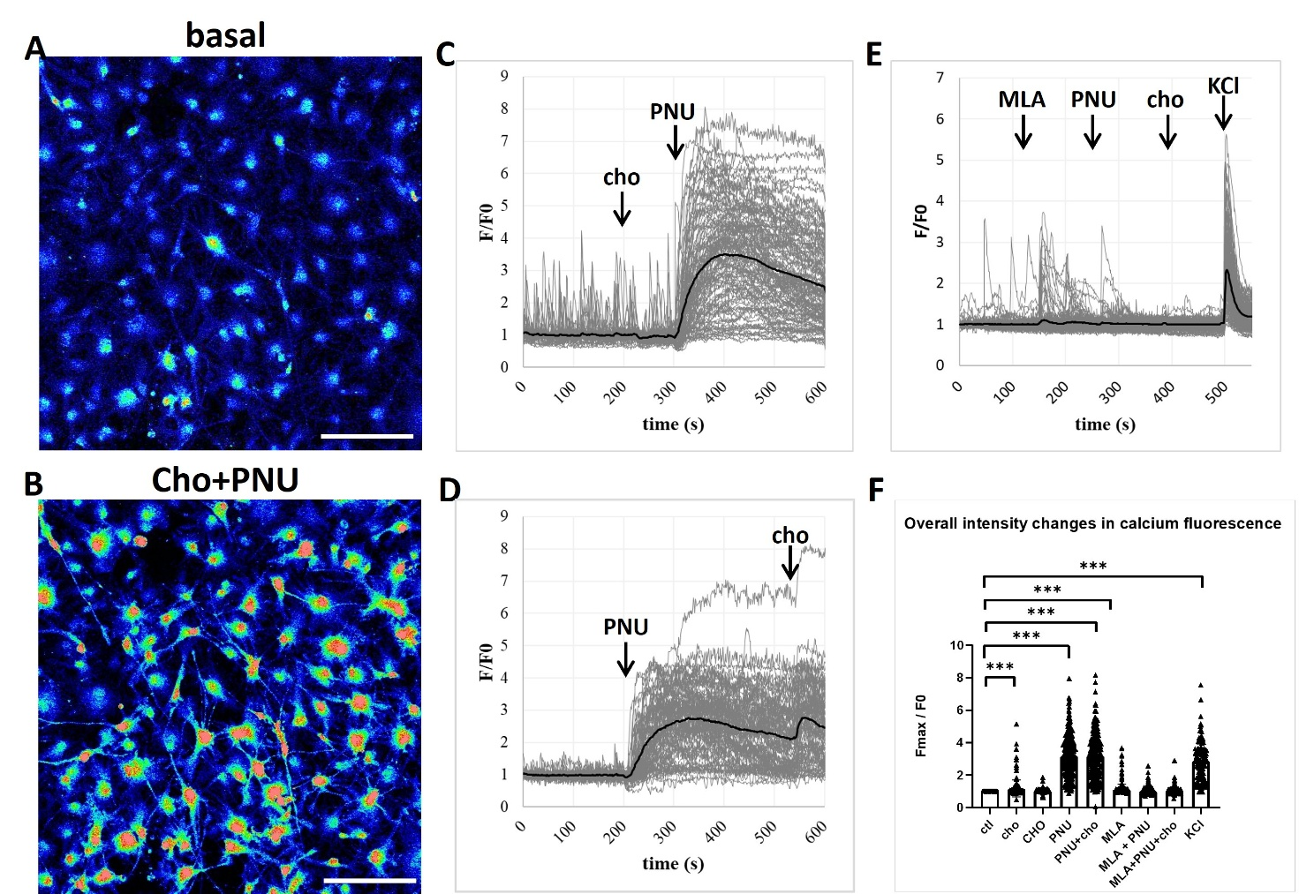
Supplementary figure 3. Alterations in calcium transients in the hIPSC XCL1-derived DG granule cells.
(A-B) Representative confocal microscopy images were obtained and calcium signals were measured in Fluo-4 loaded XCL1 hippocampal neurons. (scale bar = 100 uM, artificial colouring) (C) Choline alone did not elicit major changes in calcium transients, after the addition of PNU-120596 calcium activity increased dramatically. (D) PNU-120596 alone can evoke calcium transients in neurons that are further improved by adding choline. (E) MLA abolishes the effects of PNU-120596 +choline. (F) Overall intensity changes in calcium fluorescence after the addition of different alpha7 nAChR pharmacological agents and KCl. The bar graph shows the change in maximum intensity of each cell in response to a given treatment, after 41 days of differentiation, of XCL1-derived neurons calculated from 1-2 biological parallels. Each triangle represents one cell (N=100-458). Fmax/F0 fluorescent intensities were calculated by determining average basal activity(F0) and maximal values (Fmax) after the indicated treatments. For statistical comparison between subjects, the Kruskal-Wallis test was performed. Abbreviations: cho: Choline (40 µM), CHO: Choline (4 mM), MLA: methyllycaconitine (10 µM), PNU: PNU-120596 (4 µM), KCl: Potassium chloride, 50 mM, F/F0: Fluorescence intensity normalised to baseline activity.

