Supporting Information for
Carbonaceous composite materials from calcination of azo dye-adsorbed layered doubled hydroxide with enhanced photocatalytic efficiency for removal of Ibuprofen in water

Xiaolin Shen^{1,2}, Zhiliang Zhu^{1,2,3*}, Hua Zhang^{2,3}, Guanglan Di^{1,2}, Ting Chen^{1,2}, Yanling Qiu^{1,3}, Daqiang Yin^{1,3}
¹Key Laboratory of Yangtze River Water Environment, Ministry of Education, Tongji University, Shanghai 200092, China
² State Key Laboratory of Pollution Control and Resource Reuse, Tongji University, Shanghai 200092, China
³Shanghai Institute of Pollution Control and Ecological Security, Shanghai 200092, China

*Corresponding author, E-mail: zzl@tongji.edu.cn

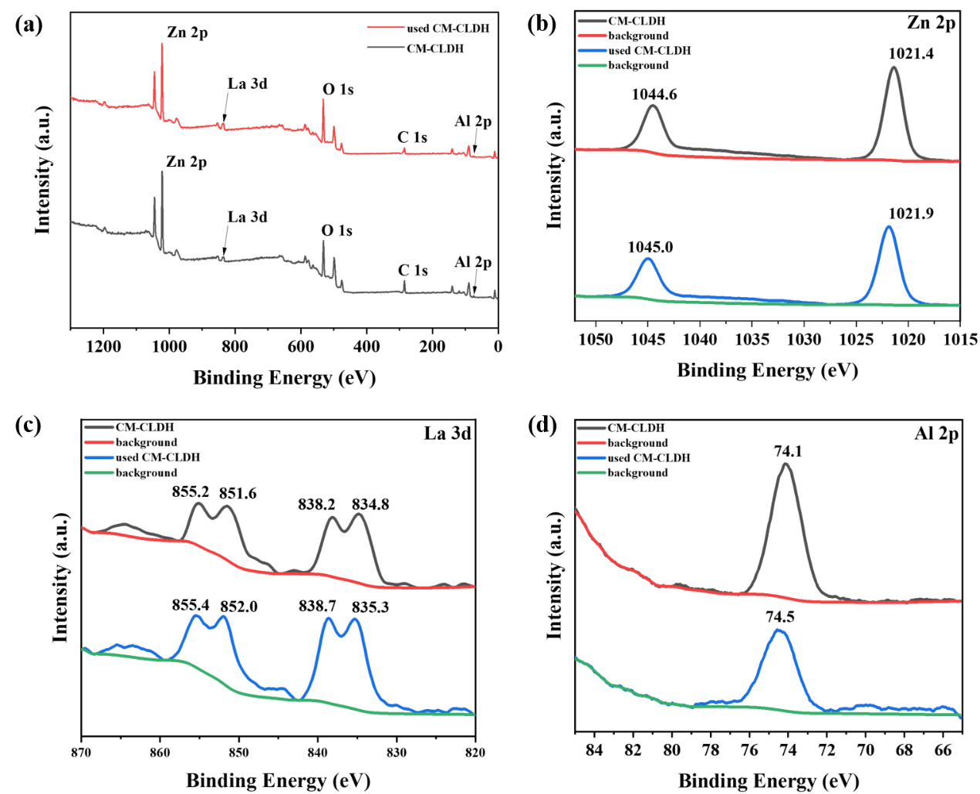
Fig. S1. XPS patterns of CM-CLDH and used CM-CLDH

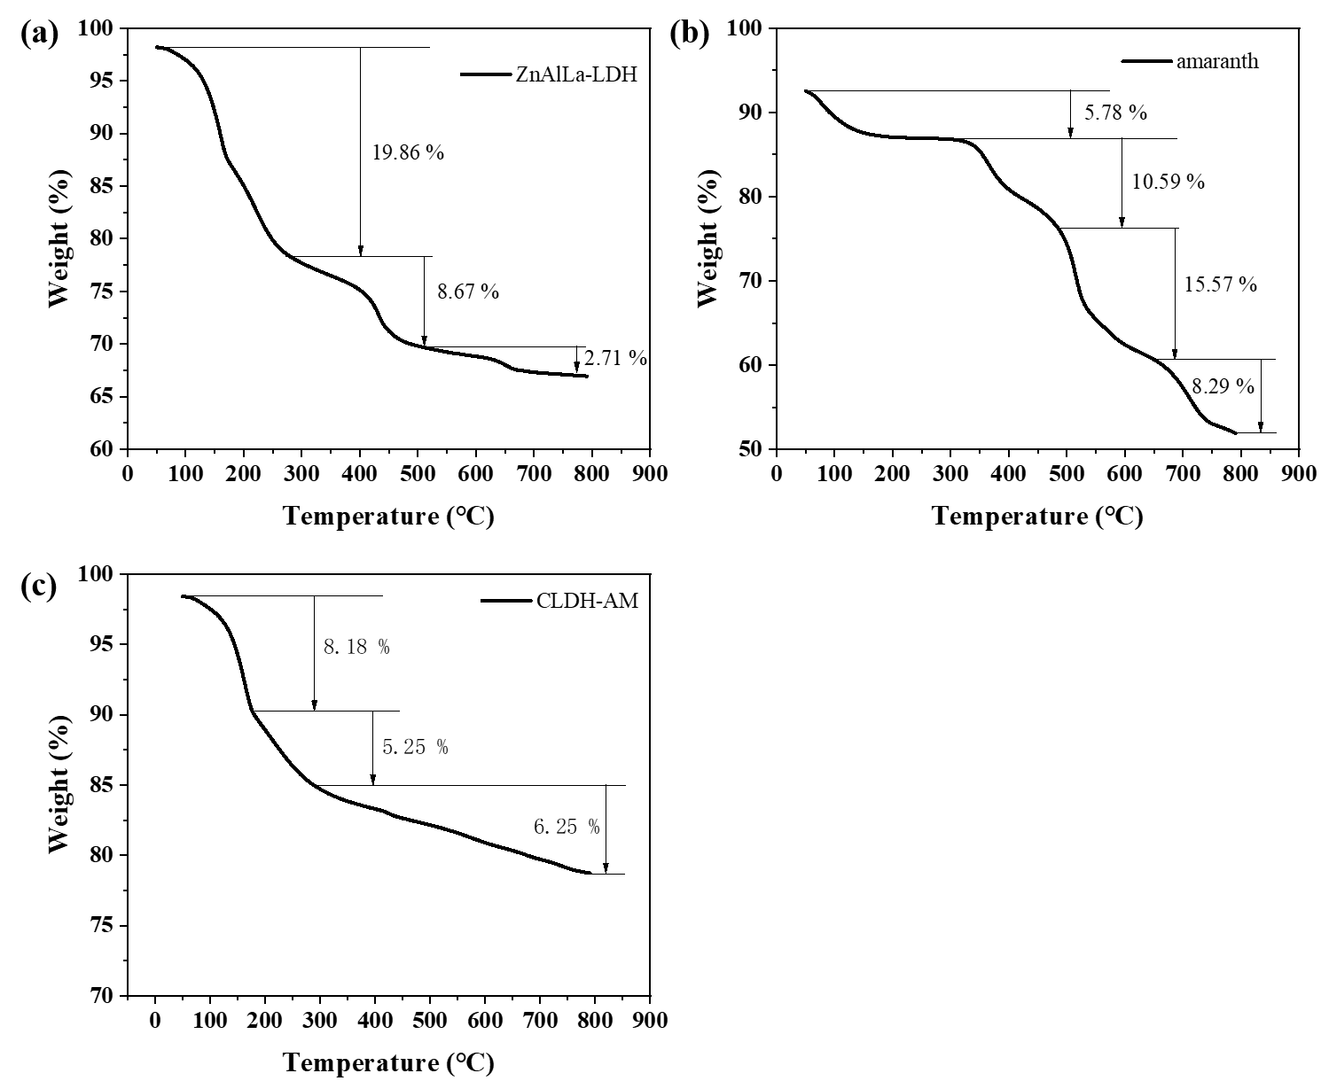
Fig. S2. thermogravimetry curves of ZnAlLa-LDH (a), amaranth (b) and CLDH-AM (c).

Fig. S3. Photocatalytic efficiency of the catalyst for several runs

