Supporting Information

Pizheng Zhang,^{a‡} Jie Wang,^{,b‡} Xiufang Ran,ª Boao Sun,ª Zifeng Liu,ª Bo Qin*ª

ªSchool of Chemistry and Chemical Engineering, Chongqing University, Chongqing 400044, China. Email: qinbo@cqu.edu.cn
^{b}Sinopec Lubricant Co., Ltd. Synthetic Grease Branch, Chongqing 400039
‡ Co-first author: Pizheng Zhang, Jie Wang

Contents

Section S1 Instruments and Materials 1
Section S2 Synthesis and characterization of compounds 3
Section S3 Comparison of gelation ability of different branching chain ligands. 24
Section S4 Hydrogen Bond Characterization and Model Analysis of Gels 26

Section S1 Instruments and Materials
Experimental solvents and reagents: All solvents and reagents were obtained from Adamas, Aldrich, or Alfa, they are analytical grade quality and used as received unless otherwise mentioned. Especially, CDCl₃-d₁, and DMSO-d₆ solutions using TMS (0.03%) as an internal standard.
Supramolecular Gel Samples: The gel ligand and KPF₆ (1: 1 molar ratio) were added into were dissolved in certain amount of acetonitrile. The supramolecular gels formed after ultrasonic treatment for 5 minutes. Unless otherwise specified, the test samples used are all such gels.
Nuclear Magnetic Resonance (NMR): ¹H NMR and ¹³C NMR spectra were measured on Agilent NMR Spectrometer (¹H: 400 MHz; ¹³C: 100 MHz) at 25℃. The sample solvents were all deuterated reagents.
Electrospray ionization mass spectra (ESI-MS): MS spectra were measured on Bruker solariX Spectrometer. The sample solvents were chromatographic grade.
Sample preparation process: The gel ligand and KPF₆ (1: 2 molar ratio) were added into certain amount of acetonitrile, supramolecular gels formed after ultrasonic treatment for 10 minutes. And then the solvent was rotated to dry to obtain solid powder.
UV-vis spectra: The UV absorption spectrum of H6-L gel was measured using a TU-1900 UV-Vis spectrophotometer to verify the photoreactive properties of the hydrazone group.
FT-IR: Infrared testing of the gel and H6-L ligand was carried out using a Nicolet iS20 Fourier infrared spectrometer, with ZnSe mode selected and a test temperature of 25°C
Differential Scanning Calorimeter (DSC): The DSC was used to measure the gelation point of each gel. The instrument model is DSC404F3 from NETZSCH, Germany. The testing conditions are as follows: 5 mg of gel sample was heated from 25°C to 100°C at a heating rate of 10 K/min, with an argon atmosphere for purging and a gas flow rate of 20 mL/min.
Rheological Measurements: The strain sweep and frequency sweep spectra were obtained on Anton Paar high temperature and pressure rheometer (MCR-302). The samples were implemented with a 50 mm diameter parallel plate. The gap distance was fixed at 750μm. Test environment condition was normal temperature and pressure. The strain sweep was obtained in the strain range (0.01%-100%). The frequency sweep was obtained from 0.1 rad/s to 100 rad/s at a constant strain of 0.1%, well within the linear regime determined by the strain sweep.
Scanning Electron Microscopy (SEM): The morphologies and sizes of supramolecular gels were characterized by field emission scanning electron microscopy (JEOL-SEM, JSM7600F) at an accelerating voltage of 10 kV. Sample preparation process: Gel samples were prepared by dropping the diluted gels on silicon slices and dried for 24 h. In order to increase the conductivity of samples, a thin layer of Au was deposited onto the samples before SEM examination.
Electrical Conductivity Measurements: The conductivities of supramolecular gels were measured by a conductivity meter of Rex Electric Chemical (DDSJ-308F).

Section S2 Synthesis and characterization of compounds
Synthesis of compound 1
Weigh urea (125 mmol) was added to xylene solution (50 mL) in a round bottom flask, then diethyl acetone dicarboxylate (0.083 mol) and triethyl orthoformate (0.167 mol) were added dropwise into the reaction system. Reaction was refluxed at 120°C for 4 h. The by-product ethanol of reaction mixture was evaporated to dryness under reduced pressure, and another xylene (30 mL) was added into the residue, then continued to reflux at 150°C for 1 h. After the reaction system mixture was sufficiently cooled, suction filtration was carried out, the resulting solid was washed with methanol (50 mL). Drying at 60°C for 12 h obtained compound 1 (15.3 g, 76% yield) as a light yellow solid powder. ¹H NMR (400 MHz, DMSO-d6) δ 11.98 (s, 1H, NH), 8.18 (s, 2H, CH), 4.19 (q, J = 7.1 Hz, 4H, CH₂), 1.25 (t, J = 7.1 Hz, 6H, CH₃).
ESI-MS ES⁺: calculate for [M+H]⁺ (C₁₁H₁₃NO₅): m/z 240.08, found: m/z 240.35. Synthesized according to the procedures in the related literatureS1-S3 and showed identical ¹H NMR spectra and MS to those reported therein.
Synthesis of compound 2
Compound 1 (10 mmol) and anhydrous potassium carbonate (30 mmol) were added to Acetonitrile (100 mL) solution in a round-bottom flask, then bromo-n-octane (15 mmol, 1.5 eq) was added dropwise into the reaction system. The reaction was refluxed at 70°C for 12 h. The reaction mixture was filtered, and the filtrate was evaporated to dryness under reduced pressure. Then 100ml of chloroform was added to the dried sample to precipitate a white precipitate, filtered again, the liquid was collected and vacuum dried to obtain compound 2 (3.33 g, 90% yield) (Carbon chain lengths of 2 and 4 as a white solid powder; Carbon chain lengths of 6 and 8 as a Pale yellow colloid)
2a: diethyl 1-hexyl-4-oxo-1,4-dihydropyridine-3,5-dicarboxylate
¹H NMR (400 MHz, CDCl₃) δ 8.02 (s, 2H, CH), 4.33 (q, J = 7.1 Hz, 4H, CH₂), 3.83 (t, J = 7.3 Hz, 2H, CH₂), 1.79 (dd, J = 13.4, 6.7 Hz, 2H, CH₂), 1.34 (dd, J = 15.0, 7.8 Hz, 12H, CH₂, CH₃), 0.87 (d, J = 6.3 Hz, 3H, CH₃). ESI-MS ES+: calculated for [M+Na]⁺ (C₁₇H₂₅NaNO₅): m/z 346.1625, found: m/z 346.1652.
2b: ¹H NMR (400 MHz, CDCl₃) δ 7.96 (s, 2H, CH), 4.27 (q, J = 7.1 Hz, 4H, CH₂), 4.05 (q, J = 7.1 Hz, 2H, CH₂), 3.79(t, J=7.4Hz, 2H, CH), 2.23(t, J=7.4Hz, 2H, CH₂), 1.78(p, J=7.5Hz, 2H, CH₂), 1.57(pd, J=7.3, 2.2Hz, 2H, CH₂), 1.29 (m, 10H, CH_{2,} CH₃), 1.18 (t, J = 7.1 Hz, 3H, CH₃). ESI-MS ES+: calculated for [M+H]⁺ (C₂₀H₃₀NO₇): m/z 396.2017, found: m/z 396.2020.
2c: ¹H NMR (400 MHz, DMSO-d₆) δ 8.24 (s, 2H, CH), 5.08 (t, J = 5.2 Hz, 1H, OH), 4.20 (q, J = 7.1 Hz, 4H, CH₂), 4.05 (dd, J = 6.3, 3.6 Hz, 2H, CH₂), 3.67 (q, J = 5.1 Hz, 2H, CH₂), 1.26 (t, J = 7.1 Hz, 6H, CH₃).(2OH) ESI-MS ES+: calculated for [M+H]⁺ (C₁₃H₁₈NO₆): m/z 284.1129 found: m/z 284.1125.
2d: ¹H NMR (400 MHz, Chloroform-d) δ 8.68 – 8.32 (s, 2H, CH), 4.28 (q, J = 7.1 Hz, 4H, CH₂), 4.23 – 4.01 (m, 2H, CH₂), 3.73 – 3.62 (m, 2H, CH₂), 2.04 (dq, J = 15.7, 8.6, 7.2 Hz, 2H, CH₂), 1.34 – 1.15 (m, 6H, CH₃).(3OH) ESI-MS ES+: calculated for [M+H]⁺ (C₁₄H₂₀NO₆): m/z 298.1285, found: m/z 298.1293.
2e: ¹H NMR (400 MHz, Chloroform-d) δ 8.01 (s, 2H, CH), 4.31 – 4.21 (m, 4H, CH₂), 3.90 (t, J = 7.5 Hz, 2H, CH₂), 3.65 (t, J = 5.8 Hz, 2H, CH₂), 1.91 (d, J = 7.7 Hz, 2H, CH₂), 1.58 – 1.50 (m, 2H, CH₂), 1.28 (td, J = 7.0, 2.3 Hz, 6H, CH₃).(4OH) ESI-MS ES+: calculated for [M+Na]⁺ (C₁₅H₂₁NaNO₆): m/z 334.1261, found: m/z 334.1276.
2f: ¹H NMR (400 MHz, CDCl₃) δ 7.97 (s, 2H, CH), 4.20 (q, J = 7.1 Hz, 4H, CH₂), 3.82 (t, J = 7.4 Hz, 2H, CH₂), 3.54 (t, J=6.5Hz, 2H, CH₂), 1.77(m, 2H, CH₂), 1.35(m, 4H, CH₂). (5OH) ESI-MS ES+: [M+K]⁺ (C₁₆H₂₃NKO₆): m/z 364.1157, found: m/z 364.1160.
2g: ¹H NMR (400 MHz, DMSO-d6) δ 8.28 (s, 2H, CH₂), 4.33 (t, J = 5.1 Hz, 1H, OH), 4.20 (q, J = 7.1 Hz, 4H, CH₂), 3.98 (t, J = 7.4 Hz, 2H, CH₂), 3.41 – 3.34 (m, 2H, CH₂), 1.70 (t, J = 7.4 Hz, 2H, CH₂), 1.41 (t, J = 6.8 Hz, 2H, CH₂), 1.26 (q, J = 7.1, 6.7 Hz, 10H, CH₂, CH₃). ESI-MS ES+: calculated for [M+Na]⁺ (C₁₇H₂₅NNaO₆): m/z 362.1574, found: m/z 362.1574.
2h: ¹H NMR (400 MHz, Chloroform-d) δ 8.00 (s, 2H, CH₂), 4.24 (q, J = 7.1 Hz, 4H, CH₂), 3.85 (t, J = 7.4 Hz, 2H, CH₂), 3.52 (t, J = 6.5 Hz, 2H, CH₂), 1.75 (p, J = 7.2 Hz, 2H, CH₂), 1.46 (p, J = 6.9 Hz, 2H, CH₂), 1.31 – 1.24 (m, 12H, CH₂, CH₃).(7OH) ESI-MS ES+: calculated for [M+H]⁺ (C₁₈H₂₈NO₆): m/z 354.1911, found: m/z 354.1892.
2i: ¹H NMR (400 MHz, Chloroform-d) δ 7.97 (s, 2H, CH₂), 4.27 (q, J = 7.1 Hz, 4H, CH₂), 3.80 (q, J = 7.3, 6.5 Hz, 2H, CH₂), 3.55 (t, J = 6.5 Hz, 2H, CH₂), 1.76 (dtd, J = 14.2, 11.2, 9.2, 5.3 Hz, 2H, CH₂), 1.48 (p, J = 6.7 Hz, 2H, CH₂), 1.28 (d, J = 7.0 Hz, 14H, CH₂, CH₃). ESI-MS ES+: calculated for [M+Na]⁺ (C₁₉H₂₉NNaO₆): m/z 390.1887, found: m/z 390.1899.
Synthesis of compound 3a-i
Compound 2a (10 mmol, 3.5 g) was added to a 50 mL round bottom flask of absolute ethanol, hydrazine hydrate (160 mmol, 7.7 mL) was added dropwise, and the reaction was refluxed at 60°C for 12 h. The reaction system was completely cooled, and a large amount of white crystals were precipitated, filtered and washed with methanol (50 mL) to obtain a pure white crystal product (3.07 g, 95% yield), which was compound 3a-d.
3a: diethyl 1-hexyl-4-oxo-1,4-dihydropyridine-3,5-dicarboxylate
¹H NMR (400 MHz, CDCl₃) δ 10.80 (s, 2H, NH), 8.49 (s, 2H, CH), 4.18 (d, 4H, NH₂), 4.00 (t, J = 7.3 Hz, 2H, CH₂), 1.91 – 1.81 (m, 2H, CH₂), 1.31 (s, 6H, CH₂), 0.88 (t, J = 6.6 Hz, 3H, CH₃). ESI-MS ES+: calculated for [M+Na]⁺ (C₁₃H₂₁N₅NaO₃): m/z 318.1537, found: m/z 318.1536.

Compound 2b (10 mmol) was added to a 50 mL round bottom flask of absolute ethanol, hydrazine hydrate (100 mmol) was added dropwise, and the reaction was refluxed at 35°C for 6 h. A large amount of white crystals were precipitated from the reaction system, filtered and washed with methanol (50 mL) to obtain a pure white crystal product (3.07 g, 95% yield), which was compound 3b.
3b: ¹H NMR (400 MHz, Chloroform-d) δ 10.73 (s, 2H, NH), 8.42 (s, 2H, CH), 4.11 (d, J = 3.4 Hz, 4H, NH₂), 4.06 (q, J = 7.1 Hz, 2H, CH₂), 3.94 (t, J = 7.4 Hz, 2H, CH₂), 2.22 (t, J = 7.3 Hz, 2H, CH₂), 1.82 (p, J = 7.4 Hz, 2H, CH₂), 1.56 (d, J = 7.3 Hz, 2H, CH₂), 1.30 (dq, J = 7.8, 4.8, 4.1 Hz, 4H, CH₂), 1.18 (t, J = 7.1 Hz, 3H, CH₃). ESI-MS ES+: calculated for [M+Na]⁺ (C₁₆H₂₅N₅NaO₅): m/z 390.1748, found: m/z 390.1746.

Compound 2c-i (10 mmol) was added to a 50 mL round bottom flask of absolute ethanol, hydrazine hydrate (100 mmol) was added dropwise, and the reaction was refluxed at 60°C for 12 h. The reaction system was completely cooled at -20℃, and a large amount of white crystals were precipitated, filtered and washed with methanol (50 mL) to obtain a pure white crystal product (3.07 g, 95% yield), which was compound 3c-i.
3c: ¹H NMR (400 MHz, DMSO-d6) δ 10.67 (s, 2H, NH), 8.63 (s, 2H, CH), 5.06 (t, J = 5.3 Hz, 1H, OH), 4.68 (s, 4H, NH₂), 4.28 (t, J = 4.8 Hz, 2H, CH₂), 3.69 (q, J = 5.1 Hz, 2H, CH₂). (2OH) ESI-MS ES+: calculated for [M+Na]⁺ (C₉H₁₃N₅NaO₄): m/z 278.0860, found: m/z 278.0854.
3d: ¹H NMR (400 MHz, DMSO-d6) δ 10.66 (s, 2H, NH), 8.64 (d, J = 1.6 Hz, 2H, CH), 4.87 – 4.60 (m, 5H, OH, NH₂), 4.29 (t, J = 6.9 Hz, 2H, CH₂), 3.39 (s, 2H, CH₂), 1.90 (p, J = 6.6 Hz, 2H, CH₂).(3OH) ESI-MS ES+: calculated for [M+Na]⁺ (C₁₀H₁₅N₅NaO₄): m/z 292.1016, found: m/z 292.1021.
3e: ¹H NMR (400 MHz, DMSO-d6) δ 10.66 (s, 2H, NH), 8.67 (s, 2H, CH), 4.69 (s, 4H, NH₂), 4.49 (t, J = 5.3 Hz, 1H, OH), 4.26 (t, J = 7.3 Hz, 2H, CH₂), 3.40 (q, J = 5.9 Hz, 2H, CH₂), 1.77 (p, J = 7.5 Hz, 2H, CH₂), 1.38 (dq, J = 12.9, 6.6 Hz, 2H, CH₂).(4OH) ESI-MS ES+: calculated for [M+Na]⁺ (C₁₁H₁₇N₅NaO₄): m/z 306.1173 found: m/z 306.1174.
3f: ¹H NMR (400 MHz, DMSO-d6) δ 10.65 (d, J = 4.1 Hz, 2H, NH), 8.66 (s, 2H, CH), 4.67 (d, J = 4.1 Hz, 4H, NH₂), 4.36 (t, J = 5.1 Hz, 1H, OH), 4.24 (t, J = 7.2 Hz, 2H, CH₂), 3.37 (td, J = 6.3, 5.1 Hz, 2H, CH₂), 1.80 – 1.68 (m, 2H, CH₂), 1.43 (p, J = 6.6 Hz, 2H, CH₂), 1.26 (tt, J = 9.5, 5.8 Hz, 2H, CH₂).(5OH) ESI-MS ES+: calculated for [M+Na]⁺ (C₁₂H₁₉N₅NaO₄): m/z 320.1329, found: m/z 320.1329.
3g: ¹H NMR (400 MHz, DMSO-d6) δ 10.67 (s, 2H, NH), 8.67 (d, J = 2.4 Hz, 2H, CH), 4.69 (s, 4H, NH₂), 4.34 (s, 1H, OH), 4.24 (t, J = 6.8 Hz, 2H, CH₂), 3.37 (d, J = 8.0 Hz, 2H, CH₂), 1.74 (p, J = 7.4 Hz, 2H, CH₂), 1.39 (q, J = 7.0 Hz, 2H, CH₂), 1.35 – 1.17 (m, 4H, CH₂). (6OH) ESI-MS ES+: calculated for [M+Na]⁺ (C₁₃H₂₁N₅NaO₄): m/z 334.1486, found: m/z 334.1486.
3h: ¹H NMR (400 MHz, DMSO-d6) δ 10.65 (s, 2H, NH), 8.66 (s, 2H, CH), 4.78 – 4.53 (m, 4H, NH₂), 4.30 (s, 1H, OH), 4.24 (t, J = 7.3 Hz, 2H, CH₂), 3.37 (d, J = 6.5 Hz, 2H, CH₂), 1.73 (p, J = 7.4 Hz, 2H, CH₂), 1.38 (p, J = 6.6 Hz, 2H, CH₂), 1.26 (dp, J = 13.0, 4.6 Hz, 6H, CH₂).(7OH) ESI-MS ES+: calculated for [M+Na]⁺ (C₁₄H₂₃N₅NaO₄): m/z 348.1642, found: m/z 348.1644.
3i: ¹H NMR (400 MHz, DMSO-d6) δ 10.66 (s, 2H, NH), 8.66 (s, 2H, CH), 4.68 (s, 4H, NH₂), 4.30 (t, J = 5.1 Hz, 1H, OH), 4.24 (t, J = 7.3 Hz, 2H, CH₂), 3.40 – 3.34 (m, 2H, CH₂), 1.73 (p, J = 7.2 Hz, 2H, CH₂), 1.39 (t, J = 6.8 Hz, 2H, CH₂), 1.29 – 1.20 (m, 8H, CH₂). (8OH) ESI-MS ES+: calculated for [M+Na]⁺ (C₁₅H₂₅N₅NaO₄): m/z362.1799, found: m/z 362.1811.

Synthesis of compound 4
N-methylformanilide (40 mmol) was added into a clean round-bottom flask, and phosphorus oxychloride (44 mmol) was added dropwise and stirred at room temperature for 20 min. Benzo-15-crown-5 (20 mmol) was added to the reaction flask, the reaction was carried out at 90°C for 6 h, and ice water was added to quench the reaction. The reaction system mixture was extracted with DCM and water, the organic phases were combined and dried with anhydrous Na₂SO₄ and filter, and concentrated to obtain a dark brown oil, which was Preliminarily purified through column chromatography (DCM: methanol = 50: 1 v/v), then isopropanol was added, recrystallized at -20 °C, a large amount of white precipitate was precipitated, and filtered to obtain pure compound 4 (5 g, 60% yield) as a white solid. ¹H NMR (400 MHz, CDCl₃) δ 9.83 (s, 1H, CHO), 7.44 (dd, J = 8.1, 1.7 Hz, 1H, CH), 7.38 (d, J = 1.6 Hz, 1H, CH), 6.93 (d, J = 8.2 Hz, 1H, CH), 4.20 (dd, J = 8.5, 5.2 Hz, 4H, CH₂), 3.96 – 3.89 (m, 4H, CH₂), 3.77 (d, J = 3.0 Hz, 8H, CH₂). ¹³C NMR (400 MHz, CDCl₃) δ 190.88 (CHO), 154.48 (C-crown ether), 149.27 (C-crown ether), 130.06 (C-aldehyde), 126.92 (CH), 111.74 (CH), 110.95 (CH), 71.07 (CH₂), 70.20 (CH₂), 70.13 (CH₂), 69.14 (CH₂), 69.03 (CH₂), 68.60 (CH₂), 68.52 (CH₂). ESI-MS ES⁺: calculated for [M+Na]⁺ (C₁₅H₂₀NaO₆): m/z 319.12, found: m/z 319.22. Synthesized according to the procedures in the related literatureS4 and showed identical ¹H NMR, ¹³C NMR and MS spectra to those reported therein.

Synthesis of ligand 5
Compound 3 (7.5 mmol) and Compound 4 (16.5 mmol) were added into a clean round-bottom flask, then absolute ethanol (50 mL) and glacial acetic acid (2 mmol) were added dropwise to the bottle. The reaction was refluxed at 70°C for 12 h. The reaction system was sufficiently cooled, and a large amount of pale yellow solid was precipitated, filtered and washed with methanol. The resulting crude product was recrystallized with acetonitrile. Finally, a relatively pure yellow solid product was obtained as compound 5 (5.5 g, yield 83%).
5a: ¹H NMR (400 MHz, CDCl₃) δ 12.95 (s, 2H, CH), 8.66 (s, 2H, NH), 8.16 (s, 2H, CH), 7.52 (s, 2H, CH), 7.16 (d, J = 7.9 Hz, 2H, CH), 6.84 (d, J = 8.2 Hz, 2H, CH), 4.20 (m, J = 26.7 Hz, 8H, CH₂), 4.09 (t, J = 7.1 Hz, 2H, CH₂), 3.92 (m, 8H, CH₂), 3.77 (s, 16H, CH₂), 1.89 (t, J = 5.6 Hz, 2H, CH₂), 1.32 (s, 6H, CH₂), 0.89 (t, J = 6.0 Hz, 3H, CH₃). ¹³C NMR (100 MHz, CDCl₃) δ 175.41(C=O), 160.05(C=O), 151.51(CH), 149.76(C-crown ether), 149.28(C-crown ether), 145.05(C=N), 126.92(quaternary C), 123.36(CH), 121.34(CH), 112.51(CH), 111.00(quaternary C), 71.14(CH2), 71.09(CH2), 70.38(CH2), 70.34(CH2), 69.42(CH2), 69.36(CH2), 68.90(CH2), 68.63(CH2), 59.23(CH2), 31.12(CH2), 30.72(CH2), 25.81(CH2), 22.40(CH2), 13.92(CH2). ESI-MS ES+: calculated for [M+H]⁺ (C₄₃H₅₈N₅O₁₃): m/z 852.4025, found: m/z 852.4030.(C6)
5b: ¹H NMR (400 MHz, Chloroform-d) δ 12.86 (s, 2H, CH), 8.59 (s, 2H, NH), 8.10 (s, 2H, CH), 7.46 (s, 2H, CH), 7.14 – 7.04 (m, 2H, CH), 6.77 (d, J = 8.2 Hz, 2H, CH), 4.22 – 4.01 (m, 12H, CH₂), 3.85 (q, J = 4.2 Hz, 8H, CH₂), 3.76 – 3.64 (m, 16H, CH₂), 2.25 (q, J = 7.2 Hz, 2H, CH₂), 1.86 (p, J = 7.8 Hz, 2H, CH₂), 1.61 (q, J = 7.5 Hz, 2H, CH₂), 1.40 – 1.22 (m, 4H, CH₂), 1.17 (d, J = 7.6 Hz, 3H, CH₃). ¹³C NMR (101 MHz, CDCl₃) δ 174.48(C=O), 172.41(C=O), 159.01(C=O), 150.53(CH), 148.80(C-crown ether), 148.30(C-crown ether), 144.02(C=N), 125.93(quaternary C), 122.34(CH), 120.44(C-acyl), 111.52(CH), 109.98( quaternary C), 70.08(CH₂), 70.02(CH₂), 69.37(CH₂), 69.33(CH₂), 68.39(CH₂), 68.34(CH₂), 67.87(CH₂), 67.61(CH₂), 59.32(CH₂), 58.03(CH₂-O), 33.00(CH₂), 29.59(CH₂), 27.42(CH₂), 24.83(CH₂), 23.54(CH₂), 13.24(CH₃). ESI-MS ES⁺: calculated for [M+Na]⁺ (C₄₆H₆₁N₅NaO₁₅): m/z 946.4009, found: m/z 946.4018.(6z)
5c: ¹H NMR (400 MHz, DMSO-d₆) δ 13.01 (s, 2H, CH), 8.84 (s, 2H, NH), 8.40 (s, 2H, CH), 7.42 (d, J = 1.9 Hz, 2H, CH), 7.33 (dd, J = 8.2, 1.9 Hz, 2H, CH), 7.10 (d, J = 8.3 Hz, 2H, CH), 5.19 (t, J = 5.3 Hz, 1H, OH), 4.52 – 4.37 (m, 2H, CH₂), 4.17 (dd, J = 5.4, 2.8 Hz, 8H, CH₂), 3.92 – 3.79 (m, 10H, CH₂), 3.69 (s, 16H, CH₂). ¹³C NMR (151 MHz, CDCl₃+CD₃OD) δ 174.95(C=O), 160.38(C=O), 151.11(CH), 149.49(C-crown ether), 148.99(C-crown ether), 145.92(C=N), 126.59(quaternary C), 123.38(CH), 119.90(C-acyl), 112.06(CH), 110.18(quaternary C), 70.74(CH₂), 70.68(CH₂), 70.06(CH₂), 70.03(CH₂), 69.21(CH₂), 69.08(CH₂), 68.35(CH₂), 68.22(CH₂), 61.23(CH₂), 60.85(CH₂). ESI-MS ES⁺: calculated for [M+H]⁺ (C₃₉H₅₀N₅O₁₄): m/z 812.3348, found: m/z 812.3345.(2OH)

5d: ¹H NMR (400 MHz, CDCl₃) δ 12.74 (s, 2H, CH), 8.49 (s, 2H, NH), 7.93 (s, 2H, CH), 7.38 (s, 2H, CH), 6.99 (d, J = 8.1 Hz, 2H, CH), 6.64 (d, J = 8.2 Hz, 2H, CH), 4.22 (t, J = 7.0 Hz, 2H, CH₂), 4.16 – 3.96 (m, 8H, CH₂), 3.82 (d, J = 5.3 Hz, 8H, CH₂), 3.69 (s, 16H, CH₂), 3.63 (d, J = 5.5 Hz, 2H, CH₂), 2.00 (p, J = 6.2 Hz, 2H, CH₂). ¹³C NMR (101 MHz, CDCl₃+CD₃OD) δ 179.36(C=O), 164.40(C=O), 155.40(CH), 153.96(C-crown ether), 153.09(C-crown ether), 149.68(C=N), 130.67(quaternary C), 127.33(CH), 124.68(C-acyl), 116.43(CH), 114.70(quaternary C), 74.79(CH₂), 74.72(CH₂), 74.11(CH₂), 74.06(CH₂), 73.19(CH₂), 73.10(CH₂), 72.44(CH₂), 72.35(CH₂), 61.06(CH₂), 59.74(CH₂), 36.57(CH₂). ESI-MS ES⁺: calculated for [M+Na]⁺ (C₄₀H₅₁N₅NaO₁₄): m/z 848.3282, found: m/z 848.3312.(3OH)
5e: ¹H NMR (400 MHz, CDCl₃) δ 12.83 (s, 2H, CH), 8.56 (s, 2H, NH), 8.07 (s, 2H, CH), 7.46 (d, J = 1.9 Hz, 2H, CH), 7.07 (dd, J = 8.1, 2.0 Hz, 2H, CH), 6.74 (d, J = 8.3 Hz, 2H, CH), 4.12 (ddd, J = 28.4, 5.5, 3.0 Hz, 10H, CH₂), 3.90 – 3.81 (m, 8H, CH₂), 3.75 – 3.66 (m, 16H, CH₂), 3.63 (t, J = 5.9 Hz, 2H, CH₂), 1.94 (p, J = 7.4 Hz, 2H, CH₂), 1.53 (t, J = 7.1 Hz, 2H, CH₂). ¹³C NMR (101 MHz, CDCl₃) δ 174.24(C=O), 159.10(C=O), 150.45(CH), 148.81(C-crown ether), 148.25(C-crown ether), 144.09(C=N), 125.87(quaternary C), 122.39(CH), 120.08(C-acyl), 111.51(CH), 109.92(quaternary C), 70.04(CH₂), 69.97(CH₂), 69.34(CH₂), 69.30(CH₂), 68.42(CH₂), 68.34(CH₂), 67.82(CH₂), 67.58(CH₂), 60.53(CH₂), 57.91(CH₂), 27.74(CH₂), 26.61(CH₂). ESI-MS ES⁺: calculated for [M+Na]⁺ (C₄₁H₅₃N₅NaO₁₄): m/z 862.3438, found: m/z 862.3467.(4OH)
5f: ¹H NMR (400 MHz, CDCl₃+CD₃OD) δ 12.84 (s, 2H, CH), 8.54 (s, 2H, NH), 8.05 (s, 2H, CH), 7.49 (d, J = 1.9 Hz, 2H, CH), 7.06 (dd, J = 8.3, 2.0 Hz, 2H, CH), 6.74 (d, J = 8.2 Hz, 2H, CH), 4.20 – 4.05 (m, 8H, CH₂), 4.02 (t, J = 7.4 Hz, 2H, CH₂), 3.89 – 3.81 (m, 8H, CH₂), 3.74 – 3.66 (m, 16H, CH₂), 3.59 – 3.52 (m, 2H, CH₂), 1.88 – 1.79 (m, 2H, CH₂), 1.52 – 1.47 (m, 2H, CH₂), 1.40 – 1.33 (m, 2H, CH₂). ¹³C NMR (101 MHz, CDCl₃) δ 179.28(C=O), 164.29(C=O), 155.40(CH), 153.94(C-crown ether), 153.15(C-crown ether), 149.29(C=N), 130.67(quaternary C), 127.33(CH), 124.81(C-acyl), 116.38(CH), 114.68(quaternary C), 74.85(CH₂), 74.78(CH₂), 74.12(CH₂), 73.22(CH₂), 73.14(CH₂), 72.53(CH₂), 72.48(CH₂), 72.39(CH₂), 65.25(CH₂), 62.86(CH₂), 35.35(CH₂), 34.30(CH₂), 26.26(CH₂). ESI-MS ES⁺: calculated for [M+Na]⁺ (C₄₂H₅₅N₅NaO₁₄): m/z 876.3593, found: m/z 876.3594.(5OH)
5g: ¹H NMR (400 MHz, Chloroform-d) δ 12.86 (s, 2H, CH), 8.57 (s, 2H, NH), 8.09 (s, 2H, CH), 7.46 (d, J = 2.0 Hz, 2H, CH), 7.09 (dd, J = 8.3, 1.9 Hz, 2H, CH), 6.76 (d, J = 8.3 Hz, 2H, CH), 4.19 – 4.07 (m, 8H, CH₂), 4.03 (t, J = 7.2 Hz, 2H, CH₂), 3.86 (dt, J = 6.3, 3.4 Hz, 8H, CH₂), 3.70 (q, J = 2.0 Hz, 16H, CH₂), 3.56 (t, J = 6.2 Hz, 2H, CH₂), 1.83 (p, J = 7.2 Hz, 2H, CH₂), 1.49 (t, J = 6.9 Hz, 2H, CH₂), 1.41 – 1.26 (m, 4H, CH₂). ¹³C NMR (151 MHz, CDCl₃+CD₃OD) δ 175.21(C=O), 160.25(C=O), 151.40(CH), 149.87(C-crown ether), 149.17(C-crown ether), 145.24(C=N), 126.76(quaternary C), 123.44(CH), 120.83(C-acyl), 112.38(CH), 110.67(quaternary C), 70.89(CH₂), 70.83(CH₂), 70.20(CH₂), 70.16(CH₂), 69.30(CH₂), 69.21(CH₂), 68.60(CH₂), 68.42(CH₂), 61.70(CH₂), 58.85(CH₂), 31.97(CH₂), 30.40(CH₂), 25.58(CH₂), 24.89(CH₂). ESI-MS ES⁺: calculated for [M+H]⁺ (C₄₃H₅₈N₅O₁₄): m/z 868.3974, found: m/z 868.3979.(6OH)
5h: ¹H NMR (400 MHz, Chloroform-d) δ 12.86 (s, 2H, CH), 8.58 (s, 2H, NH), 8.08 (s, 2H, CH), 7.48 (d, J = 1.9 Hz, 2H, CH), 7.08 (dd, J = 8.3, 1.9 Hz, 2H, CH), 6.76 (d, J = 8.3 Hz, 2H, CH), 4.19 – 4.07 (m, 8H, CH₂), 4.02 (t, J = 7.4 Hz, 2H, CH₂), 3.86 (dt, J = 6.1, 3.1 Hz, 8H, CH₂), 3.70 (h, J = 2.2 Hz, 16H, CH₂), 3.56 (t, J = 6.5 Hz, 2H, CH₂), 1.47 (q, J = 6.7 Hz, 2H, CH₂), 1.32 – 1.15 (m, 8H, CH₂).¹³C NMR (101 MHz, CDCl₃) δ 174.31(C=O), 159.09(C=O), 150.46(CH), 148.80(C-crown ether), 148.23(C-crown ether), 144.06(C=N), 125.85(quaternary C), 122.40(CH), 120.19(C-acyl), 111.42(CH), 109.83(quaternary C), 69.99(CH₂), 69.93(CH₂), 69.32(CH₂), 69.27(CH₂), 68.36(CH₂), 68.30(CH₂), 67.80(CH₂), 67.51(CH₂), 61.52(CH₂), 57.99(CH₂), 31.36(CH₂), 29.42(CH₂), 27.51(CH₂), 24.90(CH₂), 24.45(CH₂). ESI-MS ES⁺: calculated for [M+Na]⁺ (C₄₄H₅₉N₅NaO₁₄): m/z 904.3906, found: m/z 904.3910.(7OH)
5i: ¹H NMR (400 MHz, Chloroform-d) δ 12.86 (s, 2H, CH), 8.60 (s, 2H, NH), 8.11 (s, 2H, CH), 7.46 (s, 2H, CH), 7.10 (d, J = 8.1 Hz, 2H, CH), 6.78 (d, J = 8.2 Hz, 2H, CH), 4.13 (dt, J = 24.6, 4.2 Hz, 8H, CH₂), 4.02 (t, J = 7.4 Hz, 2H, CH₂), 3.85 (q, J = 4.4 Hz, 8H, CH₂), 3.70 (d, J = 2.5 Hz, 16H, CH₂), 3.57 (t, J = 6.5 Hz, 2H, CH₂), 1.84 (s, 2H, CH₂), 1.49 (t, J = 6.6 Hz, 2H, CH₂), 1.28 (d, J = 5.4 Hz, 8H, CH₂). ¹³C NMR (151 MHz, CDCl₃) δ 175.35(C=O), 160.13(C=O), 151.45(CH), 149.80(C-crown ether), 149.23(C-crown ether), 145.12(C=N), 126.87(quaternary C), 123.41(CH), 121.19(C-acyl), 112.39(CH), 110.81(quaternary C), 71.00(CH₂), 70.94(CH₂), 70.32(CH₂), 70.27(CH₂), 69.36(CH₂), 69.30(CH₂), 68.78(CH₂), 68.50(CH₂), 62.66(CH₂), 59.07(CH₂), 32.59(CH₂), 30.55(CH₂), 29.01(CH₂), 28.73(CH₂), 25.87(CH₂), 25.56(CH₂). ESI-MS ES⁺: calculated for [M+H]⁺ (C₄₅H₆₂N₅O₁₄): m/z 896.4287, found: m/z 896.4308.(8OH)

Figure S1 ¹H NMR spectrum of compound 1 (400 MHz, DMSO-d6, 25°C)

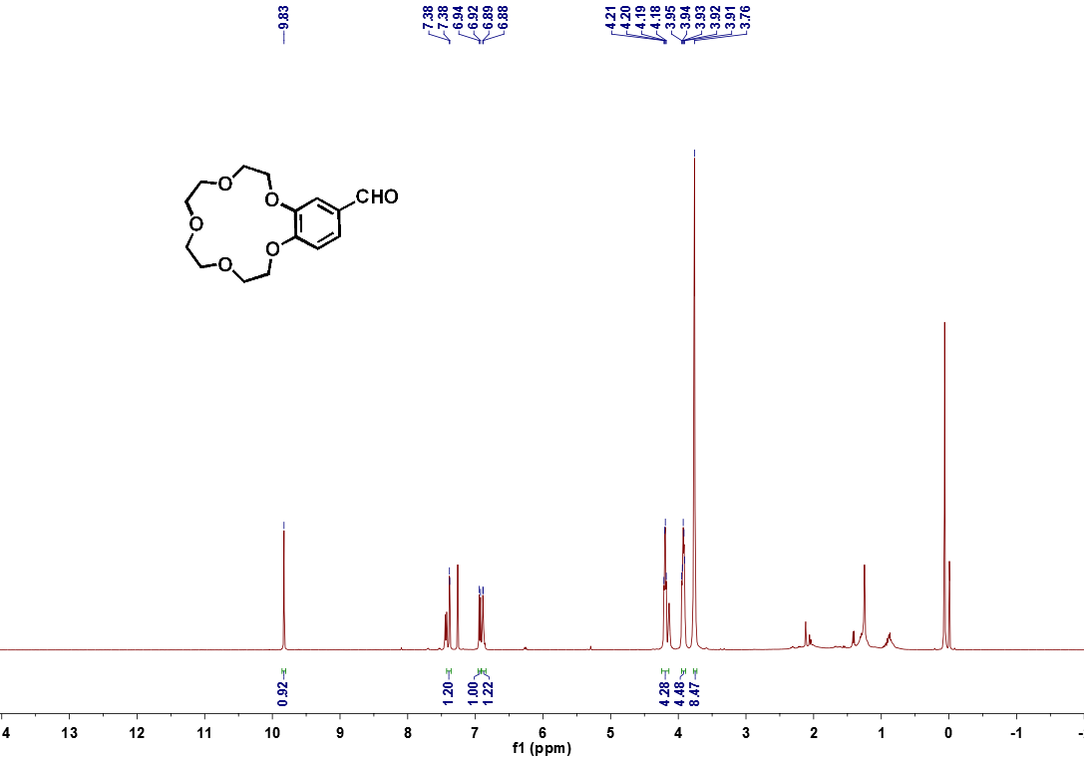
Figure S2 ¹H NMR spectrum of compound 4 (400 MHz, CDCl₃, 25°C)

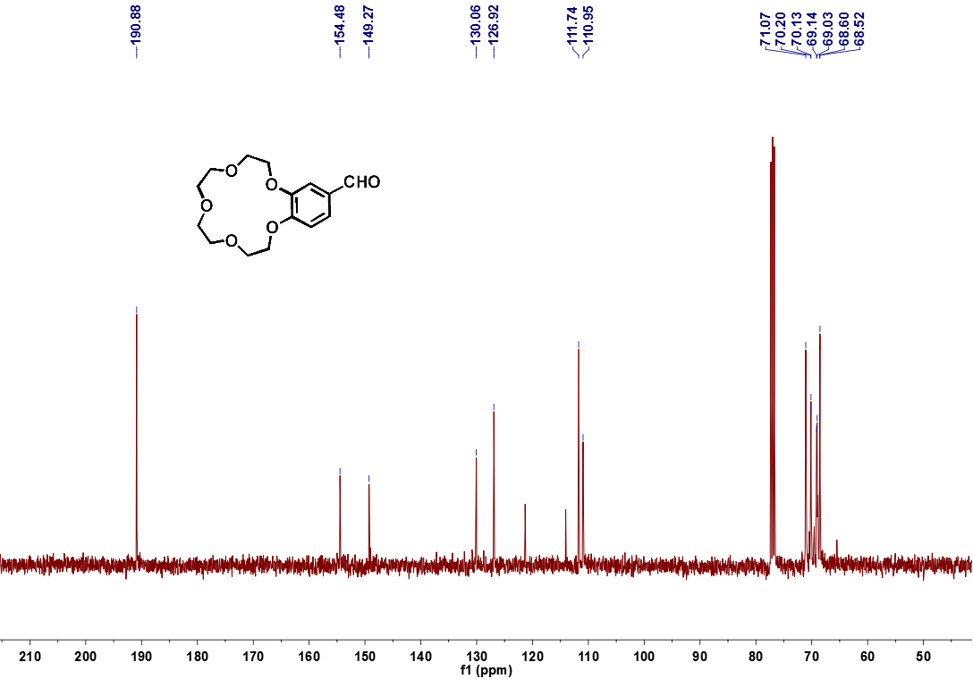
Figure S3 ¹³C NMR spectrum of compound 4 (100 MHz, CDCl₃, 25°C)

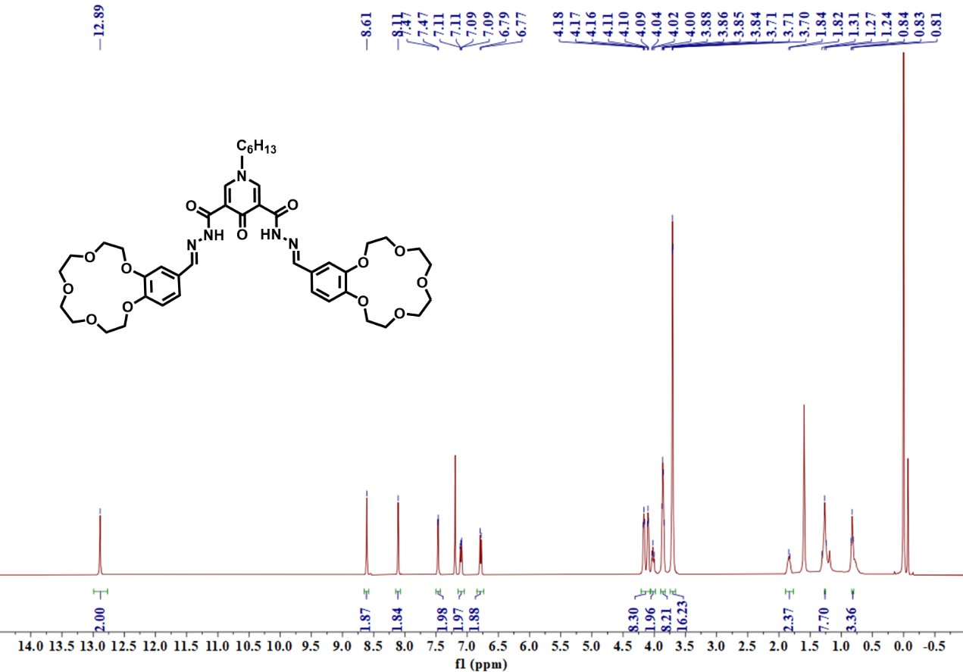
Figure S4 ¹H NMR spectrum of compound 5a (400 MHz, CDCl₃, 25°C)

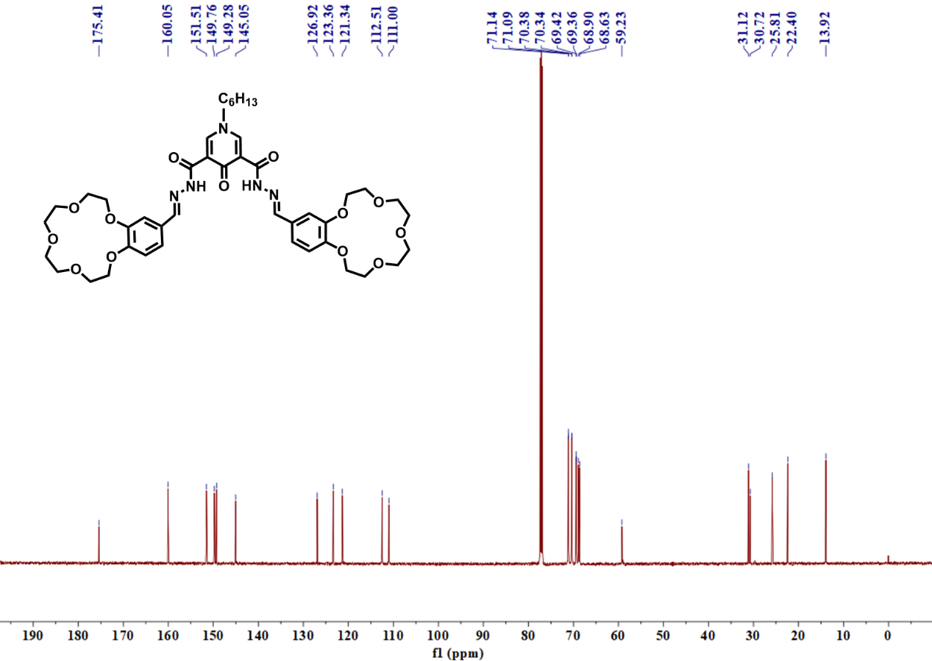
Figure S5 ¹³C NMR spectrum of compound 5a (100 MHz, CDCl₃, 25°C)

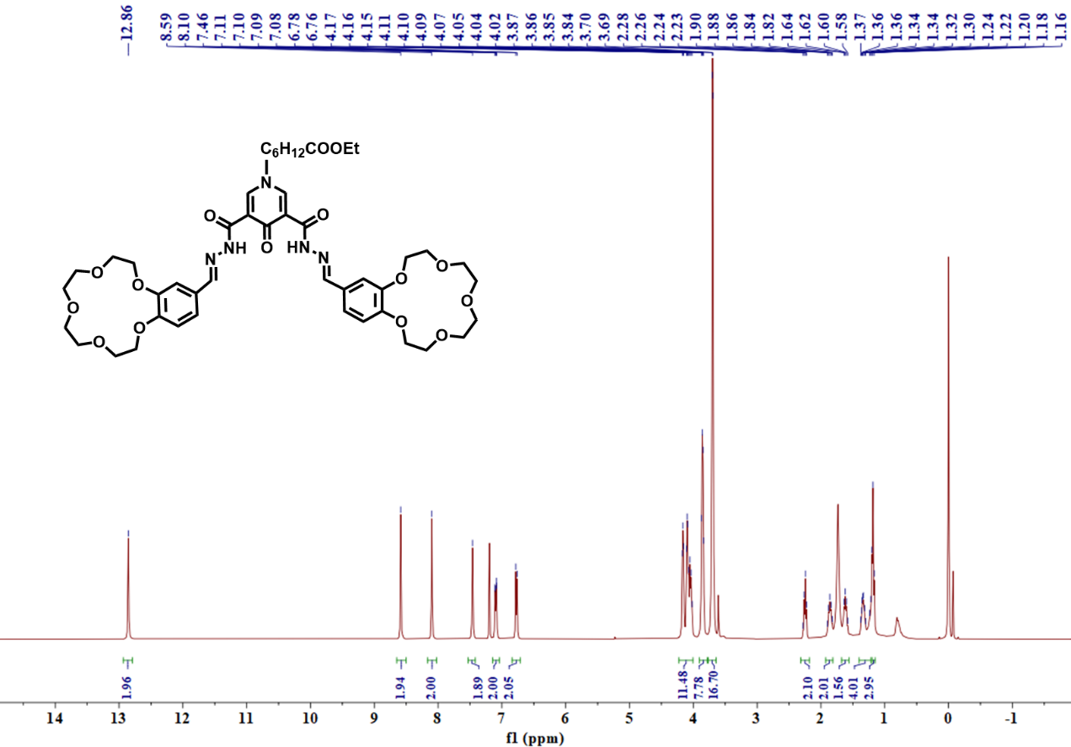
Figure S6 ¹H NMR spectrum of compound 5b (400 MHz, CDCl₃, 25°C)
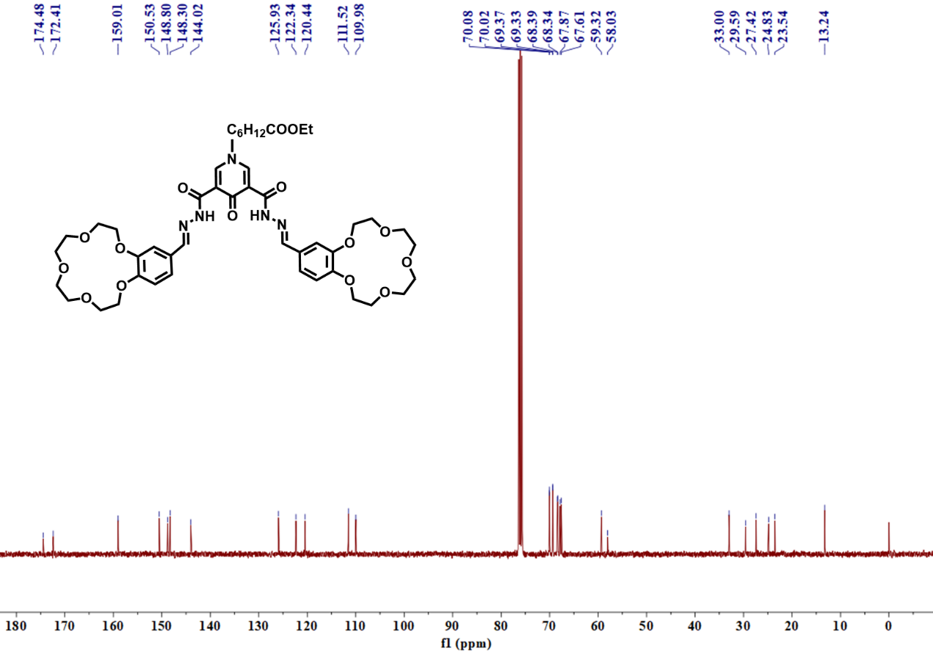

Figure S7 ¹³C NMR spectrum of compound 5b (100 MHz, CDCl₃, 25°C)
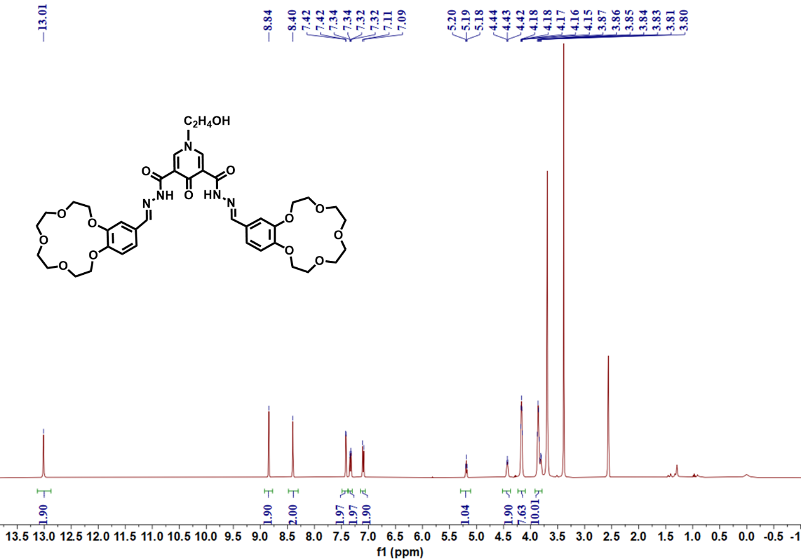

Figure S8 ¹H NMR spectrum of compound 5c (400 MHz, DMSO-d₆, 25°C)
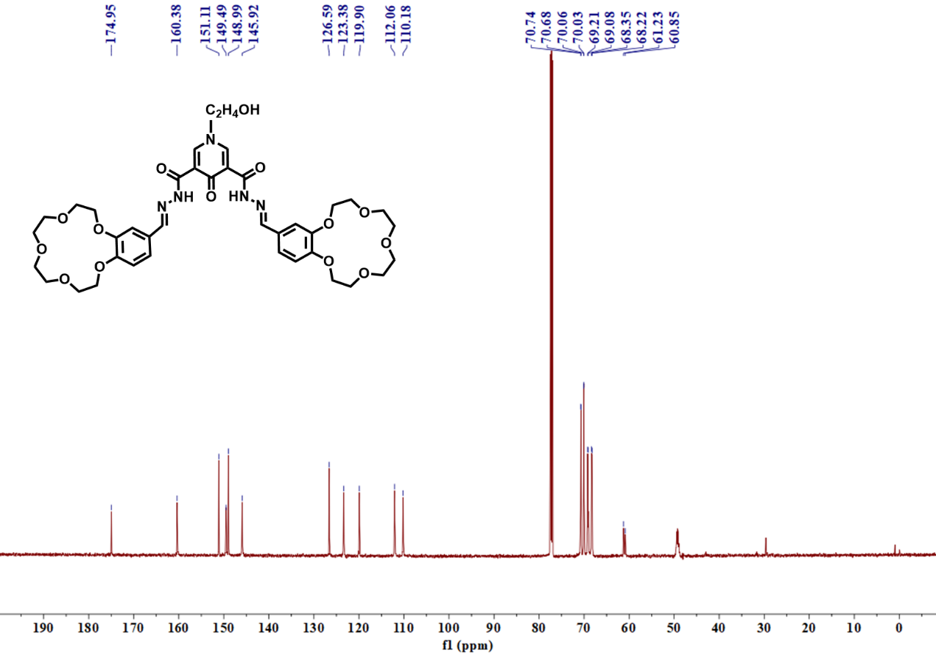
Figure S9 ¹³C NMR spectrum of compound 5c (100 MHz, CDCl₃+CD₃OD, 25°C)

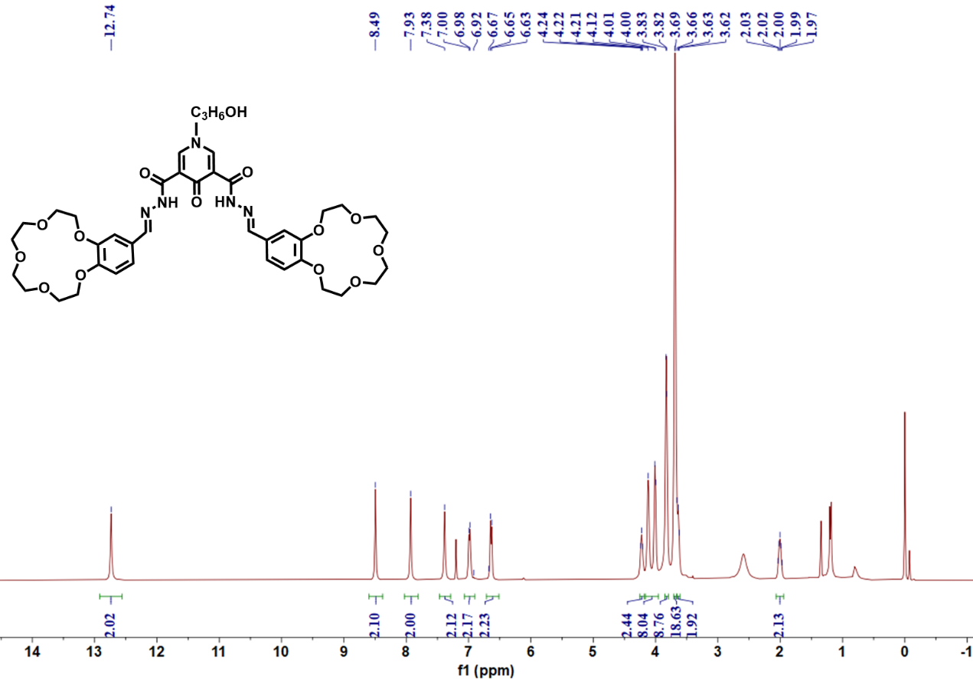
Figure S10 ¹H NMR spectrum of compound 5d (400 MHz, CDCl₃, 25°C)

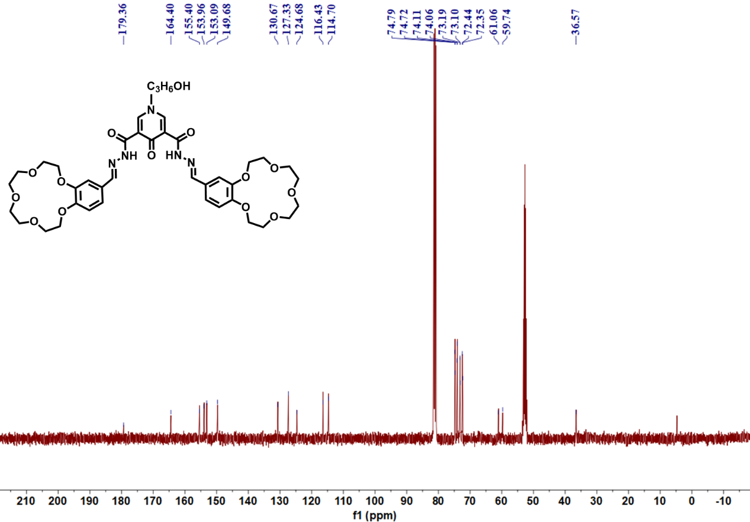
Figure S11 ¹³C NMR spectrum of compound 5d (100 MHz, CDCl₃+CD₃OD, 25°C)

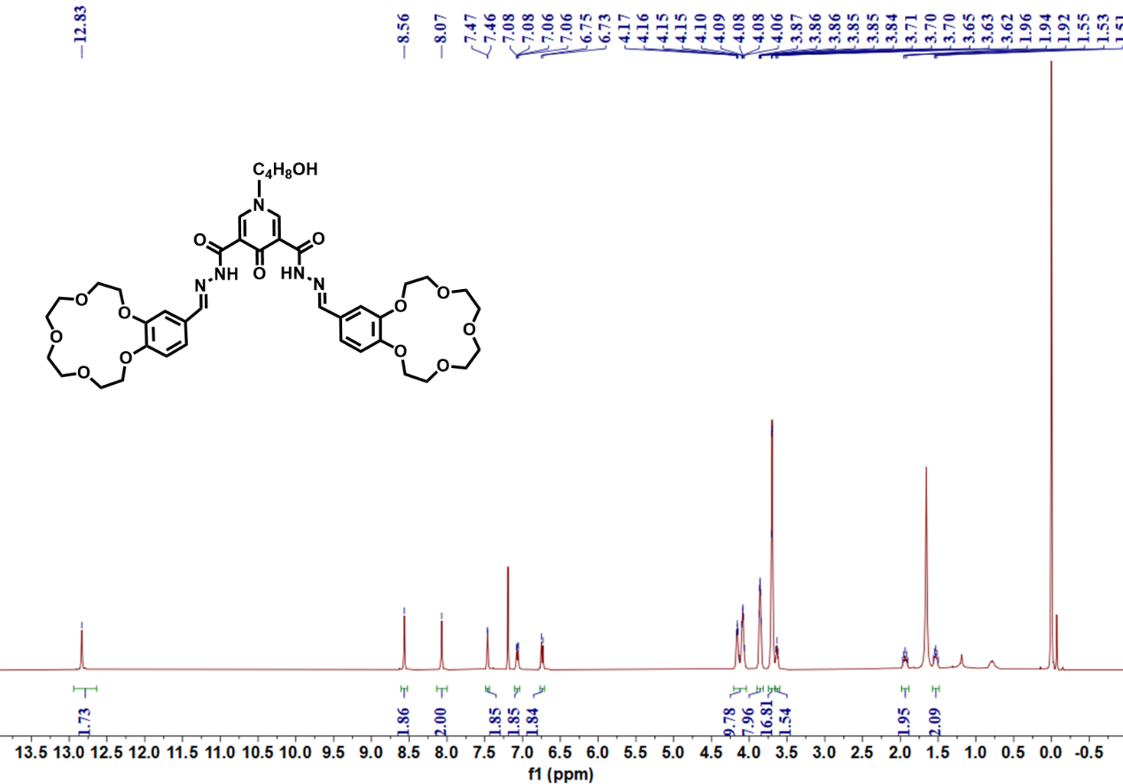
Figure S12 ¹H NMR spectrum of compound 5e (400 MHz, CDCl₃, 25°C)

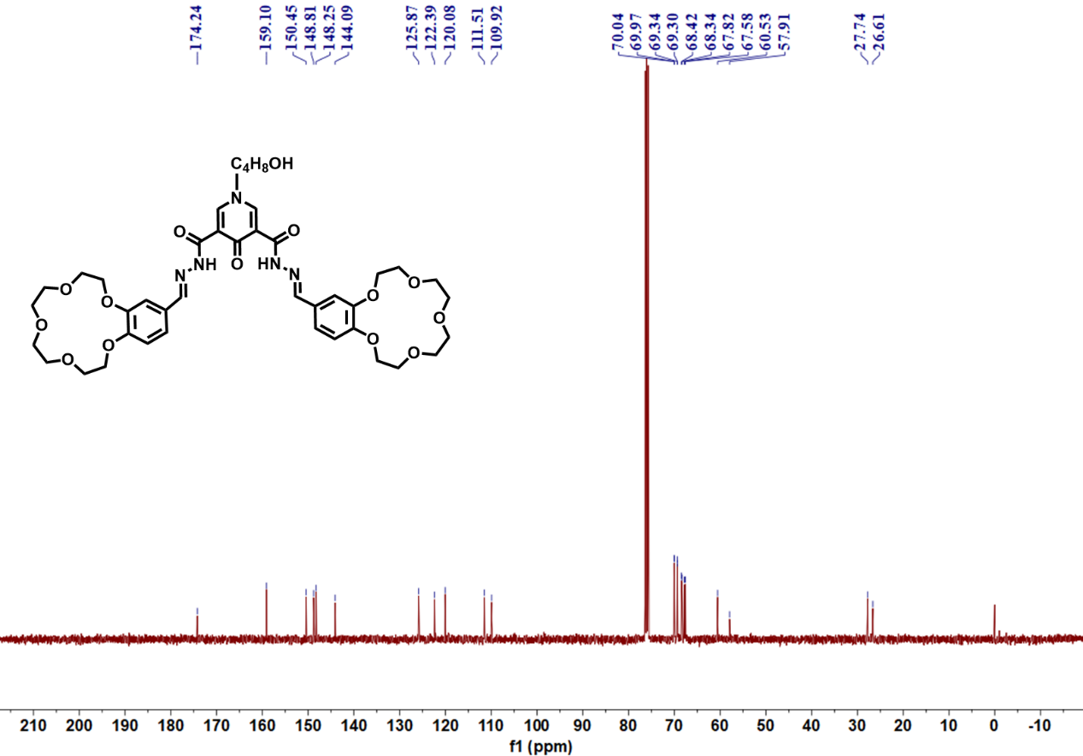
Figure S13 ¹³C NMR spectrum of compound 5e (100 MHz, CDCl₃, 25°C)

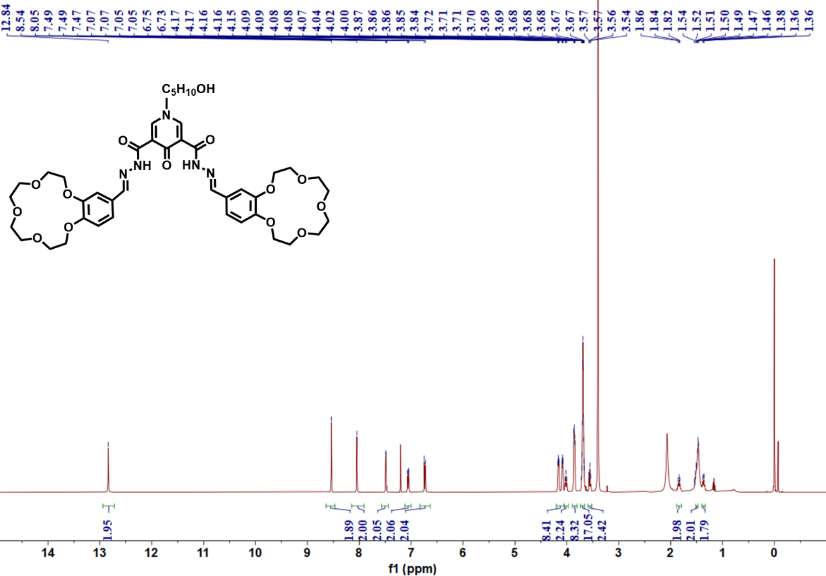
Figure S14 ¹H NMR spectrum of compound 5f (400 MHz, CDCl₃, 25°C)

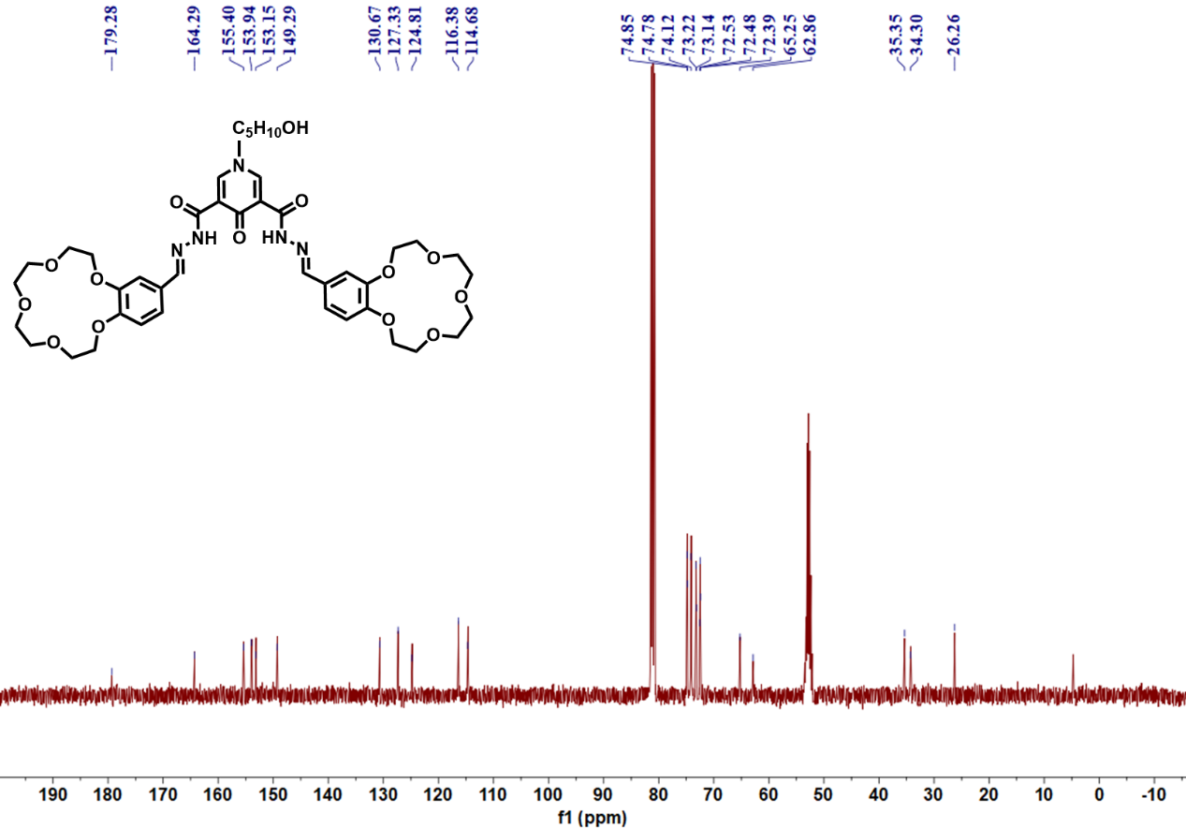
Figure S15 ¹³C NMR spectrum of compound 5f (100 MHz, CDCl₃+CD₃OD, 25°C)

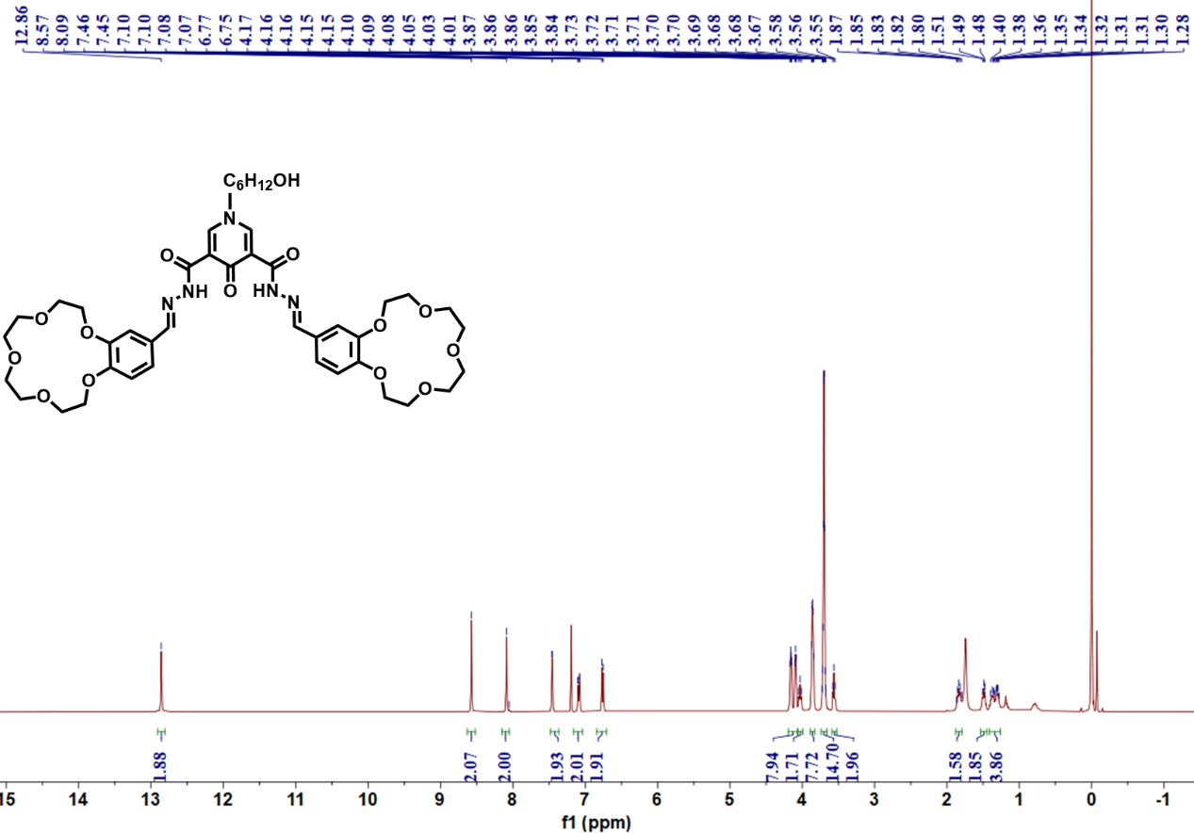
Figure S16 ¹H NMR spectrum of compound 5g (400 MHz, CDCl₃, 25°C)

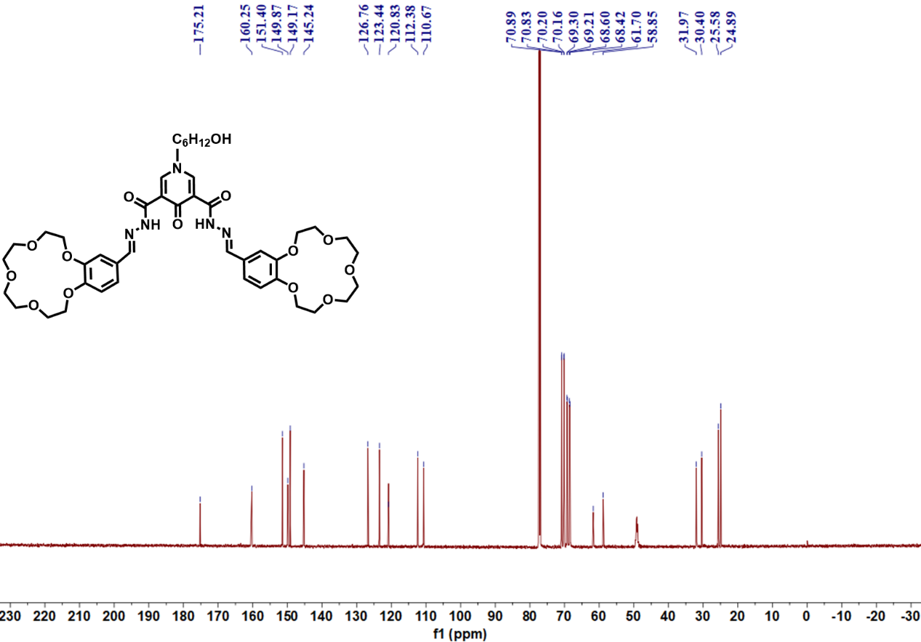
Figure S17 ¹³C NMR spectrum of compound 5g (100 MHz, CDCl₃+CD₃OD, 25°C)

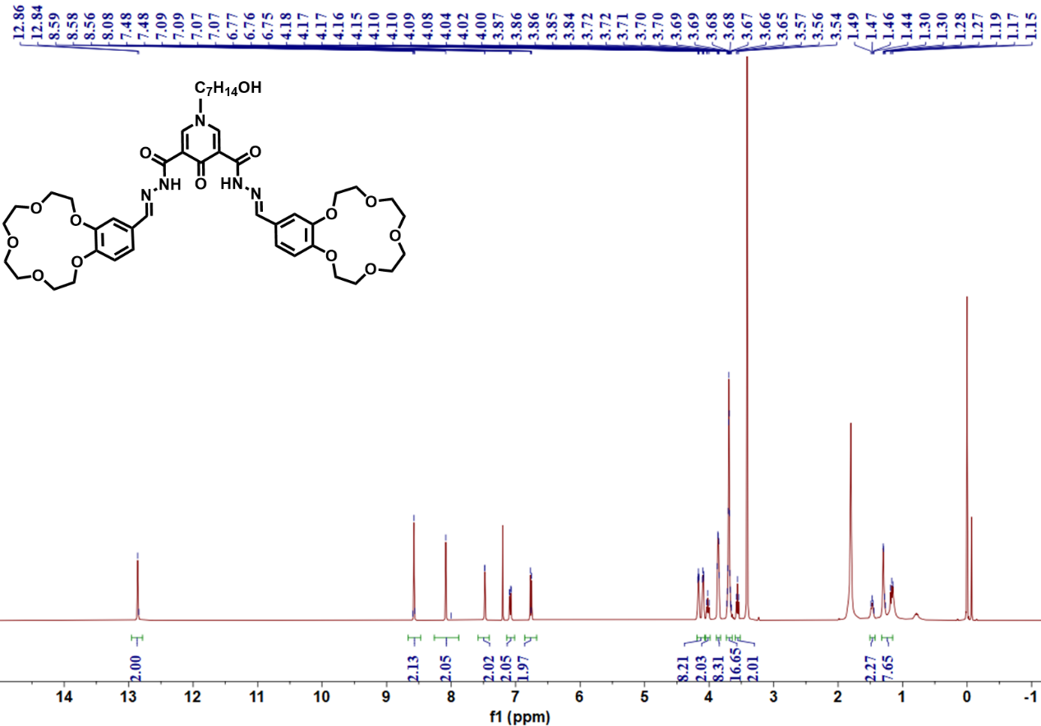
Figure S18 ¹H NMR spectrum of compound 5h (400 MHz, CDCl₃, 25°C)

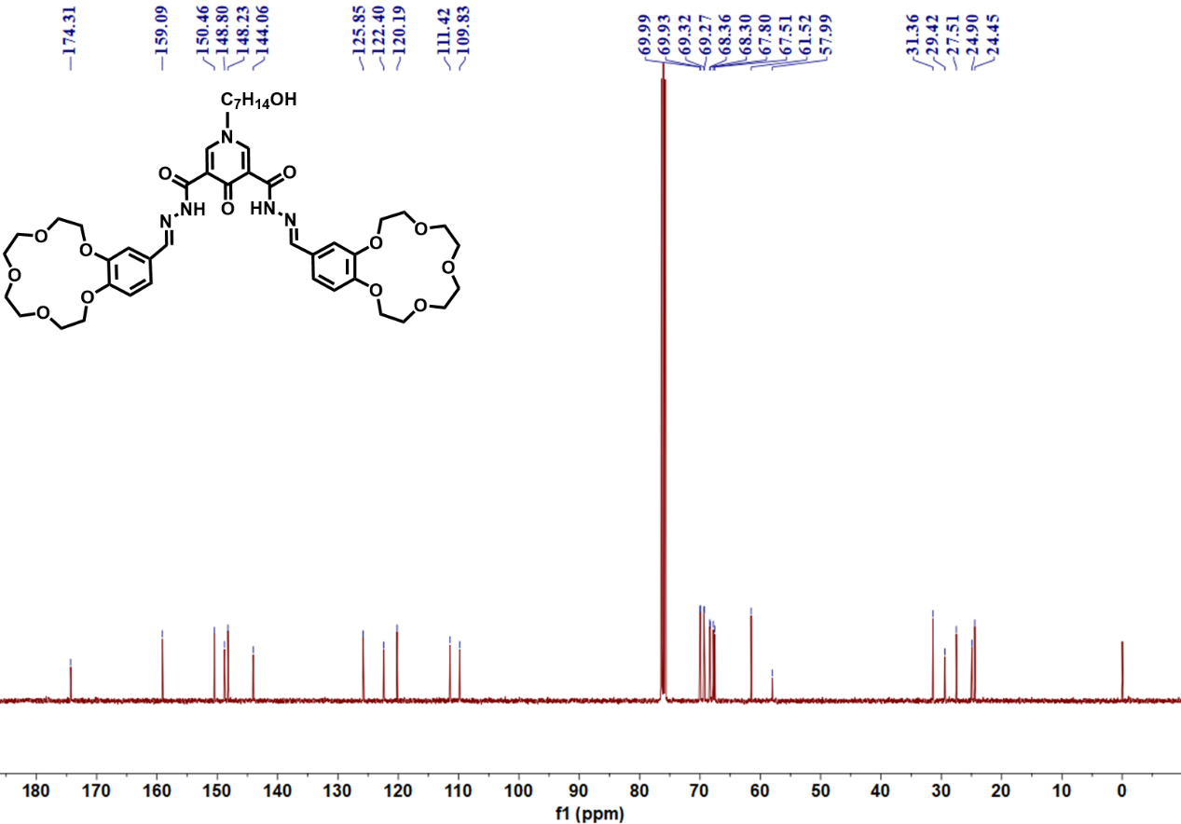
Figure S19 ¹³C NMR spectrum of compound 5h (100 MHz, CDCl₃, 25°C)

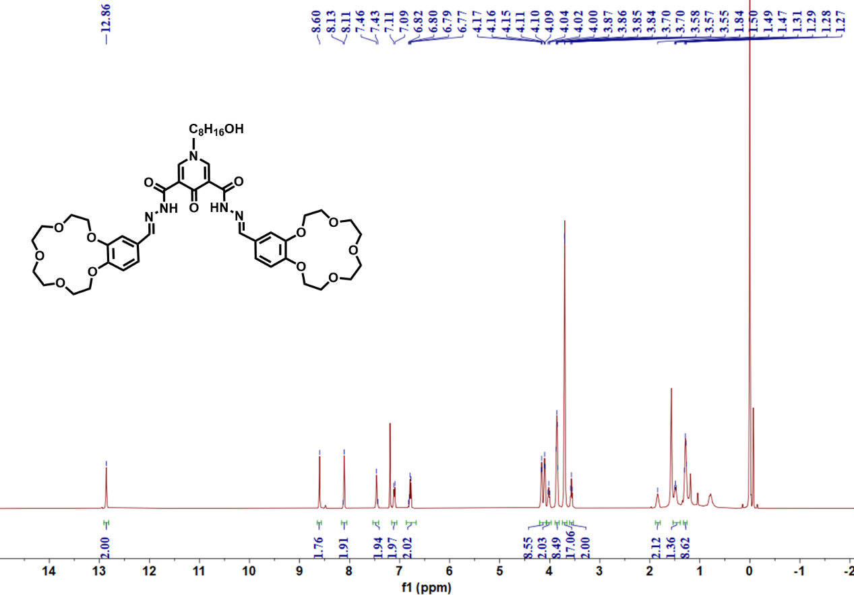
Figure S20 ¹H NMR spectrum of compound 5i (400 MHz, CDCl₃, 25°C)

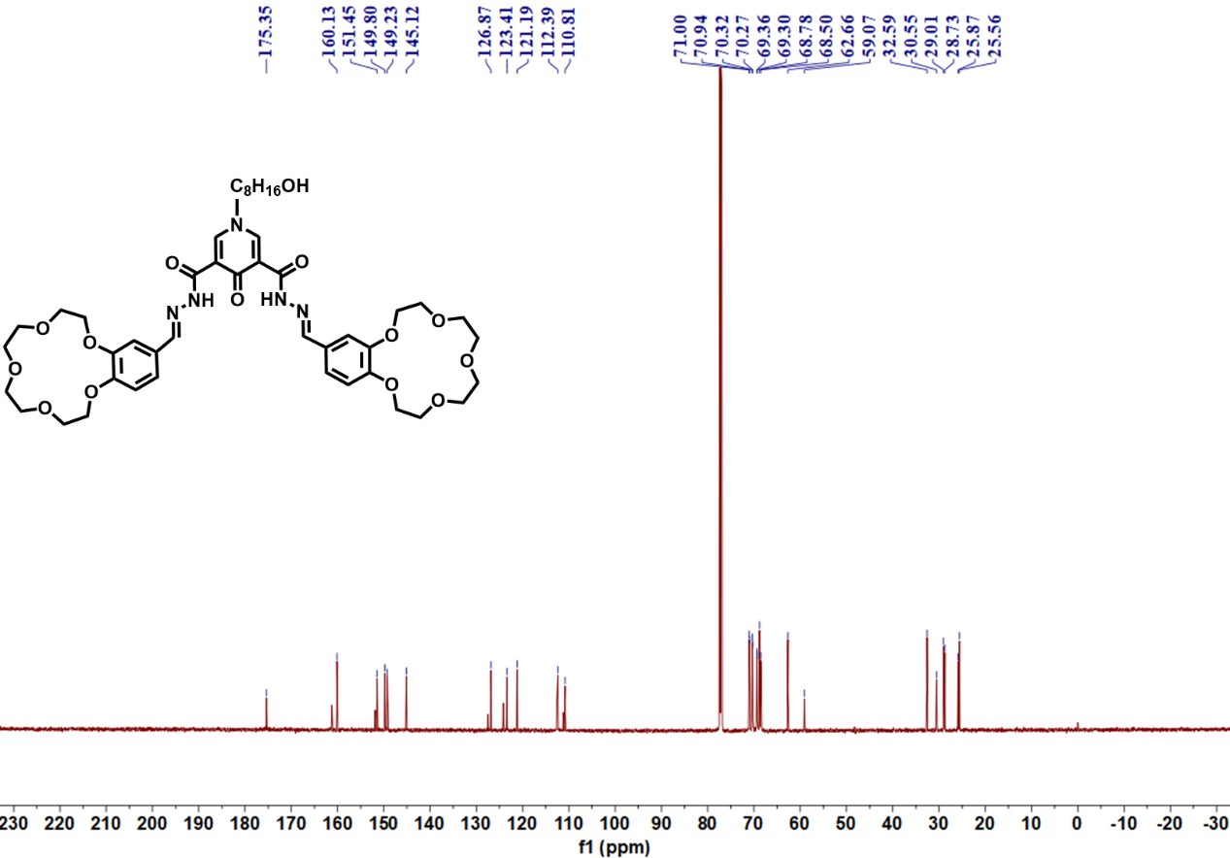
Figure S21 ¹³C NMR spectrum of compound 5i (100 MHz, CDCl₃, 25°C)

Section S3 Comparison of gelation ability of different branching chain ligands.
3.1 Comparison of gelation properties of H6-L with different equivalents of potassium salts.
5mg of the ligand was weighed out, and KPF6 was added at equivalent ratios ranging from 0.5 to 10 at 25 °C. Subsequently, 2.5 mL of acetonitrile was introduced as the solvent, and the mixture was subjected to ultrasonication for 30 seconds to prepare the gel. After standing at 25 °C for 1 hour, inversion of the vial revealed (Figure 2) that gelation occurred only when the amount of potassium salt added reached 1 eq.
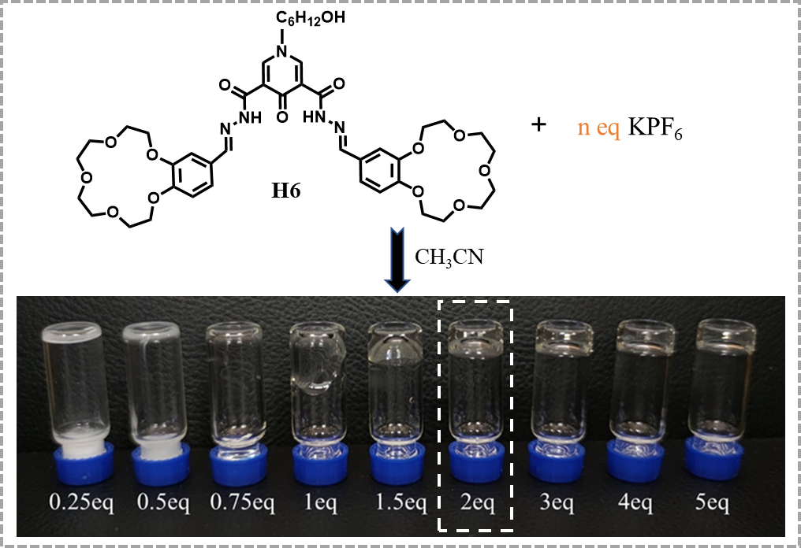
Figure S22 Gelation of the H6-L Ligand with Different Equivalents of Potassium Salt
3.2 The Effects of Branching Chain Length on Gelation.
5.8 mmol of each Hn-L ligand was weighed out, and 2 eq (11.6 mmol) of KPF6 was added. At 25 °C, 0.25 mL of acetonitrile was introduced, followed by ultrasonication of the mixture for 30 seconds to prepare the gel. After standing at 25 °C for 4 minutes, invert the vials.
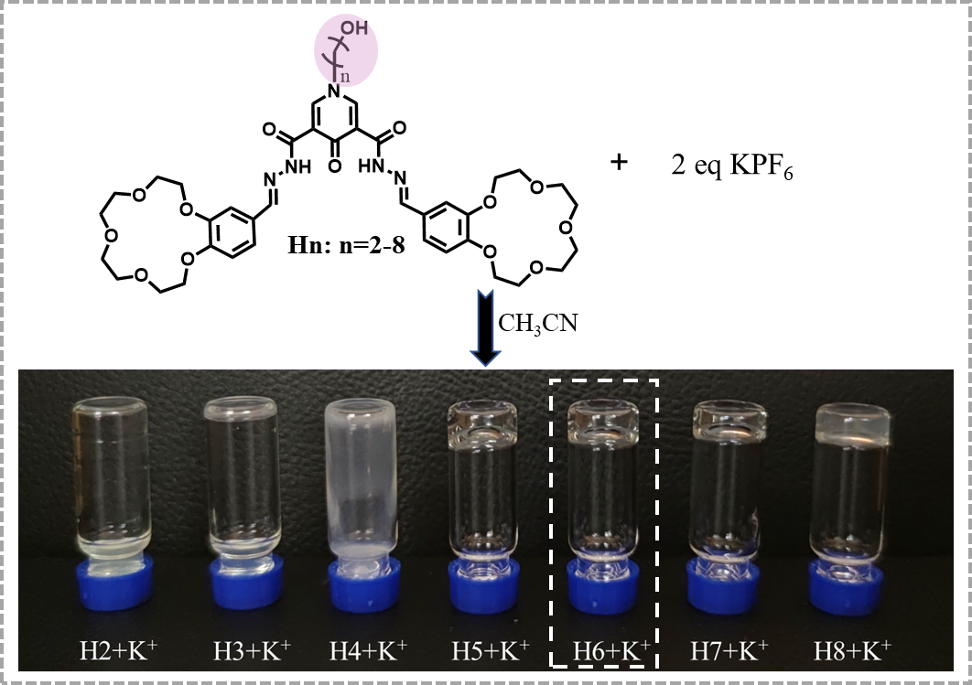
Figure S23 Gelation Behavior of Hn with Different Branching Chain Lengths
3.3 The effect of functional groups in branching chains on gel formation.
5.8 mmol of the gel ligand was weighed out respectively, followed by the sequential addition of 2eq of KPF6. At 25°C, 0.25 mL of acetonitrile was added to the mixture, which was then subjected to ultrasonication for 30s and allowed to stand for 1h before inversion.
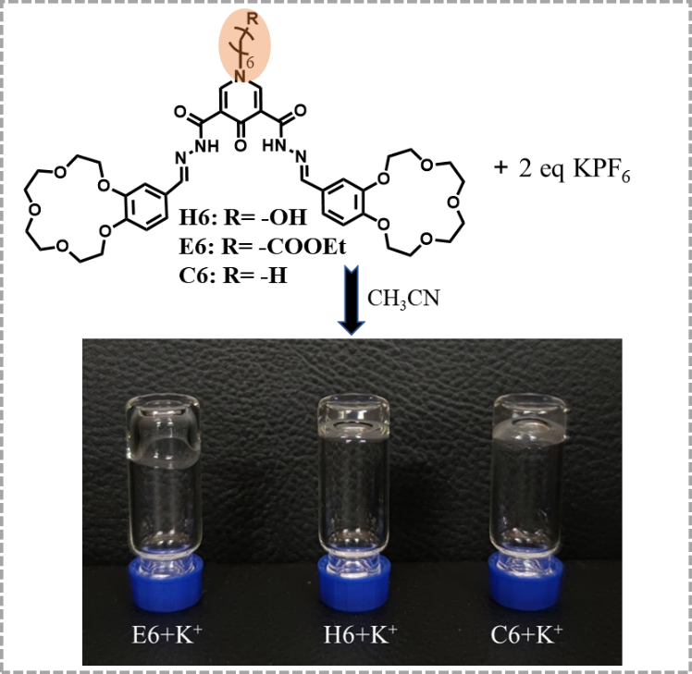
Figure S24 Comparison of Gelation with Different End Group Branching Chains
3.4 Comparative Analysis of Gelation Properties Determination of the Gel Point
The gel-sol transition temperatures of different gels were determined by heating 5 mg gel samples from 25°C to 100 °C in a one-step uniform heating procedure at a heating rate of 10 K/min, with the process conducted under an argon atmosphere purged at a constant gas flow rate of 20 mL/min.
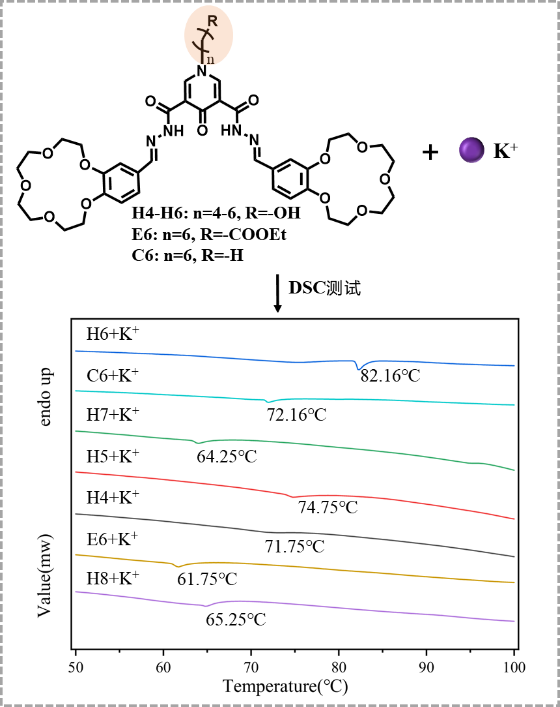
Figure S25 DSC Test Curves of Gel Samples

Section S4 Hydrogen Bond Characterization and Model Analysis of Gels

4.1 FT-IR Characterization
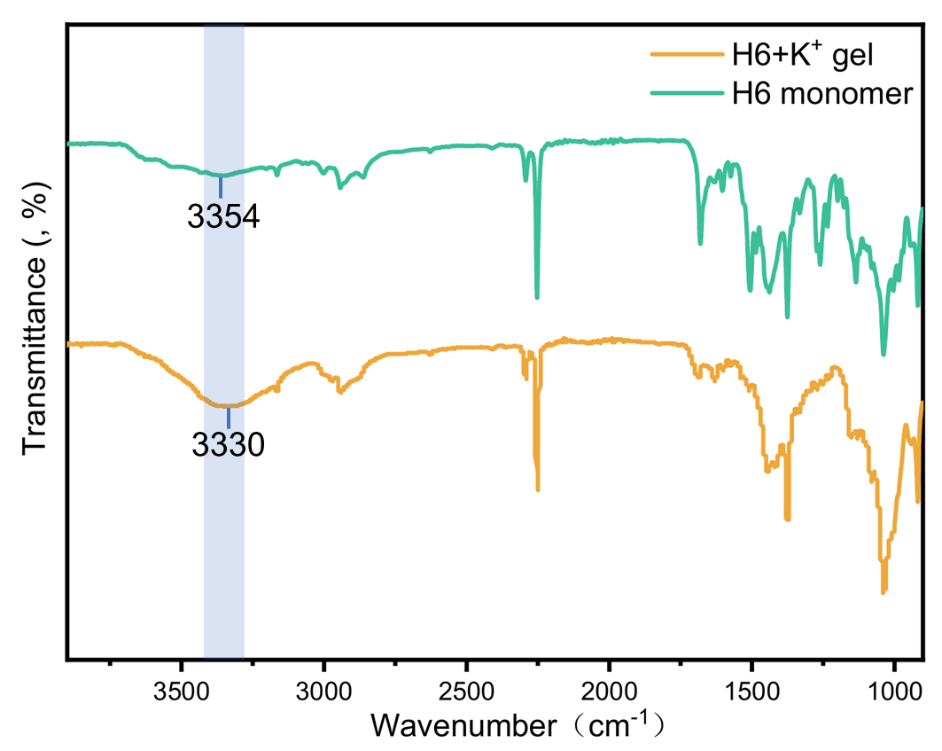
Figure S26 Fourier Transform Infrared (FTIR) Spectra of H6 Monomer and Gel
4.2 ¹H NMR Spectra Comparation And High-Resolution Mass Spectrometry
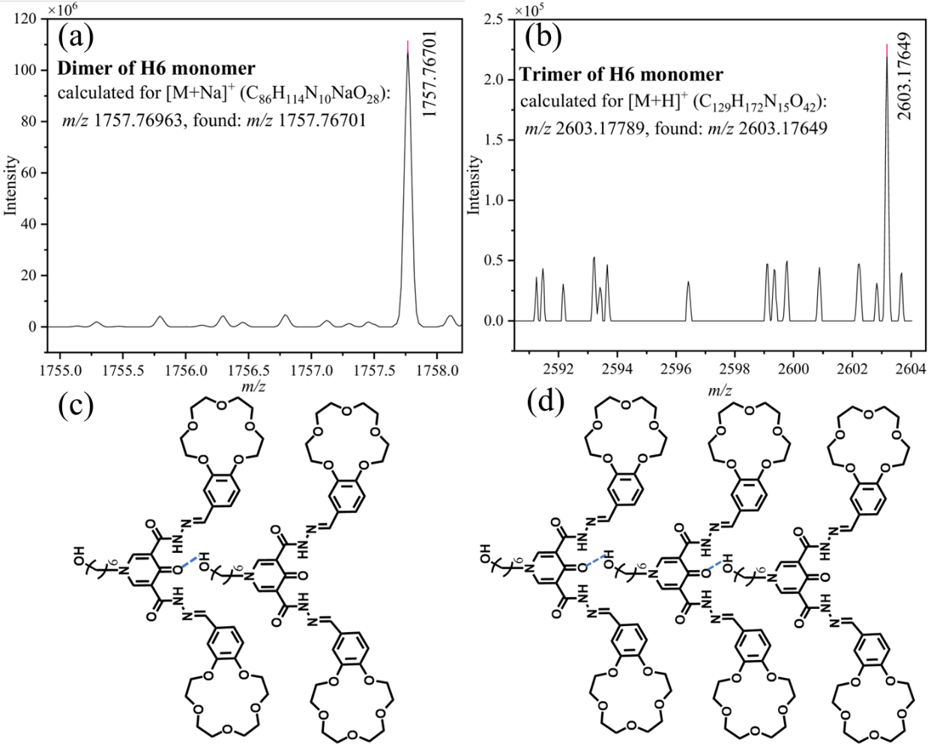
Figure S27 (a) High-resolution mass spectrum of H6 monomer and dimer (b) High-resolution mass spectrum of H6 monomer and trimer (c) Schematic diagram of the H6 monomer and dimer structure (d) Schematic diagram of the H6 monomer and trimer structure
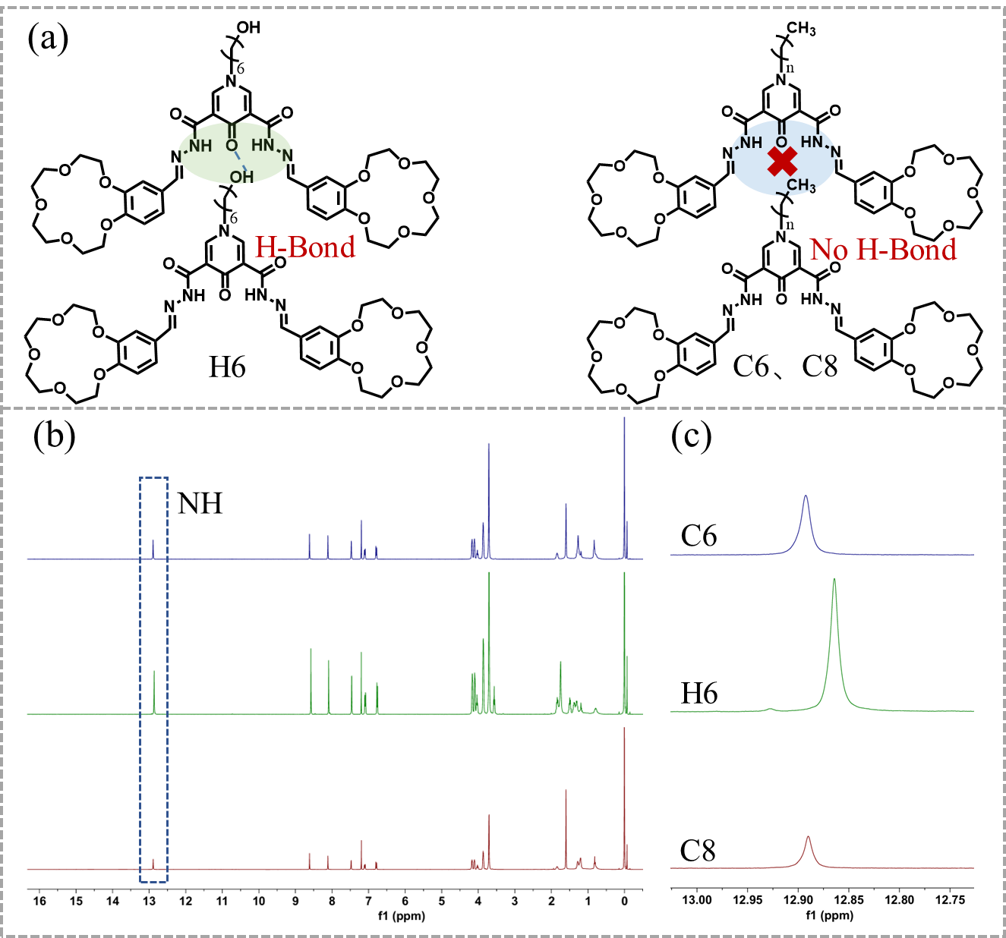
Figure S28 (a) Comparison diagram of hydrogen bond structures of H6、C6 and C8 (b) NMR spectra of C8、C6 and H6 in CDCl3 (c) Local magnification of the amide bond -NH section
4.3 SEM Characterization
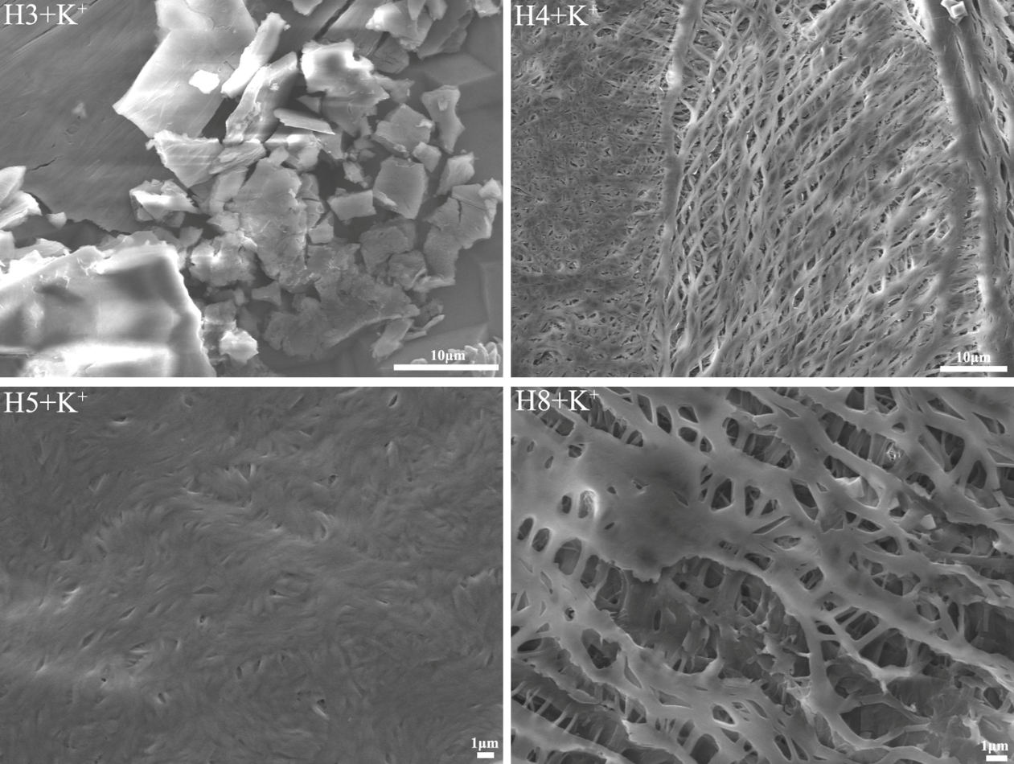
Figure S29. The SEM images of dried samples of H2、H6、C6、E6 after adding K⁺
Section S4 Gel Property Testing and Applications
4.1 Stimuli-Responsiveness Testing of Gels
Three H6+K⁺ gel samples were prepared in 5 mL sealed vials, and sequentially investigated their responsiveness to thermal, acid-base, and UV light stimuli. Specifically, one sample was placed in a programmable temperature oven with an observation window for heating; the gel response was monitored in real time, and the sample was taken out for natural cooling to room temperature after gel-sol transition to observe the state change. For another sample, a small amount of glacial acetic acid was added, followed by triethylamine solution after 1 min of standing; the vial was shaken to observe the gel state variation. The last sample was sealed, placed in a transparent beaker containing an ice-water mixture, and irradiated with a UV lamp for 10 min under a dark environment shielded from natural light. After removing the UV lamp, the sample was exposed to natural light again to record the gel state change.

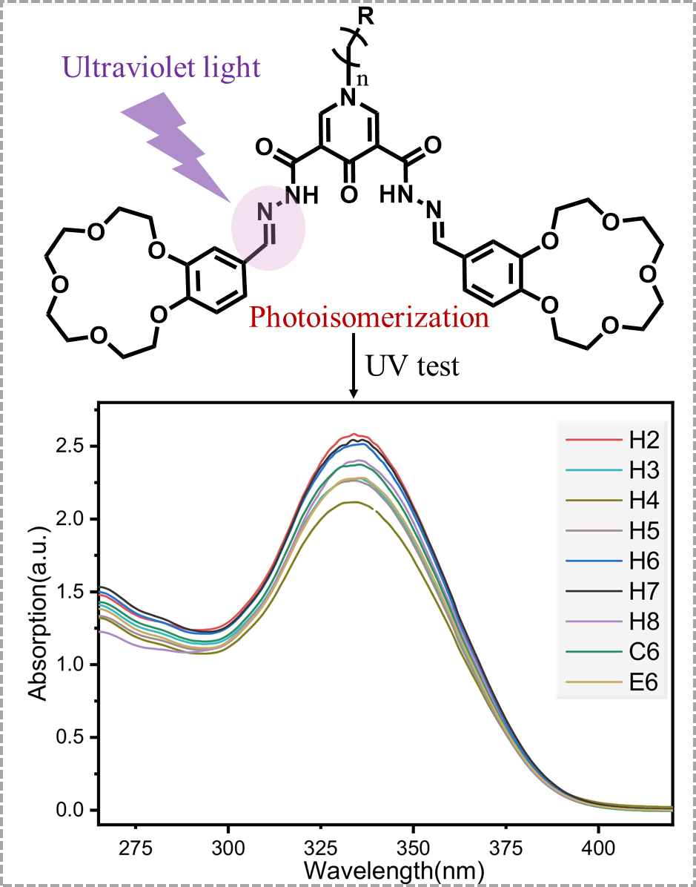
Figure S30 UV Absorption Curves of Various Gel Ligands
4.2 Characterization of Electrical Conductivity of Gels
0.148 mmol of the H4-L-H8-L、E6-L、C6-L and 2 eq of KPF₆ were weighed out, and 6 mL of acetonitrile was added to prepare the corresponding gel. Its electrical conductivity was measured at 20 °C and 60 °C conditions, respectively. First, the corresponding gel samples were prepared separately and allowed to stand for 20 min at room temperature to stabilize their gel structures. The Leici conductivity meter was turned on and calibrated with a KCl standard solution; subsequently, the conductivity electrode was rinsed with ultrapure water and dried. The electrode was inserted into the prefabricated gel samples to measure their 20 °C conductivity, and the reading was recorded after stabilization. Each sample was tested in triplicate, with the average value taken as the final conductivity. For the elevated-temperature test, the sealed samples were heated to 60 °C in a water bath and held for 20 min. The conductivity at 60 °C was measured following the same procedure as that at 20 °C. Notably, only the H6+K⁺ gel maintained a well-preserved structure, whereas all other samples disintegrated significantly into sol.
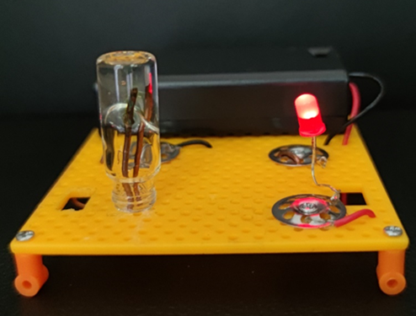
Figure S31 Conductivity of H6+K⁺ gel in a closed circuit

