Supplementary Information

Stepwise quantum chemical optimization reveals the origin of layered herringbone packing and polymorphism in polyacenes

Ryota Ono, Satoru Inoue, Kanata Koyama, Seiji Tsuzuki, and Tatsuo Hasegawa

*Correspondence to Tatsuo Hasegawa, t-hasegawa@ap.t.u-tokyo.ac.jp

Supplementary Note 1 | Crude search using the vdW contact model
In the first step of stepwise optimization, we employed a van der Waals (vdW) contact model to roughly optimize molecular positions and orientations prior to fine-tuning based on quantum chemical calculations of intermolecular interactions. In this model, all atoms are treated as rigid spheres defined by their vdW radii. The procedure is illustrated in Supplementary Figure S1. Lattice parameters (a and b) and molecular orientation angle (α) were optimized to minimize the unit cell area while avoiding overlap between the vdW spheres of atoms in neighboring molecules. Minimizing the cell area is advantageous because it enhances dispersion interactions, thereby lowering the interaction energy. In addition, avoiding vdW sphere overlap is essential due to the repulsive nature of exchange interactions. A similar procedure was applied for the crude search of interlayer stacking arrangements.

Supplementary Note 2 | Precision search using energy minimization
We calculated the total intermolecular interaction energies within both the molecular layer and the full crystal using DFT-D calculations and examined how these energies vary with changes in configuration parameters. For each optimization step, we defined appropriate calculation ranges for intralayer interactions (E_{intra(6)}, E_{intra(8)}), interlayer interactions (E_{inter(7)}), and the entire crystal (E_{int(near)}, E_{int(G1)}, E_{int(G2)}, E_{int(all)}). We then computed the sum of the interaction energies for the initial molecular arrangements generated by the vdW contact model, as well as for trial arrangements obtained by slightly perturbing each configuration parameter. The most stable arrangement—corresponding to the lowest total interaction energy—was adopted as the new starting point for the next optimization step. By repeating this iterative process, we identified locally stable arrangements corresponding to energy minima. The variation in total interaction energy was plotted as a function of each configuration parameter to construct potential energy maps. Supplementary Figure S2 illustrates the optimization of the molecular layer during the first step. In addition, comprehensive energy potential maps of E_{intra(8)} were calculated, confirming that our optimization covered all locally stable structures.

Supplementary Note 3 | Actual treatment of uniform long-axis inclination
A uniform long-axis inclination of molecules in the R-form monomolecular layer is actually treated by an operation of long-axis sliding shift ΔZ_{t} and ΔZ_{p} in the unit cell. Then the uniform long-axis inclination is presented by two variables; θ_{incl} and φ_{incl}. These are related with ΔZ_{t} and ΔZ_{p} by the following equations.
$$θ_{incl}=\cos^{-1}\left\{1/{\sqrt{1+{({(2Z_{t}-Z_{p})}/a)}^{2}+{({Z_{p}}/b)}^{2}}}\right\}$$
$$φ_{incl}=\arg\left\{{(2Z_{t}-Z_{p})}/a+i{Z_{p}}/b\right\}$$
Conversely, ΔZ_{t} and ΔZ_{p} are related with θ_{incl} and φ_{incl} by the following equations.
$$Z_{t}=\left\{sgn\left(\cos{φ_{incl}}\right)×a+sgn\left(\sin{φ_{incl}}\right)×b\left|\tan{φ_{incl}}\right|\right\}\frac{\tan{θ_{incl}}}{2\sqrt{1+\tan^{2}φ_{incl}}}$$
$$Z_{p}=sgn\left(\sin{φ_{incl}}\right)×b\left|\tan{φ_{incl}}\right|\frac{ \tan{θ_{incl}}}{\sqrt{1+\tan^{2}φ_{incl}}}$$

Supplementary Note 4 | Comparison with experimental structures
To compare the optimized molecular arrangements with experimental crystal structures, we extracted molecular displacement parameters from the crystallographic data. First, the molecular long axis and molecular plane were determined using principal component analysis. The interplanar dihedral angle between molecules in a T-shaped contact was calculated from the dot product of their normal vectors. In cases where the molecular long axes are aligned in parallel, the molecular shift was evaluated using the dot product of the unit vector along the molecular long axis and the translation vector.
We also simulated powder X-ray diffraction (XRD) patterns based on the optimized model structures for comparison with the experimental data. The reciprocal lattice was constructed from the optimized lattice vectors, and for each scattering vector, the diffraction angle, atom scattering factor, and structure factor were calculated. To facilitate comparison of diffraction angles and peak intensities, Laue’s function with N = 10,000 was employed. Additionally, the Lorentz-polarization (LP) factor, given by ${(1+\cos^{2}2θ)}/{\sin^{2}θ\cos{θ}}$, was included.

Supplementary Note 5 | Calculation of total intermolecular interactions in crystals
The intermolecular interaction energy between neutral polyacene molecules decreases rapidly with increasing distance, as it is primarily governed by a balance between attractive dispersion forces and repulsive exchange-repulsion forces. Therefore, when optimizing each stable polymorph, it is sufficient to consider only the interactions between adjacent molecules. However, to compare the energies of the resulting polymorphic structures, it is both useful and necessary to evaluate the total interaction energy—including contributions from distant molecules—using an extrapolation method.
To achieve this, we systematically classified the molecules surrounding a central molecule. The position of each molecule is expressed as a linear combination of the lattice vectors, where the coefficients are integers or half-integers within our defined parameter space. Taking advantage of the periodicity of the crystal lattice, we classified molecules based on their L1 norm—that is, the sum of the absolute values of the coefficients in the lattice vector representation of the displacement between molecules. The coordinates of the type X molecules are given by:
$$V=la+mb+nc$$
where l and m are integers or half-integers, n is an integer, and a and b are the intralayer lattice vectors, while c is the interlayer lattice vector. The classification criteria are as follows:
1. $\left|l\right|+\left|m\right|=X$ and $n=0$ (intralayer molecules),
2. $\left|l\right|+\left|m\right|+\left|n\right|=X+1$(for $\left|n\right|≠0$ and $\left|l\right|+\left|m\right|>0$; interlayer molecules),
3. $\left|l\right|+\left|m\right|=0$ and $\left|n\right|=X$ (molecules directly above or below the central molecule).
This method enables the systematic classification of molecules in the crystal according to their intermolecular distances, by leveraging the discrete and periodic nature of molecular positions, as illustrated in Supplementary Figure S10.

Supplementary Figure S1 | Geometric search for initial molecular arrangements
a Schematic illustration of the geometric search procedure used to generate initial molecular arrangements at each α. (1) A basic molecular pair is constructed with an angle α using a glide symmetry operation. (2) A polar coordinate system (R, β) is introduced to describe the relative configuration of the pair. (3) The van der Waals (vdW) contact distance, R_{vdW}, is determined for each β. (4) Additional molecules are generated via translational operations to form a monomolecular layer, with the intralayer lattice constants a and b defined for each β as: a = 2 R_{vdW} cosβ, and b = 2 R_{vdW} sinβ. b Plot of unit cell area (S = a×b) as a function of β for 2α = 50°. Solid curves indicate that the interatomic distances between adjacent slipped-parallel molecules exceed the vdW contact distances, while dashed curves indicate overlapping between adjacent slipped-parallel molecules. Initial molecular arrangements satisfying the vdW contact condition are marked with red and blue dots, and the corresponding structures are shown in the in the right panel. c Similar plots of S versus β for various values of α (5°, 15°, 25°, 35°, and 45°), showing that the local minimum at β = 45° becomes more pronounced as α approaches 45°. d Illustration of the eight nearest-neighbor interactions within the intralayer structure, consisting of four T-shaped and four slipped-parallel contacts.

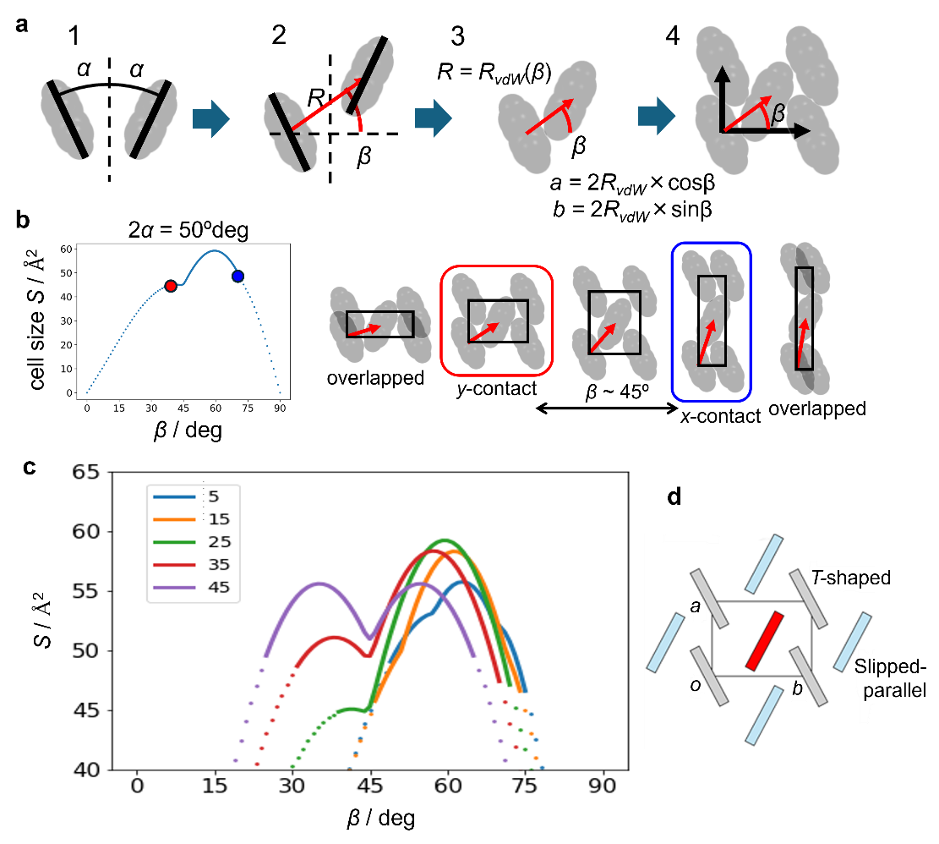

Supplementary Figure S2 | Minimization of the sum of intermolecular interaction energies for pentacene monomolecular layers
a−c Left panels: Geometric search for initial molecular arrangements. Plots of unit cell area (S = a×b) as a function of β. Center panels: Lattice energy minimization results using the hill-climbing approach. Right panels: Potential energy maps of E_{intra(8)} (limited to values < −40 kcal/mol), highlighting regions of favorable molecular arrangements. Each lower right panel shows E_{intra(8)} plotted as functions of a along the local energy valleys indicated in the corresponding upper panel. These calculations were performed for the pentacene monomolecular layer at (a) α = 25°, (b) 35°, and (c) 45°, illustrating how E_{intra(8)} varies with molecular arrangement across different α values. In the calculation of E_{intra(8)}, three of the eight intermolecular interactions (one T-shaped and two slipped-parallel contacts) are independent due to the molecular symmetry of the polyacene backbone and the symmetry of the arrangements.

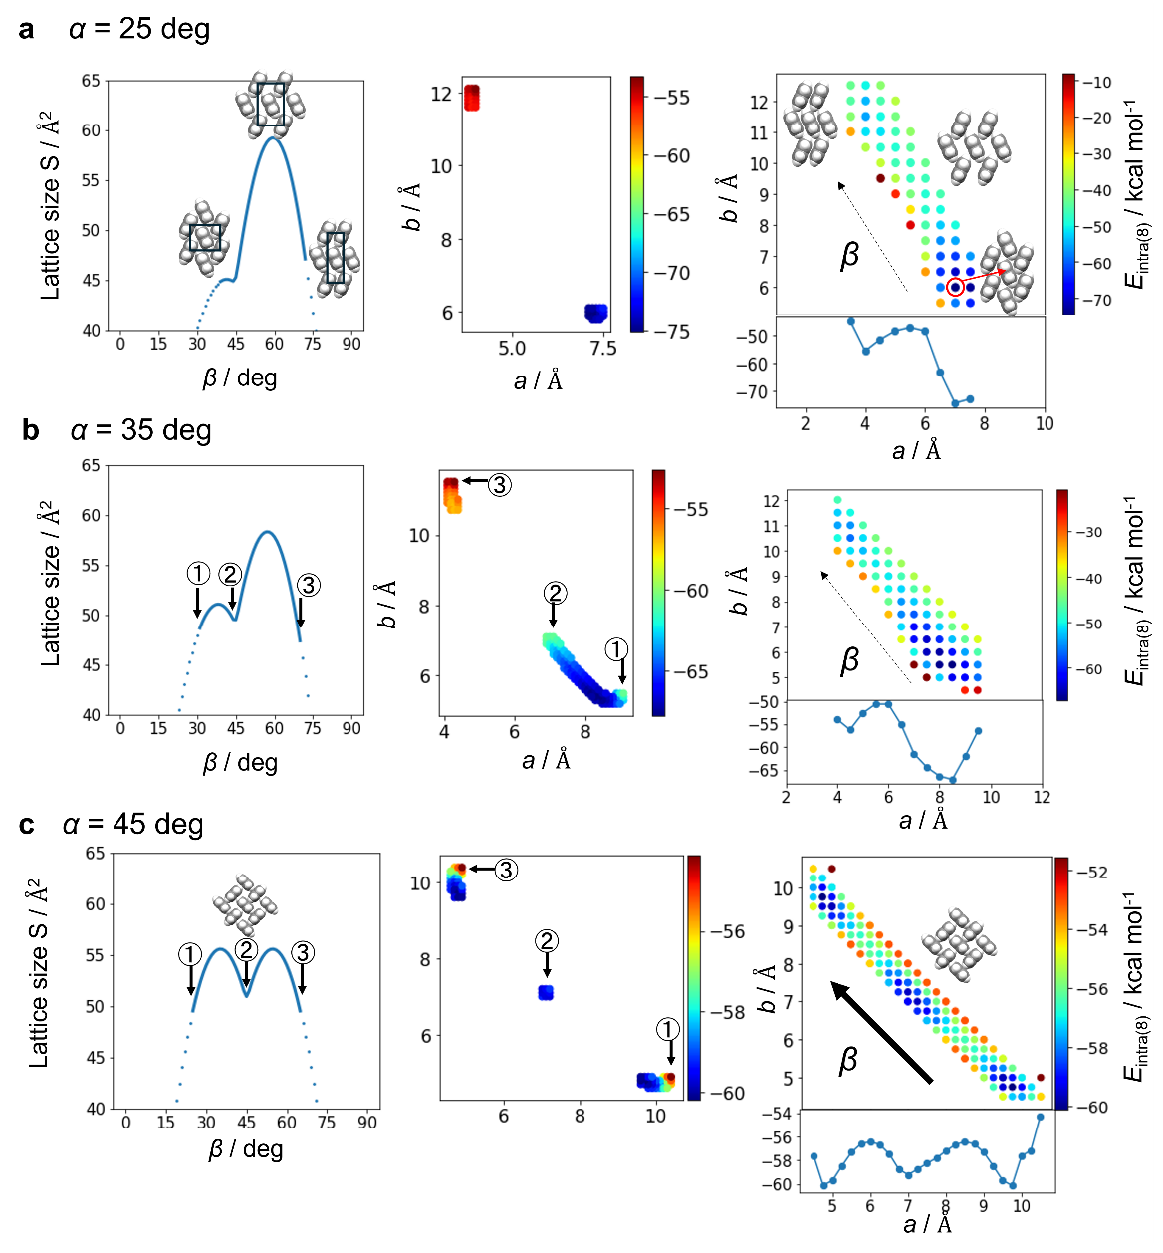

Supplementary Figure S3 | Supplementary data for optimization of regular intralayer molecular arrangements in polyacenes
a Similar plots to Fig. 2b, which was for pentacene, are shown here for naphthalene, anthracene, tetracene, and hexacene. The intralayer interaction energy E_{intra(8)} of stable and metastable molecular arrangements is plotted as a function of α. The lattice parameters a and b were optimized for each value of α. HB, PS, and CH packing motifs are shown in red, blue, and green, respectively. b Optimized lattice constants a and b for HB (left panel) and PS (right panel) packings of pentacene as a function of α. Triangles and squares indicate the intermolecular distances between the directly contacted slipped-parallel pairs and the distances between the second-nearest slipped-parallel pairs, respectively. c Radar chart showing the calculated intermolecular interactions among eight adjacent molecules in the CH packing of pentacene. d Dependence of SAPT energy and molecular polarizability on the number of fused rings. The left panel shows the variation in SAPT total interaction energy for slipped-parallel pairs in the PS packing and T-shaped pairs in the HB and CH packings. The central panel presents the decomposition of interaction energy and its dependence on ring number. The right panel displays the ring-number dependence of molecular polarizability.

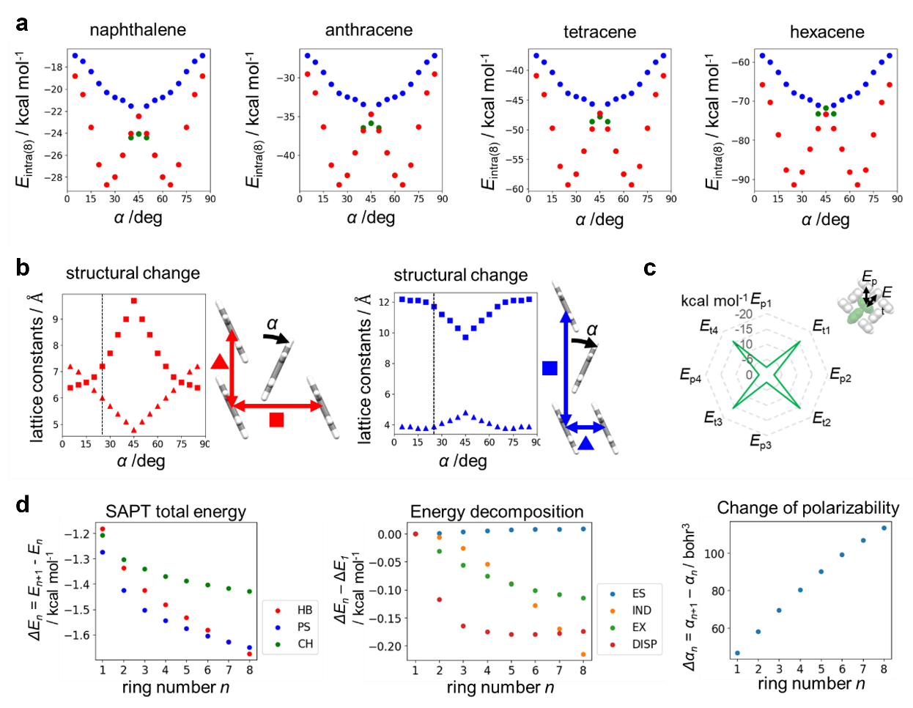

Supplementary Figure S4 | View of metastable HB and PS packing at each α
Comprehensive view of stable (shown by red filled circles at α < 45° in Fig. 2B) and metastable (blue filled circles at 45° < α in Fig. 2B)) intralayer molecular arrangements optimized at each α for pentacene, viewed along the molecular long axes.

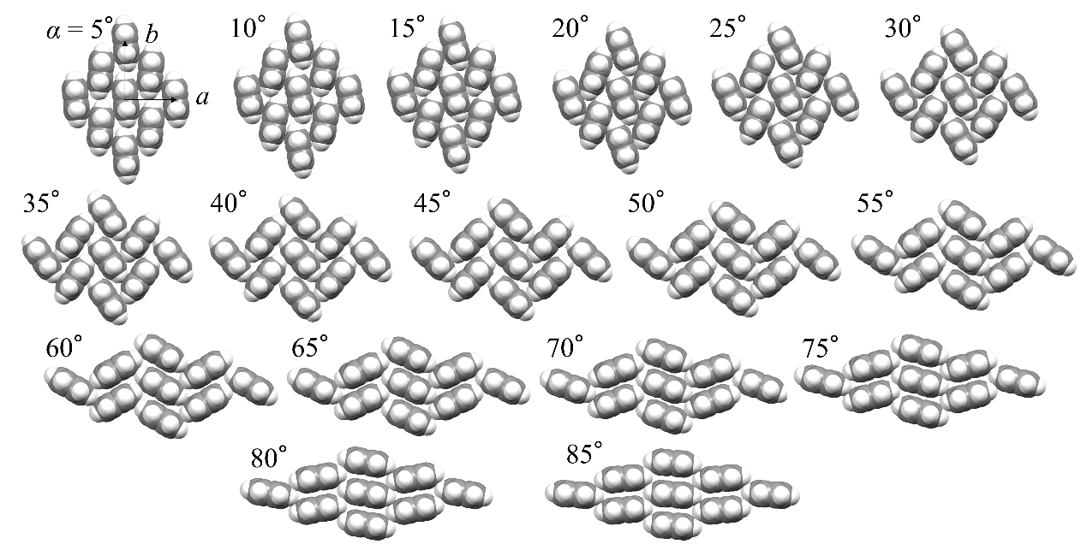

Supplementary Figure S5 | Similar plots with Fig. 5b for pentacene
E_{intra(6)} landscape for the monomolecular layers of naphthalene, anthracene, tetracene, and hexacene, with varying φ_{incl} and θ_{incl}.

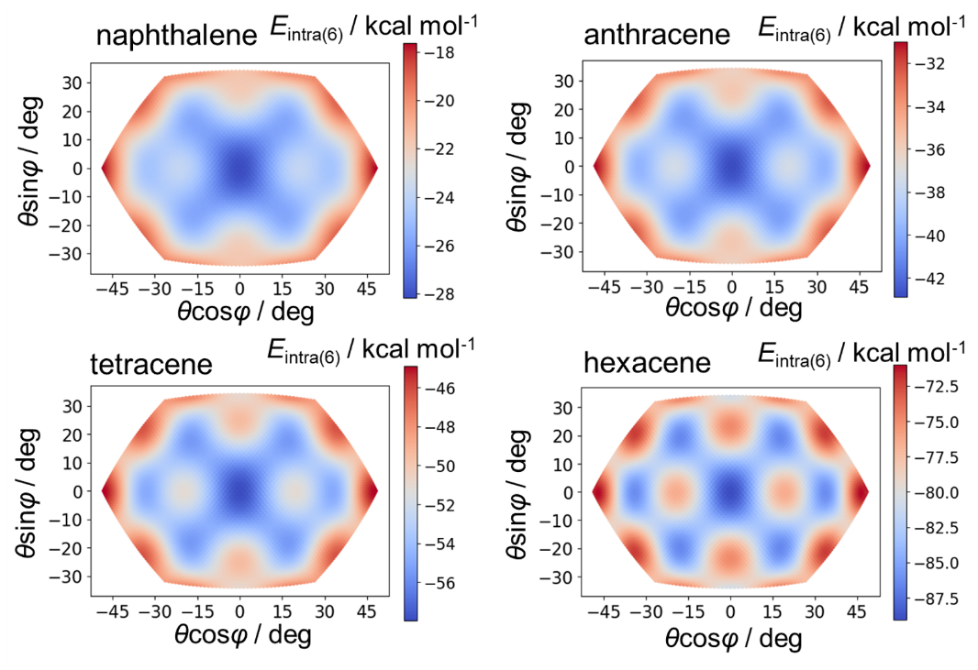

Supplementary Figure S6 | Origin of metastability in intralayer molecular arrangements due to uniform long-axis inclination
a Schematic representation of the relative long-axis sliding between six neighboring molecules in the locally stable N and G forms, as well as in an unstable arrangement at φ_{incl} = 90° and θ_{incl} ≈ 25° in pentacene. The potential map is the same as in Fig. 5B. In the N form, a one-ring-length misalignment occurs at the T-shaped contacts between two adjacent molecules, while in the G form, the same misalignment occurs between four adjacent molecules. b Variation in interaction energy as a function of long-axis sliding at T-shaped contacts (left panel) and slipped-parallel contacts (right panel).

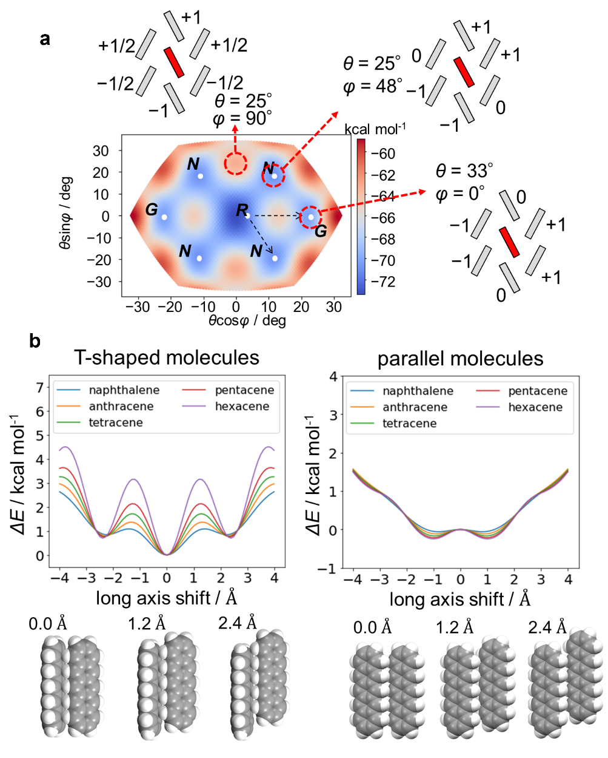

Supplementary Figure S7 | Optimization of interlayer stacking arrangements
Illustration of the relationship between a molecular pair in a T-shaped contact and the surrounding molecules in the neighboring layer. Center: Relative positions of a molecular pair in a T-shaped contact and the surrounding molecules in adjacent layer. Left: The central molecule (red) and its seven nearest neighbors in the adjacent layer (the closest molecule and its six surrounding neighbors), viewed along the molecular long axis. Right: The molecule forming the T-shaped contact (blue) and its seven nearest neighbors in the adjacent layer (the closest molecule and its six surrounding neighbors), also viewed along the molecular long axis. Due to translational symmetry, four of these pairs exhibit equivalent positional relationships (as shown in the lower part of the figure), resulting in ten unique molecular pairs used to calculate the interlayer interaction energy, E_{inter(7)}. In the Type-III structure, which preserves glide symmetry, five of these molecular pairs are symmetry-equivalent. As a result, the interlayer interaction energy is calculated from five unique molecular pairs: two T-shaped contacts and three slipped-parallel contacts.

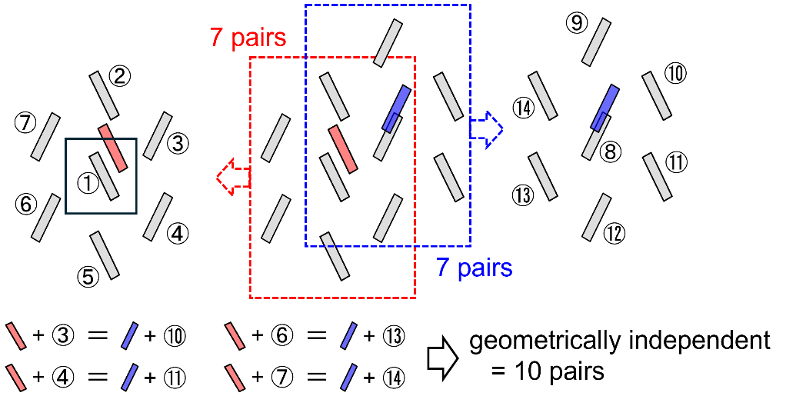

Supplementary Figure S8 | Optimization with additional non-uniform long-axis inclination
a Schematic for independent long-axis inclination of molecule in the unit cell. φ’_{incl} and θ’_{incl} are the inclination direction within the layer plane and the inclined angle from the normal to the layer surface, respectively. b Variation of calculated interaction energy (E_{intra(6)}) at arbitrary independent long-axis inclination with φ’_{incl} and θ’_{incl} for tetracene monomolecular layer. c Variation of calculated interaction energy (E_{int(near)}) by independent long-axis inclination for the interlayer stacking at N₁ (Type II, blue filled circle) and at N₂ (Type IV, red filled circle). d Variation of interaction energy (E_{int(near)}) for Type II and Type IV stacking in tetracene, pentacene, and hexacene, with and without the optimization by additional independent long-axis inclination.

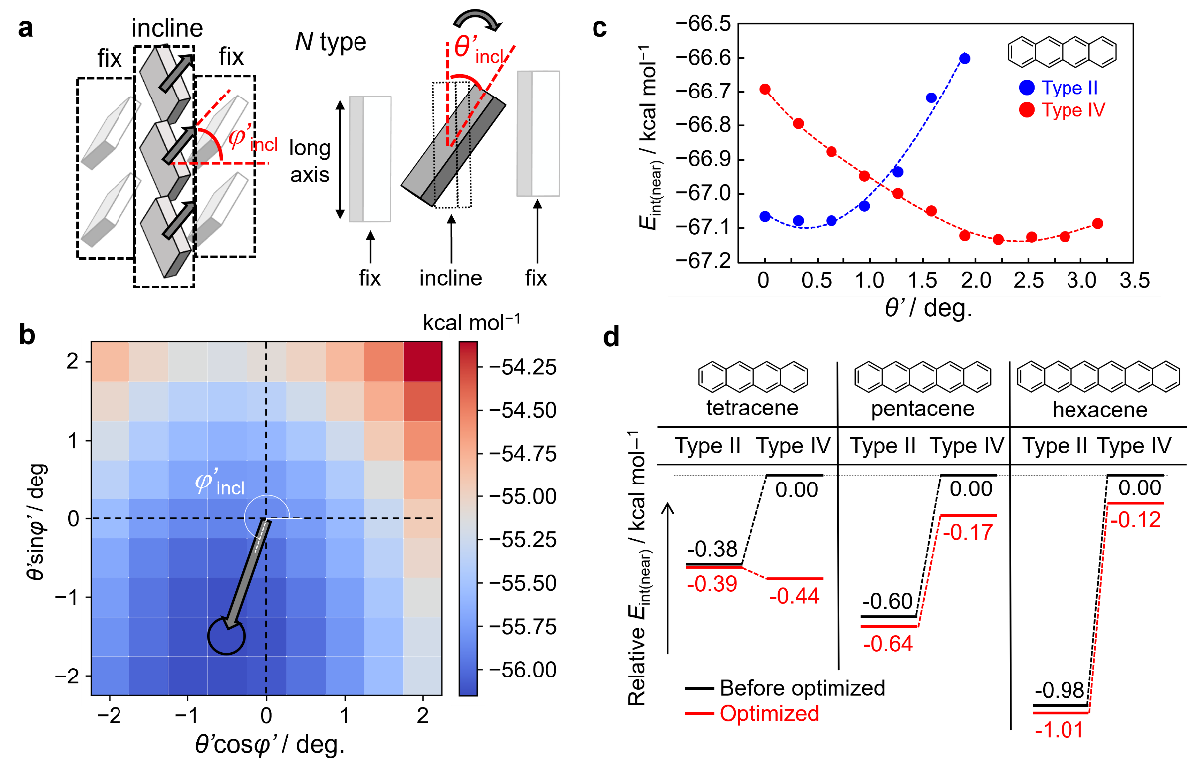

Supplementary Figure S9 | Difference between calculated R-form and actual crystal lattices of pentacene
a View along b axis, and b view along molecular long axis. c Calculated unit cell volume at the vdW contacts. Slight difference is observed in both the intralayer molecular arrangements and the stable interlayer stacking arrangements. d Calculated intralayer interaction energy (E_{intra(6)}), plotted as a function of θ_{incl} at φ_{incl} = 105°. e Calculated interlayer interaction energy (E_{inter(7)}), plotted as a function of y shift along the minimum valley in (c).

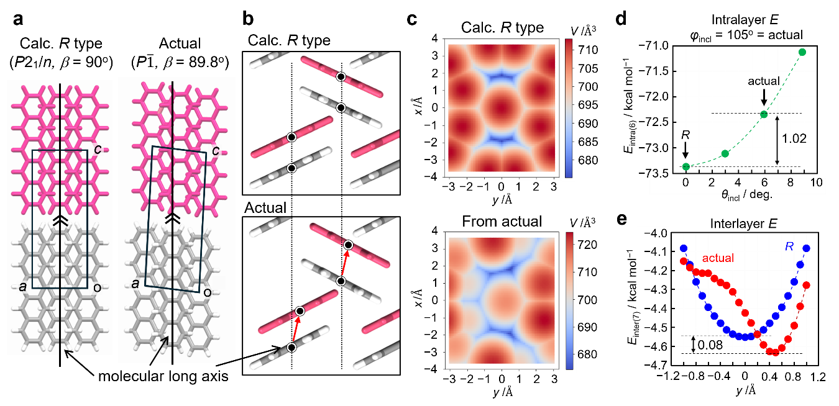

Supplementary Figure S10 | Schematic illustration of molecular groups used for the intermolecular interaction calculation
a Schematic illustration of molecular groups within the same layer—nearest neighbors, second-nearest neighbors, and third-nearest neighbors—shown in light blue, purple, and blue, respectively, and viewed along the molecular long axis. b Schematic illustration of molecular groups spanning both the same and adjacent layers, including nearest neighbors, second-nearest neighbors, and third-nearest neighbors. Molecules in the nearest-neighbor layer, second-nearest-neighbor layer, and third-nearest-neighbor layer are shown in light blue, purple, and blue, respectively.

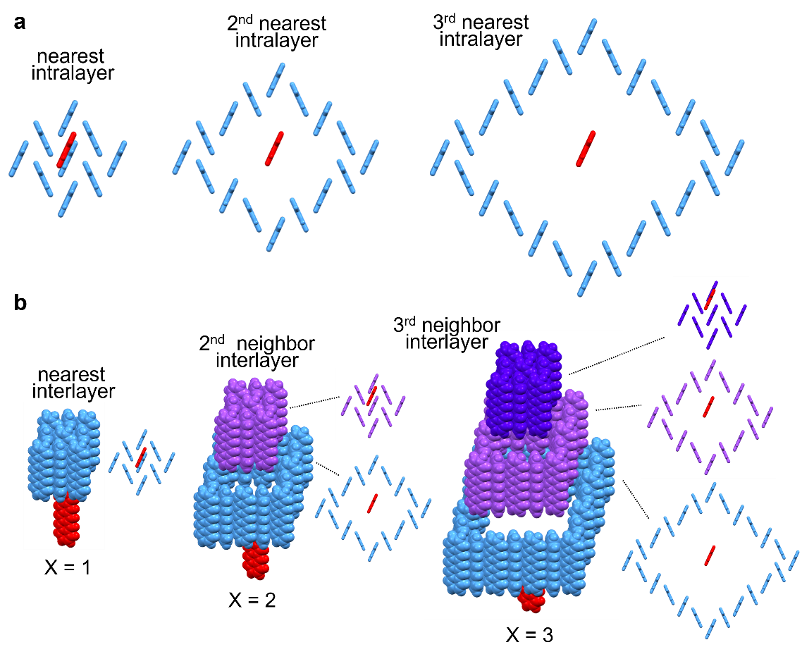

Supplementary Figure S11 | Calculation of total intermolecular interaction energy and its convergence behavior when long-distance intermolecular interactions are considered
Plots of the sums of intermolecular interaction energies as a function of X, the classification index representing the distance between the central molecule and its surrounding molecules as depicted in Supplementary Figure S10, for a naphthalene, b anthracene, c tetracene, d pentacene, and e hexacene. Dashed curves indicate the fitting exponential curves used to estimate the convergence behavior and total intermolecular interactions across the entire crystal.

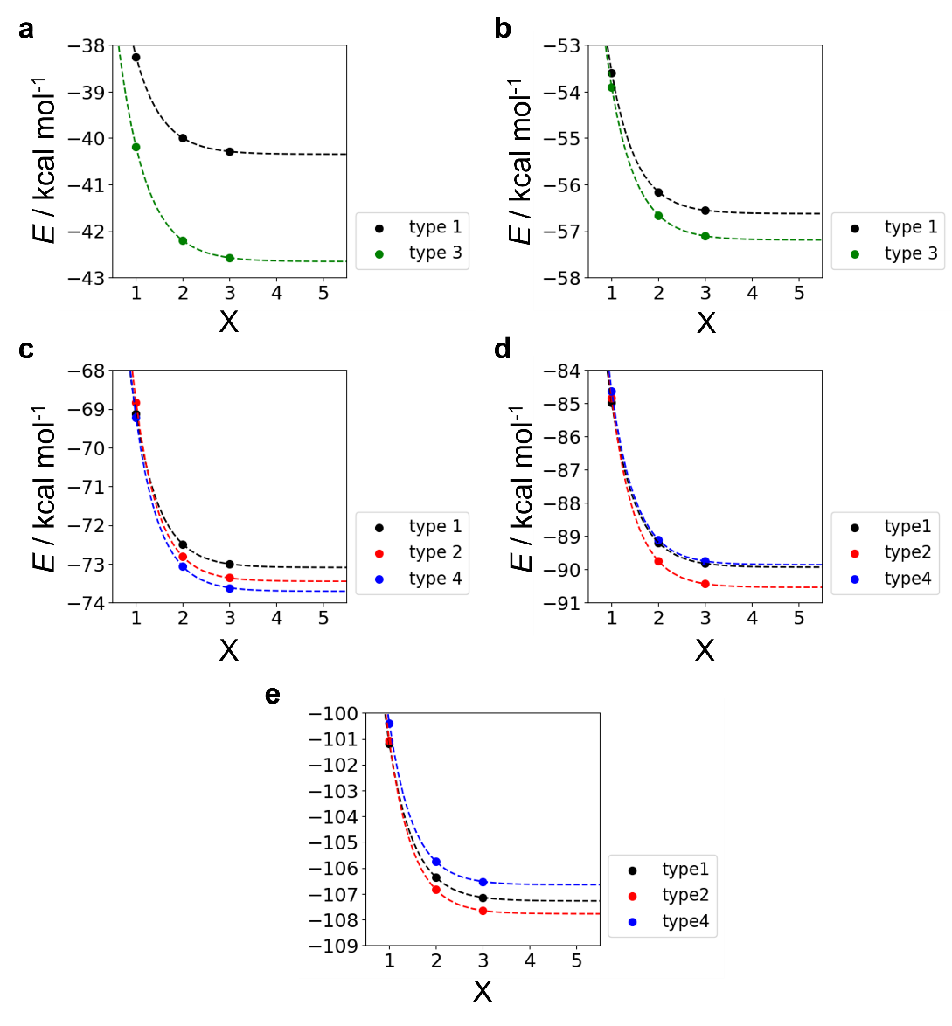

Supplementary Table S1 | Comparison of parameter values between experimental and optimized structures for naphthalene and anthracene
The optimized parameters were obtained by stepwise optimization calculations that reproduce the Type III structures of naphthalene¹⁸ and anthracene¹⁹. The final parameter values were refined by applying a long-axis twist operation under glide symmetry (see Fig. 7). These optimized values are compared with those extracted from the experimental crystal structure analyses.
Note: The parameters a and b here do not correspond to the crystallographic lattice constants. The consistency between the lattice parameters and molecular orientations in the experimental crystal structure and the optimized models is further discussed through the comparison of simulated and experimental powder XRD pattern in Fig. 8.

 |  | a /Å | b /Å | α /deg | θ_{twist} /deg | ΔZ_{T} /Å | x /Å | y /Å | z /Å
Naphthalene  Type III | exp | 5.9 | 7.4 | 65 | 13 | 1.5 | 0.0 | 1.7 | 8.4
Naphthalene  Type III | calc | 5.8 | 7.5 | 65 | 13 | 1.6 | 0.0 | 1.6 | 8.4
Anthracene  Type III | exp | 6.0 | 7.5 | 65 | 8.3 | 1.9 | 0.0 | 1.5 | 11.0
Anthracene  Type III | calc | 5.9 | 7.5 | 65 | 8.0 | 2.0 | 0.0 | 1.5 | 10.9

Supplementary Table S2 | Comparison of parameter values between experimental and optimized structures for tetracene, pentacene, and hexacene
The optimized parameters were obtained by stepwise optimization calculations that reproduce the Type I and IV structures of tetracene^{14,16}; the Type I, II, and IV structures of pentacene^{15,16,20}; and the Type II structure of hexacene¹⁷. The parameters for the Type I structures were derived from a regular intralayer molecular arrangement (Fig. 2). The Type II structure parameters were refined by applying a uniform long-axis inclination (Fig. 5), while those for the Type IV structure were optimized through a non-uniform long-axis inclination (Supplementary Figure S8). These optimized values are compared with those extracted from experimental crystal structure analyses.

 |  | a /Å | b /Å | α /deg | θ_{incl} /deg | φ_{incl} /deg | θ’_{incl} /deg | x /Å | y /Å | z /Å
Tetracene  Type I | exp | 7.6 | 5.9 | 27 | 5.7 | -82 | 1.2 | 1.9 | 0.5 | 13.0
Tetracene  Type I | calc | 7.2 | 6.0 | 25 | 0.0 | − | 0.0 | 1.9 | 0.0 | 13.0
Tetracene  Type IV | exp | 7.5 | 5.8 | 26 | 24 | 43 | 2.8 | 1.4 | -1.2 | 13.3
Tetracene  Type IV | calc | 7.4 | 5.7 | 25 | 20 | 46 | 2.2 | 1.6 | -1.1 | 13.1
Pentacene  Type IV | exp | 7.7 | 5.9 | 27 | 22 | 41 | 1.9 | 1.5 | -1.0 | 15.9
Pentacene  Type IV | calc | 7.4 | 5.8 | 25 | 22 | 43 | 1.3 | 1.5 | -1.0 | 15.6
Pentacene  Type I | exp | 7.6 | 5.9 | 27 | 6.0 | −75 | 0.6 | 2.1 | 0.6 | 15.5
Pentacene  Type I | calc | 7.2 | 6.0 | 25 | 0.0 | − | 0.0 | 1.9 | 0.0 | 15.4
Pentacene  Type II | exp | 7.4 | 5.9 | 26 | 25 | 48 | 0.8 | 0.3 | 1.4 | 16.0
Pentacene  Type II | calc | 7.2 | 5.9 | 25 | 27 | 48 | 0.3 | 0.2 | 1.3 | 16.0
Hexacene  Type II | exp | 7.3 | 5.9 | 26 | 26 | 47 | 0.6 | 0.2 | 1.4 | 18.5
Hexacene  Type II | calc | 7.2 | 5.9 | 25 | 27 | 48 | 0.3 | 0.2 | 1.3 | 18.5

