Supplementary Information

Prediction And Investigation of Transition Metal Oxides for Hydrogen Storage Application via Machine Learning-Assisted Density Functional Theory

Romel Mark B. Irabon^{1,3}, Rustom R. Hibone³, Francis Kirby B. Burnea^{2,3}, Giovanni J. Paylaga^{1,3}, Leo Cristobal C. Ambolode II^{1,3}

¹Department of Physics, Mindanao State University – Iligan Institute of Technology, A. Bonifacio Avenue, Tibanga, 9200 Iligan City, Philippines
²Department of Chemistry, Mindanao State University – Iligan Institute of Technology, A. Bonifacio Avenue, Tibanga, 9200 Iligan City, Philippines
³Center for Nanoscience Research, Premiere Research Institute of Science and Mathematics (PRISM), Mindanao State University – Iligan Institute of Technology, A. Bonifacio Avenue, Tibanga, 9200 Iligan City, Philippines
Email: romelmark.irabon@g.msuiit.edu.ph

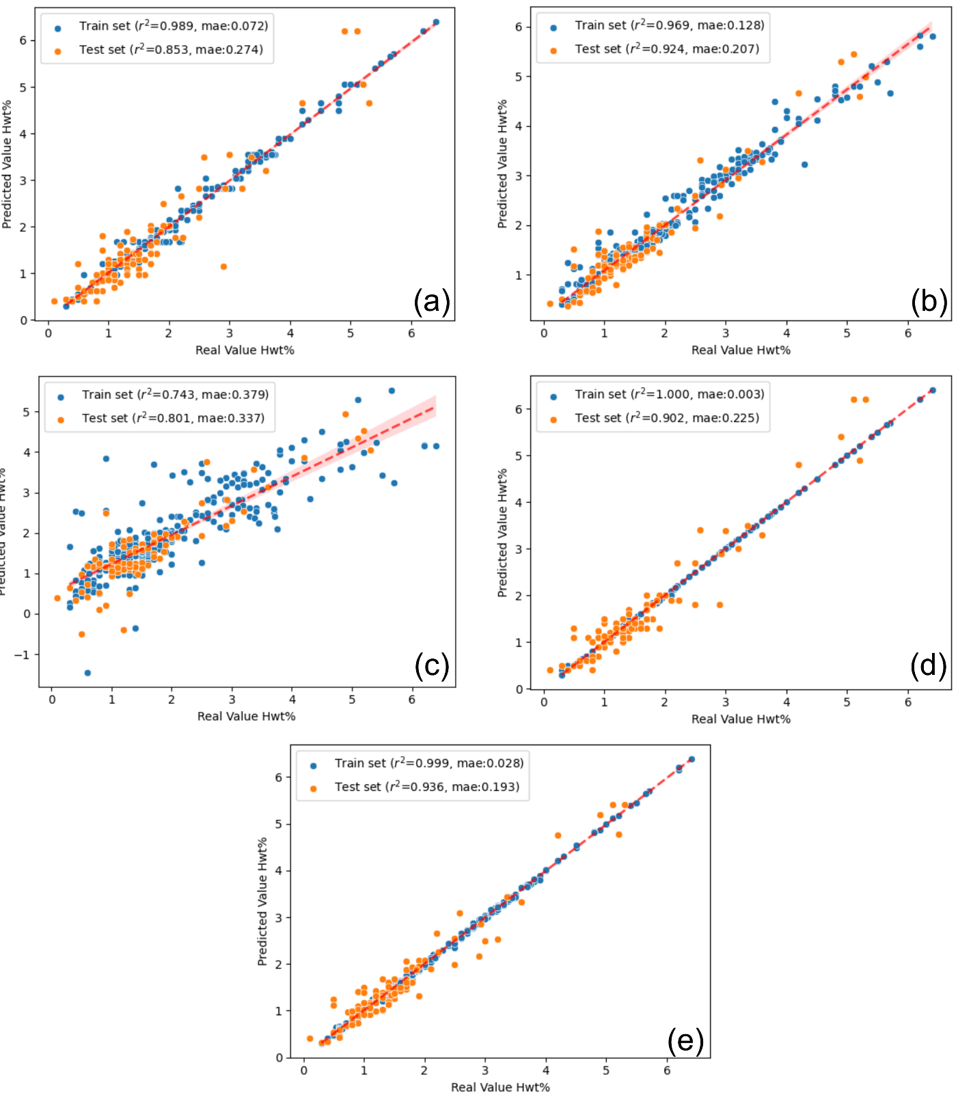
H. Storage Predictions of Machine Learning Models M. Hydrides
Fig. S1 Real vs Predicted Hwt% plot for (a) Decision Tree, (b) Random Forest, (c) Linear Support Vector Regression, (d) AdaBoost, and (e) eXtreme Gradient Boost machine learning models.

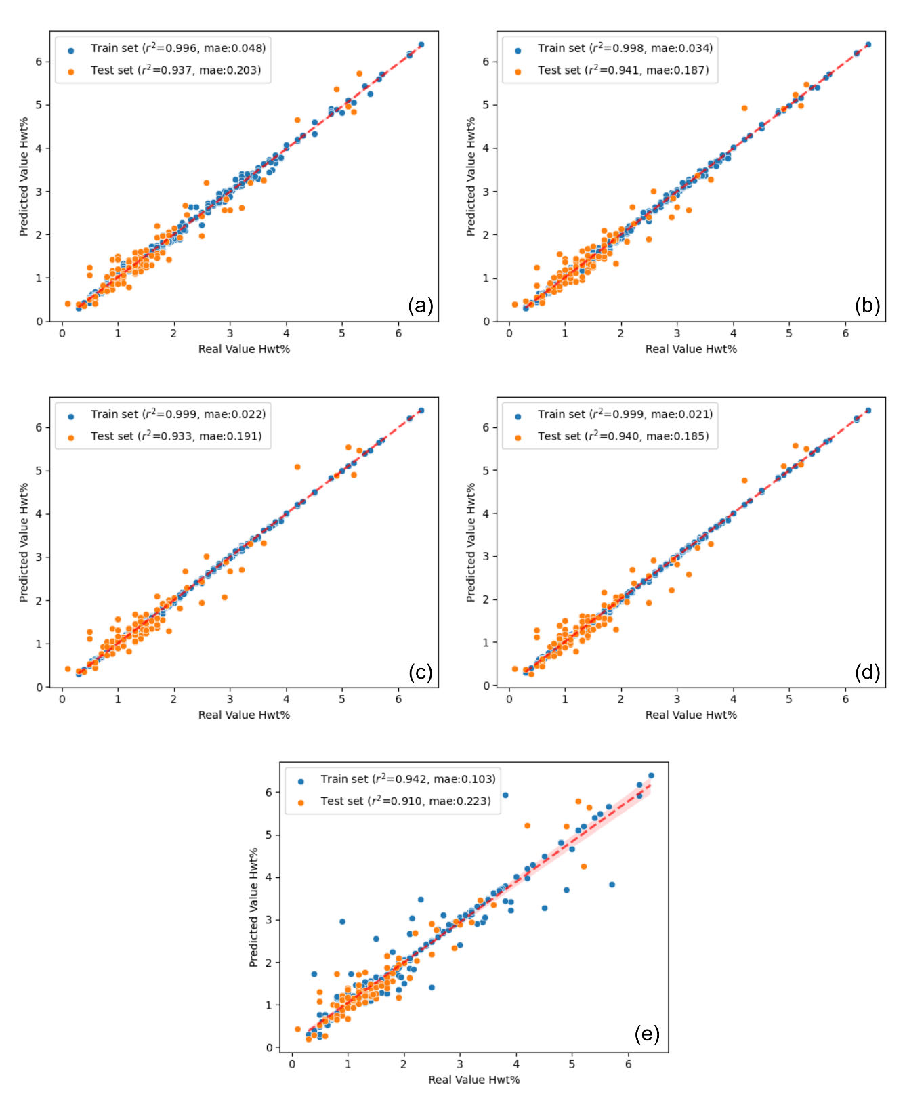
Unsupervised Domain Adaptation Model Results
Fig. S2 Source accuracy testing via Unsupervised Domain Adaptation projected prediction vs real Hwt% plot on source domain using instance-based models (a) Kullback-Leibler Importance Estimation Procedure (KLIEP), (b) Unconstrained Least-Squares Importance Fitting (ULSIF), (c) Relative Unconstrained Least-Squares Importance Fitting (RULSIF), (d) Nearest Neighbors Weighting, and (e) Kernel Mean Matching.

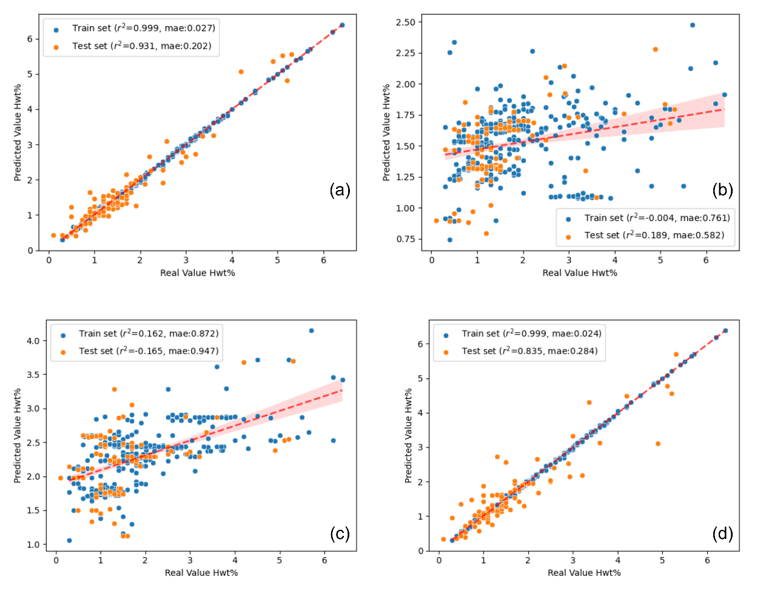
Fig. S3 Source accuracy testing via Unsupervised Domain Adaptation projected prediction vs real Hwt% plot on source domain using feature-based models (a) feature Selection with MMD (fMMD), (b) Subspace Alignment (SA), (c) CORrelation ALignment (CORAL), and (d) Transfer Component Analysis (TCA).

Relaxed Structures of Hydrogen Surface-adsorbed Transition Metal Oxides Ca₂TiO₄ and CaVO₃
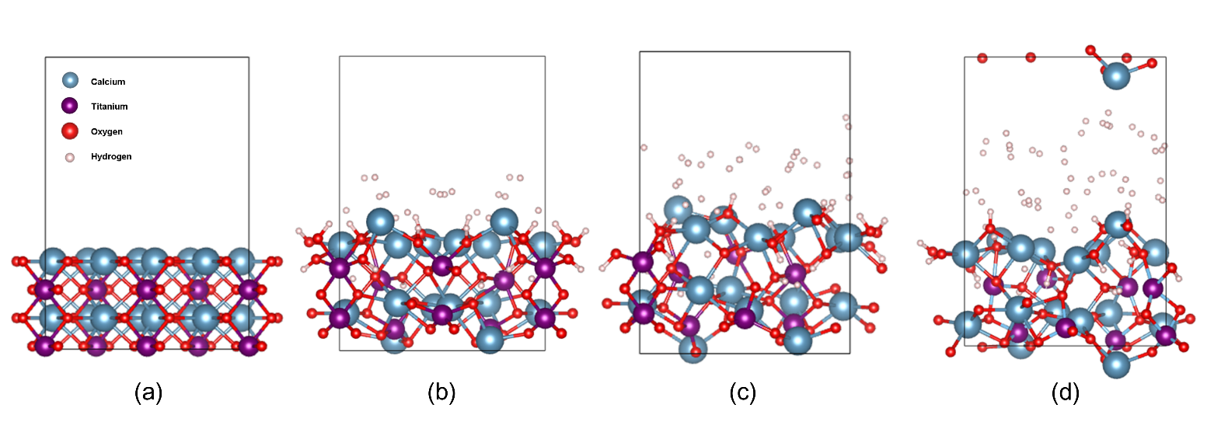
Fig. S5 Structure configuration of fully relaxed (a) pristine CaVO₃, (b) CaVO₃H₃, (c) CaVO₃H₆, and (d) CaVO₃H₉.
Fig. S4 Structure configuration of fully relaxed (a) pristine Ca₂TiO₄, (b) Ca₂TiO₄H₄, (c) Ca₂TiO₄H₆, and (d) Ca₂TiO₄H₈.
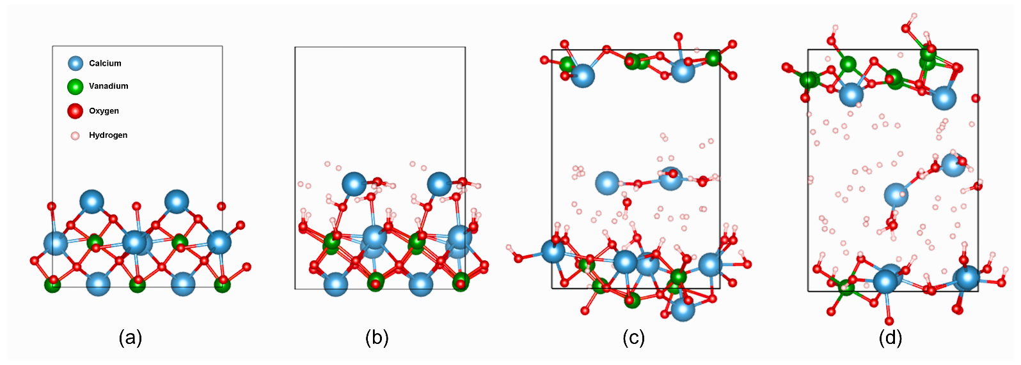

Table S6 $E_{fermi}$ and d-band center (Ti) based on the pDOS calculation on the pristine and H-adsorbed Ca₂TiO₄
Ca₂TiO₄ | $$E_{Fermi} (eV)$$ | $$d-band Center Ti \left(eV\right)$$  _{Relative to} $E_{Fermi}$
Pristine | 1.7688 | 0.022
Pristine + H₂ | 2.5356 | -0.892

Table S7 $E_{fermi}$ and d-band center (V) based on the pDOS calculation on the pristine and H-adsorbed CaVO₃
CaVO₃ | $$E_{Fermi} (eV)$$ | $$d-band Center V \left(eV\right)$$  _{Relative to} $E_{Fermi}$
Pristine | 1.5278 | -1.053
Pristine + H₂ | 2.1685 | -1.502

