Supporting Information
Ultra-High Discharge Voltage Plateau of 3.2 V Achieved in Li-CO₂ Batteries Using Iron Polyphthalocyanine
Ning Zhao⁺, Yi Zhang⁺, Li-Min Liu, Han-Qi Zhang, Xiao-Sha Wu, Xuan Lu, Han Yun, Yang Gao, Wen-Long Su, Yi-Ming Fan, Rong-Fen Feng, Zheng Meng*, Shu-Jiang Ding, Wen-Feng Liu, Qiang Wang, Xiao-Fei Hu*

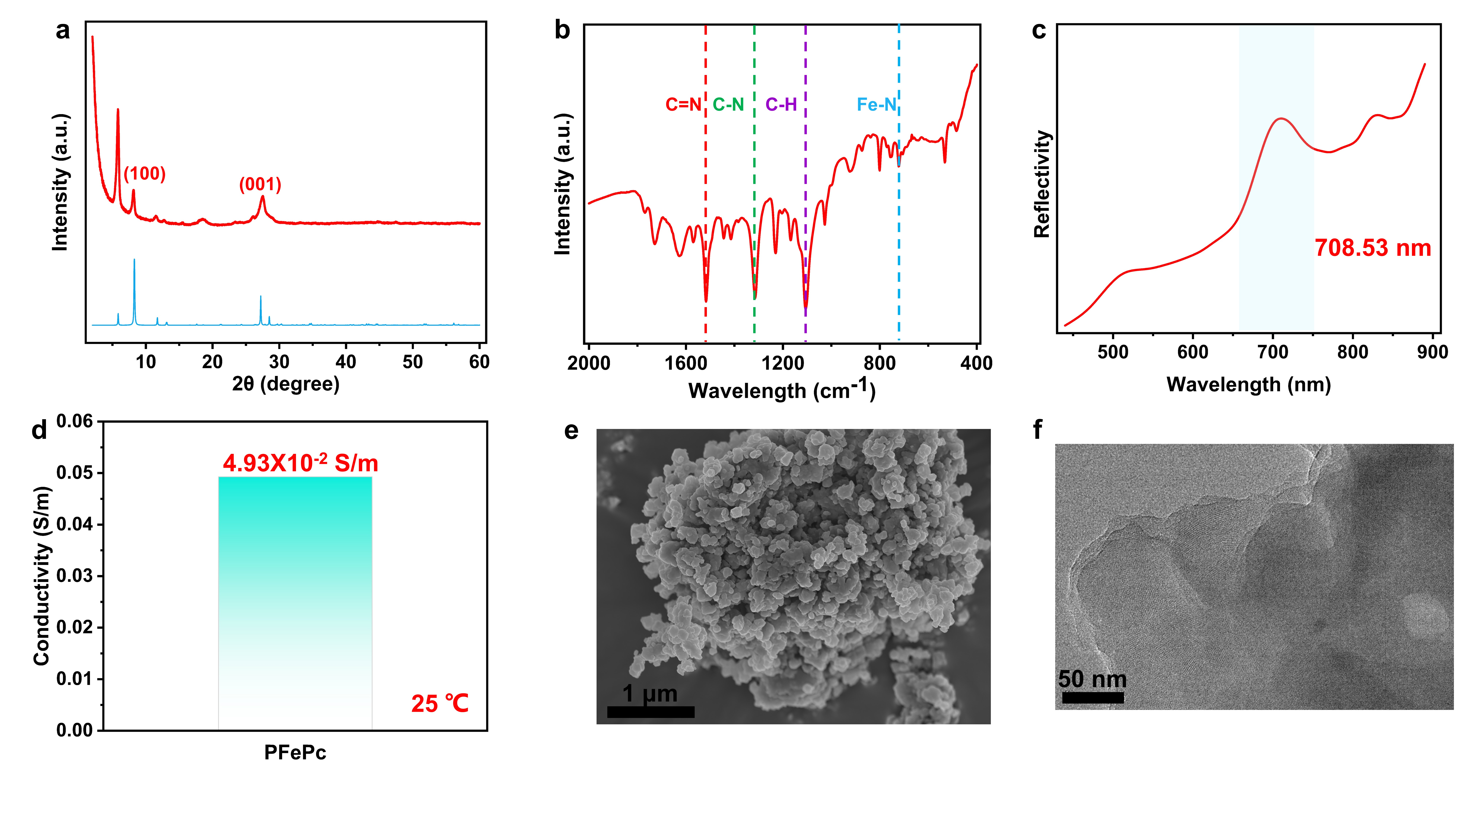Figure S1. a) XRD pattern b) FT-IR spectrum c) UV–vis spectrum d) Conductivity e) SEM and f) TEM of solid-state redox mediator pFe^{II}Pc.

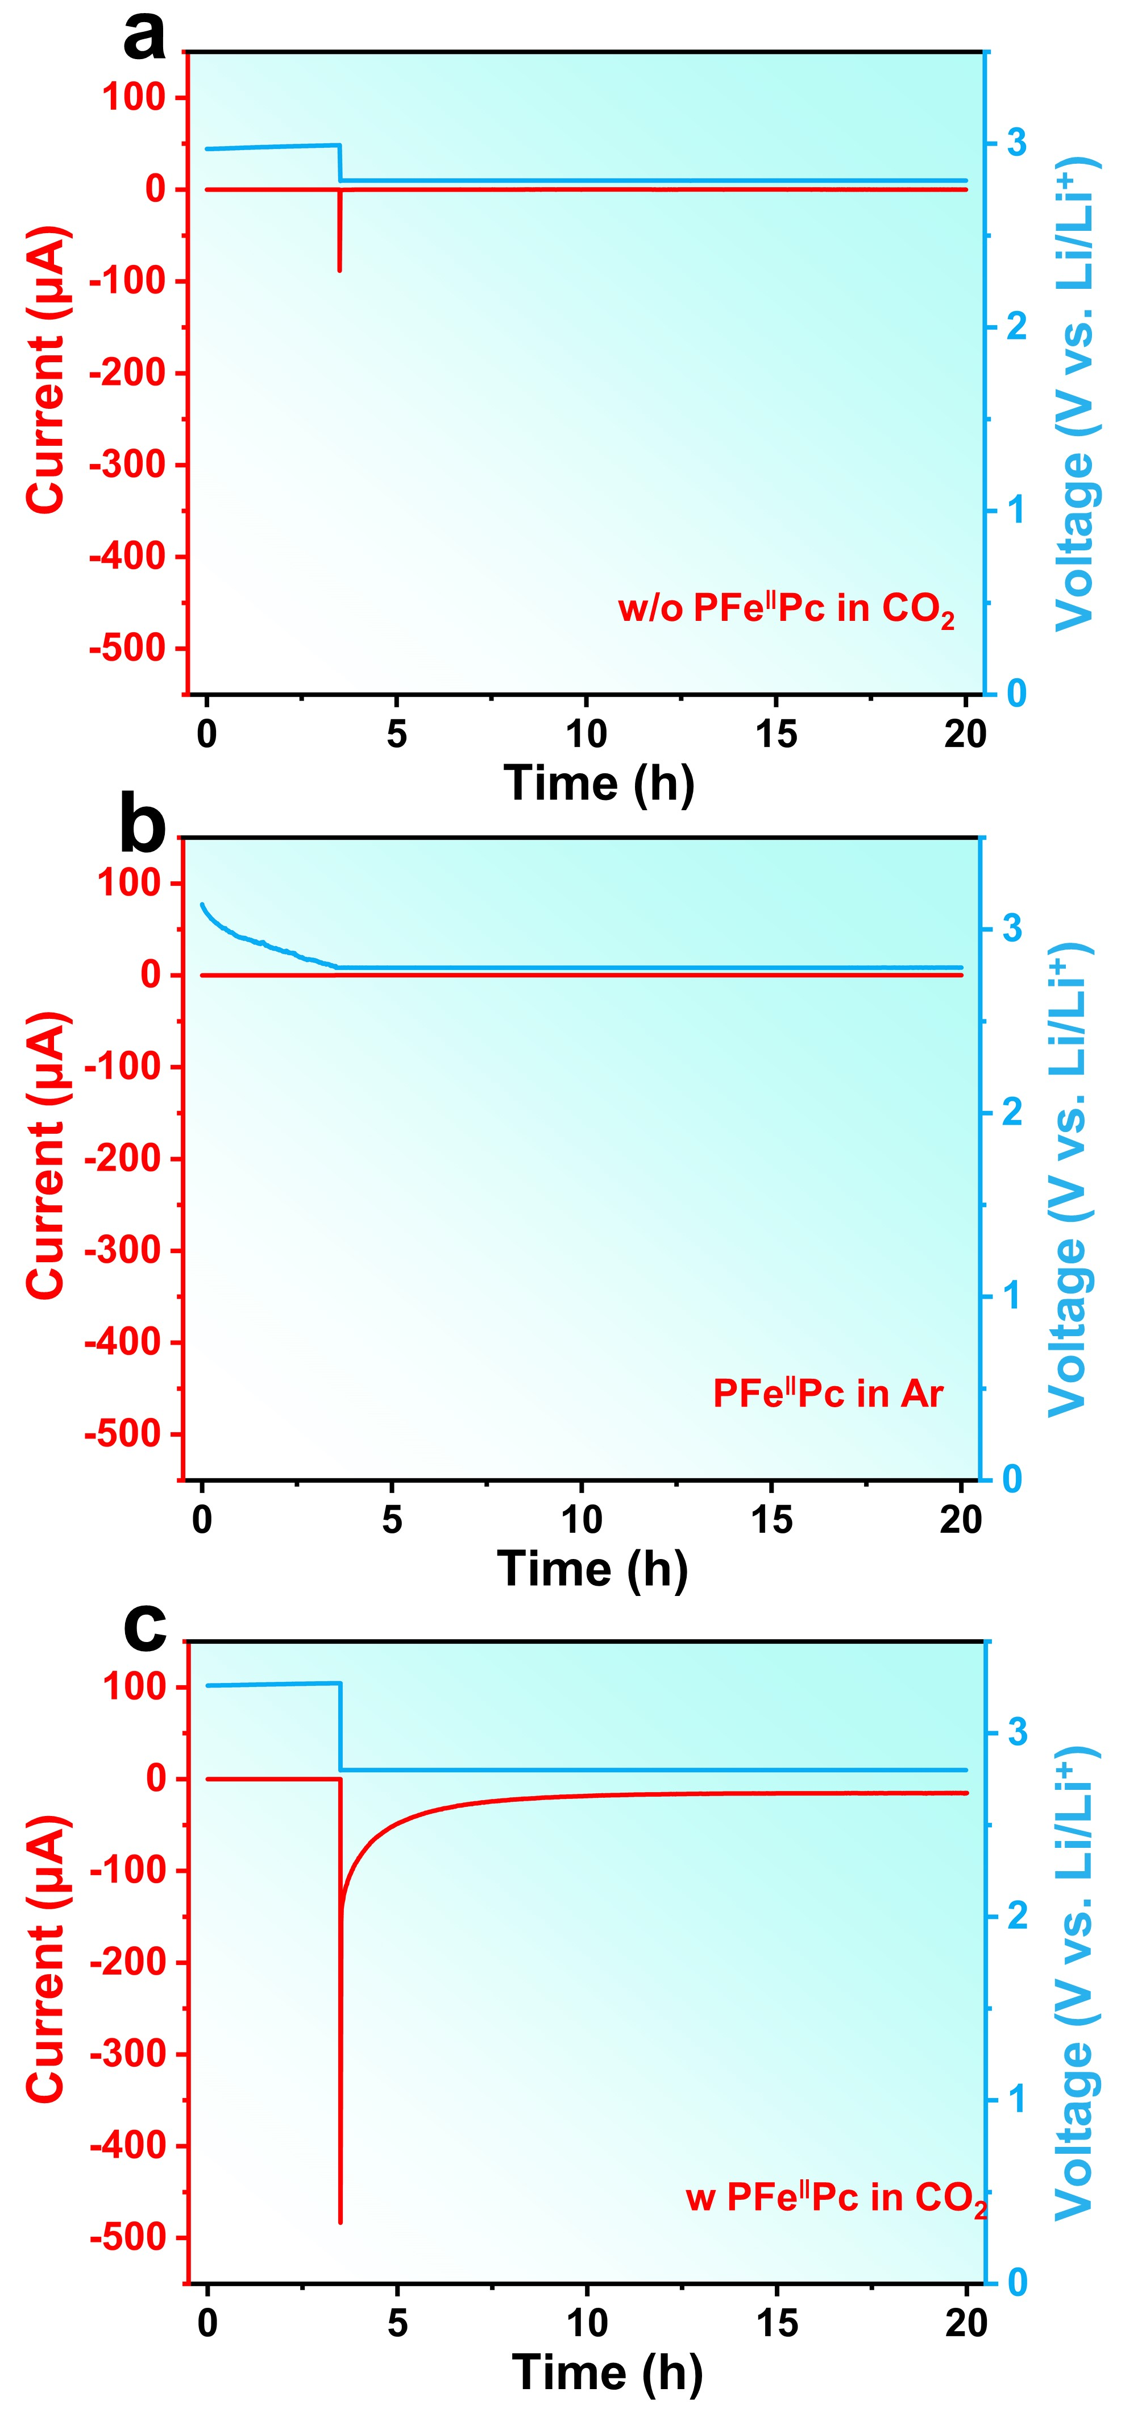
Figure S2. Current-Time curve under constant voltage of a) CNTs and pFe‖Pc cathode in b) Ar and c) CO₂ atmosphere.

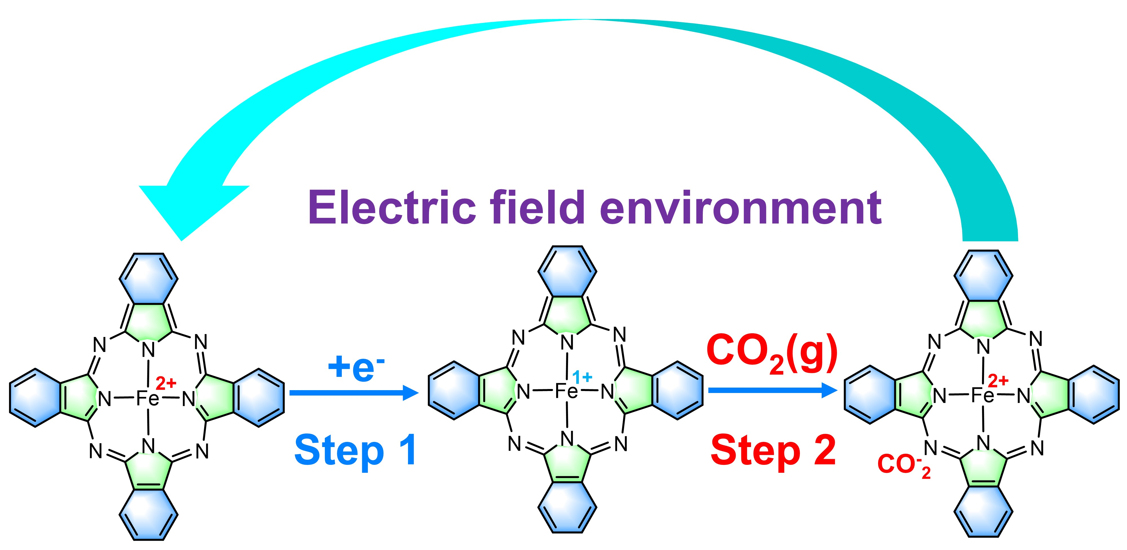

Figure S3. Schematic diagram of CO₂ Reduction by pFe^{II}Pc via priority electron transfer.

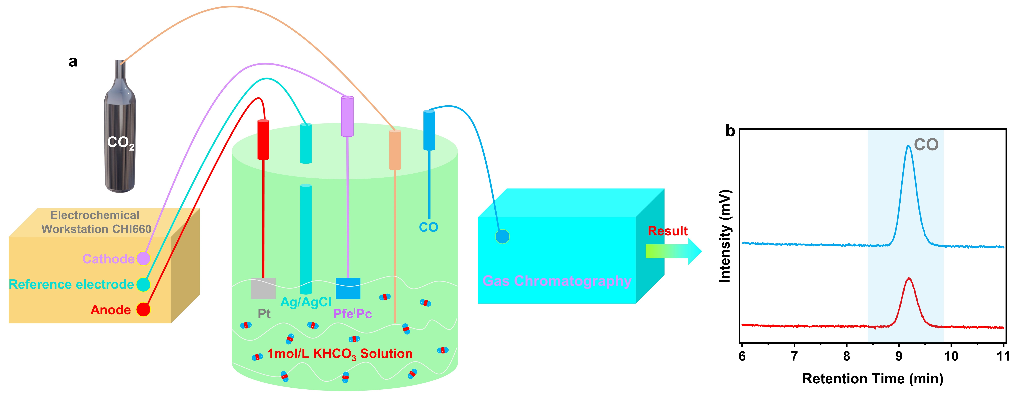

Figure S4. a) Schematic diagram of in-situ online GC-MS. b) GC-MS spectrum based on pFe^{I}Pc cathode during discharging in CO₂ atmosphere.

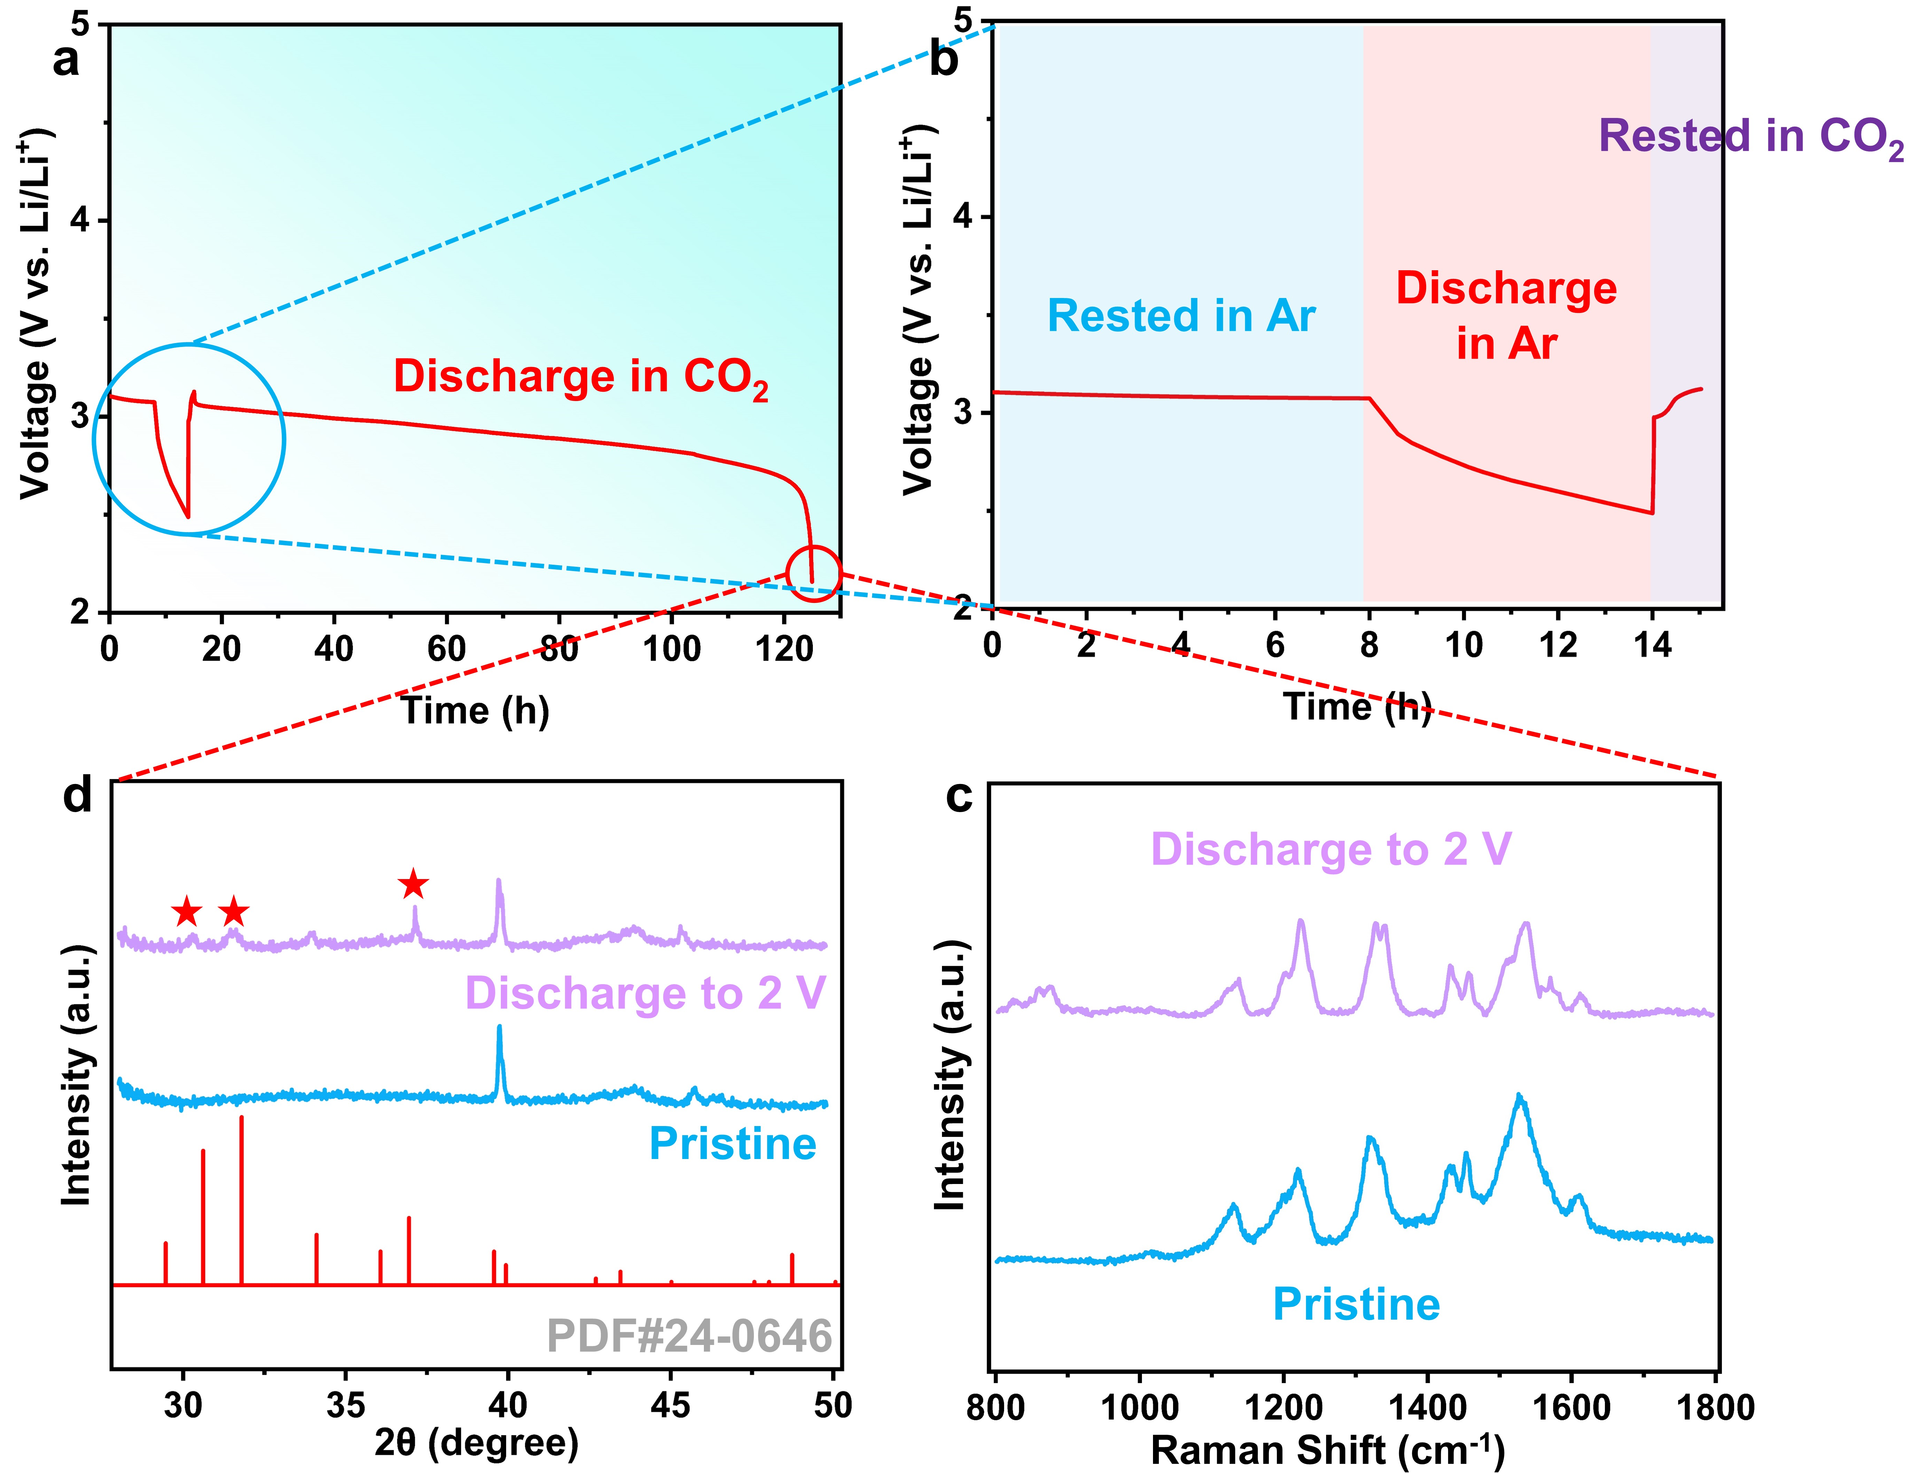

Figure S5. a) Discharge curve of Li-CO₂ battery using pFe^{II}Pc, first discharged in Ar and then in CO₂. b) Magnified view of figure S5a. c) XRD pattern and d) Raman spectrum of discharge products.

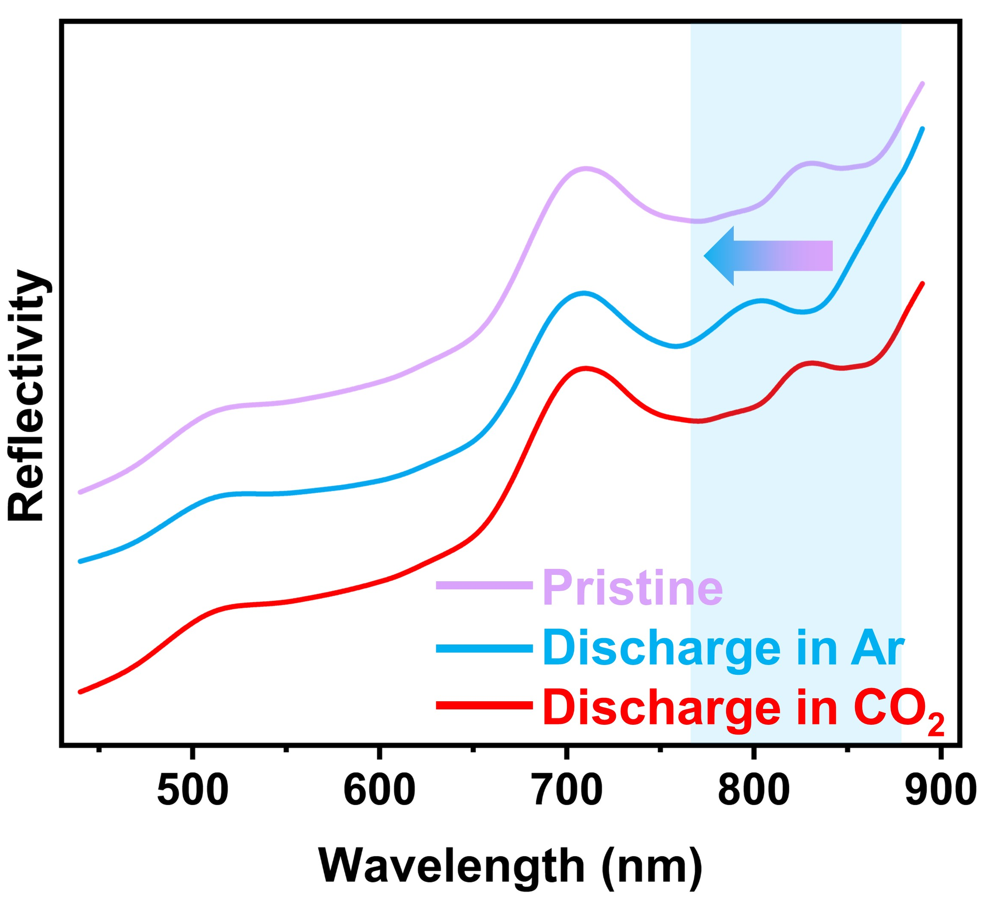

Figure S6. UV-vis spectra of the pristine state, after discharge in an Ar and in a CO₂ atmosphere.

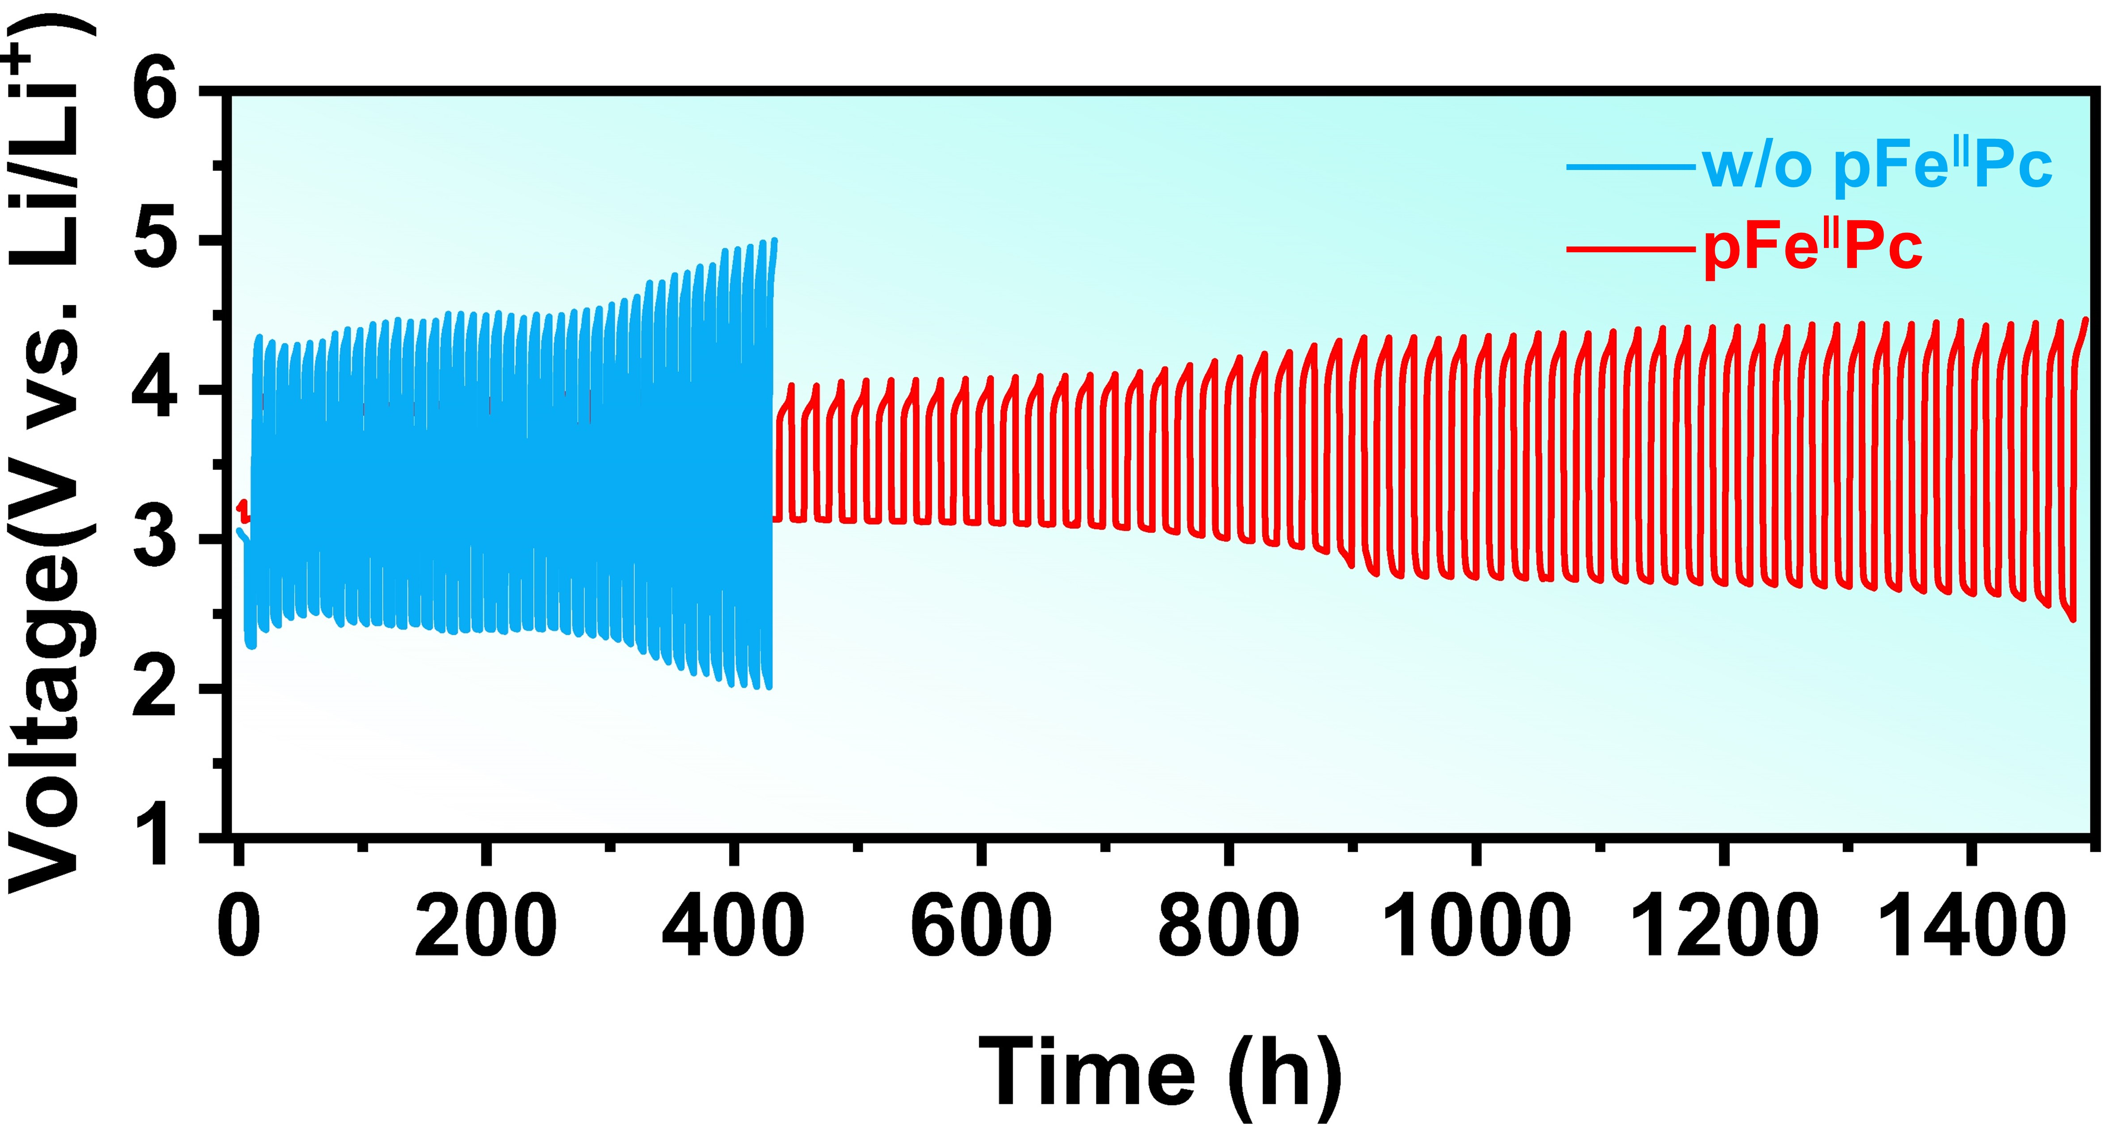
Figure S7. The cycling performance comparison of Li-CO₂ batteries with and without pFe‖Pc.

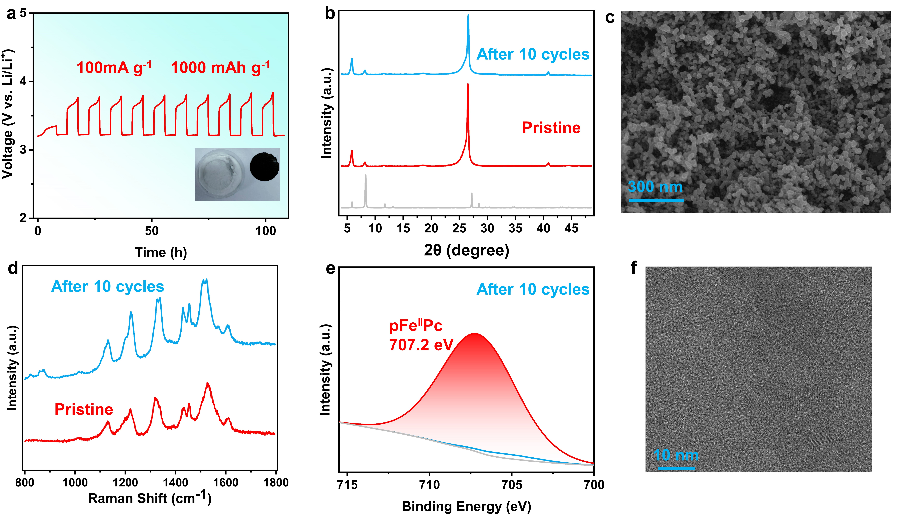Figure S8. a) The charge-discharge curves of the Li-CO₂ battery containing pFe‖Pc, cycled for 10 cycles at a current density of 100 mA g⁻¹ with a cut-off capacity of 1000 mAh g⁻¹. b) XRD pattern of the electrode in pristine state and after 10 cycles. c) SEM images after 10 cycles. d) Raman spectrum of the electrode in pristine state and after 10 cycles. e) XPS spectrum of the electrode in pristine state and after 10 cycles. f) TEM images after 10 cycles.

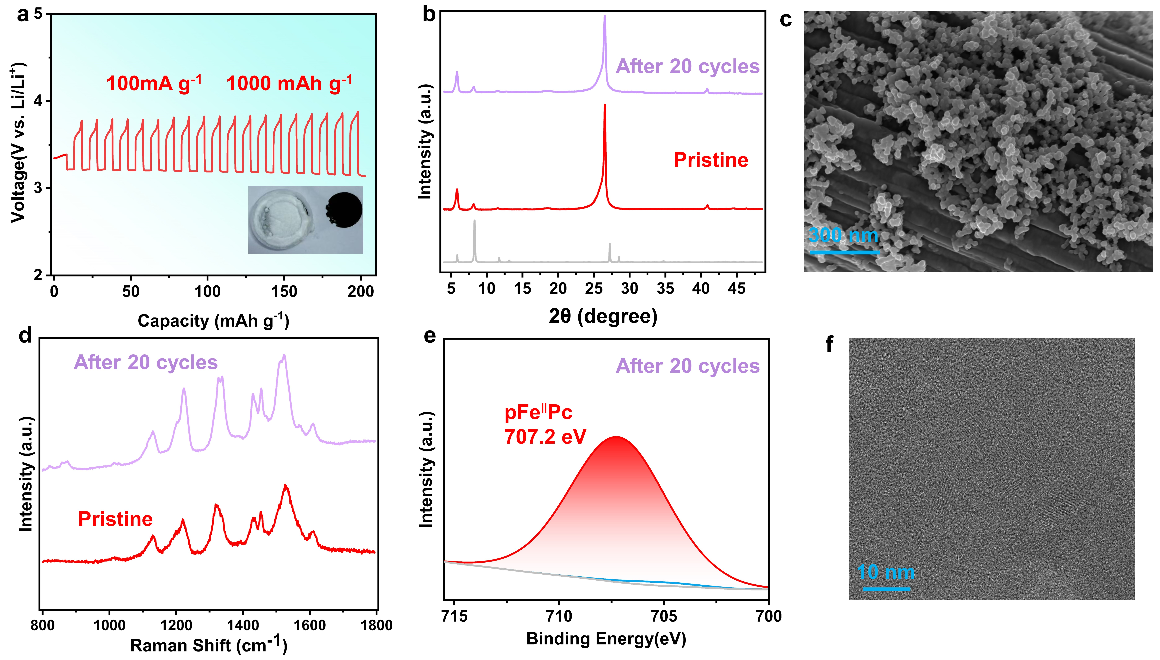

Figure S9. a) The charge-discharge curves of the Li-CO₂ battery containing pFe‖Pc, cycled for 20 cycles at a current density of 100 mA g⁻¹ with a cut-off capacity of 1000 mAh g⁻¹. b) XRD pattern of the electrode in pristine state and after 20 cycles. c) SEM images after 20 cycles. d) Raman spectrum of the electrode in pristine state and after 20 cycles. e) XPS spectrum of the electrode in pristine state and after 20 cycles. f) TEM images after 20 cycles.

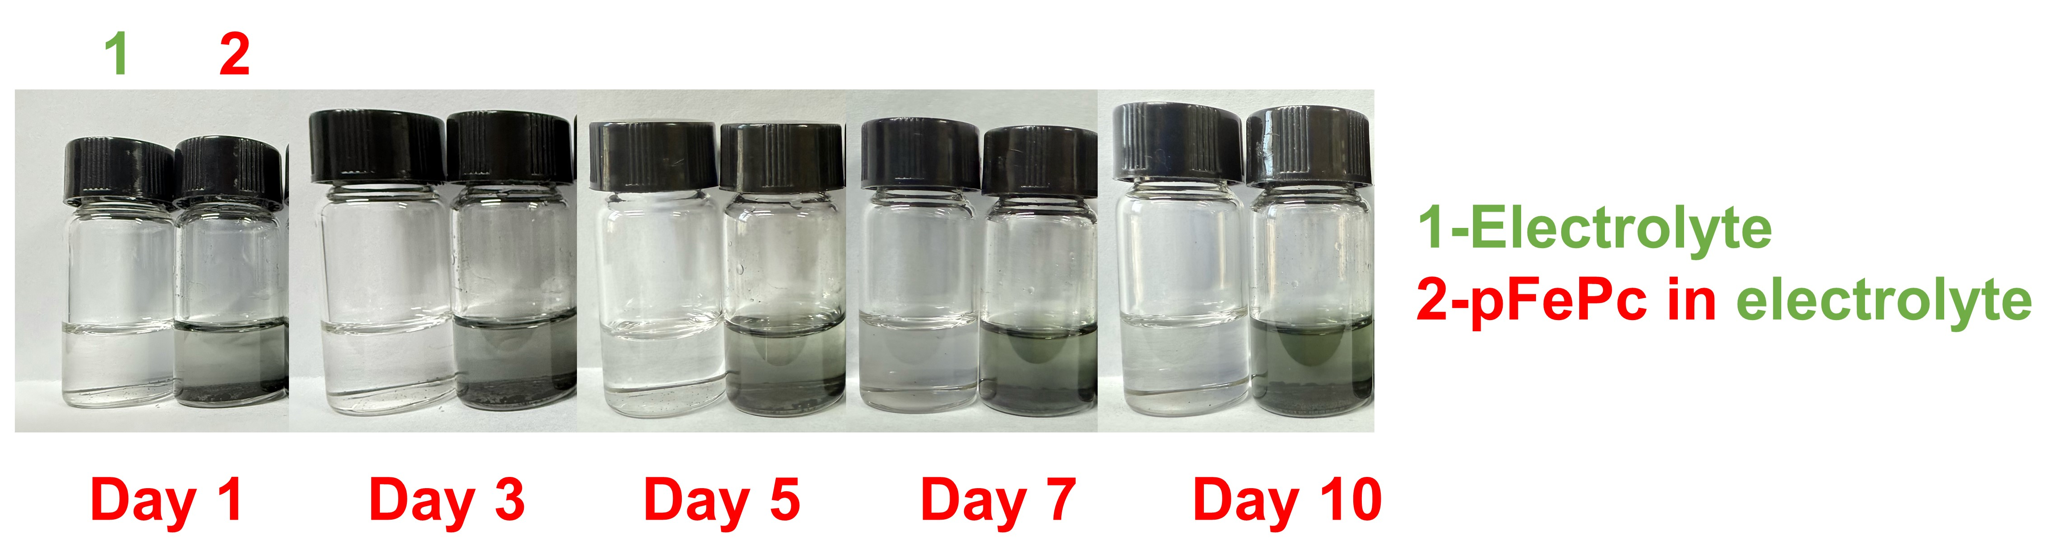

Figure S10. The dissolution behavior of pFe^{II}Pc in LiTFSI/TEGDME solutions at different times.

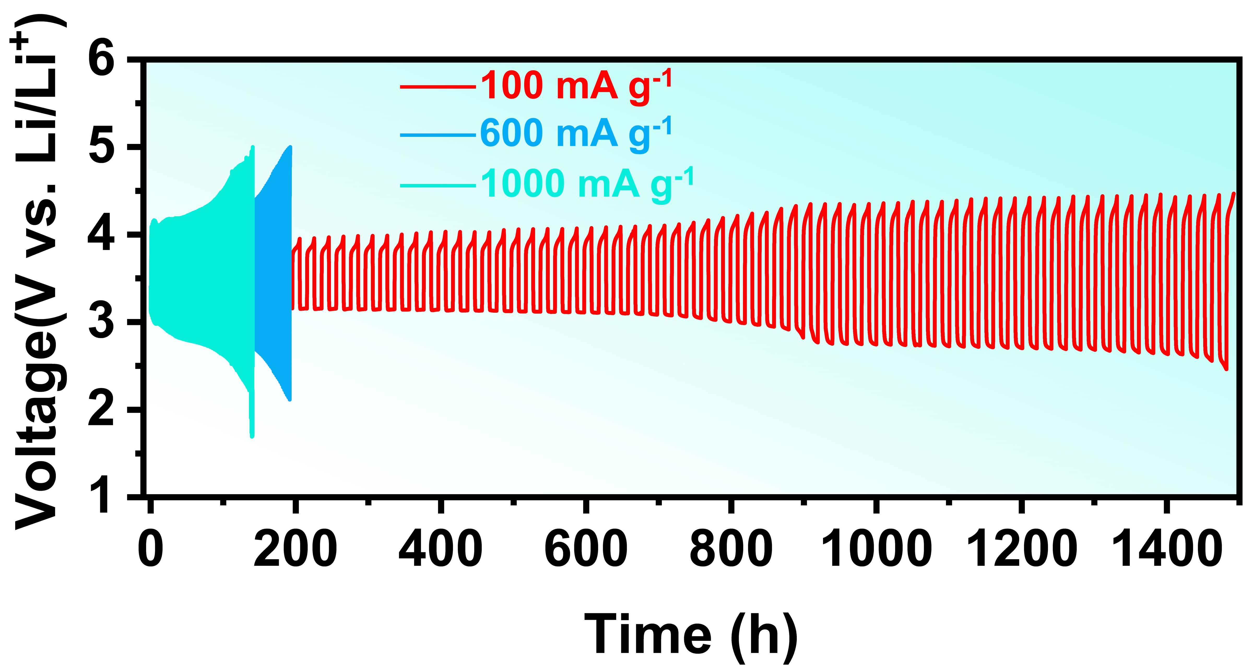
Figure S11. The cycling performance comparison of Li-CO₂ batteries with pFe‖Pc at 100, 600 and 1000 mA g⁻¹, respectively.

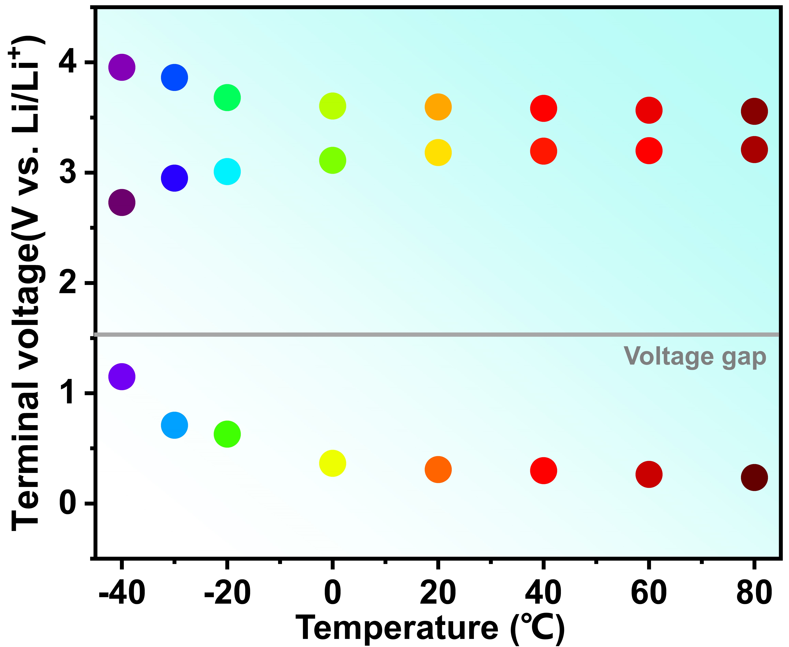
Figure S12. Median voltage and voltage gap of Figure 1h.

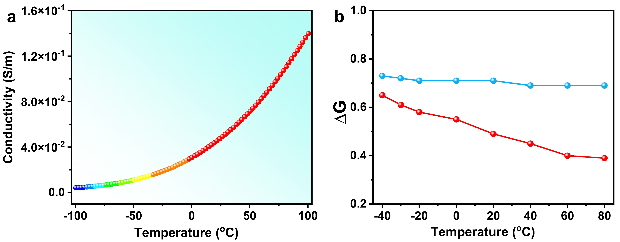Figure S13. a) The electrical conductivity of pFe^{II}Pc at different temperatures. b) ∆G of the rate-determining step for the formation of Li₂C₂O₄ in the Li-CO₂ battery with pFe^{II}Pc at different temperatures.

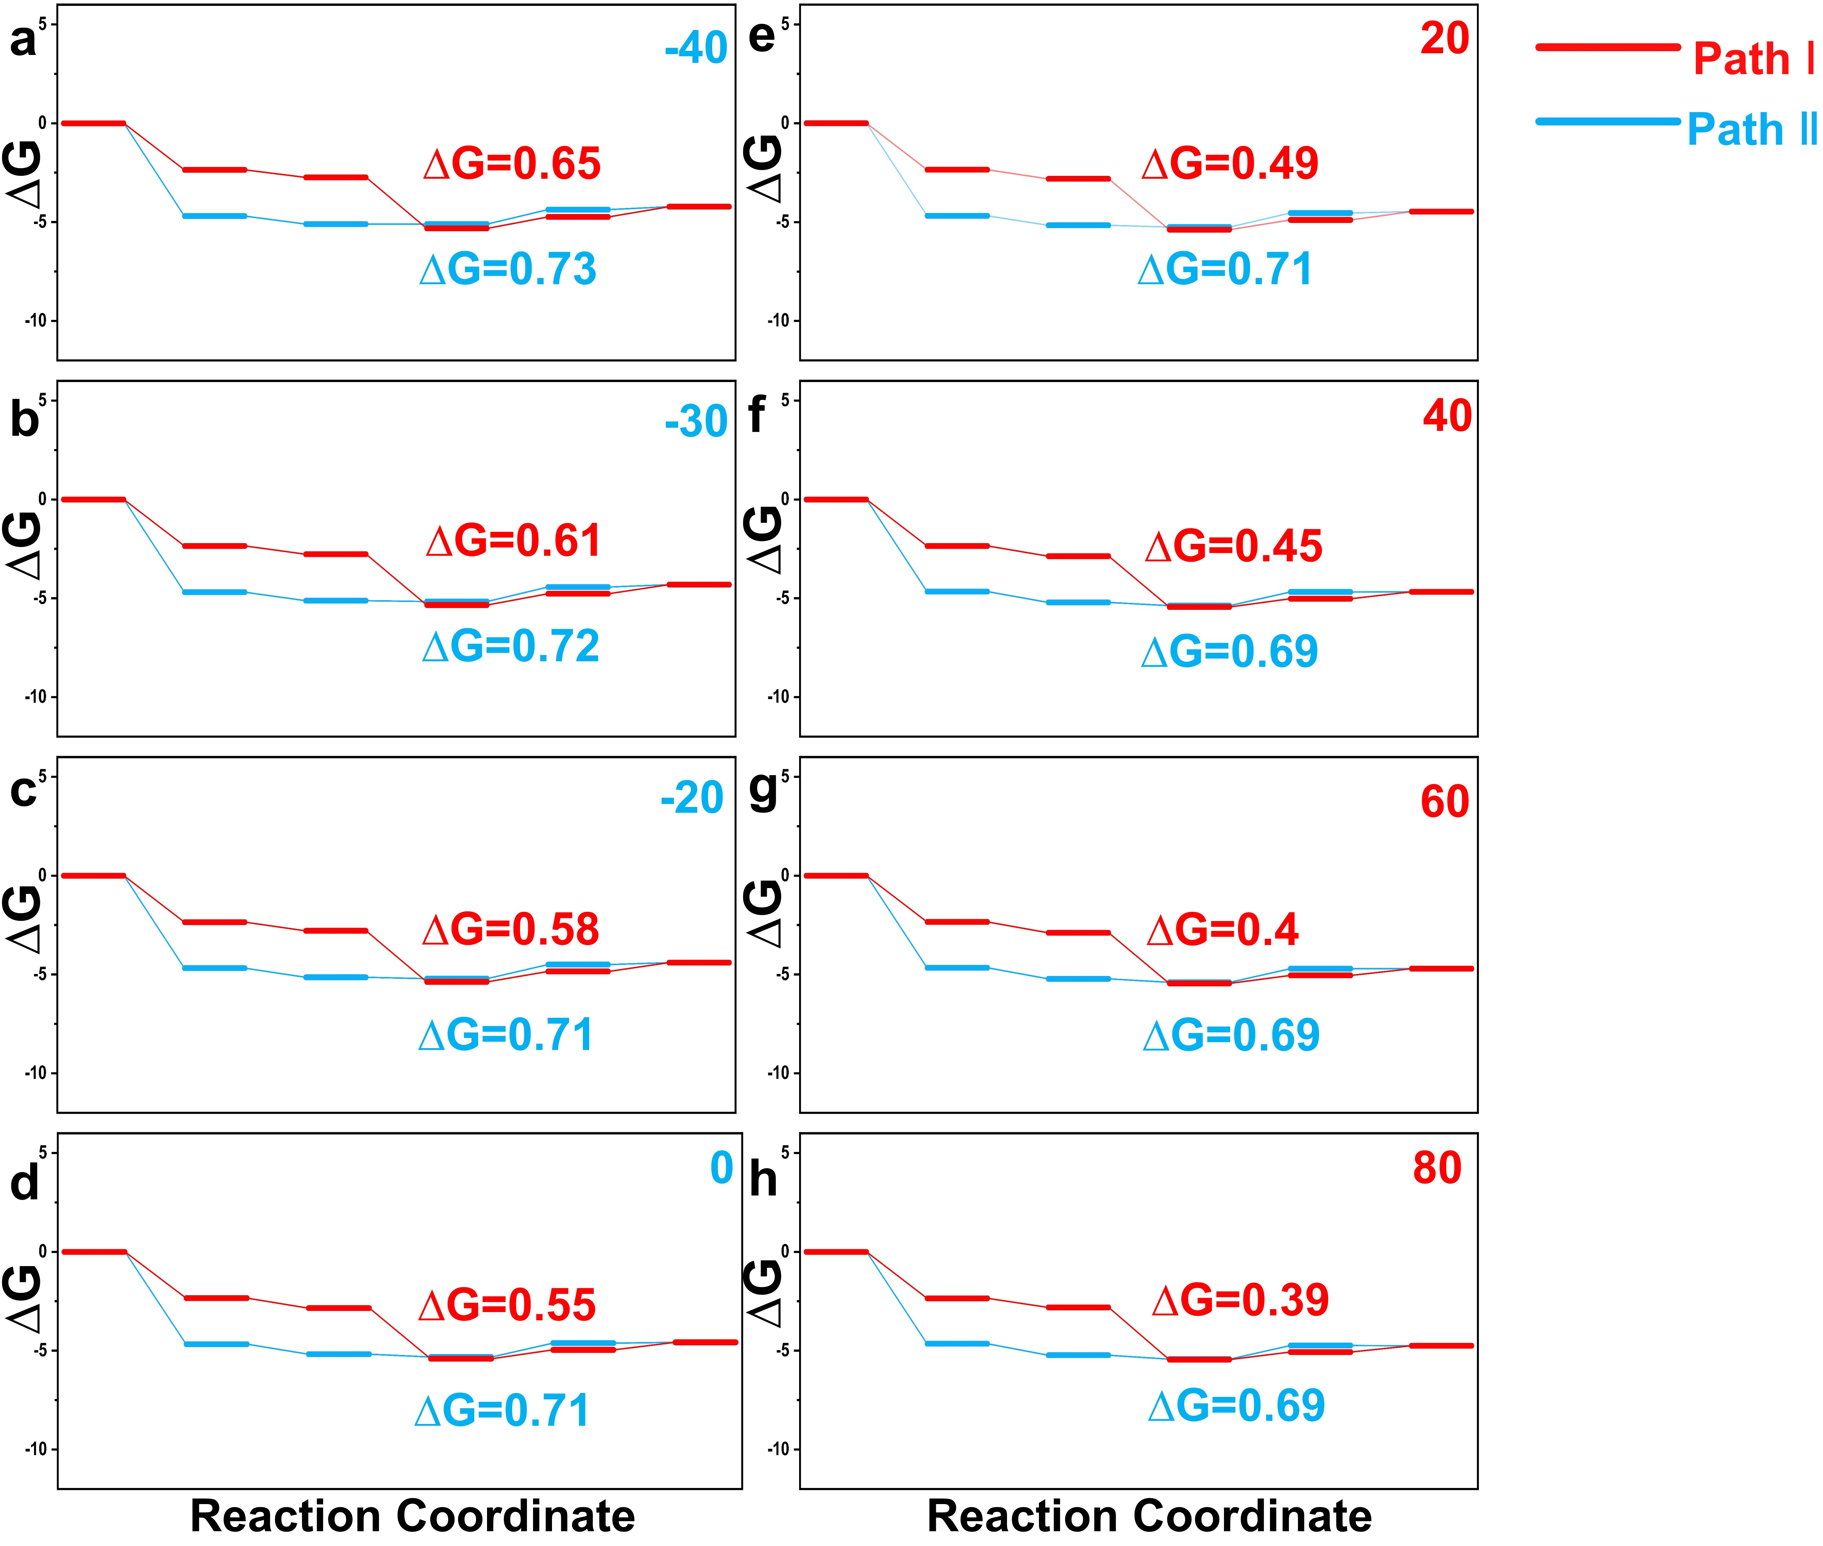

Figure S14. Free energy diagrams of different nucleation pathways of Li₂C₂O₄ on C₃₂H₁₆N₈Fe and C₅₈H₂₆N₁₆Fe₂ at a) -40 ºC a) -30 ºC a)-20 ºC a) 0 ºC a)20 ºC a) 40 ºC a) 60 ºC a)80 ºC.

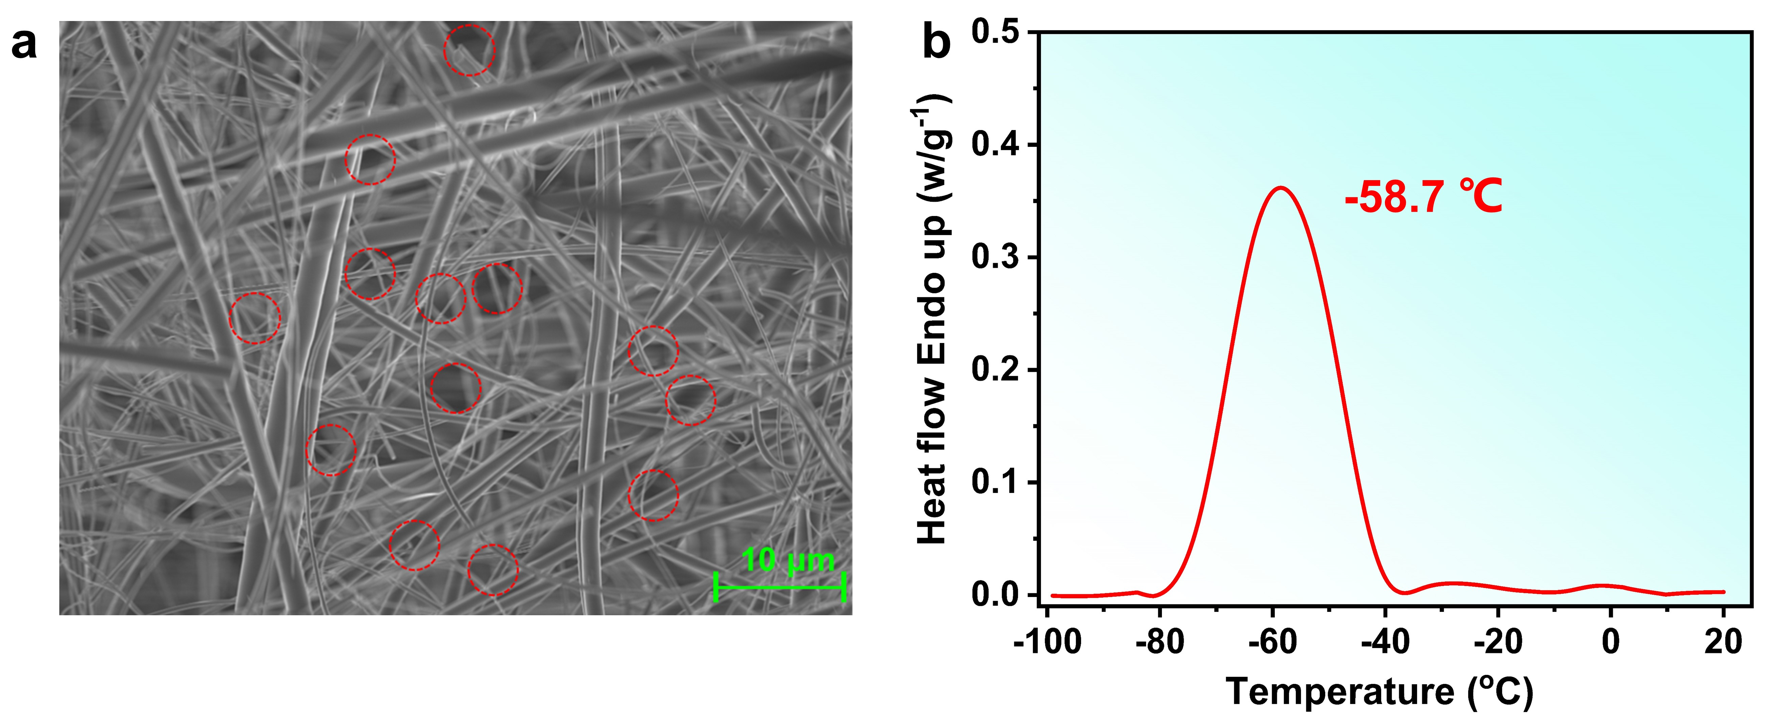Figure S15. a) SEM image of the separator. b) The DSC curve of 1.0 M LiTFSI/TEGDME electrolyte in separator.

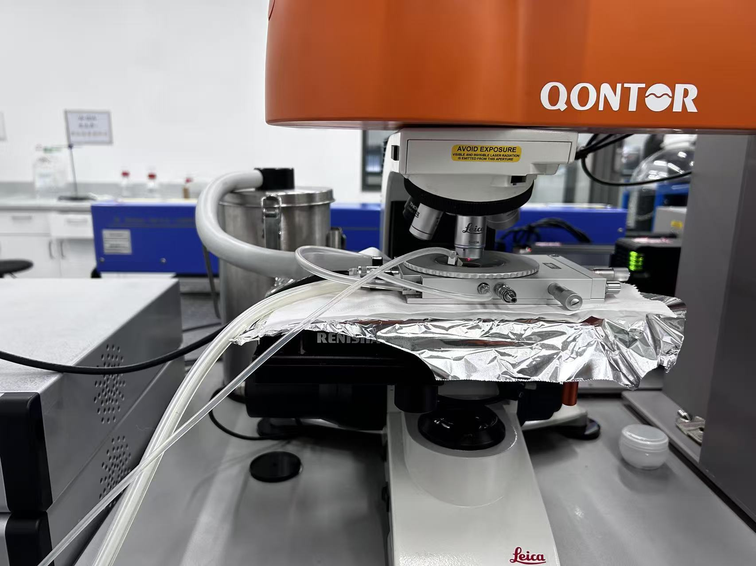
Figure S16. Optical image of the variable-temperature in-suit Raman testing process.

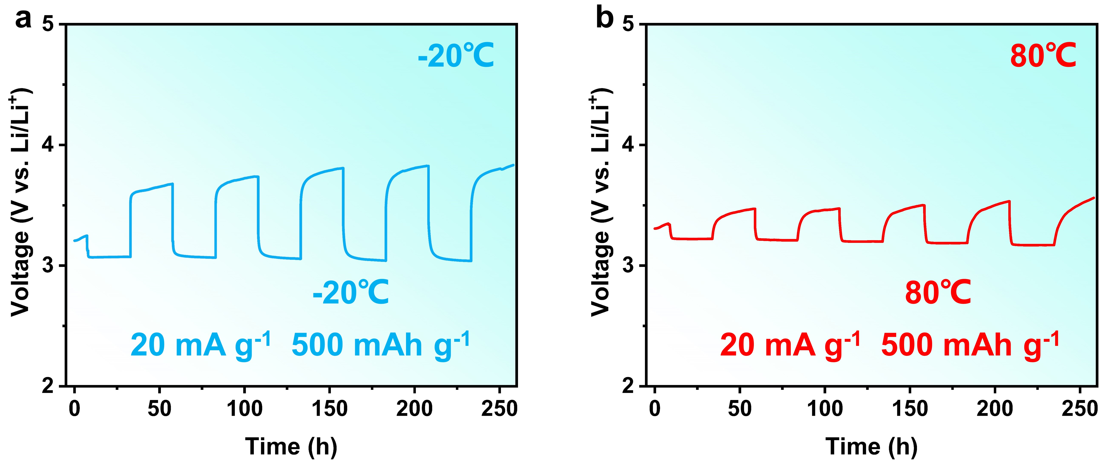

Figure S17. a) The cycling curve of the Li-CO₂ battery with pFe‖Pc and a current density of 20 mA g⁻¹ at a) -20 ºC and b) 80 ºC.

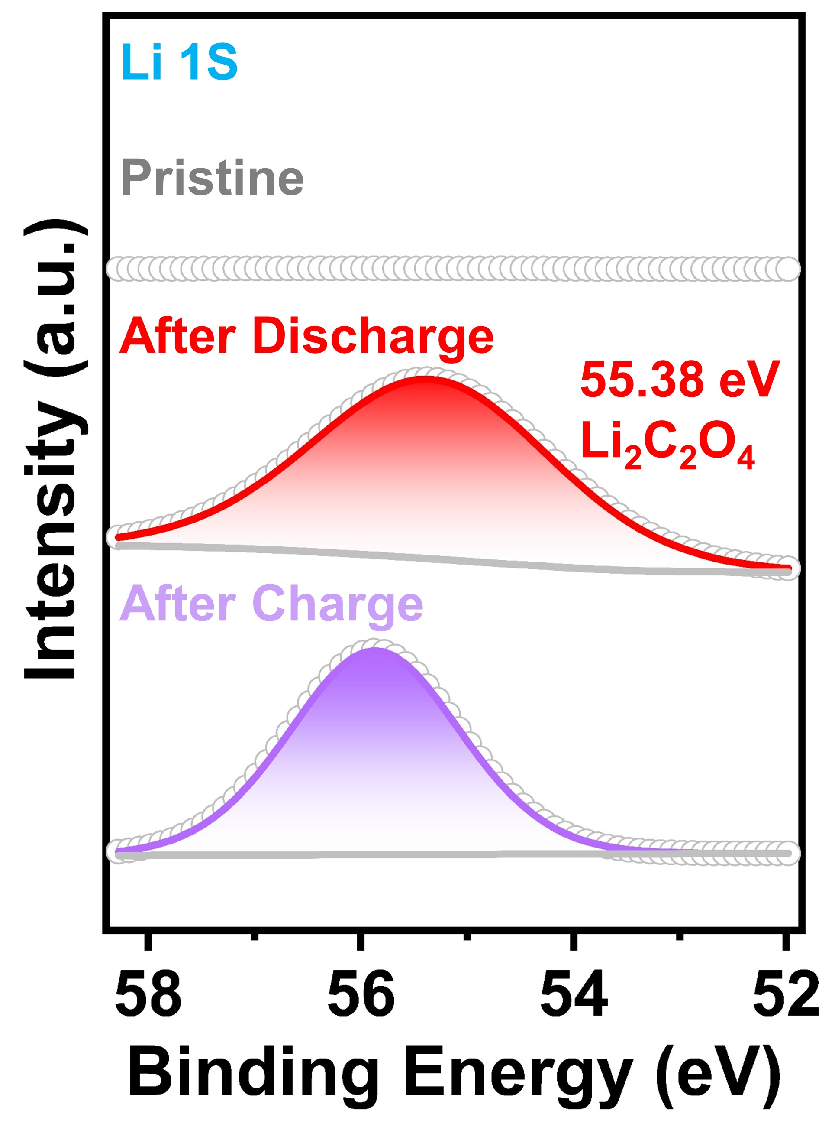
Figure S18. XPS spectrum of Li 1s at pristine, after discharge and after charge.

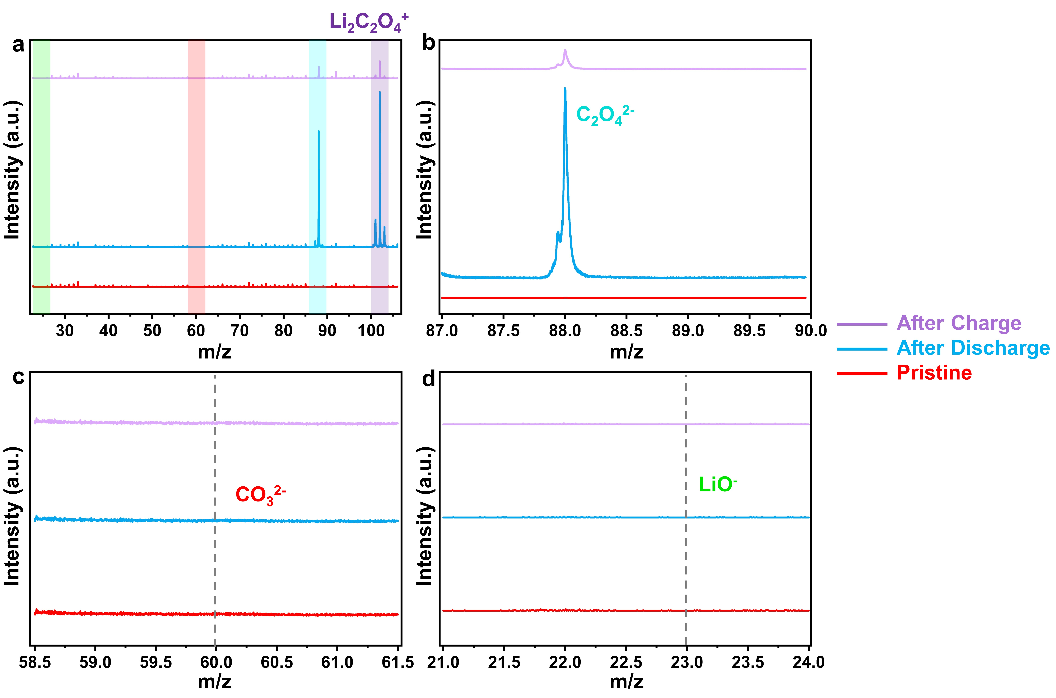
Figure S19. a) m/z of 20-110. b) m/z of 87-90. c) m/z of 58.5-61.5. d) m/z of 21-24.

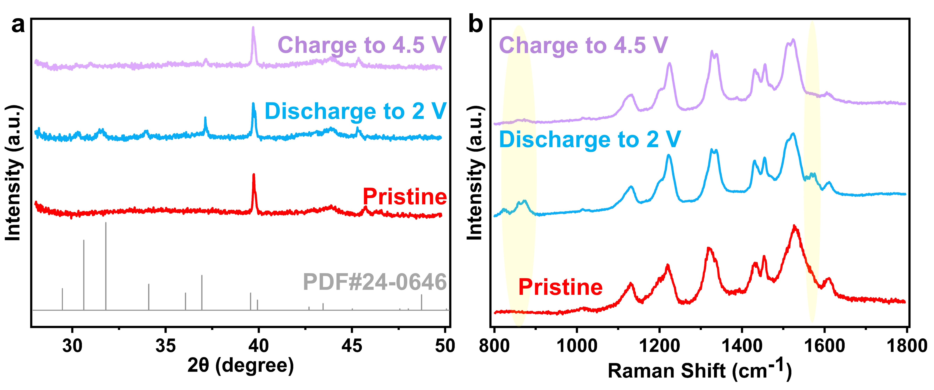
Figure S20. a) XRD pattern b) Raman spectrum of Li-CO₂ battery with pFe^{II}Pc at pristine, after discharge to 2 V and charge to 4.5 V.

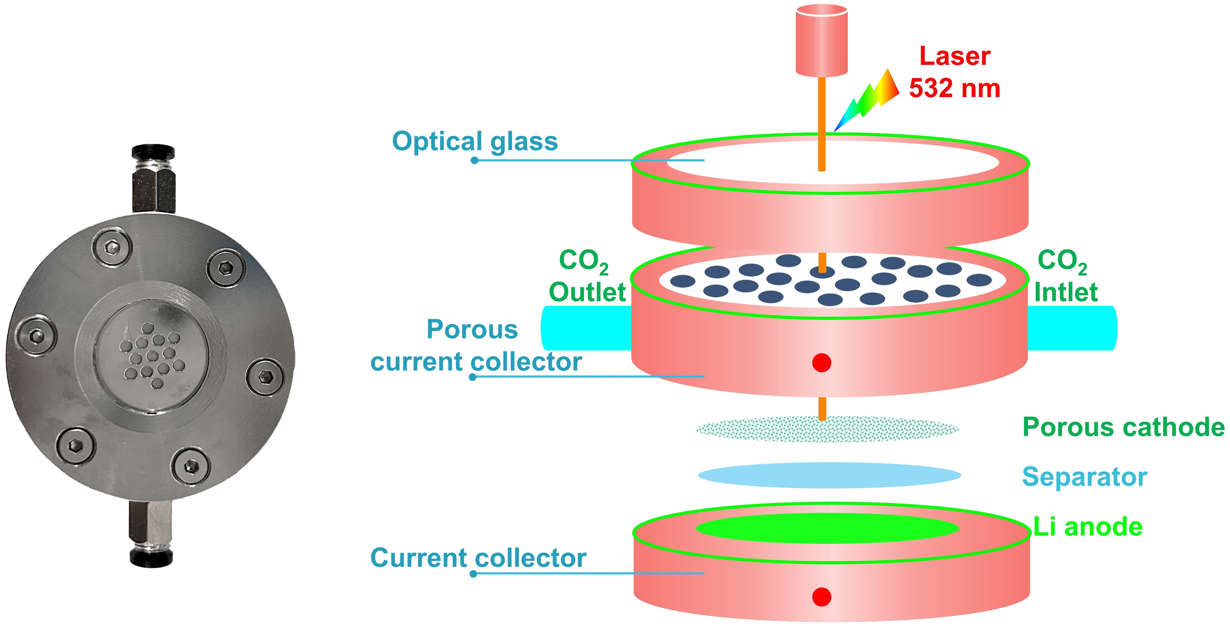
Figure S21. The structure of in-situ Li-CO₂ Raman battery.

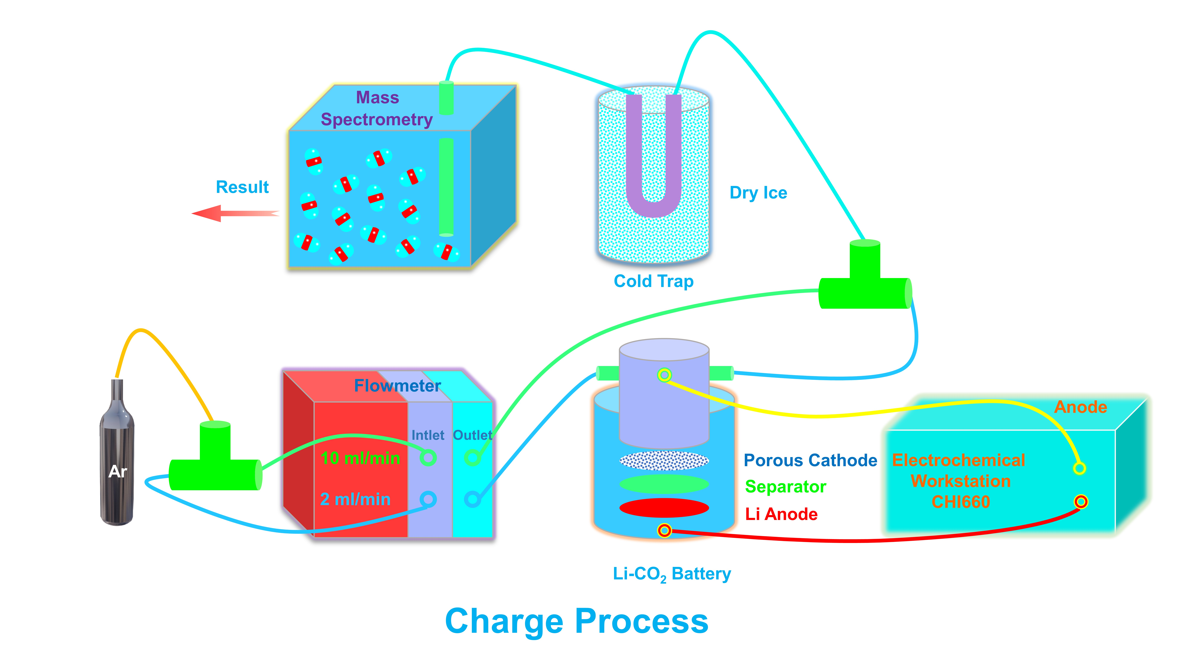
Figure S22. Schematic diagram of the in-situ DEMS for the charge process of the Li-CO₂ battery.

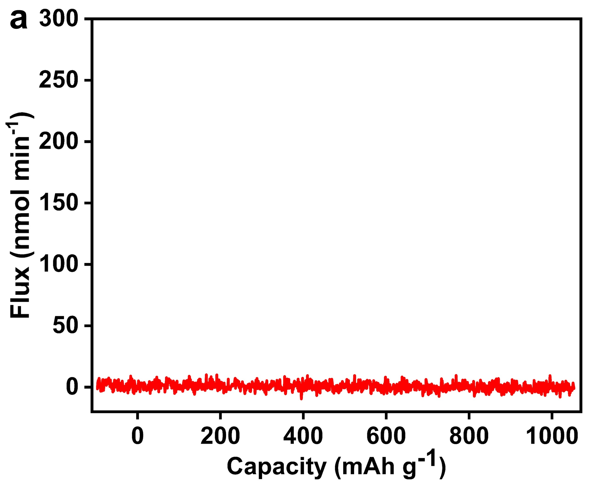

Figure S23. a) In-situ DEMS profiles of Li-CO₂ batteries with pFe‖Pc as solid-state redox mediators at 150 μA during charge process of CO.

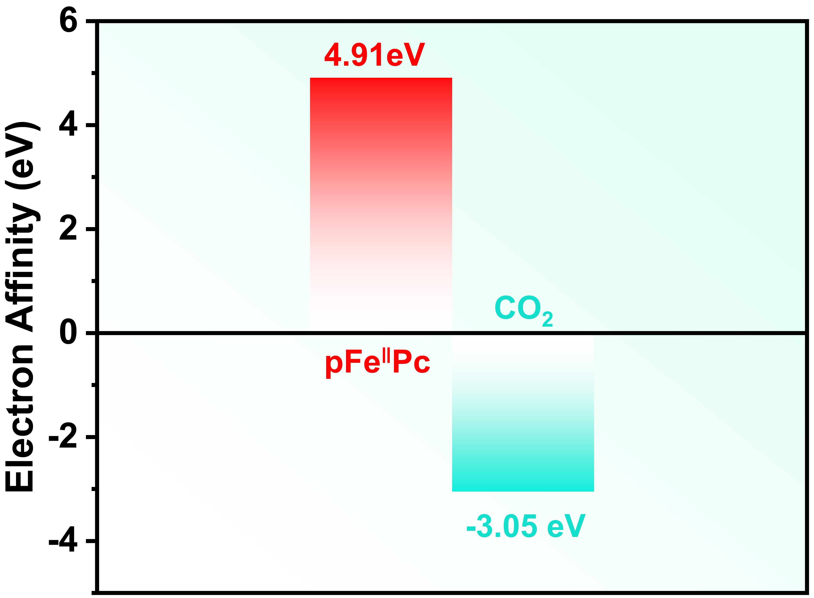
Figure S24. A comparison of the electron affinities of CO₂ and pFe‖Pc

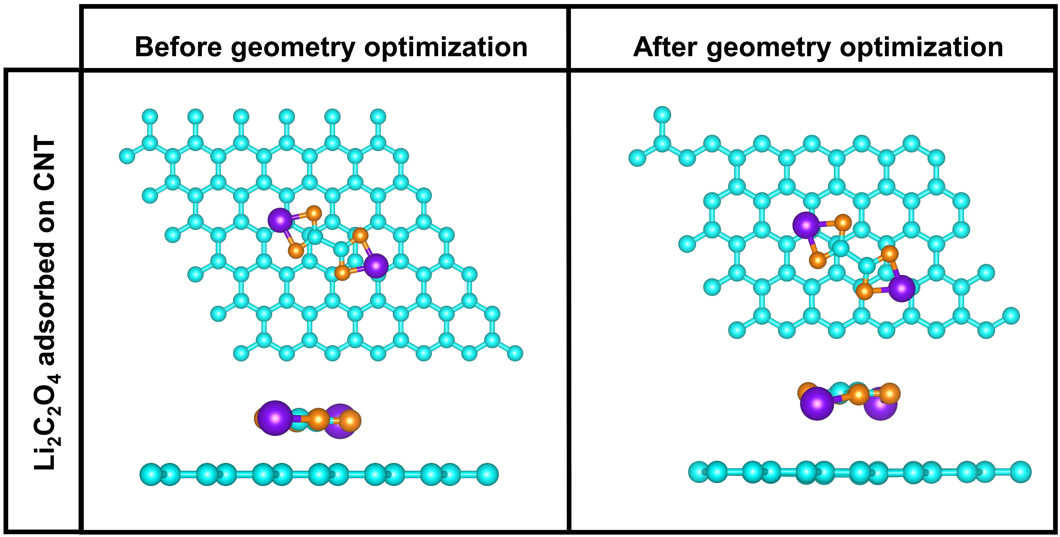

Figure S25. Comparison of the Li₂C₂O₄ adsorption model on the CNT surface before and after optimization.

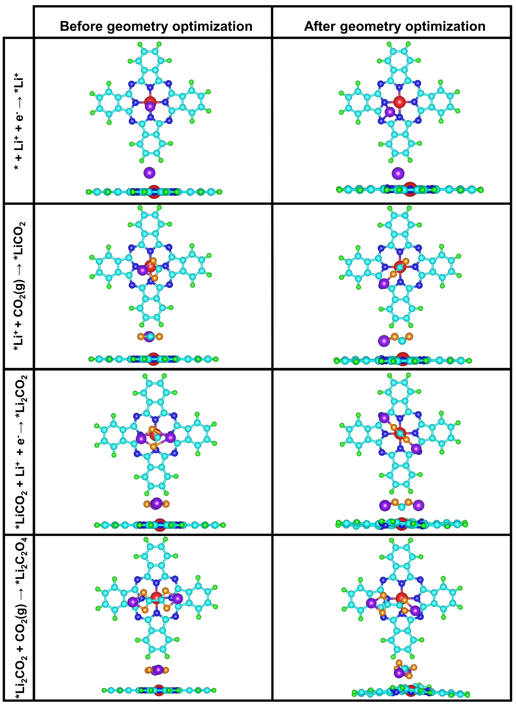

Figure S26. Comparison of ground state structures before and after optimization for each step in Path ǀ.

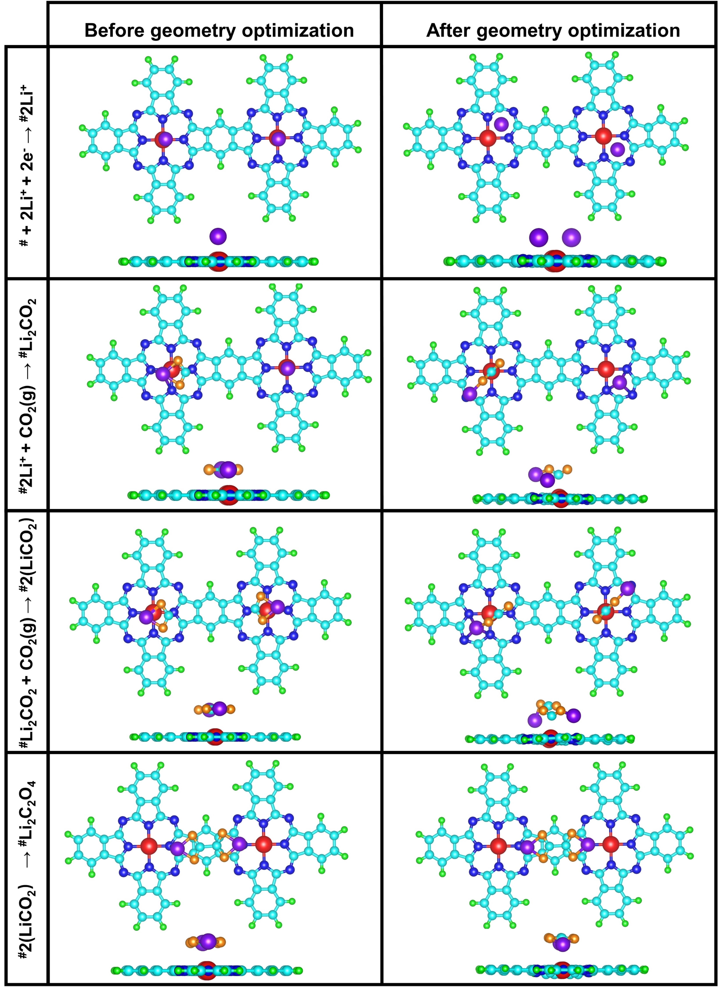

Figure S27. Comparison of ground state structures before and after optimization for each step in Path ‖.

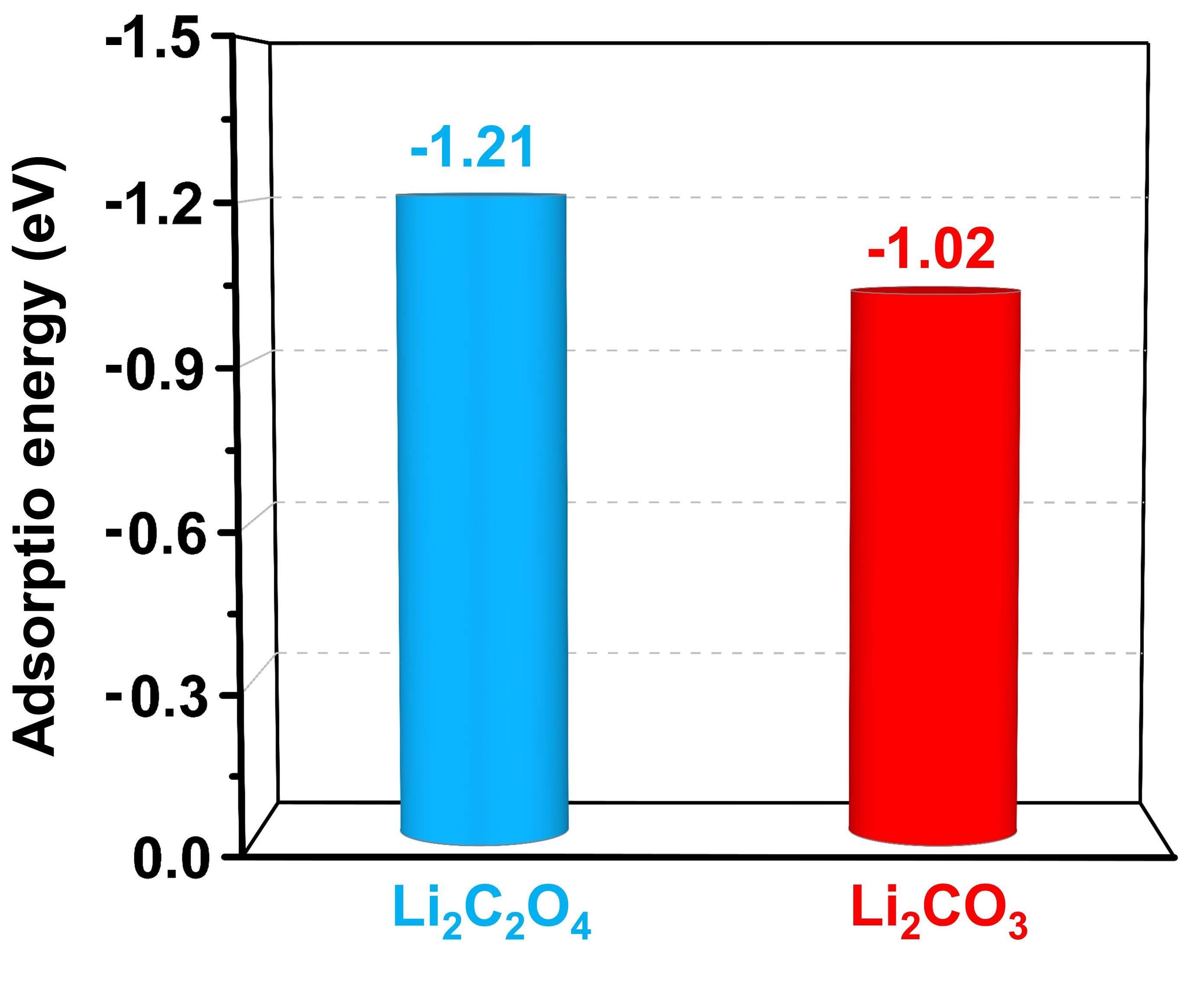

Figure S28. Adsorption energy of Li₂C₂O₄ and Li₂CO₃ on C₃₂H₁₆N₈Fe.

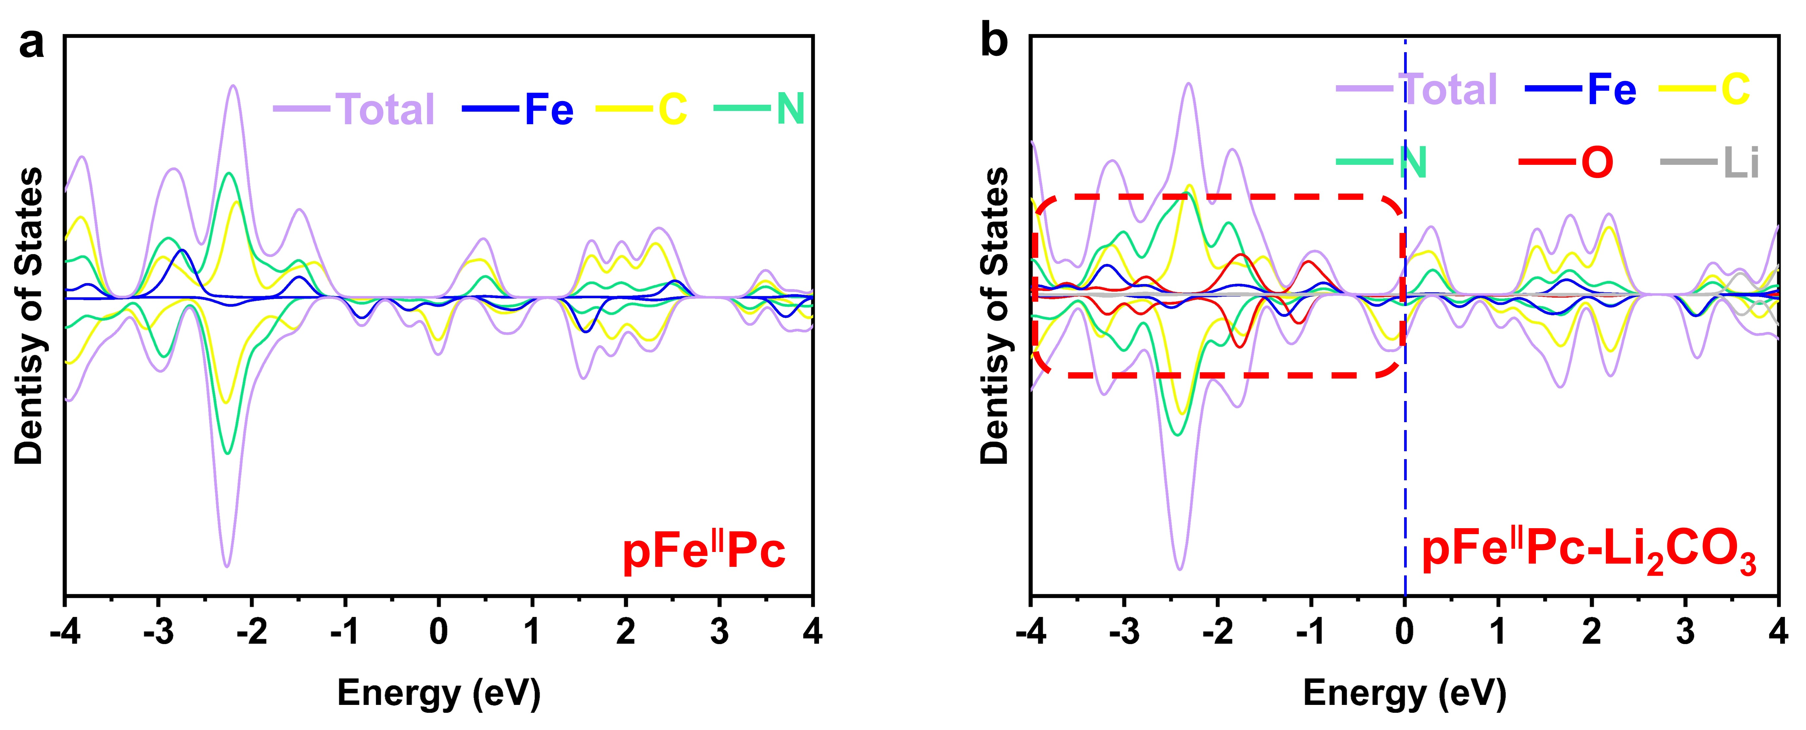

Figure S29. PDOS of C₃₂H₁₆N₈Fe around the Fermi level a) C₃₂H₁₆N₈Fe and b) C₃₂H₁₆N₈Fe after Li₂CO₃ adsorption.

