Supplementary material

Table S1. Questionnaire 2
Table S2. Summary statistics of each items of questionnaire. 4
Table S3. EFA results and inter-item reliability test for all 35 items. 6
Table S4. Pearson correlation results among the constructs. 8
Table S5. Subgroup comparisons of six factors. 9
Note: SE: self-efficacy, RP: research pressure, RIA: research integrity awareness, TP: time pressure, PP: promotion pressure, PL: plagiarism, DA: dishonest authorship, MS: multiple submissions. 10
Figure S1. Theoretical model illustrating hypothesized associations among Self-Efficacy, Research Pressure, and Research Integrity Awareness, with subdimensions indicated. 11
Figure S2. Confirmatory factor analysis (CFA) of the measurement model with six latent constructs. SE: self-efficacy, RP: research pressure, RIA: research integrity awareness, TP: time pressure, PP: promotion pressure, PL: plagiarism, DA: dishonest authorship, MS: multiple submissions. 12
Figure S3. Hypothesized first-order SEM with six latent constructs modeled separately (SE=Self-Efficacy, TP=Time Pressure, PP=Promotion Pressure, PLA=Plagiarism, DA=Dishonest Authorship, MS=Multiple Submissions). Standardized path coefficients are shown. 13
Figure S4. Subgroup differences in six latent constructs (SE=Self-Efficacy, TP=Time Pressure, PP=Promotion Pressure, PLA=Plagiarism, DA=Dishonest Authorship, MS=Multiple Submissions). 14

Table S1. Questionnaire

SE -Item 1: As long as I do my best, I can always solve scientific research problems.
SE -Item 2: If I put in the necessary effort, I will definitely solve most of the scientific research difficulties.
SE -Item 3: Even if others oppose it, we still firmly believe in the correctness of our research results.
SE -Item 4: For me, it is relatively easy to persist in scientific research ideas and achieve scientific research goals.
SE -Item 5: I am confident in handling any unexpected events during the research process.
SE -Item 6: With my ability, I can handle any unforeseen situation in scientific research.
SE -Item 7: I can face difficulties calmly because I trust my ability to solve scientific research problems.
SE -Item 8: When encountering a scientific research difficulty, I usually find several solutions.
SE -Item 9: When facing difficulties in scientific research, I don’t back down and usually come up with some solutions.
SE -Item 10: No matter what scientific research difficulties I encounter, I can always handle them confidently.
RP -Item 1: The current research performance evaluation cycle always puts a lot of pressure on me.
RP -Item 2: To meet evaluation requirements, I have to spend a lot of time and energy.
RP -Item 3: Clinical work takes up a large portion of my time, leaving very little time for research.
RP -Item 4: When working on research projects outside of clinical regulations, I always feel that I don’t have enough time.
RP -Item 5: If given enough time, I could do better in my research work.
RP -Item 6: I often feel pressured by my colleagues’ competition for research resources.
RP -Item 7: The research abilities of my colleagues within the institution put a lot of pressure on me.
RP -Item 8: Slow progress in research performance and promotion brings me significant pressure.
RP -Item 9: Limited promotion opportunities make me feel stressed.
RP -Item 10: Limited project funding applications make me feel anxious when applying.
RIA-Item 1: Medical staff omit some citation marks when frequently citing large amounts of references.
RIA-Item 2: Medical staff believe they only need to cite viewpoints that support their own opinions.
RIA-Item 3: When ideas align and the language is similar, medical staff consider it acceptable not to cite.
RIA-Item 4: Medical staff translate foreign scholars' viewpoints and publish them domestically under their own name.
RIA-Item 5: Medical staff directly borrow others' unpublished research designs to apply for projects.
RIA-Item 6: Medical staff add colleagues who did not participate in the research to meet group size requirements.
RIA-Item 7: Medical staff list a well-known professor as the nominal project leader when applying for projects.
RIA-Item 8: Medical staff add the names of absent team members when concluding projects.
RIA-Item 9: Under pressure from superiors, medical staff add their names to their own publications.
RIA-Item 10: Medical staff are credited for projects completed entirely by students without their participation.
RIA-Item 11: A small research outcome should not be divided into multiple papers for publication.
RIA-Item 12: Medical staff submit to multiple journals simultaneously but only publish in one.
RIA-Item 13: Medical staff write multiple papers using the same data but different analysis methods.
RIA-Item 14: Medical staff submit to multiple journals simultaneously to increase acceptance chances.
RIA-Item 15: Medical staff revise previously published papers and resubmit them for publication.

Table S2. Summary statistics of each items of questionnaire.
Scale Items | Mean | SD
Self-Efficacy
SE-Item1 | 5.01 | 1.476
SE-Item2 | 5.04 | 1.436
SE-Item3 | 5.00 | 1.429
SE-Item4 | 4.25 | 1.623
SE-Item5 | 4.44 | 1.583
SE-Item6 | 4.40 | 1.599
SE-Item7 | 4.77 | 1.534
SE-Item8 | 4.74 | 1.563
SE-Item9 | 4.99 | 1.479
SE-Item10 | 4.41 | 1.556
Research Pressure
RP-Item1 | 5.31 | 1.449
RP-Item2 | 5.46 | 1.362
RP-Item3 | 5.59 | 1.498
RP-Item4 | 5.59 | 1.478
RP-Item5 | 5.52 | 1.359
RP-Item6 | 5.20 | 1.486
RP-Item7 | 5.14 | 1.428
RP-Item8 | 5.37 | 1.529
RP-Item9 | 5.30 | 1.538
RP-Item10 | 5.48 | 1.445
Research integrity
RIA-Item1 | 3.46 | 1.600
RIA-Item2 | 3.75 | 1.708
RIA-Item3 | 3.62 | 1.599
RIA-Item4 | 3.94 | 1.642
RIA-Item5 | 3.89 | 1.624
RIA-Item6 | 4.10 | 1.825
RIA-Item7 | 4.06 | 1.807
RIA-Item8 | 4.07 | 1.820
RIA-Item9 | 3.98 | 1.806
RIA-Item10 | 4.06 | 1.779
RIA-Item11 | 3.58 | 1.633
RIA-Item12 | 3.78 | 1.904
RIA-Item13 | 3.81 | 1.739
RIA-Item14 | 3.86 | 1.851
RIA-Item15 | 4.00 | 1.721
Note: SE: self-efficacy, RP: research pressure, RIA: research integrity awareness

Table S3. EFA results and inter-item reliability test for all 35 items.
Factor |  | 1 | 2 | 3 | 4 | 5 | 6 | Communality | Eigenvalue | Cronbach's Alpha
F1: Self-efficacy | SE-Item1 | 0.713 |  |  |  |  |  | 0.555 | 6.600 | 0.932
F1: Self-efficacy | SE-Item2 | 0.752 |  |  |  |  |  | 0.626 | 6.600 | 0.932
F1: Self-efficacy | SE-Item3 | 0.714 |  |  |  |  |  | 0.556 | 6.600 | 0.932
F1: Self-efficacy | SE-Item4 | 0.736 |  |  |  |  |  | 0.595 | 6.600 | 0.932
F1: Self-efficacy | SE-Item5 | 0.796 |  |  |  |  |  | 0.680 | 6.600 | 0.932
F1: Self-efficacy | SE-Item6 | 0.798 |  |  |  |  |  | 0.676 | 6.600 | 0.932
F1: Self-efficacy | SE-Item7 | 0.791 |  |  |  |  |  | 0.683 | 6.600 | 0.932
F1: Self-efficacy | SE-Item8 | 0.794 |  |  |  |  |  | 0.659 | 6.600 | 0.932
F1: Self-efficacy | SE-Item9 | 0.771 |  |  |  |  |  | 0.632 | 6.600 | 0.932
F1: Self-efficacy | SE-Item10 | 0.769 |  |  |  |  |  | 0.639 | 6.600 | 0.932
F2: Time pressure | RP-Item1 |  | 0.665 |  |  |  |  | 0.636 | 3.910 | 0.901
F2: Time pressure | RP-Item2 |  | 0.829 |  |  |  |  | 0.798 | 3.910 | 0.901
F2: Time pressure | RP-Item3 |  | 0.677 |  |  |  |  | 0.628 | 3.910 | 0.901
F2: Time pressure | RP-Item4 |  | 0.751 |  |  |  |  | 0.708 | 3.910 | 0.901
F2: Time pressure | RP-Item5 |  | 0.834 |  |  |  |  | 0.835 | 3.910 | 0.901
F3: Promotion pressure | RP-Item6 |  |  |  |  | 0.766 |  | 0.744 | 3.698 | 0.839
F3: Promotion pressure | RP-Item7 |  |  |  |  | 0.650 |  | 0.592 | 3.698 | 0.839
F3: Promotion pressure | RP-Item8 |  |  |  |  | 0.690 |  | 0.620 | 3.698 | 0.839
F3: Promotion pressure | RP-Item9 |  |  |  |  | 0.735 |  | 0.715 | 3.698 | 0.839
F3: Promotion pressure | RP-Item10 |  | 0.492 |  |  | 0.490 |  | 0.512 | 3.698 | 0.839
F4: Plagiarism | RIA-Item1 |  |  |  | 0.693 |  |  | 0.621 | 3.556 | 0.871
F4: Plagiarism | RIA-Item2 |  |  |  | 0.512 |  | 0.411 | 0.583 | 3.556 | 0.871
F4: Plagiarism | RIA-Item3 |  |  |  | 0.822 |  |  | 0.782 | 3.556 | 0.871
F4: Plagiarism | RIA-Item4 |  |  |  | 0.722 |  |  | 0.671 | 3.556 | 0.871
F4: Plagiarism | RIA-Item5 |  |  |  | 0.821 |  |  | 0.772 | 3.556 | 0.871
F5: Dishonest authorship | RIA-Item6 |  |  |  |  |  | 0.682 | 0.715 | 2.934 | 0.884
F5: Dishonest authorship | RIA-Item7 |  |  |  |  |  | 0.655 | 0.751 | 2.934 | 0.884
F5: Dishonest authorship | RIA-Item8 |  |  |  |  |  | 0.781 | 0.751 | 2.934 | 0.884
F5: Dishonest authorship | RIA-Item9 |  |  |  |  |  | 0.651 | 0.721 | 2.934 | 0.884
F5: Dishonest authorship | RIA-Item10 |  |  |  | 0.412 |  | 0.427 | 0.587 | 2.934 | 0.884
F6: Multiple submissions | RIA-Item11 |  |  | 0.737 |  |  |  | 0.684 | 2.802 | 0.888
F6: Multiple submissions | RIA-Item12 |  |  | 0.693 |  |  |  | 0.676 | 2.802 | 0.888
F6: Multiple submissions | RIA-Item13 |  |  | 0.743 |  |  |  | 0.672 | 2.802 | 0.888
F6: Multiple submissions | RIA-Item14 |  |  | 0.767 |  |  |  | 0.742 | 2.802 | 0.888
F6: Multiple submissions | RIA-Item15 |  |  | 0.718 |  |  |  | 0.680 | 2.802 | 0.888
*RP-Item10, RIA-Item2 and RIA-Item10 were eliminated due to cross loadings.

Table S4. Pearson correlation results among the constructs.
 | F1 | F2 | F3 | F4 | F5 | F6
F1: Self-efficacy | 1
F2: Time pressure | -0.328*** | 1
F3: Promotion pressure | -0.315*** | 0.574*** | 1
F4: Plagiarism | 0.334*** | -0.510*** | -0.501*** | 1
F5: Dishonest authorship | 0.512*** | -0.526*** | -0.529*** | 0.554*** | 1
F6: Multiple submissions | 0.343*** | -0.587*** | -0.592*** | 0.494*** | 0.608*** | 1
Note: *** P<0.001.

Table S5. Subgroup comparisons of six factors.
Factors | Group | N | Mean | SD | t | df | P value
SE | Male | 171 | 0.006 | 1.033 | 0.099 | 370 | 0.921
SE | Female | 241 | -0.004 | 1.052 | 0.099 | 370 | 0.921
TP | Male | 171 | -0.061 | 1.033 | -1.05 | 337 | 0.295
TP | Female | 241 | 0.043 | 0.913 | -1.05 | 337 | 0.295
PP | Male | 171 | 0.026 | 0.959 | 0.471 | 358 | 0.638
PP | Female | 241 | -0.018 | 0.926 | 0.471 | 358 | 0.638
PLA | Male | 171 | 0.013 | 1.228 | 0.181 | 361 | 0.856
PLA | Female | 241 | -0.009 | 1.2 | 0.181 | 361 | 0.856
DA | Male | 171 | -0.005 | 1.446 | -0.055 | 354 | 0.956
DA | Female | 241 | 0.003 | 1.372 | -0.055 | 354 | 0.956
MS | Male | 171 | -0.06 | 1.414 | -0.746 | 354 | 0.456
MS | Female | 241 | 0.043 | 1.342 | -0.746 | 354 | 0.456
SE | Senior title | 111 | 0.098 | 1.003 | 1.189 | 206 | 0.236
SE | Lower title | 301 | -0.036 | 1.056 | 1.189 | 206 | 0.236
TP | Senior title | 111 | -0.102 | 1 | -1.27 | 188 | 0.206
TP | Lower title | 301 | 0.038 | 0.951 | -1.27 | 188 | 0.206
PP | Senior title | 111 | -0.024 | 0.968 | -0.31 | 189 | 0.757
PP | Lower title | 301 | 0.009 | 0.929 | -0.31 | 189 | 0.757
PLA | Senior title | 111 | 0.109 | 1.221 | 1.104 | 194 | 0.271
PLA | Lower title | 301 | -0.04 | 1.206 | 1.104 | 194 | 0.271
DA | Senior title | 111 | 0.106 | 1.348 | 0.953 | 206 | 0.342
DA | Lower title | 301 | -0.039 | 1.421 | 0.953 | 206 | 0.342
MS | Senior title | 111 | 0.071 | 1.276 | 0.662 | 215 | 0.509
MS | Lower title | 301 | -0.026 | 1.407 | 0.662 | 215 | 0.509
SE | With administrative position | 69 | 0.166 | 0.928 | 1.587 | 107 | 0.116
SE | Without administrative position | 343 | -0.033 | 1.062 | 1.587 | 107 | 0.116
TP | With administrative position | 69 | -0.018 | 0.911 | -0.178 | 102 | 0.859
TP | Without administrative position | 343 | 0.004 | 0.977 | -0.178 | 102 | 0.859
PP | With administrative position | 69 | -0.201 | 0.981 | -1.881 | 94 | 0.063
PP | Without administrative position | 343 | 0.04 | 0.926 | -1.881 | 94 | 0.063
PLA | With administrative position | 69 | 0.144 | 1.206 | 1.088 | 98 | 0.279
PLA | Without administrative position | 343 | -0.029 | 1.211 | 1.088 | 98 | 0.279
DA | With administrative position | 69 | 0.264 | 1.379 | 1.741 | 98 | 0.085
DA | Without administrative position | 343 | -0.053 | 1.402 | 1.741 | 98 | 0.085
MS | With administrative position | 69 | 0.187 | 1.348 | 1.257 | 99 | 0.212
MS | Without administrative position | 343 | -0.038 | 1.375 | 1.257 | 99 | 0.212
SE | Clinical area | 256 | -0.01 | 1.05 | -0.258 | 332 | 0.796
SE | Others | 156 | 0.017 | 1.033 | -0.258 | 332 | 0.796
TP | Clinical area | 256 | -0.042 | 0.987 | -1.141 | 343 | 0.255
TP | Others | 156 | 0.068 | 0.927 | -1.141 | 343 | 0.255
PP | Clinical area | 256 | -0.022 | 0.942 | -0.612 | 329 | 0.541
PP | Others | 156 | 0.036 | 0.935 | -0.612 | 329 | 0.541
PLA | Clinical area | 256 | 0.062 | 1.215 | 1.345 | 331 | 0.180
PLA | Others | 156 | -0.102 | 1.199 | 1.345 | 331 | 0.180
DA | Clinical area | 256 | 0.02 | 1.453 | 0.376 | 353 | 0.707
DA | Others | 156 | -0.033 | 1.316 | 0.376 | 353 | 0.707
MS | Clinical area | 256 | 0.017 | 1.382 | 0.332 | 332 | 0.740
MS | Others | 156 | -0.029 | 1.359 | 0.332 | 332 | 0.740

Note: SE: self-efficacy, RP: research pressure, RIA: research integrity awareness, TP: time pressure, PP: promotion pressure, PL: plagiarism, DA: dishonest authorship, MS: multiple submissions.

Figure S1. Theoretical model illustrating hypothesized associations among Self-Efficacy, Research Pressure, and Research Integrity Awareness, with subdimensions indicated.

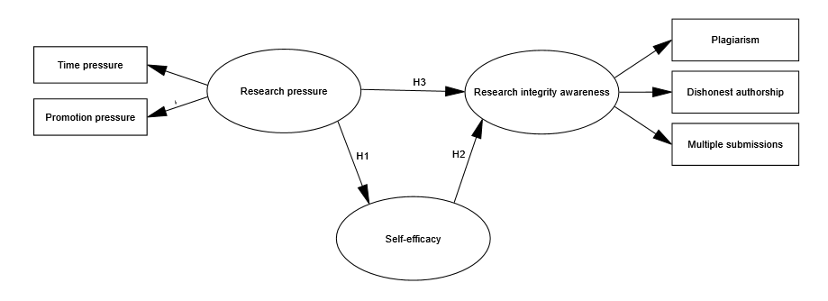

Figure S2. Confirmatory factor analysis (CFA) of the measurement model with six latent constructs. SE: self-efficacy, RP: research pressure, RIA: research integrity awareness, TP: time pressure, PP: promotion pressure, PL: plagiarism, DA: dishonest authorship, MS: multiple submissions.
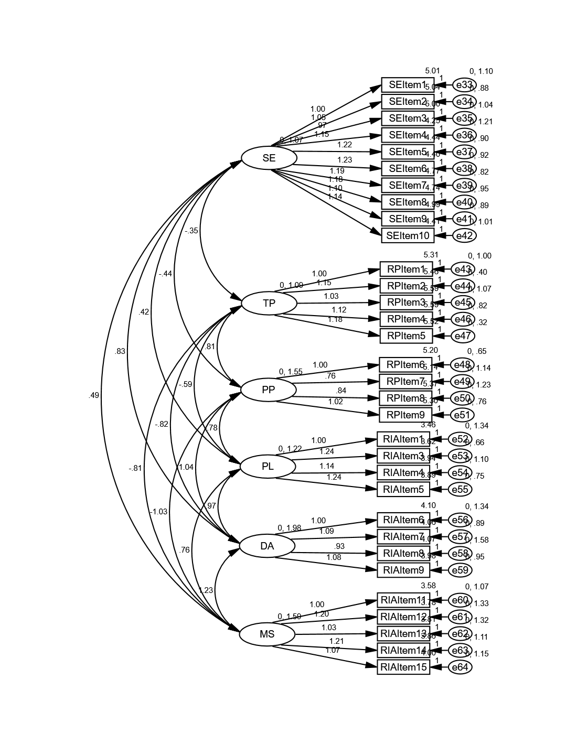

Figure S3. Hypothesized first-order SEM with six latent constructs modeled separately (SE=Self-Efficacy, TP=Time Pressure, PP=Promotion Pressure, PLA=Plagiarism, DA=Dishonest Authorship, MS=Multiple Submissions). Standardized path coefficients are shown.

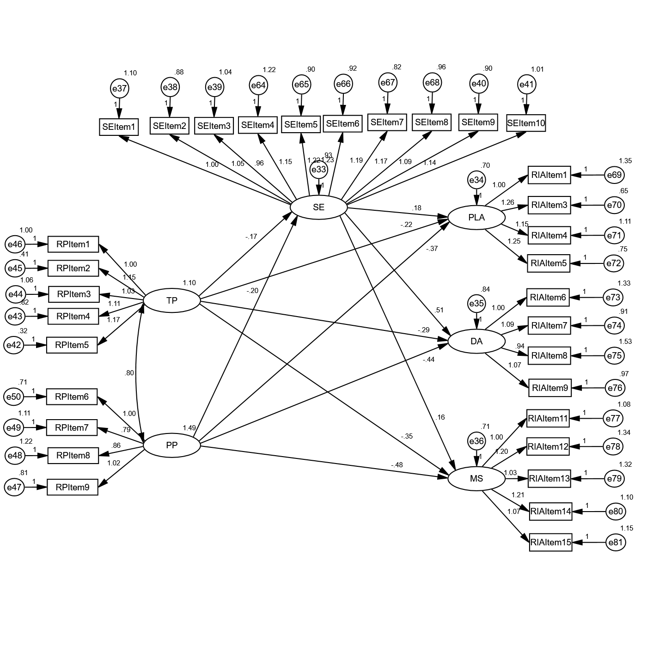

Figure S4. Subgroup differences in six latent constructs (SE=Self-Efficacy, TP=Time Pressure, PP=Promotion Pressure, PLA=Plagiarism, DA=Dishonest Authorship, MS=Multiple Submissions).
