Supporting Information
Achieving Near 21% Efficiency Organic Solar Cells with Minimal Nonradiative Energy Loss through Controlled Packing of Fused-Ring Electron Acceptors
Nan Wei, Tong Sun, Hao Lu, Xiaodong Wang, Xueqing Ma, Jiahe Zhang, Bohan Shang, Jieni Chen, Wenkai Zhang, Ming Fan, Yukun Xia, Zaifei Ma, Xiangwei Zhu*, Zhishan Bo* and Yahui Liu*

1. Instrument and test parameters
The optical and electrochemical properties of the materials were thoroughly characterized using a series of advanced techniques. UV-vis absorption spectra were acquired on a PerkinElmer Lambda 750 spectrophotometer, while photoluminescence (PL) measurements were performed using a Zolix Flex One PL microscopic spectrometer equipped with a 660 nm continuous-wave laser. Electrochemical characterization was carried out through cyclic voltammetry (CV) measurements using a CHI 630A Electrochemical Workstation in a three-electrode system consisting of a platinum working electrode, platinum wire counter electrode, and Ag/AgNO₃ reference electrode (0.01 M in acetonitrile), with experiments conducted in 0.1 M Bu₄NPF₆ acetonitrile solution under nitrogen atmosphere at a scan rate of 0.1 V/s, using the ferrocene/ferrocenium (Fe/Fe⁺) redox couple as an internal reference for energy level calculations.^{[1]} The HOMO/LUMO energy levels were calculated using the formula:
E_{HOMO/LUMO} = - (Eonset Ox - E1/2 Fe/Fe⁺ + 4.8) eV equation S1

Grazing incidence wide-angle x-ray scattering (GIWAXS) experiments were conducted at the beamline of 7.3.3 at the Advanced Light Source (ALS). Surface morphology was examined by atomic force microscopy (AFM) using a Bruker Nanoscope VIII MultiMode system operating in tapping mode with silicon probes (TESP, resonant frequency ~300 kHz, spring constant ~40 N/m). Time-resolved spectroscopic studies included in situ UV-vis absorption measurements using a DU-100 system with 1 ms sampling intervals and 80 ms integration time, as well as femtosecond transient absorption (fs-TA) spectroscopy to probe charge transfer dynamics, where selective excitation of acceptor components was achieved using low-power pump beams at 823 nm to distinguish the contributions from Y6, Y6-2Cl and Y6-4Cl in the blend films.

Single-Crystal Analyses: Data were collected from a shock-cooled single crystal at 150(2) K on a Bruker D8 VENTURE dual wavelength Mo/Cu three-circle diffractometer with a microfocus sealed X-ray tube using a mirror optics as monochromator and a Bruker PHOTON III detector. CCDC-2520709 contain the supplementary crystallographic data for Y6-2Cl, which can be obtained free of charge from the Cambridge Crystallographic Data Centre via http://www.ccdc.cam.ac.uk/structures.

2. Fabrication and characterizations of organic solar cells
2.1 Preparation process of OSCs
Y6-2Cl and Y6-4Cl were synthesized according to the steps in Scheme 1, and Y6/D18 were prepared from the reported work.^{[2-3]} The ITO-glass underwent cleaning with detergent and were then positioned in a PTFE cleaning rack for an ultrasonic treatment spanning 20 minutes, sequentially in deionized water, acetone, and isopropanol. To evaluate the photovoltaic performance of the donor and acceptor, conventional organic solar cells (OSCs) were fabricated with a configuration comprising ITO/2PACz/Donor: Acceptor (100 nm)/ PDINN (8 nm)/Ag (100 nm). The 2PACz (0.3 mg/mL in alcohol solution) layer was applied onto the ITO surface through spin-casting at 5000 rpm for 20 seconds and subsequently baked in air at 75°C for 5 minutes. The photovoltaic active layer was prepared by spin-coating a blended chloroform solution containing D18 polymer donor, non-fullerene acceptors, and the additive DIB onto ITO/2PACz substrates under nitrogen atmosphere. The solution formulation maintained a fixed D18 concentration of 5 mg/mL with an equivalent DIB concentration, while employing a donor-to-acceptor mass ratio of 1:1.2. Prior to deposition, the solution was heated to 90°C to ensure complete dissolution of all components, then cooled to 50°C for optimal processing conditions. The spin-coating process was performed in a nitrogen glove box environment, yielding uniform thin films with a targeted thickness of 100 nm, followed by brief thermal annealing at 100°C for 20s. For device completion, a PDINN interfacial layer (1.5 mg/mL in methanol) was deposited atop the bulk heterojunction layer via spin-coating at 3000 rpm for 20 s. Final device architecture was achieved through thermal evaporation of a 100 nm silver electrode under high vacuum conditions (~4×10⁻⁶ Torr). All organic solar cells were fabricated on substrates with an active area of 4 mm². Current density-voltage (J-V) characterization was conducted in glove box environment at ambient temperature (~25°C) using an Enli Technology SSF53A measurement system, with illumination provided by an AM 1.5G solar simulator (AAA class, 100 mW/cm²) calibrated with a reference silicon photodiode. External quantum efficiency (EQE) spectra were acquired in ambient conditions using an Enli Technology QER3011 system, similarly calibrated with a certified Si reference cell. All substrate materials, including ITO-coated glass and specialized PTFE cleaning racks, were procured from Advanced Election Technology Co., the PE, DCM and DMF were sourced from Energy Chemical, while high-purity solvents (methanol, acetone, isopropanol) were sourced from Bei Jing TongGuang Fine Chemicals Company. The fabrication process maintained strict environmental controls to ensure device reproducibility and performance consistency.

2.2 Computational process of P_{diss}/P_{coll}, α/n and μ_{h}/μ_{e}
To investigate the charge recombination dynamics in the three device configurations, we examined the light intensity (P_{light}) dependence of both short-circuit current density (J_{SC}) and open-circuit voltage (V_{OC}). The recombination characteristics were assessed through power-law analyses:
- Short-Circuit Current (J_{SC}) versus light intensity (P_{light}), the J_{SC} - P_{light} relationship obeys:
J_{SC} ∝ P_{light}^{α} equation S2
where α represents the exponential coefficient. When α approaches unity (α ≈ 1), minimal bimolecular recombination occurs, suggesting optimal charge extraction. Values below unity (α <1) indicate substantial bimolecular recombination, resulting in photocurrent losses.^{[4]}
- Open-Circuit Voltage (V_{OC}) versus light intensity (P_{light}), the V_{OC} - P_{light} correlation follows:
V_{OC} ∝ (nKT/q)lnP_{light} equation S3
where: n = recombination ideality factor, K = Boltzmann's constant, T = absolute temperature, q = electron charge. An ideality factor near unity (n≈1) suggests predominant trap-assisted recombination (e.g., Shockley-Read-Hall mechanism).
When n approaches 2 (n≈2), bimolecular recombination dominates.^{[5]}
Through fitting the experimental results (Figure 1) to these models, we characterized the recombination processes in the three systems. Devices exhibiting lower α values coupled with higher n factors demonstrate enhanced bimolecular recombination, whereas parameters approaching ideal values (α ≈ 1, n ≈ 1) signify reduced recombination and improved charge extraction.
The exciton dissociation probability (P_{diss}) and charge collection efficiency (P_{coll}) were derived from J_{ph}-V_{eff} analysis. The photocurrent density (J_{ph}) was calculated as J_{ph} = J_{L} - J_{D}, where J_{L} and J_{D} correspond to illuminated and dark current densities, respectively. The effective voltage (V_{eff}) was defined as V_{eff} = V - V₀, where V₀ represents the compensation voltage at J_{ph} = 0. The exciton dissociation yield was determined from the J_{ph}/J_{sat} ratio, with J_{sat} being the saturation photocurrent density.
Charge carrier mobilities were characterized using the Space Charge Limited Current (SCLC) method. Hole mobility (μ_{h}) measurements employed ITO/2PACz/Donor:Acceptor/MoO₃/Ag architectures, while electron mobility (μ_{e}) assessments used ITO/ZnO/Donor:Acceptor/PDINN/Ag configurations. Mobilities were extracted through SCLC analysis using:
J = 9ε_{r}ε₀μ/(8L³)V² equation S4
where: J = space charge limited current density, ε₀ = vacuum permittivity (8.85×10⁻¹² F/m), ε_{r} = active layer dielectric constant, μ = zero-field charge mobility, L = active layer thickness, and V = applied bias voltage.^{[6]}

2.3 Energy Loss Analysis in Organic Solar Cells
2.3.1 Non-Radiative Energy Loss (ΔE_{nr})
The non-radiative energy loss is calculated from the electroluminescence external quantum efficiency (EQE_{EL}) using:
ΔE_{nr} = −kT ln (EQE_{EL}) equation S5
where k represents the Boltzmann constant, T is the temperature in Kelvin, and EQE_{EL} denotes the electroluminescence external quantum efficiency of the device.
2.3.2 Total Energy Loss (E_{loss})
The total energy loss is derived from the optical bandgap (E_{g}, Figure S9) and open-circuit voltage (V_{OC}):
E_{loss} = E_{g} -qV_{OC} equation S6
where E_{g} was determined from the intersection of the photoluminescence (PL) and UV-vis spectra of the neat acceptor films (Figure S1).
The total energy loss (E_{loss}) was further decomposed into three components:
E_{loss} = ΔE_{CT} + ΔE_{r} + ΔE_{nr} equation S7
To explore the origin of this reduced energy loss in the ternary device, we performed high-sensitivity measurements of photovoltaic external quantum efficiency (EQE_{PV}) and electroluminescence (EL) (Figure S2). E_{CT} is the charge transfer (CT, Figure S10) state energy, and ΔE_{CT} and ΔE_{r} denote the charge transfer state energy loss and radiative energy loss, respectively, ΔE_{CT} = E_{g} − E_{CT}. equation S8

2.4 Femtosecond Transient Absorption (fs-TA) Measurement for Determining Exciton Lifetime
To precisely determine the exciton diffusion length (L_{D}) in neat D18, Y6, Y6-2Cl and Y6-4Cl films, we employed exciton-exciton annihilation (EEA) analysis combined with transient absorption (TA) spectroscopy. The exciton diffusion length was calculated using the relation:
L_{D} = (Dτ)^{1/2} equation S9
where:D = exciton diffusion coefficient
τ = effective exciton lifetime
The exciton lifetime (τ) was obtained through multi-exponential fitting of the TA decay kinetics:
𝐼(𝑡) = 𝐴₁𝑒^{−𝑡/𝜏1} + 𝐴₂𝑒^{−𝑡/𝜏2} + 𝐴₃𝑒^{−𝑡/𝜏3} equation S10
𝜏 = 𝐴₁ × 𝜏₁ + 𝐴₂ × 𝜏₂ + 𝐴₃ × 𝜏₃ equation S11
Here, A_{i} represents the amplitude fraction of each decay component (τ_{i}).
Exciton Quenching Mechanisms
Exciton decay dynamics are governed by two primary quenching pathways:
- Trap-assisted recombination (rate constant: κ)
- Bimolecular EEA recombination (rate constant: γ)
The exciton population decay is described by:
$-\frac{dn(τ)}{dτ}=κn\left(τ\right)+γn^{2}(τ)$ equation S12
The solution to this differential equation yields the exciton density (n(τ)) at a given time (τ):
Experimental Determination of κ and γ
$n\left(τ\right)=\frac{n\left(0\right)exp⁡(-kτ)}{1+\frac{γ}{κ}n\left(0\right)[1-exp⁡(-κτ)}$ equation S13
TA measurements were performed at two excitation intensities to isolate the contributions of κ and γ:
Low-intensity regime (0.12 μJ cm⁻² for Y6/Y6-2Cl/Y6-4Cl)
EEA is negligible → monoexponential decay:
$\frac{dn(τ)}{dτ}=kn\left(τ\right)$ equation S14
Extracted κ values:
Y6: 32.8 × 10⁹ s⁻¹
Y6-2Cl: 38.5 × 10⁹ s⁻¹
Y6-4Cl: 82.5 × 10⁹ s⁻¹
High-intensity regime (0.59 μJ cm⁻² for for Y6/Y6-2Cl/Y6-4Cl)
EEA dominates → non-exponential decay:
$τ_{1/2}=\frac{α ln2}{κ} , α<1$ equation S15
$γ=\frac{κ(2\exp\left(α ln2\right)-1}{n_{0}(1-\exp\left(-α ln2\right))}$ equation S16
Measured τ₁/₂ (exciton density decay to 50%):
Y6: 9.4 ps
Y6-2Cl: 6.8 ps
Y6-4Cl: 3.9 ps
Extracted γ values:
Y6: 16.3 × 10⁻⁸ cm³ s⁻¹
Y6-2Cl: 25.8 × 10⁻⁸ cm³ s⁻¹
Y6-4Cl: 23.4 × 10⁻⁸ cm³ s⁻¹
Finally, the diffusion coefficient (D) was calculated from κ and γ using:
$D=\frac{γ}{4πR}$ equation S17
where R is the annihilation radius of singlet excitons. R is assumed to be 2 nm.
- Synthetic details and characterizations
Materials and synthesis
All chemicals and solvents were purchased from commercial sources (Bidepharm, Leyan, Macklin, Energy Chemical and Bei Jing TongGuang Fine Chemicals Company) and used as received. The synthetic details are as follows.
Scheme S1. The synthetic route of Y6-2Cl and Y6-4Cl.
Synthesis of compound 4 and 5
Compound 1 (374 mg, 0.5 mmol), compound 2 (518 mg, 1.25 mmol), compound 3 (145 g, 0.75 mmol), KI (200 mg, 1.20 mmol), K₂CO₃ (580 mg, 4.2 mmol) and dry DMF (12 mL) were added to the flask.^{[7]} The reaction was stirred at 100 ℃ in N₂ environment for 24 hours. After the reaction was cooled to room temperature, the mixture was poured into water and extracted three times with DCM. Then, the solvent was removed under reduced pressure. The crude products were purified by silica gel column chromatography (eluent: PE:DCM = 4:1, v/v) to obtain pure compound 4 (226 mg, yield: 38%) and compound 5 (240 mg, yield: 34%) as red sticky oil.
Compound 4: ¹H NMR (600 MHz, Chloroform-d) δ 7.16 (d, 2H), 7.03 (s, 1H), 7.00 (s, 1H), 6.92 (dd, 2H), 6.86 (dd, 2H), 6.50 (t, 2H), 4.66 (dd, 1H), 4.57-4.52 (m, 3H), 2.84 (t, 4H), 2.26-0.97 (m, 58H), 0.89-0.57 (m, 12H).
Compound 5: ¹H NMR (600 MHz, Chloroform-d) δ 7.15 (d, 4H), 7.01 (s, 2H), 6.93 (t, 4H), 6.83 (t, 4H), 6.49-6.46 (m, 4H), 4.59-4.54 (m, 2H), 4.49-4.46 (m, 2H), 2.85 (t, 4H), 2.22-0.96 (m, 62H), 0.89-0.83 (m, 6H).

Synthesis of compound 6
Compound 4 (180 mg, 0.15 mmol), DMF (2 mL), and 1,2-dichloroethane (15 mL) were added to a two-necked flask, followed by several cycles of degassing. Then, POCl₃ (1 mL) was added dropwise at 0 ℃. The mixture was stirred under nitrogen protection at 0 ℃ for 0.5 hours, followed by heating to 85 ℃ and stirring for 12 hours. After the completion of the reaction, the mixture was poured into a saturated NaHCO₃ solution (200 mL) and stirred for 2 hours. After extraction with DCM, the solvent was removed under reduced pressure. The crude product was purified by silica gel column chromatography (eluent: PE:DCM = 1:1, v/v) to obtain pure compound 6 as orange oil (150 mg, yield: 80%). ¹H NMR (600 MHz, Chloroform-d) δ 10.15 (s, 2H), 7.19 (dd, 2H), 6.92 (t, 2H), 6.87 (dd, 2H), 6.44 (t, 2H), 4.69 (dd, 1H), 4.55-4.51 (m, 3H), 3.25-3.17 (m, 4H), 2.33-0.97 (m, 58H), 0.88-0.53 (m, 12H).

Synthesis of compound 7
The same procedure as for compound 6 was used with compound 5 as initial raw material. And compound 7 was obtained also as orange oil. ¹H NMR (600 MHz, Chloroform-d) δ 10.15 (s, 2H), 7.19 (t, 4H), 6.92-6.83 (m, 8H), 6.45-6.39 (m, 4H), 4.60-4.54 (m, 2H), 4.48-4.42 (m, 2H), 3.27-3.20 (m, 4H), 2.34-0.96 (m, 62H), 0.87 (t, 6H).

Synthesis of Y6-2Cl
Compound 6 (125 mg, 0.1 mmol) and IC-2F (60 mg, 0.25 mmol) were dissolved in toluene (10 mL). Then, BF₃·OEt₂ (0.5 mL) and acetic anhydride (1.0 mL) were added. The mixture was stirred at room temperature for 15 min. After the completion of the reaction, the mixture was poured into water. After extraction with DCM, the solvent was removed under reduced pressure. The crude product was purified by silica gel column chromatography (eluent: PE:DCM = 1:1, v/v) to obtain Y6-2Cl as black solid: (120 mg, yield: 72%).
MALDI-TOF: m/z= 1672.555. ¹H NMR (600 MHz, Chloroform-d) δ 9.17 (d, 2H), 8.59 (dd, 2H), 7.72 (dt, 1H), 7.63 (dt, 1H), 7.13 (dd, 2H), 6.90 (dt, 2H), 6.85 (dd, 2H), 6.50 (t, 2H), 4.83 (dd, 1H), 4.68-4.63 (m, 3H), 3.30-3.20 (m, 4H), 2.42-0.95 (m, 58H), 0.88-0.56 (m, 12H).

Synthesis of Y6-4Cl
The same procedure as for Y6-2Cl was used with compound 7 as initial raw material. And Y6-4Cl was obtained also as black solid.
MALDI-TOF: m/z= 1894.561. ¹H NMR (600 MHz, Chloroform-d) δ 9.16 (s, 2H), 8.59 (t, 2H), 7.62 (dt, 2H), 7.13 (t, 4H), 6.92 (d, 2H), 6.86 (d, 4H), 6.82 (d, 2H), 6.53 (d, 2H), 6.41 (d, 2H), 4.72-4.69 (m, 2H), 4.55-4.53 (m, 2H), 3.29-3.24 (m, 4H), 2.51-1.02 (m, 62H), 0.87 (t, 6H).

Supplementary Figures and Tables

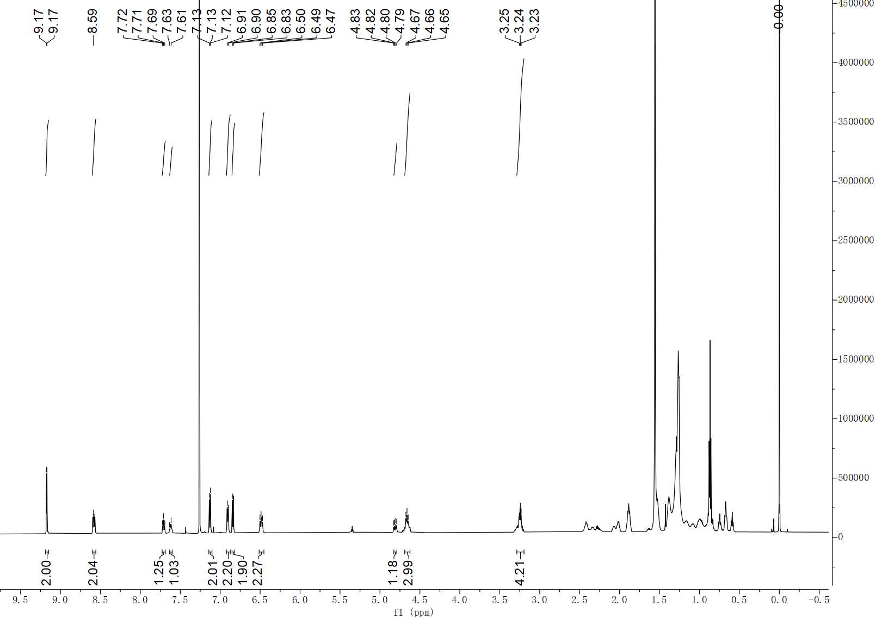
Figure S1. ¹H NMR spectrum of Y6-2Cl in chloroform-d.

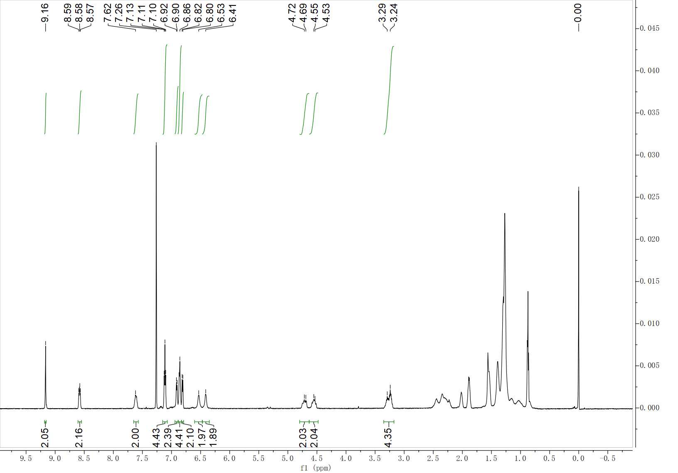
Figure S2. 1H NMR spectrum of Y6-4Cl in chloroform-d.

Figure S3. Plot of absorption maximum vs. solution concentration for (a) Y6, (b) Y6-2Cl and (c) Y6-4Cl. The solubilities of Y6, Y6-2Cl and Y6-4Cl are 25.6 mg/mL, 28.0 mg/mL and 39.2 mg/mL as derived from concentration and absorption data.

Figure S4. The chemical structures of D18.

Figure S5. The UV-vis spectra of Y6, Y6-2Cl and Y6-4Cl solution (CF)/film (a); the cyclic voltammograms of Y6, Y6-2Cl and Y6-4Cl (b).

Figure S6. The PLQY of Y6 (a), Y6-2Cl (b) and Y6-4Cl (c) neat films, and the TRPL spectra of three acceptor neat films (d).

Figure S7. The view of the molecular network of Y6 (a) and Y6-4Cl (b).

Figure S8. The J^{1/2}−V characteristics of electron-only devices (c) and electron-only devices (d) by the space-charge-limited current (SCLC) method of different systems.

Figure S9. Normalized absorption and photoluminescence (PL) emission spectra of Y6 (a), Y6-2Cl (b) and Y6-4Cl (c).

Figure S10. EQE_{pv} and EL spectra of the D18:Y6 (a), D18:Y6-2Cl (b) and D18:Y6-4Cl (c) binary OSCs. E_{CT} of the solar cells is determined by a Gaussian fitting using the method described in the literature.

Figure S11. 2D GIWAXS patterns (a) and 1D GIWAXS profiles (b) of Y6, Y6-2Cl and Y6-4Cl neat films.

Figure S12. The AFM height and phase images of Y6 neat film (a) Y6-2Cl neat films (b) and Y6-4Cl neat films (c).

Figure S13. Time-dependent contour plots of UV-vis absorption spectra of donor: acceptor blend films (a); the time evolution of acceptor peak position and intensity in blend films. The conditions used in the testing process are consistent with those of the OSCs active layers (b).

Figure S14. TA results of Y6, Y6-2Cl and Y6-4Cl neat films and the corresponding GSB delay signal.

Figure S15. The J-V and EQE curves of different D18:L8-BO:Y6-2Cl ternary OSCs.

Table S1. Crystal data and structure refinement for Y6-2Cl.
CCDC number | 2520709
Empirical formula | C₉₄H₉₂Cl₂F₄N₈O₂S₅
Formula weight | 1672.95
Temperature [K] | 150(2)
Crystal system | triclinic
Space group (number) | $P\overline{1}$ (2)
a [Å] | 13.147(6)
b [Å] | 15.000(6)
c [Å] | 23.840(10)
α [°] | 80.079(16)
β [°] | 79.687(11)
γ [°] | 69.211(10)
Volume [Å³] | 4294(3)
Z | 2
ρ_{calc} [gcm⁻³] | 1.294
μ [mm⁻¹] | 2.321
F(000) | 1756
Crystal size [mm³] | 0.030×0.100×0.100
Crystal colour | colourless
Crystal shape | block
Radiation | CuK_{α} (λ=1.54178 Å)
2θ range [°] | 6.35 to 118.62 (0.90 Å)
Index ranges | −14 ≤ h ≤ 14  −14 ≤ k ≤ 16  −26 ≤ l ≤ 26
Reflections collected | 35809
Independent reflections | 11987  R_{int} = 0.1787  R_{sigma} = 0.1380
Completeness to θ = 59.309° | 96.2 %
Data / Restraints / Parameters | 11987 / 1371 / 1139
Absorption correction T_{min}/T_{max} (method) | 0.4821 / 0.7516  (multi-scan)
Goodness-of-fit on F² | 1.034
Final R indexes  [I≥2σ(I)] | R₁ = 0.1446  wR₂ = 0.3152
Final R indexes  [all data] | R₁ = 0.2599  wR₂ = 0.3721
Largest peak/hole [eÅ⁻³] | 0.99/−0.54
Extinction coefficient | 0.00010(4)

Table S2. Electron and hole mobilities of devices based on D18:Y6, D18:Y6-2Cl and D18:Y6-4Cl devices.
Sample | μ_{h} (cm² V ⁻¹s⁻¹) | μ_{e} (cm² V ⁻¹s⁻¹) | μ_{h}/μ_{e}
D18: Y6 | 6.58×10⁻⁴ | 5.25×10⁻⁴ | 1.25
D18: Y6-2Cl | 6.72×10⁻⁴ | 6.16×10⁻⁴ | 1.09
D18: Y6-4Cl | 5.76×10⁻⁴ | 3.80×10⁻⁴ | 1.51

Table S3. Packing behaviors of D18:Y6, D18:Y6-2Cl and D18:Y6-4Cl blend films and Y6, Y6-2Cl and Y6-4Cl neat films.
Sample | OOP（010）
Sample | q_{z} (Å⁻¹) | π-π distance (Å) | FWHM (Å⁻¹) | CCL (Å)
D18:Y6 | 1.74 | 3.62 | 0.28 | 20.20
D18:Y6-2Cl | 1.74 | 3.62 | 0.30 | 18.85
D18:Y6-4Cl | 1.74 | 3.62 | 0.31 | 18.24
Y6 | 1.74 | 3.62 | 0.29 | 19.50
Y6-2Cl | 1.74 | 3.62 | 0.32 | 17.66
Y6-4Cl | 1.74 | 3.62 | 0.33 | 17.14

Table S4. Detailed parameters of single exciton decay dynamic for films.
Materials | Pump  Energy  $$(μJ/{cm}^{2})$$ | $$n_{0}$$  $$(×{10}^{-17}{cm}^{3})$$ | $$t_{1/2}$$  $$(ps)$$ | k  $$(×{10}^{9}s^{-1})$$ | $$α$$ | $$γ$$  $$(×{10}^{-8}{cm}^{3}s^{-1})$$ | D  $$(×{10}^{-3}{cm}^{2}s^{-1})$$ | $$τ$$  $$(ps)$$ | $$L_{D}$$  $$(nm)$$
Y6 | 0.12 | 0.7 | 21.2 | 32.8 | - | - | - | 349.3 | -
Y6 | 0.59 | 3.6 | 9.4 | - | 0.44 | 16.3 | 64.9 | - | 47.6
Y6-2CL | 0.12 | 0.7 | 18.0 | 38.5 | - | - | - | 409.8 | -
Y6-2CL | 0.59 | 3.5 | 6.8 | - | 0.38 | 25.8 | 102.8 | - | 64.9
Y6-4CL | 0.12 | 1.2 | 8.4 | 82.5 | - | - | - | 380.5 | -
Y6-4CL | 0.59 | 5.9 | 3.9 | - | 0.46 | 23.4 | 93.1 | - | 59.5

Reference
[1] X. Ma, G. Ran, H. Li, Y. Liu, X. Cui, H. Lu, Z. Yin, D. Li, H. Zhang, W. Liu, J. Yu, Y. Lin, Y. Liu, W. Zhang, G. Lu, L. Bo, P. Cheng, Z. Ma, Z. Bo, Adv. Energy Mater. 2023, 13, 2302554.
[2] J. Yuan, Y. Zhang, L. Zhou, G. Zhang, H.-L. Yip, T.-K. Lau, X. Lu, C. Zhu, H. Peng, P. A. Johnson, M. Leclerc, Y. Cao, J. Ulanski, Y. Li, Y. Zou, Joule 2019, 3, 1140.
[3] Q. Liu, Y. Jiang, K. Jin, J. Qin, J. Xu, W. Li, J. Xiong, J. Liu, Z. Xiao, K. Sun, S. Yang, X. Zhang, L. Ding, Sci. Bull. 2020, 65, 272.
[4] H. Lu, W. Liu, G. Ran, Z. Liang, H. Li, N. Wei, H. Wu, Z. Ma, Y. Liu, W. Zhang, X. Xu, Z. Bo, Angew. Chem. Int. Ed. 2023, 62, e202314420.
[5] N. Wei, J. Chen, Y. Cheng, Z. Bian, W. Liu, H. Song, Y. Guo, W. Zhang, Y. Liu, H. Lu, J. Zhou, Z. Bo, Adv. Mater. 2024, 36, 2408934.
[6] Y. Sun, L. Wang, C. Guo, J. Xiao, C. Liu, C. Chen, W. Xia, Z. Gan, J. Cheng, J. Zhou, Z. Chen, J. Zhou, D. Liu, T. Wang, W. Li, J. Am. Chem. Soc. 2024, 146, 12011.
[7] F. Liu, Y. Jiang, R. Xu, W. Su, S. Wang, Y. Zhang, K. Liu, S. Xu, W. Zhang, Y. Yi, W. Ma, X. Zhu, 2024, 63, e202313791.

