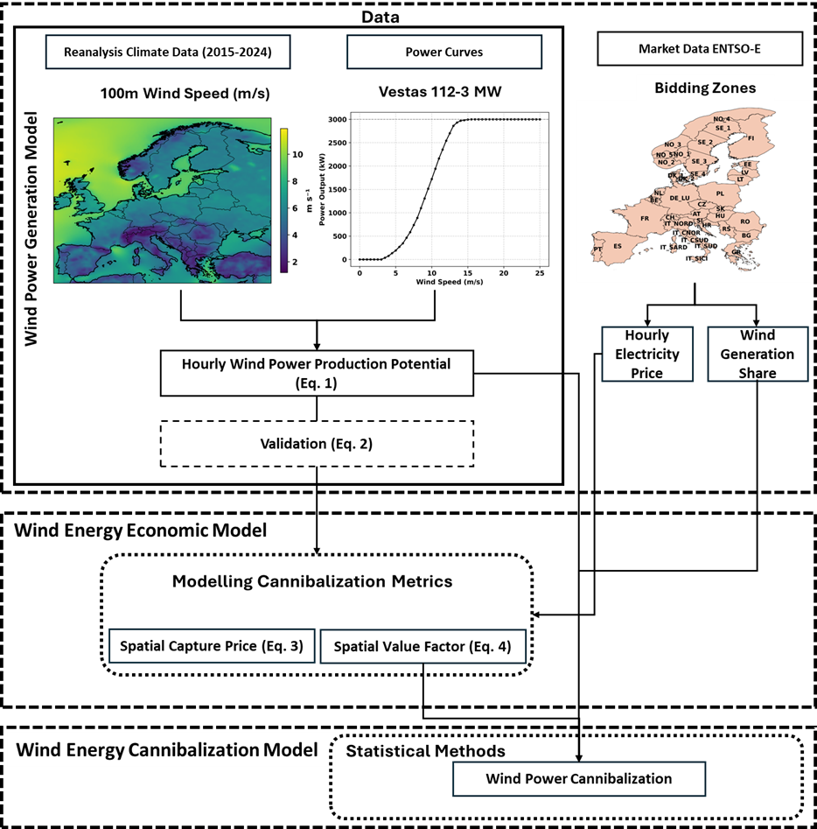
Fig. S1 | Methodological flowchart for quantifying regional wind power cannibalization across Europe using integrated market, climate and turbine data (2015-2024).

Table S1 | Europe-wide annual means of wind generation share, wind value factor, wind capture price and wholesale electricity price (2015-2024). Wind share is expressed as a percentage of total generation; value factor is the ratio of wind capture price to the wholesale price.
Year | Wind share (%) | Value factor | Capture price (EUR/MWh) | Electricity price (EUR/MWh)
2015 | 9.69 | 0.935 | 34.76 | 39.97
2016 | 9.86 | 0.912 | 32.29 | 36.44
2017 | 11.93 | 0.943 | 37.2 | 42.67
2018 | 12.08 | 0.916 | 43.67 | 49.89
2019 | 14.02 | 0.939 | 39.79 | 44.96
2020 | 14.94 | 0.907 | 29.8 | 34.71
2021 | 13.93 | 0.891 | 90.19 | 102.67
2022 | 15.51 | 0.798 | 197.33 | 232.41
2023 | 18.37 | 0.849 | 84.54 | 97.8
2024 | 18.51 | 0.775 | 65.35 | 79.58

