Electronic Supplementary Material

Diversification declines in major dinosaurian clades are not because of edge effects or incomplete fossil sampling

  - Manabu Sakamoto^{1*}, Michael J. Benton², and Chris Venditti³

Supplementary Figures
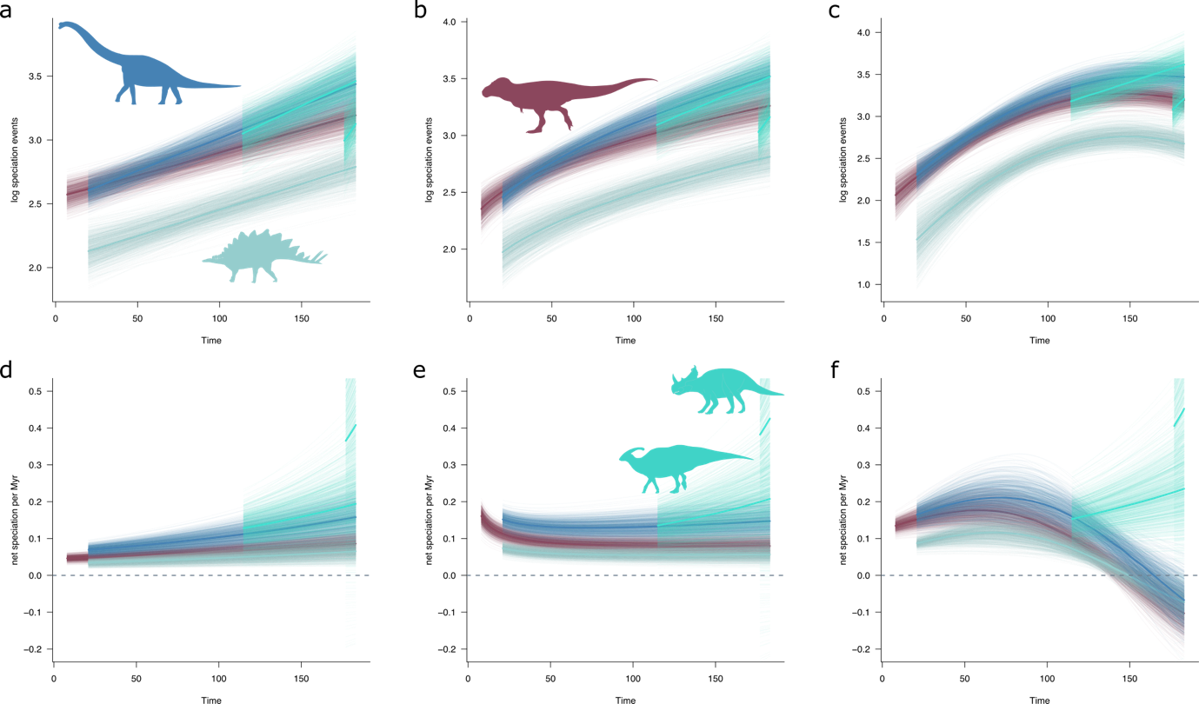
Figure S1. Number of speciation events predicted from phylogenetic models of diversification through time and net speciation per Myr. Speciation events were predicted from: (a) the Time-linear model with stage-wise effects (last two stages); (b) Time-square root model with stage-wise effects (last two stages); and (c) Time-quadratic model with stage-wise effects (last two stages). Net speciation per Myr, or diversification rates, (b) were calculated as the differences in predictions (a) at 1 Myr intervals.
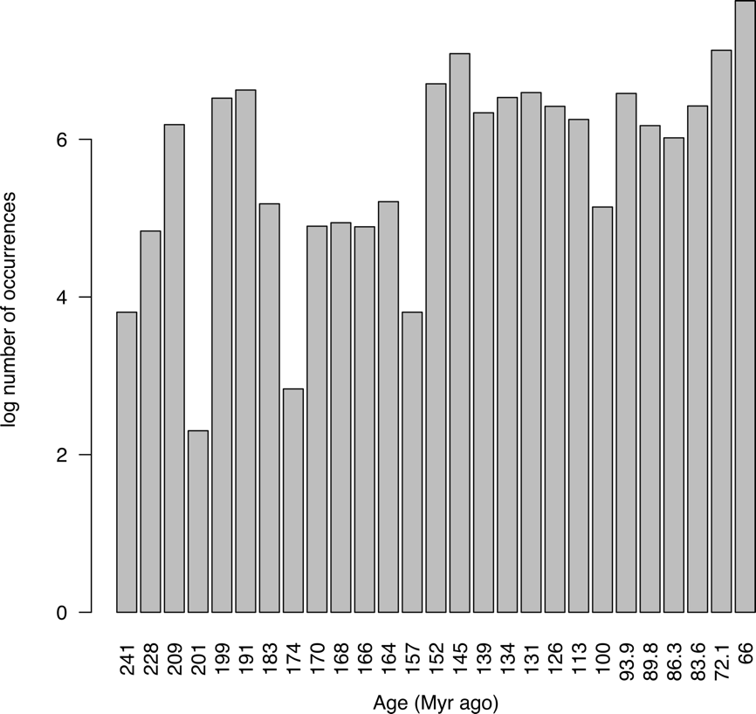
Figure S2. Numbers of fossil occurrences per geological stage.

Detailed descriptions of models

Dummy offset model group – all six Late Cretaceous stages
This set of models incorporates the effects of all six stages of the Late Cretaceous as intercept offsets. The dummy variables for each stage are 0|1 binary state variables where species coded 1 are those that have temporal ranges (between their first and last appearance dates, FAD and LAD respectively) that overlap with the stage of interest. The estimated regression coefficients are the stage-specific effects (positive or negative) on N_{Nodes} compared to the global intercept, or the phylogenetically corrected mean N_{Nodes}. A significant edge effect would be expected to be associated with progressively negative coefficients in stages more proximal to the end of the Cretaceous.

Model 001: Stage-wise effects intercept offset model
In this model, stage-wise effects are estimated as intercept offsets, while simultaneously accounting for the effects of each of the five dinosaurian subclades, Ceratopsidae, Hadrosauriformes, Ornithischia (excluding ceratopsids and hadrosauriforms), Sauropodomorpha, and Theropoda.
N_{Nodes} = Intercept + H + C + O + S + Th + Cenomanian + Turonian + Coniacian + Santonian + Campanian + Maastrichtian

Model 002: Stage-wise effects time-linear model
This model adds time-linear effects for all five groups to Model 001.
N_{Nodes} = Intercept + H + C + O + S + Th + Cenomanian + Turonian + Coniacian + Santonian + Campanian + Maastrichtian + Time:H + Time:C + Time:O + Time:S + Time:Th

Model 003: Stage-wise effects time-square root model
This model is based on Model 001, adding time-linear terms for ceratopsids and hadrosauriforms and time-square root terms for ornithischians, sauropodomorphs and theropods.
N_{Nodes} = Intercept + H + C + O + S + Th + Cenomanian + Turonian + Coniacian + Santonian + Campanian + Maastrichtian + Time:H + Time:C + √Time:O + √Time:S + √Time:Th

Model 004: Stage-wise effects time-quadratic model
This model is based on Model 001, adding time-linear terms for ceratopsids and hadrosauriforms and time-quadratic terms for ornithischians, sauropodomorphs and theropods.
N_{Nodes} = Intercept + H + C + O + S + Th + Cenomanian + Turonian + Coniacian + Santonian + Campanian + Maastrichtian + Time:H + Time:C + Time²:O + Time²:S + Time²:Th

Sampling effect model group
This set of models incorporates the effects of fossil sampling throughout the entire dinosaurian fossil record. A significant effect of sampling would be expected to be associated with a positive coefficient, meaning that lineages known from well-sampled species, with higher numbers of occurrences, will have accumulated more speciation events throughout evolutionary history.

Model 005: Sampling effect model
In this model, the effects of fossil sampling are accounted for by the inclusion of continuous variable, N_{Occ} (number of occurrences), while simultaneously accounting for the effects of each of the five dinosaurian subclades, Ceratopsidae, Hadrosauriformes, Ornithischia (excluding ceratopsids and hadrosauriforms), Sauropodomorpha, and Theropoda.
N_{Nodes} = Intercept + H + C + O + S + Th + N_{Occ}

Model 006: Sampling effect time-linear model
This model adds time-linear effects for all five groups to Model 005.
N_{Nodes} = Intercept + H + C + O + S + Th + N_{Occ} + Time:H + Time:C + Time:O + Time:S + Time:Th

Model 007: Sampling effect time-square root model
This model is based on Model 005, adding time-linear terms for ceratopsids and hadrosauriforms and time-square root terms for ornithischians, sauropodomorphs and theropods.
N_{Nodes} = Intercept + H + C + O + S + Th + N_{Occ} + Time:H + Time:C + √Time:O + √Time:S + √Time:Th

Model 008: Sampling effect time-quadratic model
This model is based on Model 005, adding time-linear terms for ceratopsids and hadrosauriforms and time-quadratic terms for ornithischians, sauropodomorphs and theropods.
N_{Nodes} = Intercept + H + C + O + S + Th + N_{Occ} + Time:H + Time:C + Time²:O + Time²:S + Time²:Th

Dummy offset model group – last two stages only
This set of models incorporates the effects of the last two stages of the Late Cretaceous as intercept offsets, as a result of backward elimination of non-significant stage effects from Models 001-004.

Model 009: Stage-wise effects (last two stages) intercept offset model
In this model, stage-wise effects for the last two stages are estimated as intercept offsets, while simultaneously accounting for the effects of each of the five dinosaurian subclades, Ceratopsidae, Hadrosauriformes, Ornithischia (excluding ceratopsids and hadrosauriforms), Sauropodomorpha, and Theropoda.
N_{Nodes} = Intercept + H + C + O + S + Th + Campanian + Maastrichtian

Model 010: Stage-wise effects (last two stages) time-linear model
This model adds time-linear effects for all five groups to Model 009.
N_{Nodes} = Intercept + H + C + O + S + Th + Campanian + Maastrichtian + Time:H + Time:C + Time:O + Time:S + Time:Th

Model 011: Stage-wise effects (last two stages) time-square root model
This model is based on Model 009, adding time-linear terms for ceratopsids and hadrosauriforms and time-square root terms for ornithischians, sauropodomorphs and theropods.
N_{Nodes} = Intercept + H + C + O + S + Th + Campanian + Maastrichtian + Time:H + Time:C + √Time:O + √Time:S + √Time:Th

Model 012: Stage-wise effects (last two stages) time-quadratic model
This model is based on Model 009, adding time-linear terms for ceratopsids and hadrosauriforms and time-quadratic terms for ornithischians, sauropodomorphs and theropods.
N_{Nodes} = Intercept + H + C + O + S + Th + Campanian + Maastrichtian + Time:H + Time:C + Time²:O + Time²:S + Time²:Th

Time-varying edge effect model group – last two stages combined
This set of models incorporates a time-varying edge effect on N_{Nodes} for taxa in the last two stages (Models 017-019). For completeness, we fitted models comparable to the model sets above, but where the last two stages are combined into a single “edge” effect variable, Edge (Models 013-016). The Edge variable is a dummy variable coded 1 for any taxa in the last two stages (excluding hadrosauriforms and ceratopsids) and the rest coded 0. Time-varying edge effect was modelled as an interaction term between the Edge variable and Time for the taxa occurring in the last two stages (excluding hadrosauriforms and ceratopsids). It was necessary to combine the last two stages into a single edge variable in order to secure enough variation through time for testing a time-varying edge effect.

Model 013: Edge effect (last two stages combined) intercept offset model
In this model, the edge effect is estimated as an intercept offset, taken across the last two stages (dummy variable Edge), while simultaneously accounting for the effects of each of the five dinosaurian subclades, Ceratopsidae, Hadrosauriformes, Ornithischia (excluding ceratopsids and hadrosauriforms), Sauropodomorpha, and Theropoda.
N_{Nodes} = Intercept + H + C + O + S + Th + Edge

Model 014: Edge effect (last two stages combined) time-linear model
This model adds time-linear effects for all five groups to Model 013.
N_{Nodes} = Intercept + H + C + O + S + Th + Edge + Time:H + Time:C + Time:O + Time:S + Time:Th

Model 015: Edge effect (last two stages combined) time-square root model
This model is based on Model 013, adding time-linear terms for ceratopsids and hadrosauriforms and time-square root terms for ornithischians, sauropodomorphs and theropods.
N_{Nodes} = Intercept + H + C + O + S + Th + Edge + Time:H + Time:C + √Time:O + √Time:S + √Time:Th

Model 016: Edge effect (last two stages combined) time-quadratic model
This model is based on Model 013, adding time-linear terms for ceratopsids and hadrosauriforms and time-quadratic terms for ornithischians, sauropodomorphs and theropods.
N_{Nodes} = Intercept + H + C + O + S + Th + Edge + Time:H + Time:C + Time²:O + Time²:S + Time²:Th

Model 017: Time-varying edge effect (last two stages combined) time-linear model
This model incorporates a time-varying edge effect for taxa occurring in the last two stages (except hadrosauriforms and ceratopsids) while the parameterisations of Model 014 are applied to the remaining taxa.
N_{Nodes} = Intercept + H + C + O_{NotEdge} + S_{NotEdge} + Th_{NotEdge} + Edge + Edge:Time + Time:H + Time:C + Time:O_{NotEdge} + Time:S_{NotEdge} + Time:Th_{NotEdge}

Model 018: Time-varying edge effect (last two stages combined) time-square root model
This model incorporates a time-varying edge effect for taxa occurring in the last two stages (except hadrosauriforms and ceratopsids) while the parameterisations of Model 015 are applied to the remaining taxa.
N_{Nodes} = Intercept + H + C + O_{NotEdge} + S_{NotEdge} + Th_{NotEdge} + Edge + Edge:Time + Time:H + Time:C + √Time:O_{NotEdge} + √Time:S_{NotEdge} + √Time:Th_{NotEdge}

Model 019: Time-varying edge effect (last two stages combined) time-quadratic model
This model incorporates a time-varying edge effect for taxa occurring in the last two stages (except hadrosauriforms and ceratopsids) while the parameterisations of Model 016 are applied to the remaining taxa.
N_{Nodes} = Intercept + H + C + O_{NotEdge} + S_{NotEdge} + Th_{NotEdge} + Edge + Edge:Time + Time:H + Time:C + Time²:O_{NotEdge} + Time²:S_{NotEdge} + Time²:Th_{NotEdge}

