Supplementary Information

Engineering Structural Discontinuity in Ordered Co₃O₄ Nanocube Arrays for Volatile Memristive Dynamics

Inhyeok Oh†, Jun Beom Hwang†, Minwoo Kang, Daehyeok Kim, Seohyeon Kim, Jungdae Lee, Hyeon Kim, Donghyeon Lee, Myoung Hwan Oh*, Sanghan Lee*

This file includes:

Supplementary Note 1. Image segmentation and particle size estimation
Supplementary Note 2. Particle orientation analysis
Supplementary Note 3. Contour-resolved interparticle gap measurement
Supplementary Note 4. Inter-bin variation of the interparticle gap
Supplementary Note 5. Radial distribution function
Supplementary Note 6. Peak analysis of $g(r)$
Supplementary Note 7. Orientational correlation function $g_{orient}(r)$

Supplementary Fig. 1-12

Supplementary Note 1. Image segmentation and particle size estimation
All detectable particles in each image were segmented using instance-level binary masks without omission. The original SEM images are shown in Fig. S3, and the corresponding masked images with indexed particle sizes are presented in Fig. S4. The projected area of each particle was calculated from the binary mask as

$$A_{i}=\sum_{p}{M_{i}}(p)$$

where $M_{i}(p)$ is the instance-level binary mask for particle $i$ (1 for foreground pixels and 0 otherwise).
The physical projected area was obtained as

$$A_{i}^{phys}=A_{i}s^{2}$$

where $s$ is the calibrated pixel size (nm${\text{px}}^{-1}$).
An effective particle size $L_{i}$ was defined as the side length of an equivalent square having the same projected area:
$$L_{i}=\sqrt{A_{i}^{phys}}$$
The particle centroid was computed using image moments. The resulting size distribution indicates that all particles lie within the range 9–11 nm, confirming the high uniformity of the synthesized nanocrystals.

Supplementary Note 2. Particle orientation analysis
The in-plane orientation of each particle was extracted from the minimum-area bounding rectangle obtained using the OpenCV minAreaRect function. The returned angle follows OpenCV’s internal convention, in which the reported angle corresponds to the rectangle width axis and lies within the interval $[-{90}^{∘},0^{∘})$. To ensure consistent orientation definition, the principal axis was always defined as the longer side of the bounding rectangle. If the detected width $w$ was smaller than the height $h$, ${90}^{∘}$ was added to the raw angle so that the orientation corresponds to the long axis of the particle. The normalized orientation angle $θ_{i}$ was then mapped to

$$\left.θ_{i}∈[0^{∘},{180}^{∘}\right)$$
Because the particle array exhibits square-lattice symmetry, orientations were further folded into the interval

$$\left.θ_{i}∈[0^{∘},{90}^{∘}\right)$$
The dominant lattice orientation for each sample was defined as the median orientation angle

$$θ_{0}=median(θ_{i})$$

Angular deviations from the lattice axis were evaluated using the shortest angular difference under ${90}^{∘}$ periodicity. Orientation-colored masks illustrating the angular distribution are shown in Fig. S5, where blue and red correspond to counterclockwise and clockwise rotations relative to the principal lattice axis, respectively. All particles are aligned within approximately ±10°, indicating strong orientational order.

Supplementary Note 3. Contour-resolved interparticle gap measurement
The interparticle gap between neighboring particles was determined using a contour-based geometric method rather than centroid subtraction. This approach directly measures the separation between opposing particle faces and therefore preserves the true interparticle geometry. Representative interparticle gap regions are shown in Fig. S6.

Coordinate transformation
Particle centroid coordinates $(c_{x}, { c}_{y})$ in pixel units were converted into physical units (nm):

$$x_{i}=s { c}_{x,i} \\ y_{i}=s (H_{\text{px}}-c_{y,i})$$

where $s$is the pixel size and $H_{\text{px}}$ is the image height.
To align the array with the dominant lattice axis, coordinates were rotated by angle $θ_{\text{dom}}$:

$$\left(\begin{aligned}u_{i} \\ v_{i}\end{aligned}\right)=\left(\begin{matrix}\cos{θ_{\text{dom}}} & -sin{ θ}_{\text{dom}} \\ \sin{θ_{\text{dom}}} & \cos{θ_{\text{dom}}}\end{matrix}\right)\left(\begin{aligned}x_{i} \\ y_{i}\end{aligned}\right)$$
The rotated frame $\left(u, v\right)$defines directions parallel and perpendicular to the lattice axis.

Directional nearest neighbor identification
For each particle $i$, directional nearest neighbors (right, left, up, down) were identified in the rotated frame.
Two particles were considered to belong to the same row when

$$∣v_{i}-v_{j}∣≤T$$

and to the same column when
$$∣u_{i}-u_{j}∣≤T$$

where the tolerance was set to $T=10\text{ nm}$.
Among candidates satisfying the directional condition, the nearest particle was selected by minimizing the Euclidean distance

$$d_{ij}=\sqrt{\left(u_{i}-u_{j})^{2}+(v_{i}-v_{j})^{2}\right.}$$

Particles located within 20 nm of the image boundary were excluded from directional assignment to avoid incomplete gap estimation.
Local face separation from contour projection
Let the contour coordinates of particles $i$and $j$in the rotated frame be

$C_{i}=\{\left(u_{i,k},v_{i,k}\right), C_{j}=\{(u_{j,l},v_{j,l})\}$.

For horizontal neighbors, the overlapping $v$-range is divided into bins of width $Δv=1\text{ nm}$.
Within each bin $b$, the local face separation was defined as

$g_{b}=\underset{l∈b}{min⁡}(u_{j,l})-\underset{k∈b}{max⁡}(u_{i,k})$.

Only positive values $g_{b}>0$ were retained. For vertical neighbors the same procedure was applied along the $u$-axis:
This procedure yields a set of bin-wise gap values

$$\left\{g_{b}\}\right.$$
for each particle pair.

Robust gap estimation
To suppress contour irregularity and pixel discretization noise, the final interparticle gap between particles 𝑖 and 𝑗 was defined using a 10% trimmed mean

$${\overset{ˉ}{g}}_{ij}={\text{TrimmedMean}}_{0.10}\left(\{g_{b}\}\right)$$

For each particle $i$, the mean directional gap was defined as

$$g_{i}=\frac{1}{n_{i}}\sum_{d}{{\overset{ˉ}{g}}_{i,d}}$$

where $d$ spans valid directional neighbors.

Supplementary Note 4. Inter-bin variation of the interparticle gap
To evaluate the reliability of the contour-based gap measurement, the variation of the gap values within each particle pair was quantified. If two particles are perfectly aligned, the opposing faces remain parallel and the local gap values $g_{b}$ obtained from each bin are nearly constant across bins. However, when particles are slightly rotated relative to each other, the local separation varies along the face region because different parts of the contours approach each other at different distances.
To quantify this effect, the coefficient of variation (CV) of the bin-wise gap values was calculated as
$$CV_{ij}=\frac{σ(g_{b})}{μ(g_{b})}$$
The distribution of inter-bin CV values is shown in Fig. S7. The average CV is approximately 0.27, indicating that the variation within individual face regions remains moderate and that the particles are well aligned with respect to the lattice axis. This analysis confirms that the extracted interparticle gaps are not dominated by local contour irregularities or rotational mismatch and therefore provides a statistically meaningful estimate of interparticle separation.

Supplementary Note 5. Radial distribution function
The radial distribution function describes the probability of finding a particle at distance r from a reference particle relative to a random distribution. The radial distribution function was calculated as:
$$g(r)=\frac{1}{ρ}⟨\sum_{i≠j}{δ(r-}r_{ij})⟩,$$

where $ρ$is number density and $r_{ij}$ is the interparticle distance. Since Region 1–Region 4 exhibit similar distributions, the averaged curve $g(r)_{\text{avg}}$was used for quantitative interpretation. Individual and averaged results are shown in Fig. S8.

Supplementary Note 6. Peak analysis of $g(r)$
Since the histogram bin width was 1 nm, accurate peak position extraction required Voigt profile fitting. The fitting successfully reproduces the first four peaks within approximately 0.1 nm error. For higher-order peaks, the sixth composite peak corresponds to overlapping contributions from the $3d$ and $\sqrt{10}d$ lattice positions. The full width at half maximum (FWHM) of this peak is approximately 7.85 nm, whereas the separation between the two expected lattice positions (36.9–41.2 nm) is only 4.3 nm. Since peak separation requires:

$$Δr>\text{FWHM}$$

these peaks cannot be resolved individually. The observed peak positions nevertheless coincide with the expected square-lattice distances

$$d,\sqrt{2}d,2d,\sqrt{5}d, 3d,\sqrt{10}d, \sqrt{13}d$$

confirming that the particles form a well-ordered square lattice. The fitting results are shown in Fig. S9.

Supplementary Note 7. Orientational correlation function $g_{orient}(r)$
Each particle $i$ was assigned an in-plane orientation angle $θ_{i}$, defined as the direction of the particle’s principal axis obtained from the minimum-area bounding rectangle. For a particle pair $(i, j)$, the angular difference was defined as

$$Δθ_{ij}=∣θ_{i}-θ_{j}∣.$$

Because the nanoparticle array exhibits square-lattice symmetry, particle orientations are equivalent under rotations of ${90}^{∘}$. To account for this symmetry, angular differences were folded into the interval $\left[0,π/4\right]$ according to

$$Δθ_{ij}^{folded}=\left\{\begin{matrix}Δθ_{ij}, & Δθ_{ij}≤\frac{π}{4} \\ \frac{π}{2}-Δθ_{ij}, & Δθ_{ij}>\frac{π}{4}.\end{matrix}\right.$$

Under this definition, $Δθ=0$ corresponds to perfectly aligned particles, whereas larger values indicate stronger orientational mismatch.
The orientational correlation function $g_{orient}(r)$ was defined as the average folded angular mismatch between particle pairs separated by a distance $r$. For particle pairs satisfying $r_{k}≤r_{ij}<r_{k}+Δr$, the function is calculated as

$$g_{orient}(r_{k})=\frac{1}{N_{pair}(r_{k})}\sum_{i<j}{Δ}θ_{ij}^{folded},$$
where $r_{ij}$is the interparticle distance and $N_{pair}(r_{k})$is the number of particle pairs within the radial shell.
If particles maintain a common orientation across the lattice, the orientational mismatch remains small and $g_{orient}(r)$ stays close to zero over long distances. In contrast, if orientations become decorrelated, $g_{orient}(r)$ increases with distance. In the present system, the curves obtained from the four analyzed regions remain within approximately $3^{∘}$ over the entire observable distance range, indicating that orientational alignment is preserved throughout the nanoparticle array. The corresponding plots are shown in Fig. S10.

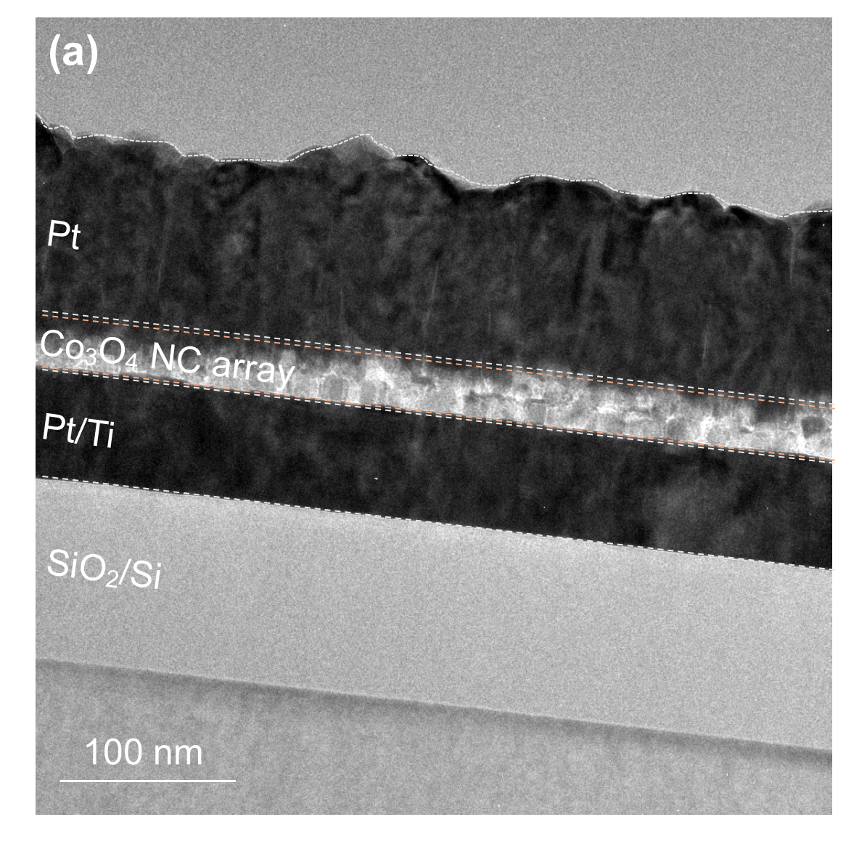
Fig. S1 Cross-sectional FIB image of the Co₃O₄ NC array device. Focused ion beam (FIB)-prepared cross-sectional view showing the vertical integration of the Pt/ Co₃O₄ NC array/Pt/Ti heterostructure on a SiO₂/Si substrate.

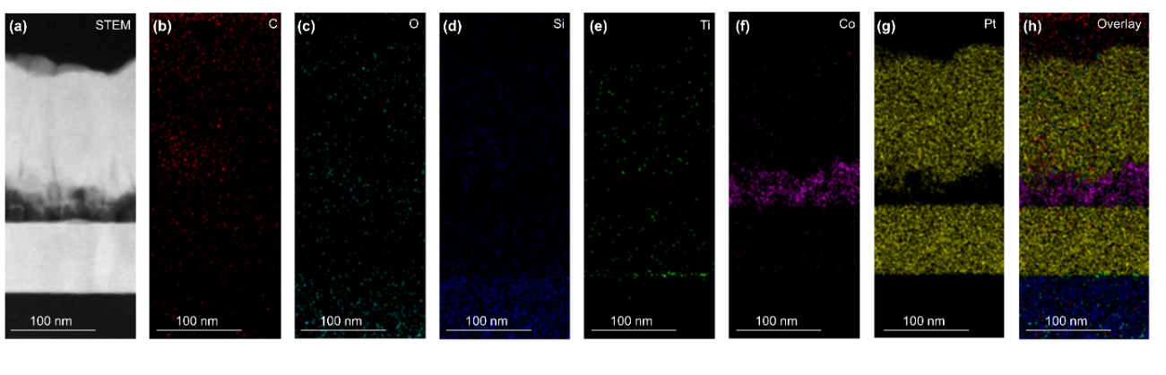
Fig. S2 EDS elemental mapping of the device cross-section. (a) STEM image and the corresponding energy-dispersive X-ray spectroscopy (EDS) elemental maps for (b) C, (c) O, (d) Si, (e) Ti, (f) Co, and (g) Pt, along with (h) an overlay image.

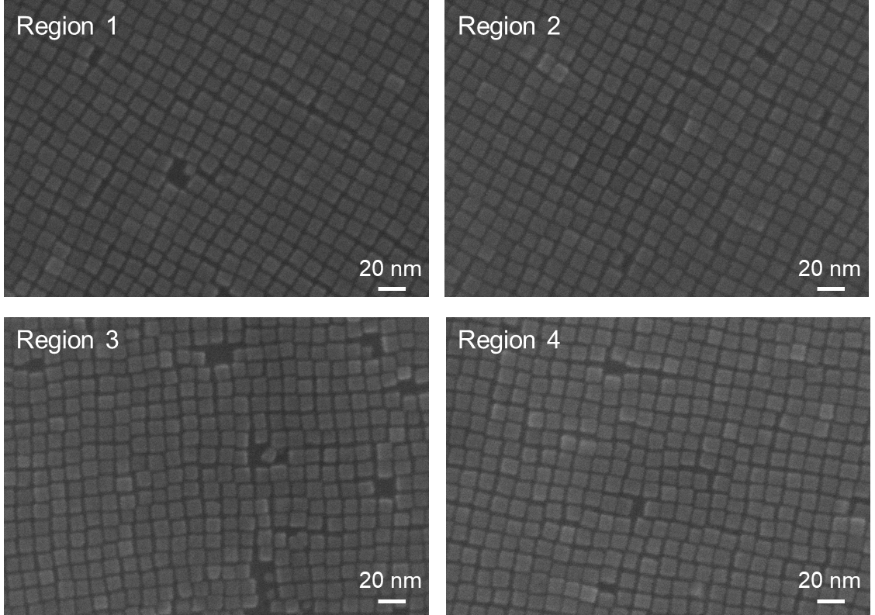
Fig. S3 top-view SEM images of the self-assembled NC arrays corresponding to Regions 1–4 presented in Fig. 2a.

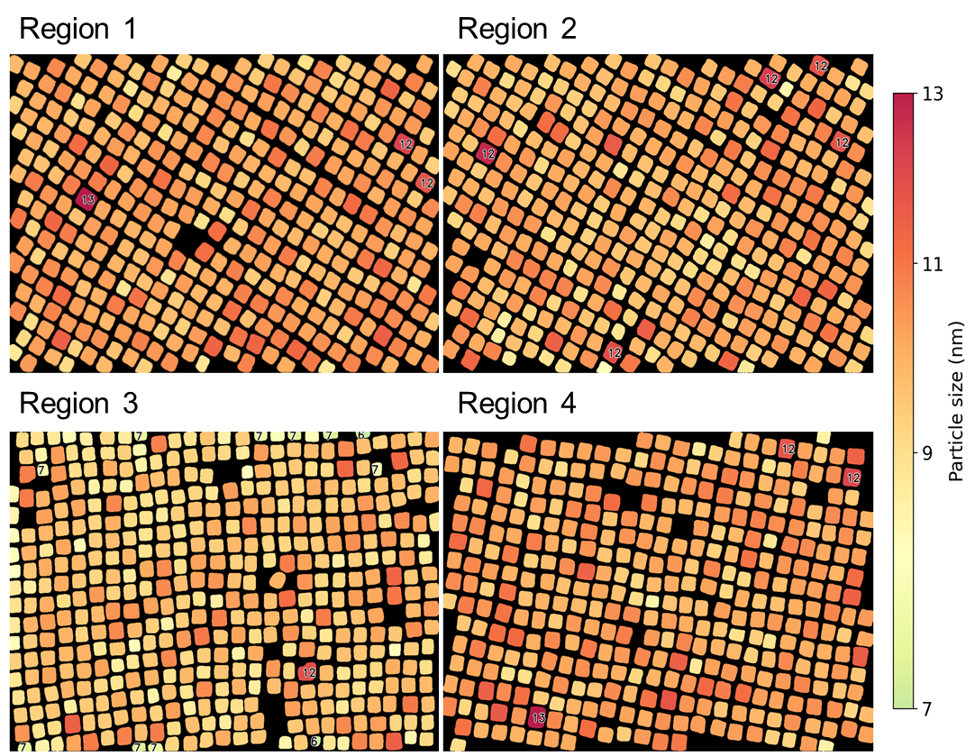
Fig. S4 Spatial maps of particle size obtained from instance-level segmentation masks corresponding to the SEM images shown in Fig. S3. Each particle is color-coded by its effective size $L$, defined as the side length of an equivalent square with the same projected area. The colormap spans particle sizes from 7 to 13 nm. Particles outside this range ($L<7$ nm or $L>13$nm) are explicitly annotated to indicate size outliers. The maps show that most particles fall within a narrow size distribution across all regions.

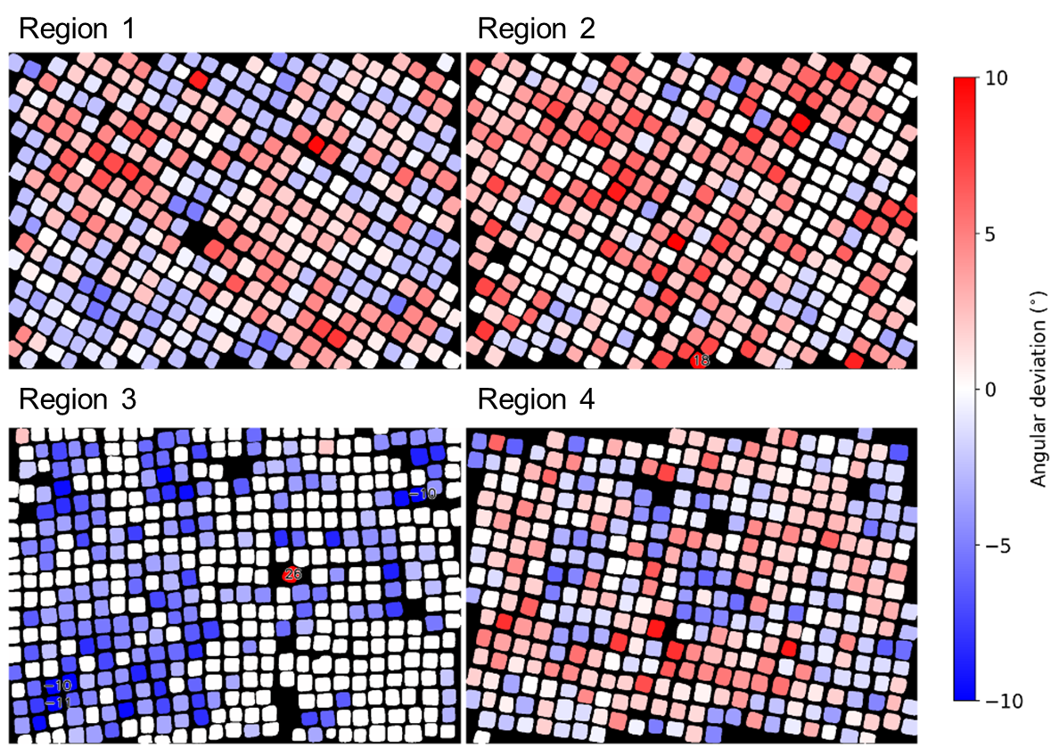
Fig. S5 Particles are colored according to their in-plane rotation angle relative to the dominant lattice orientation. Blue and red indicate counterclockwise and clockwise rotations, respectively. Most particles fall within approximately ±10°, demonstrating strong orientational alignment across the nanoparticle array. The color scale is limited to ±10° to emphasize the dominant orientation distribution; a few particles exhibit larger deviations.

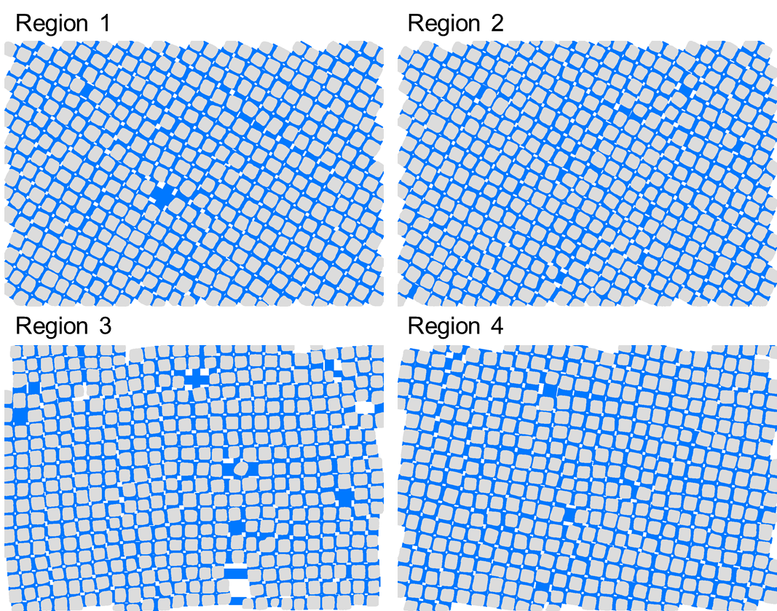
Fig. S6 Representative nanoparticle arrays used for contour-based gap analysis. Interparticle gaps between neighboring particles were determined from contour projections rather than centroid distances to preserve the true interparticle geometry.

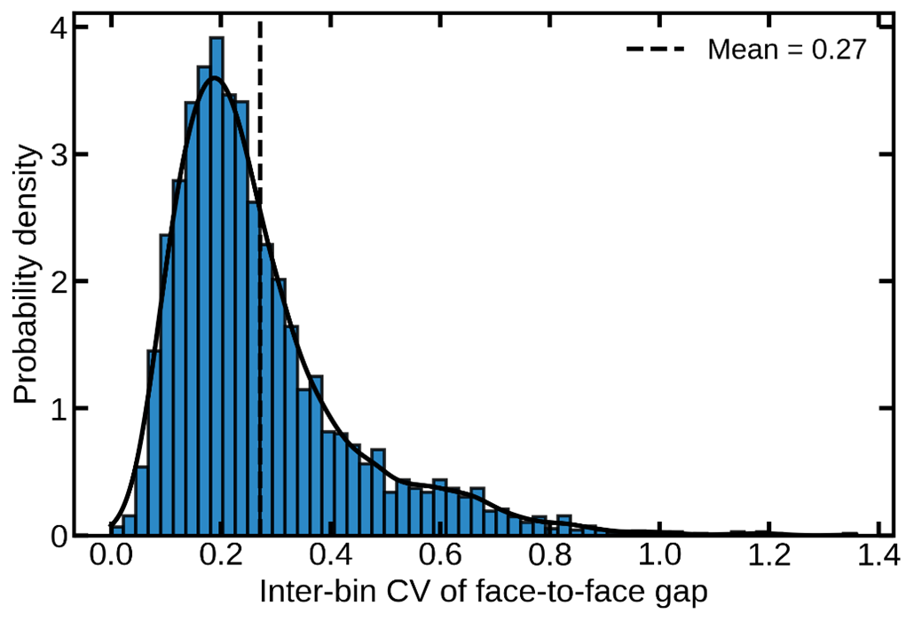
Fig. S7 Probability density distribution of the coefficient of variation calculated from bin-resolved local gap values within each particle pair. The mean CV (~0.27) indicates moderate variation within face regions, confirming that the measured gaps are not dominated by contour irregularities or rotational mismatch.

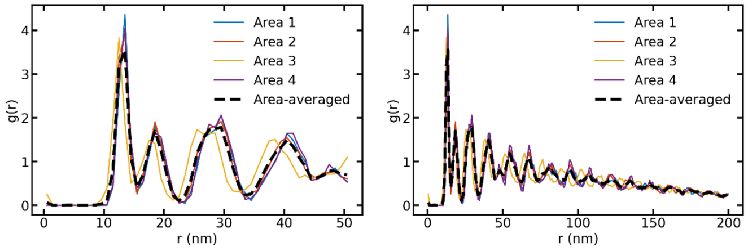
Fig. S8 Radial distribution functions g(r)calculated for four independent regions together with the averaged curve. The nearly identical profiles confirm consistent positional ordering across different regions of the sample. The presence of well-defined peaks indicates long-range positional order in the nanoparticle lattice.

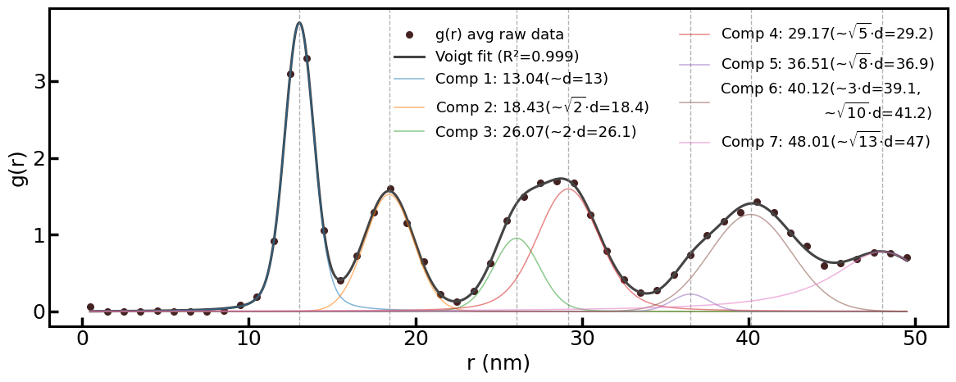
Fig. S9 Voigt profile fitting applied to the averaged $g(r)$curve to determine peak positions. The extracted peaks correspond to the expected square-lattice distances $d,\sqrt{2}d,2d,\sqrt{5}d,3d,\sqrt{10}d,$and $\sqrt{13}d$, confirming long-range square-lattice ordering.

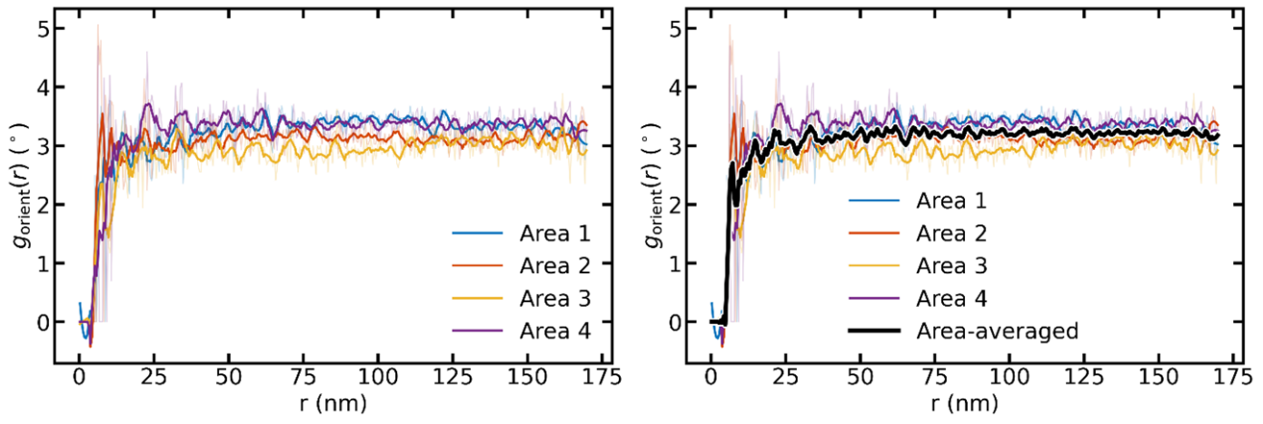
Fig. S10 Orientational mismatch between particle pairs as a function of interparticle distance. Curves obtained from four regions remain within approximately $3^{∘}$over the entire observable distance range, indicating that orientational alignment is preserved across the nanoparticle lattice.

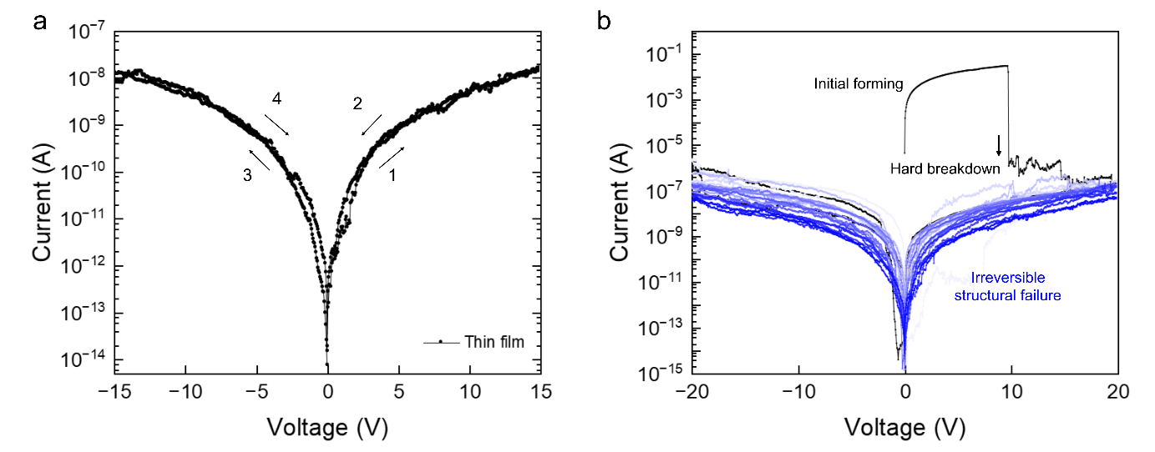
Fig. S11 Characteristic lack of hysteresis (a) and irreversible hard breakdown (b) in continuous Co₃O₄ thin films.

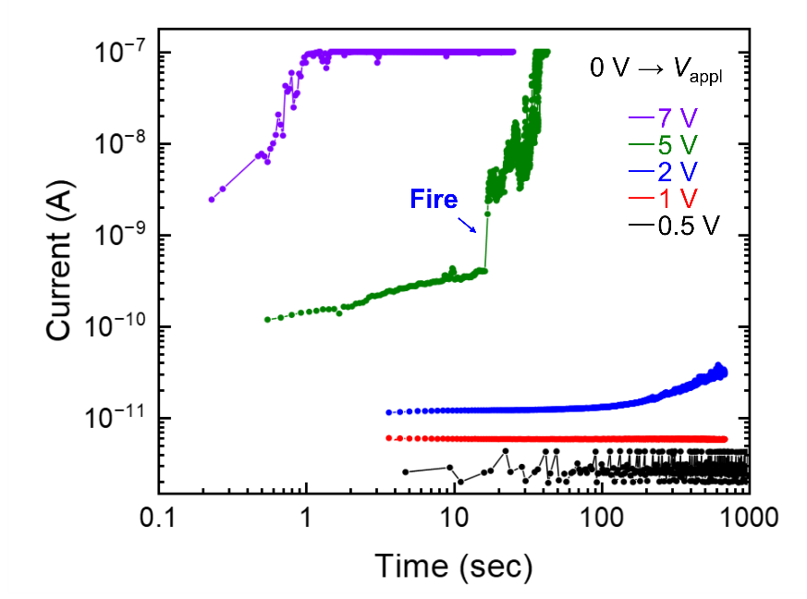
Fig. S12 Time-dependent conductance integration and biomimetic firing characteristics.

