Clonal hematopoiesis in lung cancer and its impact on liquid biopsy
Supplementary Figures

Yang Xue^{1﻿,†}, Youyu Wang^{1,†}, Yingmei Li^{2,†}, Danni Liu², Mengqi Shao¹, Lei Liu¹, Yida Liao¹, Tanxiao Huang², Jing Zhang², Shifu Chen^{2,*}, Gang Feng^{1,*}, Kegang Jia^{1,*}

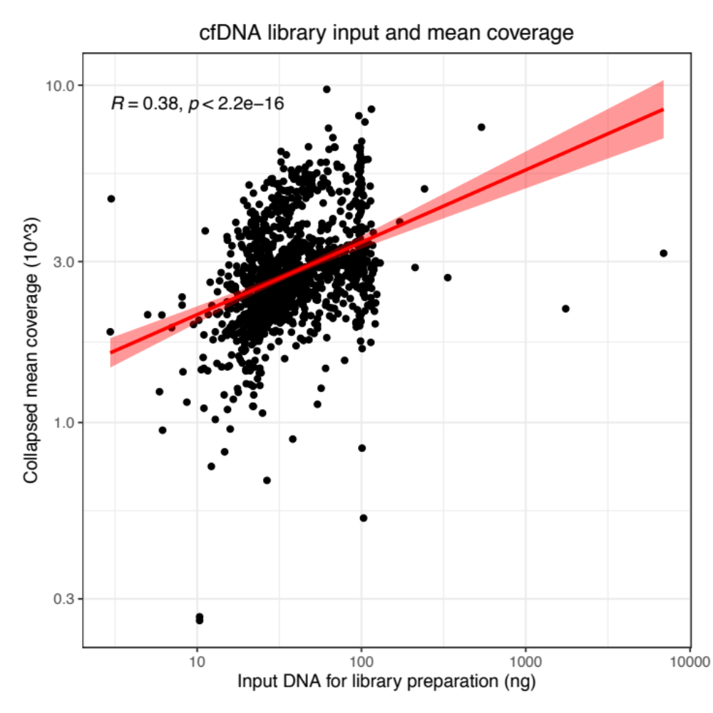
Figure S1. Input DNA quantity and collapsed mean coverage in cfDNA sequencing.
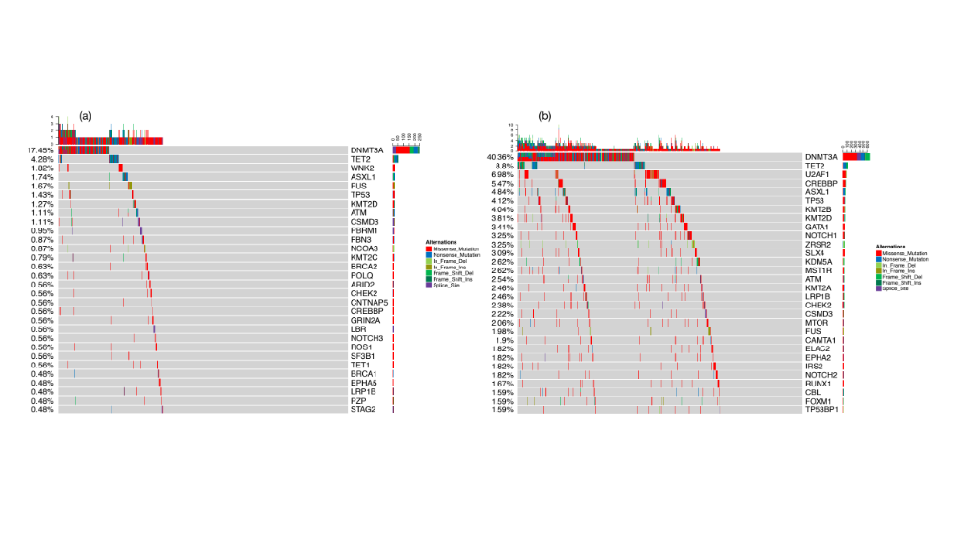
Figure S2. Top 30 mutated potential CH related genes in all lung cancer patients at (a) threshold and (b) subthreshold.

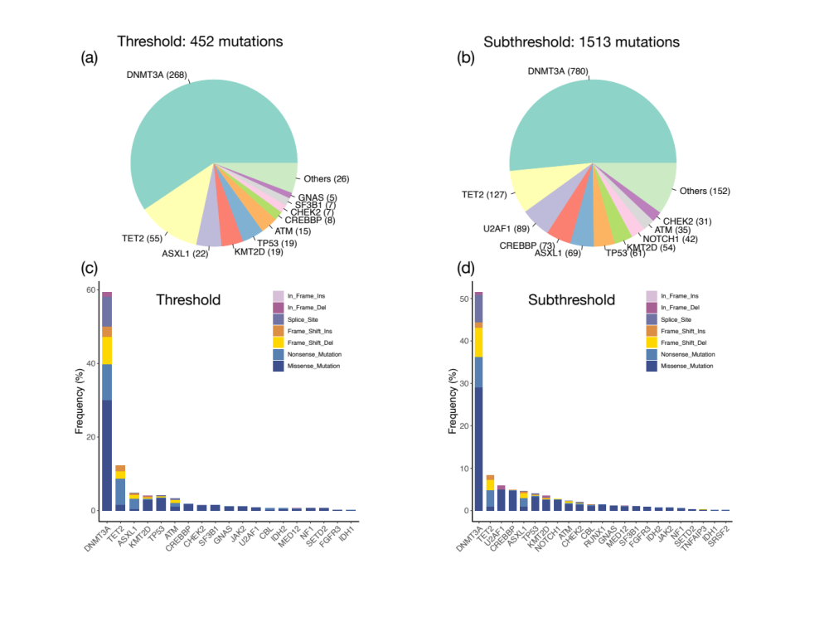
Figure S3. Distribution of all detected CH mutations. Pie chart of CH mutations composition at threshold (a) and subthreshold (b). Different mutations types at (c) threshold and (d) subthreshold.
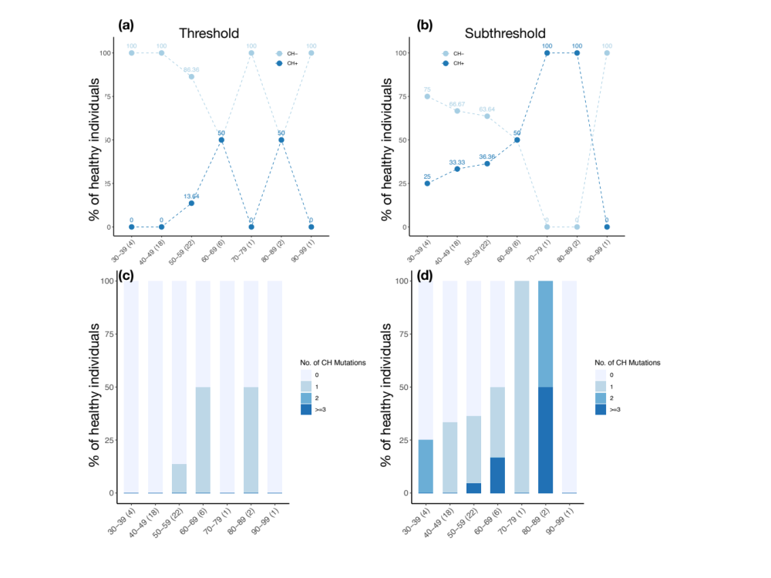
Figure S4. CH related mutations in healthy individuals
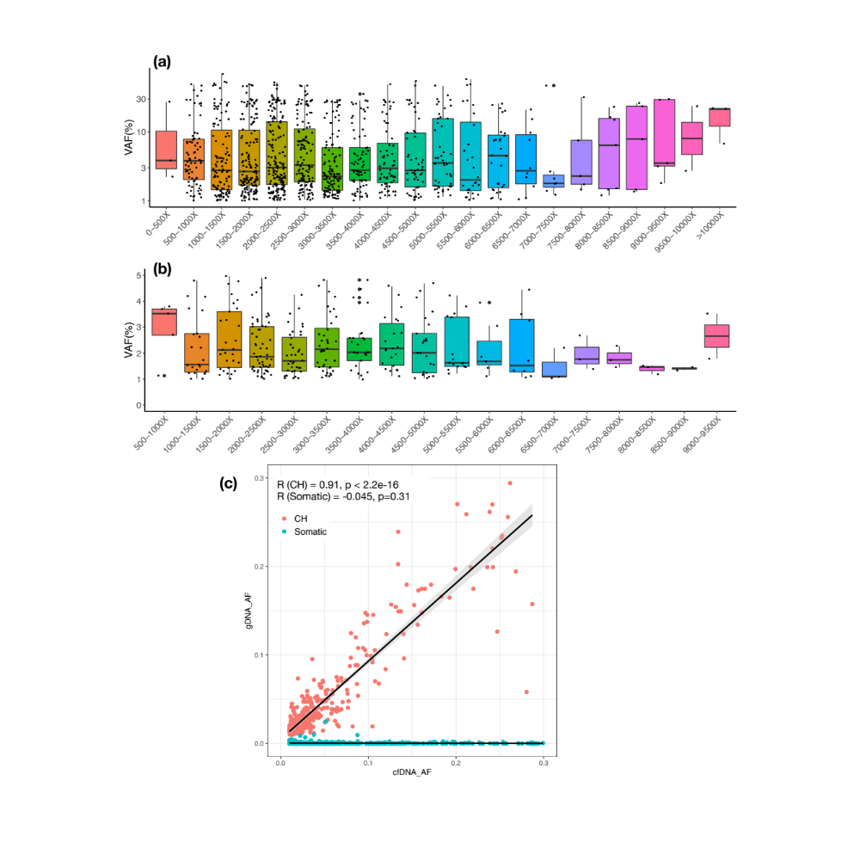
Figure S5. Mutations with the threshold setting. (a) All mutations detected in cfDNA at different sequencing range; (b) CH mutations detected in cfDNA at different sequencing ranges; (c) mutant allele frequencies in cfDNA and gDNA (Pearson’s correlation).

